Name – Vikas Srivastava
Topic – Git/Github Assignment 1
Batch - DATACOM+5G Dev
Batch Id - 25SUB4505
User Id – 55984
Email Id – vikas200027@gmail.com
-------------------------------------------------------------------------------------------------------------------------------------------------------------------
Assignment 4 : Write SQL statements to CREATE a new database and tables that reflect the library schema you designed earlier. Use ALTER statements to modify the table structures and DROP statements to remove a redundant table.

Solution :
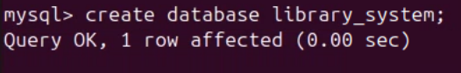
1.

2.
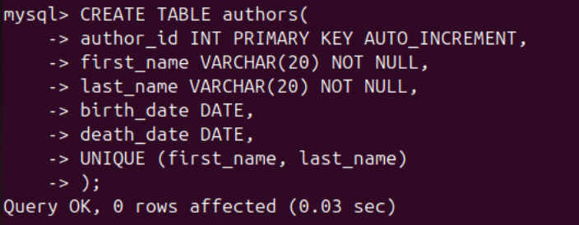
3.
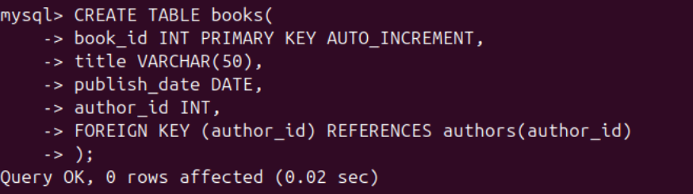
4.
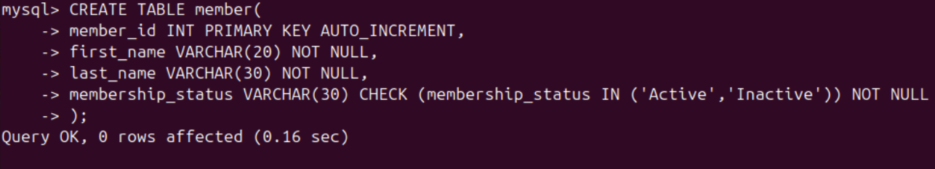
5.
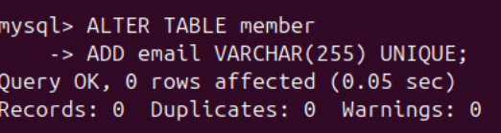
6.
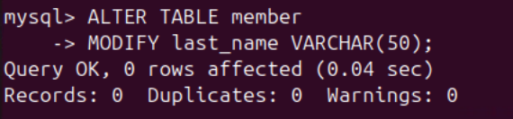
7.
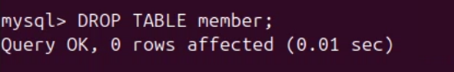
8.

