Name – Vikas Srivastava
Topic – Git/Github Assignment 1
Batch - DATACOM+5G Dev
Batch Id - 25SUB4505
User Id – 55984
Email Id – vikas200027@gmail.com
---------------------------------------------------------------------------------------------------------------------------------------------------
Assigment 5 : Demonstrate the creation of an index on a table and discuss how it improves query performance. Use a DROP INDEX statement to remove the index and analyze the impact on query execution.
Solution : Using the Employee data lets analyze;
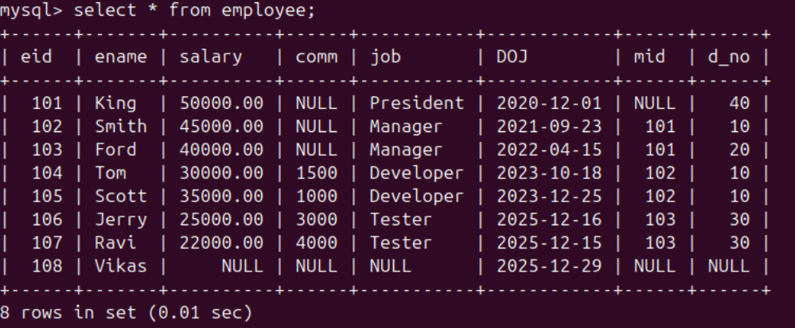
1.
- After creating the index on d_no and salary, running the same query will be much faster:
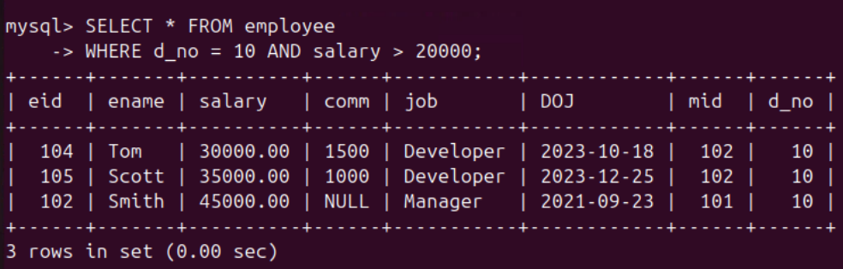
2.
- Without the index, the database will likely use a full table scan, which is much slower when you have a large number of rows.
- Without the Index: After dropping the index, queries will again require a full table scan, leading to slower query performance, especially for large datasets.
- Performance Analysis:
    - Before Index: The query is slower because of the full scan.
    - After Index: The query is faster due to the index seek.
    - After Dropping Index: The query slows down again because the database has to scan all the rows.

3.

