Name – Vikas Srivastava
Topic – Git/Github Assignment 1
Batch - DATACOM+5G Dev
Batch Id - 25SUB4505
User Id – 55984
Email Id – vikas200027@gmail.com
-------------------------------------------------------------------------------------------------------------------------------------------------------------------
Assignment 6: Create a new database user with specific privileges using the CREATE USER and GRANT commands. Then, write a script to REVOKE certain privileges and DROP the user.
Solution :
1.
2.
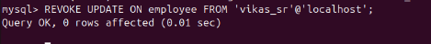
3.

4.

