Name – Vikas Srivastava
Topic – Git/Github Assignment 1
Batch - DATACOM+5G Dev
Batch Id - 25SUB4505
User Id – 55984
Email Id – vikas200027@gmail.com
-------------------------------------------------------------------------------------------------------------------------------------------------------------------
Assignment 7: Prepare a series of SQL statements to INSERT new records into the employee tables, UPDATE existing records with new information, and DELETE records based on specific criteria. Include BULK INSERT operations to load data from an external source.
Solution :
- Select the table employee and now perform the INSERT, UPDATE, DELETE OPERATIONS.
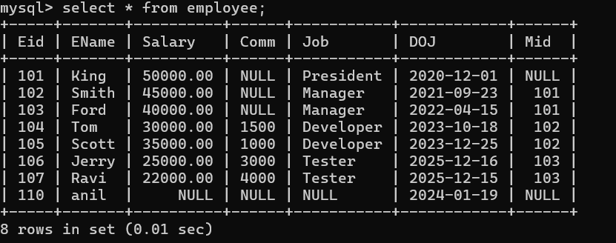
1.
- INSERT operation :
2.
- Output :
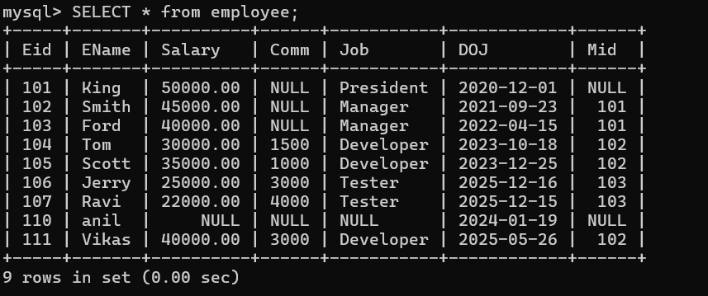
3.
- UPDATE operation :

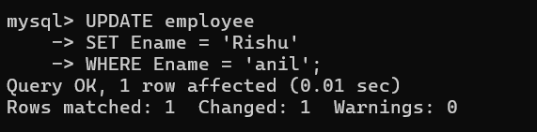
4.
- Output :

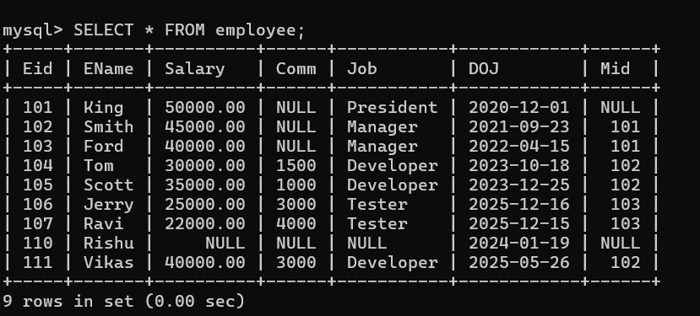
5.
- DELETE operation :
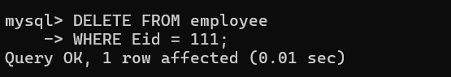
6.
- Output :

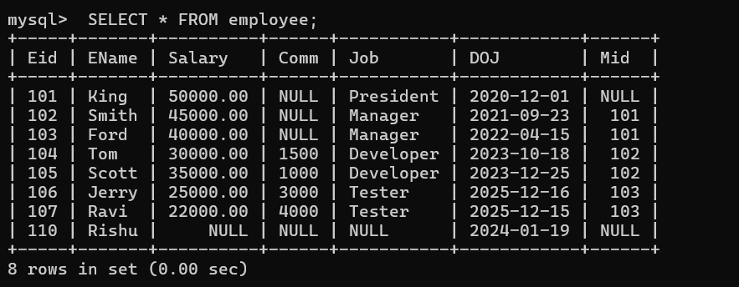
7.

- Bulk Insertion :

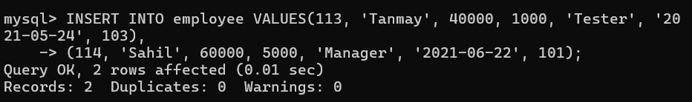
8.
- Output :
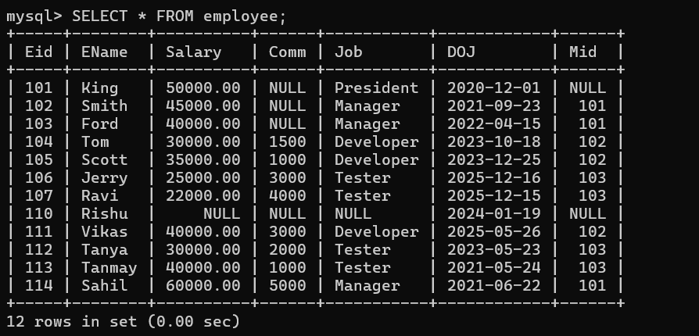
9.

