Assignment 6: Given a sample log file, write a script using grep to extract all lines containing "ERROR". Use awk to print the date, time, and error message of each extracted line.
Data Processing with sed
Solution :
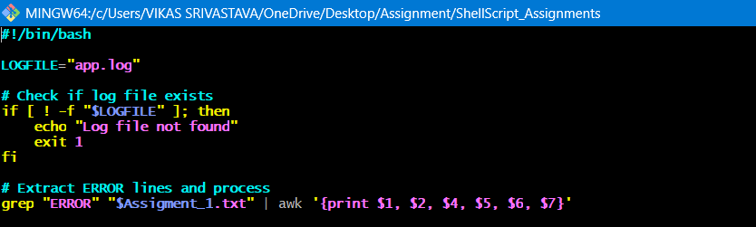
1.

