Name – Vikas Srivastava
Topic – SQL Assignment : 10
Batch - DATACOM+5G Dev
Batch Id - 25SUB4505
User Id – 55984
Email Id – vikas200027@gmail.com
-----------------------------------------------------------------------------------------------------------------------------------------------------------------
Assignment 10: Utilize a subquery to find customers who have placed orders above the average order value, and write a UNION query to combine two SELECT statements with the same number of columns.
Solution :
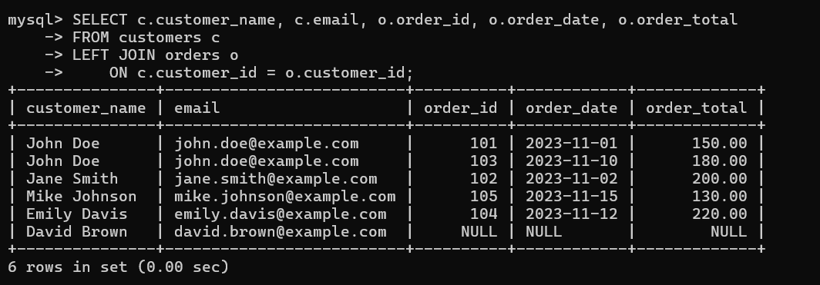
1.
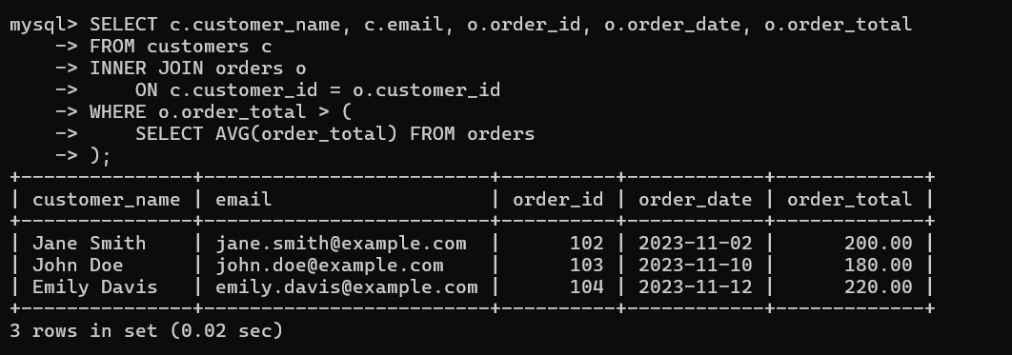
2.
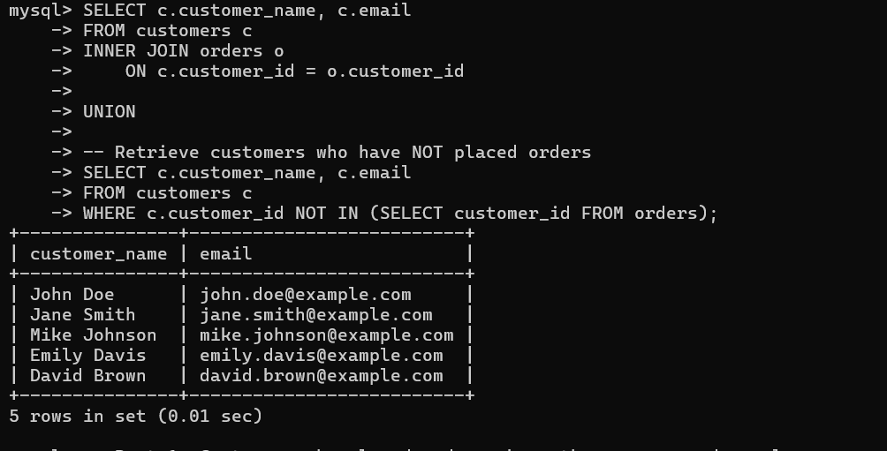
3.

