Name – Vikas Srivastava
Topic – SQL Assignment : 08
Batch - DATACOM+5G Dev
Batch Id - 25SUB4505
User Id – 55984
Email Id – vikas200027@gmail.com
-------------------------------------------------------------------------------------------------------------------------------------------------------------------
Assignment 8: Write a SELECT query to retrieve all columns from a 'customers' table, and modify it to return only the customer name and email address for customers in a specific city.
Solution :
- Create a customer table :
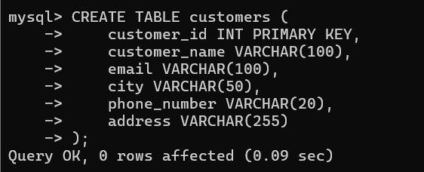
1.
- Insert Records :
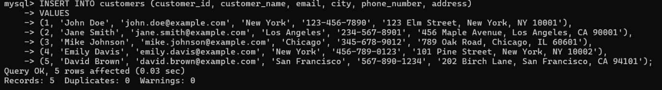
2.
- View whole Table :
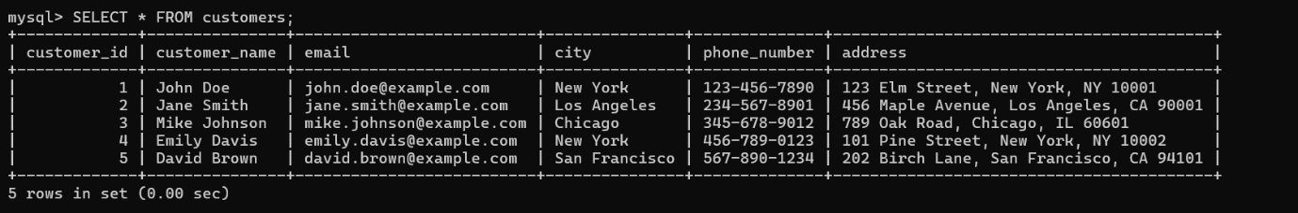
3.
- modify it to return only the customer name and email address for customers in a specific city.
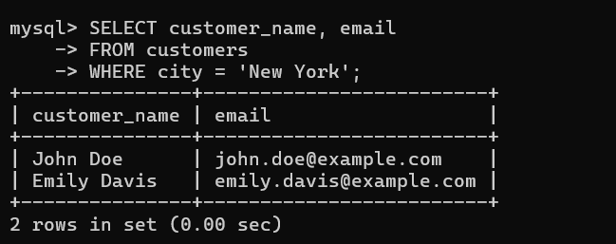
4.

