Name – Vikas Srivastava
Topic – Git/Github Assignment 1
Batch - DATACOM+5G Dev
Batch Id - 25SUB4505
User Id – 55984
Email Id – vikas200027@gmail.com
---------------------------------------------------------------------------------------------------------------------------------------------------
Assignment 1: Initialize a new Git repository in a directory of your choice. Add a simple text file to the repository and make the first commit.

Solution : To initialize a new Git repository in a directory of my choice the steps are as follows :
- First create a folder anywhere in your system. Example : Hello
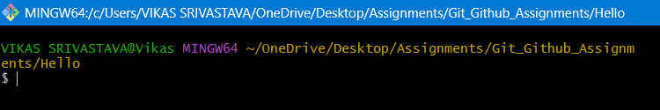

2. Open the command prompt or Git Bash and navigate to the Hello folder.
3. Run the command:
- git init
- It converts a normal folder into a Git repository.
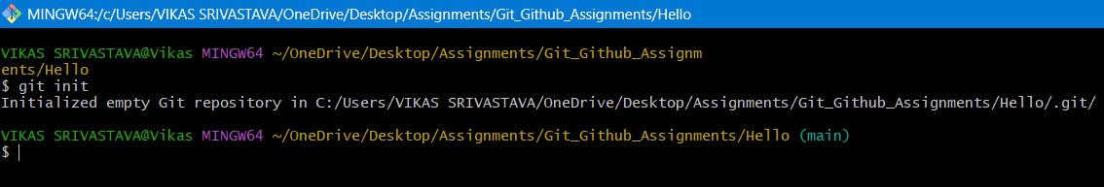

4. Create a simple text file inside the folder, for example vikas.txt.
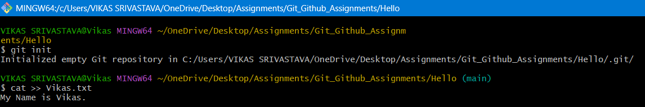

5. Now connect the local repo to github.
- git remote add origin “github-link”
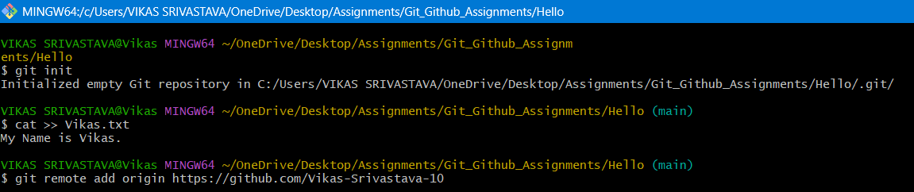
6. Add the file to the staging area using:
- git add .
7. Check the repository status using:
- git status
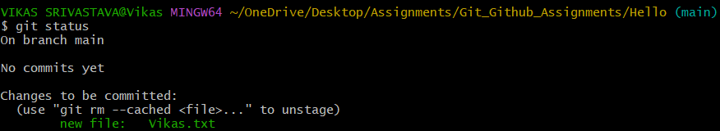
8. Configure Git user identity (only required once):
- git config --global user.name "Your Name"
- git config --global user.email "youremail@gmail.com"
9. Make the first commit using:
- git commit -m "Initial commit"
