Name – Vikas Srivastava
Topic – Git/Github Assignment 1
Batch - DATACOM+5G Dev
Batch Id - 25SUB4505
User Id – 55984
Email Id – vikas200027@gmail.com
-------------------------------------------------------------------------------------------------------------------------------------------------------------------
Assignment 2: Branch Creation and Switching
Create a new branch named 'feature' and switch to it. Make changes in the 'feature' branch and commit them.
Solution : To create a new branch :
1. Open the command prompt or Git Bash and navigate to the Git repository.
2. Create a new branch named feature using:
- git branch feature
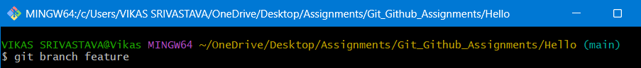
3. Switch to the feature branch using:
- git checkout feature
4. Make changes in the feature branch by editing an existing file or creating a new file (for example, update name.txt).
5. Add the modified files to the staging area:
- git add .
6. Commit the changes in the feature branch:
- git commit -m "Changes added in feature branch”
