Software Development Life Cycle (SDLC)
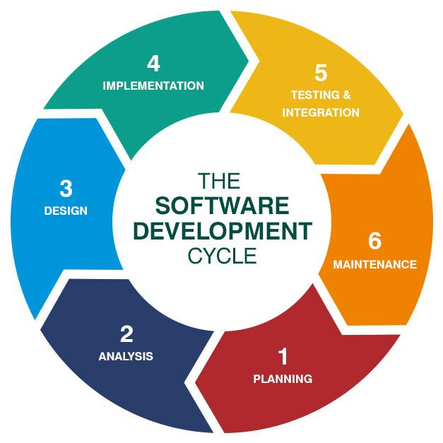
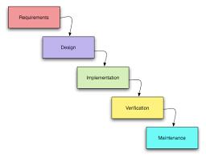
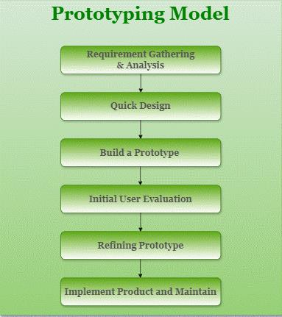
5
What is SDLC?
SDLC (Software Development Life Cycle) is a structured framework that defines the phases involved in building high-quality software efficiently and predictably.
SDLC Phases
- Requirement Analysis
- System Design
- Development
- Testing
- Deployment
- Maintenance

SDLC Models
1️⃣ Waterfall Model
Definition
The Waterfall model is a sequential and linear SDLC model where each phase must be completed before the next begins.
Flow
Requirements → Design → Development → Testing → Deployment → Maintenance
Advantages
- Simple and easy to manage
- Clear documentation
- Suitable for stable requirements
Disadvantages
- No flexibility for changes
- Testing happens late
- High risk for evolving projects
Best Use Case
- Government or compliance-heavy projects
- Fixed-scope systems

2️⃣ Prototype Model
Definition
The Prototype model involves creating an early working model of the system to understand and refine requirements through user feedback.
Flow
Initial Requirements → Prototype → User Feedback → Refinement → Final Product
Advantages
- Clear requirements
- Early user involvement
- Reduced rework
Disadvantages
- Scope creep
- Increased cost if unmanaged
Best Use Case
- UI-intensive applications
- Unclear or evolving requirements

3️⃣ Agile Model ⭐ (Modern SDLC Approach)
Definition
Agile is an iterative and incremental SDLC model that delivers software in small, usable parts called iterations or sprints.

Agile Core Principles
- Customer collaboration over contracts
- Working software over documentation
- Responding to change over rigid plans
- Continuous improvement

Agile Lifecycle
- Backlog Creation
- Sprint Planning
- Sprint (2–4 weeks)
- Development & Testing
- Sprint Review
- Sprint Retrospective
- Release
🔁 Cycle repeats until product completion

Agile Roles
- Product Owner – Defines requirements & priorities
- Scrum Master – Facilitates Agile process
- Development Team – Builds the product

Agile Frameworks
- Scrum
- Kanban
- SAFe
- Extreme Programming (XP)

Advantages of Agile
- Faster delivery
- Early and continuous feedback
- High adaptability
- Improved customer satisfaction

Disadvantages of Agile
- Less documentation
- Requires experienced teams
- Harder to predict timelines

Agile vs Waterfall
Aspect | Waterfall | Agile
Development Style | Sequential | Iterative
Requirement Changes | Difficult | Easy
Testing | At end | Continuous
Delivery | Single release | Frequent releases

DevOps Principles and Culture
What is DevOps?
DevOps is a cultural and technical approach that extends Agile by integrating development and operations for faster and more reliable delivery.

DevOps Key Principles
- Collaboration
- Automation
- Continuous Feedback
- Monitoring & Reliability
- Customer-centric delivery

DevOps Lifecycle
Plan → Code → Build → Test → Release → Deploy → Operate → Monitor → Feedback
Importance of Automation
- Faster releases
- Reduced manual errors
- Environment consistency
- Scalability

CI/CD Fundamentals
What is CI/CD?
- Continuous Integration (CI):
Automatically build and test code after every commit
- Continuous Delivery / Deployment (CD):
Automatically deploy validated code to environments

CI/CD Pipeline Components
- Source Code Repository
- Build Automation
- Automated Testing
- Artifact Management
- Deployment Automation
- Monitoring & Logging

CI/CD Pipeline Flow
Code Commit → Build → Test → Artifact → Deploy → Monitor

CI/CD Tools Overview
Tool | Type | Best For
Jenkins | Open Source | Custom pipelines
GitHub Actions | Cloud | GitHub-native CI/CD
GitLab CI | Integrated | End-to-end DevOps
Azure DevOps | Enterprise | Microsoft stack
CircleCI | Cloud | Fast builds

SDLC → Agile → DevOps → CI/CD (Big Picture)
Stage | Focus
SDLC | Process framework
Agile | Iterative development
DevOps | Collaboration & automation
CI/CD | Automated delivery

Mode Name | Docker Flag / Syntax | What It Does | Typical Use Case
Interactive Mode | -it | Opens terminal with STDIN & TTY | Debugging, manual testing
Detached Mode | -d | Runs container in background | Web servers, databases
Foreground Mode | (default) | Runs and shows logs in terminal | Log monitoring, quick runs
Non-Interactive (Batch) | docker run <img> <cmd> | Runs command & exits | CI/CD jobs, scripts
STDIN Open Only | -i | Accepts input without terminal | Piped input, automation
TTY Only | -t | Terminal allocated, no input | Rare / special cases
Auto-Remove Mode | --rm | Deletes container after exit | Temporary tasks
Privileged Mode | --privileged | Full host access | Hardware/system operations
Read-Only Mode | --read-only | File system is immutable | Security-focused workloads
CPU-Limited Mode | --cpus="1" | Limits CPU usage | Resource control
Memory-Limited Mode | -m 512m | Limits memory usage | Prevent OOM issues
Host Network Mode | --network host | Shares host network | Performance-critical apps
No Network Mode | --network none | Disables networking | Security isolation
Restart Always | --restart always | Always restarts container | Production services
Restart On-Failure | --restart on-failure | Restarts only on crash | Batch jobs
Restart Unless-Stopped | --restart unless-stopped

What is DevOps?
DevOps is a combination of Development (Dev) and Operations (Ops), which is a set of practices aimed at automating and integrating the processes between software development and IT teams. It emphasizes collaboration, continuous integration (CI), continuous delivery (CD), and ensuring quick, reliable releases of applications and services.
The primary goal of DevOps is to shorten the software development lifecycle and deliver high-quality software continuously, using automation and monitoring at every step of the process, from development to deployment.
Key Concepts in DevOps:
- Continuous Integration (CI):
- CI is the practice of merging code changes frequently into a shared repository several times a day.
- Automated builds and tests ensure that new code integrates well with the existing codebase.
- Tools like Jenkins, GitLab CI, and Travis CI are often used.
- Continuous Delivery (CD):
- CD is the next step after CI, where code changes are automatically tested and prepared for a release to production.
- While CI focuses on integration, CD focuses on delivering the integrated code in a deployable format, minimizing the need for manual intervention.
- Continuous Deployment:
- This extends Continuous Delivery by automatically deploying changes to production without manual approval, if they pass all tests.
- Helps teams deploy more frequently and reduce human error.
- Infrastructure as Code (IaC):
- IaC allows teams to manage and provision computing infrastructure using machine-readable configuration files, rather than manually configuring physical hardware.
- Tools: Terraform, Ansible, and CloudFormation.
- Microservices Architecture:
- Breaking down monolithic applications into smaller, independent services that communicate over APIs.
- Each microservice can be developed, deployed, and scaled independently, enabling faster iterations.
- Monitoring and Logging:
- Continuous monitoring of applications, infrastructure, and processes ensures stability and performance.
- Logs help identify and troubleshoot issues before they affect end-users.
- Tools: Prometheus, Grafana, ELK Stack (Elasticsearch, Logstash, Kibana), and Datadog.
- Version Control:
- All code changes and configurations are stored in version control systems (e.g., Git), allowing tracking of changes, collaboration, and rollback to previous versions if necessary.
- Collaboration and Communication:
- DevOps promotes open communication between development, operations, and other teams (QA, security).
- Tools: Slack, Microsoft Teams, Jira, and Confluence.

CI/CD Pipeline Use Cases
A CI/CD pipeline automates the process of integrating, testing, and deploying code. Below are some use cases for CI/CD pipelines:
- Automated Testing:
- After code is committed, automated unit and integration tests are triggered to ensure new changes do not introduce bugs.
- Deployment to Different Environments:
- A pipeline can deploy applications to development, testing, staging, and production environments, ensuring the code works consistently across all environments.
- Rollback Mechanism:
- A well-structured pipeline includes mechanisms to roll back to previous versions of the software in case of issues.
- Blue-Green Deployment:
- Involves deploying a new version of the application to a new environment (blue), running tests and ensuring stability, and then switching traffic from the old version (green) to the new version.
- Canary Deployment:
- Similar to blue-green, but involves releasing new code to a small subset of users before gradually rolling out to the rest of the system.

How a CI/CD Pipeline Looks in a Project
- Source Control (Version Control):
- Developers push code changes to a repository like GitHub, GitLab, or Bitbucket.
- Build Stage:
- The code is pulled from the repository and compiled (if necessary) using tools like Maven, Gradle, or npm.
- Code linting, style checks, and code analysis tools (e.g., SonarQube) can also be integrated at this stage.
- Testing Stage:
- Unit tests, integration tests, and other automated tests are run to validate the code.
- Tools: JUnit, Selenium, Jest.
- Artifact Creation:
- The application is packaged into deployable artifacts (e.g., Docker images, JAR/WAR files, etc.).
- Deployment to Staging Environment:
- The artifact is deployed to a non-production environment (like staging) where further integration or user acceptance testing can occur.
- Approval Gate (Optional):
- At this stage, manual or automated approval may be required before moving to production. This step ensures that only reviewed and approved changes are deployed.
- Deployment to Production:
- If all tests pass, the artifact is deployed to production.
- The deployment can be done using various strategies (e.g., rolling deployment, blue-green deployment).
- Monitoring and Feedback:
- Once in production, monitoring tools are used to track application performance and gather feedback on issues like latency, crashes, etc.

Detailed Explanation of CI/CD Pipeline
- Source Code Management:
- All team members push their changes to a version control system like Git.
- Code reviews or pull requests are conducted before merging into the main branch.
- Triggering the Pipeline:
- Every time code is pushed or merged into the main branch, the CI/CD pipeline is automatically triggered.
- Automated Builds:
- The first stage of the pipeline is building the application. For compiled languages like Java or C++, the code is compiled. For interpreted languages like Python, the code may undergo validation checks.
- Automated Testing:
- Once the build is successful, automated tests run to ensure code quality.
- These can include unit tests, integration tests, and UI tests.
- Test coverage reports may also be generated and reviewed.
- Artifact Generation:
- If the code passes all tests, a deployable artifact (e.g., a Docker image, JAR file, or ZIP) is created.
- The artifact is stored in an artifact repository (e.g., Nexus, Artifactory, or AWS S3).
- Staging Deployment:
- The artifact is then deployed to a staging environment. This environment mirrors the production setup and allows for testing in a production-like environment.
- Integration and user acceptance testing (UAT) are performed in this environment.
- Production Deployment:
- Once the staging environment passes all tests, the application is deployed to the production environment.
- Deployment strategies like blue-green deployment, canary releases, or rolling updates ensure minimal downtime.
- Monitoring & Logging:
- After deployment, the application is monitored using tools like Prometheus, Grafana, or New Relic.
- Any errors, performance issues, or failures are tracked, and alerts are sent to the development and operations teams.
- Logs are collected to diagnose issues in production.

Example Tools in a DevOps Pipeline
- Source Control: GitHub, GitLab, Bitbucket.
- CI Tools: Jenkins, GitLab CI, CircleCI, Travis CI.
- Build Tools: Maven, Gradle, npm.
- Testing Tools: JUnit, Selenium, Jest, Cucumber.
- Artifact Repository: Nexus, Artifactory, AWS S3.
- Containerization: Docker, Kubernetes.
- Configuration Management: Ansible, Chef, Puppet.
- Monitoring and Logging: Prometheus, Grafana, ELK Stack, Splunk, Datadog.

Benefits of CI/CD in DevOps:
- Faster Time to Market: Automating the software delivery pipeline allows faster delivery of new features and fixes.
- Improved Code Quality: Continuous testing and monitoring help identify bugs early, improving the quality of the code.
- Increased Deployment Frequency: With automated processes, teams can deploy more frequently, ensuring faster feedback and iteration cycles.
- Reduced Risk: Automation reduces human errors and ensures that consistent processes are followed across environments.

Conclusion
DevOps transforms traditional software development processes by promoting collaboration, automation, and continuous delivery. The adoption of a CI/CD pipeline ensures that code changes are integrated, tested, and deployed efficiently, reducing errors and accelerating the release cycle. A well-designed DevOps strategy significantly improves the reliability, scalability, and security of applications in any project.

--------------------------------------------------------------------------------------------------------------------------

What is Docker ?
Docker is a platform designed to simplify the process of creating, deploying, and running applications by using containerization technology. Containers are lightweight, portable, and run consistently across different computing environments. Docker enables developers to package an application along with all its dependencies into a standardized unit called a container.

How dose docker work ?
Docker works through the CLI by allowing users to interact with the Docker Daemon using a set of command-line commands. When a user issues a command via the Docker CLI (e.g., docker run to start a container), the CLI translates this command into an API request and sends it to the Docker Daemon (dockerd). The Docker Daemon then processes the request and manages the necessary Docker objects. For example, if the command is to run a container, the Daemon pulls the specified Docker image (if not already present locally), creates a new container from that image, and starts it. The CLI provides a comprehensive interface for all Docker operations, such as building images (docker build), managing containers (docker start, docker stop, docker rm), and handling networks and volumes. This interaction ensures that users can efficiently manage their Docker environments through simple, consistent commands.
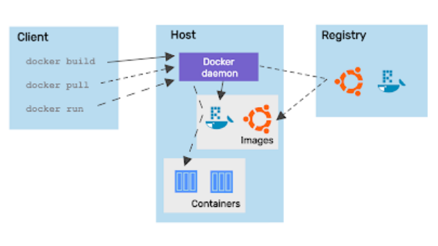

Key Components of Docker
- Docker Engine:
- The core component that allows you to create and run containers.
- Consists of a daemon, an API, and a CLI.
- Docker Daemon (dockerd):
- A background service running on the host operating system that manages Docker containers, images, networks, and storage volumes.
- Listens for Docker API requests and manages Docker objects like images, containers, networks, and volumes.
- Docker Client (docker):
- The command-line interface (CLI) used by users to interact with the Docker Daemon.
- Sends commands to the Docker Daemon through REST API requests.
- Docker Images:
- Read-only templates used to create Docker containers.
- Can be built from scratch or downloaded from Docker Hub or other repositories.
- Docker Containers:
- Executable instances of Docker images.
- Encapsulate an application and its dependencies in a standardized unit.
- Lightweight and isolated from the host and other containers.
- Docker Hub:
- A cloud-based repository where Docker users can create, test, store, and distribute container images.
- Offers public and private repositories for sharing container images.
- Docker Compose:
- A tool for defining and running multi-container Docker applications.
- Uses a YAML file to configure the application's services, networks, and volumes.
- Allows for the orchestration of multiple containers as a single service.
- Dockerfile:
- A text file containing a series of instructions on how to build a Docker image.
- Specifies the base image, commands to run, files to include, and environment variables.
- Docker Swarm:
- A native clustering and orchestration tool for Docker.
- Turns a pool of Docker hosts into a single, virtual Docker host.
- Allows for the management of a cluster of Docker engines, creating and scaling services.
- Docker Volumes:
- Mechanisms for persisting data generated and used by Docker containers.
- Allow data to be shared between containers and survive container restarts.
- Docker Network:
- A virtual network that connects Docker containers.
- Provides various network drivers (bridge, host, overlay) to control how containers communicate.
Docker Lifecycle

The Docker life cycle encompasses the stages from the creation of a Docker image to the termination of a Docker container. Here’s an overview of the Docker life cycle:
- Build: This is the initial phase where you create a Docker image. You define the image in a Dockerfile, specifying the base image, dependencies, configurations, and the application code. The docker build command processes the Dockerfile and creates a Docker image.
- Registry (Optional): After building the image, you can push it to a Docker registry (such as Docker Hub, AWS ECR, or a private registry) to make it accessible for others or for deployment purposes.
- Pull (Optional): On any host machine, you can pull the Docker image from the registry to run it.
- Run: You create and start a container from the Docker image using the docker run command. During this phase, the container is in a running state, executing the application as specified.
- Pause and Unpause: You can temporarily pause and later resume a container's processes. This is useful for resource management.
- Stop: To stop a running container, you can use the docker stop command. This gracefully stops the container by sending a SIGTERM signal and then a SIGKILL if the container does not stop within a grace period.
- Restart: You can restart a stopped or running container using the docker restart command.
- Kill: If you need to forcefully stop a container, you can use the docker kill command, which sends a SIGKILL signal to the container.
- Remove (rm): After stopping a container, you can remove it to free up resources. Use the docker rm command to remove a stopped container
- Prune (Optional): To clean up unused Docker objects (containers, networks, images, volumes), you can use the docker system prune command. This helps in maintaining a clean Docker environment.
Here are the top Docker commands often asked about in interviews
- docker version: Displays the Docker version information.
- docker info: Displays detailed system-wide information about Docker.
- docker build: Builds an image from a Dockerfile.
- docker pull: Downloads an image from a Docker registry.
- docker push: Uploads an image to a Docker registry.
- docker images: Lists all Docker images on the local machine.
- docker rmi: Removes one or more Docker images.
- docker ps: Lists all running containers.
- docker run: Creates and starts a new container from an image.
- docker exec: Runs a command in a running container
- docker stop: Stops a running container.
- docker start: Starts a stopped container.
- docker restart: Restarts a running or stopped container.
- docker kill: Kills a running container.
- docker rm: Removes one or more stopped containers
- docker logs: Fetches the logs of a container.
- docker inspect: Displays detailed information about a container or image.
- docker network ls: Lists all Docker networks.
- docker network create: Creates a new Docker network.
- docker-compose up: Starts and runs multi-container Docker applications defined in a docker-compose.yml file.
- docker-compose down: Stops and removes containers, networks, images, and volumes created by docker-compose up.
- docker volume ls: Lists all Docker volumes.
- docker volume rm: Removes one or more Docker volumes.
- docker tag: Creates a tag for an image.
- docker prune: Cleans up unused Docker objects (containers, images, networks, volumes).

What is Docker File ?

A Dockerfile is a script that contains a series of commands and instructions to create a Docker image. The image is a lightweight, standalone, and executable software package that includes everything needed to run a piece of software, including the code, a runtime, libraries, environment variables, and configuration files.
Here are some key components and concepts related to a Dockerfile:
- Base Image: The starting point for your Docker image. It is defined by the FROM instruction.
- Maintainer: (Optional) The author or maintainer of the image, defined by the MAINTAINER instruction.
- Commands: Instructions that are executed during the image build process.
- RUN: Executes commands in a new layer on top of the current image and commits the results.
- COPY and ADD: Copy files and directories from the host filesystem into the image.
- CMD: Provides a default command to run when a container is started from the image.
- ENTRYPOINT: Configures a container to run as an executable.
- ENV: Sets environment variables.
- EXPOSE: Informs Docker that the container listens on the specified network ports at runtime.
- WORKDIR: Sets the working directory for any RUN, CMD, ENTRYPOINT, COPY, and ADD instructions.
- USER: Sets the user name or UID to use when running the image and for any RUN, CMD, and ENTRYPOINT instructions.
- VOLUME: Creates a mount point with the specified path and marks it as holding externally mounted volumes from the host or other containers.
Here is a simple example of a Dockerfile for a Nginx application:
# Use the official Nginx image as a base image
FROM nginx:latest

# Set the working directory to the default Nginx HTML directory

WORKDIR /usr/share/nginx/html

# Copy the index.html file from the current directory on your host to the container's HTML directory

COPY index.html .
# Expose port 80 (the default Nginx port)
EXPOSE 80
# No need to define CMD as the base image already has the default command to run Nginx

Steps to Build and Run the Docker Image
- Prepare the index.html file: Ensure you have an index.html file in your project directory. This file should be on your Windows machine.
- Write the Dockerfile: Create a file named Dockerfile in your project directory with the content provided above.
- Build the Docker image: Open a terminal (e.g., PowerShell or Command Prompt) and navigate to the directory containing the Dockerfile. Run the following command to build the image:

docker build -t my-nginx-image .
This command builds the image and tags it as my-nginx-image.
- Run the Docker container with a random port: Use the following command to run a container based on your image and map a random port on your host to port 80 in the container:

docker run -d -P my-nginx-image
The -d flag runs the container in detached mode, and the -P flag automatically maps a random port on the host to the exposed port 80 in the container.
- Find the mapped port: To find the port that Docker has mapped to port 80, you can use the following command:

docker ps
This command will list all running containers and their details, including the port mappings. Look for the line corresponding to your container, which will show something like 0.0.0.0:<random_port>->80/tcp.
1️⃣ Why Docker Networking Is Needed
Without networking:
- Containers are isolated
- No API calls
- No browser access
- No database connectivity
Docker networking enables:
- 🌐 Web access (browser → container)
- 🔗 Microservice communication
- 📡 Database connections
- ⚖️ Load balancing
- 🔒 Network isolation & security
👉 No networking = containers are useless

2️⃣ Docker Networking Basics
Each container has:
- Its own IP address
- Its own network namespace
- Its own virtual network interface
Docker creates virtual networks on the host OS.

3️⃣ Default Docker Network
🔹 Bridge Network (default)
When Docker is installed, it creates a default bridge network called:
bridge
If you run a container without specifying a network, Docker attaches it to the bridge network.
docker run -d nginx
✔ Container gets:
- Private IP (e.g., 172.17.0.2)
- Internet access via NAT
- Isolated from host network

4️⃣ Types of Docker Networks (Very Important)
📘 Summary Table
Network Type | Scope | Use Case
bridge | Single host | Default, container-to-container
host | Single host | High performance
none | Single container | Full isolation
overlay | Multi-host | Docker Swarm
macvlan | LAN level | Direct IP from LAN

🔹 How it works
- Docker creates a virtual bridge (like a virtual switch)
- Containers connect to it
- Containers can talk using container names
🔹 Default Bridge Limitations
❌ Containers must use IP
❌ No automatic DNS
❌ Not recommended for production

🔹 Custom Bridge Network (Best Practice)
docker network create my_bridge
docker run -d --name web1 --network my_bridge nginx
docker run -d --name web2 --network my_bridge nginx
✔ Advantages:
- Container-name-based communication
- Automatic DNS resolution
- Better isolation
- Recommended for apps
Example:
web1 → http://web2

Behavior
- Container shares host’s network
- No separate IP
- No port mapping needed
🔹 Pros & Cons
✔ Very fast
✔ Useful for monitoring tools
❌ No isolation
❌ Port conflicts
❌ Linux only

7️⃣ None Network
docker run --network none nginx
🔹 Behavior
- No networking
- Only loopback interface
✔ Maximum security
✔ Used for batch jobs
❌ No internet
❌ No communication

8️⃣ Port Mapping (MOST IMPORTANT)
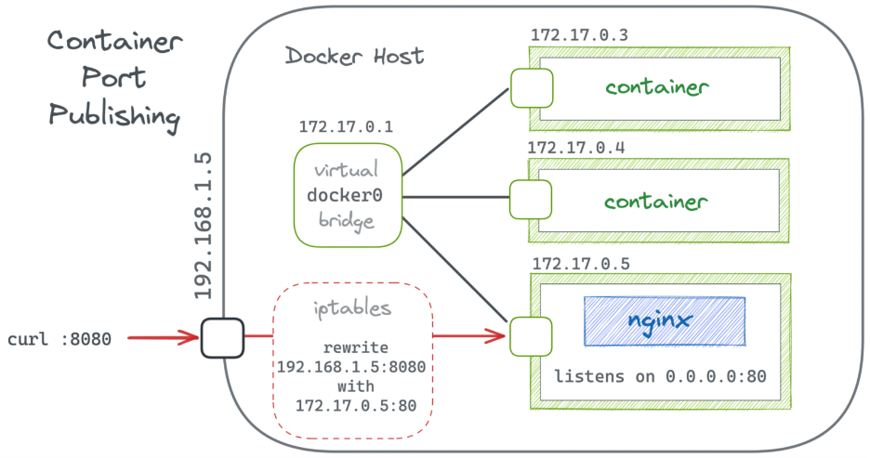
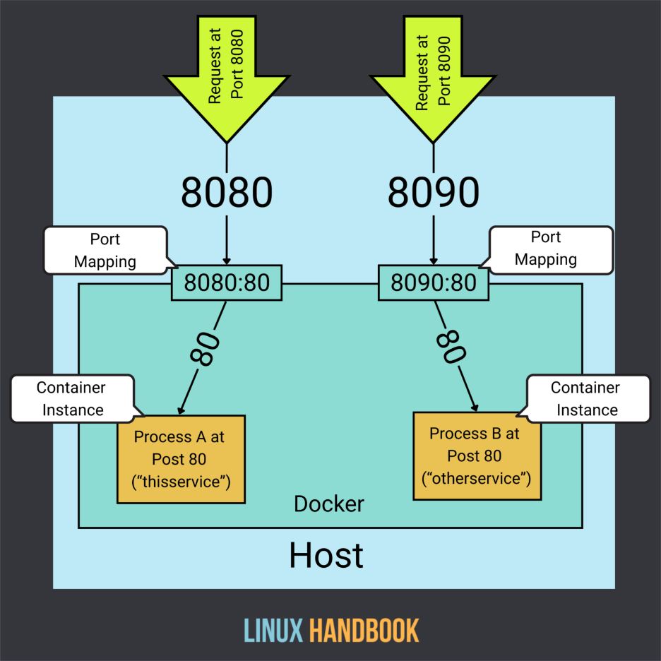
Containers run inside private networks.
To access them from outside:
docker run -d -p 8080:80 nginx
🔹 Meaning
Host Port → Container Port
8080 → 80
Browser:
http://localhost:8080

🔹 Multiple Ports
docker run -p 3000:3000 -p 8080:80 app

9️⃣ How Containers Communicate
🔹 Same Network
✔ Container → Container via name
ping web1
curl http://web1

🔹 Different Networks
❌ Cannot communicate by default
Solution:
docker network connect my_bridge container_name

🔟 Inspecting Docker Networks
🔹 List networks
docker network ls
🔹 Inspect a network
docker network inspect bridge
🔹 Check container network
docker inspect container_name

1️⃣1️⃣ Docker DNS & Service Discovery
In custom bridge networks:
- Docker runs an internal DNS server
- Containers resolve each other by name
Example:
db → mysql
backend → db
frontend → backend

1️⃣2️⃣ Real-World Example (3-Tier App)
Browser
↓
Frontend (nginx)
↓
Backend (API)
↓
Database (MySQL)
All containers:
- Same custom bridge network
- No IP hardcoding
- Secure & scalable

1️⃣3️⃣ Security in Docker Networking
✔ Network isolation
✔ Firewall rules (iptables)
✔ Only exposed ports are accessible
✔ Internal traffic stays private
Best practice:
- Use custom bridge
- Expose only required ports
- Avoid --network host in production

1️⃣4️⃣ Docker Networking vs Kubernetes (Quick View)
Docker | Kubernetes
Manual networking | Automatic networking
Port mapping needed | Services handle traffic
Single host focus | Multi-node clusters

Docker Volumes are the recommended way to persist data generated and used by containers.
They are a core storage feature of Docker.

1️⃣ Why Docker Volumes Are Needed
Containers are ephemeral (temporary):
- When a container stops or is removed → data is lost
- Containers are meant for stateless apps
- Real applications need persistent storage
Docker Volumes solve:
- 💾 Data persistence
- 🔁 Data sharing between containers
- 🚀 Faster backups & migrations
- 🔒 Isolation from container lifecycle
👉 Delete container ❌ → Data stays ✅

2️⃣ Container Storage Problem (Without Volume)
docker run -it ubuntu bash
echo "Hello" > file.txt
exit
docker rm ubuntu_container
❌ file.txt is gone

3️⃣ What Is a Docker Volume?
A Docker Volume is:
- A directory outside the container filesystem
- Managed by Docker
- Mounted inside the container
📁 Stored on host (Linux):
/var/lib/docker/volumes/

4️⃣ Types of Docker Storage (Very Important)
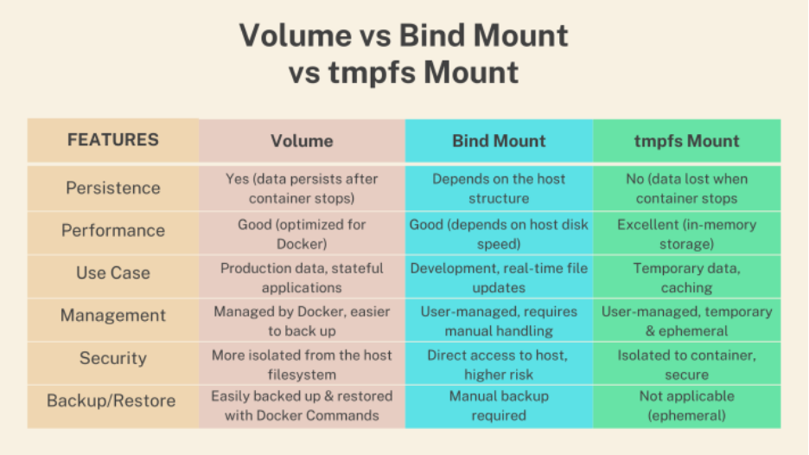
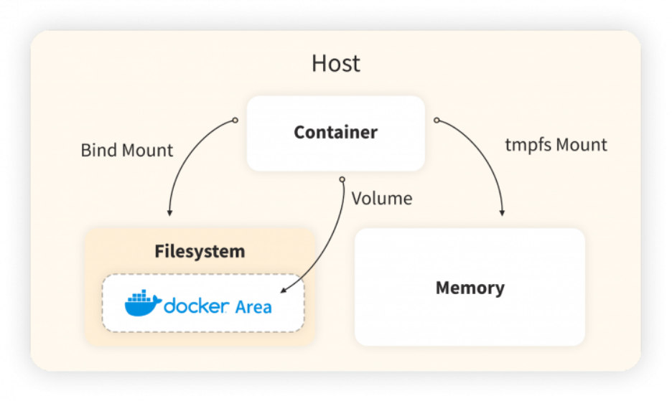
Type | Managed By | Best Use
Volume | Docker | Production, persistence
Bind Mount | User | Local development
tmpfs | Memory | Sensitive temporary data

5️⃣ Docker Volume (Recommended)
🔹 Characteristics
- Docker manages location
- Portable
- Secure
- Best for production
🔹 Create a Volume
docker volume create mydata
🔹 List Volumes
docker volume ls

6️⃣ LAB 1️⃣ – Volume with Nginx (Persistence Test)
Step 1: Create Volume
docker volume create webdata

Step 2: Run Nginx with Volume
docker run -d \
--name nginx1 \
-p 8080:80 \
-v webdata:/usr/share/nginx/html \
nginx

Step 3: Add File Inside Container
docker exec -it nginx1 bash
echo "<h1>Hello from Volume</h1>" > /usr/share/nginx/html/index.html
exit

Step 4: Test in Browser
http://localhost:8080
✔ Page loads

Step 5: Delete Container
docker rm -f nginx1

Step 6: Run New Container Using Same Volume
docker run -d \
--name nginx2 \
-p 8081:80 \
-v webdata:/usr/share/nginx/html \
nginx
✔ Data still exists
✔ Volume survived container deletion

7️⃣ Bind Mount (Host ↔ Container Mapping)
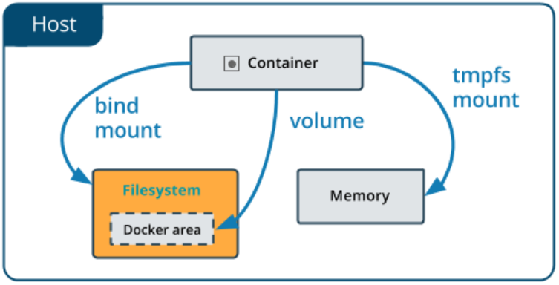
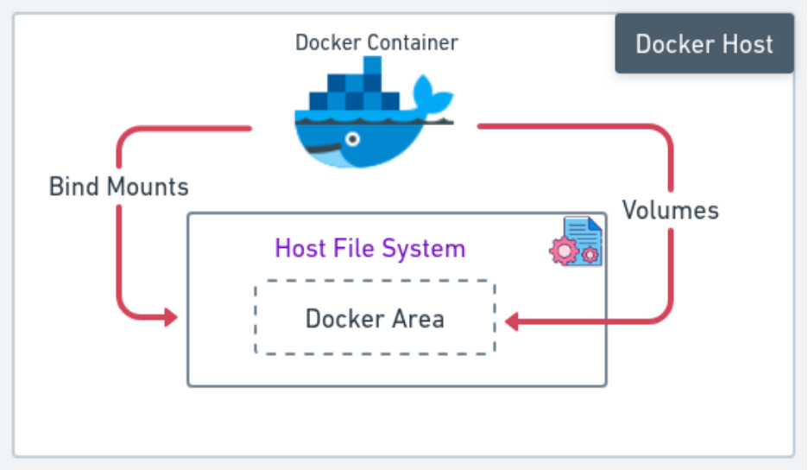
🔹 What Is Bind Mount?
Maps specific host path to container path.
docker run -d \
-p 8082:80 \
-v C:\docker-data:/usr/share/nginx/html \
nginx
🔹 Use Case
- Local development
- Live code changes
- Debugging

❌ Problems with Bind Mount
- OS dependent paths
- Permission issues
- Less portable

8️⃣ LAB 2️⃣ – Bind Mount Live Update
Step 1: Create Folder on Host
C:\docker-data
Create index.html:
<h1>Hello from Host</h1>

Step 2: Run Container
docker run -d \
--name web \
-p 8083:80 \
-v C:\docker-data:/usr/share/nginx/html \
nginx

Step 3: Modify File on Host
Edit index.html → refresh browser
✔ Changes appear instantly
✔ No container restart

9️⃣ tmpfs Mount (In-Memory Storage)
docker run -d \
--tmpfs /app/temp \
nginx
🔹 Characteristics
- Stored in RAM
- Deleted on container stop
- Very fast
- No disk usage
✔ Passwords
✔ Session data

🔟 Sharing Volume Between Containers
LAB 3️⃣ – Shared Volume
docker volume create sharedvol
docker run -d --name c1 -v sharedvol:/data busybox sleep 3600
docker run -d --name c2 -v sharedvol:/data busybox sleep 3600
Write from c1:
docker exec -it c1 sh
echo "Shared Data" > /data/file.txt
exit
Read from c2:
docker exec -it c2 cat /data/file.txt
✔ Data shared

1️⃣1️⃣ Inspect Volume
docker volume inspect webdata
Shows:
- Mountpoint
- Driver
- Labels

1️⃣2️⃣ Remove Volumes
docker volume rm webdata
Remove unused volumes:
docker volume prune
⚠️ Deletes all unused volumes

1️⃣3️⃣ Volumes in Dockerfile (Important Note)
VOLUME /data
- Creates anonymous volume
- Not recommended unless required
- Better to manage volumes via docker run

1️⃣4️⃣ Docker Volume vs Bind Mount (Interview)
Feature | Volume | Bind Mount
Managed by Docker | ✅ | ❌
Portable | ✅ | ❌
Secure | ✅ | ❌
Best for Prod | ✅ | ❌

1️⃣5️⃣ Real-World Use Cases
- 🗄️ Databases (MySQL, PostgreSQL)
- 📁 Logs
- 🌐 Web content
- 🔄 CI/CD artifacts
- 📊 Monitoring data

