WEEK 3 — STATISTICAL ANALYSIS AND HYPOTHESIS TESTING IN PYTHON
Iris Species: Testing Whether Mean Petal Length Differs by Species
Author: Vikas Yadav
MCA-DSAI
Dataset: UCI Iris Dataset (ID 53)
Analysis sample: 149 cleaned observations

1. Introduction
This Week 3 project applies inferential statistics and hypothesis testing to the cleaned Iris working dataset carried forward from Weeks 1 and 2. The objective is to move beyond descriptive visualization and formally evaluate whether an observed difference among Iris species is statistically supported. The analysis focuses on petal length because the previous exploratory and visualization work showed clear separation among species on petal measurements.
Research question: Do mean petal lengths differ among Setosa, Versicolor, and Virginica?
H0 (null hypothesis): The population mean petal length is equal across the three Iris species.
H1 (alternative hypothesis): At least one Iris species has a different population mean petal length.
Significance level: α = 0.05.

2. Dataset and Data Preparation
The analysis uses the cleaned 149-row working dataset produced during Week 1 and carried forward into Week 2. No new artificial missing values or duplicate records were introduced for Week 3. The dataset contains four continuous flower measurements and a categorical species variable. The three species groups contain 50 Setosa, 50 Versicolor, and 49 Virginica observations in the cleaned working file.
Group | n | Mean petal length (cm)
Setosa | 50 | 1.462
Versicolor | 50 | 4.258
Virginica | 49 | 5.561

3. Statistical Methodology
The analysis follows a staged approach: (1) descriptive statistics, (2) assumption checks, (3) omnibus testing, (4) effect-size and confidence-interval reporting, and (5) pairwise follow-up testing. The classical one-way ANOVA is included for reference, while Welch's one-way ANOVA is treated as the primary omnibus test because the variance-homogeneity check indicates unequal variances. A Kruskal-Wallis test is included as a non-parametric sensitivity analysis.
- One-way ANOVA: tests whether at least one group mean differs under the standard equal-variance framework.
- Welch ANOVA: tests the same mean-difference question without requiring equal population variances; this is the primary robust test here.
- Kruskal-Wallis: non-parametric sensitivity test based on ranks.
- Welch pairwise t-tests with Holm correction: identify which species pairs differ while controlling family-wise error across the three comparisons.
- 95% confidence intervals: quantify uncertainty around each species mean.
- Eta-squared and omega-squared: provide effect-size context for the classical ANOVA.

4. Assumption Checks
Levene's test for equality of variances: statistic = 19.322, p = 3.59118e-08. Because p < 0.05, the equal-variance assumption is not supported for petal length. This is why Welch ANOVA is emphasized.
Shapiro-Wilk test on the classical ANOVA residuals: W = 0.9799, p = 0.0279943. The result indicates some departure from normality at the 0.05 threshold; therefore, the report also includes the non-parametric Kruskal-Wallis sensitivity analysis rather than relying on a single assumption-dependent test.

5. Primary Hypothesis Test — Welch One-Way ANOVA
Welch ANOVA: F = 1807.216, p = 1.580e-65. Since p < 0.05, the null hypothesis is rejected for this sample. The data provide strong statistical evidence that mean petal length is not the same across all three species.
Classical one-way ANOVA (supporting result): F = 1177.360, p = 8.690e-91. The classical test reaches the same substantive decision, but its equal-variance assumption is not supported.
Kruskal-Wallis (sensitivity result): H = 129.533, p = 7.452e-29. This non-parametric analysis also rejects the null hypothesis of identical distributions across species.

6. Effect Size and Confidence Intervals
Classical ANOVA eta-squared = 0.9416; omega-squared = 0.9404. These measures indicate that species membership accounts for a large share of the observed variation in petal length in this sample. Effect sizes describe magnitude and should be considered alongside the study design and practical context.
Species | n | Mean | 95% CI low | 95% CI high
Setosa | 50 | 1.462 | 1.413 | 1.511
Versicolor | 50 | 4.258 | 4.125 | 4.391
Virginica | 49 | 5.561 | 5.402 | 5.720

7. Pairwise Follow-Up Tests
Because the omnibus test indicates that not all group means are equal, pairwise Welch t-tests were used to identify the specific differences. Holm adjustment was applied to the three p-values.
Comparison | t | df | Raw p | Mean difference | Holm p
Setosa vs Versicolor | -39.494 | 62.16 | 9.677e-46 | 2.796 | 1.935e-45
Setosa vs Virginica | -49.492 | 57.18 | 1.218e-48 | 4.099 | 3.655e-48
Versicolor vs Virginica | -12.619 | 93.84 | 6.261e-22 | 1.303 | 6.261e-22
All three pairwise comparisons remain statistically significant after Holm correction at α = 0.05. The observed mean differences are approximately 2.796 cm (Versicolor vs Setosa), 4.099 cm (Virginica vs Setosa), and 1.303 cm (Virginica vs Versicolor).

8. Visual Evidence Supporting the Statistical Results
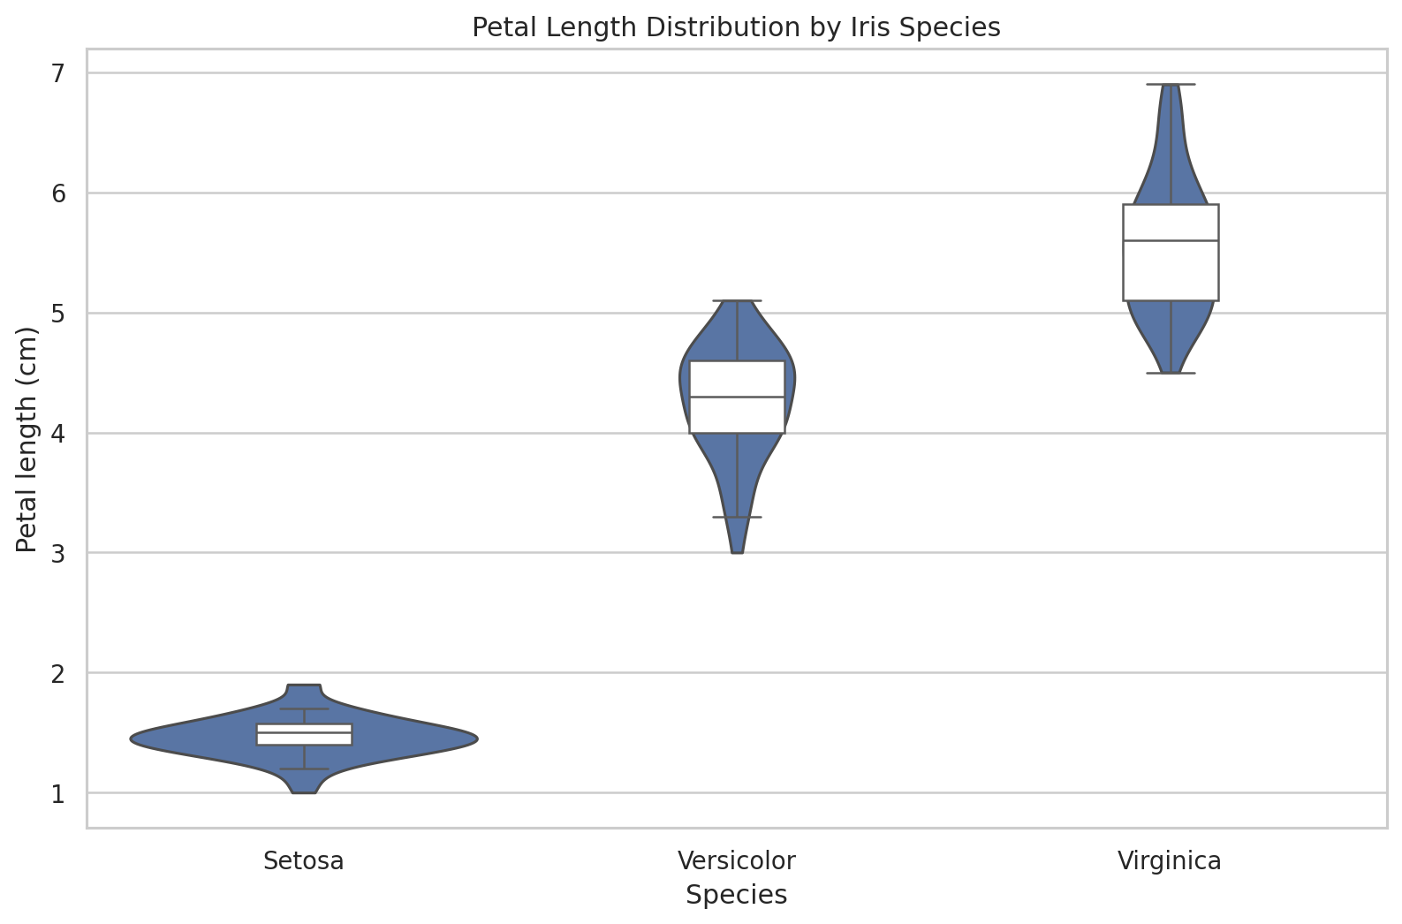
Figure 1 — Petal-length distributions by species.
The violin and box plot shows the group distributions, medians, spread, and overlap. The clear separation supports the direction of the inferential result.
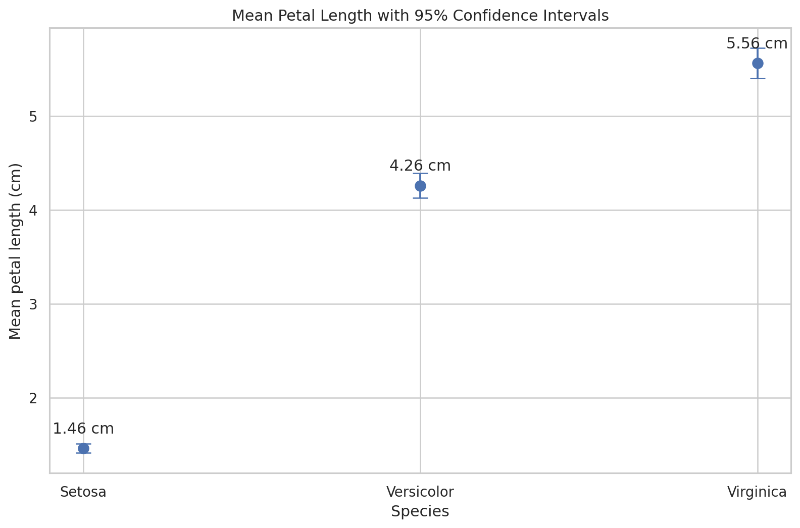
Figure 2 — Group means with 95% confidence intervals.
The confidence intervals provide a direct visual representation of uncertainty around each group mean.
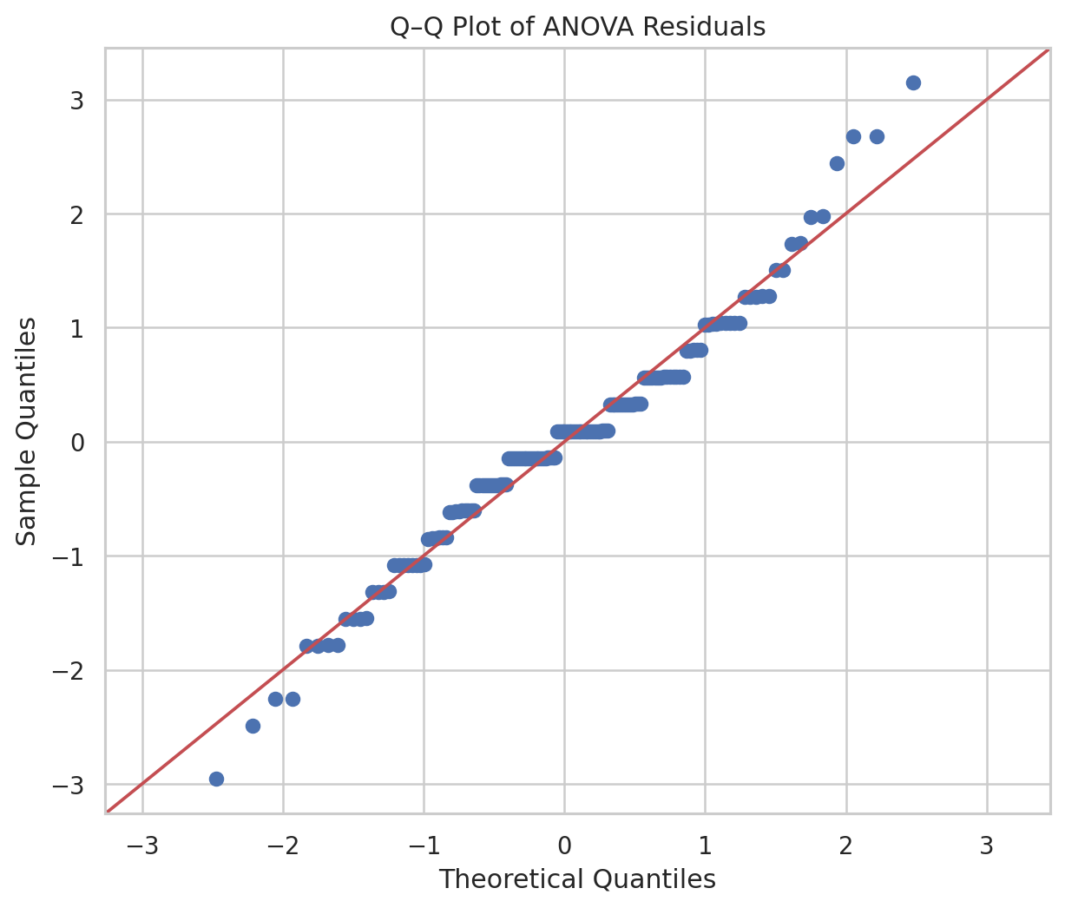
Figure 3 — Q–Q plot of ANOVA residuals.
This diagnostic helps evaluate whether residuals approximately follow a normal pattern.
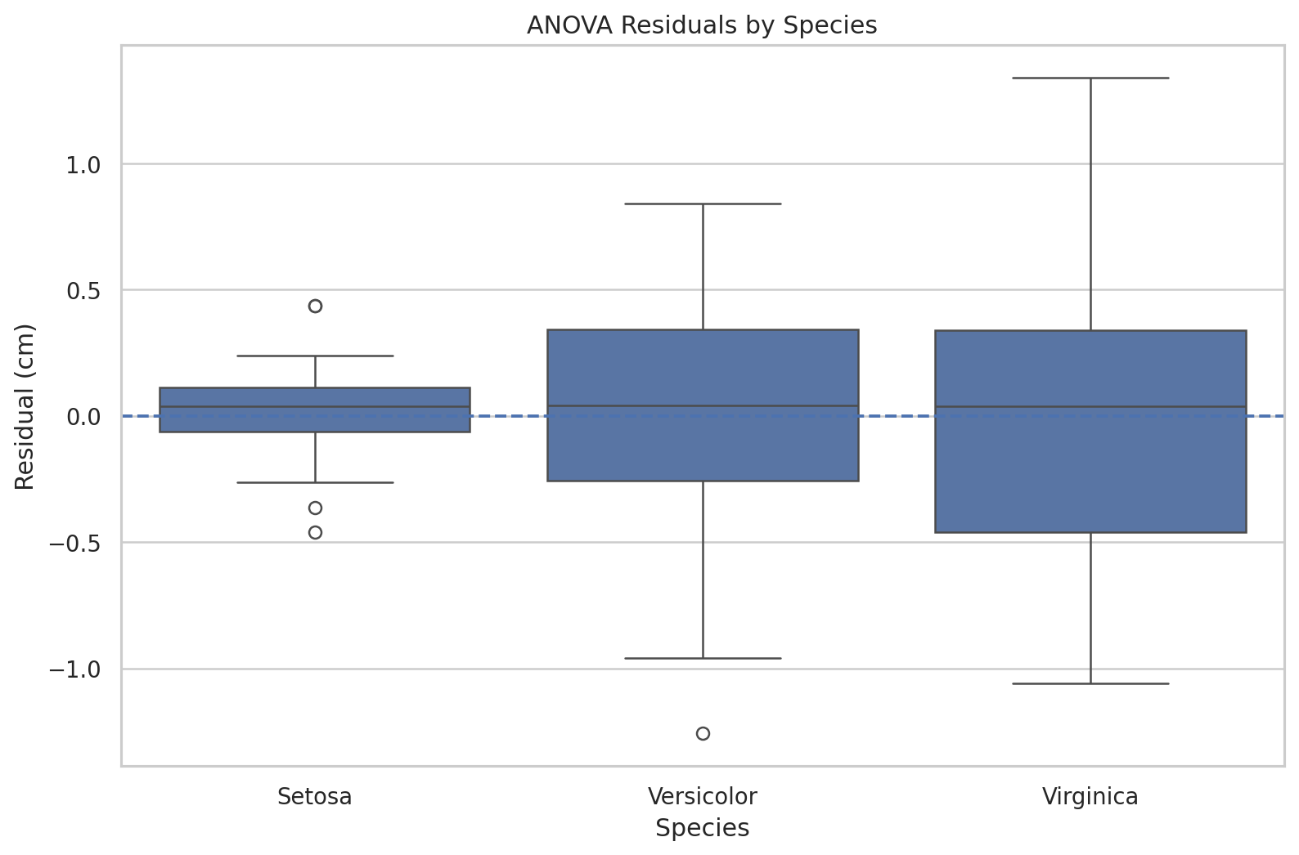
Figure 4 — Residuals by species.
This chart helps reveal unequal residual spread across groups, consistent with the Levene result.
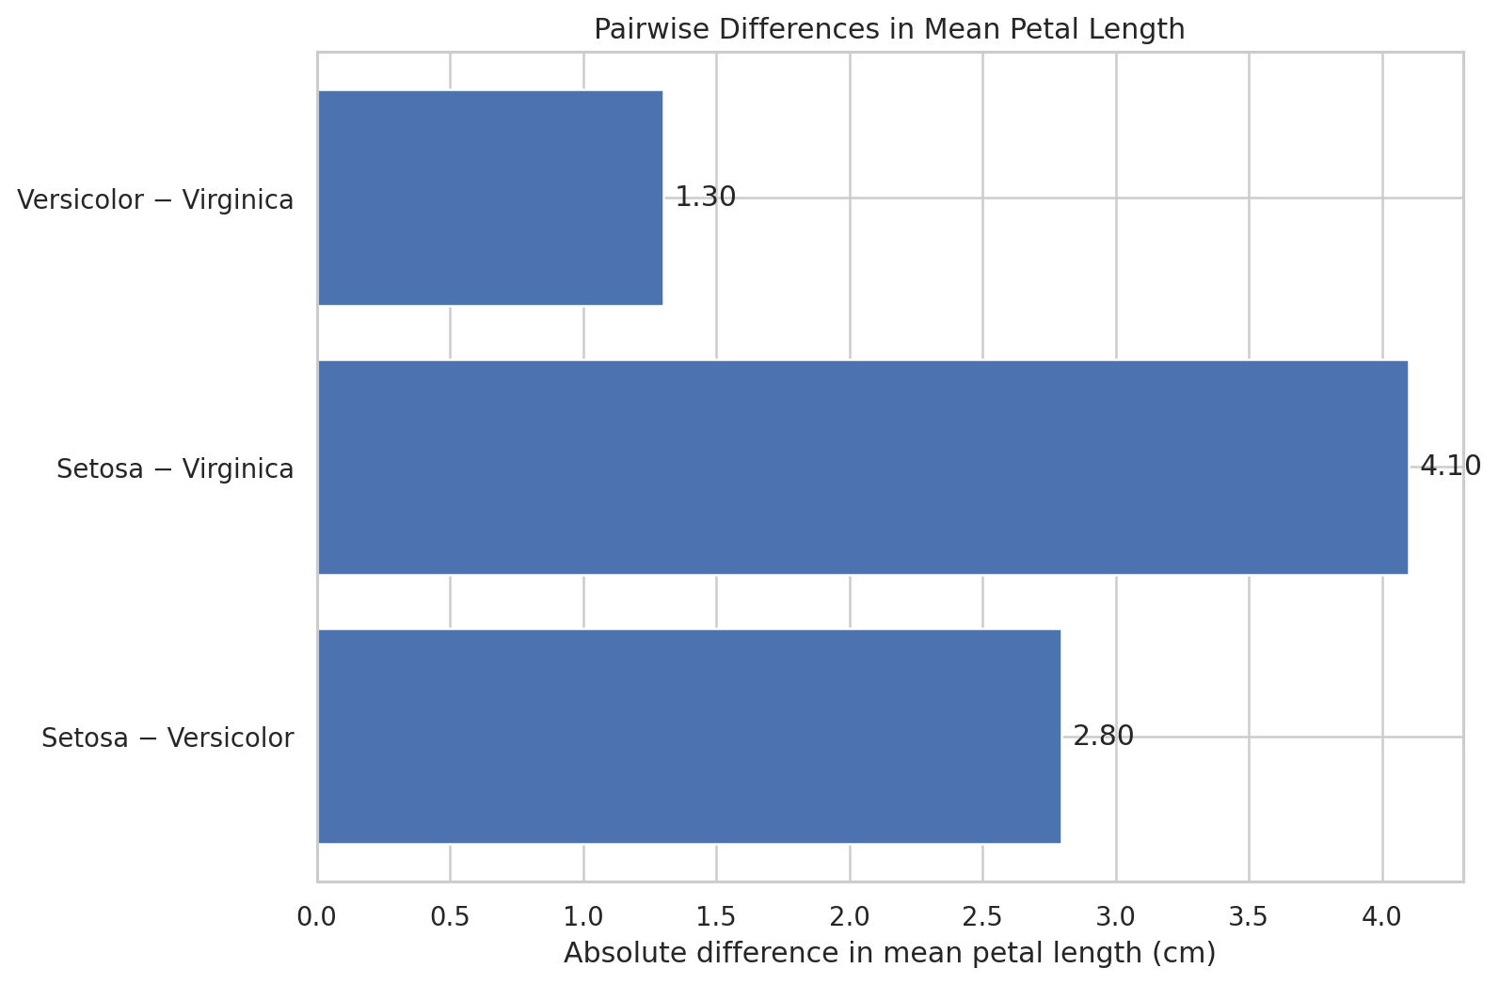
Figure 5 — Pairwise mean differences.
The chart summarizes the magnitude of the observed differences between species means.
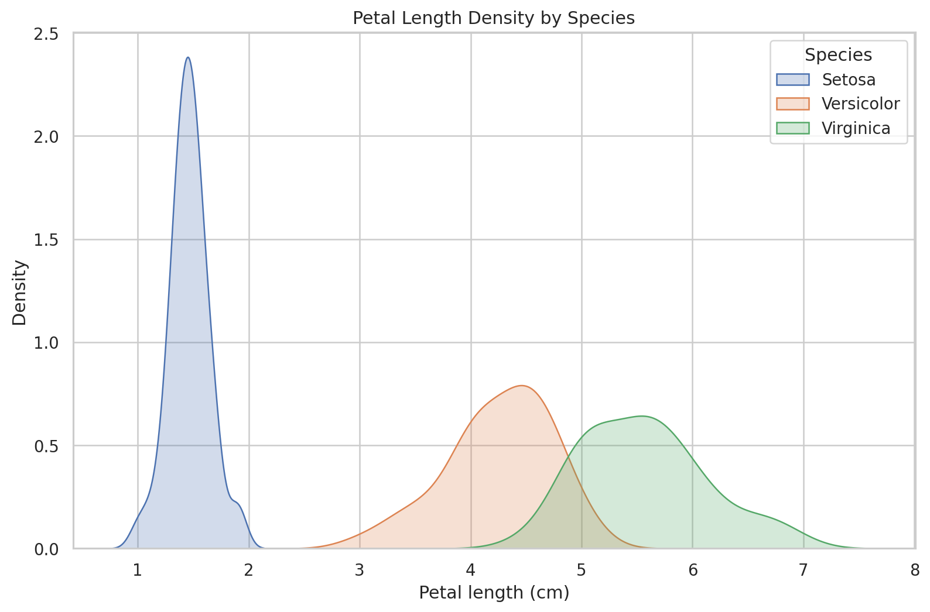
Figure 6 — Petal-length density curves.
The density curves show the strong separation of Setosa and the relative proximity of Versicolor and Virginica.

9. Python Code Used
# Load data
df = pd.read_csv("../data/processed/iris_cleaned_week3.csv")
# Group the target variable by species
groups = [df.loc[df.species == s, "petal_length"]
for s in ["setosa", "versicolor", "virginica"]]
# Assumption checks
model = ols("petal_length ~ C(species)", data=df).fit()
stats.levene(*groups, center="median")
# Primary robust omnibus test
stats.f_oneway(*groups, equal_var=False)
# Non-parametric sensitivity analysis
stats.kruskal(*groups)
# Pairwise Welch t-tests
stats.ttest_ind(x, y, equal_var=False)

10. Interpretation and Scientific Implications
The statistical evidence supports the conclusion that petal length differs among the three Iris species in this dataset. The result is consistent across Welch ANOVA, classical ANOVA, and Kruskal-Wallis testing, while the pairwise Welch tests show that each species pair has a statistically detectable difference after multiple-comparison adjustment. From a scientific perspective, this provides quantitative support for the descriptive patterns identified in earlier weeks. In a practical classification setting, petal length may therefore be a useful feature for distinguishing Iris species. However, statistical significance does not establish causation, and the analysis should not be interpreted as proving that the same effect size will occur in every population or measurement setting.

11. Limitations
- The analysis uses the small, well-known Iris dataset rather than a newly collected real-world sample.
- The cleaned working file contains 149 observations because duplicate cleaning in Week 1 removed one repeated record.
- The analysis tests association/difference among species groups; it does not establish causal mechanisms.
- The inferential results are conditional on the observed dataset and its sampling/design limitations.
- A future study could validate the result on an independent dataset and examine additional features or multivariate models.

12. Conclusion
At the 5% significance level, the null hypothesis of equal mean petal length across the three Iris species is rejected for the analyzed sample. Welch ANOVA was selected as the primary test because equal variances were not supported. The conclusion is reinforced by the Kruskal-Wallis sensitivity analysis and by pairwise Welch tests with Holm correction. The confidence intervals, effect-size measures, and supporting visualizations provide additional context about the size and consistency of the observed differences.

13. Reproducibility and Project Files
The project includes the cleaned dataset, Jupyter notebook, Python source code, six statistical-analysis figures, requirements file, README, and this Word report. The complete project can be reproduced by installing the listed dependencies and executing the notebook from the project directory.
Source dataset: UCI Machine Learning Repository, Iris Dataset (Dataset ID 53), DOI 10.24432/C56C76.
Week 1/Week 2 connection: the statistical analysis uses the cleaned working dataset prepared in the earlier project stages and does not introduce new artificial data-quality issues.

14. References
UCI Machine Learning Repository. Iris Dataset, Dataset ID 53. DOI: 10.24432/C56C76.
Fisher, R. A. (1936). The use of multiple measurements in taxonomic problems. Annals of Eugenics, 7(2), 179–188.
SciPy documentation: statistical hypothesis-testing functions.
Statsmodels documentation: ordinary least squares and ANOVA functionality.

