Software Requirements Specification (SRS) Document
Web-Annotation And Renarration

SSAD 43

KAMINENI VIKAS
MOIZ HUSSAIN
DEERAJ POLEPALLY
VANALATA BULUSU
SRIPRAVALIKA

Brief problem statement:

The web is a huge knowledge base and is indeed prolific with useful content. However, some segments of the user population – for example, users with body disability, or users with minimal (English) language expertise, or users with less higher-order-thinking skills, or users from a different cultural background – may at times find some of the same relevant material on the web complex, foreign, incomprehensible and inaccessible. So, on the web, while good content exists, not all users are able to benefit from it equally. We suggest that each existing web content, is often meaningful only to some limited set of users. That may be said to be its scope. And, to increase its relevance, meaning, value to other set of users, one would sometimes need to provide an alternative representation, perhaps an amended, adjusted, annotated version of the original source, such that it has more information, more context, more relevance for this neglected community of users. There are already some contributions and efforts underway to address the specific problem of web inaccessibility due to body disability. From our point of view, what is less addressed is the inaccessibility to web content due to sociocultural gaps, and also due to different thinking abilities.

System Requirements:

Languages – Python, Java-script, Mongo-db.
WEB-SERVICES – SELENIUM WEB-DRIVER
SERVERS – FLASK SERVER

Users profile
This system is meant for regular users of the web, who wish to translate and modify,manipulate the webpages for their convenience. Example can be of a user trying to translate the webpage to another language for others who are convenient with that language. Others can be for Educational Purposes like teacher renarrating important points in the webpage.
No. | User Case Name | Description | Release
 | Login | Login to the tool | R1
 | Registration | Register for the tool | R1
 | Tagging | Put a special tag to a word for sematical understanding | R1
 | Search by Tag | Search information based on tag | R1
 | Conversion of data | Units conversion(time, measurments etc) | R1
 | Dynamic Table | Explaining the table in a more better way by clicking on the table | R1
 | Pop up Balloon | Annotating the page by displaying a pop up balloon with some content in it. | R1

Feature Requirements:

Use case diagram

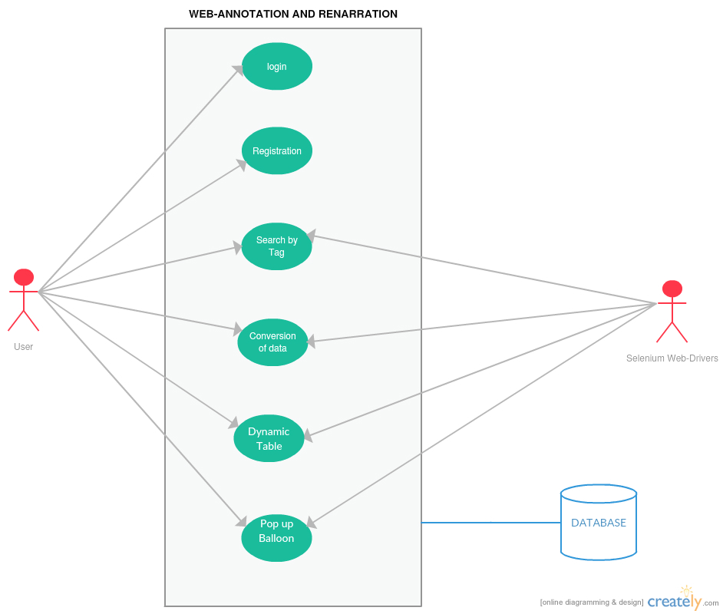

Use case description

Use Case Number: | UC-01
Use Case Name: | Log in
Overview: | User logs in to the tool and home page appears
Actors: | User
Pre condition: | Registration should be completed
Flow: | Main (success) Flow:  - User clicks on the login button  - User provides his/her credentials
Alternate Flow:
- If credentials don’t match with the provided registration details then a message “invalid credentials” pops up
Post Condition: | Main (success) Flow: Home page is displayed  Alternate Flow: Redirect to login page

Use Case Number: | UC-02
Use Case Name: | Registration
Overview: | User registers for using the tool.
Actors: | User
Pre condition: | None
Flow: | Main (success) Flow:  - User fills the registration form  - User clicks on register
 | Alternate Flows: None
Post Condition: | R1:  - Details are added to the database  - User can now log in  R2:  User is redirected to verification page

Use Case Number: | UC-03
Use Case Name: | Tagging
Overview: | Tag a word or a sentence for manipulation .
Actors: | user
Pre condition: | Should be registered and logged in.
Flow: | Main (success) Flow:  1. Pop up box appears for selecting name of the tag  2. Search the database where Tags are stored .
 | Alternate Flows: None
Post Condition: | Pop up showing error

Use Case Number: | UC-04
Use Case Name: | Search by Tag
Overview: | Pop up box appears asking for which tag to be searched for.
Actors: | Users
Pre condition: | Should be registered and logged in.
Flow: | Main (success) Flow:  - Tag is entered .  - Validated accordingly and returned.
 | Alternate Flows: None
Post Condition: | Pop up showing error

Use Case Number: | UC-05
Use Case Name: | Conversion of data
Overview: | Converts the data from one unit to another like 24 hr format conversion.
Actors: | User.
Pre condition: | Should be registered and logged in. And the selected data should be tagged first.
Flow: | Main (success) Flow:  1. Data is converted and displayed.
 | Alternate Flows: None
Post Condition: | Pop up showing error.

Use Case Number: | UC-06
Use Case Name: | Dynamic Table
Overview: | By clicking on a table row or column a pop up appears displaying a brief content of the row..
Actors: | User
Pre condition: | Should be registered and logged in.
Flow: | Main (success) Flow:  - User clicks on the table (row) .  - Then a pop up comes displaying brief content of the table row
 | Alternate Flows: None.
Post Condition: | Shows error if table doesn’t exist.

Use Case Number: | UC-07
Use Case Name: | Pop up Balloon
Overview: | Annotation of the webpage by displaying popup balloons where the content is written.
Actors: | User
Pre condition: | Should be registered and logged in to the tool.
Flow: | Main (success) Flow:  - User clicks anywhere on webpage.  - A pop-up balloon appears on the webpage.  - By clicking on the balloon a pop-up comes asking what content to be filled.  - After entering the balloon contains that content in webpage.
 | Alternate Flows: None
Post Condition: | None.

