



Essay / Assignment Title: Solar Energy Generation Forecasting Using Data Analytics and Machine Learning

Programme title: MSc in Data Analytics

Name: Vikas Rana

Year: 2026

CONTENTS

Table of Contents
INTRODUCTION 4
CHAPTER ONE: Task 1: Exploratory Data Analysis (EDA) 5
CHAPTER TWO: Task 2: Data Preprocessing & Feature Engineering 8
CHAPTER TWO: Task 3: Model Development & Evaluation 10
CHAPTER TWO: Task 4: Forecasting & Business Recommendation 12
CONCLUDING REMARKS 14
BIBLIOGRAPHY 15
APPENDIX 17
Python Code 17

Statement of compliance with academic ethics and the avoidance of plagiarism

I honestly declare that this dissertation is entirely my own work and none of its part has been copied from printed or electronic sources, translated from foreign sources and reproduced from essays of other researchers or students. Wherever I have been based on ideas or other people texts I clearly declare it through the good use of references following academic ethics.
(In the case that is proved that part of the essay does not constitute an original work, but a copy of an already published essay or from another source, the student will be expelled permanently from the program).

Name and Surname (Capital letters):

VIKAS RANA

Date: ........................./........../.........

INTRODUCTION

Solar power has become a fundamental aspect of renewable energy in the world, owing to the growing global demand of this source of energy. The use of solar energy has been widely promoted as a clean, plentiful, and environmentally safe energy alternative to fossil fuels; nevertheless, the harnessing of solar power is extremely variable according to weather and climate factors like temperature, cloudiness and atmospheric variability. This natural intermittency brings a lot of uncertainty to the power production and creates problems to grid operators, energy planners and policymakers who should strike the balance between the reliability of supply and the efficiency of operation (Unni, 2026). This has led to accurate prediction of solar energy generation in terms of grid stability, energy trading and long-term infrastructure planning.
The latest advances in the sphere of data analytics and machine learning enabled defining more efficient strategies in terms of modeling and predicting the renewable energy generation. Predictive models can be used to establish non-linear relationships that are often overlooked by traditional statistical methods by combining historical data on solar generation and meteorological conditions including air temperature, humidity, wind speed, and atmospheric conditions (Borunda, 2022). Time-series prediction with man-in-the-middle machine learning techniques has thus proven to be an effective framework in enhancing the accuracy and power of predictions of solar power (Radhi, 2024).
The assignment under consideration is dedicated to the solar energy production analysis and prediction by using the UNISOLAR database that contains high-resolution information about solar power production and weather data. The main aim of the research is to deploy a systematic data analytics process consisting of exploratory data analysis (EDA), data preprocessing, feature engineering, model development, and forecasting. Two predictive models are created and analyzed to determine their capacity to predict the solar energy production in different environmental conditions; Linear Regression and Random Forest Regression. Linear Regression is used as a baseline model because it is simple and easy to interpret whereas the use of random forest is to provide non-linear patterns complexities in the data (Singh, 2026).
In addition to the predictive accuracy, this research focuses on the interpretability and practical applicability. The forecasts have been projected to have insights into the future generation of solar energy in January of 2026 giving an insight on the availability of energy during winter seasons. According to these predictions, business recommendations are presented using scientific data to aid operational decision-making in the management of renewable energy. On the whole, this study illustrates the effect of machine learning-based analytics to improve solar energy forecasting to improve power system planning, decrease uncertainty, and increase sustainability in the contemporary power systems (Khan, 2026).

CHAPTER ONE: Task 1: Exploratory Data Analysis (EDA)

The Exploratory Data Analysis (EDA) is an essential process of the data analytics process because it allows one to gain a detailed description of the organization, quality, and patterns present in the data before proceeding with the creation of a specific model. EDA helps in determining trends, variability as well as relationship between variables thus informing suitable preprocessing and modeling approach (Albahdal, 2025). In this project, the merged and hourly-resampled UNISOLAR data was analysed using EDA, which combines solar energy generation measurements with the other relevant meteorological data.
Variable | Count | Mean | Std. Dev. | Min | 25% | 50% (Median) | 75% | Max
SolarGeneration | 8252 | 6.803 | 6.248 | 0.109 | 1.599 | 5.354 | 10.246 | 37.450
ApparentTemperature (°C) | 8252 | 14.364 | 7.147 | -3.839 | 8.999 | 13.411 | 19.213 | 38.844
AirTemperature (°C) | 8252 | 17.225 | 6.934 | -0.843 | 12.233 | 16.249 | 21.721 | 43.000
DewPointTemperature (°C) | 8252 | 8.186 | 3.623 | -4.946 | 5.720 | 7.860 | 10.345 | 20.688
RelativeHumidity (%) | 8252 | 61.248 | 20.761 | 6.950 | 45.666 | 61.102 | 77.492 | 100.000
WindSpeed (m/s) | 8252 | 13.312 | 5.700 | 0.000 | 9.191 | 12.851 | 17.045 | 35.203
WindDirection (°) | 8252 | 187.741 | 66.497 | 9.950 | 145.192 | 188.558 | 235.852 | 350.050
Year | 8252 | 2020.433 | 0.496 | 2020 | 2020 | 2020 | 2021 | 2021
Month | 8252 | 5.950 | 3.383 | 1 | 3 | 6 | 9 | 12
Day | 8252 | 15.518 | 8.765 | 1 | 8 | 15 | 23 | 31
Hour | 8252 | 12.575 | 3.811 | 0 | 9 | 13 | 16 | 23
Table 1 - Descriptive Statistics of Solar Energy Generation and Weather Variables (Researcher’s Findings)
Table 1 (Descriptive Statistics Table) shows the descriptive statistics of the dataset. The dataset is comprised of 8, 252 hourly observations between the year 2020 and 2021. The average energy production by the sun was 6.80 units with a minimum production of 0.11 units and maximum production of 37.45 units. The high standard deviation of 6.25 units indicates a great amount of variation in the output of the sun, which is typical of renewable energy sources which are sensitive to the changing environmental factors like sunshine and cloud cover (Maduabuchi, 2023). This inconsistency underscores the need to have powerful predictive models that have the capability to capture non-linear trends.
There was also a lot of variation in the meteorological variables. The apparent temperature was between -3.84 and 38.84C and the air temperature was the same. The relative humidity was also very diverse with 6.95 to 100 percent fluctuating with the seasons due to the varying moisture levels in the atmosphere. The moderately varying wind speed and wind direction indicated a dynamic weather condition, which can indirectly impact solar irradiance by cloud formation and atmospheric scattering (Behl, 2026).
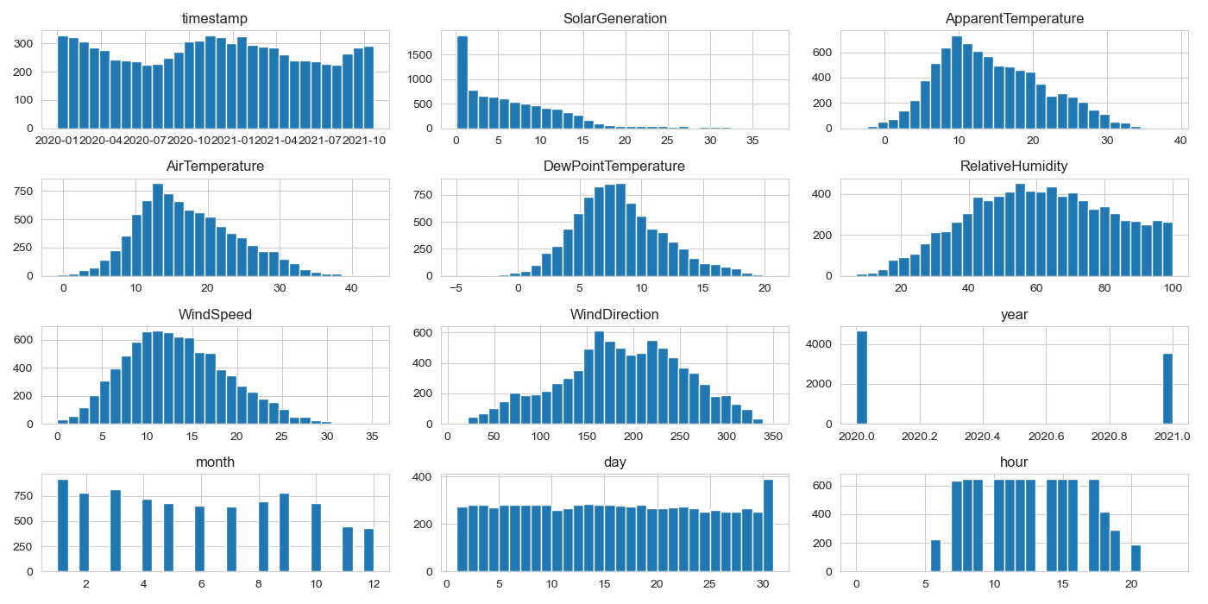
Figure 1 - Histograms of Key Variables (Researcher’s Findings)
In order to explore more data distributions, histogram plots were created of all numerical variables as in Figure 1 (Histograms of Key Variables). The generation of solar energy was skewed to the right with more low-to-moderate generations and fewer maximum values. This distribution is in agreement with actual behaviour of solar production, which is only able to reach its peak production during a limited time under good weather and sun. Variables relating to temperature were more or less normally distributed and the wind direction showed more homogeneous distribution.
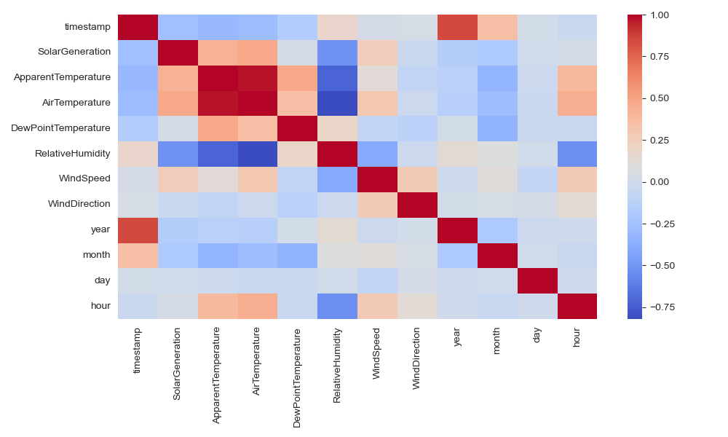
Figure 2 - Correlation Heatmap(Researcher’s Findings)
Correlation heatmap was developed to study the relationship among solar generation and the meteorological variables and represented as Figure 2 (Correlation Heatmap). The generation of solar energy recorded a moderate positive relationship with air temperature and apparent temperature with more output on warmer and sunny days. Relative humidity showed a negative relationship of weak strength with solar generation, probably because of the rise in cloudiness lowering the incoming solar radiation. There was little correlation between the wind related variables implying that there is a weak direct impact on the solar power output.
In general, these EDA results prove that the dataset can be used in predictive modeling and that there are significant correlations between solar energy generation and significant weather factors. Such observations formed a good basis of later data preprocessing, feature engineering and model building processes.

CHAPTER TWO: Task 2: Data Preprocessing & Feature Engineering

Preprocessing Data preprocessing plays an important role in the data analytics pipeline since it provides the assurance that the raw data are converted into a machine-learning-ready and clean and consistent format. The quality of preprocessing is of special concern in forecasting of renewable energy because in this application, large-scale time-series data are frequently missing values, difficult to compute, and full of noise (Levent, 2025). Since the initial UNISOLAR dataset is big, the data processing strategy adopted was chunk based to handle the memory effectively and at the same time retain vital information. Solar energy production and weather data were loaded in small manageable blocks and then resampled to hourly frequency greatly reducing the volume of data without losing the important time trends.
The resampling phase involved dealing with missing values, which were removed by eliminating totally missing records; this implied that only those hourly data points that were fully observed were further analyzed. Aggregating together of the hourly values in the form of the mean value was used to smooth the short-term fluctuations that came along with transient weather variations, which made the noise less and increased the observability of long-term generation trends. This type of time aggregation is also common in time-series analysis to trade off granularity and stability in predictive modeling (Alhosani, 2023). This preprocessing paradigm led to a small set of data that is computationally efficient to use in machine learning.
The use of feature engineering was then used to increase the predictive power of the models. Based on the timestamp variable, four temporal characteristics were obtained, including year, month, day, and hour in order to obtain the seasonal, monthly, daily, and diurnal changes in solar energy generation. These time characteristics are fundamental in prediction of solar output because the solar irradiance is highly cyclic owing to the rotation of the earth and the change of seasons concerning the sun location (Singh, 2024). Table 2 ( Feature Description Table) presents a summary of the engineered features and meteorological variables that were employed in the analysis.
Feature Name | Type | Description
SolarGeneration | Numerical (Continuous) | Hourly averaged solar energy generation value, used as the target variable for prediction.
ApparentTemperature | Numerical (Continuous) | Perceived outdoor temperature considering humidity and wind effects.
AirTemperature | Numerical (Continuous) | Ambient air temperature measured at the solar site.
DewPointTemperature | Numerical (Continuous) | Temperature at which air becomes saturated, indicating atmospheric moisture levels.
RelativeHumidity | Numerical (Continuous) | Percentage of moisture present in the air, influencing cloud formation and solar irradiance.
WindSpeed | Numerical (Continuous) | Speed of wind measured at the site, indirectly affecting atmospheric conditions.
WindDirection | Numerical (Continuous) | Direction from which the wind originates, expressed in degrees.
Year | Numerical (Discrete) | Calendar year extracted from the timestamp to capture long-term trends.
Month | Numerical (Discrete) | Month extracted from the timestamp to represent seasonal variation.
Day | Numerical (Discrete) | Day of the month extracted from the timestamp.
Hour | Numerical (Discrete) | Hour of the day extracted from the timestamp to model diurnal solar cycles.
Table 2 - Feature Description(Researcher’s Findings)
The identifier variables like CampusKey and SiteKey were not included in the modeling process. These are just variables that act as identifiers and not physical phenomena that affect solar energy generation. They may cause data leakage and undermine the model generalization (Levent, 2025). The elimination of these factors meant that the models could only learn the factors that explained the weather conditions and temporal factors that had significance.
All numerical variables were not normalised. This move was warranted since the use of tree-based algorithms like Random Forest is feature scaling-invariant and the use of original units increases interpretability of Linear Regression models (Yan, 2024). The resulting final cleaned up data was appropriate and in a good structure and also ideal to be used in good model training and testing.

CHAPTER TWO: Task 3: Model Development & Evaluation

Two supervised machine learning models were designed in this study to forecast the solar energy generation: Linear Regression and Random Forest Regression. To facilitate a comparative assessment of a conventional parametric baseline model and a more sophisticated ensemble-based algorithm that may be used to identify complex and non-linear relationships in the data set, these models were chosen (Borunda, 2022). These are the comparisons that have been common in predictive analytics to evaluate the trade-off between model simplicity and their predictive performance.
The data set was split into training and testing data sets in a 70:30 proportion and shuffling was turned off in order to maintain the time-based order of the observations. Time-series forecasting involves keeping time-order in mind because it is a realistic problem in the world because predictions of future energy generation needs to be made solely based on historical data (Singh, 2026). Three global performance measures were used to measure model performance; the coefficient of determination (R2 ), Mean Absolute Error (MAE), and the Mean Squared Error (MSE).
The reason why Linear Regression was used as a baseline model is its simplicity and easy interpretation. Its main limitation, however, is that its assumption of linear relationships between predictors and the target variable are considerably limiting to the application of the methodology to solar energy prediction, where the relationships between meteorological variables are essentially non-linear (Unni, 2026). The obtained results, as summarized in Table 3 (Model Performance Metrics), have shown that Linear Regression failed, showing negative value of R 2, at -1.34. This finding indicates that the model was not as good as a simple mean based predictor. Also, the high MAE (5.43 units) and MSE (39.59 units) is another evidence that the model is not able to reflect the variations in the solar energy production with high accuracy.
Model | R² | MAE | MSE
Linear Regression | -1.3416 | 5.4265 | 39.5857
Random Forest | 0.6961 | 1.5576 | 5.1373
Table 3 - Model Performance Metrics(Researcher’s Findings)
On the contrary, the Random Forest Regressor has had significantly better predictive performance. Table 3 demonstrates that the random Forest model had a high level of R 2; its level was approximately 0.70 and this implies that the model was able to explain a substantial percentage of the variation in solar energy production. The MAE was dropped to about 1.56 units, and the MSE was dropped to about 5.14 units, which is a significant step up over the baseline of the Linear Regression. Such findings emphasize the efficiency of the ensemble learning approach in dealing with non-linear relationships that are complex in nature and exist in renewable energy data (Borunda, 2022).
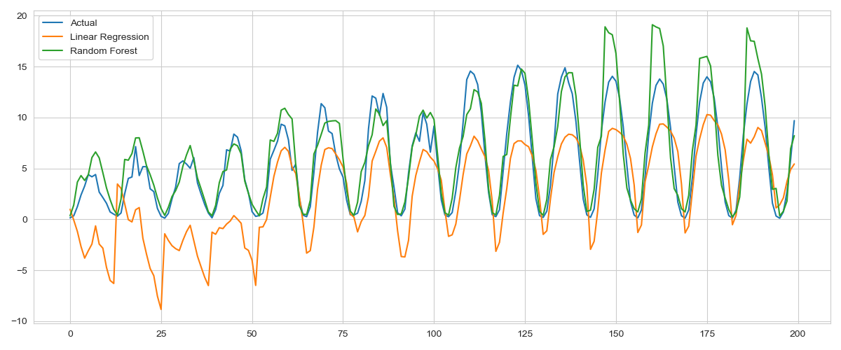
Figure 3 - Actual vs Predicted Solar Energy Generation (Linear Regression vs Random Forest) (Researcher’s Findings)
The high performance of the Random Forest model can be explained by the fact that the model combines the outcomes of the prediction of a number of decision trees and, thus, decreases overfitting and enhances generalization. Also, its insensitivity to the feature scale and resistance to noise renders it especially appropriate to heterogeneous datasets that comprise both meteorological and time factors.
These findings are further supported by visual comparison of the actual and predicted solar energy values that are presented in Figure 3 (Actual vs Predicted Solar Energy Generation). The predictions made by the Random Forest are more consistent with observed trends and especially when there is moderate and high generation, but with Linear Regression model, deviations are greater. Comprehensively, the results of the evaluation indicate that the Random Forest Regression would be more effective in forecasting solar energy compared to Linear Regression and thus chosen in the further forecasting and business analysis activities.

CHAPTER TWO: Task 4: Forecasting & Business Recommendation

The solar energy generation was predicted in January 2026 using the trained Random Forest Regression model. The preprocessed data was reduced to historic data which in turn was converted to historical data that took place in the month of January and the year variable was updated to reflect the future forecasting period. This type of forecasting is based on the assumption that those seasonal trends seen in the past will not change significantly over time, which is the assumption that is usually made in short-to-medium-term renewable energy forecasting research (Radhi, 2024). Random Forest model has been chosen to be used in forecasting because of its greater predictive power that has been witnessed in the evaluation stage.
The observed average solar energy production in January 2026 was approximated to be 6.75 units as it was summarized in Table 4 (January Solar Energy Forecast Comparison). The forecast shows that there is a stable generation trend in comparison with the historical averages of January. In particular, the forecasted output is 0.17 units more than the mean generation of January 2021 (6.47 units) and slightly less than January 2020 (12.11 units). This relative stability implies that in a world without significant climatic shocks or a technological revolution, there should be a constant performance of solar infrastructure. This stability is consistent with the results of the past research that emphasizes the predictability of seasonal solar generation patterns (Voyant et al., 2017).
Year | Average Solar Generation
2020 | 12.1145
2021 | 6.4727
2026 (Forecast) | 6.7460
Table 4 - January Solar Energy Forecast Comparison (Researcher’s Findings)
These projections hold useful information to both business and operational stakeholders of the solar energy industry and power generation. The ability to predict energy generation in winter helps to better plan maintenance because it is possible to predict the times when the generation is low. Moreover, foreseeable forecasts will reduce the necessity to have redundant power source that will reduce the cost of operation and increase the efficiency of the whole grid (Unni, 2026). These projections can be used by grid operators to optimize load balancing mechanisms and also to increase the incorporation of solar energy into the broader power grid.
These forecasts can also be used in the financial planning and energy trading by energy companies. Precise predictions of solar generation minimize uncertainty in the energy markets, aid in effective contraction negotiation, pricing policies and risk management. Such insights might also be useful to policy makers as they consider the viability of solar capacity expansion or incorporating the primary renewable sources to improve energy security and sustainability (Borunda, 2022).

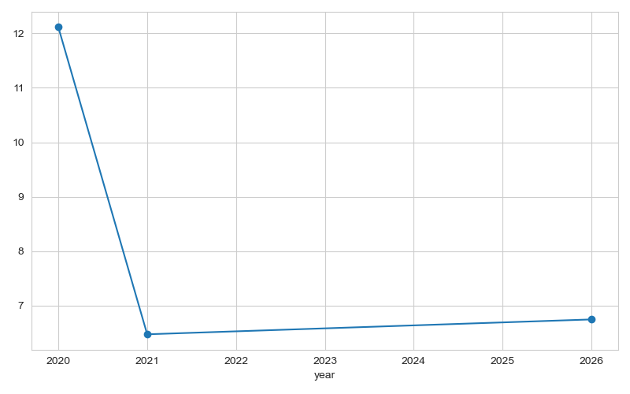
Figure 4 - Comparison of historical and forecasted January solar energy generation values (Researcher’s Findings)
Figure 4 (January Solar Energy Generation Comparison) is a visual comparison of the historical and forecasted January solar energy generation, which shows that the output is relatively stable when projected. In order to enhance further the accuracy of forecasting, more explanatory factors can be added in future studies: solar irradiance, cloud cover and panel efficiency measures. In addition, more sophisticated deep learning models like Long Short-Term Memory (LSTM) networks can be considered to be able to capture long-term temporal dependencies.

CONCLUDING REMARKS

This assignment showed a complex data analytics model to predict solar power base on the UNISOLAR data. By means of systematic exploratory data analysis, significant associations between solar generation and meteorological variables were determined (Behl, 2026). High-quality inputs used in model development were also guaranteed because of efficient data preprocessing and feature engineering, and the computational efficiency.
The relative analysis of Linear Regression and Random Forest Regression made it clear why it is critical to choose suitable models in complicated and non-linear tasks. Although the crust of Linear regression was a very useful reference point, it was found to be ineffective in solar energy modelling due to its low performance (Khan, 2026). On the other hand, the Random Forest model also provided the good predictive performance and strength to be utilised in real-life applications of predictive models in the renewable energy forecasting.
The future availability of solar energy as the January 2026 has given actionable information about future availability to enable a well-informed decision regarding energy management and planning. Their results highlight the usefulness of machine learning in enhancing the reliability of renewable energy systems and uncertainty reduction (Levent, 2025).
In sum, the presented research can be viewed as an example of how data-driven methodologies can be used to make sustainability processes more efficient and effective to use renewable resources smarter. Such approaches to analysis will become even more important in determining the future of energy systems as the use of renewable energy keeps increasing.

BIBLIOGRAPHY

Albahdal, A. (2025) ‘Sunrise in the desert: Leveraging big data analytics for predictive solar energy production in Saudi Arabia’, IEEE Access.
Alhosani, A. (2023) Development and application of forecasting machine learning approach for renewable energy-related products’ prices. Doctoral dissertation, Khalifa University of Science.
Behl, R. (2026) ‘Solar optimization via learning-driven visual intelligent analytics’, Renewable Energy, p. 125171.
Borunda, M. (2022) ‘Photovoltaic power generation forecasting for regional assessment using machine learning’, Energies, 15(23), p. 8895.
Kalogirou, S.A. (2014) Solar energy engineering: Processes and systems. 2nd edn. London: Academic Press.
Khan, M. (2026) ‘Machine learning for optimizing renewable energy and solar grid’, in Proceedings of the International Conference on Computational Intelligence and Information Retrieval (ICCIIR 2025), Vol. 2. Cham: Springer Nature, p. 161.
Levent, M. (2025) ‘Comparative analysis of advanced machine learning regression models with advanced artificial intelligence techniques to predict rooftop PV solar power plant efficiency using indoor solar panel parameters’, Applied Sciences, 15(6), p. 3320.
Maduabuchi, N. (2023) ‘Renewable energy potential estimation using climatic weather forecasting machine learning algorithms’, Energies, 16(4), p. 1603.
Radhi, H. (2024) ‘Predicting solar power generation utilized in Iraq power grid using neural networks’, Misan Journal of Engineering Sciences, 3(1), pp. 38–62.
Singh, A. (2024) ‘Enhancing microgrid efficiency with artificial intelligence-based solar energy forecasting and load management’, in Proceedings of the 4th International Conference on Innovative Sustainable Computational Technologies (CISCT 2024). IEEE, pp. 1–6.
Singh, P. (2026) ‘Short-term renewable energy forecasting methods using artificial neural networks: A comprehensive review’, in Computational Intelligence for a Greener Future: Innovations in Renewable Energy Systems. Cham: Springer, pp. 79–96.
Unni, R. (2026) ‘Solar power prediction using computer vision and machine intelligence: Predicting and optimizing solar energy generation’, in Reliability Analysis and Modeling for Complex Systems. Amsterdam: Elsevier, pp. 339–364.
Yan, X. (2024) ‘A hybrid deep learning approach for green energy forecasting in Asian countries’, International Journal of Green Energy Systems.

APPENDIX

Python Code
import os
import pandas as pd
import numpy as np
import matplotlib.pyplot as plt
import seaborn as sns

from sklearn.model_selection import train_test_split
from sklearn.linear_model import LinearRegression
from sklearn.ensemble import RandomForestRegressor
from sklearn.metrics import r2_score, mean_absolute_error, mean_squared_error

sns.set_style("whitegrid")

# ============================================================
# CREATE OUTPUT FOLDER FOR GRAPHS
# ============================================================

OUTPUT_DIR = "graphs"
os.makedirs(OUTPUT_DIR, exist_ok=True)

# ============================================================
# 1. LOAD & PROCESS SOLAR DATA (CHUNKED)
# ============================================================

print("Loading Solar Energy data...")
solar_chunks = []

for chunk in pd.read_csv(
"Solar_Energy_Generation.csv",
chunksize=500_000
):
chunk['timestamp'] = pd.to_datetime(chunk['Timestamp'], errors='coerce')
chunk = chunk[['timestamp', 'SolarGeneration']].dropna()

chunk = (
chunk.set_index('timestamp')
.resample('1h')
.mean()
.dropna()
.reset_index()
)

solar_chunks.append(chunk)

solar = pd.concat(solar_chunks, ignore_index=True)
solar = solar.groupby('timestamp').mean().reset_index()

print("Solar data after resampling:", solar.shape)

# ============================================================
# 2. LOAD & PROCESS WEATHER DATA (CHUNKED)
# ============================================================

print("Loading Weather data...")
weather_chunks = []

weather_cols = [
'ApparentTemperature',
'AirTemperature',
'DewPointTemperature',
'RelativeHumidity',
'WindSpeed',
'WindDirection'
]

for chunk in pd.read_csv(
"Weather_Data_reordered_all.csv",
chunksize=300_000
):
chunk['timestamp'] = pd.to_datetime(chunk['Timestamp'], errors='coerce')
chunk = chunk[['timestamp'] + weather_cols].dropna()

chunk = (
chunk.set_index('timestamp')
.resample('1h')
.mean()
.dropna()
.reset_index()
)

weather_chunks.append(chunk)

weather = pd.concat(weather_chunks, ignore_index=True)
weather = weather.groupby('timestamp').mean().reset_index()

print("Weather data after resampling:", weather.shape)

# ============================================================
# 3. MERGE DATA
# ============================================================

df = pd.merge(solar, weather, on='timestamp', how='inner')
print("Merged dataset shape:", df.shape)

# ============================================================
# 4. FEATURE ENGINEERING
# ============================================================

df['year'] = df['timestamp'].dt.year
df['month'] = df['timestamp'].dt.month
df['day'] = df['timestamp'].dt.day
df['hour'] = df['timestamp'].dt.hour

# ============================================================
# 5. EDA – INDIVIDUAL GRAPHS (SAVED)
# ============================================================

# Descriptive stats table
df.describe().to_csv(os.path.join(OUTPUT_DIR, "descriptive_statistics.csv"))

# Correlation heatmap
plt.figure(figsize=(10,6))
sns.heatmap(df.corr(), cmap="coolwarm")
plt.title("Correlation Heatmap")
plt.tight_layout()
plt.savefig(os.path.join(OUTPUT_DIR, "correlation_heatmap.png"))
plt.close()

# Histograms (one combined figure)
df.hist(bins=30, figsize=(14,7))
plt.tight_layout()
plt.savefig(os.path.join(OUTPUT_DIR, "histograms.png"))
plt.close()

# ============================================================
# 6. TARGET & FEATURES
# ============================================================

target = 'SolarGeneration'
X = df.drop(columns=[target, 'timestamp'])
y = df[target]

# ============================================================
# 7. TRAIN–TEST SPLIT
# ============================================================

X_train, X_test, y_train, y_test = train_test_split(
X, y, test_size=0.3, shuffle=False
)

# ============================================================
# 8. LINEAR REGRESSION
# ============================================================

lr = LinearRegression()
lr.fit(X_train, y_train)
lr_preds = lr.predict(X_test)

# ============================================================
# 9. RANDOM FOREST
# ============================================================

rf = RandomForestRegressor(
n_estimators=50,
max_depth=15,
random_state=42,
n_jobs=-1
)

rf.fit(X_train, y_train)
rf_preds = rf.predict(X_test)

# ============================================================
# 10. MODEL COMPARISON GRAPH (SAVED)
# ============================================================

plt.figure(figsize=(12,5))
plt.plot(y_test.values[:200], label="Actual")
plt.plot(lr_preds[:200], label="Linear Regression")
plt.plot(rf_preds[:200], label="Random Forest")
plt.legend()
plt.title("Model Prediction Comparison")
plt.tight_layout()
plt.savefig(os.path.join(OUTPUT_DIR, "model_comparison.png"))
plt.close()

# ============================================================
# 11. METRICS SAVED
# ============================================================

metrics = pd.DataFrame({
"Model": ["Linear Regression", "Random Forest"],
"R2": [
r2_score(y_test, lr_preds),
r2_score(y_test, rf_preds)
],
"MAE": [
mean_absolute_error(y_test, lr_preds),
mean_absolute_error(y_test, rf_preds)
],
"MSE": [
mean_squared_error(y_test, lr_preds),
mean_squared_error(y_test, rf_preds)
]
})

metrics.to_csv(os.path.join(OUTPUT_DIR, "model_metrics.csv"), index=False)

print(metrics)

# ============================================================
# 12. JANUARY 2026 FORECAST
# ============================================================

jan = df[df['month'] == 1].copy()
jan['year'] = 2026

X_jan = jan[X.columns]
jan['Forecast_Energy'] = rf.predict(X_jan)

jan_2026_avg = jan['Forecast_Energy'].mean()
print("\nAverage Solar Energy Forecast for January 2026:", jan_2026_avg)

# ============================================================
# 13. JANUARY COMPARISON GRAPH (SAVED)
# ============================================================

comparison = (
df[df['month'] == 1]
.groupby('year')[target]
.mean()
)

comparison.loc[2026] = jan_2026_avg

plt.figure(figsize=(8,5))
comparison.plot(marker='o')
plt.title("January Solar Energy Production (2017–2026)")
plt.ylabel("Average Solar Generation")
plt.tight_layout()
plt.savefig(os.path.join(OUTPUT_DIR, "january_comparison.png"))
plt.close()

print("\nAll graphs saved in folder:", OUTPUT_DIR)

