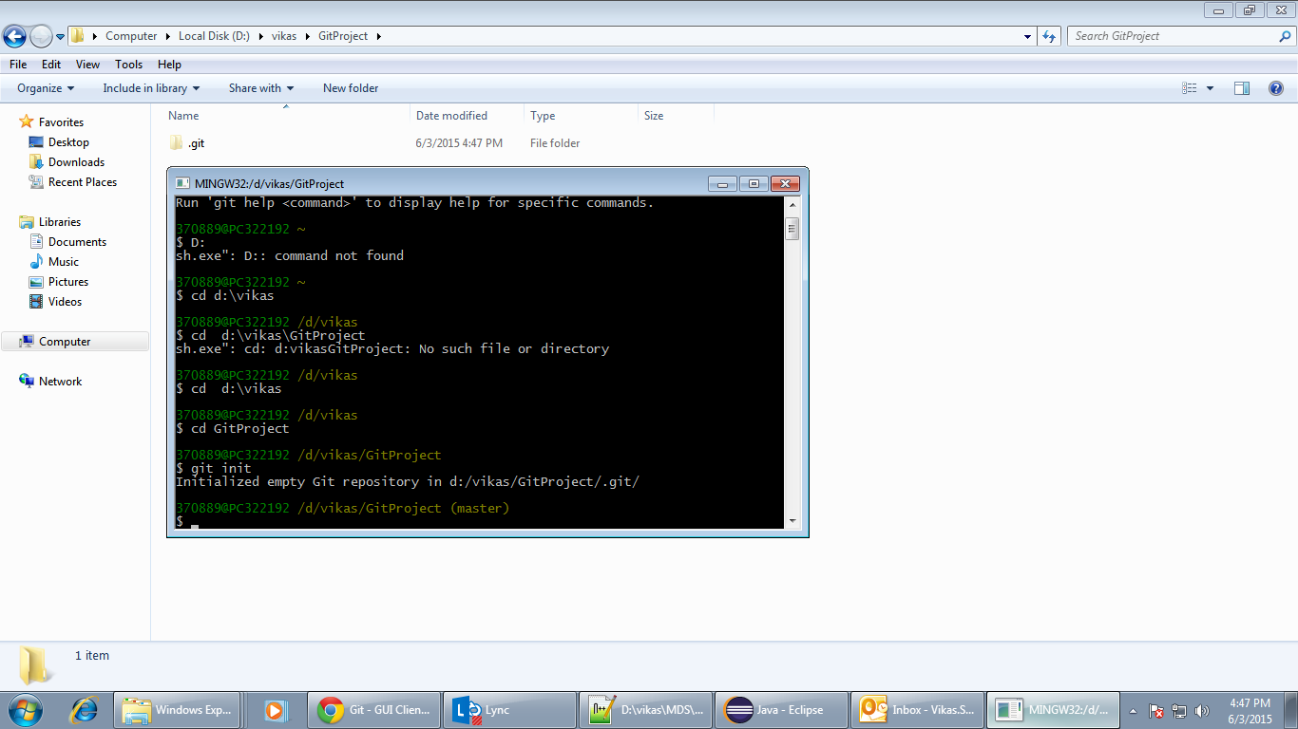

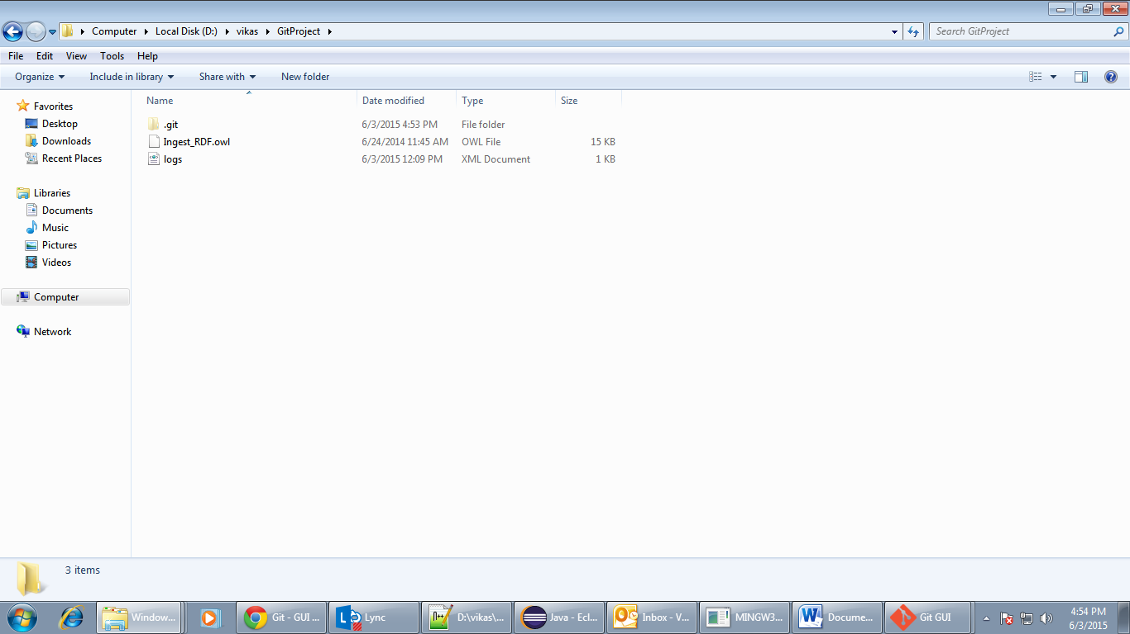

Committed two files Git

Added two path variable regarding Git

It seems like it is working as client .We need to test

<http://www.codeproject.com/Articles/655560/Step-by-Step-Setup-Git-Server-on-Windows-with-Co>

Difference between git and git hub

<https://github.com/Vikas1234/vikas-test>

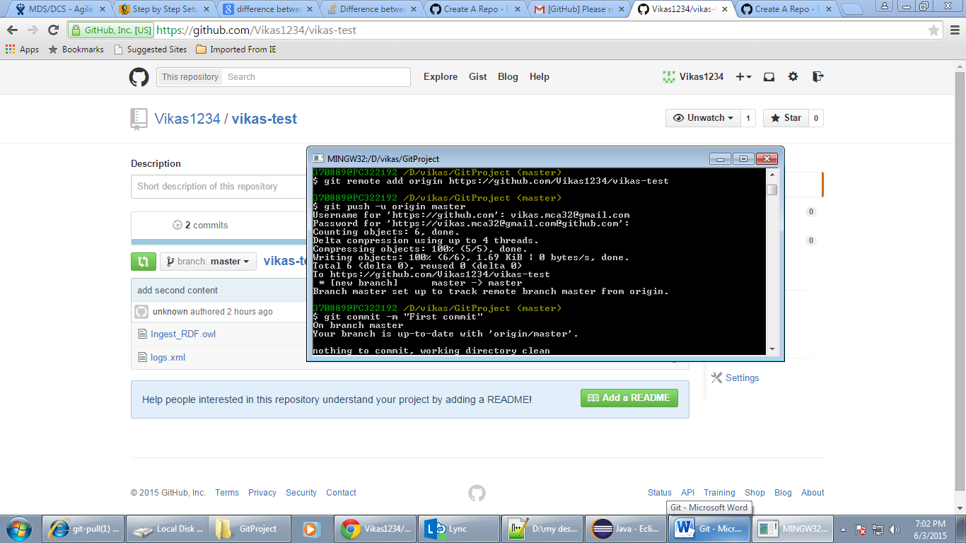

1) Created account on github

2) Created git project in local

3) Committed my changes as per screenshot

Push worked

Pull content from repository

Using git init then

Git pull <https://github.com/Vikas1234/vikas-test>

Using git log as below

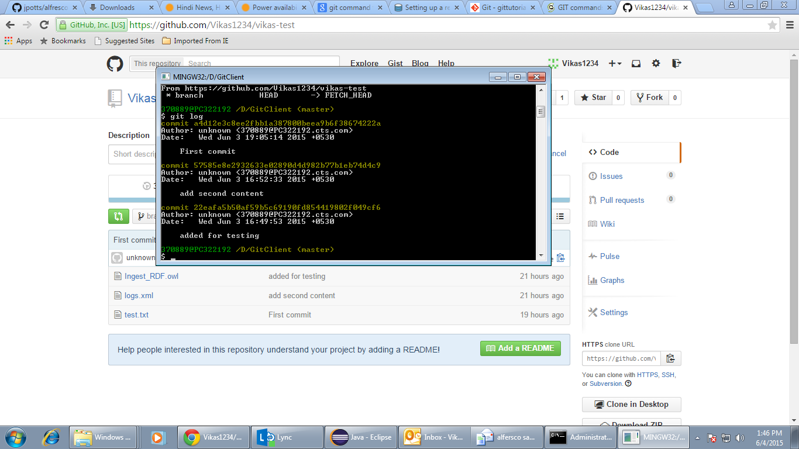

Full log using git

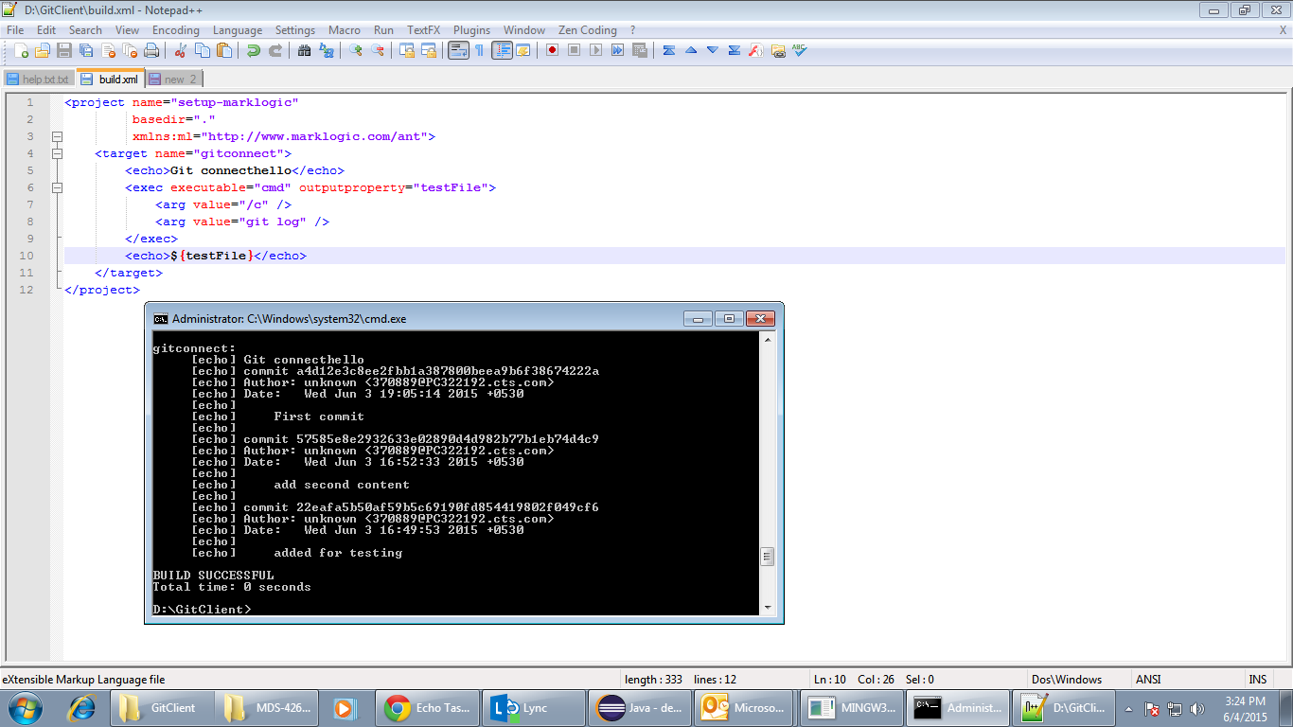

For getting revision to head

