[BioC](http://www.ncbi.nlm.nih.gov/pubmed/24048470) is a simple format to share text data and annotations. It allows a large number of different annotations to be represented. We provide simple code to hold this data, read it and write it back to XML, and perform some sample processing.

Ref: <https://www.youtube.com/watch?v=HyUjCSQB96w&t=24s>

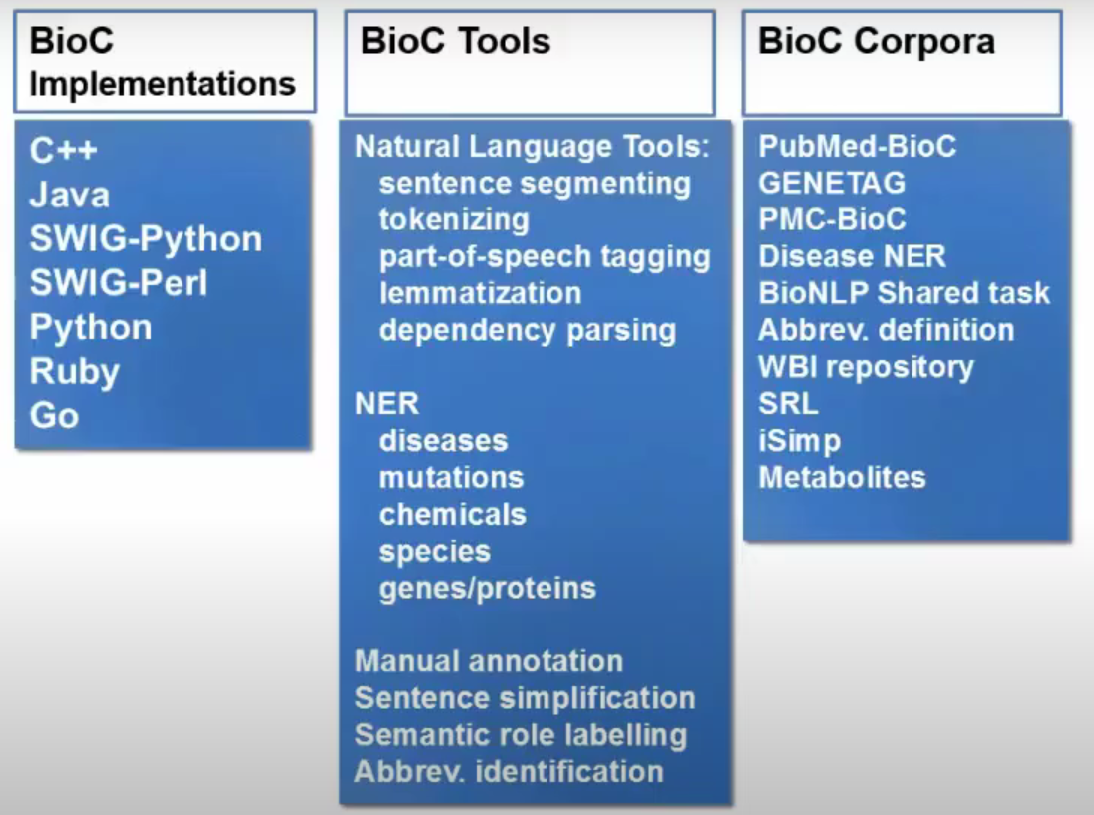

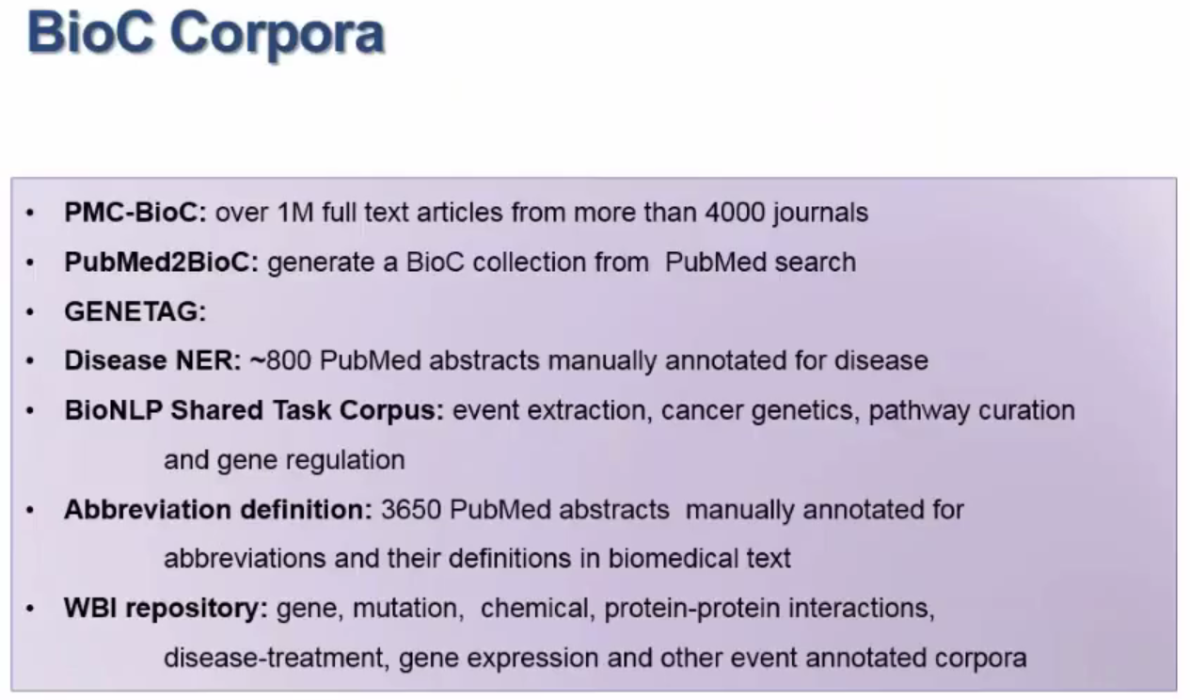

**Key file**

* Files accompanies with BioC corpus
* Describes tags used in corpus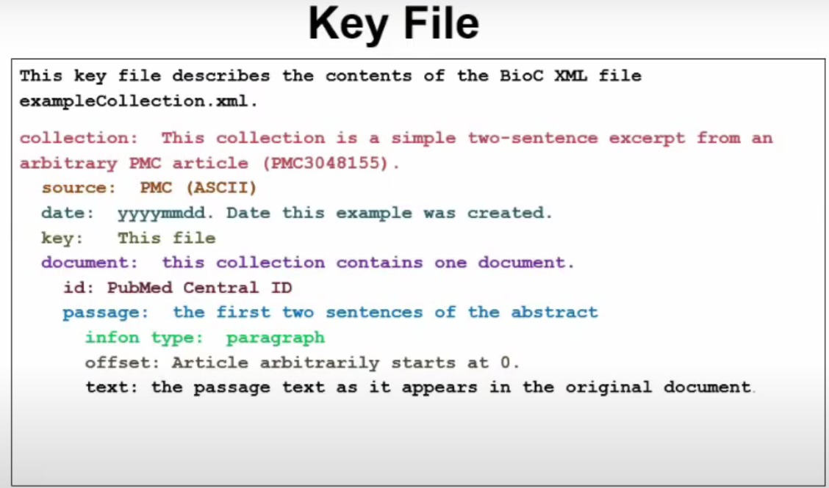

NLP Pipeline

