Assignment 1: Create an IAM user with username of your own wish and grant

administrator policy.

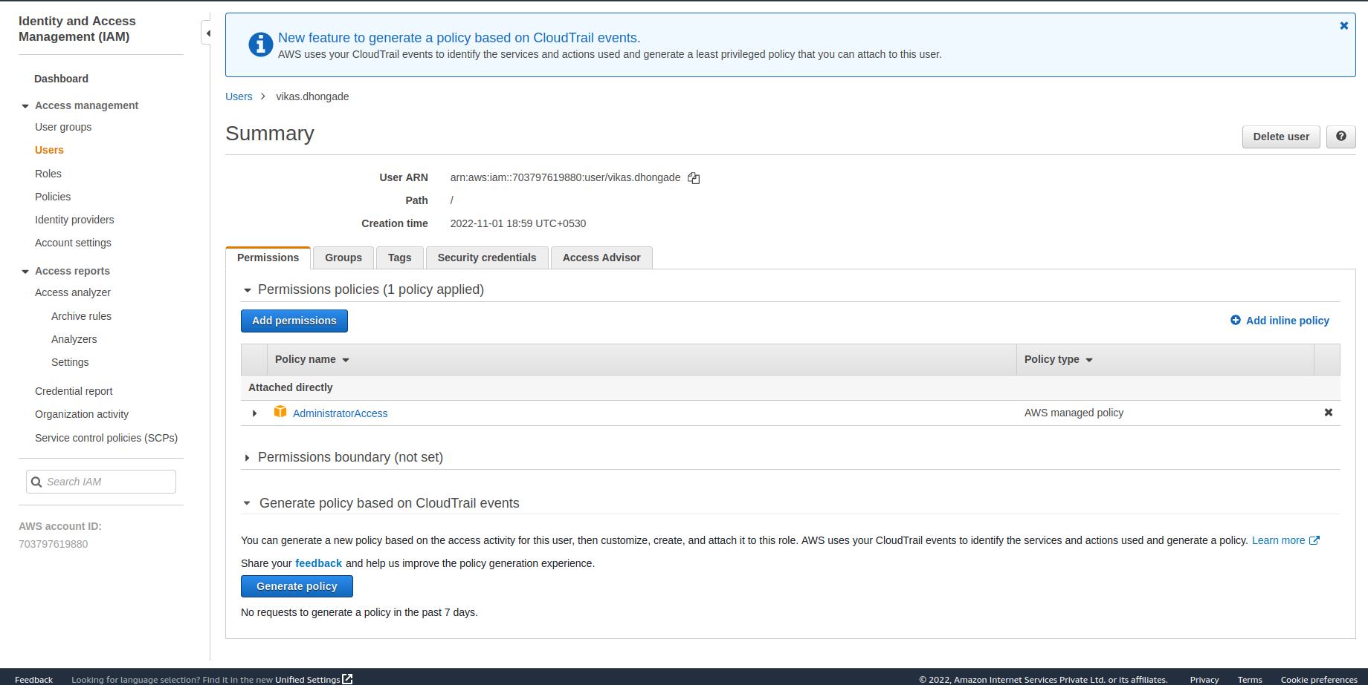

Assignment 2: Create 3 IAM users of avengers and assign them in developer’s groups with

IAM policy.

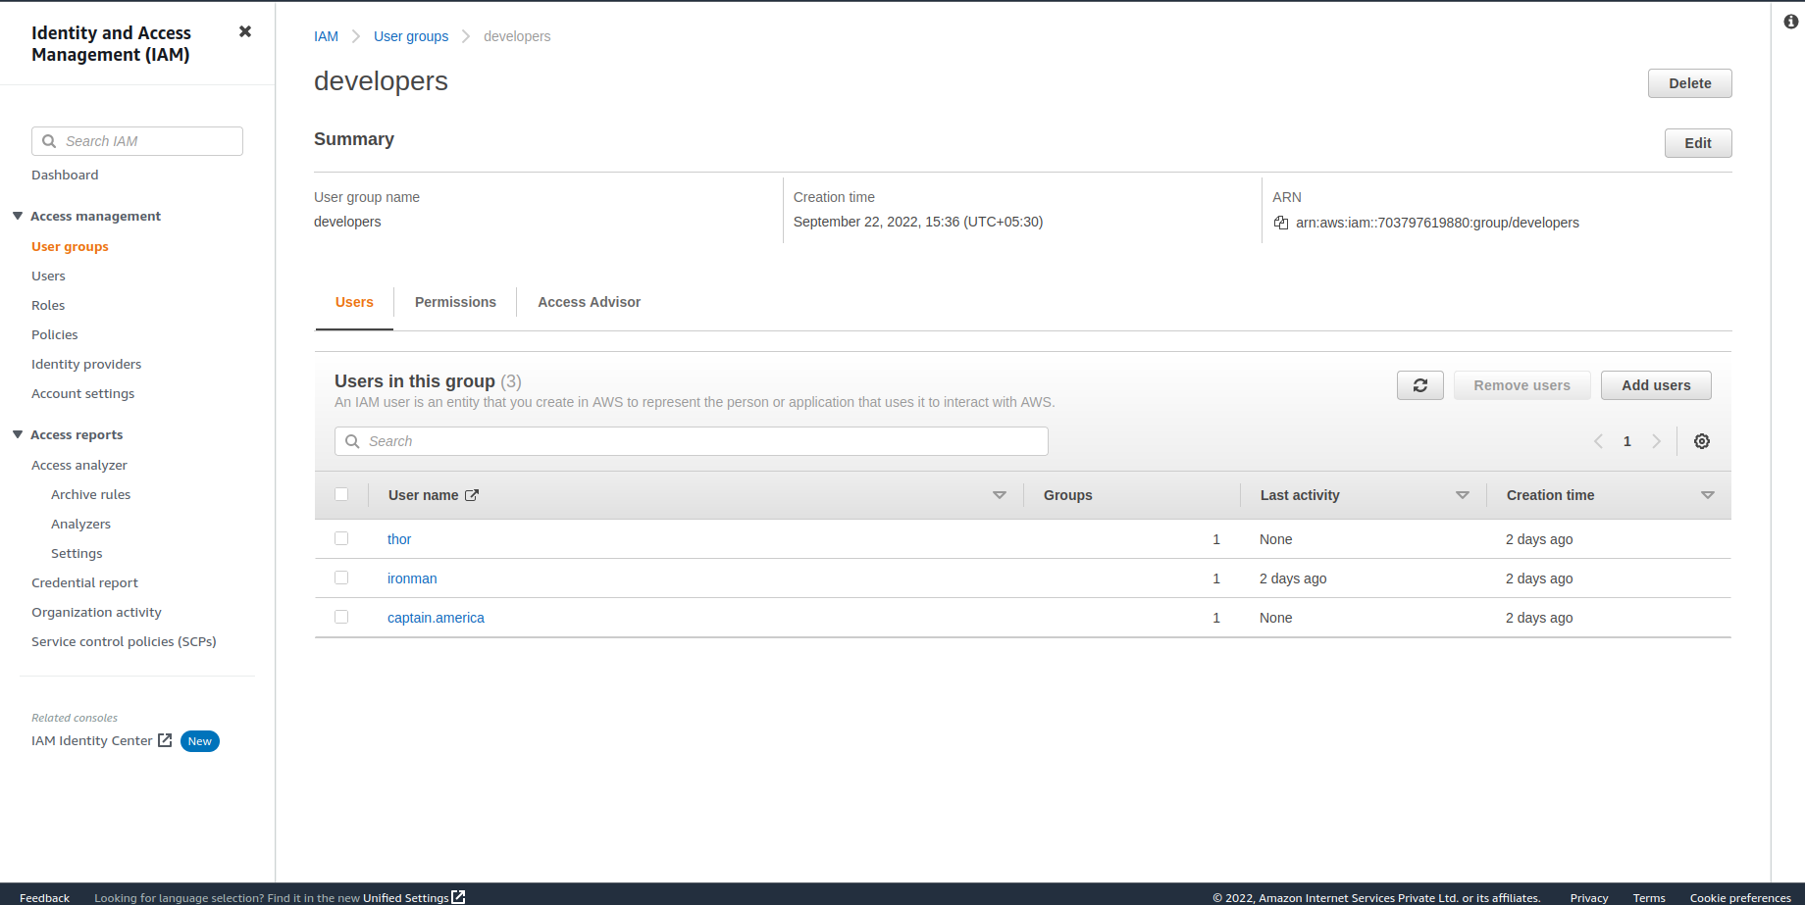

Assignment 3: Define a condition in policy for expiration

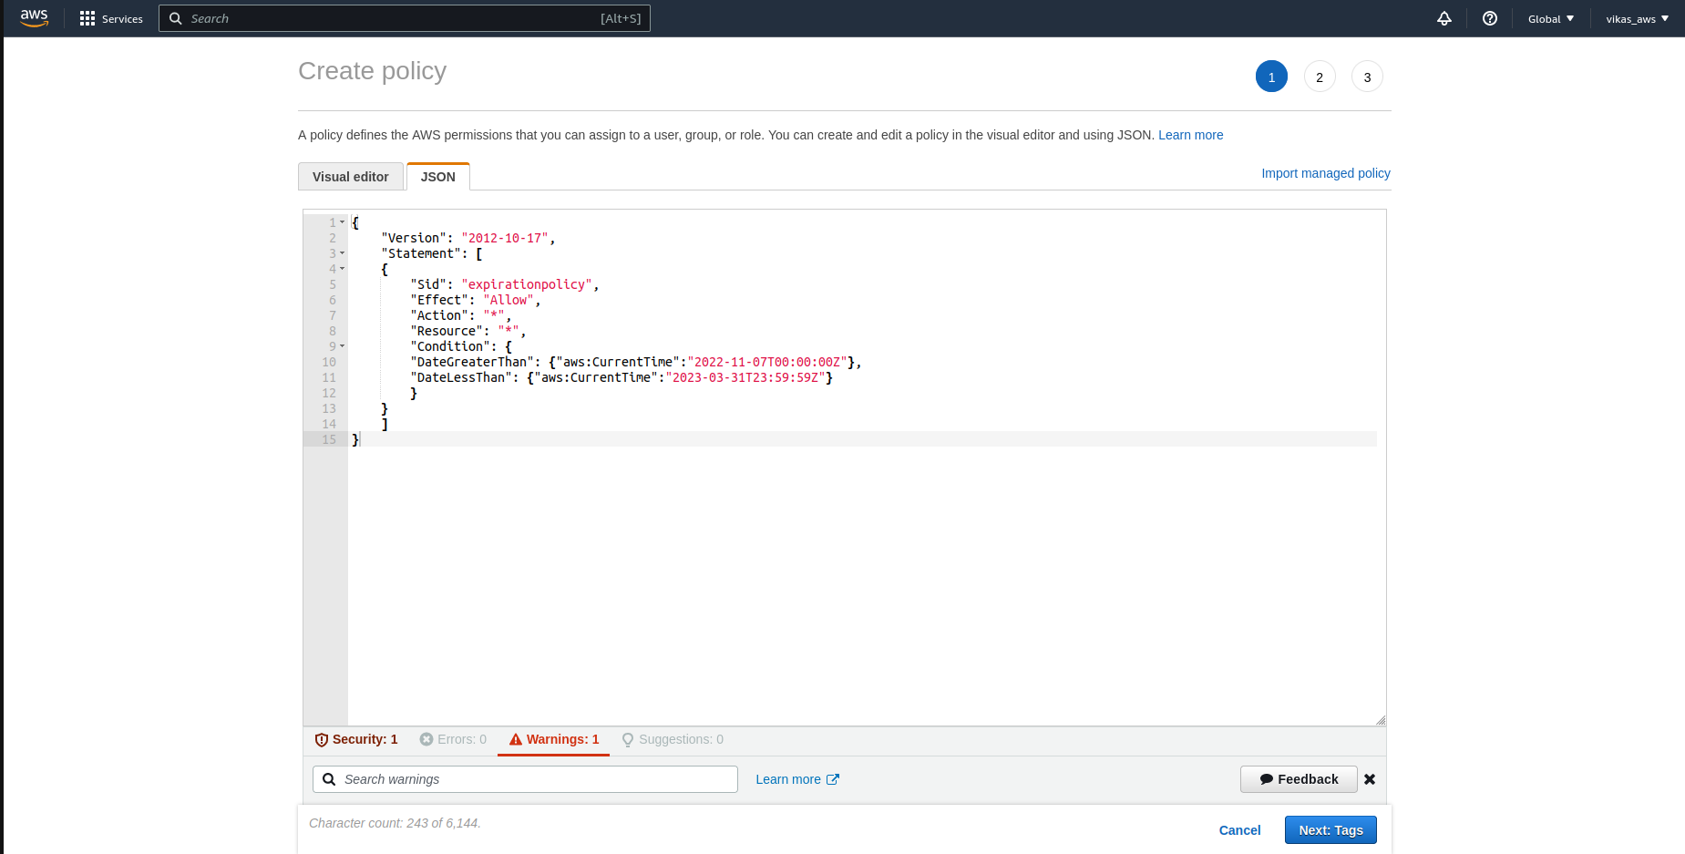

Assignment 4: Launch your linux instance in IAM and update your machine.

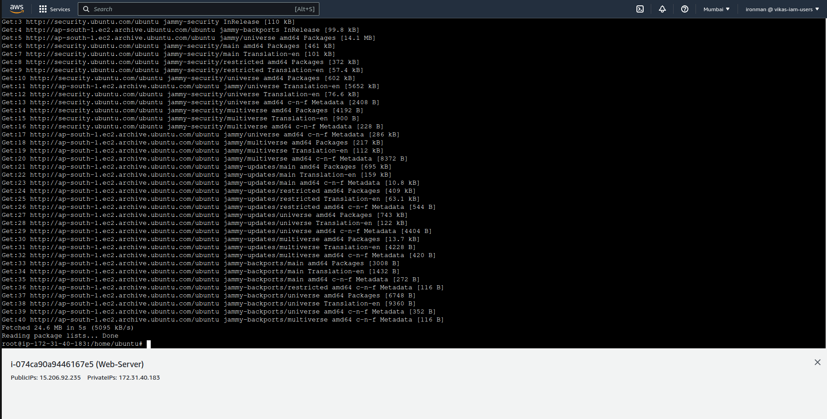

Assignment 5:

IAM Questions:

1) What are different identities provided by IAM?

2) What are AWS policies?

3) How to control authorization in IAM?

4) What is the 'Principal' mentioned in IAM policy?

5) Why we create users in AWS, why not to use root account?

6) What are different types of IAM policies?

7) What is difference between inline and managed policies?

8) what is difference between AWS managed & customer managed policies?

9) Can we track the activities of the IAM users?

10) what is 'Role' in IAM?

11) When we can go for custom policies?

12) Can we add more policies to an IAM user which is already having few policies?

13) Can IAM user be a part of multiple groups?

14) Do IAM user get all the policies from the groups to which he is aatached to?

15) Why we create groups, if we are having different users with different set pf policies?