SE LAB 2

NAME: VIKAS R

SRN: PES1UG24AM477

SEC: H

Lab 2: Agile Backlog Creation & Sprint Simulation in Jira

Objective: Use Jira to turn functional requirements into Agile backlog items, simulate a sprint, and analyse progress.

1)Jira backlog with Epics and User Stories.
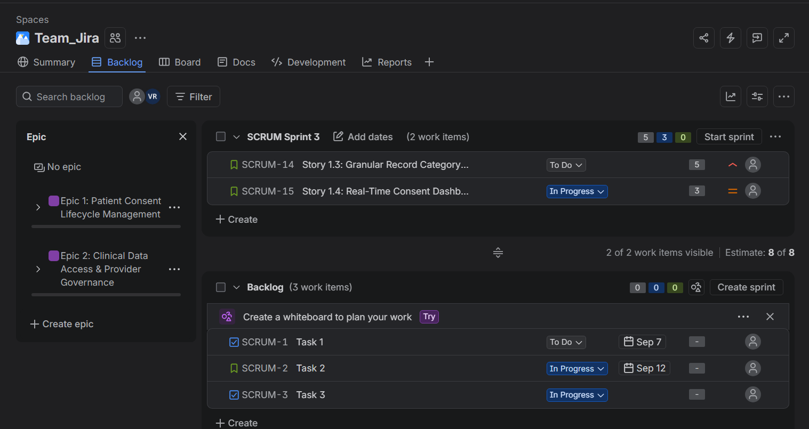

2)Story point assignments.
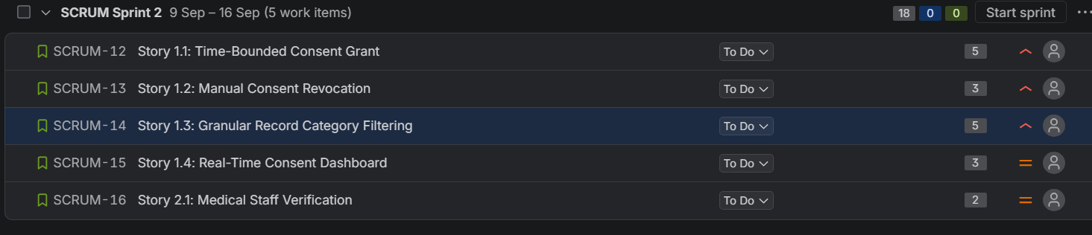
3)Sprint board (Active Sprint view).

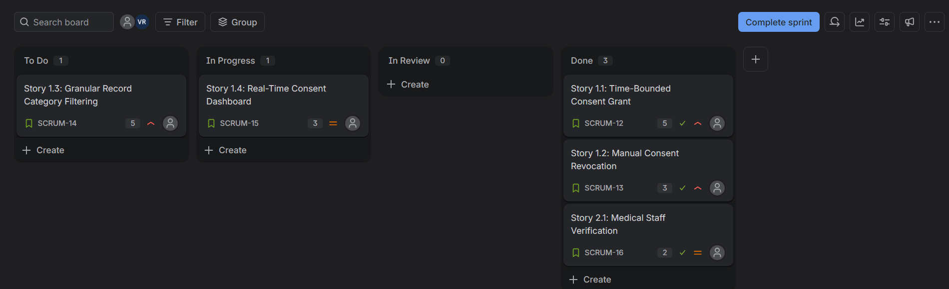

4)Burndown Chart

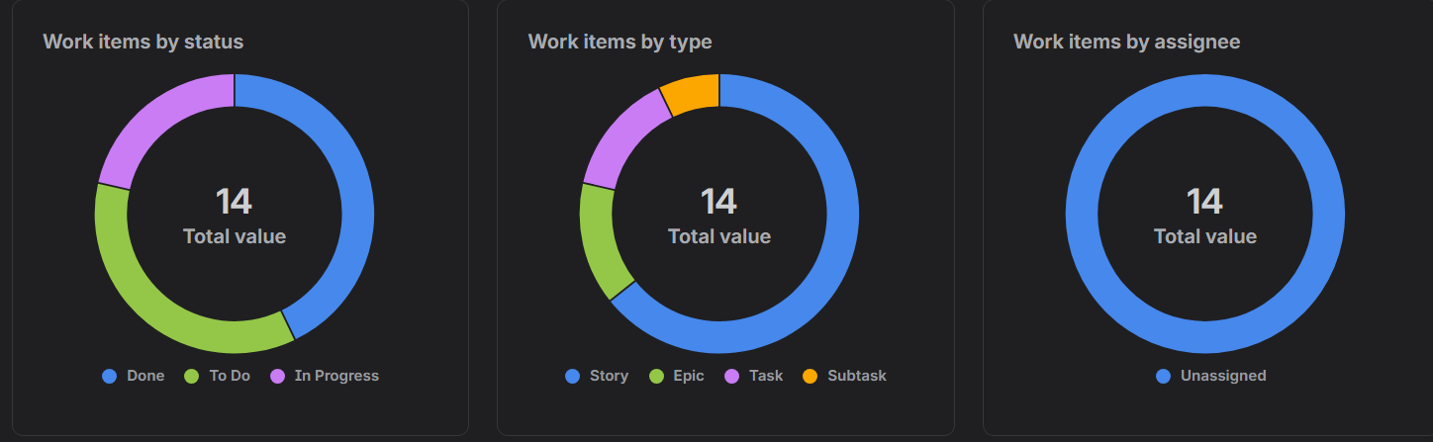
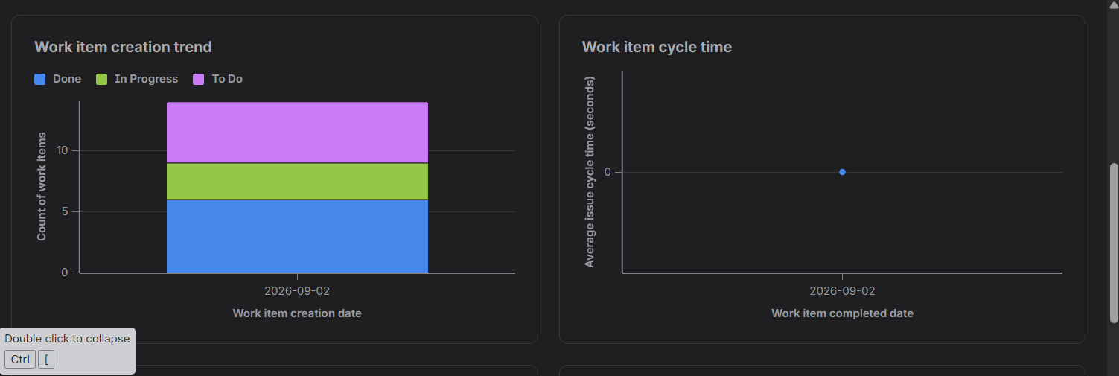
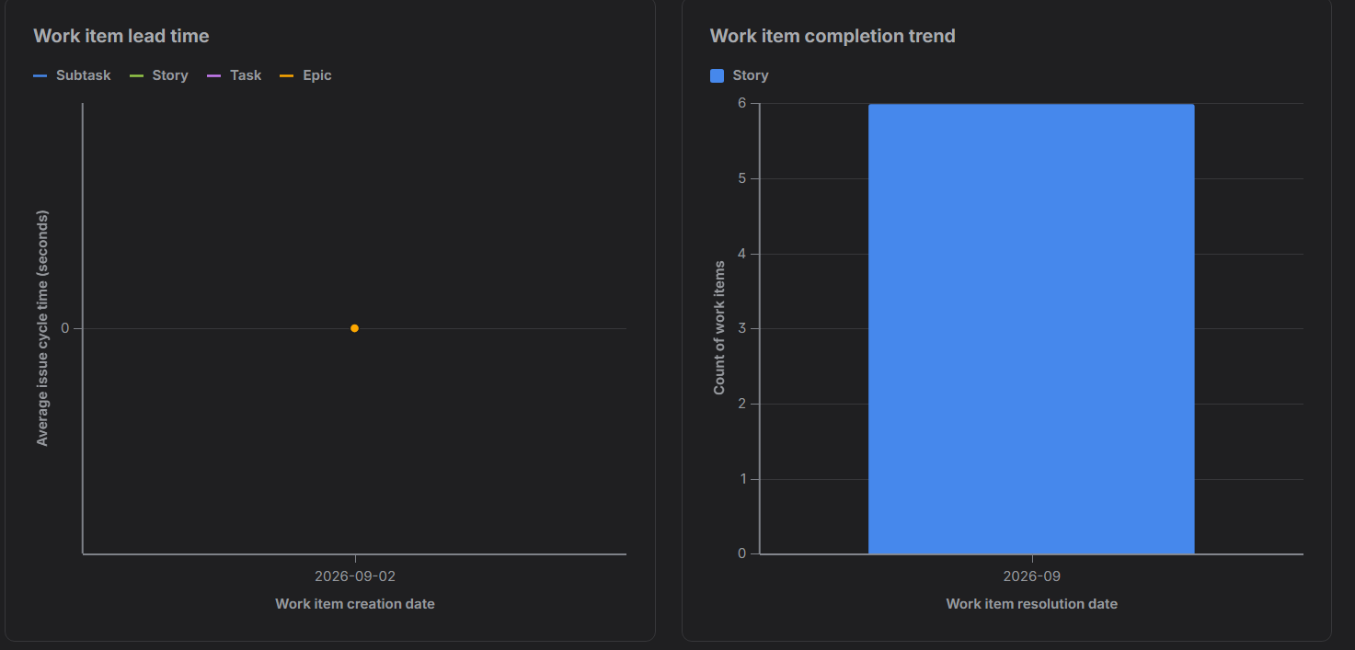

Answers to the reflection questions.

1. Did your estimations reflect the actual effort?
Yes. The Fibonacci sequence allowed our team to distinguish low-effort tasks (e.g., Medical Staff Verification at 2 points) from architecturally complex tasks involving token signing and cryptographic expiry windows (e.g., Time-Bounded Consent Grant at 5 points). Because this was a time-boxed sprint simulation, the point assignments reflected architectural complexity and data sensitivity risks rather than raw development hours alone.

2. Was your backlog well-prioritized?
Yes, the backlog strictly prioritized core security and data governance requirements first. Story 1.1 (Consent Grant) and Story 1.2 (Consent Revocation) were marked as High Priority because without patient-controlled authorization and revocation mechanisms, diagnostic data cannot legally or safely be exposed to third parties. Secondary administrative and dashboard viewing capabilities were prioritized subsequently.
3. How did your simulated sprint align with your plan?
The sprint achieved 10 out of the 18 planned story points (Stories 2.1, 1.1, and 1.2 completed). Granular filtering and real-time dashboard analytics remained partially completed, mirroring real-world agile development where core access control mechanisms must be fully stabilized before advanced filtering layers are finalized.
4. What insights did the burndown chart give about your team's capacity?
The burndown chart illustrated a step-wise drop in remaining work as large user stories (5 points) were completed and resolved. It highlighted that committing to 18 points across multiple complex features in a single 1-week sprint stretched team capacity, indicating that future velocity should stabilize around 10–12 story points per iteration to prevent scope spillover.

