Site-to-Site VPN Configuration
On-Premises Data Center to AWS Cloud
This document describes the step-by-step procedure to establish a Site-to-Site VPN connection between an On-Premises Data Center and an AWS Cloud environment.

Step 1: Create On-Premises VPC
- Create a VPC named 'On-Prem' with CIDR 172.16.0.0/16.
- Create one Public Subnet within this VPC.
- Attach an Internet Gateway (IGW) to enable internet access.

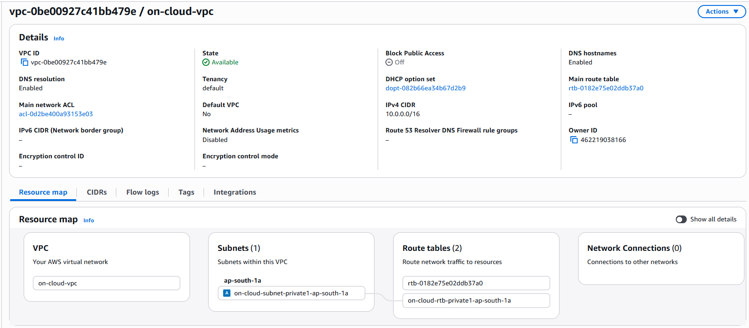

Step 2: Launch Public EC2 Instance (On-Prem)
- Launch an EC2 instance named 'Public-Instance' in the Public Subnet.
- Select Ubuntu AMI.
- Configure Security Group with:
• SSH (Port 22)
• All ICMP – IPv4
• Custom UDP (Ports 500 and 4500 for IPSec)
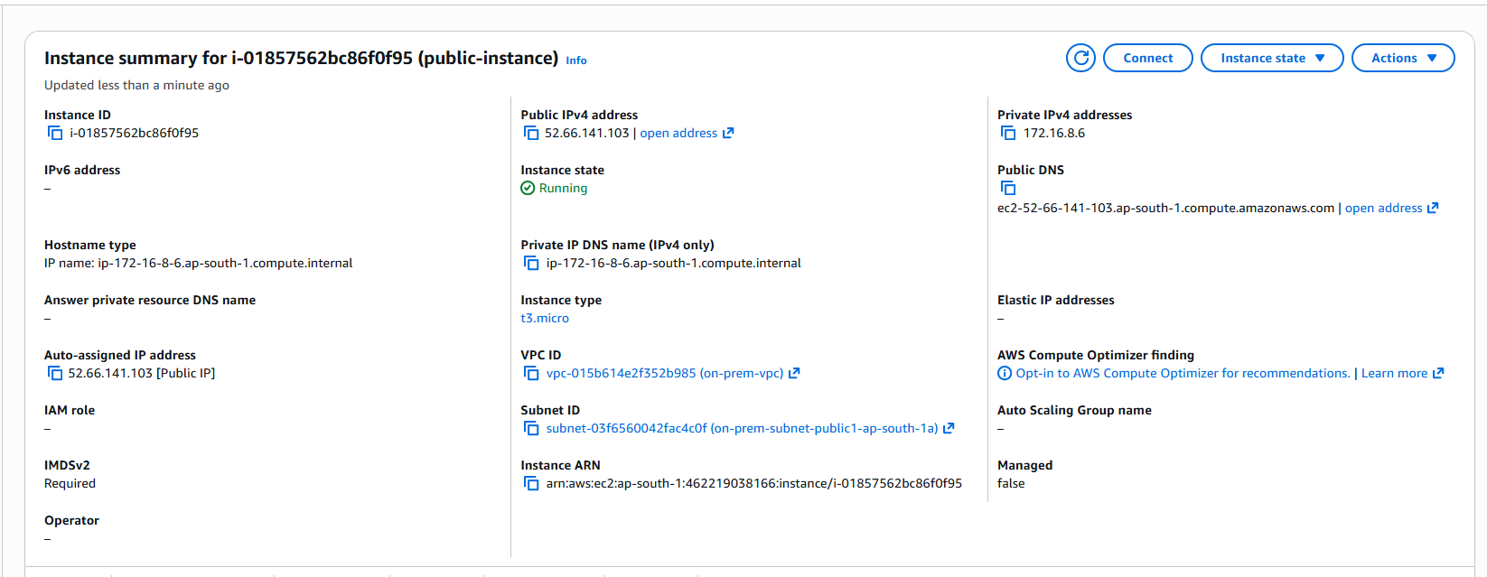

Step 3: Create Cloud VPC
- Create a VPC named 'On-Cloud' with CIDR 10.0.0.0/16.
- Create a Private Subnet within this VPC.


Step 4: Create Customer Gateway (CGW)
- Create a Customer Gateway.
- Provide the Public IP address of the On-Prem Public EC2 instance.
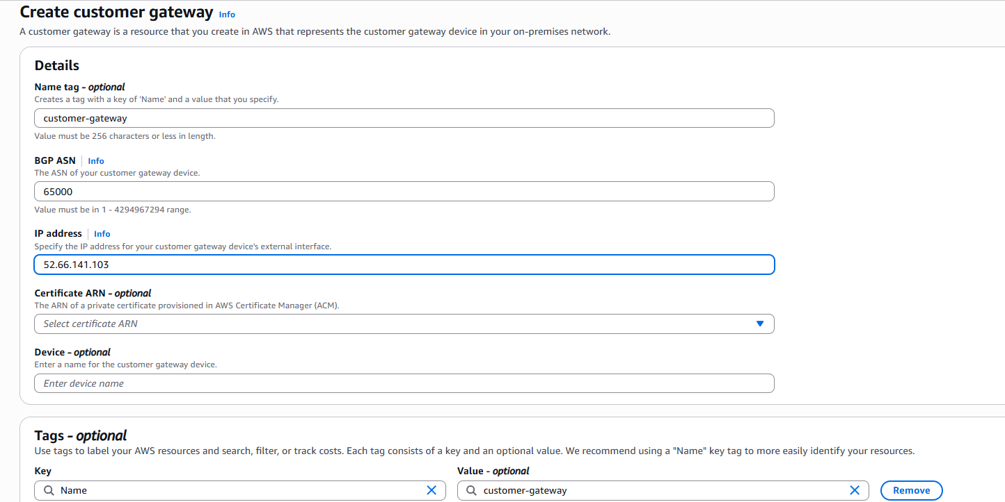
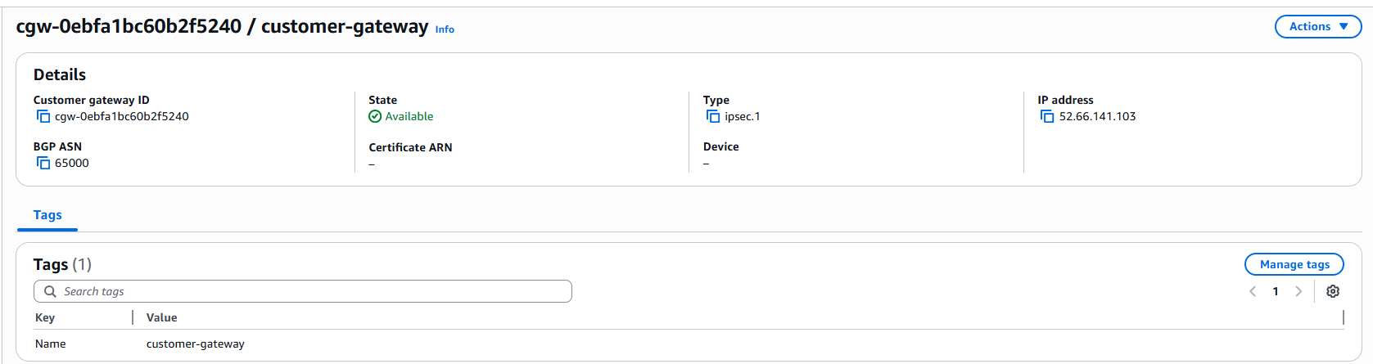

Step 5: Create Virtual Private Gateway (VGW)
- Create a Virtual Private Gateway.
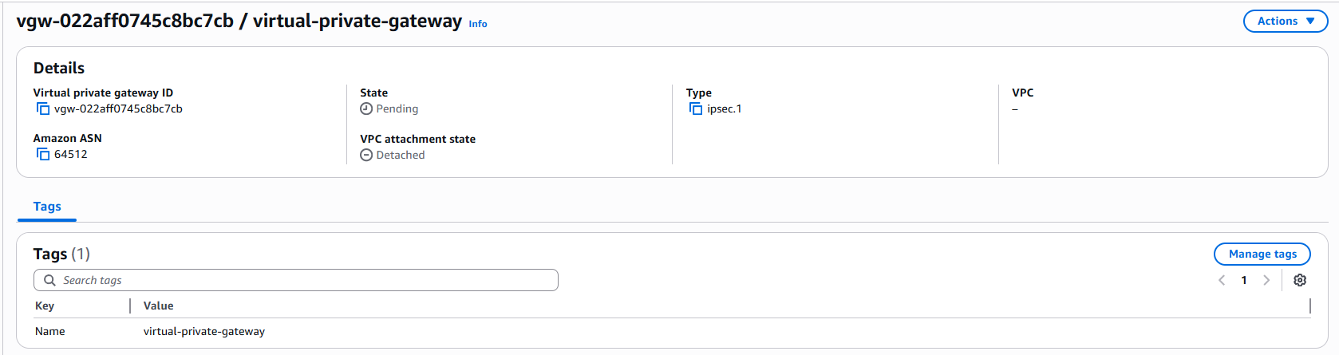

Step 6: Attach VGW to On-Cloud VPC
- Attach the created VGW to the On-Cloud VPC.

Step 7: Create Site-to-Site VPN Connection
- Create a VPN connection named 'vpn-connection'.
- Select the Virtual Private Gateway (VGW).
- Select the Customer Gateway (CGW).
- Choose Static Routing.
- Add Static IP Prefix: 172.16.0.0/16.
- Select Standard for Pre-Shared Key storage and create the VPN.
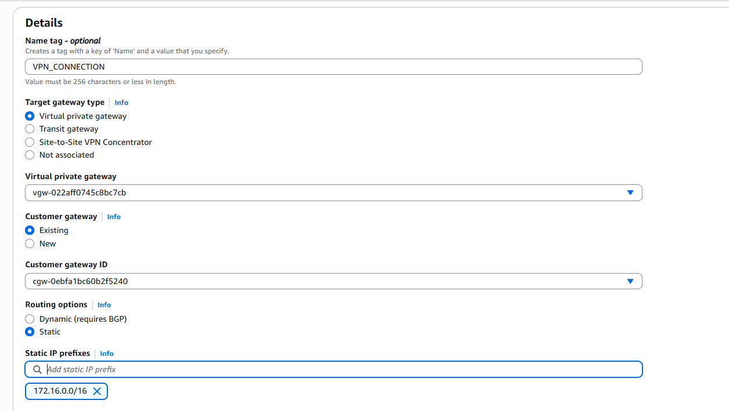
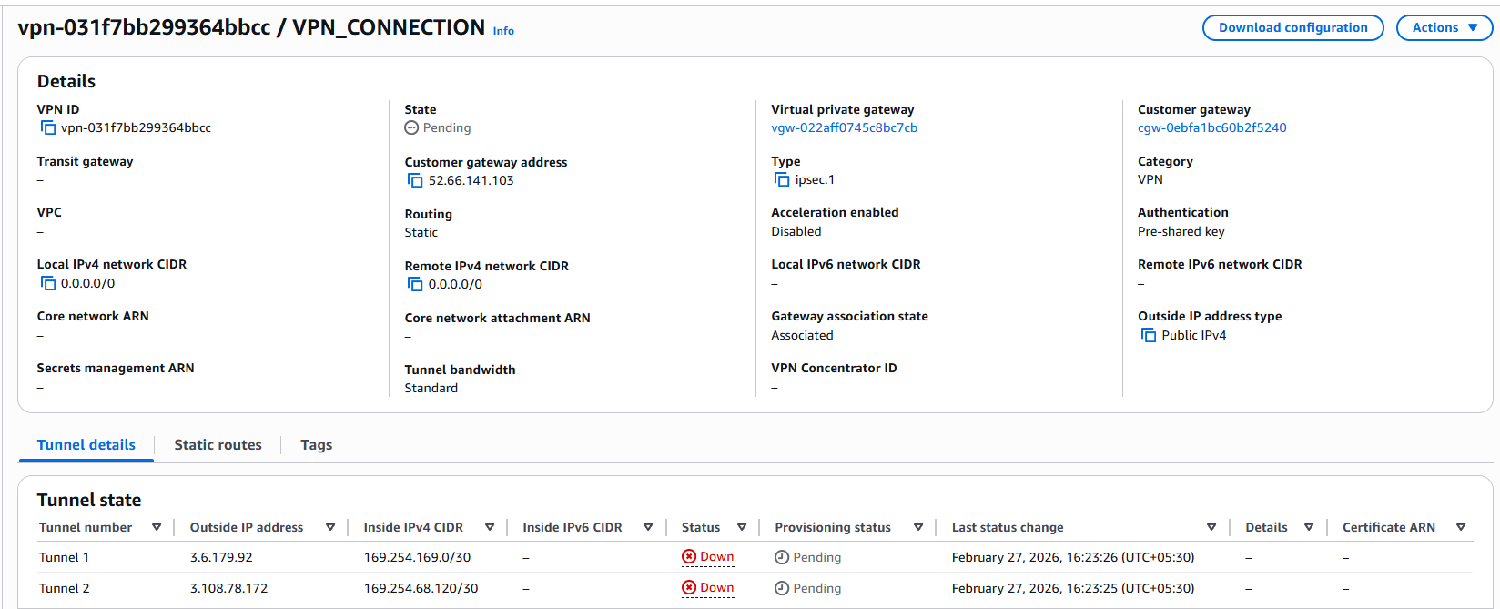

Step 8: Connect to Public-Instance
- Commands:
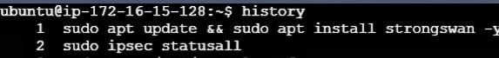

Step 9: Download VPN Configuration
- Download the VPN configuration file from AWS console.
- Log in to the On-Prem Public EC2 instance.
- Apply the configuration commands as provided in the downloaded file.
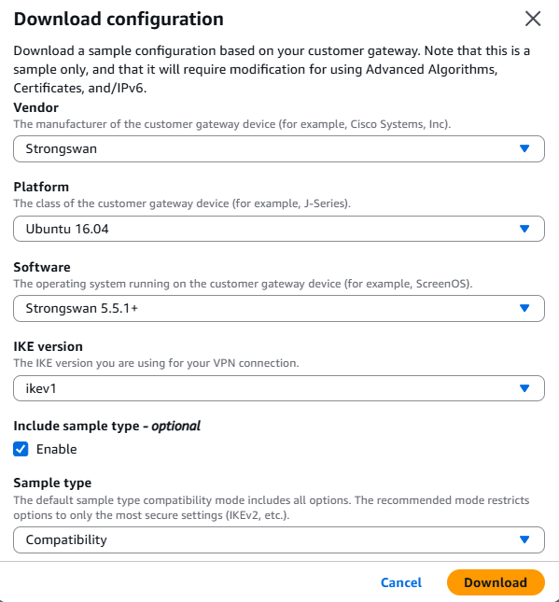
- After Downloading

#first cmd is to change the script we need to uncomment the net. ipv4.ip_forward=1
#second cmd is to apply the changes
#This cmd is to change the script and add some scripts
*Changes: uncomment the line uniqueids = no
*Add script Tunnel1 information and uncomment the line leftupdown and add the CIDR of on-cloud VPC.
*Add script tunnel2 information and uncomment the line leftupdown and add the CIDR of on-cloud VPC.
#Paste the PSK (pre-storage key) of both the tunnel1 and tunnel2.
#Under add route: In third line add code > src and Private IP Adress of Public instance
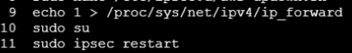
#This cmd to confirm Site-to-Site VPN connection and make tunnel1 and tunnel2 status up.
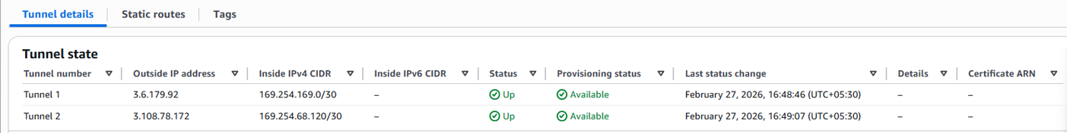

Step 10: Update Route Table (Cloud Side)
- Navigate to Route Tables of On-Cloud VPC.
- Edit routes and add:
- Destination: 172.16.0.0/16
- Target: Virtual Private Gateway (VGW-ID)
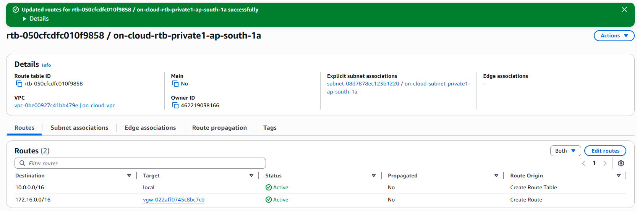

Step 11: Launch Private EC2 Instance (Cloud)
- Launch an EC2 instance named 'Private-Instance' in the Private Subnet.
- Select Ubuntu AMI.
- Assign a private IP address within 10.0.0.0/16.
- Configure Security Group to allow ICMP and SSH (if required).
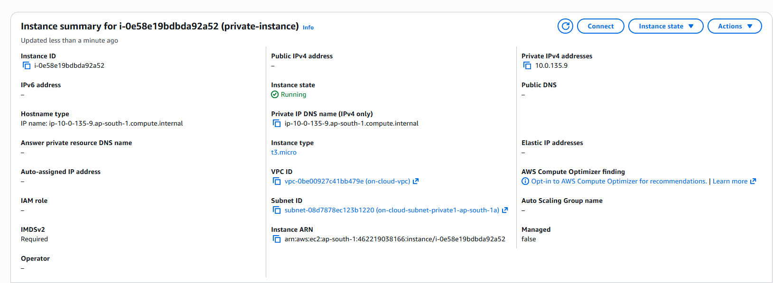

Step 12: Connect to Private Instance
- Use the following commands:
- nano dem.pem
- chmod 400 dem.pem
- ssh -i dem.pem ubuntu@<Private-Instance-IP>

Step 13: Verify VPN Connectivity
- Verify connectivity using:
- ping <Private-IP-of-On-Cloud>
- ping <Private-IP-of-On-Prem>
- Successful ping confirms that the VPN tunnel is established.

