- Rename a folder html to web tech located in /home/ubuntu/demo/dev Ops/?
First I created hierarchy of directories
>mkdir -p /home/ubuntu/demo/devops/html
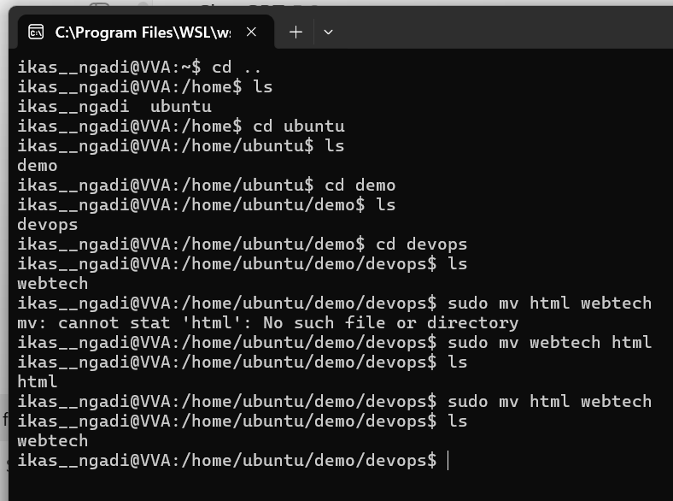
2. Create a directory named new_project inside your home directory.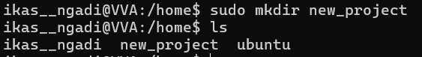
a. Create a text file named report.txt inside new_project and add some content or text in it. 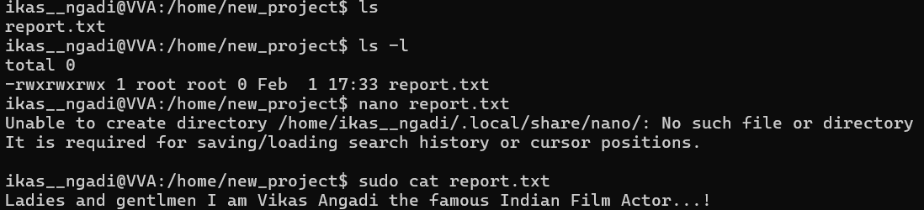

b. Copy report.txt to /tmp folder.
c. Move report.txt from /tmp to your Desktop.
d. Rename report.txt to final_report.txt on your Desktop.
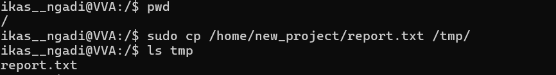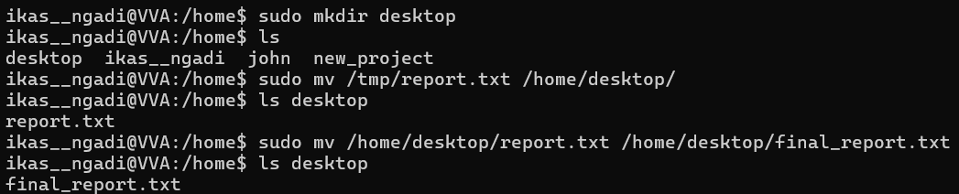
e. Delete report.txt from the original location if it still exists.
It is not present in original location, after moving it is deleted automatically
3. Create a group named engineers.
a. Add an existing user to the engineers group.
b. Check all the groups the existing user belongs to.
c. Add new transferred student to engineers’ group and remove existing user from the engineers group.
d. Delete the engineers group.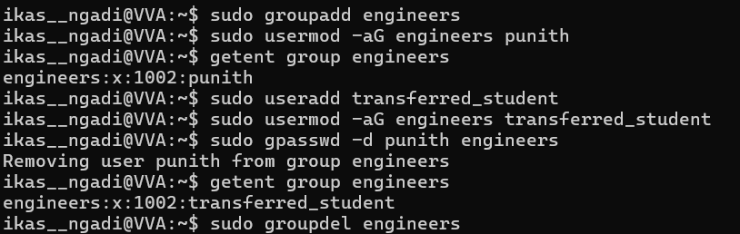

4. What is the difference between the cp and mv commands in Linux?
a. CP: Used Copies files or directories
Original files Remains after this operation
Data duplication can be done
b. MV: Used Moves file or renames files or directories
Original files Removed from original location
Data duplication cannot be done

5.Suppose there is a confidential
file/home/ubuntu/student/confidential.txt that should:
-Be accessible only to the owner.
-Should not be accessible to group members or others.
-Illustrate this by showing permission settings.
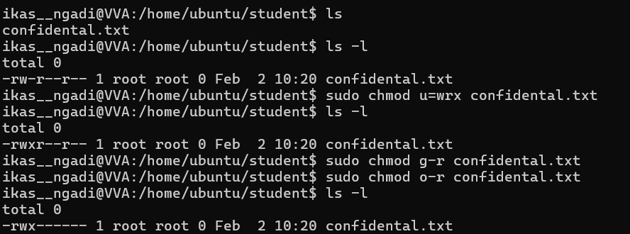
6. How do you change file permissions in Linux using chmod?
Syntax: chmod [who] [+|-|=] [permissions] <filename>
Exampe: chmod u+rwx confidential .txt or chmod 755 confidential.txt

7. How can you rename a file or directory in Linux?
For File
Syntax: mv old_filename new_filename
Example: mv report.txt final_report.txt
For Directory
Syntax: mv old_dir new_dir
Example: mv new_project pro_project

8. Create three text files: file1.txt, file2.txt, and file3.txt inside a folder named backup.
-Copy all three files to a new directory called documents in one single command.
-Move file3.txt to the /tmp directory.
-Rename the documents folder to my_documents.
-Delete the folder backup and all its contents using a single command.

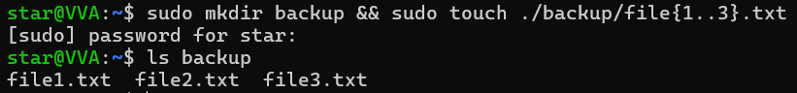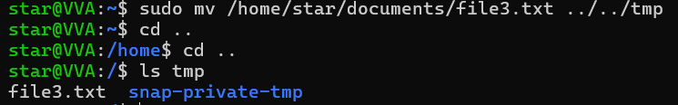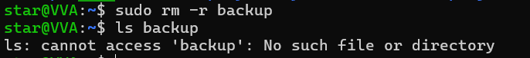

9. Create a file and give read and execute permissions to everyone but write permissions only to the owner.
-Create a directory and restrict all access for others (neither read, write, nor execute).
-Set execute-only permissions on a file and try to open it.
-Create a shared directory where users can write files but cannot delete each other's files.
-Demonstrate giving permissions using both symbolic (u+rwx) and numeric (chmod 755) methods.
-Change file permissions recursively for all files inside /home/student1/shared_folder.

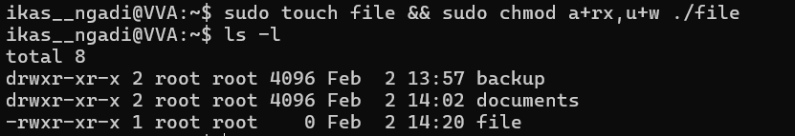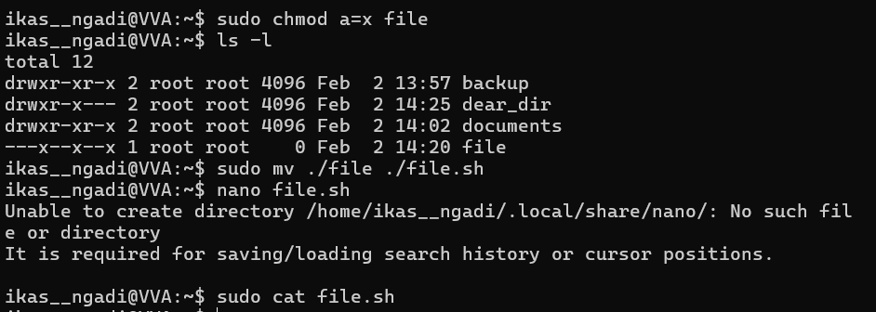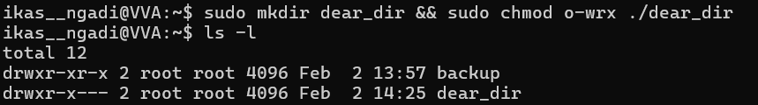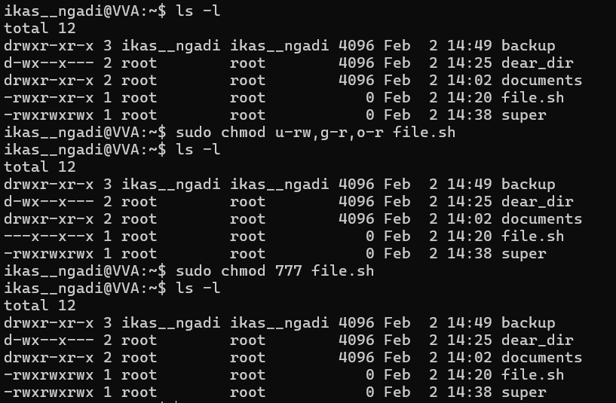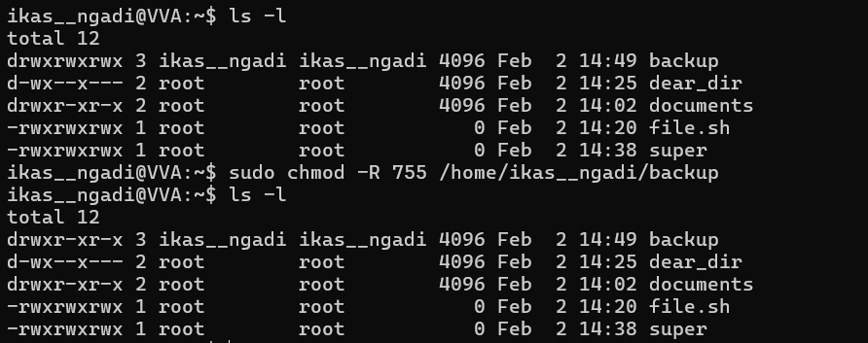

11. Demonstrate the difference between changing ownership (chown) and changing group ownership (chgrp).
chown:
changes the user ownership and optionally group
a. chown <new-user> <file_name>#Changing user name not group
b. chown new_user: new_group <file_name>#Changing user and group
c. chown -R new_user: new_group#Recursive ownership changing

chgrp:
changes only the group ownership of a file or directory.
1.chgrp <group_name> <file_name>

12. Create 3 users called as smith john tom

In user1
- create 2 folders such as demo and test
- in test folder create 3 files such as a1.txt a2.txt a3.txt
- copy a1.txt a2.txt a3.txt from test folder to demo folder through absolute path

>sudo adduser smith
>sudo adduser john
>sudo adduser tom
>getent passwd
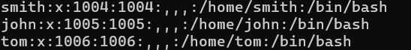
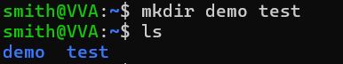
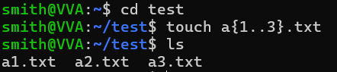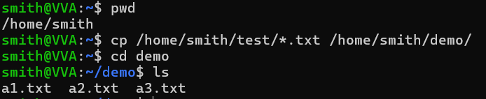

In user2
- Create 2 folders such as sample and practice
- in sample dir create b1.txt b2.txt
- move b1.txt from sample to practice through absolute and relative path
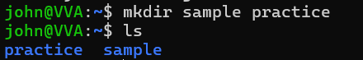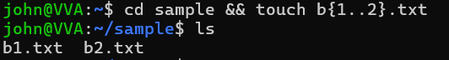
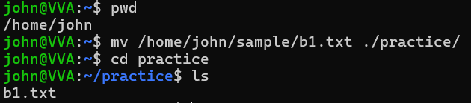

In user3
- create one dir called as jasmine
- create one file called as index.hrml
- rename that file as index.html
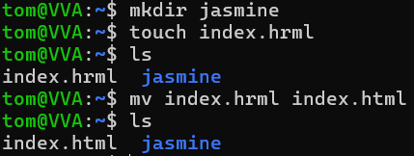

14. How do you find the current working directory in Linux?
>pwd #print or present working directory

15. Create a group named testers.
a. Add user trainee to both developers and testers groups.
b. List all groups currently available on the system.
c. Check which users are part of the testers group.
d. Create a directory /data and allow only the testers group to access it.
e. Change the default group for the trainee user to testers.
f. Set up a directory /team where any files created should automatically belong to the developers group.
g. Demonstrate removing a user from a group using two different methods.
h. Delete the testers group from the system.
i. Change group ownership of all files inside /data to the developers group at once.

> sudo groupadd testers
>sudo groupadd developers

a. >sudo usermod -aG developers trainee
>sudo usermod -aG testers trainee

b. >getent group

c. >getent group testers

d. >sudo mkdir data && sudo chgrp testers data && sudo chmod g+rwx data

e. >id trainee && sudo usermod -g testers trainee

f. >sudo mkdir team && sudo chgrp developers’ team
>sudo chmod 2777 team
>cd team && sudo touch smart_vinnu
>ls -l

g. >sudo gpasswd -d trainee testers
>

h. >sudo usermod -g trainee trainee
>sudo groupdel testers

