**WATECHPARK**

SMART Parking Lot System

**Vikas Sharma, George Alexandris, Elias Sabbagh**

|  |
| --- |
|  |

January 15, 2020

Computer Engineering Technology

Status

/1 Hardware present?

/1 Title Page

/1 Declaration of Joint Authorship

/1 Proposal (500 words)

/1 Executive Summary

# Declaration ofJoint Authorship

We, Student A (Vikas Sharma), Student B (George Alexandris), andStudent C (Elias Sabbagh), confirm that this work submitted is the joint work of our group and is expressed in our own words. Any uses made within it of the works of any other author, in any form (ideas, equations, figures, texts, tables, programs), are properly acknowledged at the point of use. A list of the references used is included. The work breakdown is as follows: Each of us provided functioning, documented hardware for a sensor or effector. Student Aprovided VCNL4010 Proximity Sensor. Student B provided IR Beam Sensor. Daniel O Donnellprovided LSR Camera Sensor/2 Stepper motors. Due to unexpected circumstances, Daniel’s involvement with the project was passed to Elias Sabbagh joining the group during the Winter 2020 semester, to ensure successful progression of the project. In the integration effort, Student A is the lead for further development of our mobile application, Student B is the lead for the Hardware, and Student C is the lead for connecting the two via the Database.

# Proposal

**WatechPark**- SMART Parking Lot System Proposal

**From:**Vikas Sharma, N01160135

**Discipline:** Computer Engineering Technology

**Date:** January 15, 2020

# Background

This document will outline the software portion of the project in CENG 319 that will be coupled with hardware in CENG 317 for the final integration in CENG 355. Our project is going to be on a SMART parking lot system.Many busy parking lots are often plagued with congestion, drivers competing to find a spot by cruising around and visually finding spots. This is inefficient, time consuming where productivity is lost for consumers and businesses. The system we will be developing will address payment for parking, capacity management and location finding following an IoT approach using hardware and software.

# Problem Statement

The problem being addressedincludes, time spent searching for a parking spot, increased capacity levels during peak hours. This project is focused on solving these issues by connecting consumers to parking lot owners and providing parking services by using a more convenient, simpler method to retrieve parking lot data seamlessly.

# Methodology

Phase 1: Hardware Design/Build

The small physical prototypes that we build are to be small and safe enough to be brought to class every week as well as be worked on at home. In alignment with the space below the tray in the Humber North Campus Electronics Parts kit the overall project maximum dimensions are 12 13/16" x 6" x 2 7/8" = 32.5cm x 15.25cm x 7.25cm.Keeping safety and Z462 in mind, the highest AC voltage that will be used is 16Vrms from a wall adapter from which +/- 15V or as high as 45 VDC can be obtained. Maximum power consumption will not exceed 20 Watts.

Phase 2: System Integration/Connection

This phase will be completed during the final semester of the Computer Engineering Program. The work gathered from both software/hardware courses will be combined and integrated for the final capstone project.The development platforms we will be working with is Android Studio 3.5.2, Raspberry Pi 4 ModelB, and Google Firebase database.The mobile application provides key functionality to allow consumers to access parking lot data, view sensor/effector information specific to a location and choose the best parking space during different peak hours of the day.The VCNL4010 Proximity sensor will be used to detect the status of a given parking space at a specific time of access. The IR Beam Sensor will control the gate opening/closing and detect the presence of a vehicle near/far away. The LSR Camera sensor will be used for valid license plate recognition. The 2 stepper motors will control the gate and allow entry/exit based on the sensor data, and status of the lot.

Phase 3: Final Demonstration to Potential Employers

At this stage, we will demonstrate our 2 semester’s worth of work to be assessed.Our project description/specifications will be reviewed by, Mike Wrona, ideally an employer in a position to potentially hire once we graduate.

# Hypothesis

This project is focused on providing a solution for managingparking lot data, providing a less time-consuming experience with a simple, intuitive interface. This is an opportunity to showcase our knowledge and understanding to build a collaborative effort for an industry sampled IoT project. I request approval of this project.

# Executive Summary

In retrospect, this document outlines both the hardware and software aspects of the project. This project intends to build anIoTdesign that would help support industry related issues such as capacity management, location-finding by finding ways to reduce the time spent manually searching for parking spots. This document aims to provide insight into the design, development, testing phase of our SMART parking lot system project. In collaboration with our partner at ParkingBoxx, we have gathered our ideas to create a simple, intuitive and user-friendly platform for consumers within the market.

Our product aims to provide the essential needs for both consumers/businesses to view and manage parking lot data. In terms of market use, we believe through the project we will build a product that can be offered from an industry standpoint as well as be marketable to other fields of interest. Through the development of this product, we wanted to reach as many demographics and be able to provide aninexpensive and reliable platform where parking lot information can be retrieved at a glance.We offer users with the ability to be able to add/manage cars, view parking lot data, make on-the go reservations for parking passes, accessible via an online database to send/receive information in real-time, all built-in with a simple, effective interface. Due to these reasons, we believe it will be ideal to be considered to be hired by an investor for employment. This will be an extraordinary opportunity for us to be able present our work, knowledge and skills to promote our product from a marketing perspective.

# 1.0 Introduction

This report will outline the development and integration ofour final capstone project as part of the Computer Engineering Technology program at Humber. The individual team contribution for this project goes towards George Alexandris, Vikas Sharma, and Elias Sabbaghall 3 of whom were extensively involved with bringing the project to life. The focus was to implement an IoT (Internet of Things) design,where software and hardware interaction would be vital to address an industry related issue and help solve real-world problems. This project consists of a SMART parking lot management platform, which allows consumers/businesses the ability to manage and monitor parking lot data through real-time progression. The goal, being to address problems arising in the parking industry specifically in terms of capacity management, increased manual interference, and the lack of location-finding near/far from an area. The product looks towards determining the challenges in the parking industry today, and provide a platform to navigate to a parking space quicker, and in a more efficient manner. This includes, managing parked users, or monitoring the status of a lot at a given time.The main objective of this undertaking is to provide a more efficient and reliable platform to aid with parking scenarios. In particular, for the purpose of the consumer demographic who may be searching for an alternative parking lot management system.Our focus was to develop a platform, that would be the gateway to support consumers with finding the best parking space during any time, any place or anywhere in the world.

# Project Schedule

The following is an overall breakdown of our work schedule for the duration of the entire project, and the two consecutive semesters:

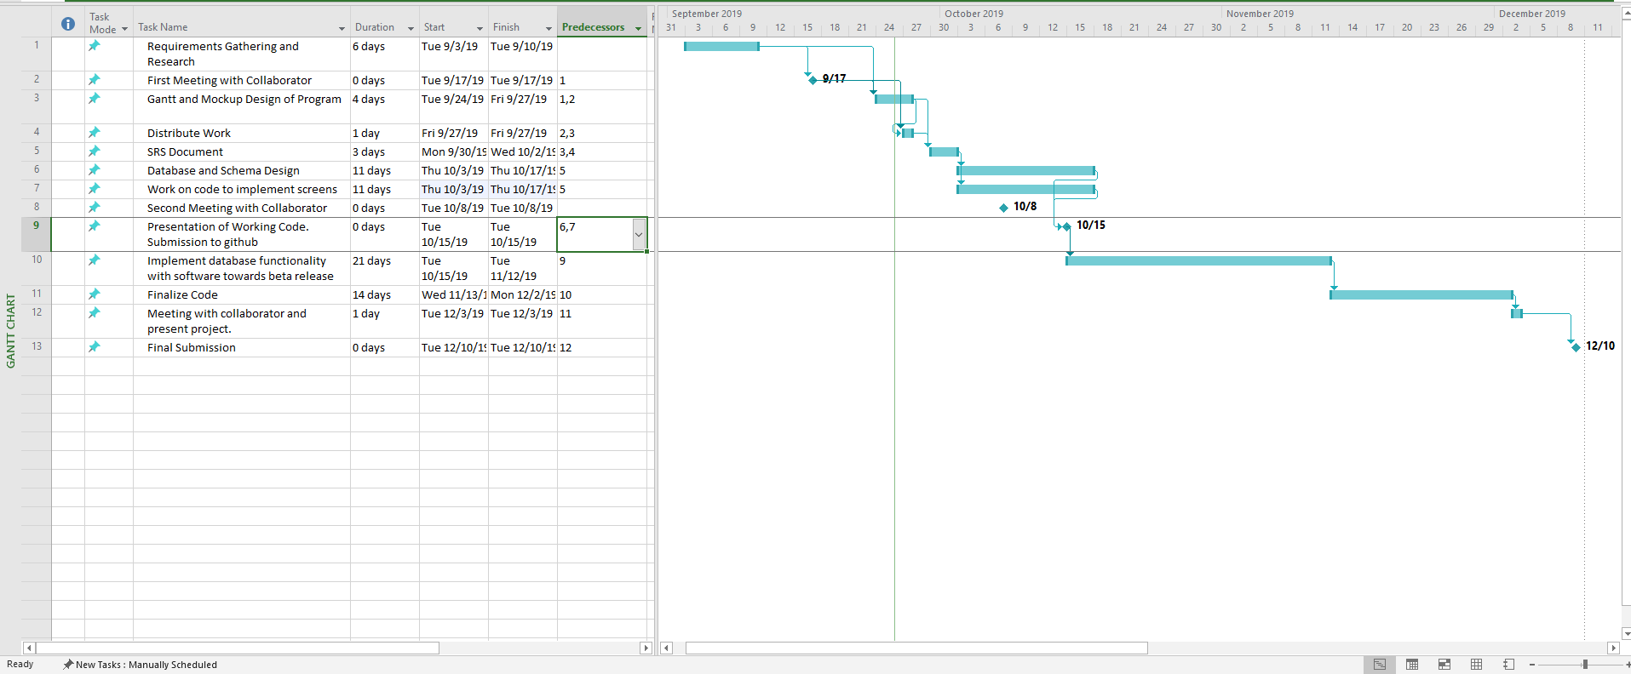

Figure 1 - Gantt Chart (Software)

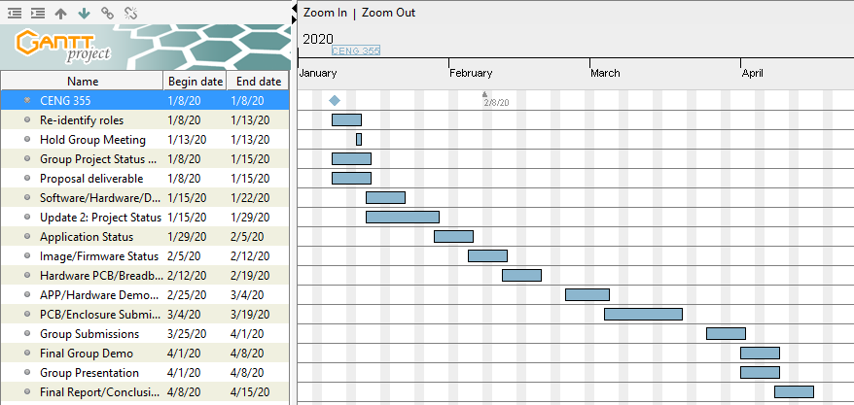

Figure 2 - Gantt Chart (Final Breakdown)

In terms of overall scheduling purposes, the project requires approximately fifteen weeks to complete during the Winter 2020 semester of the Computer Engineering Technology program. During the start of the final semester, the work done from the previous fall 2019 semester from CENG 319 and CENG 317 was carried over to complete the final integration. Most of the software development portion of the mobile application, and the connection to the database was done during the fall semester. Our group also ensured we were on the right track, by ensuring at least one of our team members can connect their sensor data to the database to send/display data to the platform during the fall semester. The core amount of work was accomplished towards the end of the Software Programming course, as well as in the Hardware Production Technology course. Our team followed our planned schedule efficiently throughout the fall semester, and carried the workload into the Winter 2020 semester. The final semester needed the group to finish implementing the sensor data to the Firebase database to be able to read/display data from the actual hardware. At this time, our team will extensively focus on completing the mobile application, and adding its intended features. As well as, re-designing our PCB boards to accumulate all three sensors from each team member into a final PCB design. The final semester will be used appropriately to ensure successful completion, and a polished end product.

## 1.1 Scope and Requirements

This report will address the key fundamentals of the project, including the software/hardware aspects of the design/specification and the final integration between these applications. It will touch on how the hardware (sensors/effectors) communicate and interact with the software application to allow consumers to track parking lot data. Further details will be examined in this document, in regards to the hardware sensors used, the main objectives behind choosing the type of hardware and how it correlates to the application being developed. Along with, describing the database structure used to push and retrieve data from the hardware to the mobile application, and vice-versa. In terms of the scope of the project, there were instances where the planned outcomes from the initial stages of the development period had to be modified or re-considered. This includes, having some minor design/features changes and removals mainly due to time constraints or software limitations, to further increase productivity and meet the overall requirements. Some of these changes included, a major overhaul of the main Home screen to provide a smoother, sleeker interface for user interaction, removing Google API login integration, removing the search function from the mobile application after much consideration. A major change, occurred during the Winter 2020 semester, where our development team decided it was in our best interest to not move forward with the development of the business aspect of the application. This feature would have allowed users to track their daily progress and set goals to reach in the mobile application from a marketing standpoint. The team decided to improve on the existing consumer functionality instead, with implementing the proposed camera sensor functionality, and stepper motor gate control. Due to this reason, these features had to be omitted as a result of not meeting the plan, and the overall extent of the project had to be re-evaluated and worked on. Our team followed an agile methodology/procedure where work would be committed and evaluated on a daily basis to ensure the team stays on track. Development was split into distinct sprints of software coding/hardware testing to ensure both applications are met within the due time. During this time, coding was separated into blocks of development periods where the team focused on completing a single feature, and aiming towards further progression from both sides. The limitations provided our team with an outlet, to focus on the main goal/priority and cut down on excess amount of work that can be evaluated later in terms of a marketing perspective. For example, one of the ideas the team came up with was introducing the business aspect through an online website where users would be able to view financial, user information along with providing identical software/hardware interaction. This SMART parking assist platformprovidesreal-time proximity measurements, lot detection methods with use of the hardware elements. Such as, the entry/exits of vehicles, detecting parking space movement, gate control.

## Development Platform Specification

The following are the specifications of the software side of development. In terms of application use, consumers only need to know how to use a smartphone device. No technical expertise is needed as the platform we develop will be simple to use and gain a grasp of. The following are the list of software requirements vital for the platform to operate as intended:

* Android Studio 3.5.2 development platform
* Java (coding language) used for mobile application
* Software must have bilingual capabilities for English/French language integration
* Internet connection (Wi-fi) is needed to access the mobile application, and its main functions.

## Hardware Specification

The following is a list of hardware requirements needed by the user to operate the application, and its functions:

* Raspberry Pi 4 Model B (CPU platform to process sensor data)
* Must support at least 2GB of storage, RAM
* Embedded CPU (Raspberry Pi) device will always need a connection to the server for the purposes of authenticating users, and receiving data.

## Android Device Specification

* Must be running Android OS on mobile system
* Mobile APP will run only on Android devices
* API 21(Android Version 5.0 Lollipop) and above (supported roughly over 80% of the Android population)

## Database Specification/Protocols

* Google Firebase database for storage purposes, push/retrieve real-time data from sensors to mobile application, and vice -versa.
* User Authentication

**Protocols:**

* HTTPS/SSL Encryption end to end communication
* TCP/UDP Connection
* Wifi/Cellular connection

**Server-Side:**

* Email: SMTP (Simple Mail Transfer Protocol)
* Data transfer rates must be capped to not utilize an excess amount of data, depending on connection type (size must be compressed).

Report

/1 Hardware present?

/1 Introduction (500 words)

/1 Scope and Requirements

/1 Background (500 words)

/1 References

# 2.0 Background

In the industry today, there have many occurrences where parking in general has become a hassle for city residents and parking lot owners. This includes, not possessing the right tools to manage capacity when a parking lot is full, where drivers are struggling to find the best spot to park their vehicles. This can lead to dis-satisfying scenarios, where drivers are unaware of their surroundings, before even entering into the space. Due to this reason, it can lead to congestion in major traffic centric cities, with drivers competing to find a spot. This can be time-consuming, inefficient where productivity is lost for consumers and businesses. This project is focused on helping reduce the impact of this cause, by developing a system that will address payment for parking by taking an advanced and modern approach towards capacity management, and real-time information gathering to keep consumers up to date with their daily occurrences.

The group would like to thank Mike Wrona, installation manager, of Parking Boxx who provided support for this project. The project is a SMART parking lot system that incorporates a phone app to manage a user’s tickets, account, and where to park in the parking lot. The idea of this project came up when the group realized that we can develop an easier way to find parking spots, by connecting all the spots to a parking app. We thought about creating an IoT parking lot that can connect to a database and update the database with information about its open/closed parking spots. It will be able to send and retrieve information about the parking lot. The mobile application will allow users to connect to the database and manage user accounts and payments for their tickets. Examples of some existing platforms are Indigo, BestParking, EasyPark and ParkWhiz. These platforms have reservation capabilities, on the go parking with mobile or web application. What we are going to do differently from these companies is to integrate sensors to help users navigate to a parking spot.

One of the parking companies we looked at is EasyPark(EasyPark, 2016). EasyPark offers monthly payments for its customers to park in the EasyPark parking facilities. The goal for EasyPark is “provide safe, clean, friendly, convenient and affordable parking to the Greater Vancouver community” (EasyPark, 2016). EasyPark offers a phone app (EasyPark, 2016) called EasyPark Parking as well that allows it users to view parking available at its facilities. You can pay for parking on the phone app (Google Play, 2020). The parking app allows its users to register, find EasyPark parking lots close to you, keeptrack of how long and where your car is parked in the parking facility. Payment is done through the mobile platform with a much simpler method of operation.

We looked at the other parking companies that were mentioned such as Indigo, BestParking, and ParkWhiz. In terms of overall design and interface almost each application had full resemblance to the previous. Indigo offers a map that allows users to choose which parking lot they want to park at. Users can book their parking ticket in advance, reserve the spot for thedesignated parking facility owned by the company they want to park at, and they can see the rates of the parking lots (Park Indigo Canada Inc, 2019). Apps such asParkWhiz, offers the options to add cars for verification, pay for monthly parking on the app and their ticket (ParkWhiz, 2019).

# 6.0 References

*EasyPark*. (2016). Retrieved from EasyPark Mobile Parking App: https://www.easypark.ca/products-services/mobile-parking-app

*EasyPark*. (2016). Retrieved from City Parking Vancouver, Public Parking, EasyPark Mission: https://www.easypark.ca/about-easypark/mission

*EasyPark*. (2016). Retrieved from History: https://www.easypark.ca/about-easypark/history

*Google Play*. (2020). Retrieved from EasyPark Parking - Apps on Google Play: https://play.google.com/store/apps/details?id=ca.easypark2.app&hl=en

Park Indigo Canada Inc. (2019). Indigo. Retrieved from https://ca.parkindigo.com/en

ParkWhiz. (2019). Find and Book Parking Anywhere. Retrieved from https://www.bestparking.com/

# 

# 3.0 Methodology

The following section will outline and extensively explain our method of operation for the duration of this project. This includes the steps taken to ensure we meet the correct criteria in reaching the end goal. Following an agile methodology, we will keep working diligently to get each part of the application up and running. In the event of any outstanding circumstance, we will review the design and re-assess which parts are causing the issue and work around from there. Development and testing phases of the project will be split into distinct sprints of development. The next few branches of this section, will go into detail in regards to the required resources. Initially, focusing on the parts/components/materials used to complete the project, the manufacturing process for PCB and enclosure, tools/facilities utilized, shipping/duty/taxes and lastly touch on the working time versus lead time needed to complete the final hardware integration for the project.

## 3.1 Required Resources

Report

/1 Parts/components/materials (500 words)

/1 PCB, case (500 words)

/1 Tools, facilities (500 words)

/1 Shipping, duty, taxes (250 words)

/1 Working time versus lead time (250 words)

### 3.1.1 Parts, Components, Materials

## Parts and Components

This project consists of a variety of parts, components and materials which were utilized during the development, testing and final integration phase of our parking application. These components were essential to different features/functionalities of the parking platform and vital in terms of performing each functionality of our application. The project made use of three primary hardware sensors/effectors. These included, the VCNL4010 Proximity Sensor, IR Break Beam Sensor (Receiver/Transmitter), USB Camera Sensor (YoLuke HD Webcam). The CPU Broadcom Development platform chosen for the project is the Raspberry Pi 4 Model B. The Raspberry Pi 4 is the fastest, latest piece of technology that is capable in providing multi-support interfaces, at much higher speeds. For large data processing, and data heavy projects such as this extensive project it is the suggested microcontroller to do the job. Firstly, for the VCNL4010 Proximity sensor, we made use of the following hardware components: 3 (220) ohm variable resistors to limit the current flow through the circuit, Common Anode RGB(red,green,blue) LED to detect and react to changing states in proximity readings/parking lot status, 20x2 stackable header, to mount the PCB board to the Raspberry Pi, 6 pin stackable header, to mount the sensor to the soldered PCB board, and finally a set of jumper wires(female to male) for the breadboard testing portion. For the IR Break Beam sensor, the components used included the following: 4.7K ohm resistor, 1.0K ohm resistor, and a red LED to detect movement of an object, in this case for our application it would detect if a vehicle is in the way of the gate to allow entry/exit as a result, breaking the beam. The Raspberry Pi 4 Model B microcontroller will provide the key functionalities for the VCNL4010 Proximity sensor, IR Bream Beam sensor, and the USB Camera sensor alongside the 2 stepper motors used for parking lot gate control.

Furthermore, other components used include a power supply alongside an Ethernet to USB (Universal Serial Bus) adapter cable. These components will provide the interface to connect to the Broadcom Development platform through either remote desktop connection or via VNC Viewer connection to further develop, integrate the sensor/effector functionalities. An SD card will be used to provide the imaging/firmware configuration settings from an Ethernet connection, using the universal serial bus to Ethernet adapter.

Along with these essential parts, multiple jumper wires were used to connect to the GPIO (General Purpose Input/Output) pins of the Raspberry Pi device. The VCNL4010 Proximity sensor, and the IR Beam sensor will be used under a I2C interface. Using a 40-pin stackable header for the GPIO pins of the Raspberry Pi, the VCNL4010 Proximity sensor and the IR Beam sensor will be connected to the Raspberry Pi using its general-purpose input/output pins corresponding to each circuitry design for each sensor. These sensors will then communicate based on the surrounding environment, and its conditions. For example, detect whether a vehicle is in the way of the gate or a space is being occupied/ statuses of the lot. These components will then interface through the real-time database setup through Firebase database to push/retrieve parking lot data/statuses actively. The USB Camera sensor will be used for license plate recognition and capture an image of a valid license plate at entry. The data captured will be sent to the database for further examination. More details in terms of the mobile application, and how the data is presented will be explained in the Development Platform section under the Mobile Application branch in this report.

Additionally, three stackable headers were needed to mount all three sensors to the PCB (printed circuit board) for the final PCB design process, further detailed in the Manufacturing part of this section. Our team focused on retrieving parts and components that were feasible and inexpensive to our planned budget and would provide the best quality of performance. The parts made use of for the project included the presented ones above, including the added components needed to successfully test and implement each sensor.

## Materials

The materials to be used as part of the project, includes the following: laser-cut acrylic for the final enclosure design, to protect all three sensors from potential harm/damage prepared in a suitable housing environment. Other materials included making use of a breadboard to test the hardware sensors and the corresponding circuits that were built. Some other materials used included, the printed circuit board constructed and etched through sheets/layers of copper foil, and glass fiber material (fiberglass epoxy resin). These dielectric materials, such as glass, fiber was used as an insulating layer to create the PCB from the ground up through both the top/bottom layers of the printed board. Through the laser-cutting work achieved for the enclosure, acrylic material will be used alongside plastic housing to support the hardware and provide panels for the safety of the Raspberry Pi platform, printed circuit board, and its sensors. Acrylic material is lightweight, superior in quality and provides the best resistance for each sensor housed in the case. Similar to fiberglass material, the enclosure will be able to offer a clearer insight into the different components and sensors/effectors and provide high protection for all hardware components assembled. All-inclusively, these parts, components and materials gathered will be important in the integration effort to ensure successful completion of the project, following our planned methodology and strategy.

### 3.1.2 Manufacturing

### PCB/Case

In terms of the manufacturing process, most of the components gathered were ordered through the Amazon, BuyAPi, and Adafruit industrial companies.The printed circuit board designed was also manufactured and produced by the prototype lab, free of cost.

The final PCB and enclosure designs were all discussed in this semester including completed PCB and case designs from last semester. Last semester in the Hardware Production Technology course we had to design PCB’s and enclosures for the sensors we required for the final Parking Lot project in this semester. In this part of the report, we will take a look at the previous designs of the PCBs and cases being used in the project, and how they will be integrated into one final design.

The IR Break Beam Sensor project was designed by George Alexandris. The IR Break Beam sensor had a few design changes over the Hardware course last semester. The first version of the PCB design for the IR Break Beam Sensor did not fit onto the Raspberry Pi 4 Model B. The size of the first version was too large to be put onto the Raspberry Pi. The second size of the PCB was smaller and was able to be fit onto the board successfully.

Below are images of the second version of the PCB in Fritzing and the printed PCB: 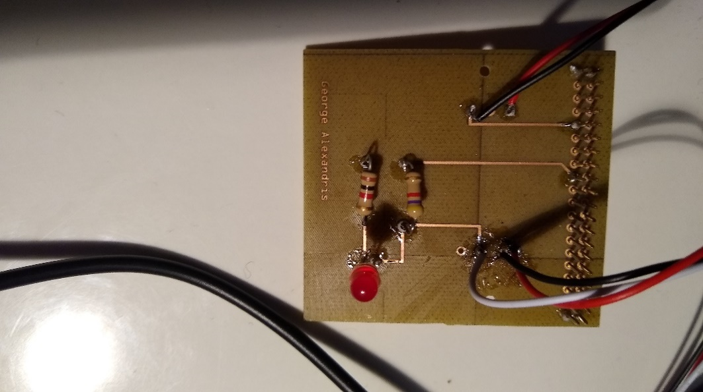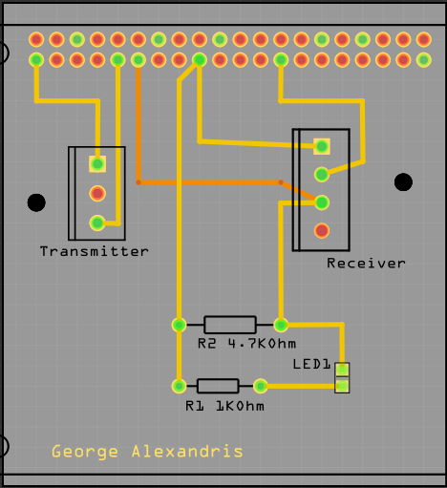

Figure 3: Printed PCB from Fritzing file Figure 4: Image of PCB Design in Fritzing

PCB’s were all designed in a free program called Fritzing and were printed in the Prototype Lab at Humber College. IR Break Beam sensor is in two parts one is the transmitter which as two connections directly to 3.3V power and ground on the board. The other part is the receiver which has three connections one for 3.3V and ground directly to the Pi while the third connection is to one of the GPIO pins. The GPIO pins can be setup for either input or output but the third wire from the receiver is a digital output so the GPIO pin it is connected to is set up as an input to read the value from the output wire.

The enclosure design for the IR Break Beam sensor project went through many design changes as well. The design for the case had to consider the size of the Raspberry Pi and the PCB for the IR Break beam sensor. The cases were designed in CorelDRAW and laser cut in the prototype lab. Early designs for the case of the IR Break Beam Sensor Project did not fit the sensor and the Raspberry Pi together in one case. The PCB of the IR sensor was long and the early design for the enclosure was too small in length for the case to fit. The measurements were taken to adjust the size of the case so the PCB and Raspberry Pi can fit together. The new design was longer for the PCB and Raspberry Pi to fit and the final design is shown below.

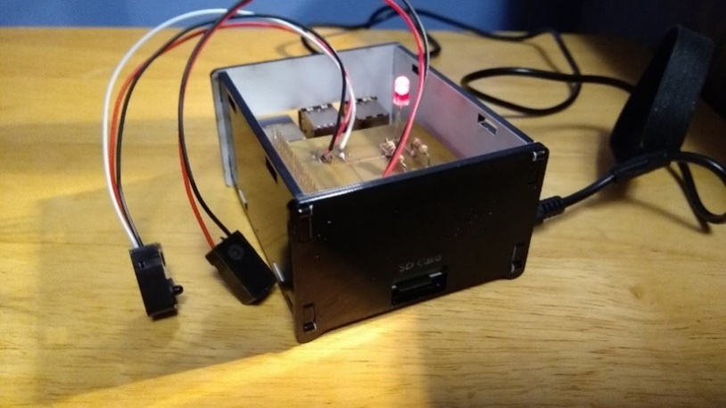

Figure 5: Final Case Design for IR Break Beam Sensor

The second sensor being used for the project is the VCNL4010 Proximity/Light Sensor. The PCB and case for this sensor was designed by Vikas Sharma. This step required use of the Fritzing software, which is an open-source application that allows users to visually create schematic, breadboard designs and finally incorporate their designs into a printed circuit board to be sent for etching and laser-cutting services. Over the course of the semester, Vikas had many different design flaws for the PCB. This was due to connections to the top layer of his PCB. In previous designs there were overlapping connections for the top/bottom layers, so Vikas had to redesign his PCB many times to not overlap his connections. The connection for the GPIO pins has to be on the top layer because of soldering the PCB to a 40-pin connector for the Raspberry Pi, it is not possible to solder the bottom layer.

To solder the PCB board, you would require a lot of focus, and attention, because any accidental procedures/connections going wrong can cause you to redesign the whole board. Vikas was able to luckily not have to go through that process, while soldering. For his design, there were 4 vias that needed to be soldered. You must thread a single thin wire through the holes, solder it and then cut off the remaining excess wires. The same process, was taken for the resistors where Vikas set up the resistors in their place and had to solder the 2 sides. Then, cut off the excess wire. While soldering the LED, Vikas had to be very cautious as the connections were designed really close to each other, so a lot of focus was needed here. Initially, there is a 6-pin header that comes with the sensor that needed to be soldered. Vikas also soldered the 40 pin GPIO pins on the PI, to keep the header stable while soldering and to create a sturdy connection. After soldering, the board should be ready to be tested, and should look like the screenshot shown on the leftbelow.

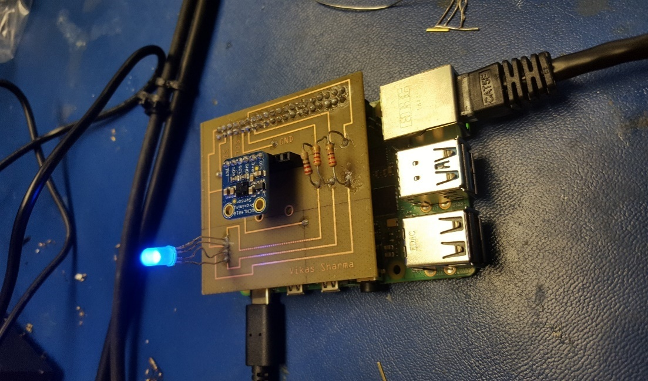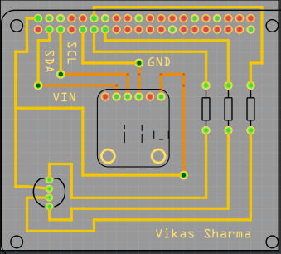

Figure 6: PCB final Design for VCNL4010 Figure 7: PCB Design for VCNL4010 in Fritzing

Once the PCB board testing phase was successfully complete and Vikas was retrieving/sending data to Firebase and the mobile application, he moved on to the enclosure design . For this, he decided to use the CorelDraw software as it seemed like the best choice to design the case the way you want. Vikas went with a acrylic case design, as the case is to prevent/protect your Raspberry Pi and sensor from potentially being damaged. While making the case , you have to be aware of the dimensions of the Raspberry Pi(height,width from all sides). For the design, he had to make some changes due to using the Raspberry Pi 4, some ports are arranged differently. Such as the LAN(ethernet port), and the 2 micro HDMI ports. For this, Vikas decided to make a wider port/hole to fit both mini HDMI ports into one. Vikas ran into a issue where the hole for the power port was cut too short, for this he had to shave off some excess acrylic to get the hole to be wider, to fit the power cable into the port. Vikas was able to fit it perfectly in the outcome. For the design, Vikas kept the top of the case open with a medium-sized hole, as there needed to be a object in the way of the sensor or far away for it to display the readings.Once all the requirements for the dimensions of the openings were met the final case design was complete.

14

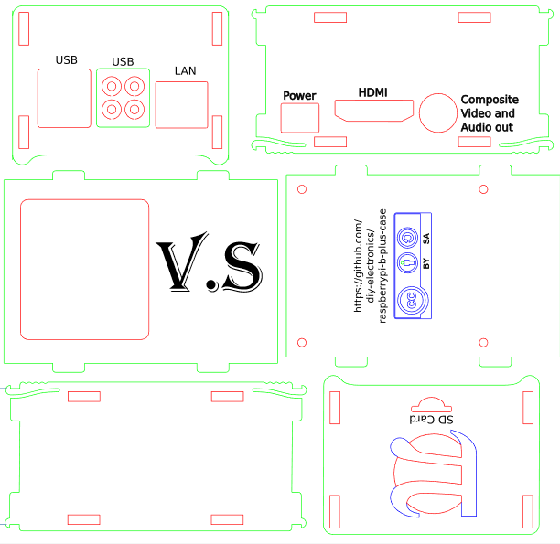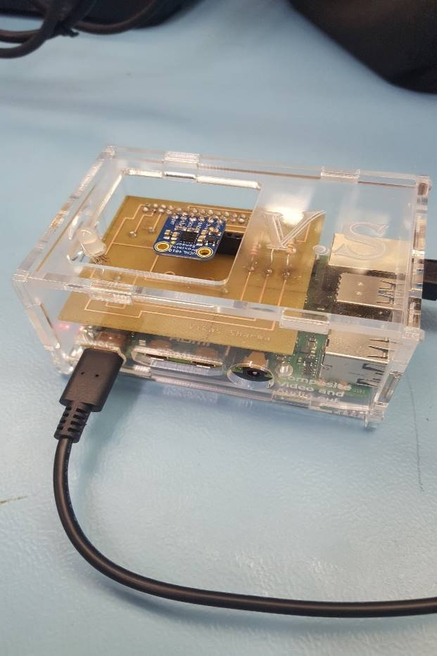

Figure 8: Final Case CorelDRAW design for VCNL4010 Figure 9: Printed Case for VCNL4010

The last sensor, Yoluke HD Camera Sensor, did not have a design for an enclosure and its PCB since it is just a USB camera. The servo motor however, does have a PCB design and will be shown below.

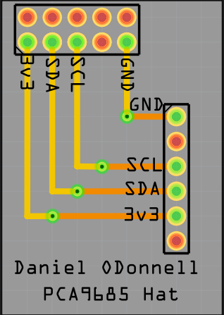

Figure 10: Fritzing PCB design for Servo motor

Taking into account the previous semesters work, the initial plan which will be immediately targeted is to combine all three sensors into a single printed circuit board entity. This will be done to ensure progression of the project, and meet the requirements for this semester in completing the capstone project. After testing each sensor, and connecting it to the database and the mobile application we will design a new PCB using the Fritzing software. This will enable us to work with all three sensors using only one Raspberry Pi 4 Model B Broadcom Development Platform, connected to a single PCB in the final stage. Elias will be responsible for helping with the hardware implementation and design the final PCB through the open-source software. Along with gaining further support from Vikas in working with the VCNL4010 Proximity sensor, IR Break Beam sensor, and the USB Camera sensor to read/display the values according to the parking lot data/changes in status. Using the I2C interface we will design the final PCB through integrating each sensor into a single design for multiple sensor support. The IR Beam sensor will be extensively tested for the gate control mechanics and George will be accountable to ensure the hardware functions as designed.

Towards the final stages of the project, a re-design of the enclosure will be needed for a cleaner, sleeker and compact design. It will be important to house all three sensors which will be part of the final PCB design, and create a suitable and appropriate design to meet the requirements for each sensor. A collaborative effort will be made from all three members of the WatechPark developer team here, to redesign and refine the casing using the CorelDraw software. The prototype lab will be used for further inspection, and laser-cutting services during this phase of the project. Generally, this section helped explain the design process/experience with the hardware PCB and case. This included, providing an individual look at each sensor, and its printed circuit board design process and the work that was put into each hardware project initially. Finally, this section addresses the final PCB, casing design and integration that will be the focus for this semester with the criteria mentioned above.

### 3.1.3 Tools and Facilities

Throughout the duration of the project, for accommodating both the hardware and software side, it was necessary to work with a set of tools and environments to ensure successful completion, and the planned outcome for each hardware component. The tools used to complete the project ranged from the initial design, development, testing and presentation phase of the overall end product. To begin, in terms of the PCB (printed circuit board) process, was the requirement of using copper wire, and the pin headers that came with each sensor, wire strippers to cut off excess wire during soldering the PCB together. The copper wire would be used to solder the components on the printed circuit board together, using a soldering iron provided by the Prototype Lab in Humber College itself. The soldering iron was available from the parts crib and most of the soldering was done in the prototype lab itself. Wire cutters were used to cut off excess wires from soldering the vias, or cutting down on extra wires from the components used for the PCB.

The computer lab facility provides the most necessary components at your disposal. This includes, the PC system itself where most of the configuration was done for each sensor, a soldering iron including the solder itself. Major work was accomplished in the prototype lab, where the solder was received through the parts crib and was used in conjunction with the soldering iron available at the station. The following steps were taken to solder, firstly it is recommended to heat the soldering iron before applying the solder at 360-470 degrees Fahrenheit. The solder can then be applied to the tip of the soldering iron to produce the best results before starting the process. Other tools used in the production of the PCB (printed circuit board) included a helping hand. This tool allows you to reposition the PCB at different angles to solder from different perspectives, to avoid any overlapping connections or accidently joining a connection together. This tool is used to angle the printed circuit board and hold the board while you solder the components as necessary, without having the need to manually re-adjust the board at different times of soldering.

The facilities used in the project, included the prototype lab in Humber College. This facility is the main source of providing the services to etch the PCB board during its final stages of production, as well as provide the laser-cutting services for the final enclosure design. This facility was used to solder the components, sensors together on the PCB and test the final design. Through this environment, we were able to learn the process of soldering, and using the human resources in the facility we were able to make the best decisions, or re-think our strategy to solder the PCB. The facility provided us with more viable options, recommendations and the best way to overcome any issue we were experiencing. This included, designing the PCB board, using the CorelDraw software for housing the sensors in the final enclosure developed. Adjustments were made depending on the different scenarios, and based on the advice of Vlad and Kelly whom were present to help. Along with their support, we were able to come to re-assess, learn and fix our design mistakes to create a more polished end product for both cases. These services were provided by the prototype lab, for both etching and cutting services for the printed circuit board and the acrylic casing, with a laser-cutting machine being available to us without any cost. Overall, these tools and facilities supported our team and our project in achieving its goals and provided us with the outlet of both human and machine resources. This was accomplished through the help of others in the facilities, or through etching and cutting services provided to meet the project requirements in the end.

### 3.1.4 Shipping, Duty, Taxes

Budget for the project will be discussed in this section in terms for where we ordered our parts, how much it was shipping, taxes and totals will be shown. Most of the parts were ordered from last semester. George ordered all the parts he needed for the IR Break Beam sensor project, Vikas ordered his components necessary for the VCNL4010 Proximity/Light sensor and the final parts were the 2 Servo Motors and YoLuke HD Camera Sensor.

The components utilized for this project were ordered ahead of time to ensure work can be progressed or to test any faulty hardware piece for a quicker solution. Shipping time for most of the components was divided between 2-5 days, depending on the type of service chosen at the time of the transaction. The shipping options ranged from DHL Express shipping which transits worldwide and internationally. For example, for Vikas’s case while ordering the VCNL4010 Proximity sensor and its components at the time of the order, he chose he option of DHL Express shipping. This method of shipping provided, a much faster, reliable form of service with the components arriving roughly 2 days later from when the order was placed. In this case, the shipping cost was divided between two totals as shown in the screenshot below in the red outline. The shipping method and time required was lower than expected with other methods of shipping requiring 5 business days to ship the product from the source to the destination.

Duty was not placed, and avoided at all costs during this time to prevent any further costs from materials being shipped internationally or from other countries. For George’s case, most of the products shipped were either from Amazon, or through BuyAPi, with a single purchase for the IR Beam sensor being through Adafruit. The method of shipping was also different here, as with Amazon it provides the option of Amazon prime shipping. This depends upon the location the component is being shipped from of course, and based on that location, the time is calculated to ship the product out. Although, with Amazon Prime shipping most orders placed during a significant time of the day can be processed, and shipped within 2 days and delivered at a much quicker rate. Other hardware parts required a shipping time of 2-5 days with UPS or different forms of shipping requiring higher costs, if the item is needed within a set amount of time. For the most part, the components used in this project were shipped out within 2-5 days, and duty expenses were avoided to ensure an inexpensive project or to avoid any further delays.

Taxes were applied accordingly as well, with US (United States) tax rate being applied to the parts that were purchased through online shopping. Since these rates were in US dollars, we had to convert this value into CAD(Canadian) currency with the rate of 13% being applied instead as displayed below.

Below is the total project cost for the project, in terms for all the parts we all have currently in a BOM (Bill of Materials) format:

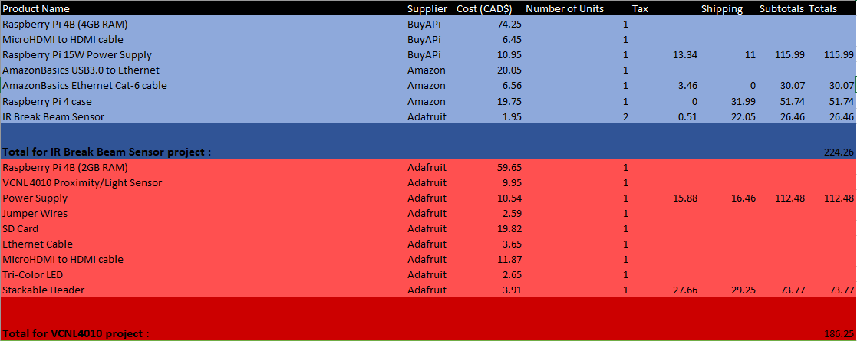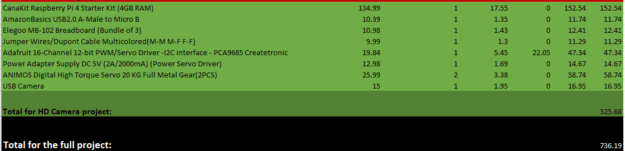

Figure 11: Final Project Budget

Most parts were ordered last semester and were used to complete their individual project. The total budget for the project is $736.19 CAD. The project total was calculated by adding up all the project budgets from last semester from each individual project. The projects involved are the IR Break Beam Sensor, VCNL4010 project and the HD Camera Project. They were all calculated from last semesters budget. There will be extra parts ordered for the final project and will be added to the total budget. These extra parts are not taken into consideration, the group is deciding on what extra parts we will use for this project. Such as, potentially ordering 3 more VCNL4010 Proximity sensor to accommodate our final parking lot prototype model with 4 parking spots. We plan on using all the parts ordered from the previous semester in the new semester. Some parts not considered in the budget are the parts being used from the parts kit such as some resistors and LEDs. The parts kit was purchased from the first semester and some of those parts are being used for the final project. This section helped provide a better insight into the shipping, duty and tax rates that went into ordering the components needed to complete the project and the financial state of the project before/after further development.

### 3.1.5 Time expenditure

Throughout the development of The WatechPark project, our overall time was split between hands on tasks, such as discussions, development, designing, building, debugging and testing, while the rest of our time was spent waiting for external tasks to be completed of a similar kind as parts delivery, laser cutting and PCB printing.

Please note that the time calculated in the following list, represents the total time spent by the three members of the project. For example, when discussing the time spent on designing the first PCB and the finalized PCB, in reality it reflects the collective time spent designing three PCBs for three different sensors and an additional three finalized PCBs for those sensors. This section of the report will touch on the total working time allotted to complete each requirement for the project, as well as address the amount of time needed to manufacturer the component from the total lead time. The following is the total breakdown of each section of both cases.  
Total of 105 hours spent as Working Time:

* 12 hours on project discussions and researching the required sensors and controllers
* 6 hours on finding the best vendor in terms or pricing and shipping time, and ordering the required parts, components and materials
* 6 hours on building and assembling breadboard prototypes
* 3 hours on voltage and safety testing for the breadboard connections before connecting our development platforms
* 6 hours on researching and installing the necessary third-party libraries for the sensors
* 6 hours on developing testing programs to be used on bread board circuits
* 6 hours on testing and debugging any anomalies in both the software code and the hardware connections
* 12 hours on designing and submitting both first and the finalized PCBs to be printed
* 6 hours on PCB assembly and soldering the needed components
* 3 hours circuit testing and safety verifications before connecting to the development platform
* 8 hours on designing, laser cutter submission and assembly of the PCB housing cases
* 15 hours on designing and developing the WatechPark android application
* 6 hours on Firebase initialization and filling up with data to be used with our android application
* 10 hours on testing and debugging our android application to ensure expected functionality with simulated sensor data stored in Firebase

Total of 22 days spent as Lead Time:

* 5 days on parts to be shipped and delivered
* 10 days on PCBs to be printed
* 7 days on housing case to be laser cut

## 

## 3.2 Development Platform

Our WatechPark application is centered on three main forms of criteria, this includes the front-end, back-end, and on-site devices used to interact with both the hardware and software aspects of the project. The front-end of our project consists around the use of Android devices/operating systems running Android Version 5.0 (Lollipop) and above. The main software utilized in terms of development, and further progression of the application was done through working with the Android Studio development environment.This was where a large majority of the coding, designing and software implementation was accomplished in terms of the mobile application side, which was then used to interface with the corresponding hardware elements. Coding was done through the use of the Java programming language, for further establishment of dedicated features or desired plans. This interaction was accomplished through our Broadcom Development platform, the Raspberry Pi 4 Model B. This CPU (central processing unit) was utilized to process the sensor data, readings along with the on-site devices, being the sensors/effectors used on location for our parking lot system. This will all be coupled with the back-end aspect, being the online database. In this case, the Firebase database will be used as a computational/server platform to retrieve real-time parking lot data, and allow the consumer access to parking lot information vital to a specific location. Collectively, these three aspects will serve as the primary connection to our project, and will act as the overall support structure to keep the work progressing through different heaps of development.

Student A (Vikas Sharma) will be addressing the development of the mobile application in this section.

### 3.2.1 Mobile Application

### Memo/ Mobile Application Integration

Initial development of the mobile application, began during the Fall 2019 semester as part of the Software Project class. During this time, our team worked extensively to build a system capable to store and retrieve parking lot data with use of an accompanying online database system. The Android application developed interacts with our Broadcom Development platform and the on-site devices, being the sensors/effectors to relay parking lot data, and monitor lot statuses at different intervals of the day. The goal for the mobile APP itself, being to allow remote access to parking lot locations and discover parking lot statuses in real-time through the working hardware assembled. The task presented for the duration of the semester, was to develop an Android mobile application that helps solve an industrial issue in the real word, working with sensors/effectors and an online database to delegate the data retrieved or sent. Based on our mockup designs created through the Balsamiq software program, we initially intended to focus development on two separate modes, consumer and business. We had planned to develop the consumer application during the Fall 2019 semester in the Software Project class, which we were able to successfully implement, with all proposed features, and some minimal changes/removals due to software limitations or constraints. The plan was to create the consumer side to allow the user to access parking lot data with a majority of the features being available at your disposal. The idea with the business side, was to allow the user to track daily goals, set goals for further achievement in the application, and view the overall history of parking passes purchased, payment details, or vehicles added to the system following an advanced approach. After much consideration, our team decided it was best to stick with the current consumer application instead, and focus on improving on the features already included, putting aside any business aspirations for potential future considerations. Instead of this idea, we devoted our full attention on the features needed to be implemented for the mobile application, and our parking lot system platform. This included, developing the functionality to allow access to parking lot data in real-time and view/monitor changes in status, rather than the current sample data coupled with the Home (Main Dashboard screen) in the application. This allowed us to focus on what is most important, and not waste valuable time on features that are additional or can be constructed in later development of the project. Therefore, the main reason to drop this idea being to the fact that it would have increased programming complexity and thus created more work to be done than is required.

Currently, our mobile application is capable of providing the key functionalities/features initially proposed during the startup phase of developing the application. This includes, allowing consumer access to a online database to monitor/display details on authenticated users in specific account information, login/register new or current users, make on-the go reservations for particular parking lots based on consumer choice, view parking lot details(in terms of sensor data, status of the lot during different instances), manage/add cars, select parking passes, payment, manage settings, help/about options. This includes, multi-support offerings of English/French language integration. Along with, automatic retrieval of transaction information through the Order History screen, working with the Firebase database to display the data back to the mobile application.

Features not yet deployed for the application, although planned to be implemented during this semester include the following: view a parking lot, monitor statuses of the lot, including overall capacity, gate entry/exit control and will help present a visual representation of the lot and the real-time changes through the use of the sensors/effectors. This feature will be implemented through this upcoming month, and work will commence in the upcoming days to ensure the feature is successfully completed by the set amount of time needed to complete the project. As of right now, our team is currently at pace in terms of continuing development of the mobile application, and actively listening for changes, removals or any potential additions to support the current state of the project. Fortunately, we were able to accomplish, and test each feature implemented from the previous semester at this time to make sure each planned feature works, and the key focus of the application is tackled. The application is designed to provide more functionality, and less cluttering of screens to encourage a further customizable experience, where the user feels comfortable using the application and its UI (User Interface).

### Login Activity/Authentication

At the start of opening up the application, the user will be prompted to a screen with options to log-in, register an account, or reset your password using the Forgot Your Password screen or Verify Your Password for different forms of authentication services in-application. We constructed an authentication process, in which we believe is a simple, intuitive interface for storing/checking credentials through secured database access. The following is a portrayal of the Register/Login screen which is automatically prompted to the user at entry of the application.

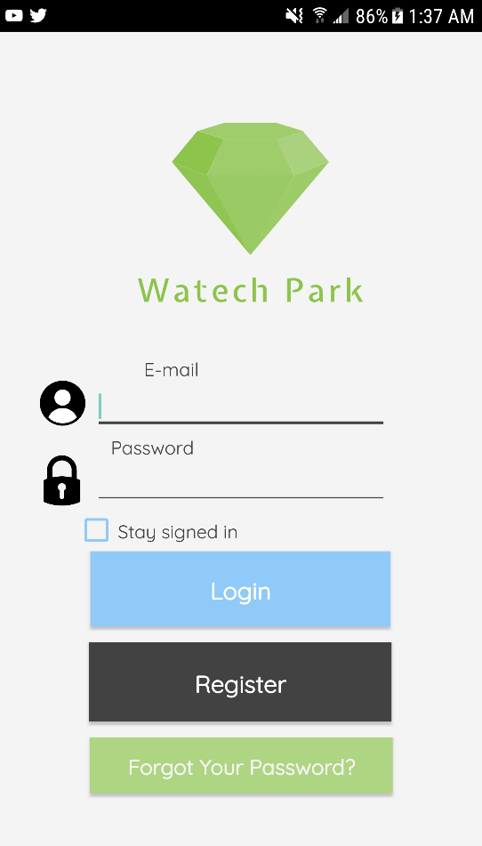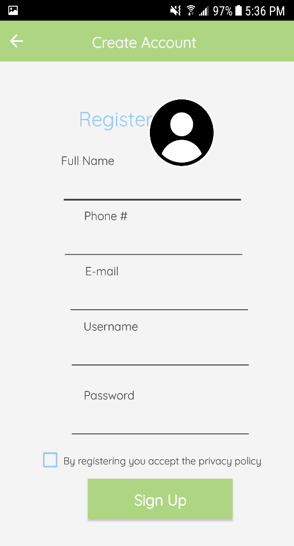

Figure 12 - Register Screen Figure 13 - Login Screen

The authentication part was designed with having a login/register screen separate from each other. The Register screen prompts user input in terms of personal information specific to a user. There is also the option for the user to choose a profile image from a real device through Firebase external storage permission. This account information is submitted onto the Firebase Real-Time database under a data structure, which holds the data. This information incudes, the full name, phone #, e-mail, username, image uploaded. So, once a user registers into the system the data is sent to the Firebase database, and stored to check for validation through login attempts further down the line.

After registering, the next step is to login. To login, we used the Firebase Authentication system for e-mail and password. This is a built-in feature of Firebase, that is used to authenticate a user that exists in the database. So, in the Login screen, the user would sign-in with the “registered” email and password. Firebase checks for valid/invalid credentials based on the information stored in theFirebase database section under that UID (unique identifier). User selections are stored with a “Stay signed in” option. This means, account information is visible after the user leaves the session, or returns to resume the activity. At this time in Firebase, the logged in user would appear in the Authentication section with the corresponding email/password information.

The authentication process continues with the “Forgot Your Password” and “Verify Your Password” screen. The Forgot Your Password screen is used to allow the user to reset their account password. There is the option to use e-mail or phone # authentication. This authentication is done through the Firebase database, where once a consumer selects a service, the other unattended service is not allowed to be accessed. The user enters an email address and through valid checking Firebase will then send a verification email to the corresponding email address. Phone number authentication requires the consumer to enter in a valid phone number using registration data from Firebase. Once the phone number has been validated, and follows the required system format (+1) a verification code is sent randomly through the phone service provider.

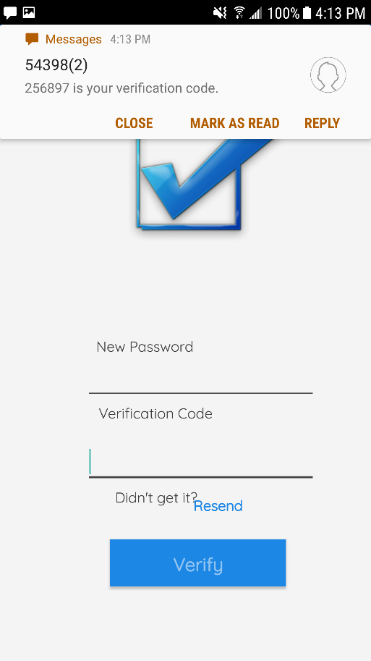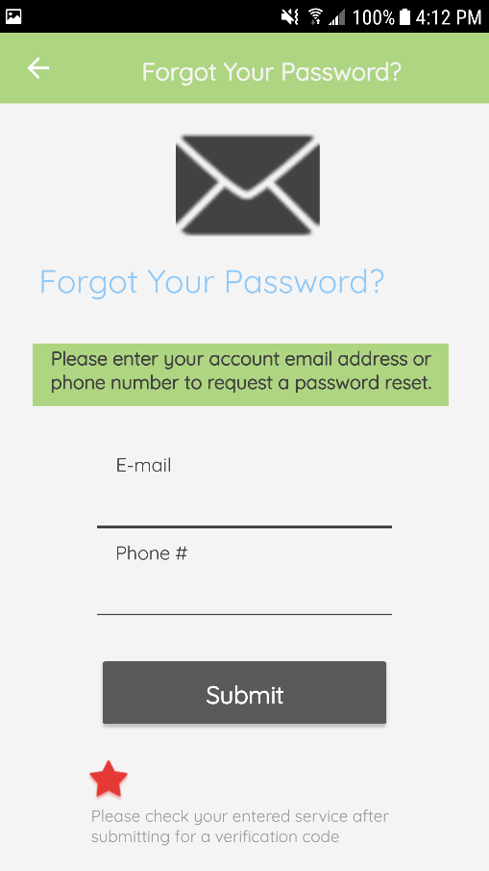

Figure 14 - Forgot Your Password Screen Figure 15 - Verify Your Password Screen

The mobile application also holds a feature, where account information is displayed specific to a user, in this case it would display different details based on the active UID. The screen followed a general layout, a little different from having to fit everything into a fragment view, we decided to use a new separate screen. This screen displays account information from the Register screen. The data is populated and displayed. Such as, the profile image stored from Firebase Storage, phone #, e-mail address, the name and a timestamp. Although, for this semester any current features/screens or designs are subject to change for that matter. we want to focus on the main functionalities of our application, and then move on to what can be added additionally, to further enhance the end product and meet the capstone project requirements.

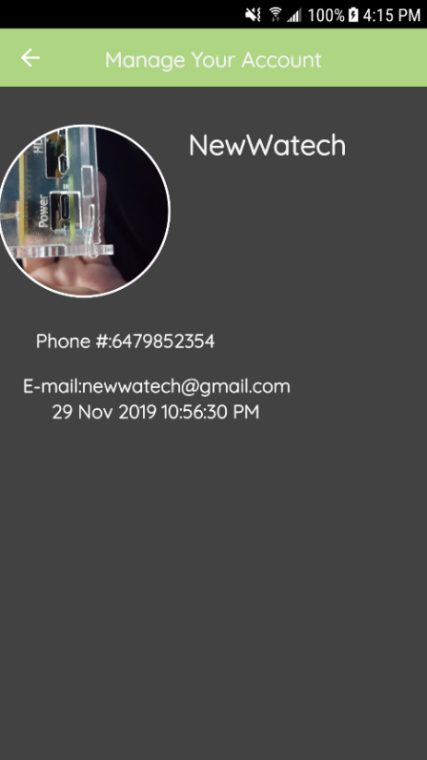

Figure 16 - Manage Your Account Screen

### Data Visualization Activity

Once the user has logged in, the main home screen appears. This is where the parking location data is displayed, and the sensor readings are gathered regarding each location with name, distance, and the total price of the parking pass. We believe this is the most streamlined approach taken for the users, and this allows easy and simple access of the data, and the activity all available within one main screen. This includes, proximity readings from the actual hardware, reservation capabilities, parking lot details and the actual lot itself visually represented in real-time. For this screen, we redesigned the main-menu from the proposed version,finally having a much sleeker interface to display each parking lot location, and its information to the screen in a more convenient manner. So, as shown above this screen offers two options to the consumers. This being “View Details and “Reserve”. View Details is where an expandable view pops up of the lot with an image, cost and the real-time proximity level of the lot at that particular time. At this stage of the project, our intentions are to build on from this feature, to provide access to the real-time parking lot prototype to be constructed during the duration of this semester. Currently, we are at the stage where we have figured out where the data will appear, once our physical parking lot model has been designed, and established. Then the goal here, is to modify this screen to show real data rather than sample data as is currently. The feature will allow further optimization of the hardware sensors/capabilities, with the plan being to provide the user with a visual representation of the application to go along with the physical hardware to be assembled later on in the upcoming month. Such as, display the parking lot and the parking spaces to be the focal point of testing purposes down the line. We have decided to create four main parking spaces, and these hardware aspects have to be mirrored within the mobile application. For example, the application will be able to show real-time changes in each parking space, individually or collectively and display data/readings fetched from the sensors. This includes, statuses of the lot (whether open/full), each parking space and changes viewed from the lot, gate entry/exits and the information will be displayed to the screen accordingly based on the conditions, from the actual hardware and sensors. Some of these conditions we have considered include the following: a vehicle enters the parking lot platform, the camera sensor on-site will immediately capture a image of the license plate, after validation/condition-checking entry is then allowed and during this time the data visible on the application should show four empty parking spaces in the lot. To indicate this, we will use three main colors: green, blue, and red. The light green will be used, when there are no objects/vehicles present in the parking lot. The blue color will be used to indicate a car is approaching and a message will appear on the application to guide the user to the next status change. The red will be used to indicate when a parking space is being occupied. Once a lot is full, the application will display this data through connecting to the database and receiving each sensor and its contents. So, in this case, entry will not be allowed further, so the application will be displaying a message saying “Lot A is Full”, or vice-versa depending on the situation. Further details on hardware will be discovered in the Breadboard/Independent PCB’s part of this section.

This data through the support of the hardware and the connection to the online database, will be further evaluated and assessed, to then be eligible to be displayed on the mobile application interface. This functionality is yet to be implemented into the final design, and will be the key focus throughout the upcoming month of March, and in Mid-February as it is the backbone/ purpose of what we set out to accomplish with this parking lot management platform. Currently, we have started initial development of the feature, and refactored the previous design into the new one, to further gauge on what is really needed and what features are not required.

Once the spot has been reserved, the corresponding data is sent automatically to the Parking Passes screen. At this time, the parking location that has been reserved on-the go, and its details as represented in the design are sent to Firebase through sample forms of data

If the parking lot has been reserved successfully, a notification pops up on the device presenting the reserved lot and to view the parking passes for the next step. By swiping to the left of the screen, brings up the side navigation drawer that is used to hold the main/other fragments and features of the application. This allows the user to access every main feature of the application within a gesture, and to avoid having to go through many hurdles or displays to get to their desired destination.

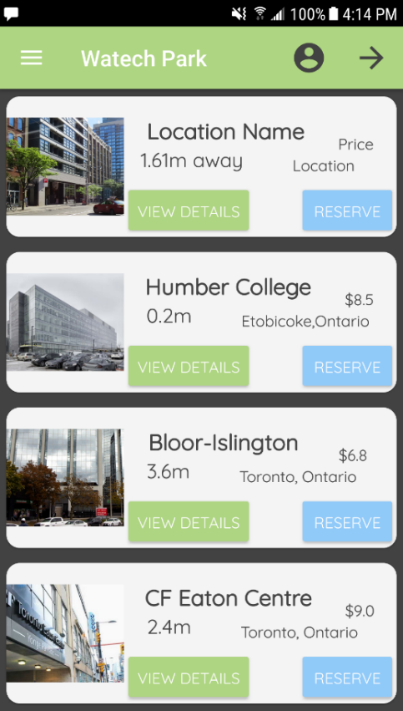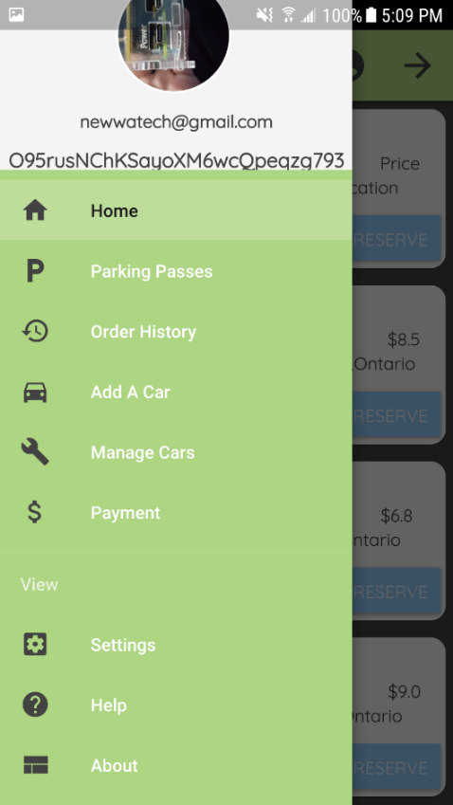

Figure 17 - Main Menu Screen (SideBar) Figure 18 - Main Menu Screen

In the “Add A Car” screen, the user enters in their vehicle details to register a car to the account. The user is prompted to enter information specific to each account, such asthe Make, Model, Color, and License Plate #. We have decided to store each added car into the system and send the data according to a specific user to the database. Once a license plate image is taken on-site of a vehicle, the application will assess this image and try to see if it can match it with the added license plate entered by the user through the mobile application. If the data matches, entry to the lot is allowed and the application would display the gate opening from a visual representation of the lot. This feature is not yet implemented, and will be developed over the current month and finalized by mid-March. There is a button to ADD A CAR, which registers the car to the Firebase database. Once the car is added into the system, and the data is sent to Firebase the consumer can access these details and the registered vehicles in the “Manage Cars” screen.

Manage Cars is where the data is fetched from Firebase database and the information for each “Car” is displayed following a similar format of the main menu. There are 2 options to choose from here: Edit/Delete. Edit allows the user to basically make a change and update the information to the database structure in Firebase. Once the user selects Edit, an inflated view pops up of the fragment prompting to enter in the new information. The user then would tap on the “Apply Changes” button to apply the changes automatically. The changes are visible in real - time through Firebase, once they are set. The Delete option asks the user if they are sure they want to delete the car.If the user approves, the car is deleted from the real-time database and is removed automatically after the next time you access the Manage Cars section. If the latter is chosen, the action is dropped and cancelled to continue the session.

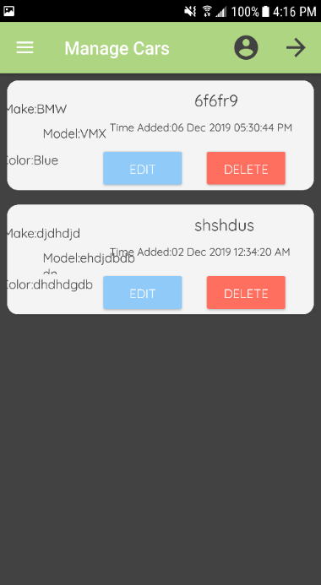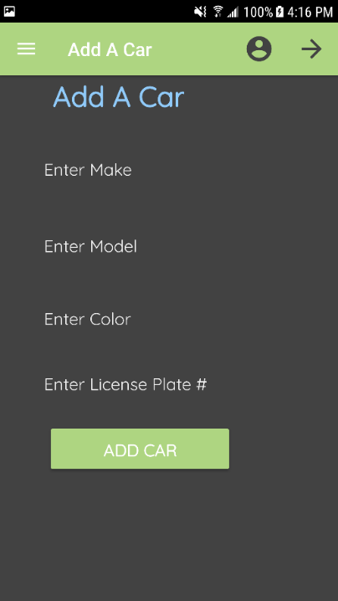

Figure 19 - Add A Car Screen Figure 20 - Manage Your Car Screen

The Parking Passes screen in the application, holds all of the available parking passes for each lot. This includes, the name, location, duration (in hours), validity (time the pass is valid for), type, expiry time, cost, and the account balance before the purchase. There is a button to “SELECT” a parking lot. Once selected the data for that lot is sent to Firebase and stored under the UID of the user. This data is also then sent to the Payment screen, which would be the next step to finalize the reservation through the transaction process.

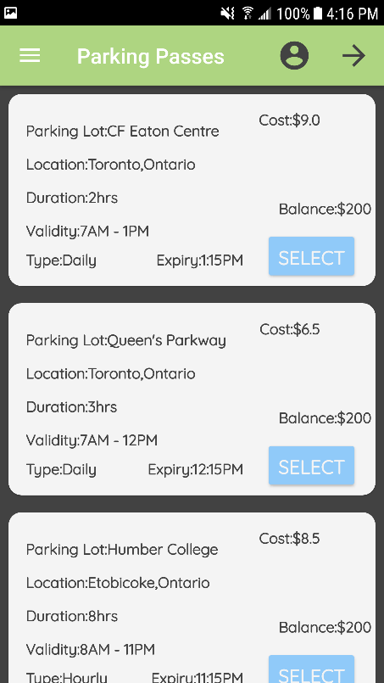

Figure 21 - Parking Passes Screen

On the Payment screen, the selected parking pass is now visible with all the data related to the particular parking lot. On this screen, similar details are displayed, with the addition of an OID (order ID), and e-mail corresponding to the account that is processing the order. Also, the total is calculated for the parking pass with tax and displayed in only a readable form. The balance after the purchase is calculated on the spot and displayed according to the total accumulation. Also, instead of following a credit card method which can be risky in terms of storing sensitive data. Such as, password details or sending data to an online database system. Instead we decided to implement a QR Code generator. The total would be calculated and based on this set value, the “Generate QR Code” button generates a random QR Code using this value. The user would then tap on the FAB (floating action button) which asks to confirm the purchase. If the order is confirmed then it is successfully been processed. A toast message appears saying “Order has been successfully placed! Please View Order History for more details”.

Order History displays the order’s that have been placed using a unique OID (order id) which is the UID used to refer to a specific account. The data is retrieved from Firebase displaying the processed information and a timestamp for when the order confirmation took place.

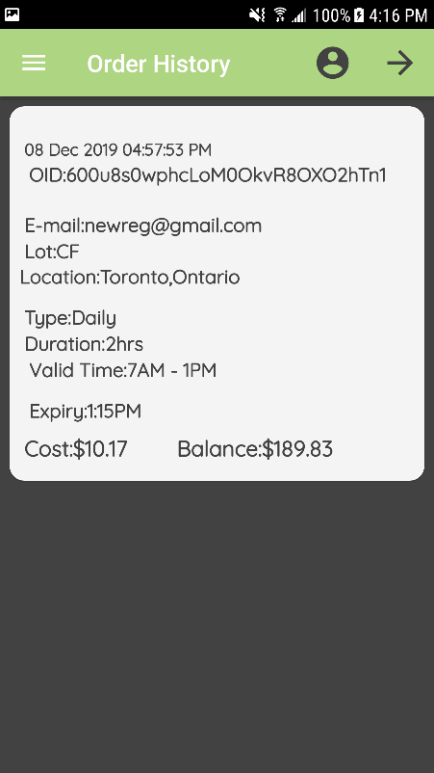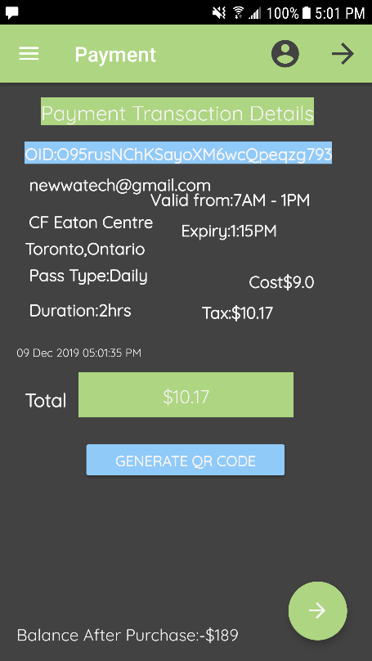

Figure 22 - Payment Screen Figure 23 - Order History Screen

The Setting screen provides a localization feature for (English/French integration). The design basically followed a simple UI, with a button to “Select Language. The user checks which one to perform and the languages change state accordingly without the need of re-entering the app. There may be further features added into the final version of the application, towards the final stages of the project which have not been discussed as of yet. The Help screen, displays general help documentation for ways to navigate to the different screens and use the functionality. The About screen displays project and 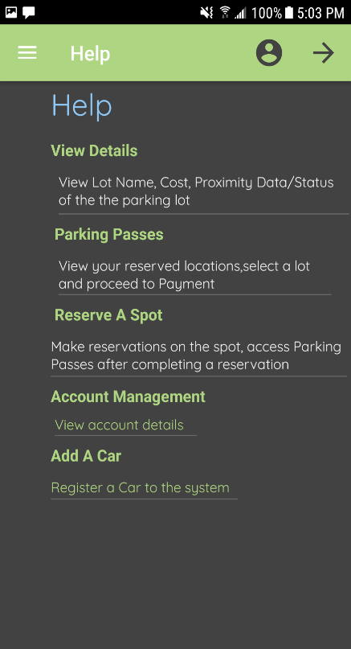general mobile application details.

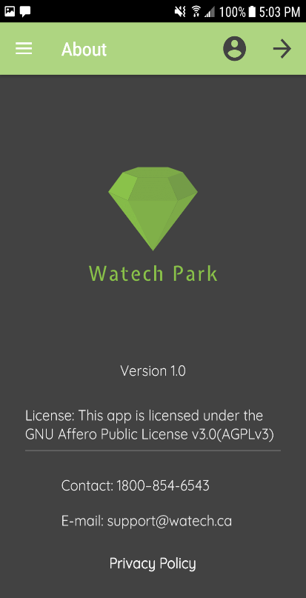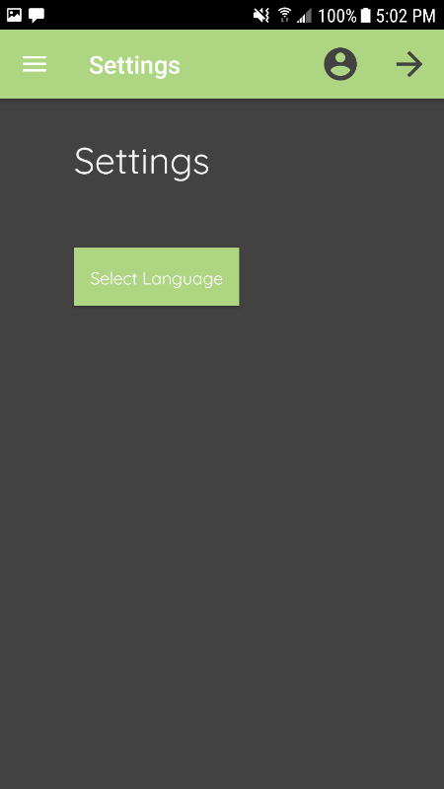

Figure 24 - Setting Screen Figure 25 - Help Screen Figure 26 - About Screen

### Action Control Activity

Hardware used for the project must be controlled in some way. This section will explain this process more clearly and how the hardware sensors/effectors, will be used with the mobile application. Each sensor will communicate with the mobile application for different purposes. To begin, the VCNL4010 Proximity sensor will be used to manage/detect when a vehicle has taken up a parking space in the lot. The sensor will be used in terms of sending/displaying proximity data from how far/near the vehicle is from the spot. This information will then be pushed to the online database, where from the application the user will be able to retrieve this data where it is displayed on the APP. The following is the method of operation for controlling the action committed, once a car has been placed on the parking spot platform, which will be designed/developed during the duration of this semester, the mobile application will detect this change and update the status of the lot in real-time. Therefore, the proximity sensor will only be used to control/detect the distance of an object or vehicle far/near from the actual location. Such as, in a scenario where the parking lot is empty and no cars are visible, the application will relay that data and show all spots “Open” on the application, under a visual manner. A green color will be used along with the RGB LED (red, green, blue) form to accomplish this on the app. In the event, where a vehicle enters the gate and is approaching one of the four spots on-site, the sensors will detect this movement. Then according to this movement, the sensors will know if a car is approaching one of the spots in the location. Our team decided it is best, to only display key data by visually showing the spots in the lot, and only showing which spots are open/occupied or if the lot is full. So, once a car is placed on one of the spots, each proximity sensor on-site will be active, listening and the spot that is taken will update the application to indicate, the spot is currently being occupied(using a red color representation) while all others are in the same state of being open(green). Proximity data/readings will be displayed accordingly based on set conditions, where if a car is approaching and the object is near the sensor the proximity level would be high and therefore the application would indicate an occupied spot. If all spots are taken on-site of the parking lot, then the proximity levels will exceed this amount, therefore the application must display a warning saying “Lot B is Full” and show the remaining spots if any and not allow further entry. This part will be explained further in the Imaging/Firmware branch of this section.

For the IR Break Beam sensor, the main motive behind using this hardware component was to control the gate movements at entry/exit of the parking lot. The sensor will be used to detect when a car is at the gates, and after full validation and error-checking the IR beam sensor will check for an object in the way of the gate. If the car is in the way, the sensor will break the beam and allow the car to enter the parking lot. At exit, the sensor will be used to control the gate as well, to basically allow the car to exit based on distance and movement. Now, once the gates open/close the corresponding data will be sent to the database, and then transferred to the mobile application. This includes, the time of entry, license plate number scanned and the specific UID under which the current user is operating the mobile application. All of this data will be visible for the user, once a specific car assigned to that user has entered/exited the parking lot. On the application, a message will be displayed mentioning “Gate A is opening…” or “Gate A is closing…” once a vehicle is no longer occupying that particular spot, it will return everything to its original state in the data present on the app.

The USB Camera sensor will be used only for the purpose of capturing an image, and license plate recognition. So, once a car comes up to the gates, the primary action to be taken is the camera sensor will automatically capture an image of the license plate, and send this data to the image processing software, and then send it out to the Firebase database. The camera sensor will be placed near the two servo motors and will be the initial action before any decision is made. Depending upon if the license plate image matches with the license plate information stored in the database, entry/exit will be allowed through the two servo motors for that particular user. To allow entry, the license plates must match from on-site of the hardware and the data entered/saved into the mobile application. The mobile application will not store any sort of images of the license plates in any form, but will only be used to track and match the information with the on-site parking lot through the online database.

The two servo motors being used will only act as the barriers between the entry/exit of a vehicle from the gates. This hardware will only be used to control the actual movement of the gates, during entry/exit. Therefore, no preliminary data will be sent through the online database or displayed in any shape or form on the mobile application, as there is no purpose of doing so.

Status

/1 Hardware present?

/1 Memo by student A + How did you make your Mobile Application? (500 words)

/1 Login activity

/1 Data visualization activity

/1 Action control activity