**WATECHPARK**

SMART Parking Lot System

**Vikas Sharma**

|  |
| --- |
|  |

January 15, 2020

Computer Engineering Technology

Status

/1 Hardware present?

/1 Title Page

/1 Declaration of Joint Authorship

/1 Proposal (500 words)

/1 Executive Summary

# Declaration of Joint Authorship

We, Student A (Vikas Sharma), Student B (George Alexandris), and Student C (Elias Sabbagh), confirm that this work submitted is the joint work of our group and is expressed in our own words. Any uses made within it of the works of any other author, in any form (ideas, equations, figures, texts, tables, programs), are properly acknowledged at the point of use. A list of the references used is included. The work breakdown is as follows: Each of us provided functioning, documented hardware for a sensor or effector. Student A provided VCNL4010 Proximity Sensor. Student B provided IR Beam Sensor. Daniel O Donnell provided LSR Camera Sensor/2 Stepper motors. Due to unexpected circumstances, Daniel’s involvement with the project was passed to Elias Sabbagh joining the group during the Winter 2020 semester, to ensure successful progression of the project. In the integration effort, Student A is the lead for further development of our mobile application, Student B is the lead for the Hardware, and Student C is the lead for connecting the two via the Database.

# Proposal

**WatechPark** - SMART Parking Lot System Proposal

**From:** Vikas Sharma, N01160135

**Discipline:** Computer Engineering Technology

**Date:** January 15, 2020

# Background

This document will outline the software portion of the project in CENG 319 that will be coupled with hardware in CENG 317 for the final integration in CENG 355. Our project is going to be on a SMART parking lot system. Many busy parking lots are often plagued with congestion, drivers competing to find a spot by cruising around and visually finding spots. This is inefficient, time consuming where productivity is lost for consumers and businesses. The system we will be developing will address payment for parking, capacity management and location finding following an IoT approach using hardware and software.

# Problem Statement

The problem being addressed includes, time spent searching for a parking spot, increased capacity levels during peak hours. This project is focused on solving these issues by connecting consumers to parking lot owners and providing parking services by using a more convenient, simpler method to retrieve parking lot data seamlessly.

# Methodology

Phase 1: Hardware Design/Build

The small physical prototypes that we build are to be small and safe enough to be brought to class every week as well as be worked on at home. In alignment with the space below the tray in the Humber North Campus Electronics Parts kit the overall project maximum dimensions are 12 13/16" x 6" x 2 7/8" = 32.5cm x 15.25cm x 7.25cm. Keeping safety and Z462 in mind, the highest AC voltage that will be used is 16Vrms from a wall adapter from which +/- 15V or as high as 45 VDC can be obtained. Maximum power consumption will not exceed 20 Watts.

Phase 2: System Integration/Connection

This phase will be completed during the final semester of the Computer Engineering Program. The work gathered from both software/hardware courses will be combined and integrated for the final capstone project. The development platforms we will be working with is Android Studio 3.5.2, Raspberry Pi 4 Model B, and Google Firebase database.The mobile application provides key functionality to allow consumers to access parking lot data, view sensor/effector information specific to a location and choose the best parking space during different peak hours of the day. The VCNL4010 Proximity sensor will be used to detect the status of a given parking space at a specific time of access. The IR Beam Sensor will control the gate opening/closing and detect the presence of a vehicle near/far away. The LSR Camera sensor will be used for valid license plate recognition. The 2 stepper motors will control the gate and allow entry/exit based on the sensor data, and status of the lot.

Phase 3: Final Demonstration to Potential Employers

At this stage, we will demonstrate our 2 semester’s worth of work to be assessed. Our project description/specifications will be reviewed by, Mike Wrona, ideally an employer in a position to potentially hire once we graduate.

# Hypothesis

This project is focused on providing a solution for managing parking lot data, providing a less time-consuming experience with a simple, intuitive interface. This is an opportunity to showcase our knowledge and understanding to build a collaborative effort for an industry sampled IoT project. I request approval of this project.

# Executive Summary

In retrospect, this document outlines both the hardware and software aspects of the project. This project intends to build an IoT design that would help support industry related issues such as capacity management, location-finding by finding ways to reduce the time spent manually searching for parking spots. This document aims to provide insight into the design, development, testing phase of our SMART parking lot system project. In collaboration with our partner at ParkingBoxx, we have gathered our ideas to create a simple, intuitive and user-friendly platform for consumers within the market.

Our product aims to provide the essential needs for both consumers/businesses to view and manage parking lot data. In terms of market use, we believe through the project we will build a product that can be offered from an industry standpoint as well as be marketable to other fields of interest. Through the development of this product, we wanted to reach as many demographics and be able to provide an inexpensive and reliable platform where parking lot information can be retrieved at a glance. We offer users with the ability to be able to add/manage cars, view parking lot data, make on-the go reservations for parking passes, accessible via an online database to send/receive information in real-time, all built-in with a simple, effective interface. Due to these reasons, we believe it will be ideal to be considered to be hired by an investor for employment. This will be an extraordinary opportunity for us to be able present our work, knowledge and skills to promote our product from a marketing perspective.

# 1.0 Introduction

This report will outline the development and integration of our final capstone project as part of the Computer Engineering Technology program at Humber. The individual team contribution for this project goes towards George Alexandris, Vikas Sharma, and Elias Sabbagh all 3 of whom were extensively involved with bringing the project to life. The focus was to implement an IoT (Internet of Things) design, where software and hardware interaction would be vital to address an industry related issue and help solve real-world problems. This project consists of a SMART parking lot management platform, which allows consumers/businesses the ability to manage and monitor parking lot data through real-time progression. The goal, being to address problems arising in the parking industry specifically in terms of capacity management, increased manual interference, and the lack of location-finding near/far from an area. The product looks towards determining the challenges in the parking industry today, and provide a platform to navigate to a parking space quicker, and in a more efficient manner. This includes, managing parked users, or monitoring the status of a lot at a given time. The main objective of this undertaking is to provide a more efficient and reliable platform to aid with parking scenarios. In particular, for the purpose of the consumer demographic who may be searching for an alternative parking lot management system. Our focus was to develop a platform, that would be the gateway to support consumers with finding the best parking space during any time, any place or anywhere in the world.

# Project Schedule

The following is an overall breakdown of our work schedule for the duration of the entire project, and the two consecutive semesters:

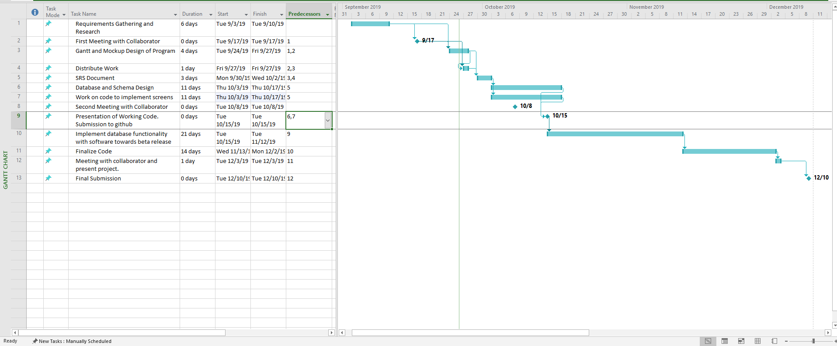

Figure 1 - Gantt Chart (Software)

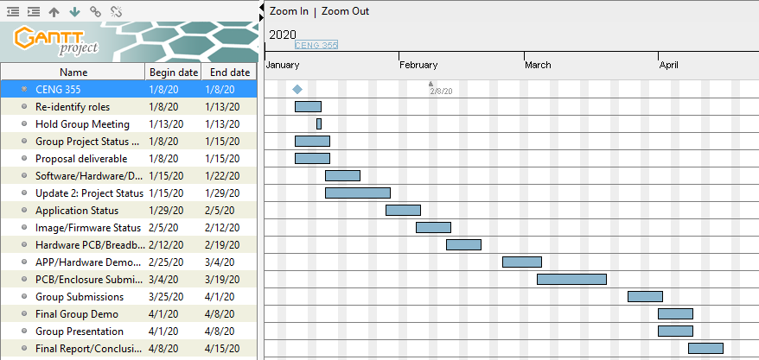

Figure 2 - Gantt Chart (Final Breakdown)

In terms of overall scheduling purposes, the project requires approximately fifteen weeks to complete during the Winter 2020 semester of the Computer Engineering Technology program. During the start of the final semester, the work done from the previous fall 2019 semester from CENG 319 and CENG 317 was carried over to complete the final integration. Most of the software development portion of the mobile application, and the connection to the database was done during the fall semester. Our group also ensured we were on the right track, by ensuring at least one of our team members can connect their sensor data to the database to send/display data to the platform during the fall semester. The core amount of work was accomplished towards the end of the Software Programming course, as well as in the Hardware Production Technology course. Our team followed our planned schedule efficiently throughout the fall semester, and carried the workload into the Winter 2020 semester. The final semester needed the group to finish implementing the sensor data to the Firebase database to be able to read/display data from the actual hardware. At this time, our team will extensively focus on completing the mobile application, and adding its intended features. As well as, re-designing our PCB boards to accumulate all three sensors from each team member into a final PCB design. The final semester will be used appropriately to ensure successful completion, and a polished end product.

## 1.1 Scope and Requirements

This report will address the key fundamentals of the project, including the software/hardware aspects of the design/specification and the final integration between these applications. It will touch on how the hardware (sensors/effectors) communicate and interact with the software application to allow consumers to track parking lot data. Further details will be examined in this document, in regards to the hardware sensors used, the main objectives behind choosing the type of hardware and how it correlates to the application being developed. Along with, describing the database structure used to push and retrieve data from the hardware to the mobile application, and vice-versa. In terms of the scope of the project, there were instances where the planned outcomes from the initial stages of the development period had to be modified or re-considered. This includes, having some minor design/features changes and removals mainly due to time constraints or software limitations, to further increase productivity and meet the overall requirements. Some of these changes included, a major overhaul of the main Home screen to provide a smoother, sleeker interface for user interaction, removing Google API login integration, removing the search function from the mobile application after much consideration. A major change, occurred during the Winter 2020 semester, where our development team decided it was in our best interest to not move forward with the development of the business aspect of the application. This feature would have allowed users to track their daily progress and set goals to reach in the mobile application from a marketing standpoint. The team decided to improve on the existing consumer functionality instead, with implementing the proposed camera sensor functionality, and stepper motor gate control. Due to this reason, these features had to be omitted as a result of not meeting the plan, and the overall extent of the project had to be re-evaluated and worked on. Our team followed an agile methodology/procedure where work would be committed and evaluated on a daily basis to ensure the team stays on track. Development was split into distinct sprints of software coding/hardware testing to ensure both applications are met within the due time. During this time, coding was separated into blocks of development periods where the team focused on completing a single feature, and aiming towards further progression from both sides. The limitations provided our team with an outlet, to focus on the main goal/priority and cut down on excess amount of work that can be evaluated later in terms of a marketing perspective. For example, one of the ideas the team came up with was introducing the business aspect through an online website where users would be able to view financial, user information along with providing identical software/hardware interaction. This SMART parking assist platform provides real-time proximity measurements, lot detection methods with use of the hardware elements. Such as, the entry/exits of vehicles, detecting parking space movement, gate control.

## Development Platform Specification

The following are the specifications of the software side of development. In terms of application use, consumers only need to know how to use a smartphone device. No technical expertise is needed as the platform we develop will be simple to use and gain a grasp of. The following are the list of software requirements vital for the platform to operate as intended:

* Android Studio 3.5.2 development platform
* Java (coding language) used for mobile application
* Software must have bilingual capabilities for English/French language integration
* Internet connection (Wi-fi) is needed to access the mobile application, and its main functions.

## Hardware Specification

The following is a list of hardware requirements needed by the user to operate the application, and its functions:

* Raspberry Pi 4 Model B (CPU platform to process sensor data)
* Must support at least 2GB of storage, RAM
* Embedded CPU (Raspberry Pi) device will always need a connection to the server for the purposes of authenticating users, and receiving data.

## Android Device Specification

* Must be running Android OS on mobile system
* Mobile APP will run only on Android devices
* API 21(Android Version 5.0 Lollipop) and above (supported roughly over 80% of the Android population)

## Database Specification/Protocols

* Google Firebase database for storage purposes, push/retrieve real-time data from sensors to mobile application, and vice -versa.
* User Authentication

**Protocols:**

* HTTPS/SSL Encryption end to end communication
* TCP/UDP Connection
* Wifi/Cellular connection

**Server-Side:**

* Email: SMTP (Simple Mail Transfer Protocol)
* Data transfer rates must be capped to not utilize an excess amount of data, depending on connection type (size must be compressed).

Report

/1 Hardware present?

/1 Introduction (500 words)

/1 Scope and Requirements

/1 Background (500 words)

/1 References

# 2.0 Background

In the industry today, there have many occurrences where parking in general has become a hassle for city residents and parking lot owners. This includes, not possessing the right tools to manage capacity when a parking lot is full, where drivers are struggling to find the best spot to park their vehicles. This can lead to dis-satisfying scenarios, where drivers are unaware of their surroundings, before even entering into the space. Due to this reason, it can lead to congestion in major traffic centric cities, with drivers competing to find a spot. This can be time-consuming, inefficient where productivity is lost for consumers and businesses. This project is focused on helping reduce the impact of this cause, by developing a system that will address payment for parking by taking an advanced and modern approach towards capacity management, and real-time information gathering to keep consumers up to date with their daily occurrences.

The group would like to thank Mike Wrona, installation manager, of Parking Boxx who provided support for this project. The project is a SMART parking lot system that incorporates a phone app to manage a user’s tickets, account, and where to park in the parking lot. The idea of this project came up when the group realized that we can develop an easier way to find parking spots, by connecting all the spots to a parking app. We thought about creating an IoT parking lot that can connect to a database and update the database with information about its open/closed parking spots. It will be able to send and retrieve information about the parking lot. The mobile application will allow users to connect to the database and manage user accounts and payments for their tickets. Examples of some existing platforms are Indigo, BestParking, EasyPark and ParkWhiz. These platforms have reservation capabilities, on the go parking with mobile or web application. What we are going to do differently from these companies is to integrate sensors to help users navigate to a parking spot.

One of the parking companies we looked at is EasyPark (EasyPark, 2016). EasyPark offers monthly payments for its customers to park in the EasyPark parking facilities. The goal for EasyPark is “provide safe, clean, friendly, convenient and affordable parking to the Greater Vancouver community” (EasyPark, 2016). EasyPark offers a phone app (EasyPark, 2016) called EasyPark Parking as well that allows it users to view parking available at its facilities. You can pay for parking on the phone app (Google Play, 2020). The parking app allows its users to register, find EasyPark parking lots close to you, keep track of how long and where your car is parked in the parking facility. Payment is done through the mobile platform with a much simpler method of operation.

We looked at the other parking companies that were mentioned such as Indigo, BestParking, and ParkWhiz. In terms of overall design and interface almost each application had full resemblance to the previous. Indigo offers a map that allows users to choose which parking lot they want to park at. Users can book their parking ticket in advance, reserve the spot for the designated parking facility owned by the company they want to park at, and they can see the rates of the parking lots (Park Indigo Canada Inc, 2019). Apps such as ParkWhiz, offers the options to add cars for verification, pay for monthly parking on the app and their ticket (ParkWhiz, 2019).

# 6.0 References

*EasyPark*. (2016). Retrieved from EasyPark Mobile Parking App: https://www.easypark.ca/products-services/mobile-parking-app

*EasyPark*. (2016). Retrieved from City Parking Vancouver, Public Parking, EasyPark Mission: https://www.easypark.ca/about-easypark/mission

*EasyPark*. (2016). Retrieved from History: https://www.easypark.ca/about-easypark/history

*Google Play*. (2020). Retrieved from EasyPark Parking - Apps on Google Play: https://play.google.com/store/apps/details?id=ca.easypark2.app&hl=en

Park Indigo Canada Inc. (2019). Indigo. Retrieved from https://ca.parkindigo.com/en

ParkWhiz. (2019). Find and Book Parking Anywhere. Retrieved from https://www.bestparking.com/