# **Terraform (Infrastructure as Code)**

* Terraform Infrastructure as code know as IAC where we need to write code for our requirement and it make the stuffs in which I need in making any environment its easy to understand and easy to write.
* 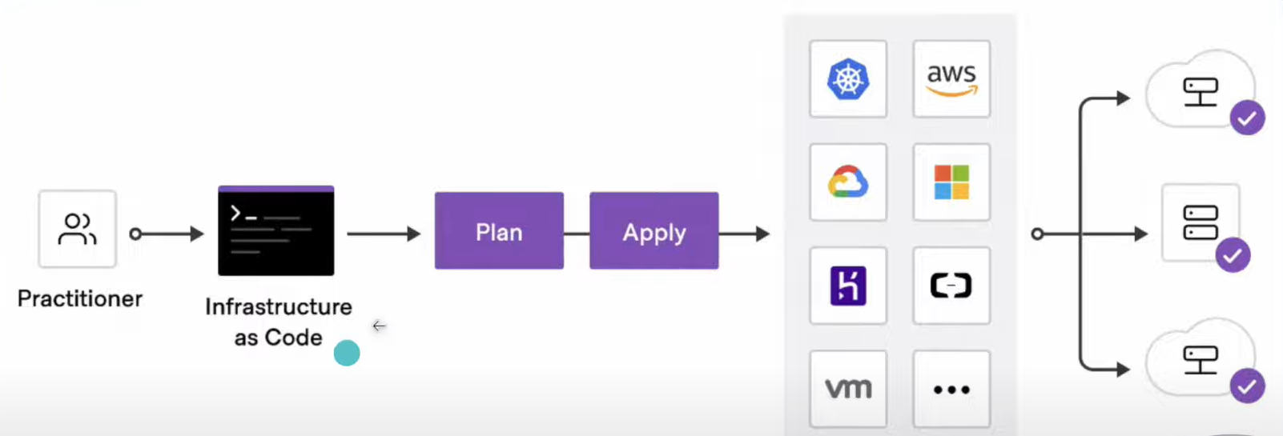
* We Need to understand working of Terraform and we have some useful command in terraform to create your env and other stuffs
* Terraform plan and terraform apply 🡪 Command 1.
* Terraform destroy 🡪 Use to Destroy Your All Resource Whenever you want to destroy it
* Terraform Handle Everything Carefully Whenever you create new resource and after that you have change that resource then terraform destroy pervious resource and make new resource according to Client Requirement.
* Terraform Validate 🡪 Use to Validate your file is it Perfect or not
* Concept of BlockName ResourceType  ResourceName{

        Arguments 1

       Arguments 2

}

* Important

local = provider

file = ResourceType

vikas = ResourceName

* Execution of Infrastructure

init --> plan --> apply

* terraform validate
* terraform show

terraform state list

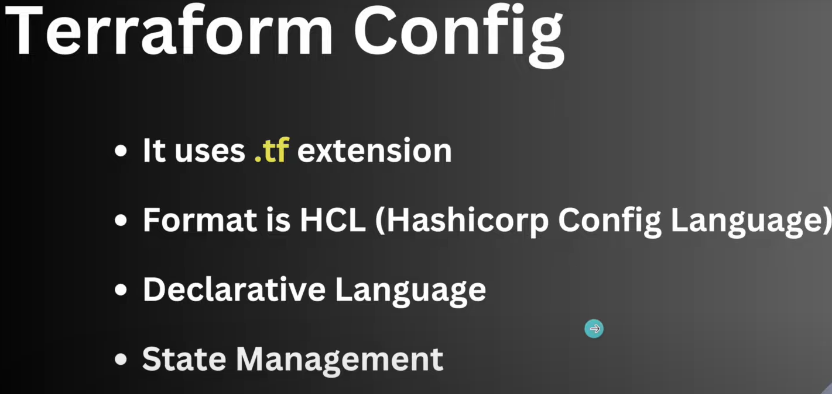

* State Management 🡪 Terraform.tfstate 🡪 File
* Terraform Support JSON format Also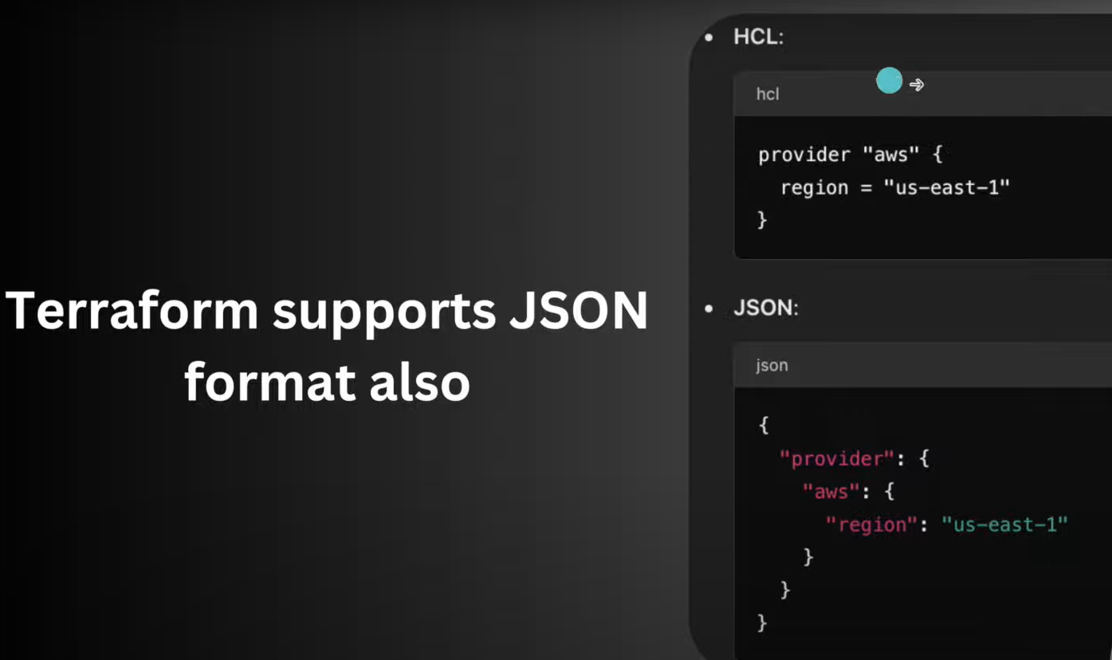
* Terraform Variables.tf
* Output.tf
* S3 Bucket using Terraform
* Terraform Remote State Management 🡪 terraform.tfstate 🡪This is important file because it store all the information regarding what you have made resource so it good thing that we can store this file on Remote .

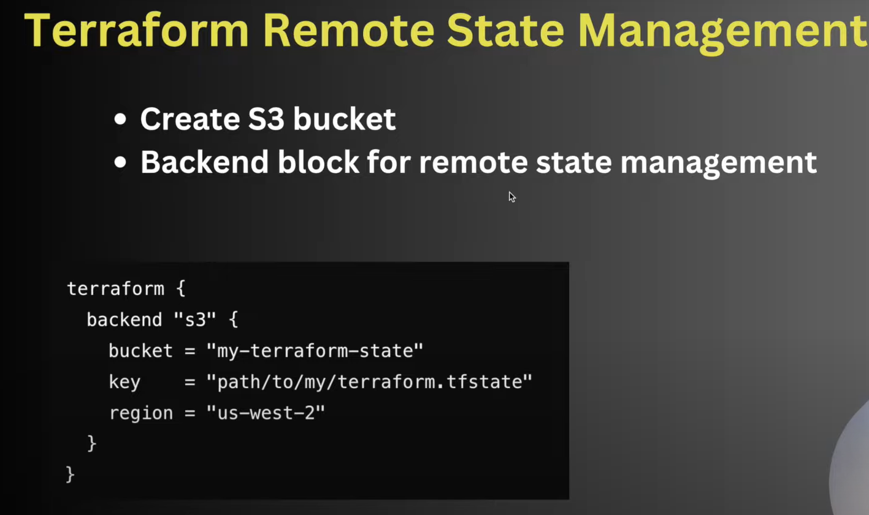

* Using Remote State Management we can Manage Every Resource or we have history of what we have made using terraform.
* Project 1 🡪 Deploy Static Website on AWS Using S3.
* 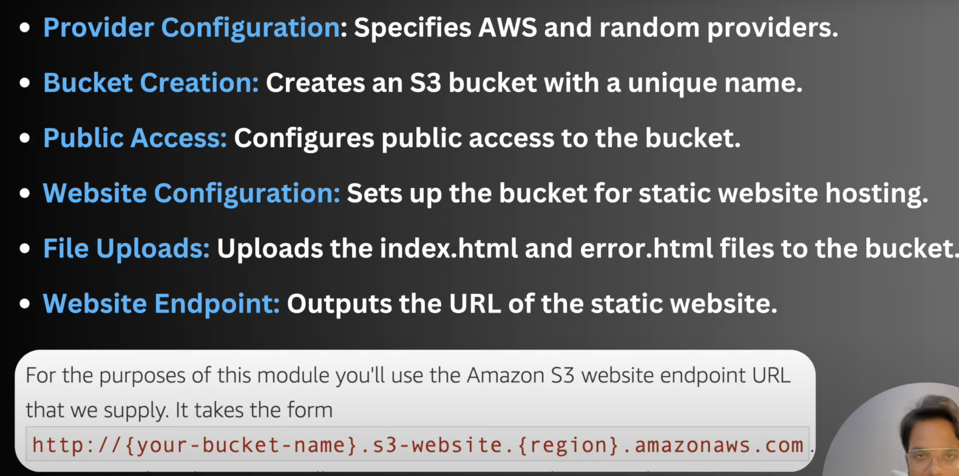
* Summary of this projects we need to follow.
* 