In this below error the resources were locked due to some other process. So we can unlock the process or we can use FORCE.

We can use this command.

**terraform force-unlock force_id**

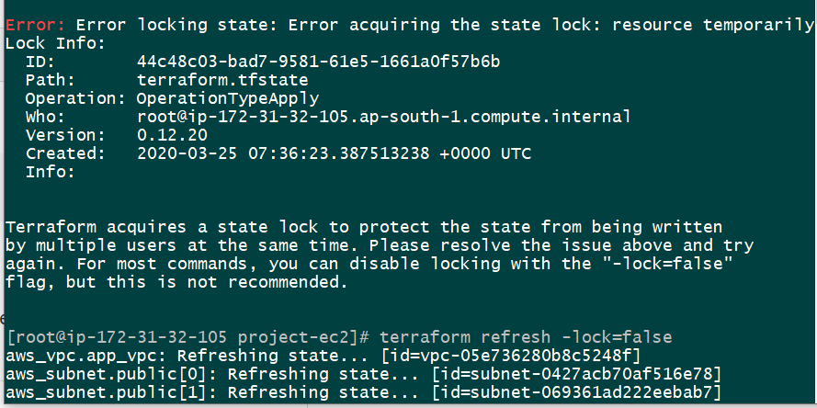

Even after trying that this doesn’t work. So I tried using

**Terraform refresh -lock=false**

But this also didn’t work. If I try to run terraform destroy or plan it will through the below error.

“**Local state cannot be unlocked by another process**”

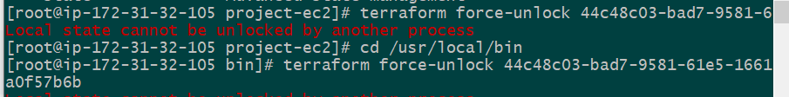

**NOTE:**

Give command “top” this will give us the CPU utilization and then kill all the subtask “terraform”

**Killall terraform**