SE - LAB 1
Problem Statement #29 – Municipal Infrastructure Damage Reporting App

Name : Vikas Gowda L
SRN : PES1UG24AM329

DELIVERABLE 1 – COMPLETE REQUIREMENTS TABLE

Req ID | Type | Description | Priority | Acceptance Criteria | Rationale
FR-001 | Functional | The system shall extract EXIF GPS metadata from uploaded damage photos to automatically pinpoint the incident location on the municipal GIS map. | High | Pass: A pothole report with a geotagged photo is routed to the Road Infrastructure division with the exact GPS coordinates. Fail: The report is submitted without location data. | Automatically identifies the exact damage location.
FR-002 | Functional | The system shall allow a citizen to submit a damage report by selecting the damage type, entering a description, and uploading a photo. | High | Pass: A report is created when a valid damage type, description, and photo are provided. Fail: The system prevents submission when a mandatory field is missing. | Provides the core functionality for reporting infrastructure damage.
FR-003 | Functional | The system shall automatically route each damage report to the appropriate municipal engineering department based on the reported damage type and location. | High | Pass: The report is assigned to the appropriate municipal engineering department. Fail: The report remains unassigned or is sent to an incorrect department. | Reduces manual assignment and speeds up issue resolution.
FR-004 | Functional | The system shall allow citizens to view the status and details of their submitted damage reports. | Medium | Pass: The citizen can view the report ID, damage type, location, assigned department, and current status. Fail: The submitted report cannot be found. | Allows citizens to monitor the progress of their complaints.
FR-005 | Functional | The system shall allow municipal engineers to update the status of assigned damage reports. | High | Pass: An authorized engineer can change a report status from Assigned to In Progress or Resolved. Fail: An unauthorized user can modify the report status. | Enables engineers to manage and track infrastructure repairs.
NFR-001 | Nonfunctional | The reporting portal shall support offline report drafting and automatically synchronize reports when mobile network connectivity resumes. | High | Pass: A report drafted while offline is automatically synchronized after connectivity is restored. Fail: The drafted report is lost or requires complete re-entry. | Allows citizens to report damage in areas with poor network connectivity.
NFR-002 | Nonfunctional | The system shall protect citizen and report data from unauthorized access. | High | Pass: Unauthorized users cannot access or modify another citizen's reports. Fail: An unauthorized user can view or modify protected report data. | Protects citizen information and maintains report integrity.

DELIVERABLE 2 – UML USE-CASE DIAGRAM

Instructions for final assembly: Insert the exported UML Use-Case Diagram from draw.io in the space below. The diagram should show all actors, primary use cases, at least one «include» relationship, and at least one «extend» relationship.
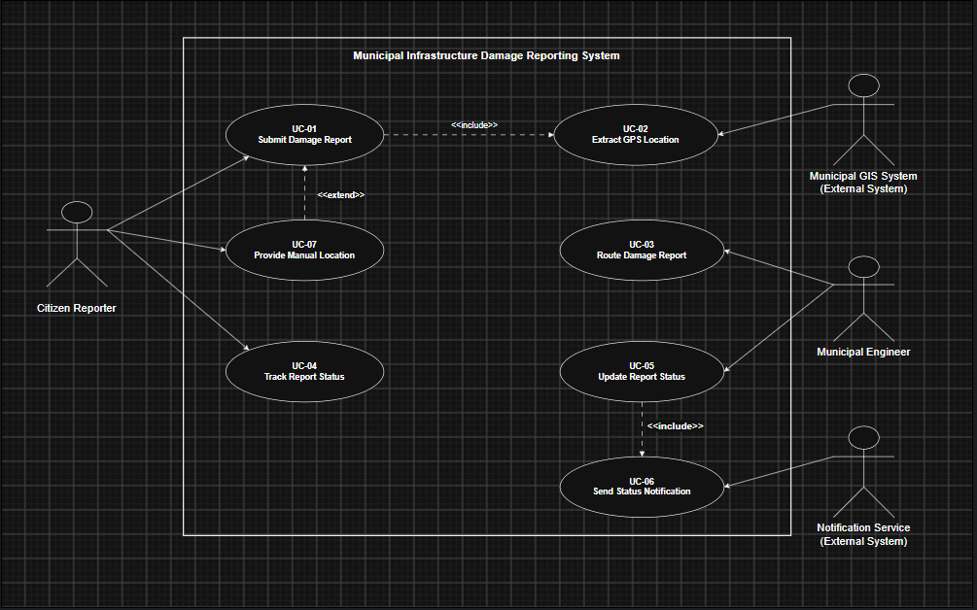
Actors expected: Citizen Reporter, Municipal Engineer, Municipal GIS System, Notification Service.
Primary use cases expected: Submit Damage Report, Extract GPS Location, Route Damage Report, Track Report Status, Update Report Status, Send Status Notification, Provide Manual Location.

DELIVERABLE 3 – USE-CASE FLOW SPECIFICATION

Use Case: Submit Damage Report.
Objective: Allow a citizen to report municipal infrastructure damage with damage details, a photograph, and location information.

1. Preconditions

- The citizen has access to the reporting application.
- The citizen has a photograph of the infrastructure damage available for upload.
- The reporting application is available for creating a damage report.

2. Postconditions

- A damage report is created with a unique report ID.
- The incident location is associated with the report.
- The report is routed to the appropriate municipal engineering department.
- The citizen can track the submitted report.

3. Main Success Scenario

- The citizen selects the "Report Damage" option.
- The system displays the damage-report form.
- The citizen selects the damage type, such as road pothole, broken streetlight, or water pipeline leak.
- The citizen enters a description of the damage.
- The citizen uploads a geotagged photograph.
- The system validates the submitted information.
- The system extracts EXIF GPS metadata from the uploaded photograph.
- The system uses the GPS coordinates to pinpoint the incident location on the municipal GIS map.
- The system creates the damage report and assigns a unique report ID.
- The system automatically routes the report to the appropriate municipal engineering department.
- The system displays a confirmation message and report ID to the citizen.
- The use case ends successfully.

4. Alternate Flow – GPS Data Unavailable

- The system detects that the uploaded photograph does not contain valid GPS metadata.
- The system asks the citizen to provide the incident location manually.
- The citizen enters or selects the incident location on the map.
- The system validates the manually provided location.
- The system continues with report creation and routing.
- The use case resumes at Step 9 of the Main Success Scenario.

