A Project Report on
Paw Connect

By
Vikas Manik Mhetre
(PRN: 20240201124)
MCA – I, SEM – I
2024-25

To

Savitribai Phule Pune University,Pune

In Partial Fulfillment of the Degree of
Master in Computer Application (M. C. A.)

Under The Guidance Of
Prof. Neha Dhakol

Suryadatta Group of Institutes, Pune
Suryadatta Institute of Management and Mass Communication (SIMMC)

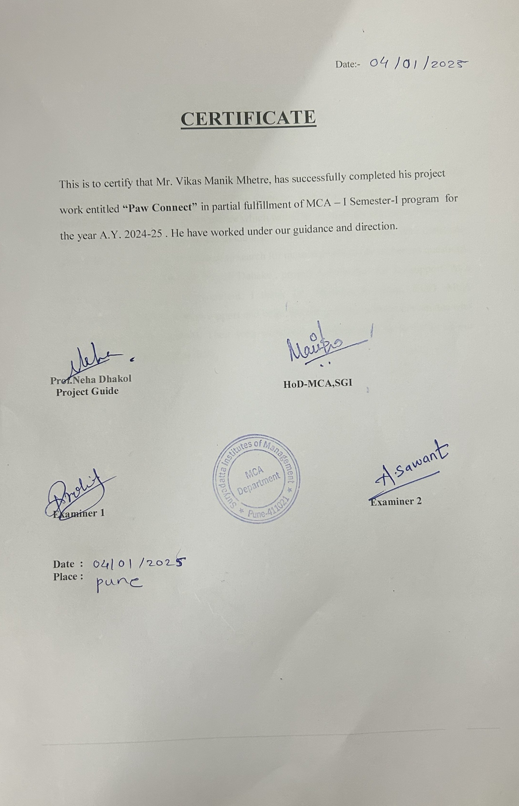

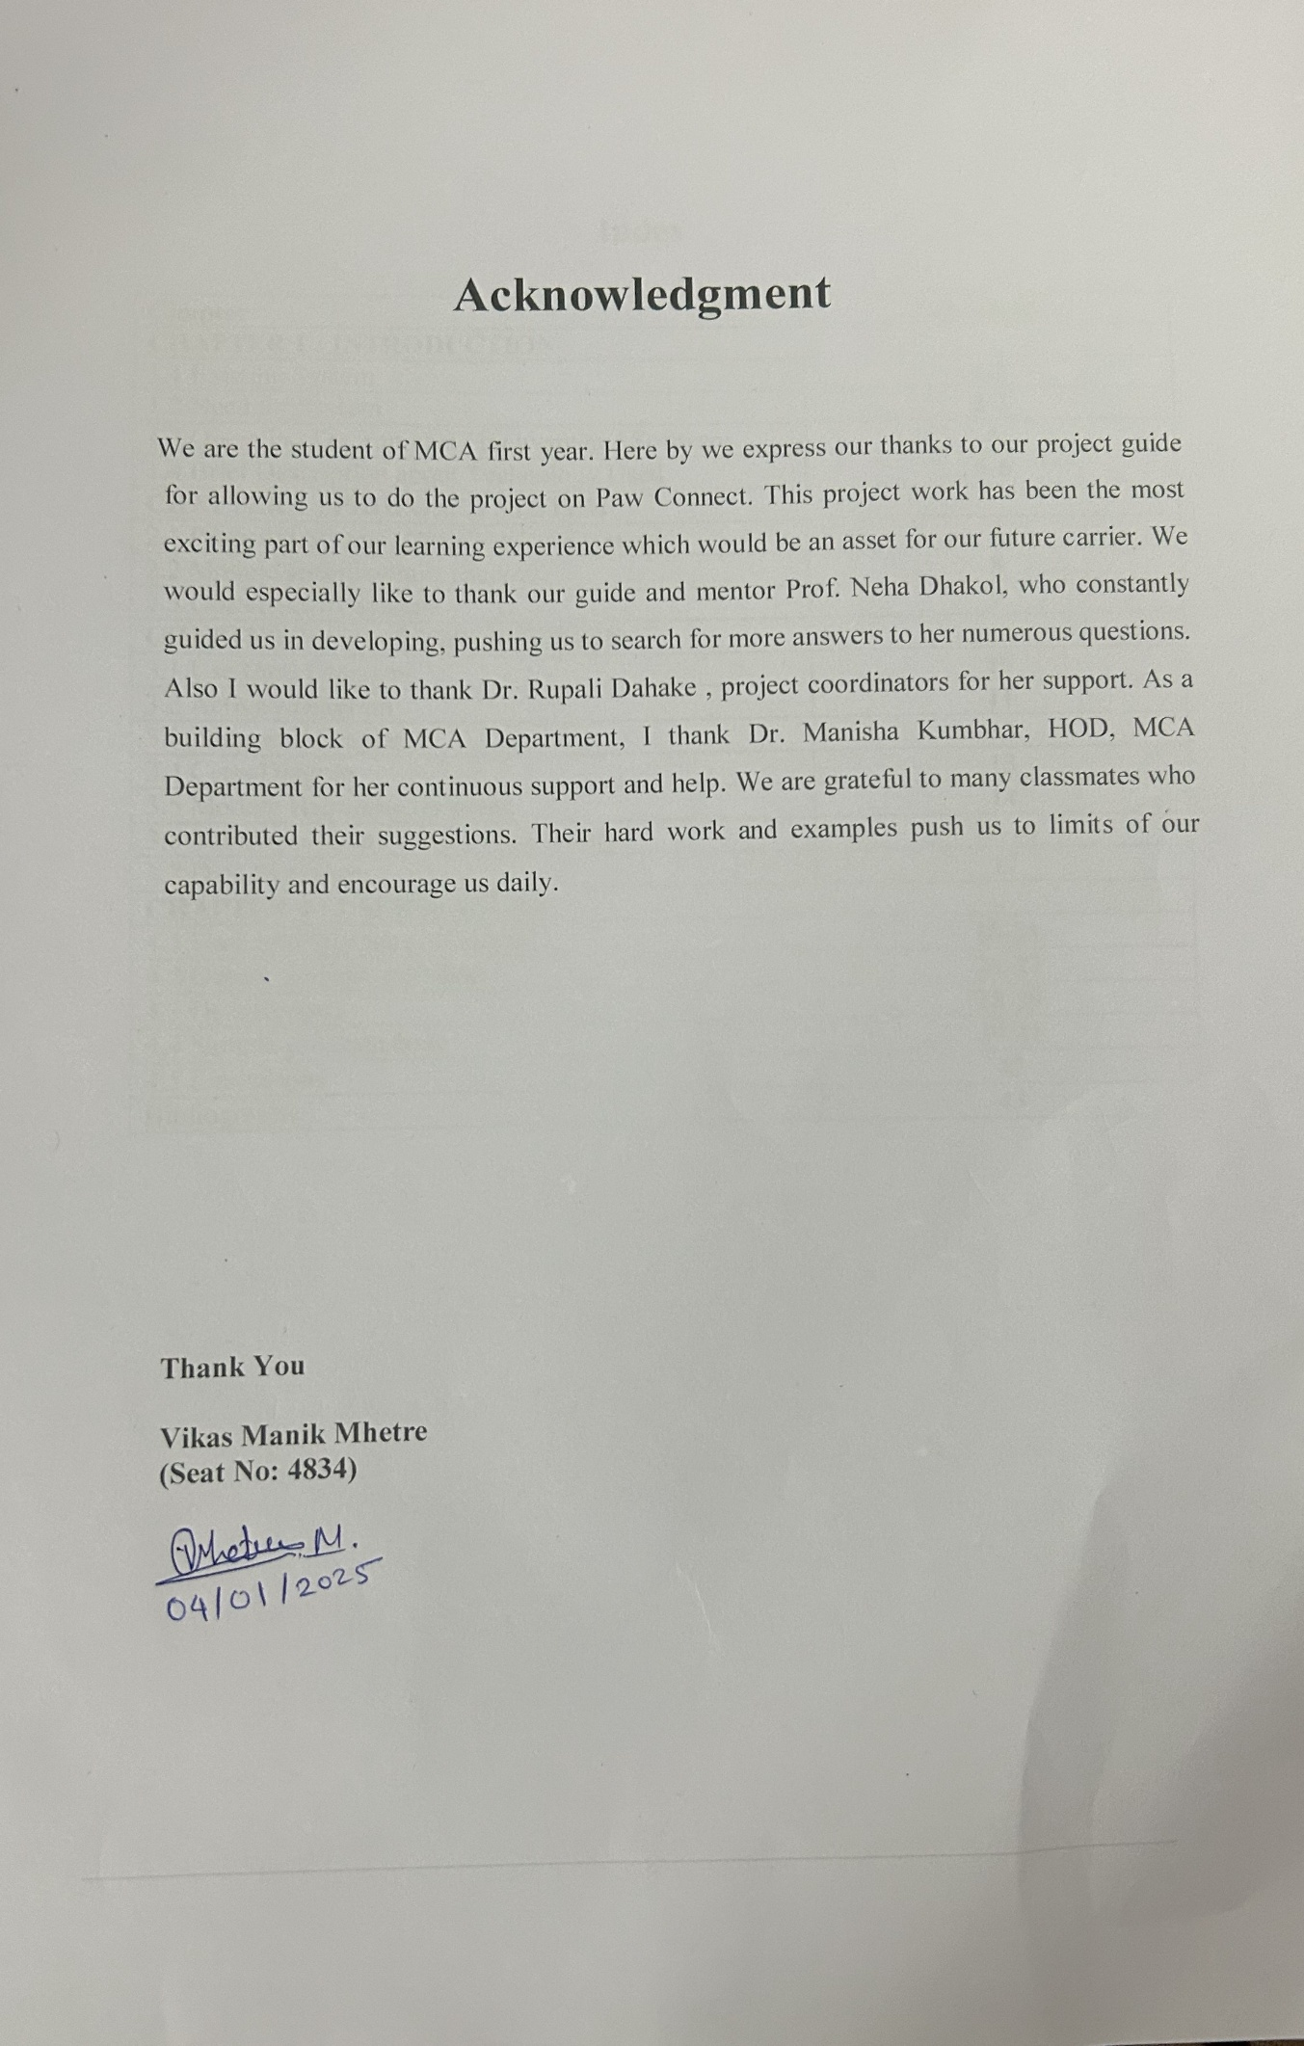
Index

Chapter | Page number
CHAPTER 1 : INTRODUCTION
1.1 Existing System | 1-2
1.2 Need for System | 2-3
1.3 Operating Environment Hardware and Software | 4
1.4 Brief Description about Technology Used | 5-6
CHAPTER 2 : PROPOSED SYSTEM
2.1 Proposed System (Introduction of system) | 7
2.2 Module specifications (Scope) | 8
2.3 Objectives of System | 9
CHAPTER 3 : ANALYSIS & DESIGN
3.1 Use Case Diagrams | 10
3.2 Activity Diagram | 11
3.3. Sequence Diagram | 12
3.4 Class Diagram | 13
3.5 Module Hierarchy Diagram | 14
3.6 Table specifications (Database design) | 15-16
3.7 Data dictionary | 17
CHAPTER 4 : USER MANUAL
4.1 User Interface Screens (Input) | 18-21
4.2 Output Screens with data | 21-27
4.3 Data Reports | 28-29
4.4 Sample program code | 29-41
4.5 Limitations | 42
Bibliography | 43

CHAPTER 1: INTRODUCTION
1.1 Existing System
The current systems employed by pet dog clinics for managing operations and scheduling appointments are often fragmented, inefficient, or entirely manual. These existing systems generally rely on outdated processes, such as:
- Paper-Based Systems: Many clinics still utilize physical logbooks and paper forms to record appointments, medical histories, and prescriptions. This approach is prone to errors, misplacement of documents, and inefficiencies in accessing records.
- Phone-Based Appointment Scheduling: Pet owners frequently call clinics to book appointments, leading to long wait times, scheduling conflicts, and a lack of transparency in available slots. This method also places a significant administrative burden on clinic staff.
- Standalone Software Solutions: Some clinics use basic software applications that are not tailored for veterinary operations. These solutions often lack critical features such as integrated appointment history tracking, prescription management, or compatibility with multiple devices and browsers.
- Limited Communication with Pet Owners: Existing systems do not effectively engage pet owners through online content, such as blogs or newsletters, which could educate them on dog care and clinic services.
- No Centralized Database: Without a robust database system, accessing and managing pet records, doctor schedules, and clinic statistics becomes cumbersome. Clinics may rely on fragmented systems that do not communicate with one another, causing inefficiencies.
- Poor Data Security: Physical records or standalone software solutions often lack proper security measures, making sensitive data susceptible to loss, theft, or unauthorized access.
- Lack of Online Presence: Many clinics fail to have a significant online presence, making it difficult for pet owners to discover their services or learn about their expertise. This gap results in missed opportunities to build trust and attract new clients.
The shortcomings of these systems hinder clinic efficiency, reduce customer satisfaction, and limit the ability to scale operations effectively. Clinics operating with such systems face challenges in maintaining accurate records, improving patient outcomes, and meeting the expectations of modern pet owners accustomed to digital conveniences.
1.2 Need for System
The "Paw Connect" system addresses the critical need for a comprehensive, user-friendly, and efficient platform tailored specifically for pet dog clinics. The following points highlight the necessity of this system:
- Streamlined Operations: By digitizing appointment scheduling, record management, and prescription tracking, Paw Connect eliminates the inefficiencies of paper-based and fragmented systems. This streamlining allows clinic staff to focus on providing quality care instead of administrative tasks.
- Improved Customer Experience: Pet owners benefit from a seamless and intuitive platform where they can book appointments, view their pets' medical history, and stay informed through blogs and articles. These features enhance the overall experience and build long-term loyalty.
- Centralized Data Management: The use of a MySQL database ensures that all data related to appointments, prescriptions, and clinic operations is stored securely in one place. This centralization makes data retrieval and analysis easier for both users and administrators.
- Enhanced Accessibility: With compatibility across major web browsers like Chrome, Firefox, and Safari, Paw Connect ensures that users can access the platform on any device, at any time. This accessibility aligns with the expectations of modern users.
- Tailored Features for Clinics:
  - Admin Dashboard: Provides administrators with real-time insights into clinic performance, appointment statistics, and operational details.
  - Prescription Management: Allows both users and administrators to add and manage prescriptions linked to specific appointments, improving medical record accuracy.
  - Team Information: Highlights the expertise of the clinic's staff, fostering trust among pet owners.
- Improved Communication: The inclusion of a blog feature allows clinics to share valuable information about dog care, health tips, and clinic updates. This not only educates pet owners but also positions the clinic as an authoritative resource in the industry.
- Scalability and Future Growth: With a robust backend powered by Python Flask and PHP, Paw Connect is designed to scale as clinics expand their operations or introduce new services. The platform's architecture supports the addition of features without disrupting existing functionalities.
- Data Security and Compliance: By utilizing secure database management practices and modern web technologies, Paw Connect ensures the confidentiality and integrity of sensitive information. This focus on security builds trust among users and complies with data protection regulations.
- Market Competitiveness: As pet owners increasingly seek digital solutions for managing their pets' healthcare, clinics that adopt innovative platforms like Paw Connect gain a competitive edge. The system's modern approach aligns with the expectations of tech-savvy customers.
- Enhanced Efficiency for Administrators: Features like fetching appointments by date and managing prescriptions reduce the workload on administrators, allowing them to focus on strategic decisions rather than routine tasks.
In summary, Paw Connect is an essential solution for modernizing pet dog clinic operations. Its comprehensive feature set, focus on user experience, and commitment to efficiency address the limitations of existing systems while meeting the evolving needs of pet owners and clinics alike.

1.3 Operating Environment: Hardware and Software

Hardware Requirements:
- Client Devices: Desktops, laptops, tablets, or smartphones.
- Server Requirements: A server capable of running PHP scripts and Python Flask applications with at least 4 GB of RAM and 500 GB of storage.
- Network: Stable internet connection for seamless data exchange.

Software Requirements:

- Frontend: HTML, CSS, and Bootstrap for responsive design.
- Backend: Python Flask for backend logic and PHP for server-side scripting.
- Database: MySQL for storing user and appointment data.
- Browser Compatibility: Chrome, Firefox, Safari.
- Operating System: Compatible with major OS platforms such as Windows, macOS, Linux, Android, and iOS.

1.4 Brief Description of Technology Used
The Paw Connect platform leverages a combination of modern technologies to deliver a comprehensive and user-friendly solution for pet dog clinics. Below is an overview of the technologies employed:
- Frontend Development:
  - HTML and CSS: These core web technologies form the foundation of the platform's design, structure, and styling, ensuring a clean and visually appealing user interface.
  - Bootstrap: This framework enhances the responsiveness of the platform, enabling it to adapt seamlessly to different screen sizes and devices. Bootstrap's components and utilities accelerate the development process while maintaining design consistency.
- Backend Development:
  - Python Flask: Flask serves as the primary backend framework, handling application logic, routing, and integration with the database. Its lightweight and flexible nature makes it ideal for building scalable and efficient web applications.
  - PHP: PHP is used for server-side scripting, enabling dynamic content generation and ensuring smooth communication between the server and the client.
- Database Management:
  - MySQL: A robust relational database system is employed for storing and managing data related to appointments, user information, prescriptions, and clinic statistics. MySQL's reliability and performance make it a popular choice for web applications.
- Browser Compatibility:
  - Paw Connect is designed to function seamlessly across major web browsers, including Google Chrome, Mozilla Firefox, and Safari. This ensures that users can access the platform without encountering compatibility issues.
- Security Measures:
  - The platform incorporates secure coding practices and database management to safeguard sensitive information, such as pet medical histories and user credentials. SSL encryption and authentication mechanisms are used to enhance security.

- User-Friendly Features:
  - The integration of interactive elements and intuitive navigation ensures a positive user experience for both pet owners and administrators. Features such as appointment scheduling, prescription management, and blog access are designed for ease of use.
By combining these technologies, Paw Connect delivers a robust, scalable, and efficient solution that meets the needs of modern pet dog clinics and their clients.

CHAPTER 2: PROPOSED SYSTEM
2.1 Proposed System
The "Paw Connect" system represents a comprehensive digital solution aimed at addressing the challenges faced by pet dog clinics in managing their operations. The proposed system is designed to streamline administrative tasks, enhance user engagement, and ensure seamless communication between clinic staff and pet owners.
Key highlights of the proposed system include:
- Digital Appointment Scheduling: A user-friendly interface allows pet owners to book appointments conveniently, minimizing the administrative burden on clinic staff and reducing scheduling conflicts.
- Integrated Medical Records: Pet owners and clinic staff can access a centralized database that stores comprehensive medical histories, prescriptions, and treatment details for each pet.
- Admin Dashboard: The system provides a dedicated dashboard for administrators to monitor clinic performance, track appointments, and manage team activities efficiently.
- Interactive Blog Section: A blog feature educates pet owners on various topics related to dog health, fostering community engagement and positioning the clinic as a trusted resource.
- Secure and Scalable Platform: Built with robust technologies, the system ensures data security and scalability to support future growth and feature enhancements.
This proposed system bridges the gap between traditional clinic operations and the expectations of tech-savvy pet owners, offering a seamless and modern solution for both users and administrators.

2.2 Module Specifications
The scope of the Paw Connect system is defined through its core modules, each designed to address specific needs of pet dog clinics and their customers. The major modules include:
- User Module:
  - Book Appointment: Allows pet owners to schedule appointments and view available time slots.
  - Appointment History: Displays past appointments, treatments, and prescriptions for easy reference.
  - Add Prescription: Enables users to upload prescriptions or medical notes linked to their appointments.
- Admin Module:
  - Manage Appointments: Provides functionality to view and manage all appointments by date, ensuring smooth clinic operations.
  - Add Prescriptions: Allows administrators to update or add prescriptions to individual appointments for better record-keeping.
  - Admin Dashboard: Offers real-time insights into clinic statistics, performance metrics, and staff activities.
- Content Module:
  - Blog Management: Hosts educational and informative content about pet care, increasing user engagement.
  - Team Information: Highlights the expertise and qualifications of clinic staff to build user trust.
- Database Management Module:
  - Ensures secure storage and retrieval of data, including user details, appointments, and medical records.
- Security Module:
  - Implements authentication and encryption protocols to protect sensitive information.
Each module is designed to integrate seamlessly with the others, providing a holistic and efficient solution for clinic operations.

2.3 Objectives of the System
The primary objectives of the Paw Connect system are as follows:
- Streamline Clinic Operations:
  - Automate administrative tasks like appointment scheduling and prescription management, reducing workload and minimizing errors.
- Enhance User Experience:
  - Provide pet owners with an intuitive platform to manage appointments, access medical histories, and stay informed through blogs and updates.
- Centralize Data Management:
  - Maintain a secure and centralized database for all clinic-related information, enabling easy access and efficient record-keeping.
- Improve Communication:
  - Facilitate seamless interaction between pet owners and clinic staff through real-time updates and notifications.
- Support Scalability:
  - Design the system to accommodate future growth, including new features, increased user base, and additional clinics.
- Ensure Data Security:
  - Employ robust security measures to protect sensitive information and build user trust.
- Promote Pet Care Awareness:
  - Use the blog feature to educate pet owners about dog health, treatments, and preventive care, fostering a knowledgeable and engaged community.
By achieving these objectives, the Paw Connect system aims to transform the way pet dog clinics operate, delivering enhanced value to both users and administrators.

CHAPTER 3 : ANALYSIS & DESIGN

3.1 Use-Case Diagram:

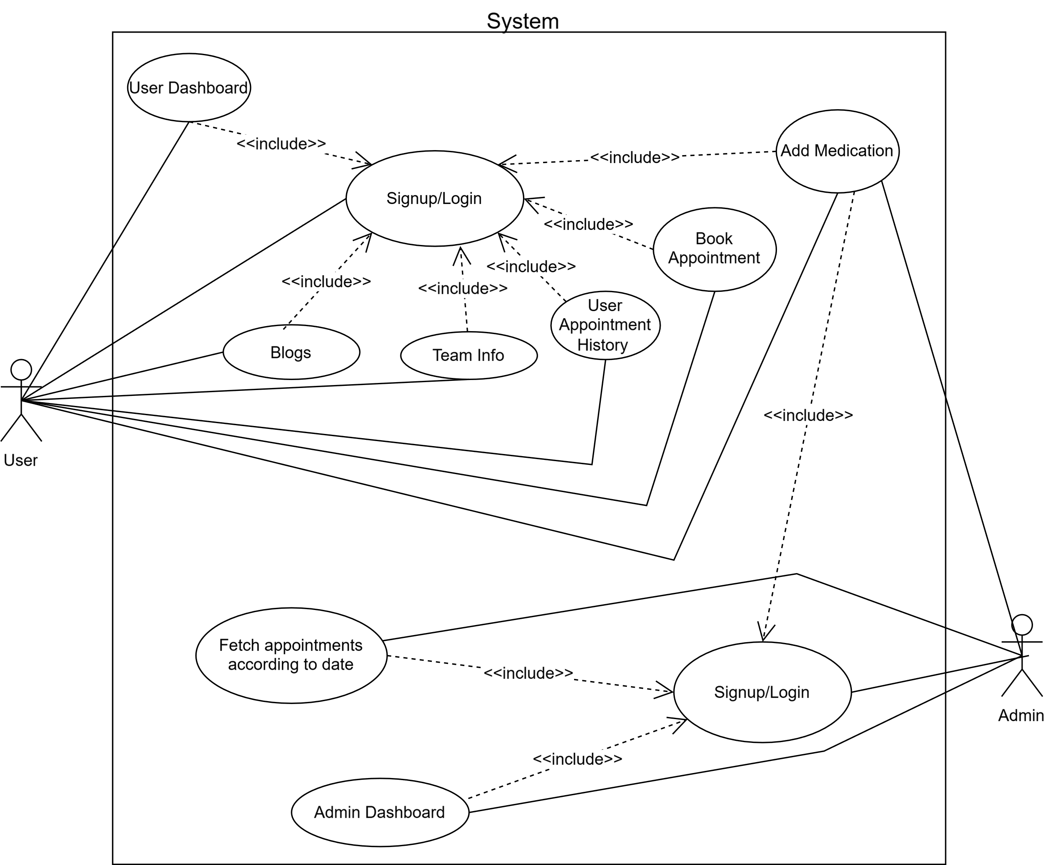

3.2 Activity Diagram:

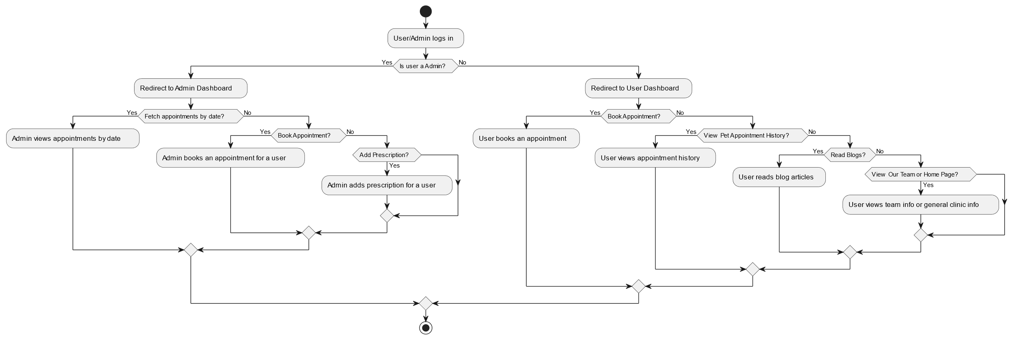
3.3. Sequence Diagram:

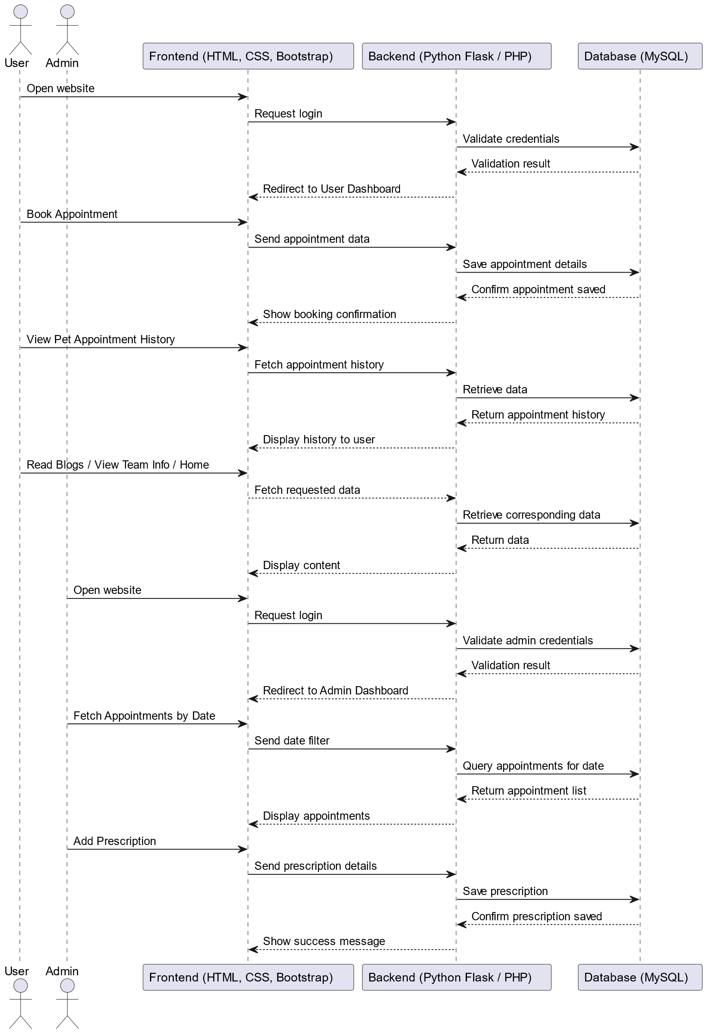

3.4 Class Diagram:

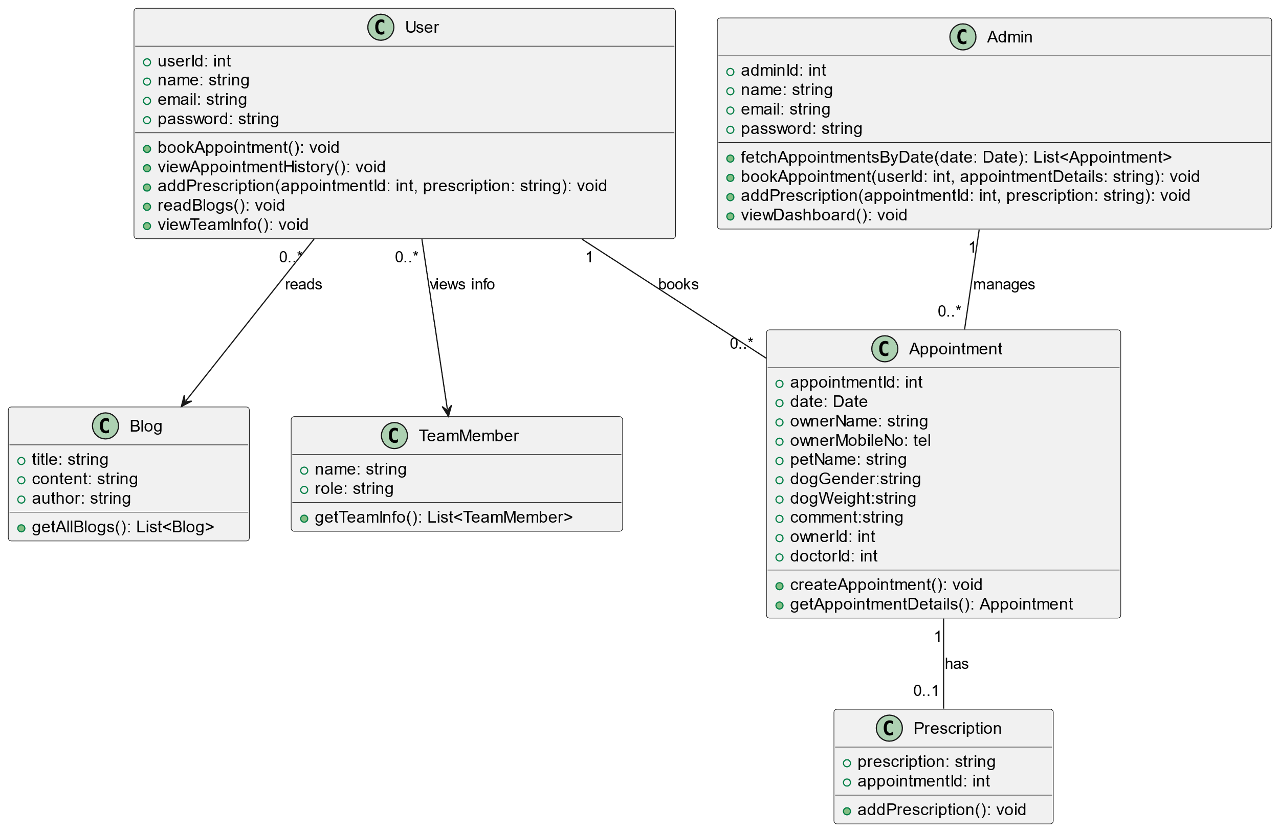

3.5 Module Hierarchy Diagram:

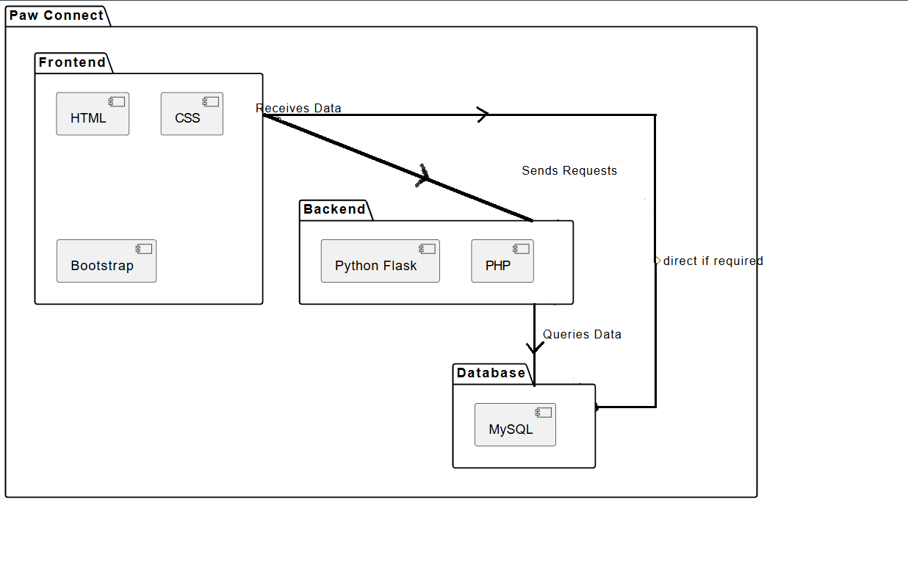

3.6 Table specifications (Database design):

1. admin_users table:

- Purpose: Store ADMIN information for authentication

- Fields:

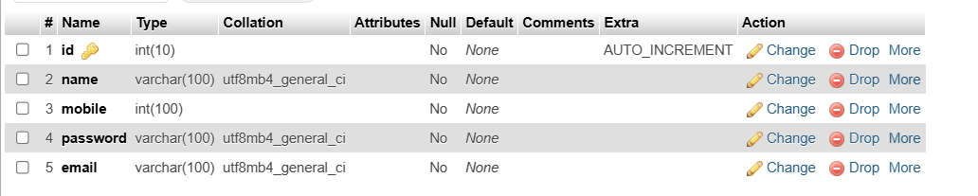

2. users:
- Purpose: Store USER information for authentication.

- Fields:

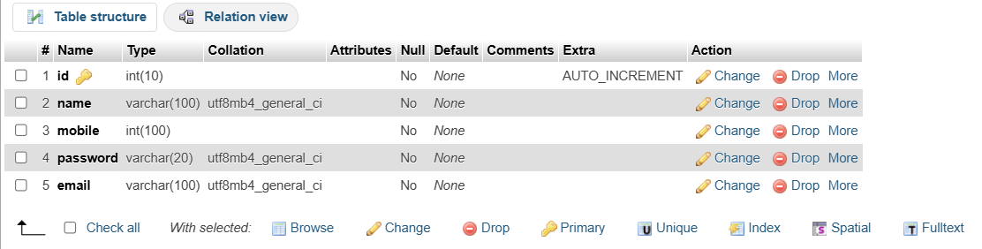

3. appointment_YYYY_MM_DDDD Table:

- Purpose: This table is created dynamically, propose is to book appointment according to date and validate appointment Only 10 appointment per date.

- Fields:

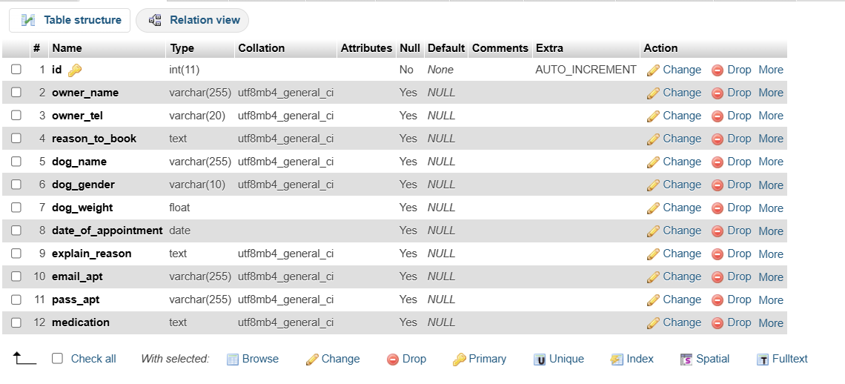

3.7 Data dictionary

Field Name | Data Type | Description | Table Name
id(for admin) | Int | Unique identifier for the admin. | admin_users
id(for User account) | Int | Reference to the userId of the user. | users
email | Varchar | Reference to the email Id of the user. | users
password | Varchar | Reference to the password of the user email. | users
date_of_appointment | date | Date and time the appointment was added to appointments | appointment_yyyy  _mm_dd
Id(Record id in appointments) | Int | Unique record d id created and reference to date of appointment for further modification | appointment_yyyy  _mm_dd
owner_name | string | Reference to owner name who book appointment | appointment_yyyy  _mm_dd
dog_name | string | Reference to dog name for whobook appointment | appointment_yyyy  _mm_dd
dog_gender | string | Reference to dog gender | appointment_yyyy  _mm_dd
email_apt | string | Reference To fatch user appointments | appointment_yyyy  _mm_dd
pass_apt | string | Reference To fatch user appointments | appointment_yyyy  _mm_dd

CHAPTER 4: USER MANUAL

4.1 User Interface Screens (Input):

- User signup :

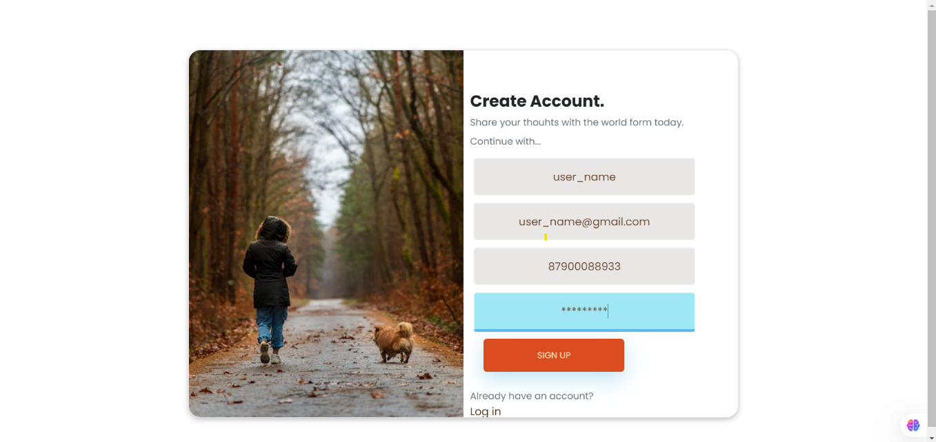

- User login:

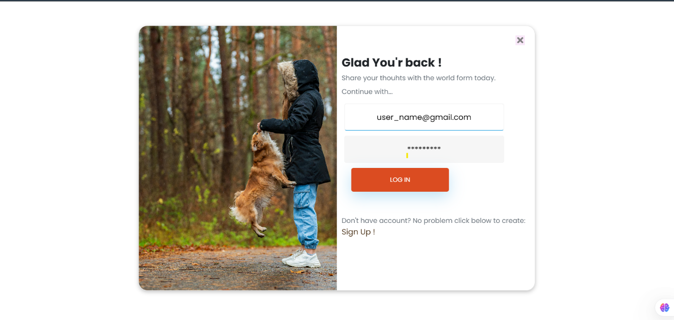

- User Book Appointment input:

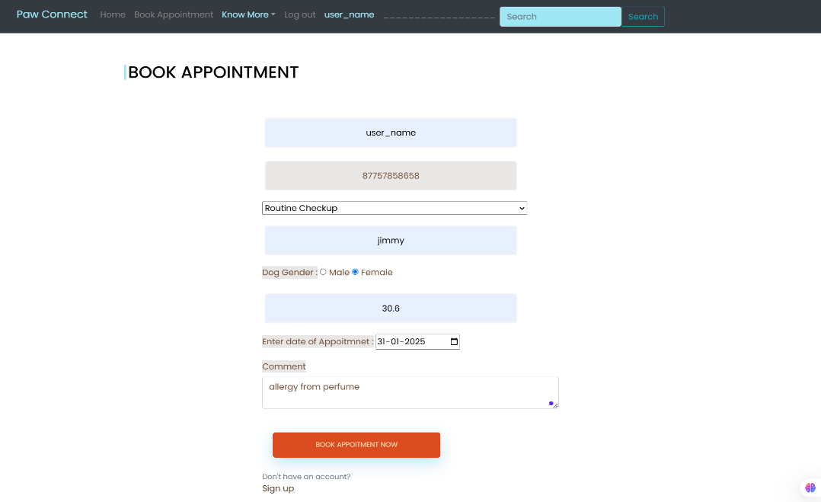

- Admin signup input:

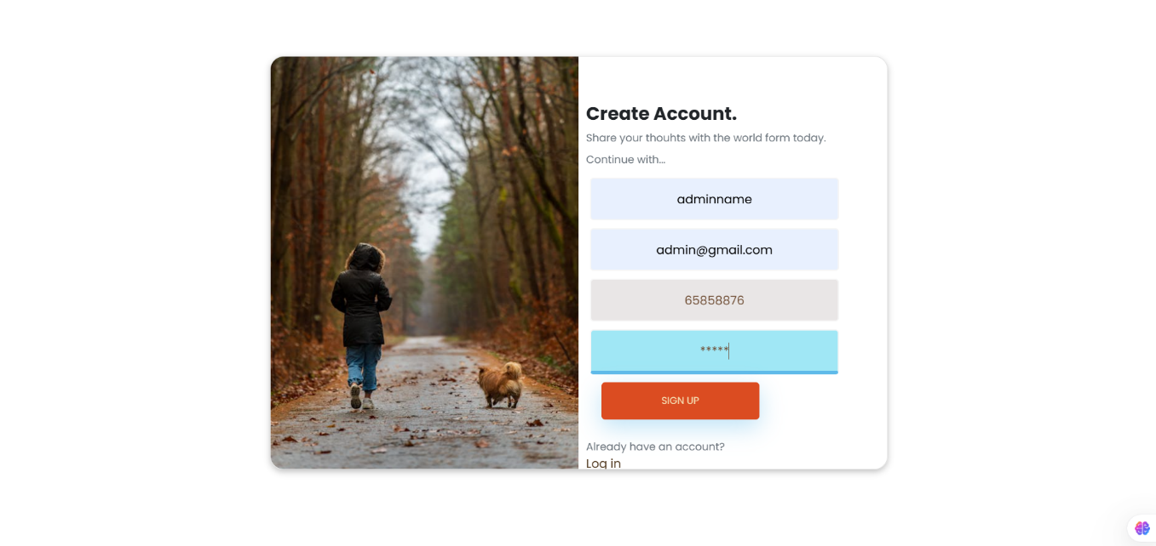

- Admin Login input:

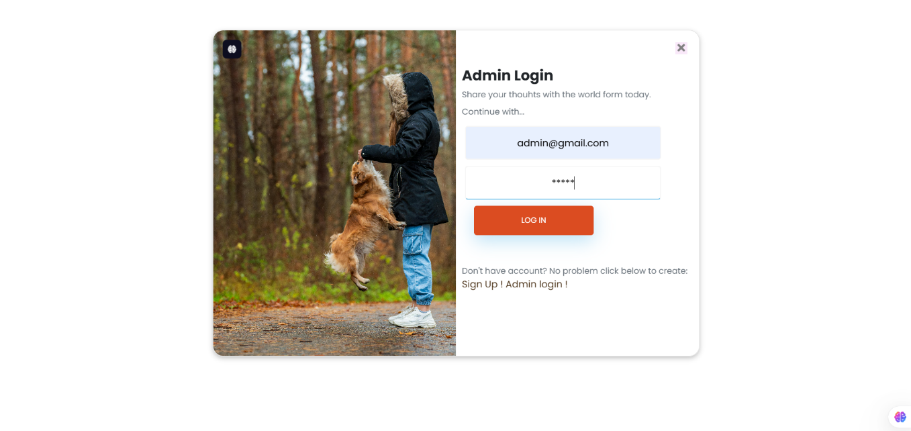

- Admin add prescription:

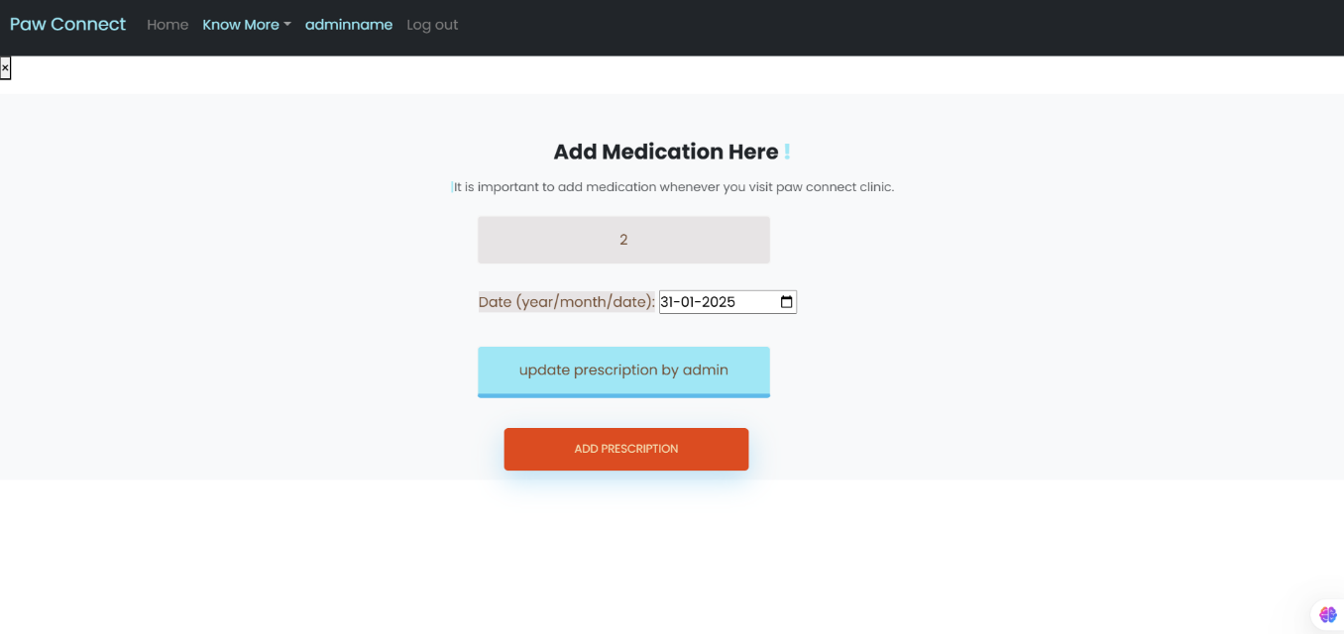

- Admin fetch appointment according to date input:

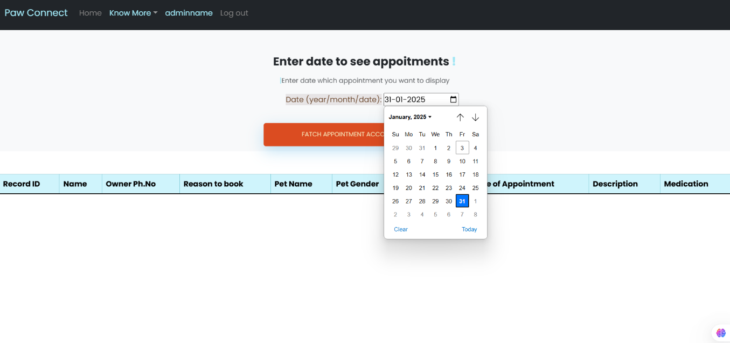

4.2 Output Screens with data:

- User login:

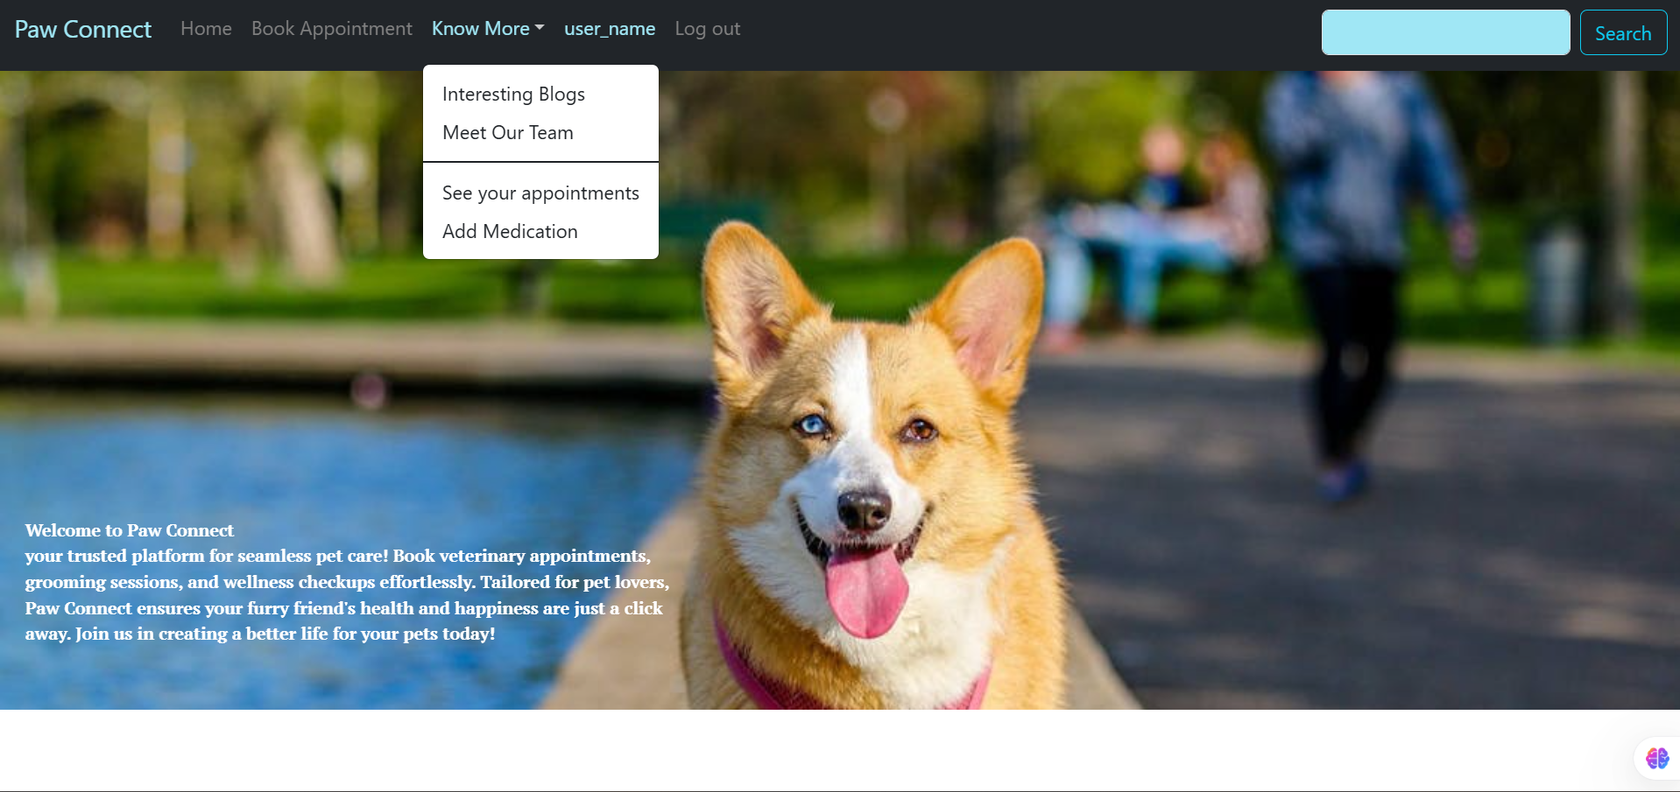

- User Book Appointment Output:

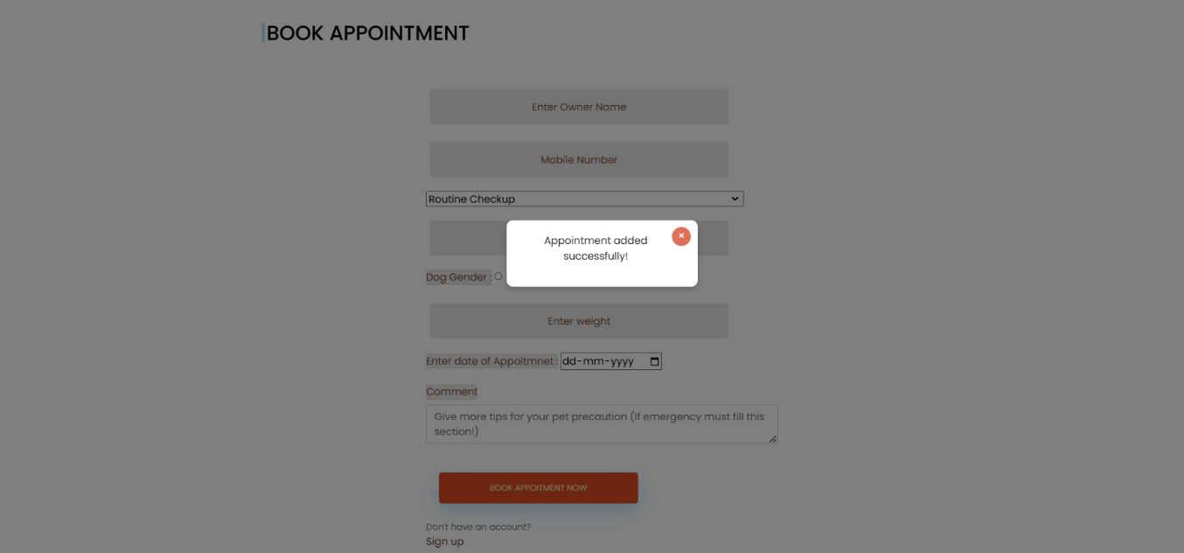

- User appointment history:

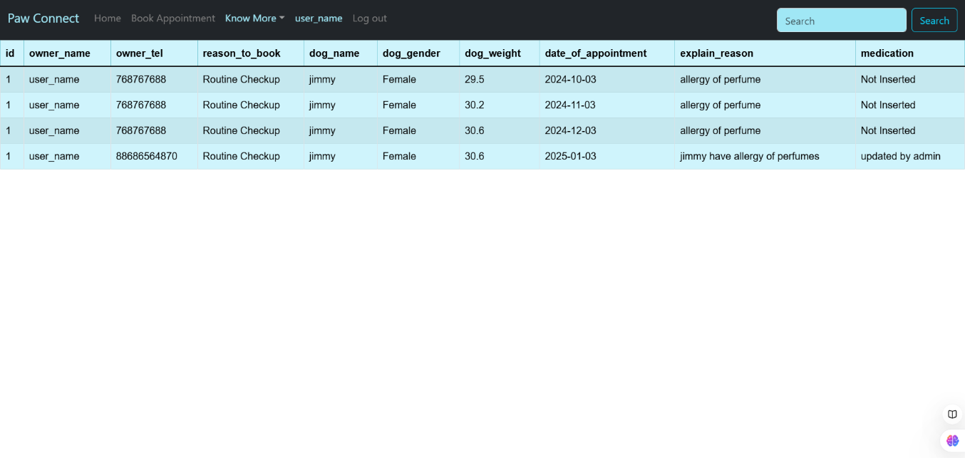

- User blog output 1:

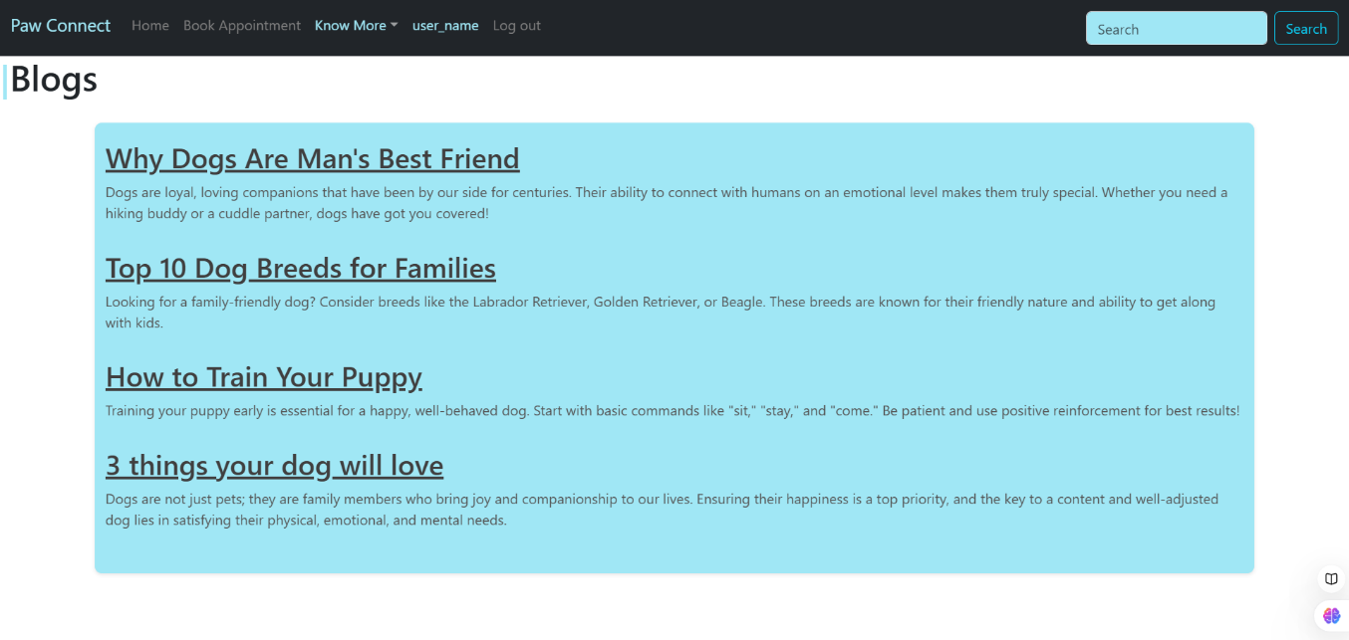

- User blog output 2:

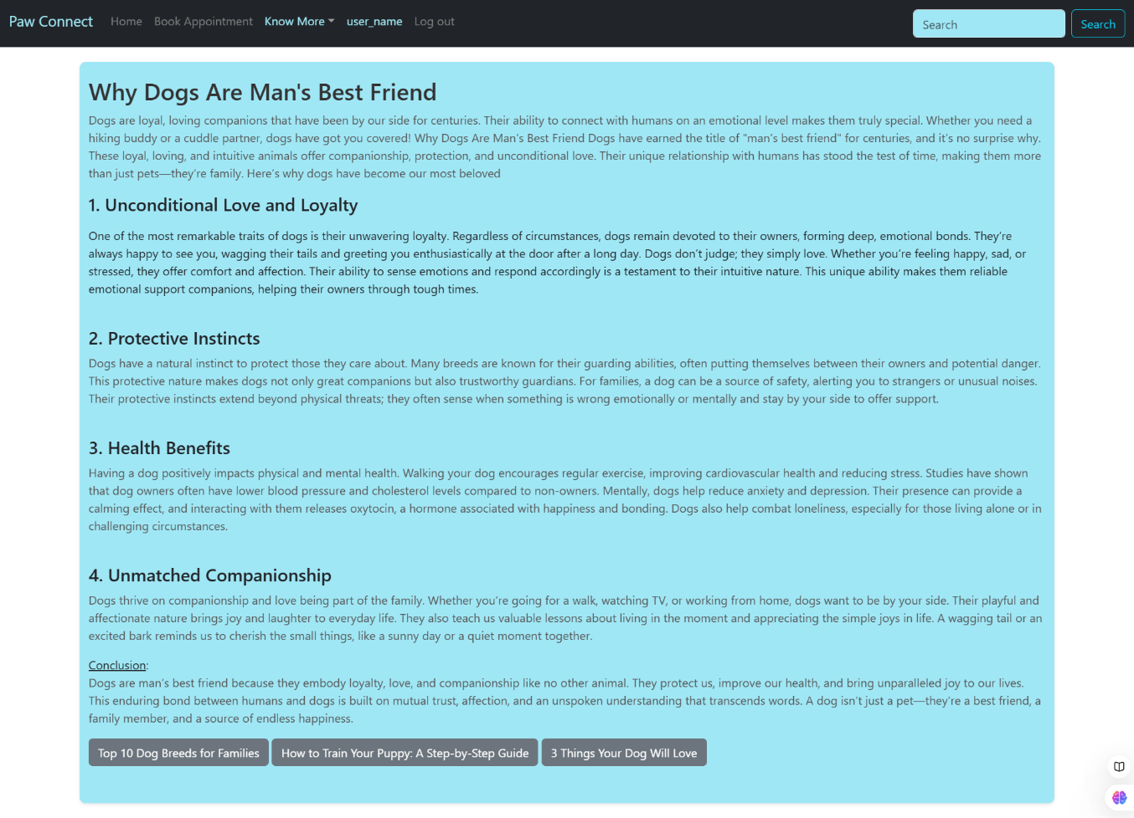

- User team info output:

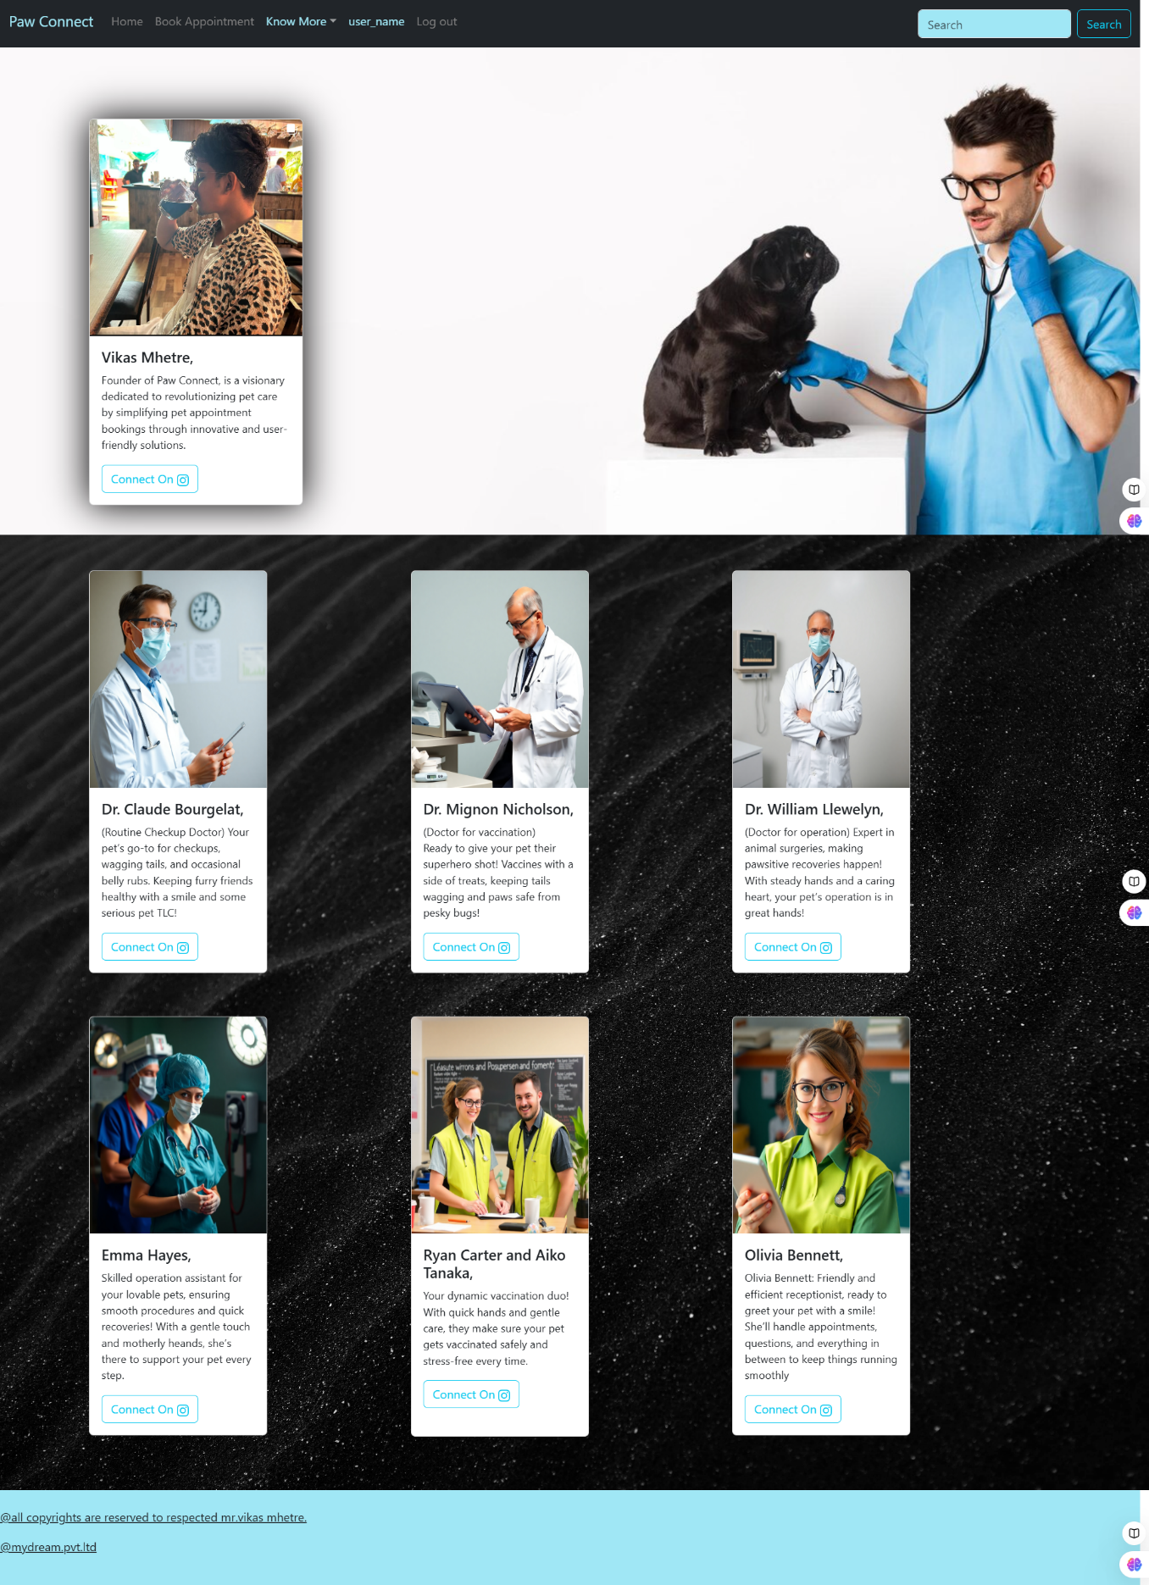

- Admin login output:

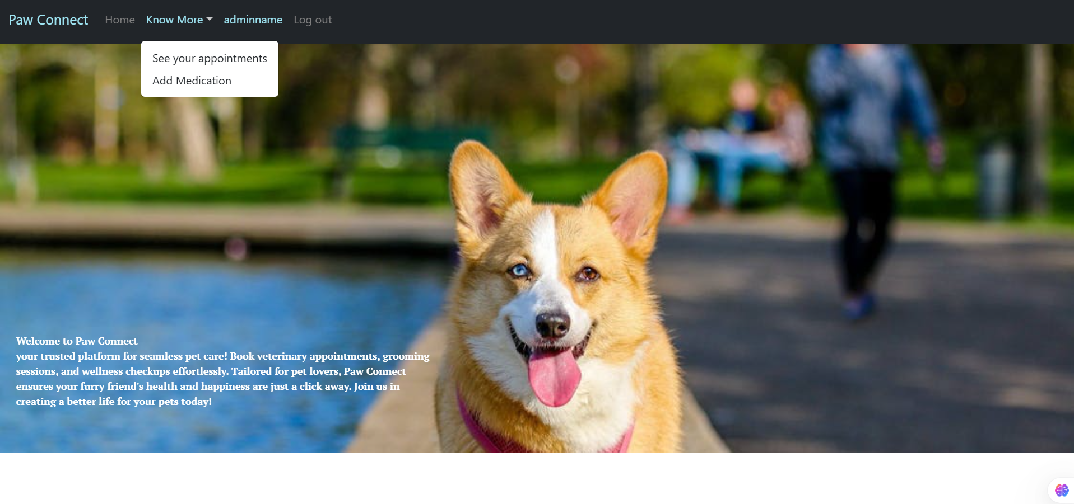

- Admin add prescription output:

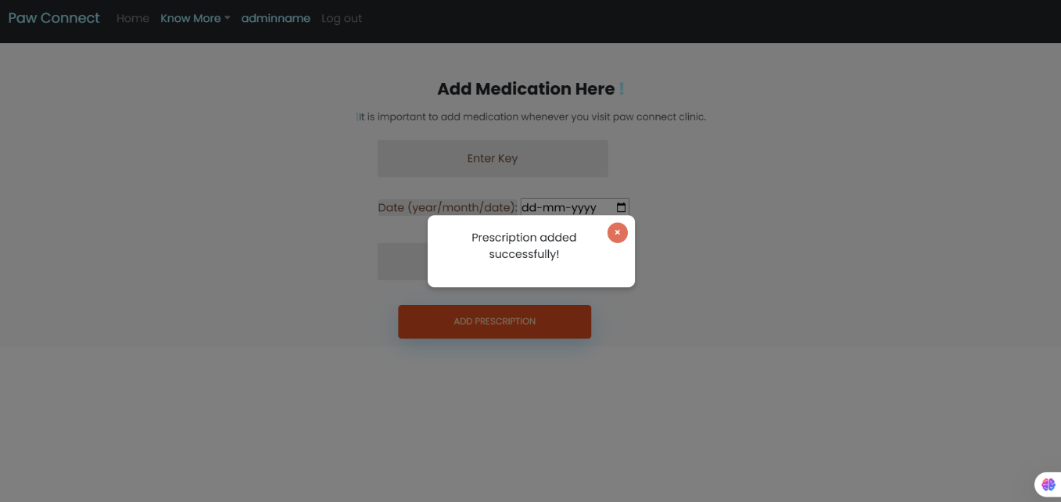

- Admin add prescription output 2:

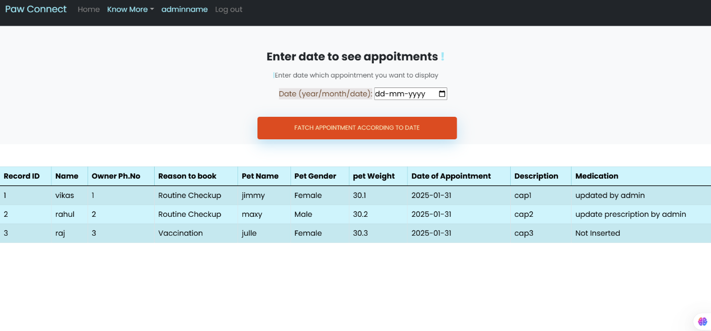

- Admin fetch appointment according to date output:

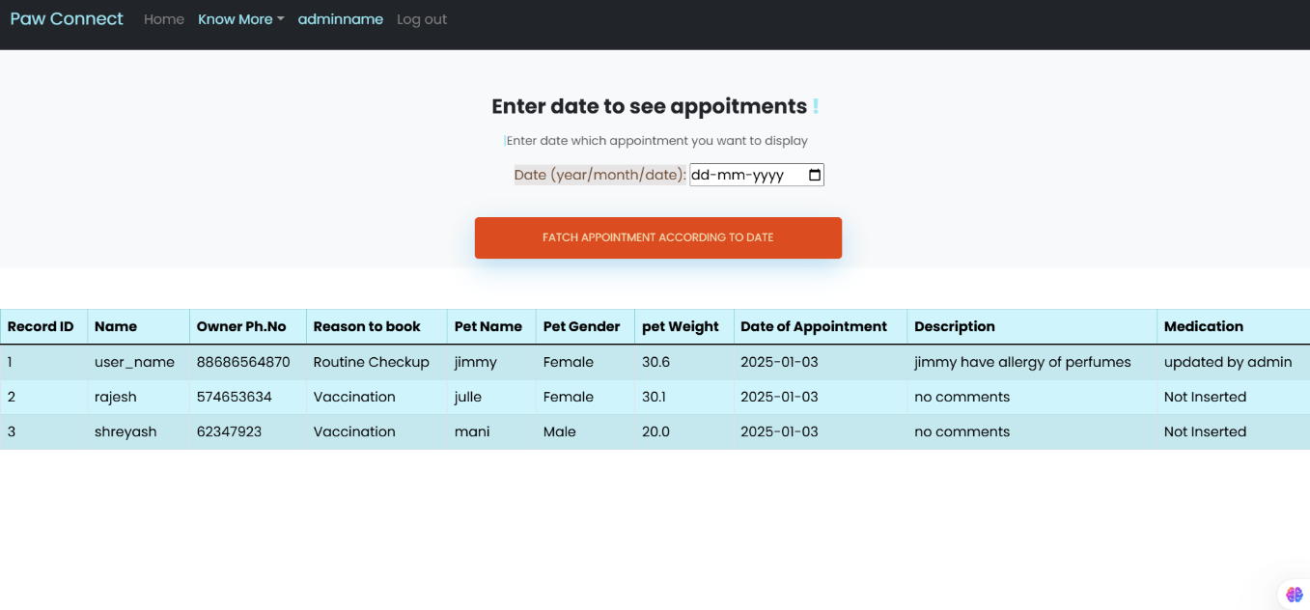

4.3 Data Reports:

- Data report of date 03-12-2024:

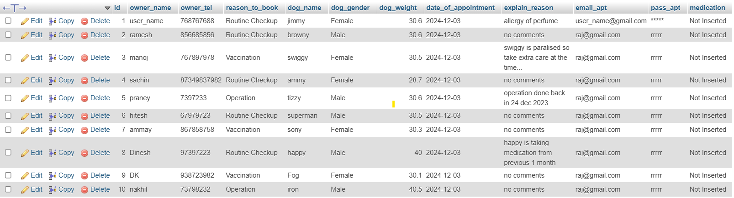

- Data report of date 03-01-2025:

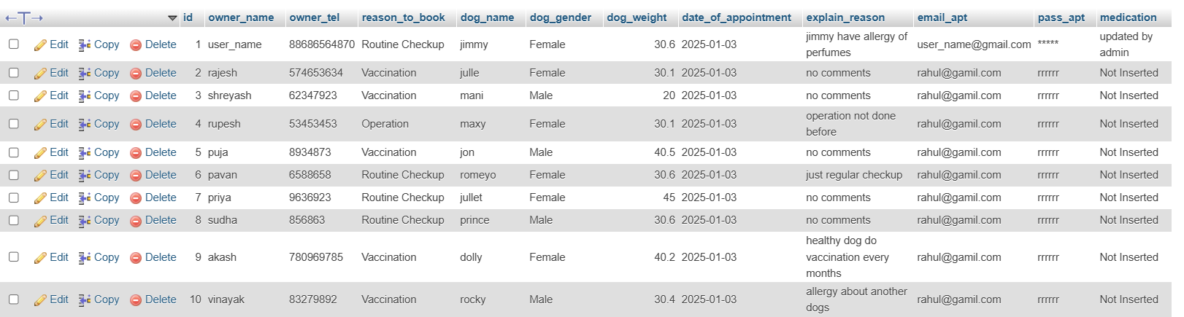

- Data report of user:

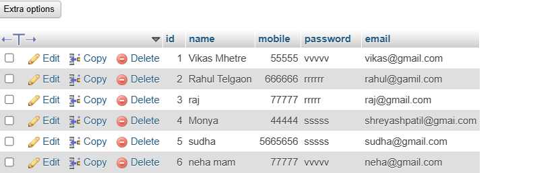

- Data report of admin user:

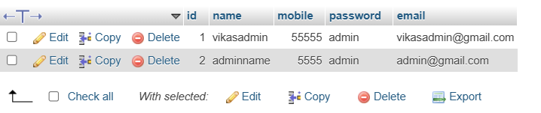

4.4 Sample program code:

from flask import Flask, request, jsonify, render_template, redirect, url_for, session
from flask_mysqldb import MySQL

app = Flask(__name__)
app.secret_key = '8f3bd5c6491a8e29c34e2d56ef4a4e20'

# MySQL Configuration
app.config['MYSQL_HOST'] = 'localhost'
app.config['MYSQL_USER'] = 'root'
app.config['MYSQL_PASSWORD'] = ''
app.config['MYSQL_DB'] = 'myflaskdb'

mysql = MySQL(app)

@app.route('/logout')
def logout():
session.clear()
return render_template("login.php")

@app.route('/create.html')
def create_html():
return render_template("/create.html")

# Create Operation
@app.route('/create', methods=['POST'])
def create_user():
if request.method == 'POST':
name = request.form['name']
email = request.form['email']
mobile=request.form['tel']
password=request.form['password']

cur = mysql.connection.cursor()
cur.execute("INSERT INTO users (name, email, mobile, password) VALUES (%s, %s, %s, %s)", (name, email, mobile, password))
mysql.connection.commit()
cur.execute("SET @id := 0;")
cur.execute("UPDATE users SET id = @id := (@id + 1);")
mysql.connection.commit()
cur.close()
return render_template("/login.php")

@app.route("/update.html")
def update_html():
return render_template("update.html")

#update user
@app.route('/update', methods=['POST'])
def update_user():
user_id = request.form['id'] # Getting ID from the form
name = request.form['name']
email = request.form['email']
cur = mysql.connection.cursor()
cur.execute("UPDATE users SET name=%s, email=%s WHERE id=%s", (name, email, user_id))
mysql.connection.commit()
cur.close()
return render_template("/index.html")

@app.route("/delete.html")
def delete_html():
return render_template("/delete.html")

# Delete Operation (taking ID from form)
@app.route('/delete', methods=['POST'])
def delete_user():
user_id = request.form['id'] # Getting ID from the form
cur = mysql.connection.cursor()
cur.execute("DELETE FROM users WHERE id=%s", (user_id,))
mysql.connection.commit()
cur.execute("SET @id := 0;")
cur.execute("UPDATE users SET id = @id := (@id + 1);")
mysql.connection.commit()
cur.close()

return render_template("/index.html")

@app.route('/read', methods=['GET'])
def read_users():
# Get a cursor to interact with the database
cur = mysql.connection.cursor()

# Execute SQL query to fetch all users
cur.execute("SELECT * FROM users")

# Fetch all the records
users = cur.fetchall()

# Close the cursor after fetching data
cur.close()

# Pass the data to the template and render it
return render_template('read.html', users=users)

@app.route("/signup.php")
def signup_php():
return render_template("signup.php")

@app.route("/admin_signup")
def admin_signup_php():
return render_template("admin_signup.php")

@app.route('/admin_create', methods=['POST'])
def create_admin_user():
if request.method == 'POST':
name = request.form['name']
email = request.form['email']
mobile=request.form['tel']
password=request.form['password']

cur = mysql.connection.cursor()
cur.execute("INSERT INTO admin_users (name, email, mobile, password) VALUES (%s, %s, %s, %s)", (name, email, mobile, password))
mysql.connection.commit()
cur.execute("SET @id := 0;")
cur.execute("UPDATE users SET id = @id := (@id + 1);")
mysql.connection.commit()
cur.close()
return render_template("/admin_login.php")

@app.route('/admin_login')
def admin_login_php():
user=session.get('name', 'name is not register')
return render_template("admin_login.php", user_name=user)

@app.route("/api_login_check",methods=['POST'])
def login_check():
if request.method == 'POST':
# Fetch email and password from form
email = request.form['email']
password = request.form['password']

# Establish database connection and execute query
try:
cur = mysql.connection.cursor()
cur.execute("SELECT * FROM users WHERE email = %s AND password = %s", (email, password))
user = cur.fetchone()

if user:
# Store user data in session
session['email'] = user[4] # Assuming 4th index is email in myflaskdb in table users
session['password'] = user[3] # Assuming 3rd index is password in myflaskdb in table users
session['name']=user[1]

# Redirect to index.html
return render_template('/home.php',user_name=user[1])
else:
# Invalid credentials
session['loginmessage'] = "Invalid UserId or Password!"
return render_template('/login.php', login_message="Invalid UserId or Password!")
except Exception as e:
return jsonify({"error ": str(e)})
else:
return jsonify({"error": "Invalid request method!"})

@app.route("/admin_dashboard.php")
def admin_dashbord_php():
user=session.get('name', 'name is not register')
return render_template("admin_dashboard.php",user_name=user)

@app.route("/api_admin_check",methods=['POST'])
def admin_login_check():
if request.method == 'POST':
# Fetch email and password from form
email = request.form['email']
password = request.form['password']

# Establish database connection and execute query
try:
cur = mysql.connection.cursor()
cur.execute("SELECT * FROM admin_users WHERE email = %s AND password = %s", (email, password))
user = cur.fetchone()

if user:
# Store user data in session
session['email'] = user[4] # Assuming 4th index is email in myflaskdb in table users
session['password'] = user[3] # Assuming 3rd index is password in myflaskdb in table users
session['name']=user[1]

# Redirect to index.html
return render_template('/admin_dashboard.php',user_name=user[1])
else:
# Invalid credentials
session['loginmessage'] = "Invalid UserId or Password!"
return render_template('/admin_login.php', login_message="Invalid UserId or Password!")
except Exception as e:
return jsonify({"error ": str(e)})
else:
return jsonify({"error": "Invalid request method!"})

@app.route('/home.php')
def home_php():
user=session.get('name', 'name is not register')
return render_template("home.php",user_name=user)

@app.route('/book_appointment.php')
def book_appointment():
user=session.get('name', 'name is not register')
return render_template("book_appointment.php", user_name=user)

@app.route('/our_team.php')
def our_team():
user=session.get('name', 'name is not register')
return render_template("our_team.php", user_name=user)

@app.route('/add_appointment', methods=['POST'])
def add_appointment():
if request.method == 'POST':
try:
# Fetch appointment details
owner_name = request.form['owner_name']
owner_tel = request.form['owner_tel']
reason_to_book = request.form['reason_to_book']
dog_name = request.form['dog_name']
dog_gender = request.form['dog_gender']
dog_weight = request.form['dog_weight']
date_of_appointment = request.form['date_of_appointment']
explain_reason = request.form['explain_reason']
email_user = session.get('email', 'Email not set')
password_user = session.get('password', 'Password not set')
medication = "Not Inserted"

# Generate dynamic table name based on the date
table_name = f"appointment_{date_of_appointment.replace('-', '_')}"

# Database interaction
cur = mysql.connection.cursor()

# Check if the table exists; if not, create it dynamically
cur.execute(f"""
CREATE TABLE IF NOT EXISTS `{table_name}` (
id INT AUTO_INCREMENT PRIMARY KEY,
owner_name VARCHAR(255),
owner_tel VARCHAR(20),
reason_to_book TEXT,
dog_name VARCHAR(255),
dog_gender VARCHAR(10),
dog_weight FLOAT,
date_of_appointment DATE,
explain_reason TEXT,
email_apt VARCHAR(255),
pass_apt VARCHAR(255),
medication TEXT
) ENGINE=InnoDB;
""")

# Check the row count in the table
cur.execute(f"SELECT COUNT(*) FROM `{table_name}`")
row_count = cur.fetchone()[0]
if row_count >= 10:
message = "The appointment limit for this date has been reached."
return render_template('/book_appointment.php', user_name=session.get('name', 'Name not registered'), message=message)

# Insert the new appointment
cur.execute(f"""
INSERT INTO `{table_name}`
(owner_name, owner_tel, reason_to_book, dog_name, dog_gender, dog_weight, date_of_appointment, explain_reason, email_apt, pass_apt, medication)
VALUES (%s, %s, %s, %s, %s, %s, %s, %s, %s, %s, %s)
""", (owner_name, owner_tel, reason_to_book, dog_name, dog_gender, dog_weight, date_of_appointment, explain_reason, email_user, password_user, medication))

# Commit the changes
mysql.connection.commit()
cur.close()

# Show success message
message = "Appointment added successfully!"
return render_template('/book_appointment.php', user_name=session.get('name', 'Name not registered'), message=message)

except Exception as e:
# Handle any errors and return a JSON response
message = f"An error occurred: {str(e)}"
return render_template('/home.php', user_name=session.get('name', 'Name not registered'), message=message)
else:
# Return an error for invalid HTTP methods
message = "Invalid request method!"
return render_template('/home.php', user_name=session.get('name', 'Name not registered'), message=message)

@app.route("/appointment_user.php")
def history_appointment_user():
return render_template("appointment_user.php")

@app.route("/history_appointment_user")
def api_history_appointment_user():
try:
# Get email and password from session
email = session.get('email', 'Email not set')
password = session.get('password', 'Password not set')

if not email or not password:
return jsonify({"error": "Email or password not set in session"}), 400

# Get a cursor to interact with the database
cur = mysql.connection.cursor()
mydb = "myflaskdb"

# Get the list of all tables excluding 'users' and 'admin_user'
cur.execute("""
SELECT table_name
FROM information_schema.tables
WHERE table_schema = %s
AND table_name NOT IN ('users', 'admin_user')
""", (mydb,))

tables = cur.fetchall()

all_data = []

# Loop through all tables
for table in tables:
table_name = table[0]

if table_name.isidentifier():
# Ensure email and password are valid columns in the table
cur.execute(f"DESCRIBE `{table_name}`")
columns = [desc[0] for desc in cur.fetchall()]

if "email_apt" in columns and "pass_apt" in columns:
query = f"SELECT * FROM `{table_name}` WHERE email_apt= %s AND pass_apt= %s"
cur.execute(query, (email, password))
rows = cur.fetchall()

# Add each row with the table name and column headers
if rows:
for row in rows:
row_data = dict(zip(columns, row))
row_data["table_name"] = table_name # Add table name to distinguish from other tables
all_data.append(row_data)

cur.close()

# Pass data to the template for rendering
user = session.get('name', 'name is not register')
return render_template('spacific_users_appointments.php', users=all_data, user_name=user)

except Exception as e:
return jsonify({"error": str(e)}), 500

@app.route('/spacific_users_appointments.html')
def spacific_users_appointments():
user=session.get('name', 'name is not register')
return render_template("spacific_users_appointments.php", user_name=user)

@app.route('/add_medication.php')
def update_spacific_user_appoitment_php():
user=session.get('name', 'name is not register')
return render_template("add_medication.php", user_name=user)

@app.route('/add_medication', methods=['POST'])
def update_spacific_user_appoitment():
keys = request.form['key'] # Getting ID from the form
date = request.form['date']
medication = request.form['medication']

# Format the table name dynamically based on the date
table_name = f"appointment_{date.replace('-', '_')}"

# Get a cursor to interact with the database
cur = mysql.connection.cursor()

try:
# Execute the update query dynamically using the table name
cur.execute(f"UPDATE `{table_name}` SET date_of_appointment=%s, medication=%s WHERE id=%s", (date, medication, keys))
mysql.connection.commit()

except Exception as e:
# Handle any potential errors
mysql.connection.rollback()
return jsonify({"error": str(e)}), 500

finally:
cur.close()

user = session.get('name', 'name is not register')
return render_template("add_medication.php", user_name=user)

@app.route('/to_add_medication_display_appointment_update')
def to_add_medication_display_appointment_update():

email_specific = session.get('email', 'Email not set')
password_spacific = session.get('password', 'Password not set')
cur = mysql.connection.cursor()
cur.execute("SELECT * FROM appointment_master WHERE email_apt = %s AND pass_apt = %s", (email_specific, password_spacific))
users = cur.fetchall()
cur.close()
user=session.get('name', 'name is not register')
return render_template('add_medication.php',user_name=user, users=users)

@app.route("/search", methods=["POST"])
def search():
query = request.form.get("query") # Retrieve the search query from the form
if query:
# Example: Search logic
if query.lower() == "book appointment" or query.lower()=="book" or query.lower()=="appointment book" or query.lower()=="book appointments":
user=session.get('name', 'name is not register')
return render_template("book_appointment.php", user_name=user)

elif query.lower() == "add medication" or query.lower()=="medication add" or query.lower()=="medication":
user=session.get('name', 'name is not register')
return render_template("add_medication.php",user_name=user)

elif query.lower() == "team" or query.lower()=="doctors" or query.lower()=="assistants" or query.lower()=="doctor":
user=session.get('name', 'name is not register')
return render_template("our_team.php", user_name=user)

elif query.lower() == "blogs" or query.lower()=="interesting blogs" or query.lower()=="blog" or query.lower()=="anything to read":
user=session.get('name', 'name is not register')
return render_template("blogs.php", user_name=user)

elif query.lower() == "history" or query.lower()=="my appointments history" or query.lower()=="appointments history" or query.lower()=="appointments" or query.lower()=="appointment":
user=session.get('name', 'name is not register')
email_specific = session.get('email', 'Email not set')
password_spacific = session.get('password', 'Password not set')
cur = mysql.connection.cursor()
cur.execute("SELECT * FROM appointment_master WHERE email_apt = %s AND pass_apt = %s", (email_specific, password_spacific))
users = cur.fetchall()

return render_template("spacific_users_appointments.php",users=users ,user_name=user)

elif query.lower() == "home" or query.lower()=="main page" or query.lower()=="home page":
user=session.get('name', 'name is not register')
return render_template("home.php", user_name=user)

else:
user=session.get('name', 'name is not register')
not_searched="May you misspell"
return render_template("home.php",user_name=user, not_searched=not_searched)
else:
user=session.get('name', 'name is not register')
return render_template("home.php",user_name=user)

#all blog post endpoints
@app.route('/blog_1_php')
def blog_one():
user=session.get('name', 'name is not register')
return render_template('blog_1.php', user_name=user)

@app.route('/blog_2_php')
def blog_two():
user=session.get('name', 'name is not register')
return render_template('blog_2.php', user_name=user)

@app.route('/blog_3_php')
def blog_three():
user=session.get('name', 'name is not register')
return render_template('blog_3.php', user_name=user)

@app.route('/blog_4_php')
def blog_():
user=session.get('name', 'name is not register')
return render_template('blog_4.php', user_name=user)

@app.route('/blogs.php')
def blogs():
user=session.get('name', 'name is not register')
return render_template("blogs.php", user_name=user)

@app.route('/admin_history_appointment')
def admin_history_appointment():
user=session.get('name', 'name is not register')
return render_template("admin_history_appointment.php", user_name=user)

@app.route("/api_admin_history_appointment")
def api_admin_history_appointment():
user=session.get('name', 'name is not register')
return render_template('admin_history_appointment.php', user_name=user)

@app.route("/admin_fatch_appointment_as_given_date", methods=["POST"])
def api_admin_according_to_date_history_appointment():
try:
email_specific = session.get('email', 'Email not set')
password_spacific = session.get('password', 'Password not set')

# Get the date from the form
date = request.form.get('date_to_see_appointment') # Use .get() to avoid KeyError

if not date:
return jsonify({"error": "Date is required"}), 400

# Validate and construct the dynamic table name
table_name = f"appointment_{date.replace('-', '_')}"
if not table_name.isidentifier():
return jsonify({"error": "Invalid table name"}), 400

# Get a cursor to interact with the database
cur = mysql.connection.cursor()

# Safely construct the SQL query for dynamic table name
query = f"SELECT * FROM `{table_name}`"
cur.execute(query)

# Fetch all the records
users = cur.fetchall()

# Close the cursor after fetching data
cur.close()

user = session.get('name', 'name is not registered')

# Render the template with the fetched data
return render_template('admin_history_appointment.php', users=users, user_name=user)

except Exception as e:
# Handle any unexpected errors
return jsonify({"error": str(e)}), 500

@app.route('/admin_add_medication.php')
def admin_add_medication():
user=session.get('name', 'name is not register')
return render_template("admin_add_medication.php",user_name=user)

@app.route('/api_admin_add_medication', methods=['POST'])
def api_admin_update_spacific_user_appoitment():
keys = request.form['key'] # Getting ID from the form
date = request.form['date']
medication = request.form['medication']

# Format the table name dynamically based on the date
table_name = f"appointment_{date.replace('-', '_')}"

# Get a cursor to interact with the database
cur = mysql.connection.cursor()

try:
# Execute the update query dynamically using the table name
cur.execute(f"UPDATE `{table_name}` SET date_of_appointment=%s, medication=%s WHERE id=%s", (date, medication, keys))
mysql.connection.commit()

except Exception as e:
# Handle any potential errors
mysql.connection.rollback()
return jsonify({"error": str(e)}), 500

finally:
cur.close()

user=session.get('name', 'name is not register')
message = "Prescription added successfully!"
return render_template("admin_add_medication.php",user_name=user, message=message)

@app.route('/admin_to_add_medication_display_appointment_update')
def admin_to_add_medication_display_appointment_update():

cur = mysql.connection.cursor()
cur.execute("SELECT * FROM appointment_master ")
users = cur.fetchall()
cur.close()
user=session.get('name', 'name is not register')
return render_template('admin_add_medication.php',user_name=user, users=users)

@app.route('/')
def index():
return render_template('/login.php') # Ensure you create a template for this

if __name__ == '__main__':
app.run(debug=True)

- Book Appointment Sample code:

<!DOCTYPE html>
<html lang="en">
<head>

<meta charset="utf-8">
<meta name="viewport" content="width=device-width, initial-scale=1">
<link rel="stylesheet" href="{{ url_for('static', filename='signup_css.css') }}">
<link rel="stylesheet" href="{{ url_for('static', filename='book_appoitment_css.css') }}">
<link rel="stylesheet" href="https://cdn.jsdelivr.net/npm/bootstrap@4.6.2/dist/css/bootstrap.min.css">
<link rel="preconnect" href="https://fonts.googleapis.com">
<link rel="preconnect" href="https://fonts.gstatic.com" crossorigin>
<link href="https://fonts.googleapis.com/css2?family=Josefin+Sans&display=swap" rel="stylesheet">
<link rel="stylesheet" href="css/style.css">
<link rel="icon" href="images/icon.png">
<title>Paw Appointment Booking</title>

</head>
<body>
<nav class="navbar navbar-expand-lg navbar-dark bg-dark" >
<div class="container-fluid">
<a class="navbar-brand" href="#" aria-disabled="true" ><label style="color:rgb(160, 231, 245)">Paw Connect </label></a>
<button class="navbar-toggler" type="button" data-bs-toggle="collapse" data-bs-target="#navbarSupportedContent" aria-controls="navbarSupportedContent" aria-expanded="false" aria-label="Toggle navigation">
<span class="navbar-toggler-icon"></span>
</button>
<div class="collapse navbar-collapse" id="navbarSupportedContent">
<ul class="navbar-nav me-auto mb-2 mb-lg-0">
<li class="nav-item">
<a class="nav-link active" aria-current="page" href="/home.php"><label style="color:gray">Home</label></a>
</li>
<li class="nav-item">
<a class="nav-link" href="/book_appointment.php"><label style="color:gray">Book Appointment </label></a>
</li>

<li class="nav-item dropdown">
<a class="nav-link dropdown-toggle" href="#" id="navbarDropdown" role="button" data-bs-toggle="dropdown" aria-expanded="false"><label style="color:rgb(160, 231, 245)"> Know More </label></a>
<ul class="dropdown-menu" aria-labelledby="navbarDropdown">
<li><a class="dropdown-item" href="/blogs.php">Interesting Blogs </a></li>
<li><a class="dropdown-item" href="/our_team.php">Meet Our Team</a></li>
<li><hr class="dropdown-divider"></li>
<li><a class="dropdown-item" href="/history_appointment_user">See your appointments</a></li>
<li><a class="dropdown-item" href="/add_medication.php">Add Medication</a></li>
</ul>
</li>
<li class="nav-item">
<a class="nav-link" href="/" tabindex="-1" aria-disabled="true"><label style="color:gray">Log out</label></a>
</li>

<li class="nav-item float-right">
<a class="nav-link disabled" href="#" tabindex="-1" aria-disabled="true"><label style="color:rgb(160, 231, 245)">{{ user_name }}</label></a>
</li>
<li class="nav-item">
<a class="nav-link" href="/book_appointment.php"><label style="color:gray">__________________</label></a>
</li>
</ul>

<form class="d-flex" action="/search" method="POST">
<input class="form-control me-2" type="search" name="query" style="background-color: rgb(160, 231, 245);" placeholder="Search" aria-label="Search">
<button class="btn btn-outline-info" type="submit">Search</button>
</form>

</div>
</div>
</nav>

<!-- Bootstrap Bundle with Popper (JS) -->
<script src="https://cdn.jsdelivr.net/npm/bootstrap@5.3.0/dist/js/bootstrap.bundle.min.js"></script>

<script src="https://cdn.jsdelivr.net/npm/jquery@3.6.4/dist/jquery.slim.min.js"></script>
<script src="https://cdn.jsdelivr.net/npm/popper.js@1.16.1/dist/umd/popper.min.js"></script>
<script src="https://cdn.jsdelivr.net/npm/bootstrap@4.6.2/dist/js/bootstrap.bundle.min.js"></script>
<!-- Popup Container -->
<div class="popup-container" id="popup">
<div class="popup-content">
<button class="close-btn" onclick="closePopup()">×</button>
<p id="popup-message"></p>
</div>
</div>

<!-- JavaScript for Popup -->
<script>
// Show the popup if a message is passed
const message = "{{ message|safe }}";
if (message) {
const popup = document.getElementById('popup');
const popupMessage = document.getElementById('popup-message');
popupMessage.textContent = message; // Set the message text
popup.style.display = 'flex'; // Show the popup
}

// Close the popup
function closePopup() {
const popup = document.getElementById('popup');
popup.style.display = 'none'; // Hide the popup
}
</script>

<section class="my-2 container con" >
<div class="py-5">
<h2 class=" pl-2 display-5"><label style="color:rgb(160, 231, 245)"> | </label><label style="color:black"> Book Appointment </label> </h2>
</div>
<div class=" w-50 m-auto">
<form action="/add_appointment" method="post">
<div class="form-group ">
<input type="text" id="name" name="owner_name" class="fadeIn second custom_placeholder" placeholder="Enter Owner Name" required>
<div class="invalid-feedback">Please fill out this field.</div>
</div>
<div class="form-group ">
<input type="text" id="tel" name="owner_tel" class="fadeIn second custom_placeholder" placeholder="Mobile Number" required>
</div>
<div class="form-group " >
<select class="form-select fadeIn second" name="reason_to_book" required>
<option selected value="Routine Checkup" style="color:rgb(112, 78, 53); font-weight: 500;" ><b>Routine Checkup</b></option>
<option value="Vaccination " style="color:rgb(112, 78, 53); font-weight: 500;"><b>Vaccination</b></option>
<option value="Operation " style="color:rgb(112, 78, 53); font-weight: 500;"><b>Operation</b></option>
<option value="Emergency" style="color:red;font-weight: 600;">Emergency (we take pre-precaution before came to clinic)</option>
</select>

</div>

<div class="form-group ">
<input type="text" id="email" name="dog_name" class="fadeIn second custom_placeholder" placeholder="Enter Pet Name" required>
<div class="invalid-feedback">Please fill out this field.</div>
</div>
<div class="form-group fadeIn second " style="color:rgb(112, 78, 53)">
<label style="background-color: #e1ddddbb;">Dog Gender :</label>
<input type="radio" id="html" name="dog_gender" value="Male">
<label for="html">Male</label>
<input type="radio" id="css" name="dog_gender" value="Female">
<label for="css">Female</label>
</div>
<div class="form-group ">
<input type="text" class="fadeIn second custom_placeholder" id="password" name="dog_weight" placeholder="Enter weight"></br>
</div>
<div class="form-group fadeIn second " style="color:rgb(112, 78, 53)">
<label style="background-color: #e1ddddbb;">Enter date of Appoitmnet : </label>
<input type="date" placeholder="Enter Date of Appointment " class="custom_placeholder" name="date_of_appointment"></br>
</div>

<div class="form-group fadeIn second " style="color:rgb(112, 78, 53)">
<label style="background-color: #e1ddddbb;"> Comment </label>
<textarea name="explain_reason" class="form-control" style="color:rgb(112, 78, 53)" placeholder="Give more tips for your pet precaution (If emergency must fill this section!) "></textarea>
</div>

<div class="form-group "><br>
<input type="submit" class="fadeIn fourth " value="Book Appoitment Now">
</div>
<div class="mt-3">
<p class="fadeIn fourth mb-0 text-muted color_font">Don't have an account?</p>
<a href="/signup.php"><div class="fadeIn fourth " id="log_in_button">Sign up</div></a>
</div>
</form>

</section>

</body>
</html>

- User Dashboard sample code:

<!DOCTYPE html>
<html>
<head>

<meta charset="UTF-8">
<meta name="viewport" content="width=device-width, initial-scale=1.0">
<!-- google fonts -->
<link rel="preconnect" href="https://fonts.googleapis.com">
<link rel="preconnect" href="https://fonts.gstatic.com" crossorigin>
<link href="https://fonts.googleapis.com/css2?family=Oswald:wght@200..700&family=PT+Serif:ital,wght@0,400;0,700;1,400;1,700&family=Roboto+Mono:ital,wght@0,100..700;1,100..700&display=swap" rel="stylesheet">
<!-- Google fonts end -->

<link rel="stylesheet" href="{{ url_for('static', filename='add_medication_css.css') }}">
<link rel="stylesheet" href="{{ url_for('static', filename='signup_css.css') }}">

<link rel="stylesheet" href="https://cdn.jsdelivr.net/npm/bootstrap@4.6.2/dist/css/bootstrap.min.css">
<link rel="preconnect" href="https://fonts.googleapis.com">
<link rel="preconnect" href="https://fonts.gstatic.com" crossorigin>
<link href="https://fonts.googleapis.com/css2?family=Josefin+Sans&display=swap" rel="stylesheet">
<link rel="stylesheet" href="css/style.css">

<link href="//maxcdn.bootstrapcdn.com/bootstrap/4.0.0/css/bootstrap.min.css" rel="stylesheet" id="bootstrap-css">
<link rel="stylesheet" href="{{ url_for('static', filename='spacific_user_appointments_css.css') }}">

<link href="https://cdn.jsdelivr.net/npm/bootstrap@5.3.2/dist/css/bootstrap.min.css" rel="stylesheet" integrity="sha384-rbsA2VBKQ0HRfSuC5I+4/yekEVnmIQLA4WbVZY72qUk5zK3n9NT1BsWuP9W2J+0U" crossorigin="anonymous">
<link href="https://cdn.jsdelivr.net/npm/bootstrap@5.0.1/dist/css/bootstrap.min.css" rel="stylesheet" >
<link href="https://cdn.jsdelivr.net/npm/bootstrap@5.0.1/dist/js/bootstrap.bundle.min.js" rel="stylesheet" >
<link href="https://cdnjs.cloudflare.com/ajax/libs/jquery/3.2.1/jquery.min.js" rel="stylesheet" >
<link href="https://cdnjs.cloudflare.com/ajax/libs/jquery/3.2.1/jquery.min.js" rel="stylesheet" >
<link href="https://use.fontawesome.com/releases/v5.7.2/css/all.css" rel="stylesheet" >
<link href="https://cdn.jsdelivr.net/npm/bootstrap@5.3.0/dist/css/bootstrap.min.css" rel="stylesheet">

<title>Spacific_user_php</title>
</head>
<body>

<nav class="navbar navbar-expand-lg navbar-dark bg-dark">
<div class="container-fluid">
<a class="navbar-brand " href="#" aria-disabled="true"><label style="color:rgb(160, 231, 245)">Paw Connect </label></a>
<button class="navbar-toggler" type="button" data-bs-toggle="collapse" data-bs-target="#navbarSupportedContent" aria-controls="navbarSupportedContent" aria-expanded="false" aria-label="Toggle navigation">
<span class="navbar-toggler-icon"></span>
</button>
<div class="collapse navbar-collapse" id="navbarSupportedContent">
<ul class="navbar-nav me-auto mb-2 mb-lg-0">
<li class="nav-item">
<a class="nav-link active" aria-current="page" href="/admin_dashboard.php"><label style="color:gray">Home</label></a>
</li>
<li class="nav-item dropdown">
<a class="nav-link dropdown-toggle" href="#" id="navbarDropdown" role="button" data-bs-toggle="dropdown" aria-expanded="false"><label style="color:rgb(160, 231, 245)"> Know More </label></a>
<ul class="dropdown-menu" aria-labelledby="navbarDropdown">
<li><a class="dropdown-item" href="/api_admin_history_appointment">See your appointments</a></li>
<li><a class="dropdown-item" href="/admin_add_medication.php">Add Medication</a></li>
</ul>
</li>
<li class="nav-item">
<a class="nav-link" href="#" tabindex="-1" aria-disabled="true"><label style="color:rgb(160, 231, 245)">{{ user_name }}</label></a>
</li>
<li class="nav-item">
<a class="nav-link" href="/" tabindex="-1" aria-disabled="true"><label style="color:gray">Log out</label></a>
</li>
</ul>
</div>
</div>
</nav>

<!-- Bootstrap Bundle with Popper (JS) -->
<script src="https://cdn.jsdelivr.net/npm/bootstrap@5.3.0/dist/js/bootstrap.bundle.min.js"></script>

<div class=" box_2_medication_css d-flex flex-column h-100">
<div class="mt-5">
<p class="mb-1 h-1"> Enter date to see appoitments <label class="color_font"> ! <t></label></p>
<p class="text-muted mb-2"><label class="color_font"> | <t></label>Enter date which appointment you want to display </p>
<div class="d-flex flex-column ">
<div class="d-flex align-items-center">
<form action="/admin_fatch_appointment_as_given_date" method="POST">
<label style="color:rgb(112, 78, 53); background-color: #e1ddddbb; margin-left: 2em;" class="fadeIn second ">Date (year/month/date):</label>
<input type="date" name="date_to_see_appointment" id="name" class="fadeIn second custom_placeholder " required><br><br>
<input type="submit" class="fadeIn fourth " style="margin-left: 2em;" value="Fatch appointment according to date">
</form>
</div>
</div>

</div>
</div>
<br>
<br>

<!-- <h1 class="fadeIn first">All Users</h1>

<-- Table to display the users -->
<table border="1" class="table table-info table-striped table-hover table-bordered">
<thead>
<tr class="fadeIn first">
<th>Record ID</th>
<th>Name</th>
<th>Owner Ph.No</th>
<th>Reason to book</th>
<th>Pet Name </th>
<th>Pet Gender</th>
<th>pet Weight </th>
<th>Date of Appointment</th>
<th>Description</th>
<th>Medication</th>

</tr>
</thead>
<tbody class="fadeIn second">
<!-- {% set seen = [] %} -->
{% for user in users %}
{% if user in users %}
<!-- {% set _ = seen.append(user|tojson) %} -->
<tr>
<td>{{ user[0] }}</td> <!-- user[0] is the ID -->
<td>{{ user[1] }}</td> <!-- user[1] is the Name -->
<td>{{ user[2] }}</td> <!-- user[2] is the Email -->
<td>{{ user[3] }}</td> <!-- user[2] is the Email -->
<td>{{ user[4] }}</td> <!-- user[2] is the Email -->
<td>{{ user[5] }}</td> <!-- user[2] is the Email -->
<td>{{ user[6] }}</td> <!-- user[2] is the Email -->
<td>{{ user[7] }}</td> <!-- user[2] is the Email -->
<td>{{ user[8] }}</td> <!-- user[2] is the Email -->
<td>{{ user[11] }}</td> <!-- user[2] is the Email -->
</tr>
{% endif %}
{% endfor %}
</tbody>
</table>

</body>
</html>

4.5 Limitations
- Internet Dependency: The system requires a stable internet connection for optimal functionality.
- Limited Mobile App Integration: Currently, the platform is web-based and lacks a dedicated mobile application.
- Feature Expansion: Advanced features such as automated reminders and integrated payment gateways are not yet implemented.
- Device Compatibility: While the system supports major web browsers, older devices with outdated browsers may face compatibility issues.
- Customization Limits: The system’s features are predefined, and significant customization requires backend code modifications.

Bibliography
- Flask Documentation: https://flask.palletsprojects.com/
- PHP Official Website: https://www.php.net/
- MySQL Documentation: https://dev.mysql.com/doc/
- Bootstrap Documentation: https://getbootstrap.com/
- Web Accessibility Guidelines: https://www.w3.org/WAI/

