SYNOPSIS

ON

Paw Connect

By

Vikas Manik Mhetre

MCA – I SEM – I

A.Y. 2024-25

Under The Guidance Of
Neha Dhakol

Suryadatta Education Foundations
Suryadatta Institute of Management and Mass Communication, Pune-21

PAW CONNECT

Project Guide Name: Neha Dhakol

Student Name & Signature: VIKAS MANIK MHETRE

Date: 16 November 2024

Place: Pune

Sr. No | Contents | Pg. No.
1 | INTRODUCTION | 4-5
 | 1 Introduction
 | 2 Features
 | 3 Existing System and Need for System
 | 4 Scope of Work
 | 5 Operating Environment – Hardware , Software
 | 6 Detail Description of Technology Used
2 | PROPOSED SYSTEM | 6-7
 | 2.1 Proposed System
 | 2.1.1 Feasibility Study
 | Technical Feasibility
 | Economic Feasibility
 | Operational Feasibility
 | 2.2 Objectives of System
 | 2.3 User Requirements
3 | UML Diagrams | 8-9
 | 3.1 Use Case Diagram
 | 3.2 Activity Diagram
 | 3.3 Module Hierarchy Diagram
4 | Functional and Non-functional Analysis | 10-11
 | 4.1 Functional
 | 4.1.1 Identification of core system function
 | 4.1.2 User interaction workflow
 | 4.2 Non-Functional
 | 4.2.1Performance requirements
 | 4.2.2 Security requirements.
 | 4.2.3 Usability and accessibility standards.
 | 4.2.4 Reliability and availability.
 | 4.2.5 Maintainability and extensibility.
 | 4.2.6 Compliance with regulations or standards
5 | Risks | 12
 | 6.1 Technical Risks
 | 6.2 Schedule Delays
 | 6.3 Requirement Changes
6 | Limitations | 13
 | 7.1 Hardware Constraints
 | 7.2 Software Compatibility Issues
 | 7.3 Performance Bottlenecks | 14
7 | Proposed System Overview

INDEX

Software Requirements Specification (SRS) Document for PAW CONNECT

1. INTRODUCTION

1.1 Introduction

PAW CONNECT is a comprehensive web-based solution designed to streamline the operations of pet dog clinics. It offers a range of services including appointment booking, medical history tracking, job applications, blog hosting, team information, clinic details, and dog breed information. This document outlines the requirements and specifications for the development of the PAW CONNECT system.

1.2 Features

- Book Appointment: Allows pet owners to schedule appointments for their dogs.
- Pet Medical History: Displays past appointment dates, medications provided, and the doctors involved.
- Job Application: Enables individuals to apply for jobs at the pet clinic.
- Blogs: Hosts articles and blog posts related to dogs.
- Our Team: Provides information about the clinic's staff, including doctors and caretakers.
- Home: Displays general information about the clinic, such as location, contact details, and patient statistics.
- Meet My Cousin: Offers information on different dog breeds.

1.3 Existing System and Need for System

- Fragmentation: Existing systems are often fragmented, leading to inefficiencies.
- Manual Processes: Many clinics rely on manual processes, which are time-consuming and error-prone.
- Unified Solution: There is a need for a unified system to streamline operations and improve service delivery.
- User Experience: Enhancing the user experience for pet owners and clinic staff is crucial.

1.4 Scope of Work

- Appointment Management: Streamline the process of booking and managing appointments.
- Medical Records: Maintain comprehensive medical histories for pets.
- Job Applications: Facilitate online job applications for potential clinic employees.
- Content Hosting: Provide a platform for hosting dog-related blogs.
- Team Information: Offer detailed information about clinic staff.
- Clinic Details: Provide general information about the clinic's operations and statistics.
- Breed Information: Educate users about different dog breeds.

1.5 Operating Environment – Hardware, Software

- Hardware:
- Web server to host the application.
- Database server to manage data.
- User devices such as PCs, tablets, and smartphones.
- Software:
- Frontend: HTML, CSS, Bootstrap for design and responsiveness.
- Backend: Python Flask for handling backend logic, PHP for server-side scripting.
- Database: MySQL for data management.
- Browsers: Compatibility with web browsers like Chrome, Firefox, and Safari.

1.6 Detail Description of Technology Used
- HTML, CSS, Bootstrap: Utilized for creating a responsive and user-friendly frontend.
- Python Flask: Chosen for its simplicity and effectiveness in handling backend logic and routing.
- PHP: Used for processing server-side scripting needs.
- MySQL: Selected for its reliability and efficiency in managing relational databases.

2. PROPOSED SYSTEM

2.1 Proposed System
PAW CONNECT proposes a centralized web application designed to manage various aspects of pet clinic operations, providing a user-friendly interface for pet owners, clinic staff, and job applicants.

2.2 Feasibility Study
A feasibility study was conducted to evaluate the practicality and benefits of PAW CONNECT.

2.3 Technical Feasibility
- Technology Stack: The selected technology stack (HTML, CSS, Bootstrap, Python Flask, PHP, MySQL) is robust, well-supported, and capable of meeting the system requirements.
- Development Tools: Availability of development tools and resources to support the technology stack.
- Community Support: Extensive community support and documentation for troubleshooting and enhancements.

2.4 Economic Feasibility
- Cost-Effective: Utilization of open-source technologies reduces development and maintenance costs.
- Return on Investment: The system's potential to increase clinic efficiency and attract more clients justifies the initial investment.
- Budget Allocation: Proper budget allocation for development, deployment, and maintenance.

2.5 Operational Feasibility
- Implementation: Straightforward implementation process due to the user-friendly design of the system.
- Training: Minimal training required for staff due to the intuitive interface.
- Maintenance: Regular maintenance and updates to ensure smooth operation.

2.6 Objectives of System
- To provide a unified platform for managing pet clinic operations.
- To reduce manual workload and improve efficiency.
- To enhance the experience for pet owners and clinic staff.
- To offer valuable information and resources related to dog care.

2.7 User Requirements
- Pet Owners:
- Ability to book and manage appointments.
- Access to their pet's medical history.
- Informative content related to dog care.
- Clinic Staff:
- Manage appointments and medical records.
- Access job applications and manage staff information.
- Publish blogs and informational content.
- Job Applicants:
- Apply for available positions at the clinic.
- Access information about the clinic and its staff.

3.UML Diagrams:

3.1: Use case Diagram:

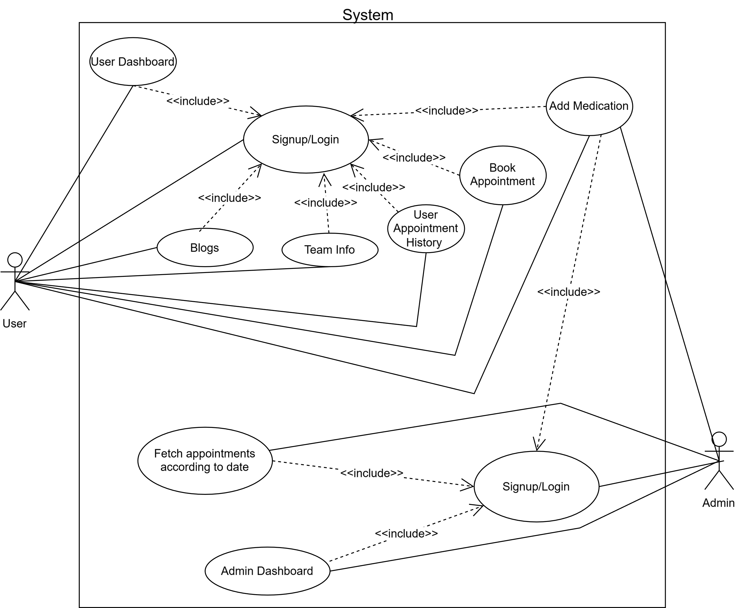

3.2 Activity diagram:

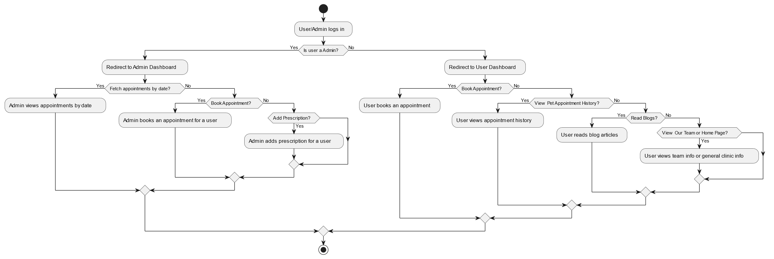

3.3 Module hierarchical diagram:
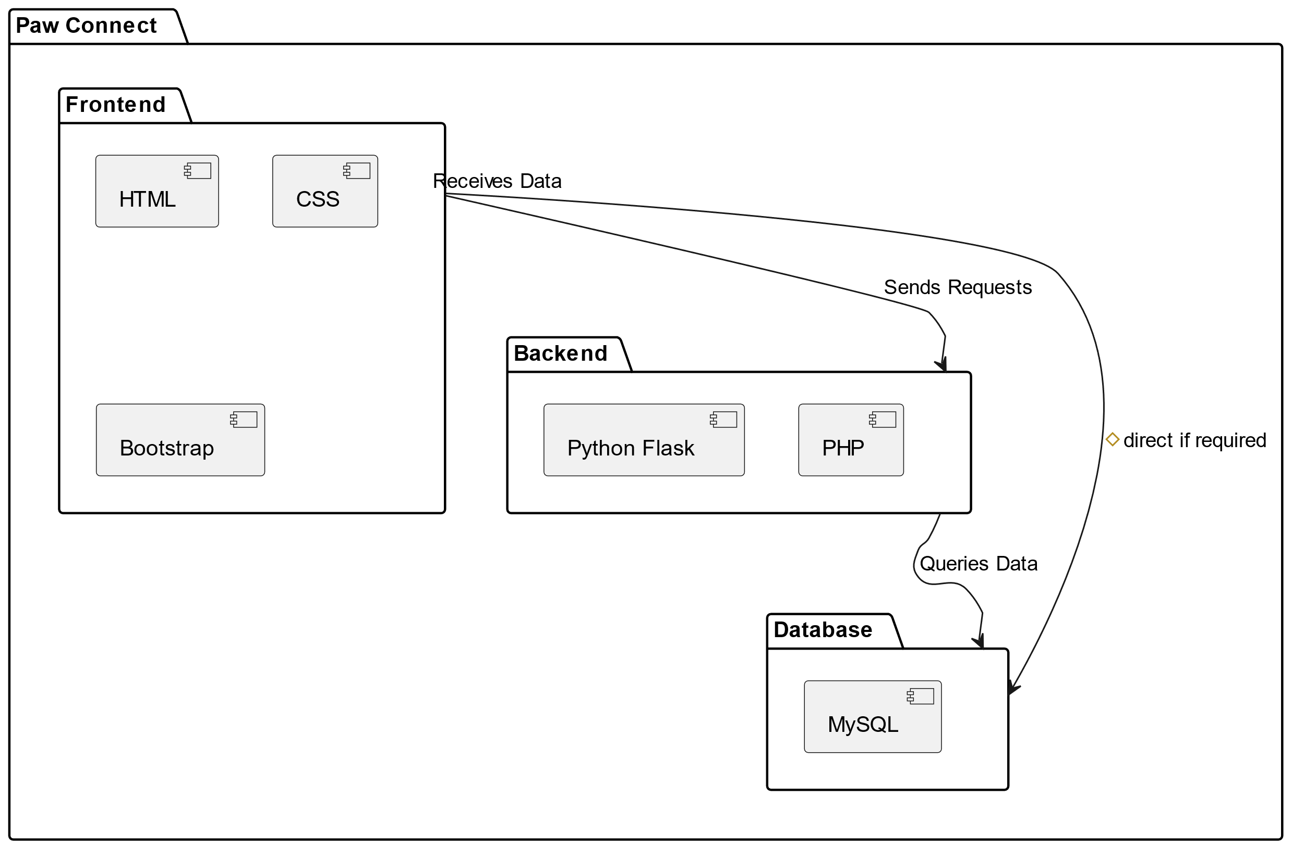

4. FUNCTIONAL AND NON-FUNCTIONAL ANALYSIS

4.1 Functional

4.1.1 Identification of Core System Functions
- Appointment Booking System: Allows users to schedule, view, and manage appointments.
- Medical History Tracking: Maintains and displays the medical history of pets.
- Job Application System: Enables online job application submissions.
- Blog Hosting Platform: Hosts and displays blog posts related to dog care.
- Staff Information Management: Manages and displays information about clinic staff.
- Clinic Information Display: Provides general information about the clinic.
- Dog Breed Information: Offers details on various dog breeds.

4.1.2 User Interaction Workflow
1. Pet Owners:
- Register/Login to the system.
- Navigate to 'Book Appointment' to schedule an appointment.
- View appointment history and medical records in 'Our Pet History'.
- Read blogs in the 'Blog' section.
- Access breed information in 'Meet My Cousin'.
2. Clinic Staff:
- Login to the system.
- Manage appointments and update medical records.
- Review job applications in the 'Job' section.
- Update team information in 'Our Team'.
- Publish new blog posts in the 'Blog' section.
3. Job Applicants:
- Navigate to the 'Job' section.
- Fill out and submit the job application form.

4.2 Non-Functional:

4.2.1 Performance Requirements
- Speed: The system should respond to user requests within 2 seconds.
- Scalability: The system should handle up to 10,000 concurrent users.

4.2.2 Security Requirements
- Data Encryption: Encrypt sensitive data during transmission and storage.
- Authentication: Implement strong user authentication mechanisms.
- Authorization: Ensure role-based access control to protect sensitive information.

4.2.3 Usability and Accessibility Standards
- Usability: The interface should be intuitive and easy to navigate.
- Accessibility: The system should comply with WCAG 2.1 standards to ensure accessibility for users with disabilities.

4.2.4 Reliability and Availability
- Uptime: The system should have an uptime of 99.9%.
- Backup: Regular data backups to prevent data loss.

4.2.5 Maintainability and Extensibility
- Code Quality: Ensure high code quality to facilitate easy maintenance.
- Modular Design: Use a modular design approach to allow for future enhancements.

4.2.6 Compliance with Regulations or Standards
- Data Protection: Comply with GDPR and other relevant data protection regulations.
- Industry Standards: Follow best practices and standards in web development.

5. RISKS:

5.1 Technical Risks
- Integration Issues: Potential challenges in integrating different technologies.
- Data Security: Risk of data breaches or unauthorized access.

5.2 Schedule Delays
- Development Delays: Potential delays in development due to unforeseen issues.
- Resource Constraints: Limited availability of resources may impact the schedule.

5.3 Requirement Changes
- Scope Creep: Risk of additional requirements emerging during the development process.
- Client Feedback: Changes based on client feedback may alter the project timeline.

6. LIMITATIONS:

- Hardware Constraints: Older devices may experience lag with animations; low storage limits AsyncStorage capacity.
- Scalability Constraints: AsyncStorage’s local storage limits handling of extensive task/note datasets, potentially causing performance issues.
- Feature Expansion: Adding complex features like cloud sync or collaboration requires significant backend integration, challenging the current architecture.
- Cross-Platform Consistency: Variations in iOS/Android rendering may lead to inconsistent animations or UI behavior, requiring extensive testing.

7. PROPOSED SYSTEM OVERVIEW:

PAW CONNECT aims to provide a centralized, user-friendly web application to manage various aspects of pet clinic operations. The proposed system will streamline appointment bookings, maintain comprehensive medical histories, facilitate job applications, host dog-related blogs, manage clinic staff information, and educate users about different dog breeds. By leveraging modern web technologies, PAW CONNECT seeks to enhance the efficiency, security, and overall experience for pet owners, clinic staff, and job applicants.

---

This SRS document provides a detailed overview of the PAW CONNECT system, outlining the necessary requirements and specifications for its development.

