GCS Prioritization Index
Detailed Operational User Guide
A guide for support analysts, queue owners, shift leads, and leadership

Purpose
This guide explains how to use the dashboard safely and consistently during normal support operations. It focuses on what users see, what each item means, and what action to take.
Important: the dashboard recommends a working order. Salesforce remains the official system of record. Confirm the case in Salesforce before making a customer-facing or ownership decision.
Document owner | GCS Operations
Audience | Dashboard end users and shift leads
Version | 1.0
Published | 27 July 2026
Application | GCS Prioritization Index

1. What the priority index does
The priority index brings active support cases into one view and places them in a recommended order. It combines Salesforce case details, response-time information, support level, escalation flags, SevOne flags, and customer sentiment. This helps users decide what to review first without manually comparing every case.
- Shows Salesforce cases whose status is New, Open, or Assigned for configured owners.
- Creates a Priority number: 1 is the first case to review, 2 is next, and so on.
- Shows whether the response deadline is upcoming or overdue.
- Allows filtering by region, owner, support level, attention group, case number, and Heal Desk.
- Displays a Weightage Meter for the cases currently visible.
- Displays active SLA breach history and breached-case details.
- Will send Slack shift digests and case-change alerts to configured analysts.

What it does not do
- It does not replace Salesforce or update a case merely because you viewed it.
- It does not decide the correct customer response. Apply support judgment and follow normal escalation policy.

2. Before you begin
You need the dashboard link, network access, and normal access to Salesforce.
Use the dashboard in a current desktop browser. A wider window makes the table easier to read. Never share passwords, access tokens, customer data, or screenshots outside approved company channels.

Opening checklist
1. Open the approved dashboard link http://agentic-support-dashboard.xactlycorporation.local:3000/.
2. Wait for the full-screen message Calculating Index for your Priority to finish.
3. Confirm the main title reads GCS Prioritization Index.
4. Select the region or owner you are responsible for before acting on the list.

3. Understanding the screen
Area | What it means | What the user should do
Refresh | Loads the newest available case snapshot into the visible dashboard. | Click at shift start, when a new-data notice appears, and before an important queue decision.
Filter row | Narrows the cases and both lower dashboard panels. | Choose only the scope you are working on.
Case Priority Index | The working list of cases in recommended order. | Start with Priority 1 unless business context requires a different action.
Weightage Meter | Total score of the currently visible cases, plus visible region and owner counts. | Use it as a quick workload indicator, not as a personal performance rating.
Ongoing SLA Breaches | Counts and details of active breached cases, split between Standard and Premium support. | Open breached details and review overdue customer-facing actions promptly.

4. Filters and search
Filters work together. For example, selecting APAC, one owner, Premium support, and Heal Desk shows only cases meeting all four conditions.

Suggested filter routine
1. Choose your Region.
2. Choose your name in Owner, or leave Owner empty for the full regional queue.
3. Keep All support levels unless your task is support-tier specific.
4. Use All priority for the complete list or Immediate Attention for the first work block.
5. Use Case # only when investigating known cases.
6. Turn on Heal Desk Only for viewing heal desk cases which needs support action.

5. Reading the Case Priority Index

Sorting
Click a column heading to sort by that column. Click it again to reverse the direction. A small triangle shows the direction. Sorting changes the viewing order only; it does not rewrite the calculated Priority values. To return to the normal recommended order, click Refresh or clear the temporary sort by returning to the standard workflow.

Color cues
- Red sentiment or overdue boxes: review promptly.
- Amber/yellow boxes: neutral sentiment or a deadline that is approaching.
- Green sentiment: positive customer tone. This does not remove the need to meet the SLA.
- Red Priority badge: the number is the rank, not a severity code.

6. How priority is calculated
The application first assigns a hidden case score, then sorts higher scores first. If scores are similar, the closer or more overdue SLA helps determine order. The user normally acts on the displayed Priority number rather than calculating the score.
Priority is guidance, not an instruction to ignore context. A live outage, manager direction, contractual commitment, safety concern, or fresh customer impact may require immediate action even if the displayed number is lower in the list.

7. Recommended operating procedure
Use this procedure at shift start and repeat it after breaks, handovers, or a new-data notification.
1. Click Refresh and wait for loading to complete.
2. Set Region and Owner to your working scope.
3. Scan for SevOne, Escalated, Critical/Negative sentiment, and red Overdue items.
4. Start with Priority 1 and review the case in Salesforce.
5. Read the latest customer-facing activity, internal notes, ownership, severity, entitlement, and required next response.
6. Take the correct action in Salesforce: respond, investigate, update the action plan, coordinate, reassign through the approved process, or escalate.
7. Return to the dashboard. Refresh after material case changes if you need a newly calculated view.
8. Continue down the ranked list, checking the SLA breach details as part of the same work cycle.
9. Before handover, make sure active urgent cases have clear Salesforce notes, ownership, and next actions.

Decision check for each case
- Is the customer currently waiting?
- Is the response overdue or nearly due?
- Is this SevOne, S1, or escalated?
- Is sentiment Negative or Critical, and what in the actual conversation supports that?
- Does the owner have the right responsibility and context?
- Is there a clear next step and an up-to-date internal note in Salesforce?

8. Ongoing SLA Breaches
This panel shows active overdue cases for New, Open, and Assigned statuses. Bars separate Standard and Premium support. The label above the chart shows the total active breaches after the current owner, search, and Heal Desk filters are applied.
1. Look at the total active breach count.
2. Compare Standard and Premium bars for the recent months shown.
3. Open View breached case details below the chart.
4. Review Case #, Customer, Owner, Severity, Support, Status, Deadline, latest customer comment, and Subject.
5. Open the official case in Salesforce and address the overdue customer-facing action.
The breach panel states that its data is refreshed hourly. The main dashboard also has a background refresh. Always click Refresh before a high-impact decision.

9. Slack notifications
Below are the different slack notifications that are sent to Analysts based on case updates and scheduled digests.
Slack Alert Type 1 :
This alert will be sent to all folks during the shift start time of each. This mentions the priority order of cases he/she should start. This is based on his/her existing cases in the queue.

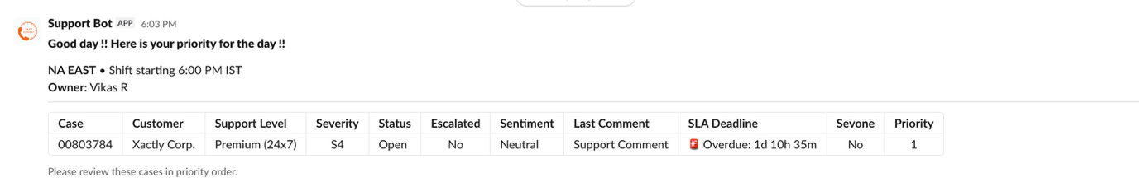

Slack Alert Type 2 :
This alert will be sent if there is any new case got assigned or any new responses for the person either from customer or in an ‘In progress’ case

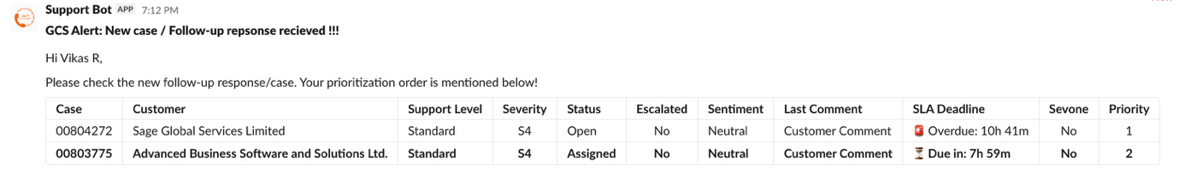

Slack Alert Type 3 :
This alert will be sent if any of his/her existing cases have an elevation in the priority order

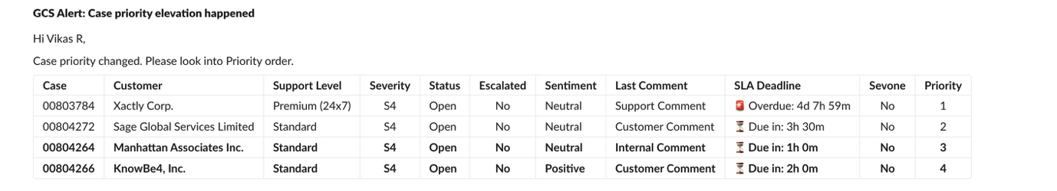

10. Common situations and what to do
Situation | Recommended response
No open cases found | Confirm Region/Owner scope. If still empty, there may be no eligible New/Open/Assigned cases or a source connection issue. Retry Refresh, then report it.
No cases match current filters | Clear search, select All priority and All support levels, turn off Heal Desk Only, and widen Region/Owner.
Known case is missing | Search the complete case number, verify its Salesforce status and owner, then Refresh. Closed or non-configured-owner cases are not expected.
Sentiment says N/A | Continue using the actual case conversation. The sentiment pipeline may not have processed the case yet.
Sentiment looks wrong | Trust the conversation, not the label. Do not edit customer facts to influence scoring. Report repeatable classification issues with the case number.
Priority looks unexpected | Check SevOne, escalation, severity, support level, sentiment, SLA, and record type. Refresh and compare again before reporting.
Dashboard differs from Salesforce | Treat Salesforce as authoritative. Refresh once. Record the case number and visible time, then report the mismatch.
Critical loading error | Capture the non-sensitive error text and time, retry once, then contact support. Do not share secrets or customer data in an unapproved channel.
Audit/SLA sync warning | The dashboard may still work, as the warning says. Continue cautiously and report the warning to support.

11. Safe use and operational controls
- Use company-approved devices, browsers, networks, and communication channels.
- Do not copy customer content into public tools or personal notes.
- Do not make ownership or escalation changes solely from a color or score; verify the Salesforce record.
- Keep Salesforce notes clear enough for the next analyst to understand the status and next action.
- Report access issues through the approved support path. Never ask another user to share credentials.
- When sharing evidence, minimize customer information and redact secrets.

12. Frequently asked questions
Is Priority 1 always the case I must work first?
It is the recommended first review. Apply live incident context, management direction, customer commitments, and support policy after checking Salesforce.
Why did priority change after Refresh?
Case facts, SLA time, sentiment, assignment, escalation, or other cases in the filtered list may have changed.
Why does search produce new Priority numbers?
Search results are deliberately re-ranked from 1 within the returned result set.
Does changing a filter change Salesforce?
No. Filters only change what you see.
Does clicking Refresh change Salesforce?
No. It reloads and recalculates the dashboard using source information.
What if the chart shows no breaches?
It means no active breach record matches the current filter scope. Clear restrictive filters and Refresh before concluding there are none.

