Notes

=======

// What is spring boot?

// what problem does it solve?

// Its features and advantages.

// =============================

Long back servlet was heavily used(2014-15).

With the help of servlet it was very hard to manage the application.

But nowadays spring Boot is used and it is very easy as compared to servlet.

Servlet and servlet container

======================

⇒ Servlet provides the foundation for building web applications.

⇒ Servlet means java class which handles client requests, processes that request and return the response.

⇒ Servlet containers are the ones which manage the servlet. I.e servlet container contains multiple servlets.

request

==============🡺 servlet class

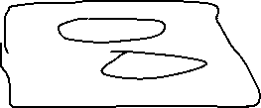

Response servlet_class

🡸===============

Servlet container

Servlet container contains multiple servlet classes.