COLLEGE DATABASE MANAGEMENT SYSTEM
Project Title: DBMS Mini project Combined report
Team Details:
Name:VinayKumar N SRN: PES2UG23CS694
Name:VikasV SRN: PES2UG23CS689

1)INTRODUCTION
In the modern educational landscape, the efficient management of academic data is paramount. The Student/College Management System is a database solution developed to serve as a central repository for an institution's data. The primary objective of this project is to replace manual filing systems with a digital architecture that ensures data is organized, retrievable, and consistent. The system is designed to handle the complex relationships between various institutional stakeholders, including the colleges themselves, the departments within them, and the faculty and students that populate them.

2)USER REQUIREMENT SPECIFICATION
Purpose of the Project:
The purpose is to provide a reliable backend database system for educational institutions that:
- Manages comprehensive student and professor information across multiple colleges
- Enforces data integrity and consistency through automated validation
- Supports efficient enrollment and course management
- Enables administrative queries and analytics (HOD lookup, student counts, departmentwise enrollment)
- Speeds up common administrative tasks (student record retrieval, course enrollment verification, departmental analytics)
- Exposes database functions for institutional metrics and reporting

Scope of project:
This project covers:
- Database layer with relational schema for colleges, departments, professors, students, courses, and enrollments
- Data validation triggers to enforce business rules (age validation, email normalization)
- Stored procedures for common operations (adding students, retrieving department-wise students, analytics)
-Database functions for lookups and aggregations (HOD retrieval, student count by college)
- Data integrity constraints including PRIMARY KEYs, FOREIGN KEYs, UNIQUE constraints, and CHECK constraints
- CRUD operations integrated with Python GUI for user-friendly access

The scope excludes: advanced scheduling algorithms, payment processing integration, and third-party credential verification APIs—although the schema supports future extensions for these features.

Detailed Description:
The system models a multi-college educational network where:

Institutions: Multiple colleges (Clg_ID, name, address) operate independently while sharing academic standards.

Academic Structure: Each college contains departments (Computer Science, Electrical Engineering, etc.) managed by Heads of Department (HOD). Departments offer multiple courses with credit values.

Personnel Professors are assigned to specific departments and teach multiple courses.
Each professor has unique contact information (email, phone) stored with data validation.

Student Management: Students enroll in their respective colleges and departments. When a new student record is created, a BEFORE INSERT trigger validates that the student is at least 18 years old—rejecting underage registrations with a clear error message. Professor emails are automatically normalized to lowercase on insertion to ensure consistency.

Enrollment Tracking: Students enroll in multiple courses per semester via the Enrollment table (junction table with composite key). Each enrollment records the student's grade, enabling transcript and academic performance analysis.

Automated Operations:
- BEFORE INSERT trigger on Professor: Converts email addresses to lowercase for consistency
- BEFORE INSERT trigger on Student: Validates date of birth (age ≥ 18 years)
- Stored procedures: sp_AddNewStudent() for safe student insertion, sp_GetStudentsByDepartment() for departmental queries
- Database functions: fn_GetDepartmentHOD() for department leadership lookup, fn_GetStudentCountByCollege_() for institutional metrics

3) Software Tools
- MySQL Server
- Python 3.x
- Tkinter GUI Library
- mysql-connector-python
- MySQL Workbench / CLI
- Windows/Linux OS

4)ER Diagram
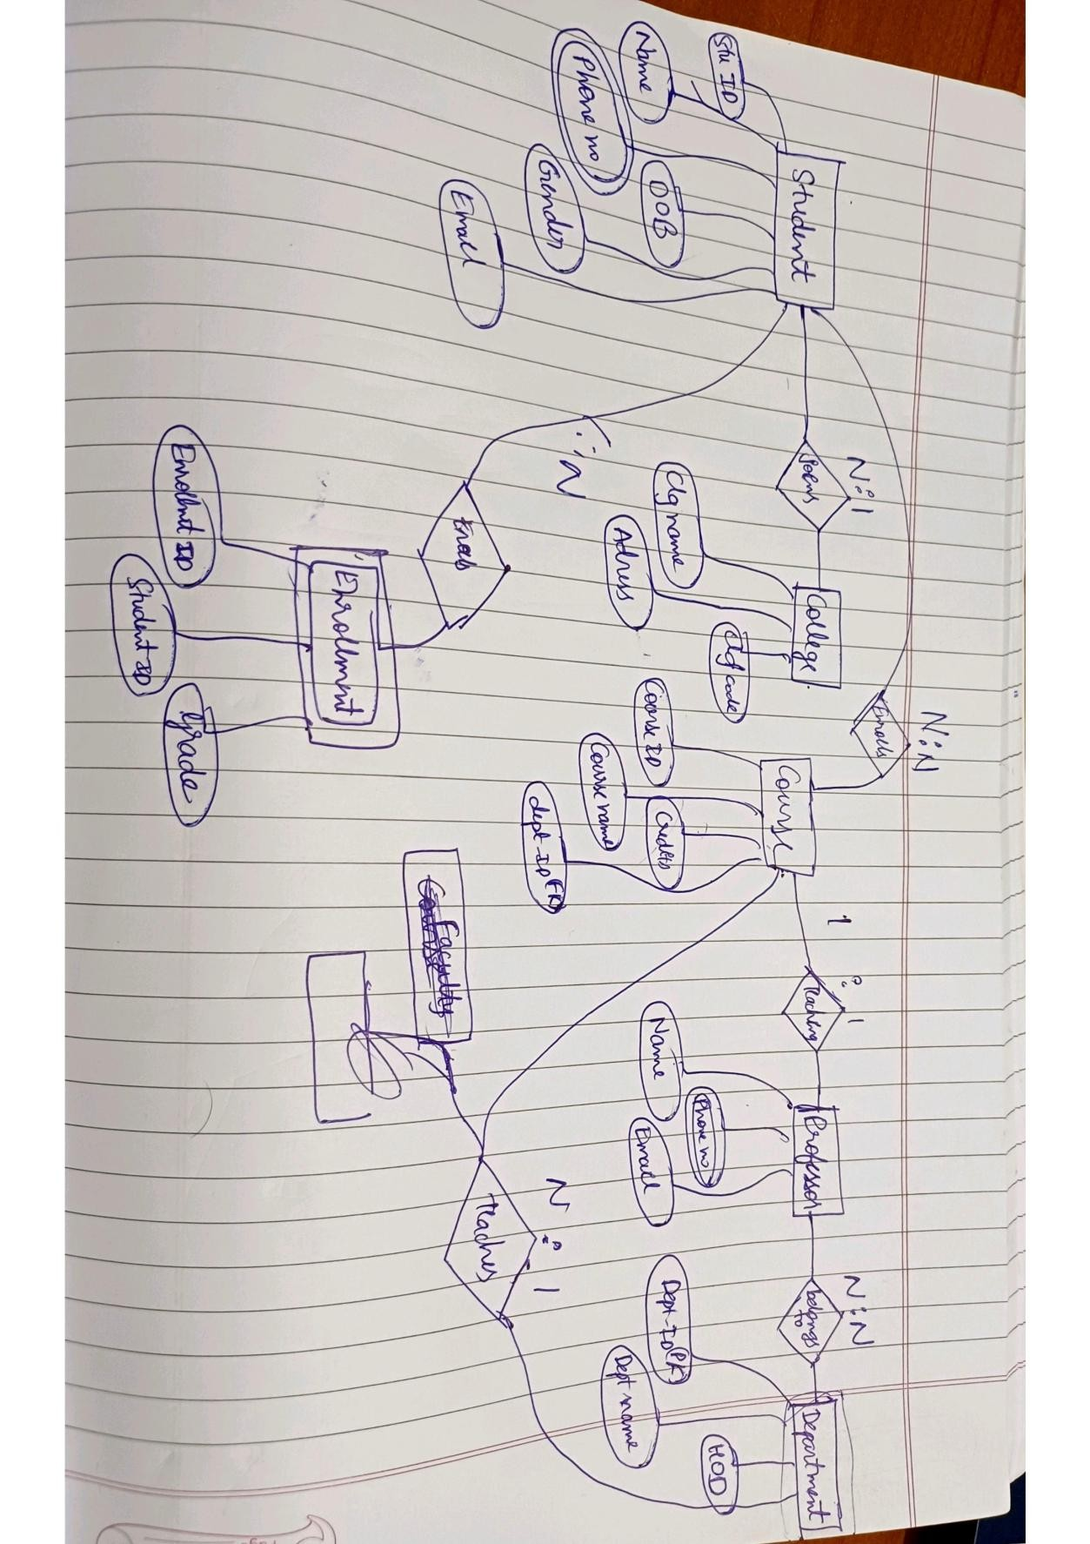

5) Relational Schema
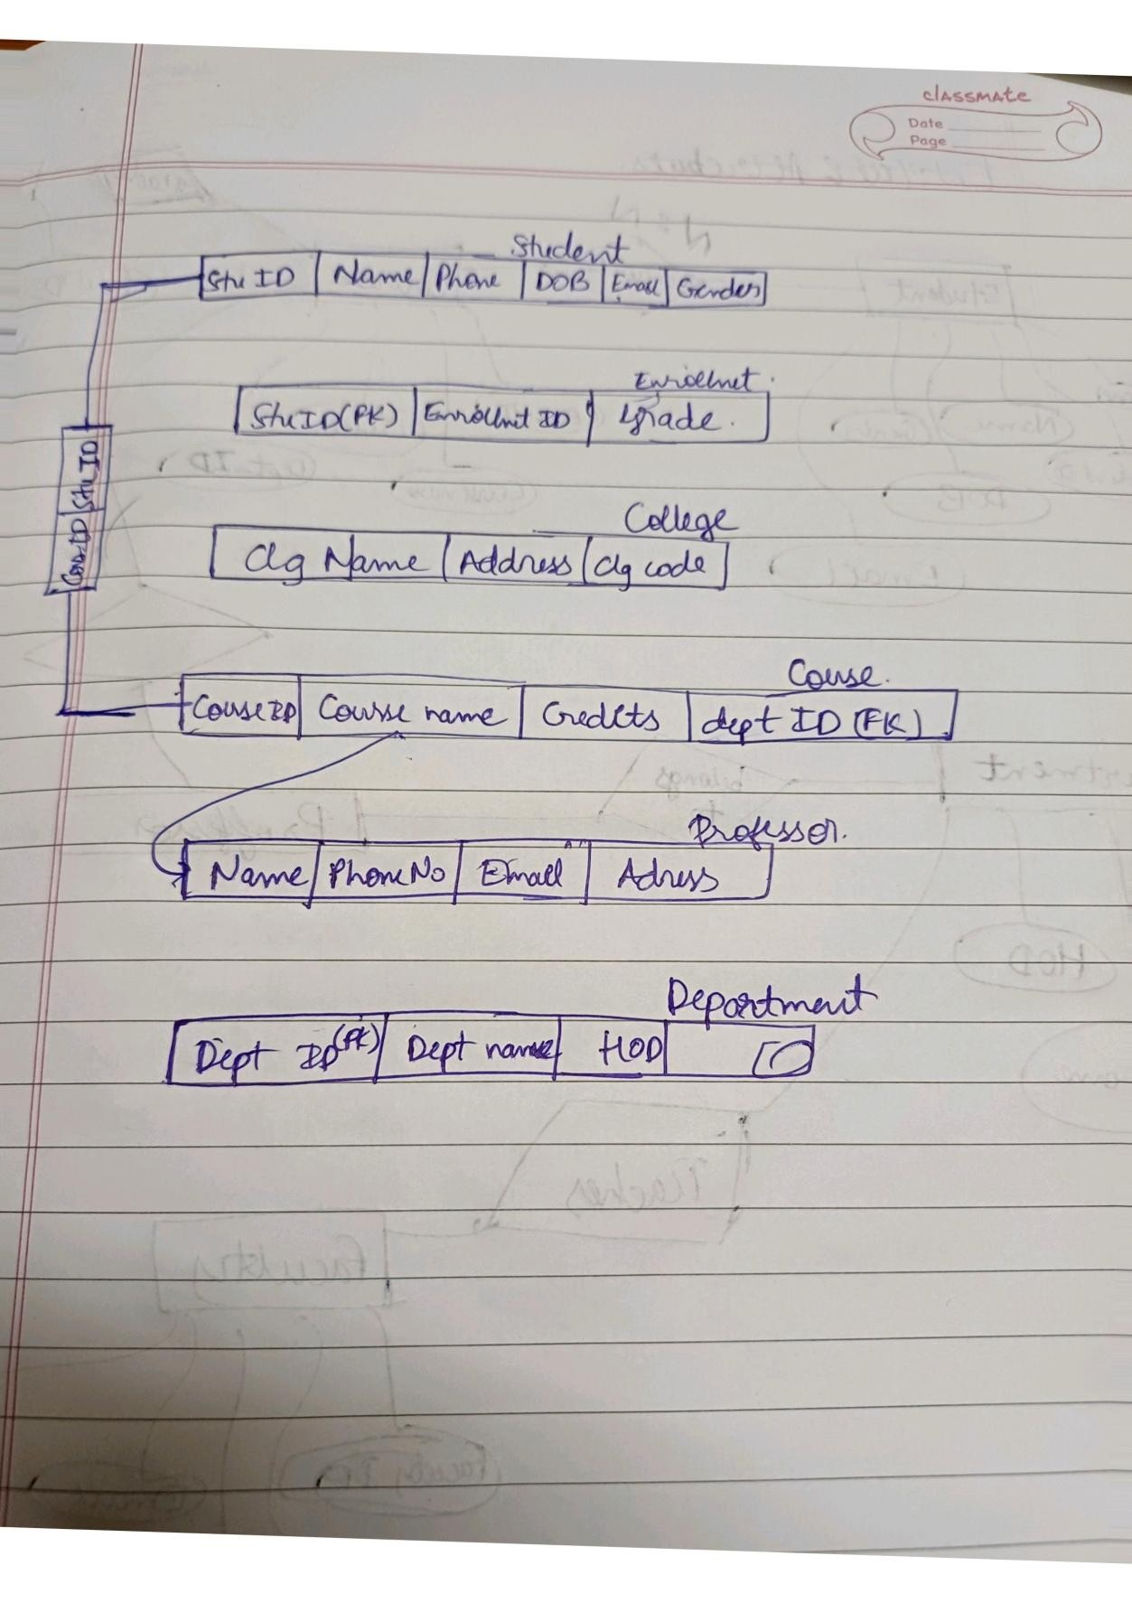

6) DDL and DML Commands
CREATE TABLE College (
Clg_ID INT PRIMARY KEY,
Clg_Name VARCHAR(255) NOT NULL UNIQUE,
Address VARCHAR(255) NOT NULL
);

-- Create the Department table
CREATE TABLE Department (
Dept_ID INT PRIMARY KEY,
Dept_Name VARCHAR(255) NOT NULL UNIQUE,
HOD VARCHAR(255)
);

-- Create the Professor table with a foreign key to Department
CREATE TABLE Professor (
Prof_ID INT PRIMARY KEY,
Name VARCHAR(255) NOT NULL,
Phone_No VARCHAR(20) UNIQUE,
Email VARCHAR(255) NOT NULL UNIQUE,
Address VARCHAR(255),
Dept_ID INT,
FOREIGN KEY (Dept_ID) REFERENCES Department(Dept_ID)
ON DELETE SET NULL
ON UPDATE CASCADE
);

-- Create the Student table with a foreign key to College CREATE TABLE Student (
Stu_ID INT PRIMARY KEY,
Name VARCHAR(255) NOT NULL,
Phone_No VARCHAR(20) UNIQUE,
Email VARCHAR(255) NOT NULL UNIQUE,
DOB DATE,
Gender VARCHAR(10),
Clg_ID INT,
Dept_ID INT,
FOREIGN KEY (Clg_ID) REFERENCES College(Clg_ID)
ON DELETE SET NULL
ON UPDATE CASCADE,
FOREIGN KEY (Dept_ID) REFERENCES Department(Dept_ID)
ON DELETE SET NULL
ON UPDATE CASCADE
);

-- Create the Course table with a foreign key to Department
CREATE TABLE Course (
Course_ID INT PRIMARY KEY,
Course_Name VARCHAR(255) NOT NULL,
Credits INT NOT NULL,
Dept_ID INT,
FOREIGN KEY (Dept_ID) REFERENCES Department(Dept_ID)
ON DELETE SET NULL
ON UPDATE CASCADE
);

-- Create the Enrollment junction table with a composite primary key
-- to link Students and Courses, and a foreign key to Professor
CREATE TABLE Enrollment (
Stu_ID INT,
Course_ID INT,
Grade VARCHAR(2),
PRIMARY KEY (Stu_ID, Course_ID),
FOREIGN KEY (Stu_ID) REFERENCES Student(Stu_ID)
ON DELETE CASCADE
ON UPDATE CASCADE,
FOREIGN KEY (Course_ID) REFERENCES Course(Course_ID)
ON DELETE CASCADE
ON UPDATE CASCADE
);
-- DML: Insert data into the tables

-- 1. Insert data into independent tables
INSERT INTO College (Clg_ID, Clg_Name, Address) VALUES
(101, 'National University of Technology', '123 Tech Park, Silicon Valley'),
(102, 'State College of Arts & Sciences', '456 Main Street, Capital City'),
(103, 'City Community College', '789 Oak Avenue, Metropolis'),
(104, 'Global Institute of Management', '101 Pine Lane, Business District'),
(105, 'St. Mary’s College', '202 Church Road, Suburbia');

INSERT INTO Department (Dept_ID, Dept_Name, HOD) VALUES
(1, 'Computer Science', 'Dr. Albus Dumbledore'),
(2, 'Electrical Engineering', 'Prof. Minerva McGonagall'),
(3, 'Business Administration', 'Dr. Severus Snape'),
(4, 'Applied Sciences', 'Prof. Filius Flitwick'),
(5, 'Humanities', 'Dr. Rubeus Hagrid');

-- 2. Insert data into tables that depend on the above (Student, Professor, Course)
-- Note: Dept_ID added to Student for convenience. Course enrollment is still tracked in Enrollment.
INSERT INTO Student (Stu_ID, Name, Phone_No, Email, DOB, Gender, Clg_ID, Dept_ID) VALUES
(1, 'John Smith', '9876543210', 'john.smith@email.com', '2005-03-15', 'Male', 101, 1),
(2, 'Jane Doe', '9988776655', 'jane.doe@email.com', '2004-10-22', 'Female', 102, 2),
(3, 'Peter Jones', '9123456789', 'peter.jones@email.com', '2006-01-30', 'Male', 101, 1),
(4, 'Emily White', '9567891234', 'emily.white@email.com', '2005-07-05', 'Female', 103, 4),
(5, 'Chris Green', '9678901234', 'chris.green@email.com', '2004-11-18', 'Male', 104, 3),
(6, 'Samantha Brown', '9789012345', 'samantha.brown@email.com', '2006-04-25', 'Female', 102, 2);

INSERT INTO Professor (Prof_ID, Name, Phone_No, Email, Address, Dept_ID) VALUES
(1, 'Dr. Smith', '1234567890', 'smith@nu.edu', '123 Main St', 1),
(2, 'Prof. Johnson', '1234567891', 'johnson@nu.edu', '456 Oak St', 2),
(3, 'Dr. Williams', '1234567892', 'williams@nu.edu', '789 Pine St', 3),
(4, 'Prof. Davis', '1234567893', 'davis@nu.edu', '101 Maple Ave', 1), (5, 'Dr. Miller', '1234567894', 'miller@nu.edu', '202 Birch Rd', 4);

INSERT INTO Course (Course_ID, Course_Name, Credits, Dept_ID) VALUES
(10, 'Introduction to Databases', 4, 1),
(11, 'Circuits and Electronics', 5, 2),
(12, 'Financial Accounting', 3, 3),
(13, 'Data Structures', 4, 1),
(14, 'Organic Chemistry', 5, 4),
(15, 'Principles of Management', 3, 3);

-- 3. Insert data into the final dependent table (Enrollment)
INSERT INTO Enrollment (Stu_ID, Course_ID, Grade) VALUES
(1, 10, 'A'),
(1, 13, 'B+'),
(2, 11, 'A-'),
(3, 10, 'B'),
(4, 14, 'A'),
(5, 12, 'B'),
(6, 11, 'C+');

6) Triggers
Trigger 1: Email Normalization
Description: Automatically converts a new professor's email to lowercase before it is inserted into the Professor table. This ensures data consistency.
CODE:
DELIMITER $$
CREATE TRIGGER trg_student _Insert_Lowercase_Email
BEFORE INSERT ON Professor
FOR EACH ROW BEGIN SET NEW.Email = LOWER(NEW.Email);
END$$
DELIMITER ;
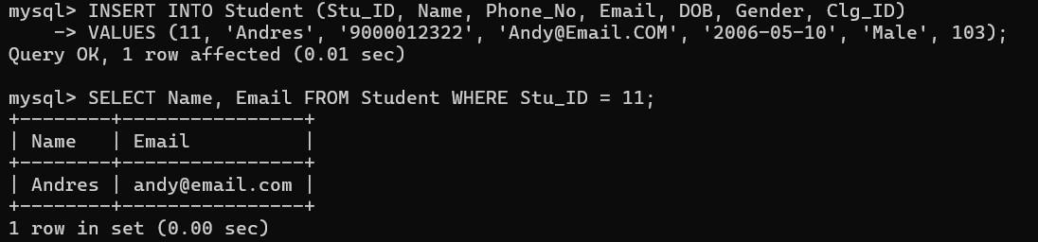
2)Trigger: trg_Before_Student_Insert_Validate_DOB
Description: To validate whether a student is eligible enough

CODE:
DELIMITER $$
CREATE TRIGGER trg_Before_Student_Insert_Validate_DOB
BEFORE INSERT ON Student
FOR EACH ROW
BEGIN
IF NEW.DOB > CURDATE() OR NEW.DOB > DATE_SUB(CURDATE(), INTERVAL 18 YEAR) THEN
SIGNAL SQLSTATE '45000'
SET MESSAGE_TEXT = 'Invalid Date of Birth. Student must be at least 18 years old.'; END IF;
END$$
DELIMITER ;

7) Stored Procedures
1) Stored Procedure: sp_AddNewStudent
Description: A procedure to add a new student record to the Student table.

CODE:
DELIMITER $$
CREATE PROCEDURE sp_AddNewStudent(
IN p_Stu_ID INT,
IN p_Name VARCHAR(255),
IN p_Phone VARCHAR(20),
IN p_Email VARCHAR(255),
IN p_DOB DATE,
IN p_Gender VARCHAR(10),
IN p_Clg_ID INT
)
BEGIN
INSERT INTO Student (Stu_ID, Name, Phone_No, Email, DOB, Gender,
Clg_ID)
VALUES (p_Stu_ID, p_Name, p_Phone, p_Email, p_DOB, p_Gender, p_Clg_ID);
END$$
DELIMITER ;
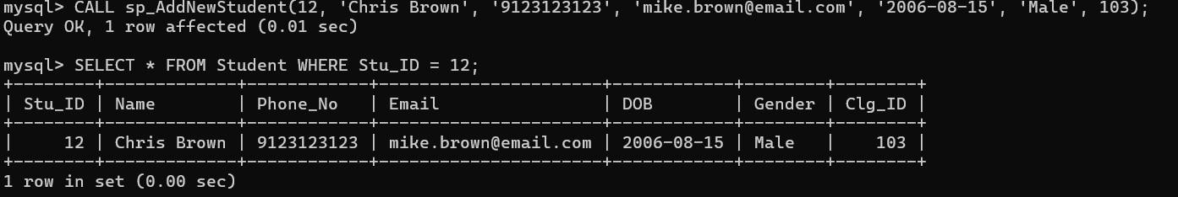

2. Stored Procedure: sp_GetStudentsByDepartment
Description: Retrieves a list of all students (Name and Email) who are enrolled in any course belonging to a specific department.

CODE:
DELIMITER $$
CREATE PROCEDURE sp_GetStudentsByDepartment(
IN p_Dept_Name VARCHAR(255)
)
BEGIN

SELECT DISTINCT s.Name,
s.Email
FROM Student s
JOIN Enrollment e ON s.Stu_ID = e.Stu_ID
JOIN Course c ON e.Course_ID = c.Course_ID
JOIN Department d ON c.Dept_ID = d.Dept_ID
WHERE d.Dept_Name = p_Dept_Name;
END$$
DELIMITER ;
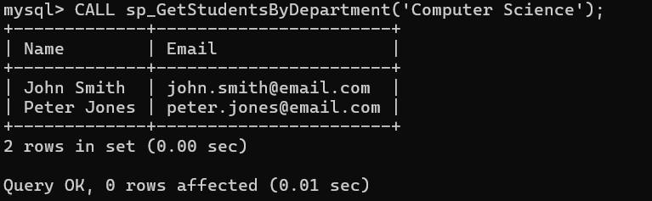

8) Functions

1) Function: fn_GetDepartmentHOD
Description: A simple lookup function that returns the name of the Head of Department (HOD) for a given department name.

CODE:
DELIMITER $$
CREATE FUNCTION fn_GetDepartmenttHOD( p_Dept_Name VARCHAR(255)
)
RETURNS VARCHAR(255)
READS SQL DATA
BEGIN
DECLARE v_HOD_Name VARCHAR(255);

SELECT HOD
INTO v_HOD_Name
FROM Department
WHERE Dept_Name = p_Dept_Name;

RETURN v_HOD_Name;
END$$
DELIMITER ;
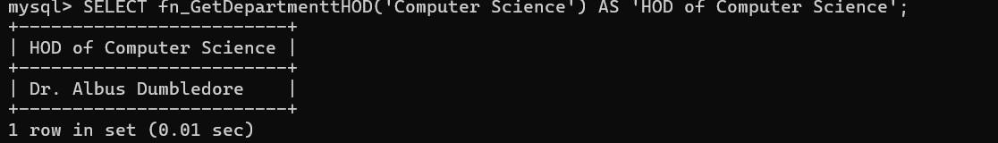

2) Function: fn_GetStudentCountByCollege_
Description: Returns the total number of students registered at a specific college, given the Clg_ID

CODE:
DELIMITER $$
CREATE FUNCTION fn_GetStudentCountByCollege_(
p_Clg_ID INT
)
RETURNS INT
READS SQL DATA
BEGIN
DECLARE v_Student_Count INT;

SELECT COUNT(*)
INTO v_Student_Count
FROM Student
WHERE Clg_ID = p_Clg_ID;

RETURN v_Student_Count;
END$$
DELIMITER ;
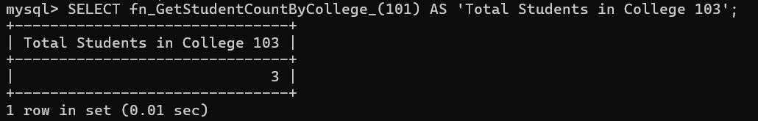
JOINS:
Description: Retrieves a list of all students (Name and Email) who are enrolled in any course belonging to a specific department.

CODE:
DELIMITER $$
CREATE PROCEDURE sp_GetStudentsByDepartment(
IN p_Dept_Name VARCHAR(255)
)
BEGIN

SELECT DISTINCT s.Name,
s.Email
FROM Student s
JOIN Enrollment e ON s.Stu_ID = e.Stu_ID
JOIN Course c ON e.Course_ID = c.Course_ID
JOIN Department d ON c.Dept_ID = d.Dept_ID
WHERE d.Dept_Name = p_Dept_Name;
END$$
DELIMITER ;

9) Application Functionalities & GUI Screenshots
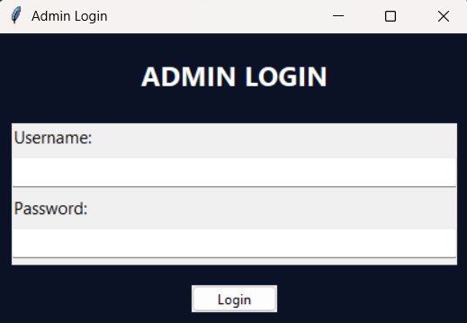

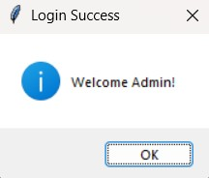

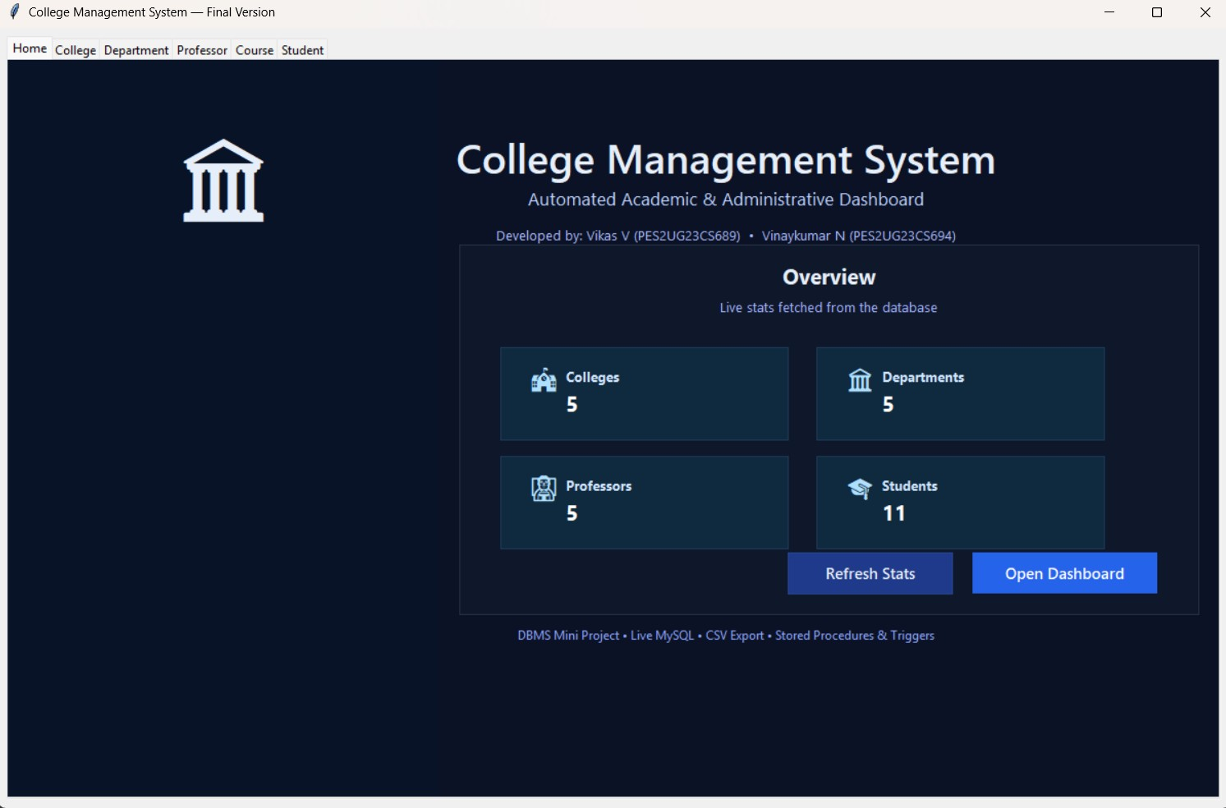
10) CRUD Operations

Create (INSERT)

Students and professors are added through:
- Direct INSERT statements
- Stored procedure sp_AddNewStudent()
- Python GUI forms

Read (SELECT)
Queries retrieve data using:
- Simple SELECT statements
- Stored procedure sp_GetStudentsByDepartment()
- Database functions for aggregations
- JOIN operations for comprehensive views

Update (UPDATE)

Updates modify:
1. Student contact information
2.Course assignments
3.Grade records
4.Department assignments

Delete (DELETE)

Deletions cascade appropriately:
1.Deleting a college removes associated students (ON DELETE SET NULL or CASCADE)
2.Deleting a course removes enrollments (ON DELETE CASCADE)
3.Cascade rules prevent orphaned records

11)Python GUI Implementaion # college_gui_complete_project_final.py import tkinter as tk from tkinter import ttk, messagebox, filedialog import csv, os import mysql.connector from datetime import datetime

# Optional logo
try:
from PIL import Image, ImageTk
PIL_AVAILABLE = True
except Exception:
PIL_AVAILABLE = False

# ----------------------- DATABASE CONNECTION ----------------------- try:
conn = mysql.connector.connect( host="localhost", user="root", # Change if needed password="Your_password ", # Change if needed database="student_database"
)
cursor = conn.cursor() print("Connected to Database:", conn.database) except mysql.connector.Error as e:
messagebox.showerror("Database Error", str(e)) raise SystemExit("MySQL connection failed.")

# ----------------------- DATABASE BACKUP ----------------------- def backup_database():
"""Creates a backup .sql file after every commit."""
try:
dump_path = os.path.join(os.getcwd(), "student_database_backup.sql")
# Note: -p followed immediately by password (no space) cmd = f'mysqldump -u root -pchintu20 student_database > "{dump_path}"' os.system(cmd) print("Backup saved:", dump_path) except Exception as e:
print("Backup failed:", e)
# ----------------------- SETUP TRIGGERS / FUNCTIONS / PROCEDURES ----------------------- def setup_sql_objects():
try:
# Trigger: Professor email lowercase cursor.execute("DROP TRIGGER IF EXISTS trg_student_Insert_Lowercase_Email;") cursor.execute("""
CREATE TRIGGER trg_student_Insert_Lowercase_Email
BEFORE INSERT ON Professor
FOR EACH ROW
BEGIN
SET NEW.Email = LOWER(NEW.Email);
END;
""")

# Trigger: Student DOB validation (student must be at least 18) cursor.execute("DROP TRIGGER IF EXISTS trg_Before_Student_Insert_Validate_DOB;") cursor.execute("""
CREATE TRIGGER trg_Before_Student_Insert_Validate_DOB
BEFORE INSERT ON Student
FOR EACH ROW
BEGIN
IF NEW.DOB > DATE_SUB(CURDATE(), INTERVAL 18 YEAR) THEN
SIGNAL SQLSTATE '45000'
SET MESSAGE_TEXT = 'Invalid DOB: Student must be at least 18 years old.';
END IF;
END;
""")
# Procedure: Add New Student (includes Dept_ID) cursor.execute("DROP PROCEDURE IF EXISTS sp_AddNewStudent;")
cursor.execute("""
CREATE PROCEDURE sp_AddNewStudent(
IN p_Stu_ID INT,
IN p_Name VARCHAR(255),
IN p_Phone VARCHAR(20),
IN p_Email VARCHAR(255),
IN p_DOB DATE,
IN p_Gender VARCHAR(10),
IN p_Clg_ID INT,
IN p_Dept_ID INT
)
BEGIN
INSERT INTO Student (Stu_ID, Name, Phone_No, Email, DOB, Gender, Clg_ID, Dept_ID)
VALUES (p_Stu_ID, p_Name, p_Phone, p_Email, p_DOB, p_Gender, p_Clg_ID, p_Dept_ID);
END;
""")

# Procedure: Get Students by Department (direct lookup using Student + Department) cursor.execute("DROP PROCEDURE IF EXISTS sp_GetStudentsByDepartment;")
cursor.execute("""
CREATE PROCEDURE sp_GetStudentsByDepartment(IN p_Dept_Name VARCHAR(255))
BEGIN
SELECT s.Name, s.Email
FROM Student s
JOIN Department d ON s.Dept_ID = d.Dept_ID
WHERE d.Dept_Name = p_Dept_Name;
END;
""")
# Function: Get Department HOD cursor.execute("DROP FUNCTION IF EXISTS fn_GetDepartmenttHOD;")
cursor.execute("""
CREATE FUNCTION fn_GetDepartmenttHOD(p_Dept_Name VARCHAR(255))
RETURNS VARCHAR(255)
READS SQL DATA
BEGIN
DECLARE v_HOD_Name VARCHAR(255);
SELECT HOD INTO v_HOD_Name FROM Department WHERE Dept_Name = p_Dept_Name;
RETURN v_HOD_Name;
END;
""")

# Function: Get Student Count by College cursor.execute("DROP FUNCTION IF EXISTS fn_GetStudentCountByCollege_;") cursor.execute("""
CREATE FUNCTION fn_GetStudentCountByCollege_(p_Clg_ID INT)
RETURNS INT
READS SQL DATA
BEGIN
DECLARE v_Student_Count INT;
SELECT COUNT(*) INTO v_Student_Count FROM Student WHERE Clg_ID = p_Clg_ID; RETURN v_Student_Count;
END;
""")
conn.commit() print("All Triggers, Procedures, and Functions created/updated.") except mysql.connector.Error as e:
print("SQL Object Creation Error:", e)

# Try to create SQL objects (safe to run even if some referenced tables don't exist yet) try:
setup_sql_objects() except Exception as ex:
print("Could not complete SQL object setup (some tables might not exist yet):", ex)

# ----------------------- UTILITIES -----------------------
def show_status(msg):
try:
status_var.set(msg) except: pass

def export_tree_to_csv(tree, filename_prefix):
rows = [tree.item(i)["values"] for i in tree.get_children()] if not rows:
messagebox.showinfo("Export", "No data to export.")
return file = filedialog.asksaveasfilename(defaultextension=".csv", initialfile=f"{filename_prefix}.csv", filetypes=[("CSV files", "*.csv")]) if file: with open(file, "w", newline="", encoding="utf-8") as f: w = csv.writer(f)
w.writerow([tree.heading(c)["text"] for c in tree["columns"]])
w.writerows(rows) messagebox.showinfo("Export", f"Exported to {file}")

# ----------------------- TABLE FRAME CLASS ----------------------- class TableFrame(ttk.Frame):
def __init__(self, parent, table, columns, insert_q, update_q, delete_q, extra_buttons=None, sp_add=False):
super().__init__(parent) self.table = table self.columns = columns self.insert_q = insert_q self.update_q = update_q self.delete_q = delete_q
self.sp_add = sp_add

ttk.Label(self, text=f"{table} Management", font=("Segoe UI", 14,
"bold")).pack(anchor="w", padx=12, pady=(8,0)) form = ttk.LabelFrame(self, text="Fields") form.pack(fill="x", padx=12, pady=8)
self.entries = {} for c in columns:
row = ttk.Frame(form); row.pack(fill="x", pady=2) ttk.Label(row, text=c, width=18).pack(side="left") e = ttk.Entry(row); e.pack(side="left", fill="x", expand=True) self.entries[c] = e
btns = ttk.Frame(self); btns.pack(fill="x", padx=12, pady=6) ttk.Button(btns, text="Add", command=self.add_record).pack(side="left", padx=4)
ttk.Button(btns, text="Update", command=self.update_record).pack(side="left", padx=4) ttk.Button(btns, text="Delete", command=self.delete_record).pack(side="left", padx=4) ttk.Button(btns, text="Refresh", command=self.fetch_data).pack(side="left", padx=4) if extra_buttons: for name, func in extra_buttons:
ttk.Button(btns, text=name, command=func).pack(side="left", padx=4)

frame = ttk.Frame(self); frame.pack(fill="both", expand=True) self.tree = ttk.Treeview(frame, columns=columns, show="headings") self.tree.pack(side="left", fill="both", expand=True) scroll = ttk.Scrollbar(frame, orient="vertical", command=self.tree.yview) self.tree.configure(yscrollcommand=scroll.set) scroll.pack(side="right", fill="y") for c in columns:
self.tree.heading(c, text=c) self.tree.column(c, width=140, anchor="center")

self.tree.bind("<ButtonRelease-1>", self.on_row_select) self.fetch_data()

def fetch_data(self):
try:
cursor.execute(f"SELECT * FROM {self.table}") rows = cursor.fetchall() except mysql.connector.Error as e:
rows = [] print(f"Error fetching {self.table}: {e}") for r in self.tree.get_children(): self.tree.delete(r) for row in rows: self.tree.insert("", "end", values=row) show_status(f"{self.table}: {len(rows)} records loaded.")

def add_record(self):
vals = tuple(e.get() or None for e in self.entries.values())
try:
if self.sp_add and self.table == "Student":
# Call stored procedure with the exact parameter order: # (Stu_ID, Name, Phone_No, Email, DOB, Gender, Clg_ID, Dept_ID) cursor.callproc("sp_AddNewStudent", vals)
else:
cursor.execute(self.insert_q, vals) conn.commit(); backup_database() self.fetch_data() messagebox.showinfo("Success", f"Record added to {self.table}.") except mysql.connector.Error as e:
messagebox.showerror("Error", str(e)) except Exception as ex:
messagebox.showerror("Error", str(ex))

def update_record(self):
vals = [e.get() for e in self.entries.values()]
# For update queries we expect queries to be written in the form that moves the key to the end.
# Example update_q: "UPDATE Student SET Name=%s,... WHERE Stu_ID=%s"
params = tuple(vals[1:] + vals[:1])
try:
cursor.execute(self.update_q, params) conn.commit(); backup_database() self.fetch_data() messagebox.showinfo("Updated", f"{self.table} record updated.") except mysql.connector.Error as e:
messagebox.showerror("Error", str(e))

def delete_record(self): sel = self.tree.focus() if not sel: return key = self.tree.item(sel)["values"][0] if not messagebox.askyesno("Confirm", f"Delete {self.table} ID {key}?"):
return try:
cursor.execute(self.delete_q, (key,)) conn.commit(); backup_database() self.fetch_data() messagebox.showinfo("Deleted", f"{self.table} record deleted.") except mysql.connector.Error as e:
messagebox.showerror("Error", str(e))

def on_row_select(self, _):
sel = self.tree.focus()
if not sel: return vals = self.tree.item(sel)["values"] for i, c in enumerate(self.columns): self.entries[c].delete(0, "end")
# If row shorter than columns (because SELECT * returns), guard it
try:
self.entries[c].insert(0, vals[i]) except Exception:
self.entries[c].insert(0, "")

# ----------------------- SPECIAL BUTTON FUNCTIONS ----------------------- def get_student_count():
clg = college_tab.entries["Clg_ID"].get()
if not clg:
messagebox.showwarning("Input Required", "Enter College ID first.")
return try:
cursor.execute("SELECT fn_GetStudentCountByCollege_(%s)", (clg,)) res = cursor.fetchone() total = res[0] if res else 0 messagebox.showinfo("Student Count", f"Total Students: {total}") except mysql.connector.Error as e:
messagebox.showerror("DB Error", f"Error while fetching count: {e}")

def get_students_by_dept():
"""
New working implementation:
- Reads Dept_Name from Department tab (Dept_Name field)
- Calls stored procedure sp_GetStudentsByDepartment (created at startup)
- Presents Name + Email in popup and allows CSV export
""" dept = dept_tab.entries["Dept_Name"].get().strip()
if not dept:
messagebox.showwarning("Input Required", "Enter Department Name first.")
return
try:
# Call stored procedure cursor.callproc("sp_GetStudentsByDepartment", (dept,))
result = [] for r in cursor.stored_results(): result.extend(r.fetchall())

if not result:
messagebox.showinfo("No Results", f"No students found for '{dept}'.")
return

# Popup window popup = tk.Toplevel(root) popup.title(f"Students in {dept}") popup.geometry("420x360")

tv = ttk.Treeview(popup, columns=("Name", "Email"), show="headings") tv.heading("Name", text="Name") tv.heading("Email", text="Email") tv.column("Name", width=200, anchor="w")
tv.column("Email", width=200, anchor="w") tv.pack(fill="both", expand=True, padx=10, pady=10)
for row in result:
tv.insert("", "end", values=row)

ttk.Button( popup, text="Export CSV",
command=lambda: export_tree_to_csv(tv, f"students_{dept}_{datetime.now().strftime('%Y%m%d')}")
).pack(pady=6) except mysql.connector.Error as e:
messagebox.showerror("DB Error", f"Error while fetching students: {e}")

def get_hod():
dept_input = course_tab.entries["Dept_ID"].get().strip() if not dept_input:
messagebox.showwarning("Input Required", "Enter Department ID or Name.")
return try:
# Translate Dept_ID → Dept_Name if necessary
cursor.execute("SELECT Dept_Name FROM Department WHERE Dept_ID = %s",
(dept_input,)) row = cursor.fetchone() dept_name = row[0] if row else dept_input cursor.execute("SELECT fn_GetDepartmenttHOD(%s)", (dept_name,)) hod = cursor.fetchone() hod_name = hod[0] if hod and hod[0] else "No HOD found" messagebox.showinfo("HOD", f"HOD of '{dept_name}': {hod_name}") except mysql.connector.Error as e: messagebox.showerror("DB Error", f"Error while fetching HOD: {e}")

# ----------------------- GUI SETUP (wrapped in function) ----------------------- def open_main_app():
global root, notebook, college_tab, dept_tab, prof_tab, course_tab, student_tab, status_var

root = tk.Tk() root.title("College Management System — Final Version") root.geometry("1200x760")

status_var = tk.StringVar(value="Ready") notebook = ttk.Notebook(root) notebook.pack(fill="both", expand=True, padx=8, pady=8)

# ----------------------- HOME PAGE -----------------------
home = tk.Frame(notebook, bg="#0b1226") home.pack(fill="both", expand=True)

canvas = tk.Canvas(home, bg="#0b1226", highlightthickness=0) canvas.pack(fill="both", expand=True)

# Accent panels canvas.create_rectangle(0, 0, 420, 2000, fill="#091327", outline="") # left panel
canvas.create_rectangle(440, 180, 1160, 540, fill="#0f172a", outline="#233044") # main card
# Logo (optional) if PIL_AVAILABLE:
try:
img = Image.open("college_logo.png").convert("RGBA").resize((140, 140)) logo_img = ImageTk.PhotoImage(img) canvas.create_image(210, 110, image=logo_img) except Exception:
canvas.create_text(210, 110, text=" ", font=("Segoe UI Emoji", 64), fill="#e6eef9")
else:
canvas.create_text(210, 110, text=" ", font=("Segoe UI Emoji", 64), fill="#e6eef9")

# Title & subtitle canvas.create_text(700, 95, text="College Management System", font=("Segoe UI Semibold", 30, "bold"), fill="#e6eef9") canvas.create_text(700, 135, text="Automated Academic & Administrative Dashboard",
font=("Segoe UI", 13), fill="#bcd0ff")

# Team line
canvas.create_text(700, 170, text="Developed by: Vikas V
(PES2UG23CS689) • Vinaykumar N (PES2UG23CS694)",
font=("Segoe UI", 10), fill="#a8b9ff")

# Card header text canvas.create_text(800, 210, text="Overview", font=("Segoe UI", 16, "bold"), fill="#e6eef9") canvas.create_text(800, 240, text="Live stats fetched from the database",
font=("Segoe UI", 10), fill="#9fb1ff")
# Helper to fetch stats def _fetch_stats(): c = d = p = s = 0 try:
cursor.execute("SELECT COUNT(*) FROM College"); c = cursor.fetchone()[0] except: pass
try:
cursor.execute("SELECT COUNT(*) FROM Department"); d = cursor.fetchone()[0] except: pass
try:
cursor.execute("SELECT COUNT(*) FROM Professor"); p = cursor.fetchone()[0] except: pass
try:
cursor.execute("SELECT COUNT(*) FROM Student"); s = cursor.fetchone()[0] except: pass return c, d, p, s

# Draw stat tiles inside the main card tile_w, tile_h = 280, 90 start_x, start_y = 480, 280 tile_gap_x, tile_gap_y = 28, 16

_stat_items = [] # keep references to easily update text values

def _draw_tiles(): nonlocal _stat_items _stat_items.clear() labels = ["Colleges", "Departments", "Professors", "Students"] values = list(_fetch_stats())
emojis = [" ", " ", " ", " "]
for i, (label, val, emoji) in enumerate(zip(labels, values, emojis)):
col = i % 2 row = i // 2 x = start_x + col * (tile_w + tile_gap_x) y = start_y + row * (tile_h + tile_gap_y)

# tile background canvas.create_rectangle(x, y, x + tile_w, y + tile_h, fill="#0f293f", outline="#1f3a5a", width=1)
# emoji canvas.create_text(x + 26, y + 30, text=emoji, font=("Segoe UI Emoji", 18), anchor="w", fill="#aee0ff")
# label canvas.create_text(x + 64, y + 28, text=label, font=("Segoe UI", 10, "bold"), anchor="w", fill="#cfe6ff")
# value (store id for refresh) val_id = canvas.create_text(x + 64, y + 54, text=str(val), font=("Segoe UI", 16, "bold"), anchor="w", fill="#ffffff") _stat_items.append((label, val_id))

def _refresh_tiles():
values = list(_fetch_stats()) for i, (_, val_id) in enumerate(_stat_items):
try:
canvas.itemconfigure(val_id, text=str(values[i])) except: pass
show_status("Stats refreshed.")
_draw_tiles()

# Buttons on card: Refresh Stats & Open Dashboard def _open_dashboard():
notebook.select(college_tab)

# Refresh button (canvas button) refresh_btn_tag = "refresh_btn" rx0, ry0, rx1, ry1 = 760, 480, 920, 520
canvas.create_rectangle(rx0, ry0, rx1, ry1, fill="#1f3a8a", outline="#274690", tags=refresh_btn_tag) canvas.create_text((rx0+rx1)//2, (ry0+ry1)//2, text="Refresh Stats", font=("Segoe UI Semibold", 11, "bold"), fill="#e6eef9", tags=refresh_btn_tag) canvas.tag_bind(refresh_btn_tag, "<Button-1>", lambda e: _refresh_tiles())

# Primary button (canvas button) start_btn_tag = "start_btn" sx0, sy0, sx1, sy1 = 940, 480, 1120, 520 canvas.create_rectangle(sx0, sy0, sx1, sy1, fill="#2563eb", outline="", tags=start_btn_tag) canvas.create_text((sx0+sx1)//2, (sy0+sy1)//2, text="Open Dashboard", font=("Segoe UI Semibold", 11, "bold"), fill="white", tags=start_btn_tag) canvas.tag_bind(start_btn_tag, "<Button-1>", lambda e: _open_dashboard())

# Footer
canvas.create_text(700, 560, text="DBMS Mini Project • Live MySQL • CSV Export • Stored Procedures & Triggers",
font=("Segoe UI", 9), fill="#89a2ff")

notebook.add(home, text="Home")

# ----------------------- DATABASE TABS ----------------------- def add_tab(title, cols, ins, upd, dele, extra=None, sp_add=False):
frame = TableFrame(notebook, title, cols, ins, upd, dele, extra, sp_add) notebook.add(frame, text=title) return frame

college_tab = add_tab("College",
["Clg_ID","Clg_Name","Address"],
"INSERT INTO College VALUES(%s,%s,%s)",
"UPDATE College SET Clg_Name=%s,Address=%s WHERE Clg_ID=%s",
"DELETE FROM College WHERE Clg_ID=%s",
[("Count Students", get_student_count)]
)

dept_tab = add_tab("Department",
["Dept_ID","Dept_Name","HOD"],
"INSERT INTO Department VALUES(%s,%s,%s)",
"UPDATE Department SET Dept_Name=%s,HOD=%s WHERE Dept_ID=%s",
"DELETE FROM Department WHERE Dept_ID=%s",
[("Get Students", get_students_by_dept)]
)
prof_tab = add_tab("Professor",
["Prof_ID","Name","Phone_No","Email","Address","Dept_ID"],
"INSERT INTO Professor VALUES(%s,%s,%s,%s,%s,%s)",
"UPDATE Professor SET Name=%s,Phone_No=%s,Email=%s,Address=%s,Dept_ID=%s WHERE Prof_ID=%s",
"DELETE FROM Professor WHERE Prof_ID=%s"
)

course_tab = add_tab("Course",
["Course_ID","Course_Name","Credits","Dept_ID"],
"INSERT INTO Course VALUES(%s,%s,%s,%s)",
"UPDATE Course SET Course_Name=%s,Credits=%s,Dept_ID=%s WHERE Course_ID=%s",
"DELETE FROM Course WHERE Course_ID=%s",
[("Get HOD", get_hod)]
)

# Student tab now includes Dept_ID as requested student_tab = add_tab("Student",
["Stu_ID","Name","Phone_No","Email","DOB","Gender","Clg_ID","Dept_ID"],
"INSERT INTO Student VALUES(%s,%s,%s,%s,%s,%s,%s,%s)",
"UPDATE Student SET
Name=%s,Phone_No=%s,Email=%s,DOB=%s,Gender=%s,Clg_ID=%s,Dept_ID=%s WHERE Stu_ID=%s",
"DELETE FROM Student WHERE Stu_ID=%s", sp_add=True
)

# ----------------------- ADMIN LOGIN PAGE ----------------------- def admin_login():
login = tk.Tk() login.title("Admin Login") login.geometry("420x260") login.configure(bg="#0b1226")

tk.Label(login, text="ADMIN LOGIN", font=("Segoe UI", 18, "bold"), bg="#0b1226", fg="white").pack(pady=18)

f = ttk.Frame(login)
f.pack(pady=6, padx=12, fill="x")

ttk.Label(f, text="Username:", font=("Segoe UI", 11)).pack(anchor="w") username_entry = ttk.Entry(f, font=("Segoe UI", 12)) username_entry.pack(fill="x", pady=6)

ttk.Label(f, text="Password:", font=("Segoe UI", 11)).pack(anchor="w") password_entry = ttk.Entry(f, font=("Segoe UI", 12), show="*") password_entry.pack(fill="x", pady=6)

def validate_login():
u = username_entry.get().strip() p = password_entry.get().strip()

if u == "Miniproject" and p == "DBMS":
messagebox.showinfo("Login Success", "Welcome Admin!")
login.destroy()
open_main_app() # Launch your full GUI
else:
messagebox.showerror("Login Failed", "Invalid Username or Password.")

btn = ttk.Button(login, text="Login", command=validate_login) btn.pack(pady=12)

# allow pressing Enter to submit login.bind('<Return>', lambda event: validate_login())

login.mainloop()

# ----------------------- START APPLICATION -----------------------
if __name__ == "__main__":
admin_login()

12) Git Repository Link
https://github.com/VikasV2005/DBMS-College-Database-System

