**PIZZA SALES REPORT**

**SALES INSIGHTS**

TOTAL REVENUE:

select sum(total_price) AS "Total_revenue" from pizza_sales

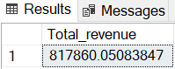

AVERAGE ORDER VALUE:

select (sum(total_price)/count(distinct(order_id))) as "Avg_order_value" from pizza_sales

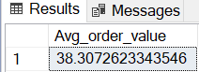

TOTAL QUANTITY OF PIZZA’S SOLD:

select sum(quantity) as "Total_pizzas_sold" from pizza_sales

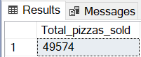

TOTAL ORDERS PLACED FOR ALL PIZZA’S:

select count(distinct(order_id)) as "Total_orders" from pizza_sales

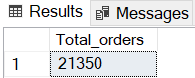

AVERAGE NUMBER OF PIZZA’S SOLD PER ORDER:

select cast(cast(sum(quantity)as decimal(10,2))/cast(count(distinct(order_id)) as decimal(10,2))as decimal(10,2)) as "Avg_no_of_pizzas_per_order" from pizza_sales

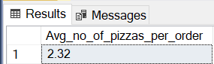

SUM OF ORDERS PLACED ON ALL DAYS OF THE WEEK:

select datename(dw,order_date) as"day", count(distinct(order_id)) as "total_orders_per_day" from pizza_sales

group by datename(dw,order_date)

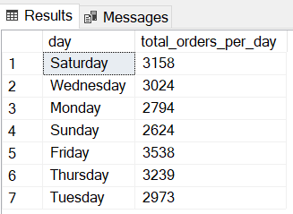

SUM OF ORDERS PLACED ON ALL MONTHS OF THE YEAR**:**

select datename(month,order_date) as "month", count(distinct(order_id)) as "total_orders_per_month" from pizza_sales

group by datename(month,order_date)

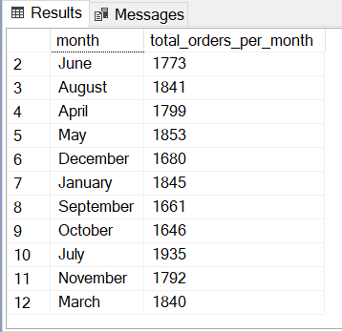

PERCENTAGE OF PIZZA CATEGORIES SOLD:

select pizza_category , sum(total_price) * 100 / (select sum(total_price) from pizza_sales) as "percentage_of_sales"

from pizza_sales

group by pizza_category

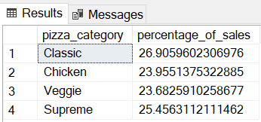

PERCENTAGE OF PIZZA’S ACCORDING TO THEIR SIZE:

select pizza_size , round(sum(total_price) * 100 / (select sum(total_price) from pizza_sales),2) as "percentage_of_sales"

from pizza_sales

group by pizza_size

order by percentage_of_sales desc

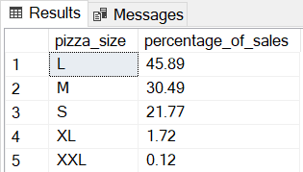

TOP 5 REVENUE EARNING PIZZA’S:

select top 5 pizza_name , round(sum(total_price),2) as "total_revenue"

from pizza_sales

group by pizza_name

order by total_revenue desc

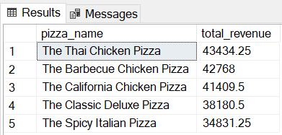

BOTTOM 5 REVENUE EARNING PIZZA’S :

select top 5 pizza_name , round(sum(total_price),2) as "total_revenue"

from pizza_sales

group by pizza_name

order by total_revenue asc

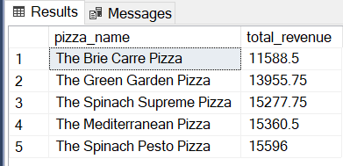

TOP 5 PIZZA’S ACCORDING TO TOTAL QUANTITY PLACED:

select top 5 pizza_name , sum(quantity) as "total_quantity"

from pizza_sales

group by pizza_name

order by total_quantity desc

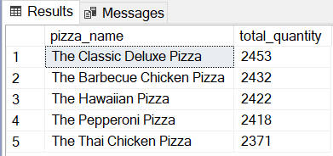

BOTTOM 5 PIZZA’S ACCORDING TO TOTAL QUANTITY PLACED:

select top 5 pizza_name , sum(quantity) as "total_quantity"

from pizza_sales

group by pizza_name

order by total_quantity ASC

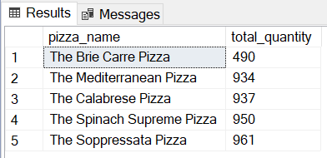

TOP 5 PIZZA’S ACCORDING TO THE NUMBER OF ORDERS PLACED:

select top 5 pizza_name , count(distinct(order_id)) as "total_orders"

from pizza_sales

group by pizza_name

order by total_orders desc

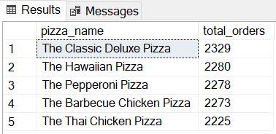

BOTTOM 5 PIZZA’S ACCORDING TO THE NUMBER OF ORDERS PLACED:

select top 5 pizza_name , count(distinct(order_id)) as "total_orders"

from pizza_sales

group by pizza_name

order by total_orders asc

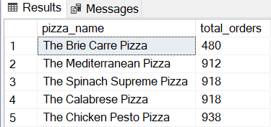

**SUGGESTIONS TO IMPROVE THE SALES FURTHER:**

* During the top selling months i.e. ***January, July*** some additional discounts can be ***provided to increase the sales***.
* During the Weekends-***Friday, Saturday*** some discounts can be provided to ***increase the sales***.
* During the weekdays also some discounts can be given if feasible and profitable.
* Worst selling pizzas-***The Brie Carrie Pizza*** can be altered taste-wise /appearance-wise etc. depending on the customer feedback.
* ***Average order value*** can be increased by giving “2+1” offer on pizzas if feasible.
* XL, XXL size pizzas can be promoted by offering discounts if feasible.