Database Setup:

1. Create the database

> create database employee_details

1. Insert into Roles table – ADMIN Role

ADMIN role needs to be added using query to be able to add more roles (like USER) using developed API.

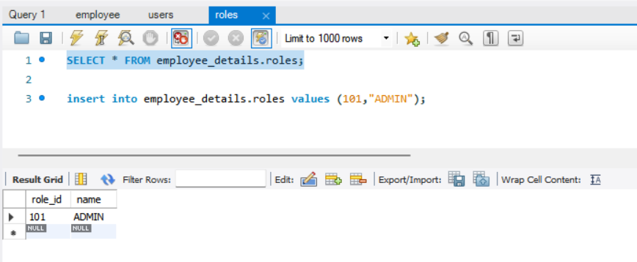

1. User Table

Insert the Username password at database level using insert query, for ‘ADMIN’ role.

Decrypt the password at <https://bcrypt-generator.com/> before inserting

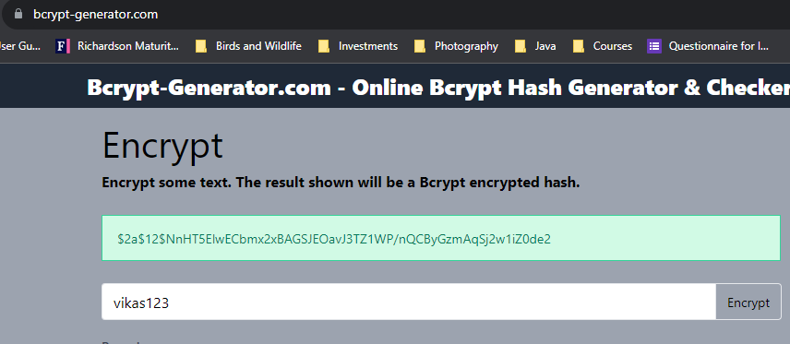

Table would look like this after Insert queries

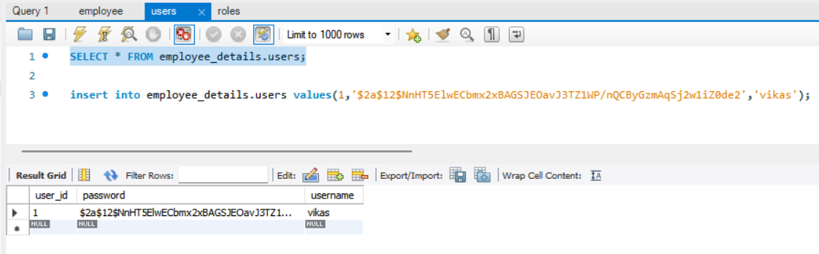

1. Users-roles table

Based on the User Id and Role ID inserted at above tables, accordingly insert the entries into this table for role assignment to the respective user

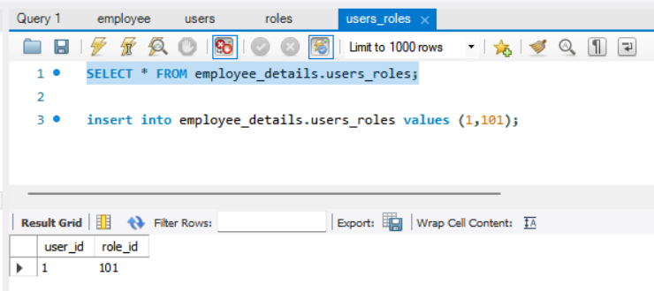

API Screenshots:

1. Insert a new role: ‘USER’ to the roles table

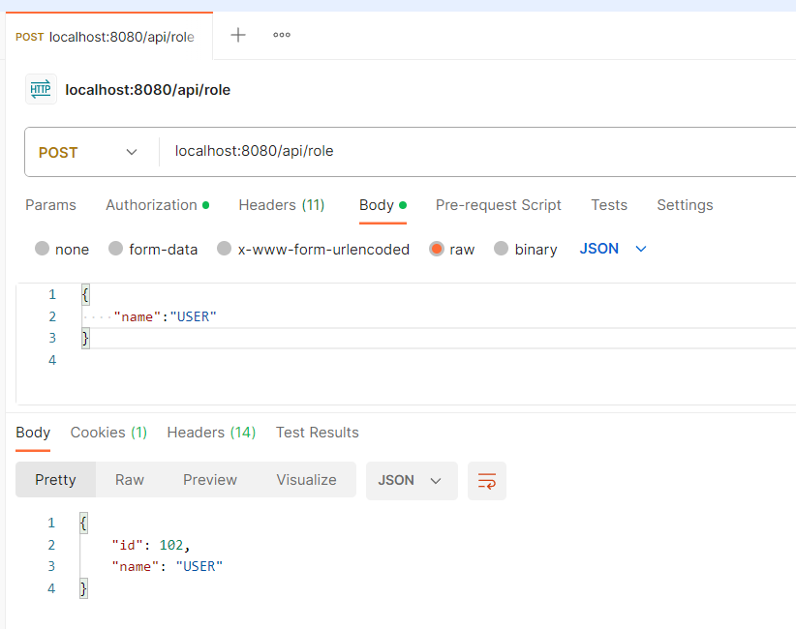

Database: Roles Table

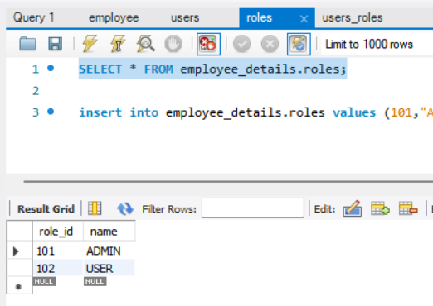

1. Insert a new User to the users table, with ADMIN credentials

Basic authentication, using ADMIN user

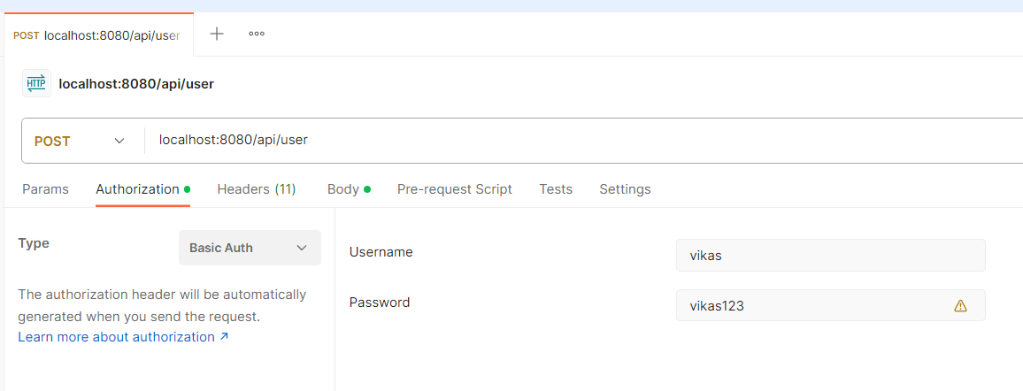

Negative Scenario testing, trying to add user with user credentials of that of role = USER.

Unauthorized, Status:401

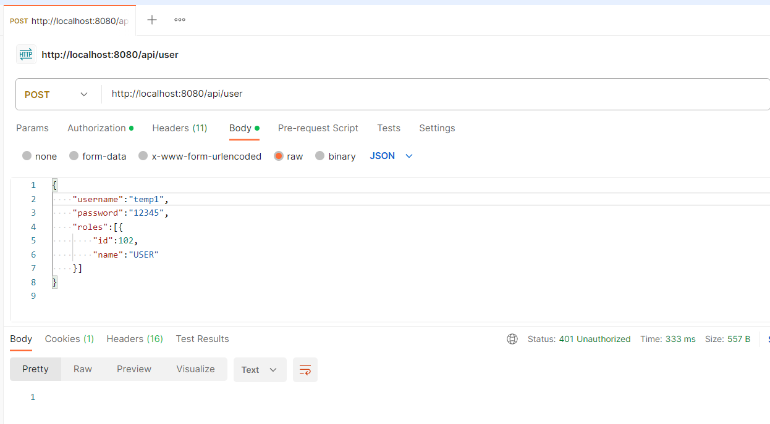

1. Create a new Employee, with ADMIN credentials

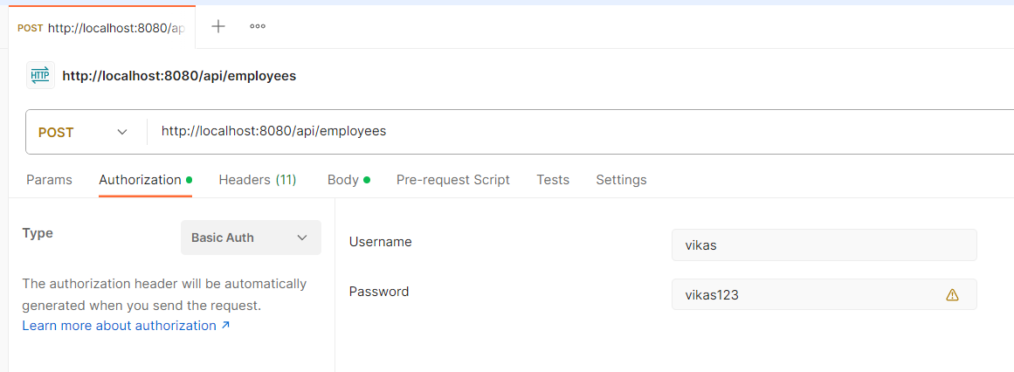

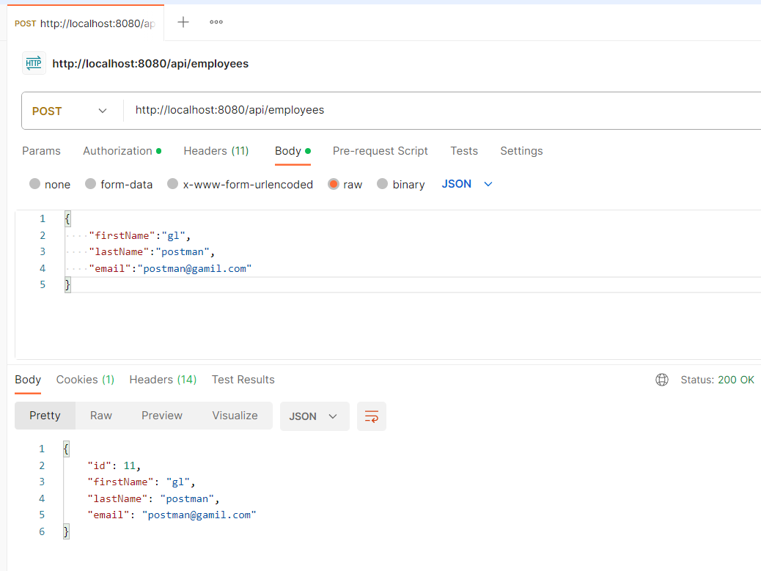

Negative Scenario testing, trying to create employee with user credentials of that of role = USER

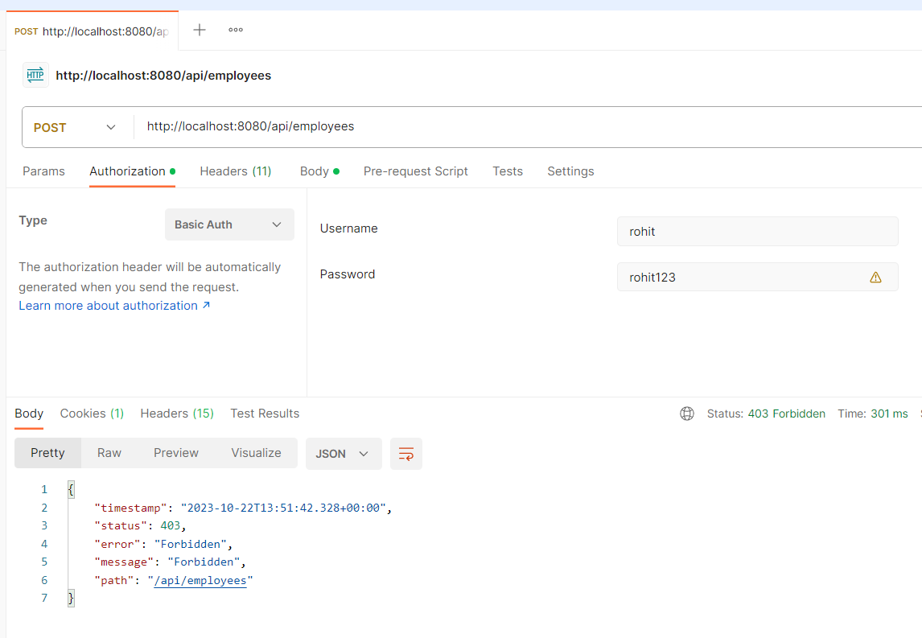

1. List employees, with ADMIN as well as USER role

Here using username = rohit, who has been created as role = USER

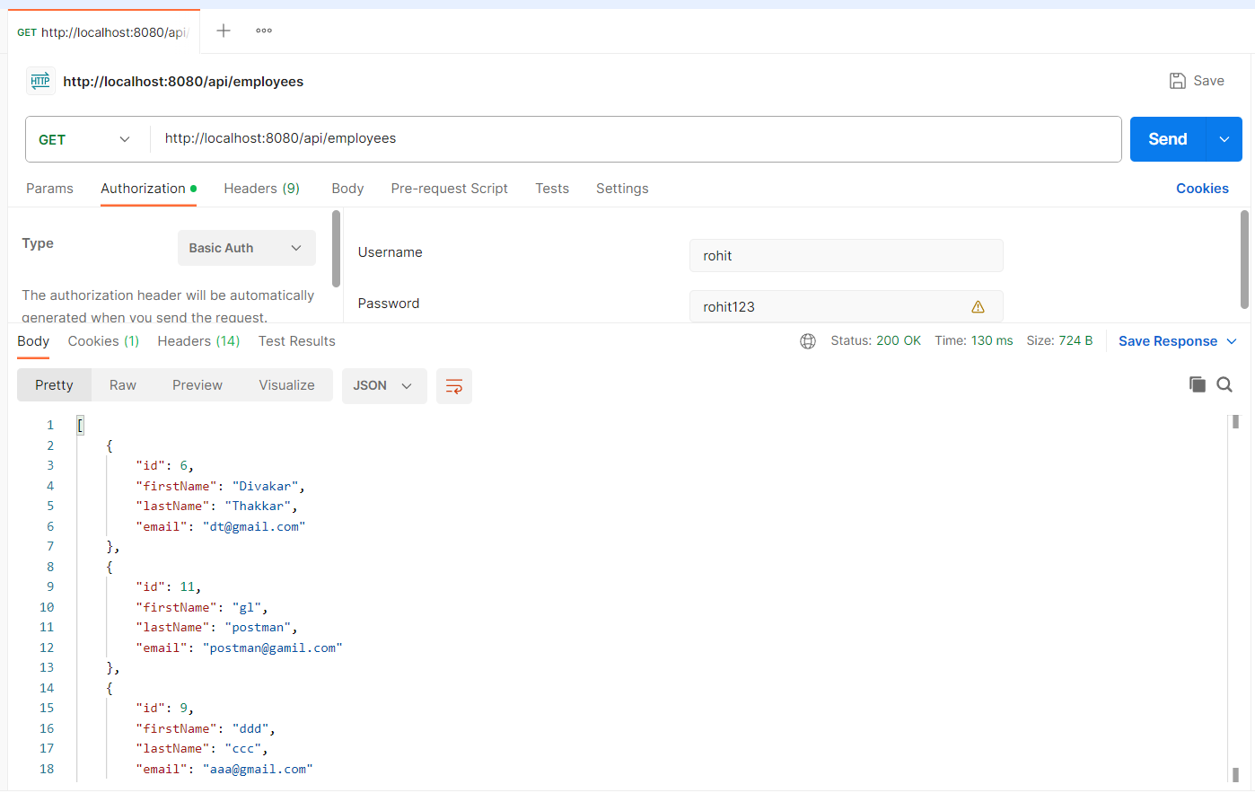

1. Get employees details, with ADMIN as well as USER role

Here using username = rohit, who has been created as role = USER

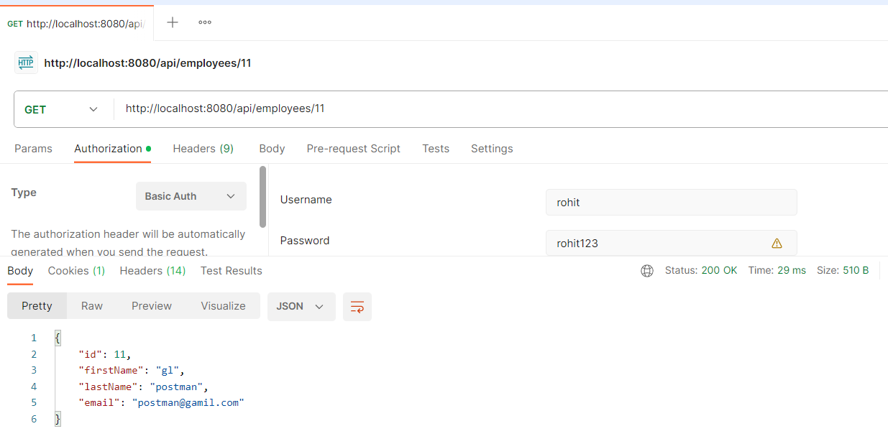

1. Update employee details, with ADMIN only

Here using username = vikas, who has been created as role = ADMIN

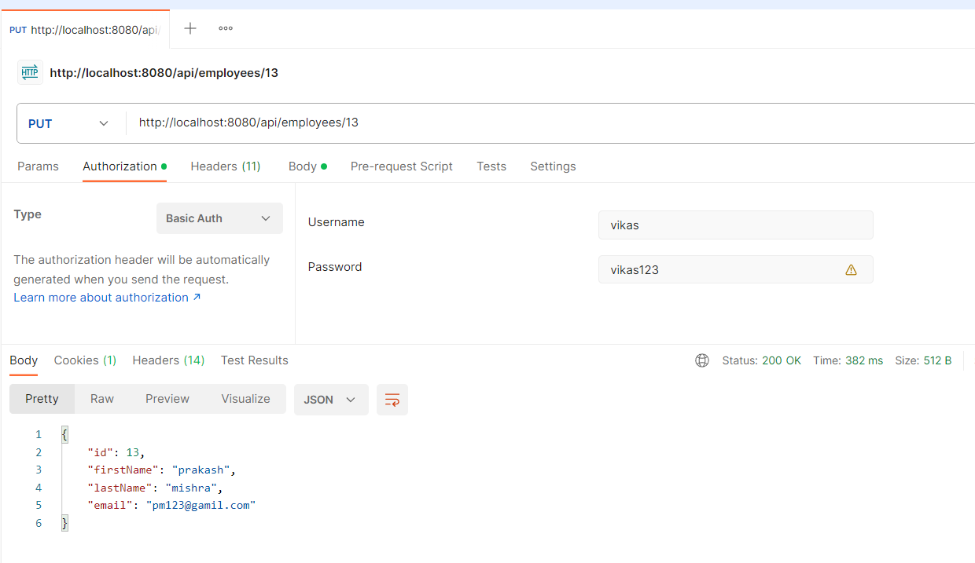

Negative Scenario testing, trying to create employee with user credentials of that of role = USER

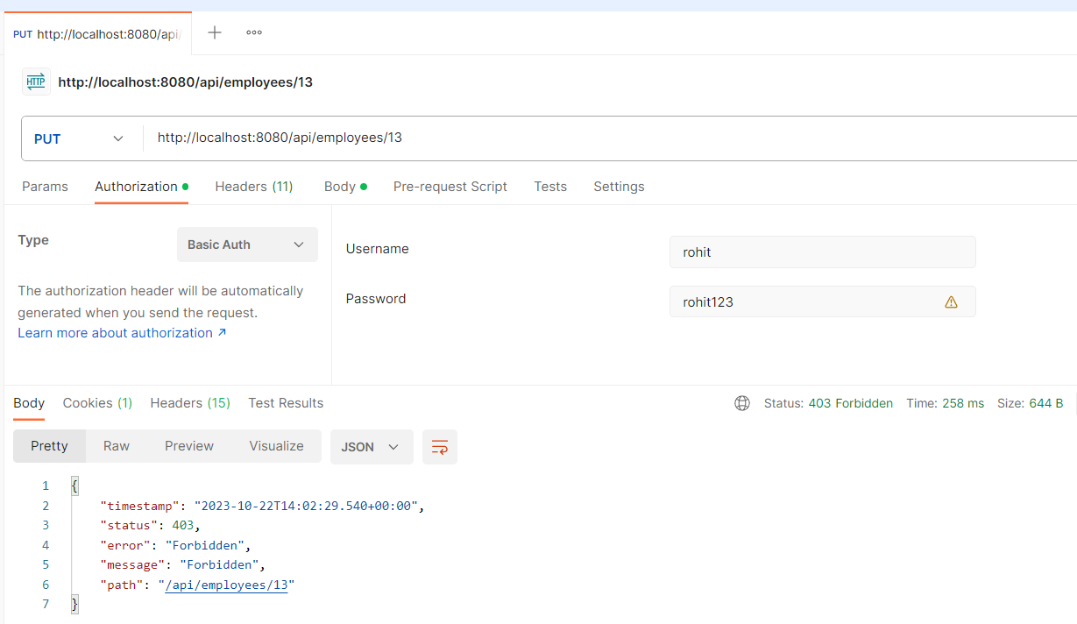

1. Delete employee, with ADMIN role

Here using username = vikas, who has been created with role = ADMIN, deleting the employee with id =11

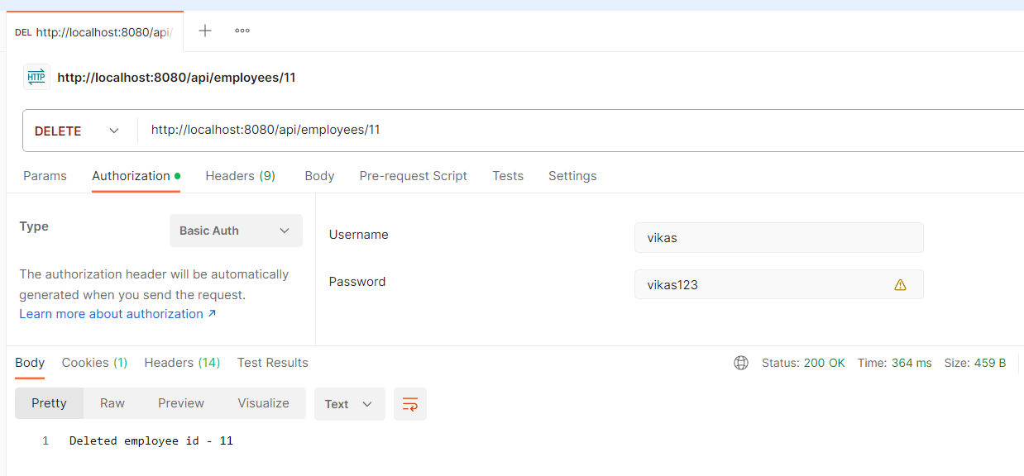

Negative Scenario testing, trying to delete employee with user credentials of that of role = USER

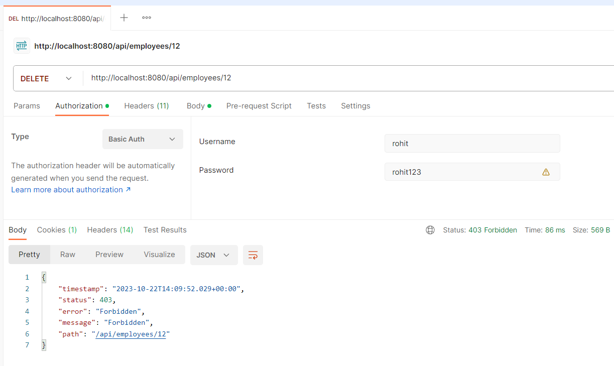

1. Search employee, with ADMIN as well as USER role

Here using role = ADMIN, searching the employee with first name = postman

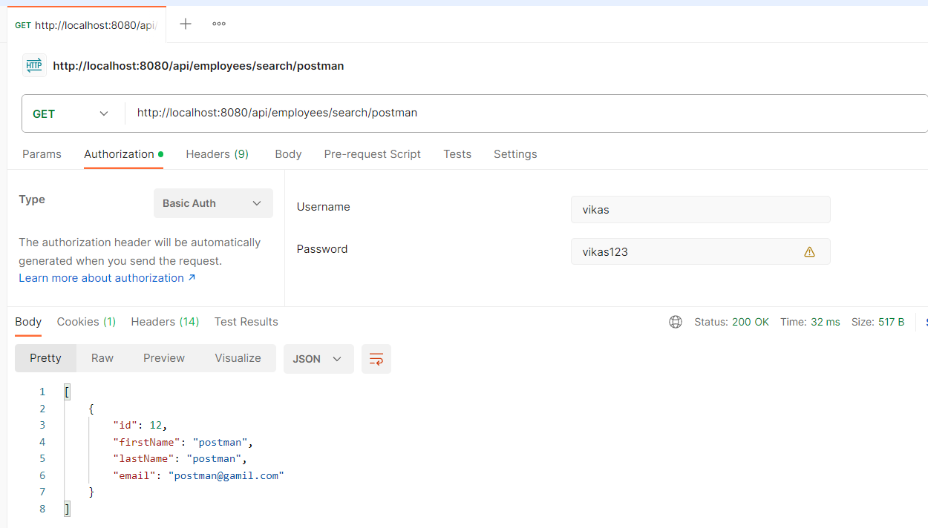

Here using role = USER, searching the employee with first name = gopal

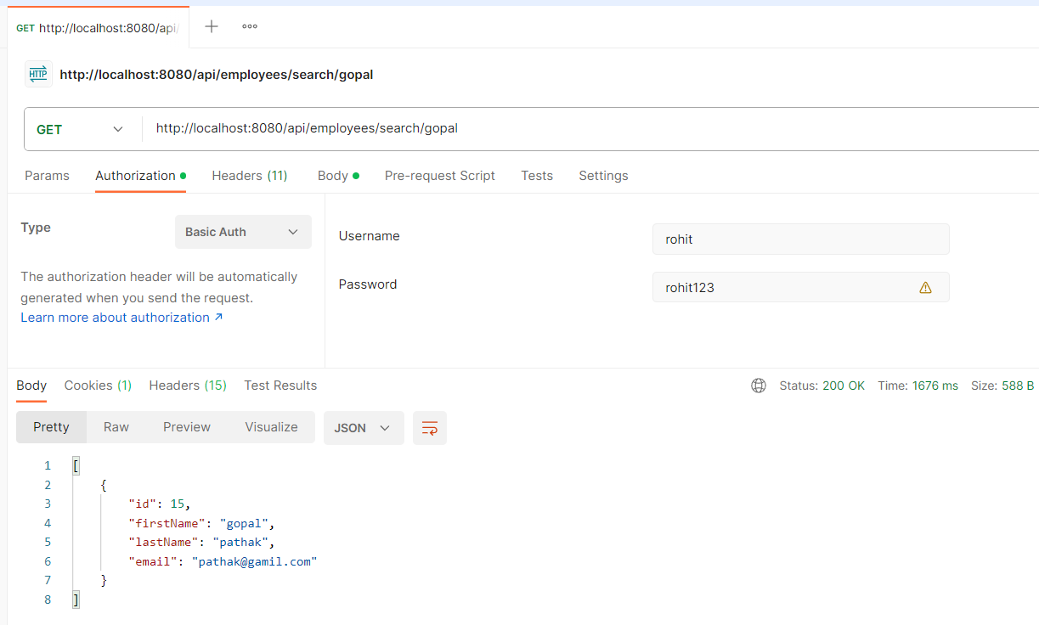

1. Sort employee, with ADMIN as well as USER role

Here using role = USER, sorting the employee in **desc** order over its first name

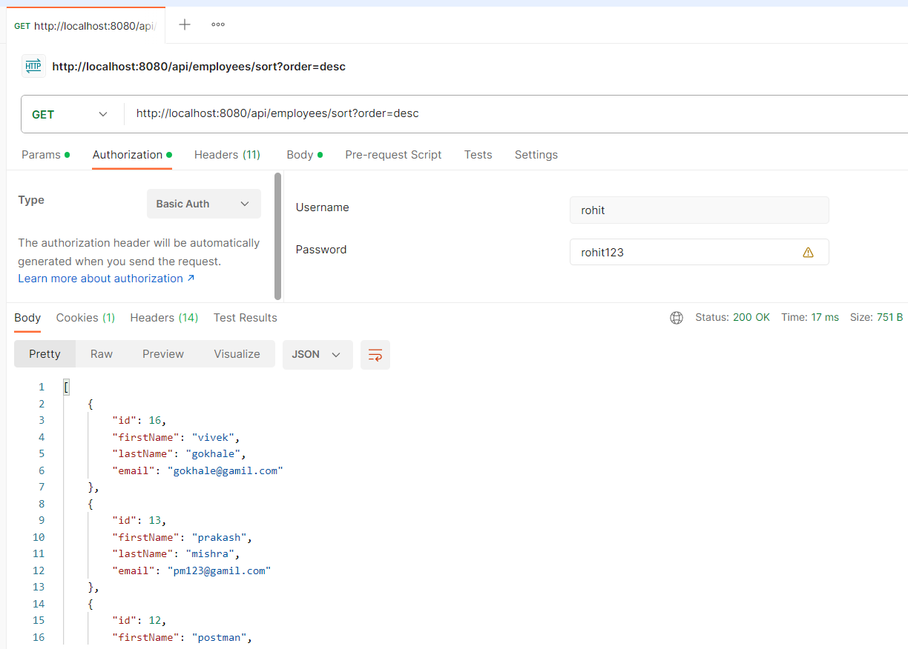

Here using role = ADMIN, sorting the employee in **ascending** order over its first name

