Landing Page



Employee Listing, initially no records to display

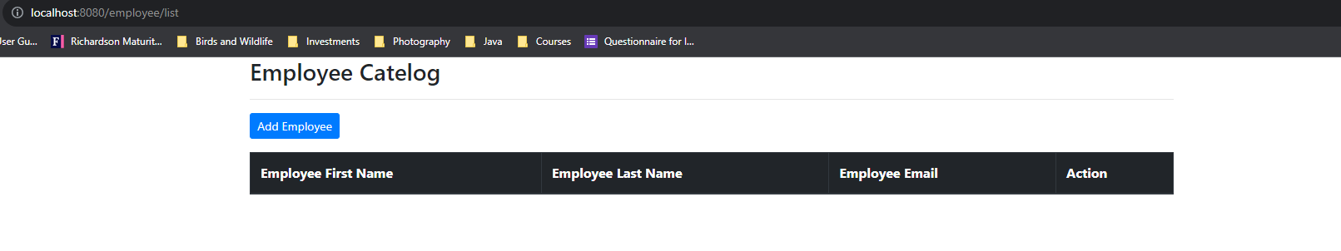

Add Employee

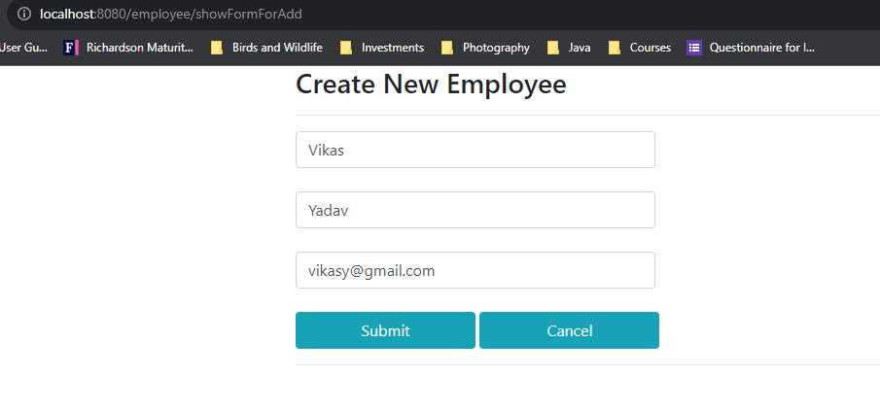

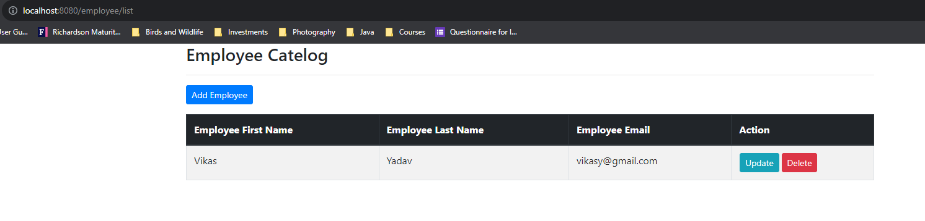

Update Employee

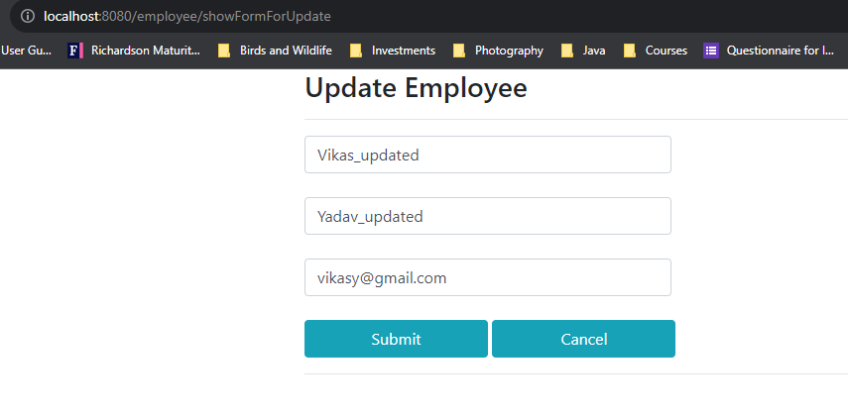

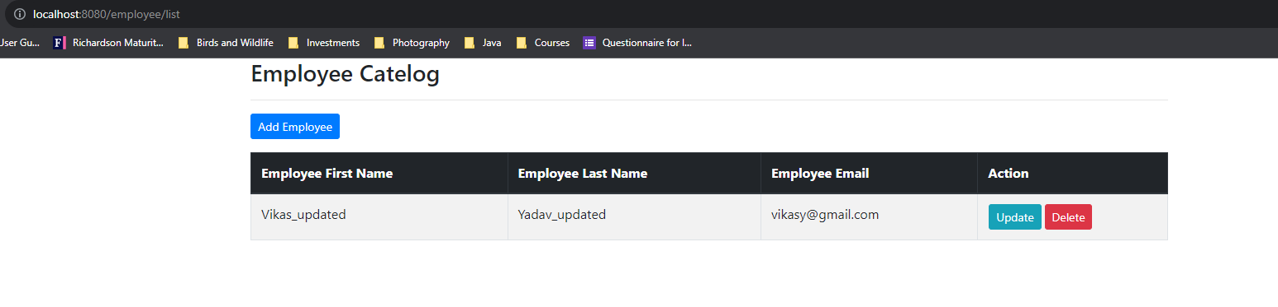

Delete Employee

Suppose, catalog having two employees

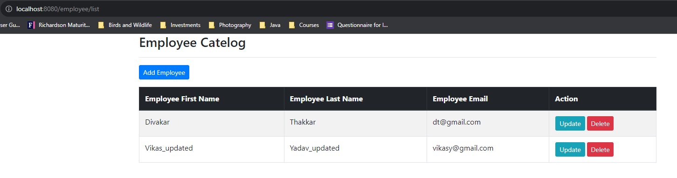

Deleting one of the records

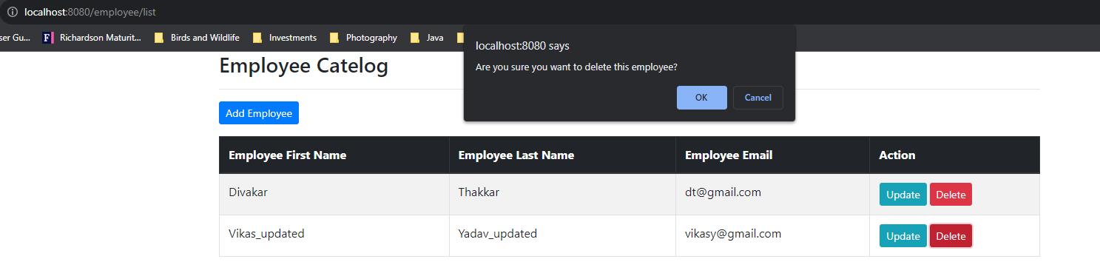

Post delete, only one record could be listed

