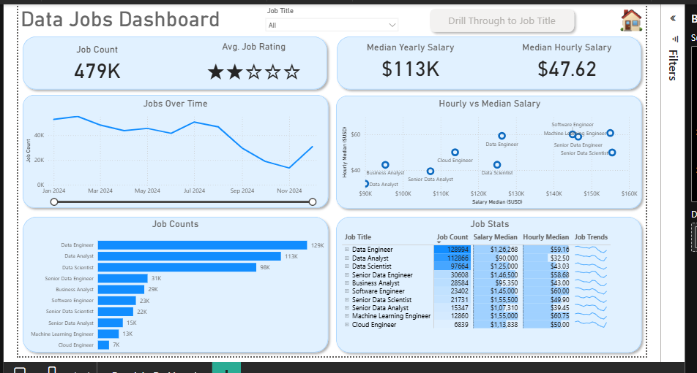
Data Jobs Dashboard – Power BI
Overview
The Data Jobs Dashboard is an interactive Power BI project designed to analyze the data job market. It provides insights into job demand, salary information, job ratings, and changes in job postings over time.
The dashboard helps users explore different data-related job roles, compare job opportunities, and understand trends in the data industry through visualizations and interactive filters.
Objectives
- Analyze the number of job postings across different data job roles.
- Compare job opportunities based on job titles.
- Explore yearly and quarterly trends in job postings.
- Understand salary information through yearly and hourly salary metrics.
- Analyze average job ratings.
- Provide an interactive dashboard for exploring job market information.
Tools & Technologies
- Power BI Desktop – Dashboard development and data visualization.
- Power Query – Data preparation and transformation, where applicable.
- Data Visualization – Cards, bar charts, line charts, and slicers.
- DAX – Measures and calculations used in the dashboard, where applicable.
Key Features
1. Job Count Analysis
Displays the number of job postings and helps users understand the availability of opportunities across different job titles.
2. Salary Analysis
Presents yearly and hourly salary metrics to help compare compensation across data-related roles.
3. Job Rating Analysis
Displays job rating information to provide an additional perspective when exploring job opportunities.
4. Job Posting Trends
Uses a line chart to explore changes in job postings over time, including yearly and quarterly trends.
5. Job Title Filtering
Provides an interactive job title slicer that allows users to filter the dashboard and explore specific roles.
6. Interactive Navigation
Includes interactive report navigation and drill-through functionality to support more detailed exploration of job-related information.
Key Insights
The dashboard can be used to explore:
- Which data job titles have more job postings.
- Differences between yearly and hourly salary metrics.
- Changes in job postings over time.
- Job ratings across the available data.
- How the selected job title affects the displayed results.
The actual findings depend on the dataset, available records, and filters selected in Power BI.
Learning Outcomes
Through this project, I gained practical experience in:
- Creating interactive dashboards using Power BI.
- Presenting job market information through charts and cards.
- Comparing job roles and salary metrics.
- Analyzing trends over time using line charts.
- Applying filters and interactive report navigation.
- Communicating data-driven information through visualizations.
Author
Vikas Chavan
- GitHub: Add your GitHub profile link here

