**Visualizing Austin Airbnb Dataset**

**Summary of the dataset:**

* **Source**: The dataset is likely sourced from Airbnb's public listings or a curated dataset provided for research purposes.
* **Topic**: Visualizing Airbnb bookings in real-time to enhance customer booking experiences.
* **Records**: This dataset contains 119390 observations for a City Hotel and a Resort Hotel. Each observation represents a hotel booking between the 1st of July 2015 and 31st of August 2017, including booking that effectively arrived and booking that were canceled.
* **Total Attributes**: 18

Sample Attributes:

* + **id**: Unique identifier for each listing.
  + **name**: The name of the customer making the booking.
  + **host_id**: Unique identifier for the host.
  + **host_name**: Name of the host.
  + **neighbourhood**: The geographical location of the property (could be a neighborhood name or geographical region).
  + **latitude & longitude**: Geographic coordinates of the listing, following the WGS84 system.
  + **room_type**: Type of accommodation booked (e.g., entire home, private room).
  + **price**: Price of the booking.

This dataset will be used to build predictive models for understanding booking trends, pricing, and customer preferences to improve booking experiences on Airbnb based on the analytics performed using Tableau for Visualization.

**Data Preprocessing:**

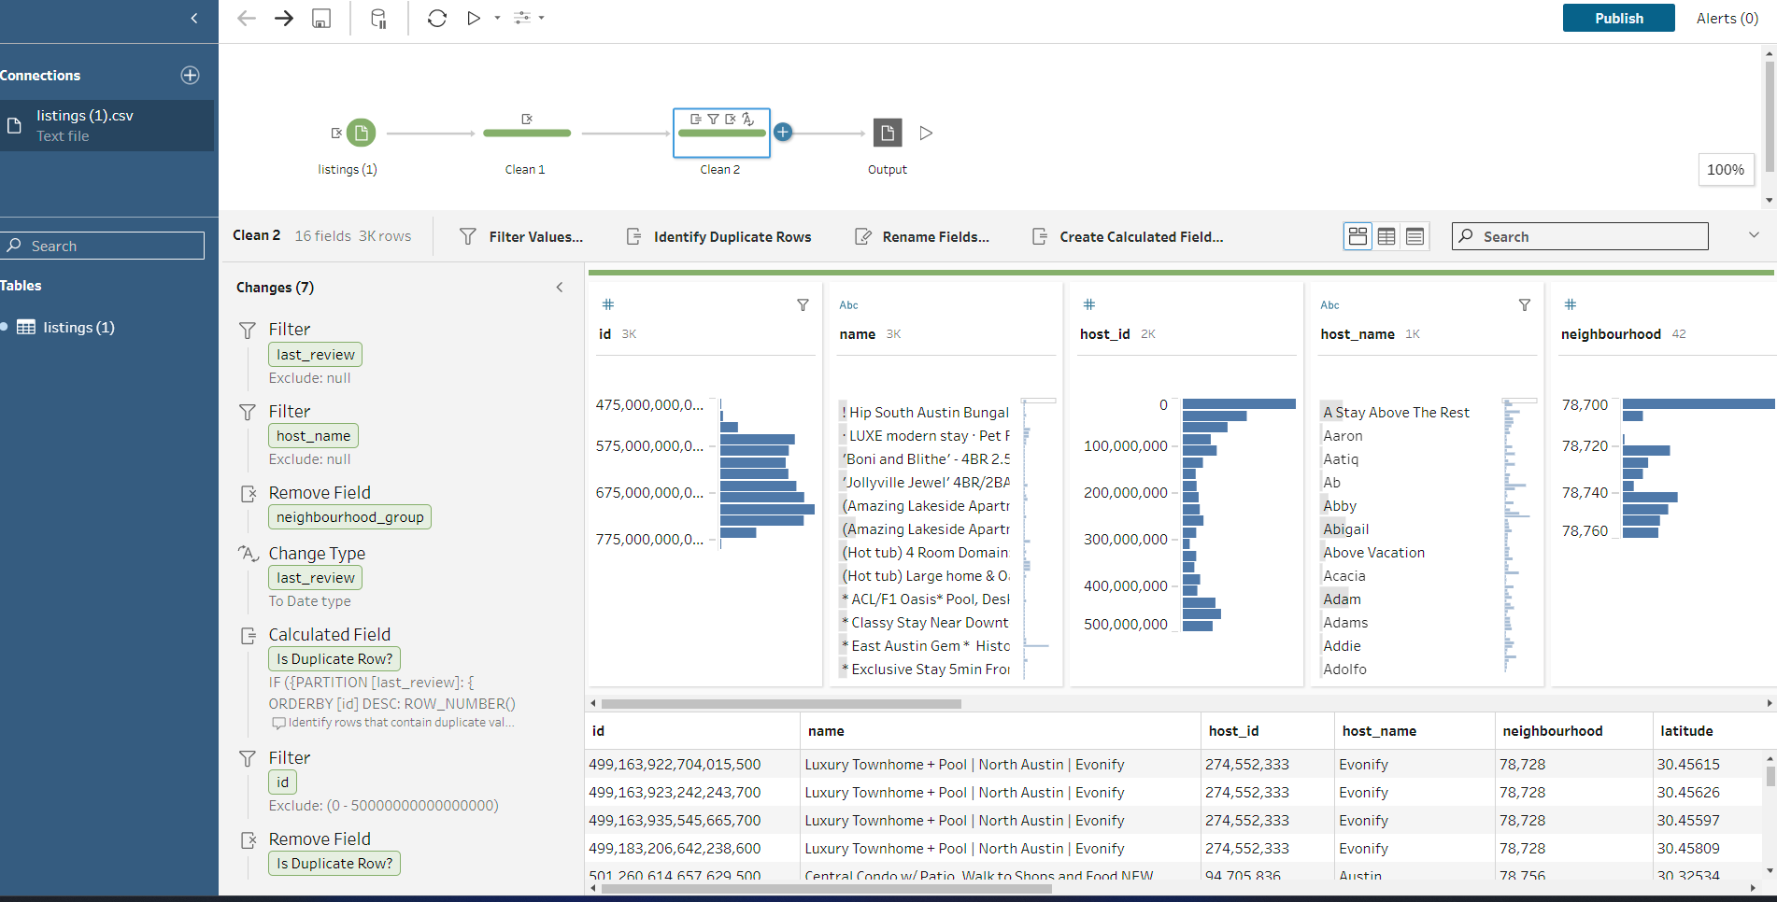We used Tableau Prep to clean and prepare the Airbnb listings dataset before conducting further analysis. The data cleaning process included the following key steps:

* **Connecting to the Data Source** We connected to the listings (1).csv file, which contains Airbnb listing information.
* **Filtering Null Values** We applied filters to remove records with missing critical information:
* Excluded rows where last_review was null.
* Excluded rows where host_name was null
* **Removing Unnecessary Fields** We removed the neighbourhood_group field, as it was not relevant to our analysis.

**4. Changing Data Types and Creating Calculated Fields** We changed the data type of the Is Duplicate Review field to Boolean.  
 We also created a calculated field to classify duplicates based on the presence of

a last_review, using the formula:  
IF ISNULL([last_review]) THEN 'DUPLICATE NOT NUMBERED'

ELSE [Is Duplicate Review]

* **Reviewing Cleaned Data** We verified the changes by examining key fields such as name, host_id, host_name, and neighbourhood. The data now reflects a cleaner structure, with consistent formatting and no unwanted nulls.

This flow allowed us to streamline the dataset and ensure its quality for accurate visualization and statistical analysis.

**Descriptive statistics:**We have analyzed a cleaned dataset of Airbnb listings in Austin and generated key descriptive statistics to understand the overall characteristics of the data. Below are the results of my analysis:

* **Average Price of Room**: The mean price across all listings is **$227**.
* **Count of Number of Reviews**: There are **3,013** listings with available review data.
* **Count of Availability (365 days)**: **3,013** listings include data on their availability throughout the year.
* **Count of Minimum Nights**: **3,013** listings have specified minimum night requirements.
* **Median Neighbourhood Value**: The median value for the Neighbourhood field is **78,725**. *(Note: This value appears to be numeric and may represent an encoded or proxy metric, rather than a direct neighborhood name. Further clarification may be needed.)*

This summary provides an overview of the dataset and helps inform further analysis or visualization steps.

**Basic figures/ Charts :**

1. **Bar chart - Top 30 Hosts by reviews**

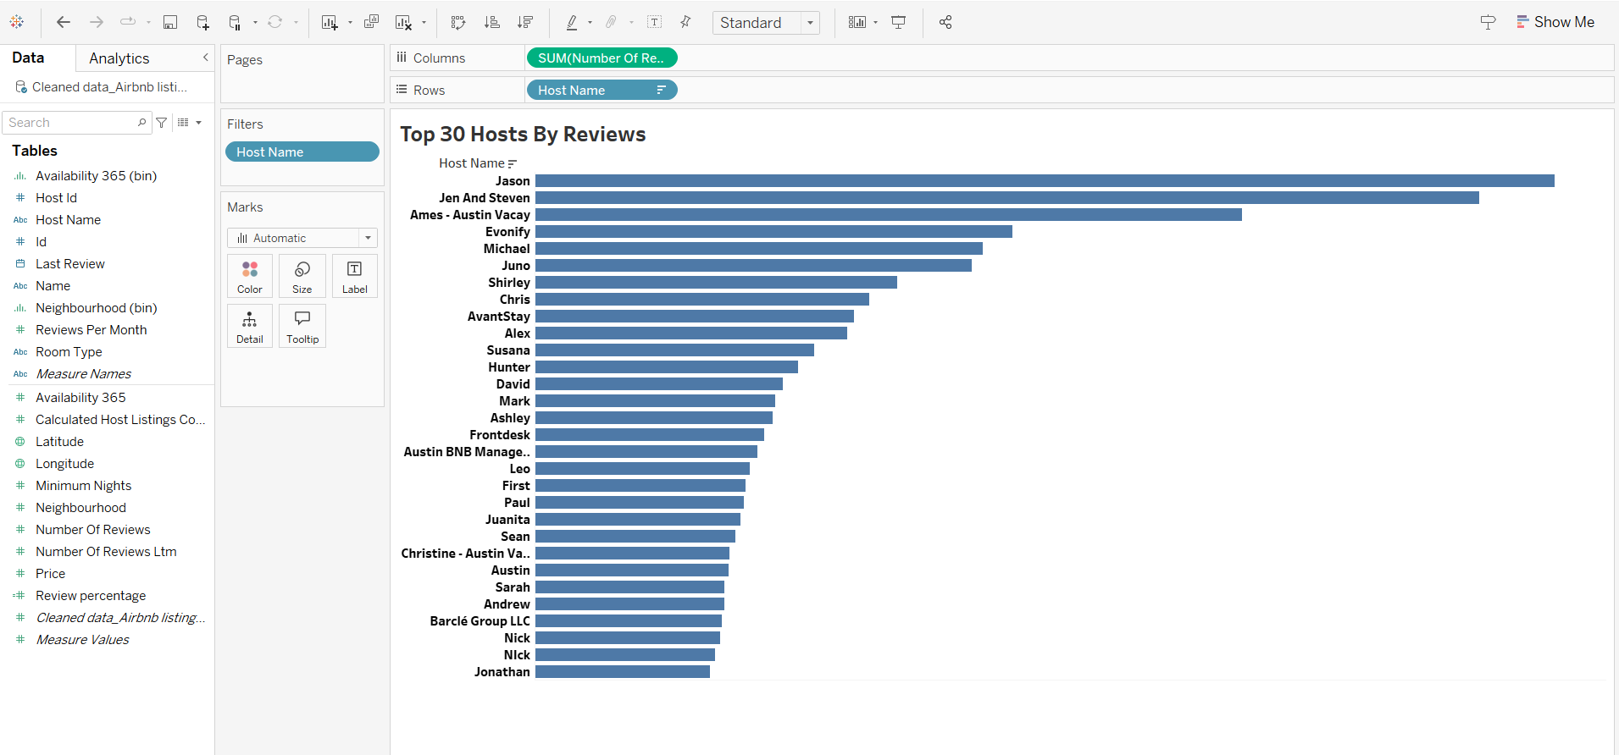

This bar chart displays the top 30 hosts based on the total number of reviews they have received. Each bar represents a unique host, and the length of the bar corresponds to the sum of their reviews.

**Key Observations:**

* Jason stands out as the host with the highest number of reviews, significantly exceeding all other hosts in this top 30 list.
* Jen And Steven also have a substantial number of reviews, placing them as the second most reviewed host.
* Following closely are Ames - Austin Vacay and Evenify, indicating a strong level of engagement with guests for these hosts as well.
* The remaining hosts in the top 30 show a gradual decrease in the total number of reviews, suggesting a varying level of activity or number of listings managed by each individual or group.

**2 . Gantt Chart with Trend Line**

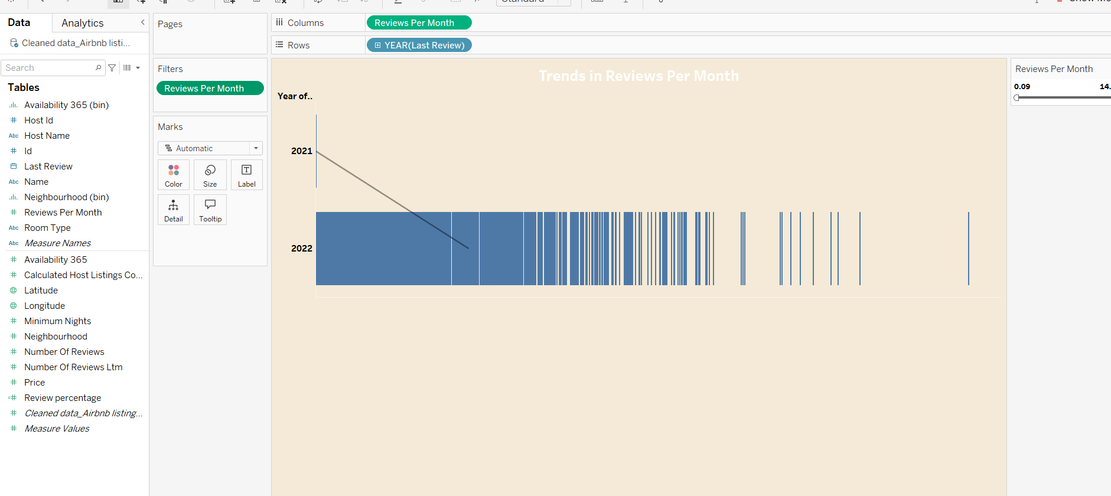

* There seems to be a significant increase in the average "Reviews Per Month" from 2021 to 2022. The average jumped from 0.09 in 2021 to 14.6 in 2022.
* The distribution of "Reviews Per Month" in 2022 appears to be more varied, with some months having considerably higher numbers of reviews than others.
* The bars for 2022 show more fluctuation compared to what we can infer about 2021 (based on the single point for the average).

**3. Pie Chart**

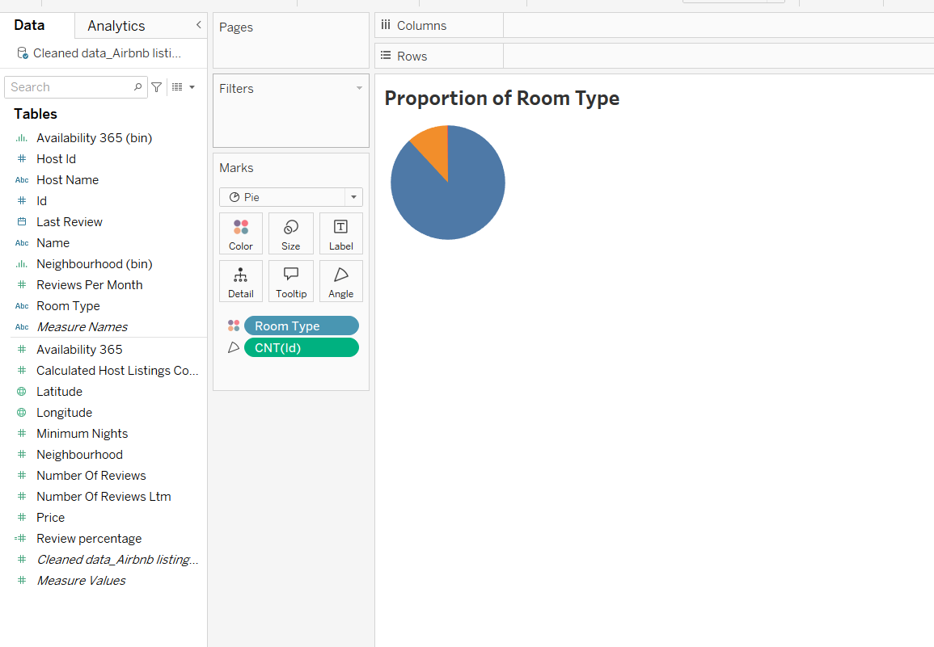

* The size of each slice corresponds to the relative frequency or count of each room type.
* The pie chart shows that "Entire home/apt" constitutes the largest proportion, followed by "Private room," with "Shared room" representing the smallest proportion

**4. Horizontal Bar Chart**

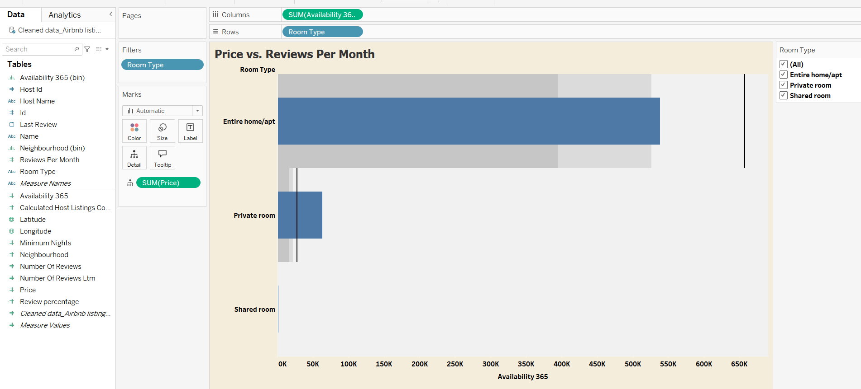

* Entire home/apt has the highest total price by a significant margin, and also the highest total availability.
* Private room has a considerably lower total price and availability compared to "Entire home/apt".
* Shared room has the lowest total price and availability among the three room types.

**5. Heat Map**

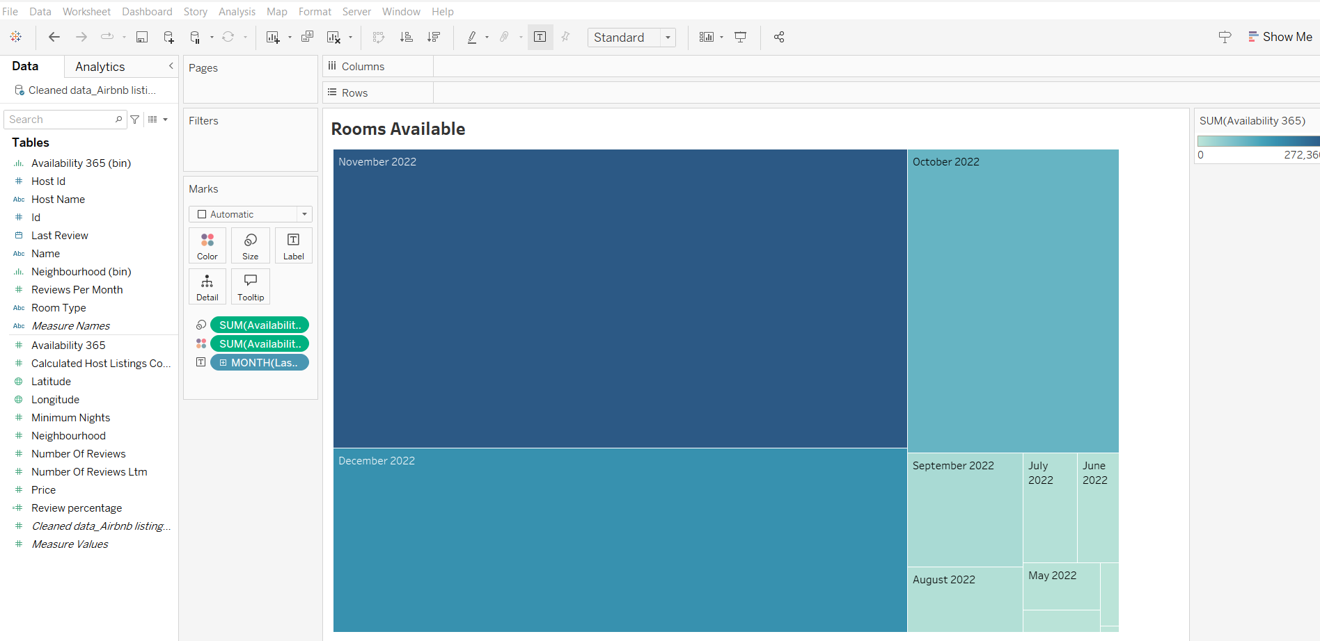

* November 2022 has the largest rectangle and the darkest shade of blue, suggesting it had the highest number of available rooms during this period.
* October 2022 also appears to have a significant number of available rooms, though less than November.
* The months from June 2022 to September 2022 seem to have a smaller number of available rooms compared to October and November, as indicated by the smaller rectangle sizes and lighter shades.
* August 2022 and May 2022 appear to have the fewest available rooms based on their small size.

**Geographic Chart**

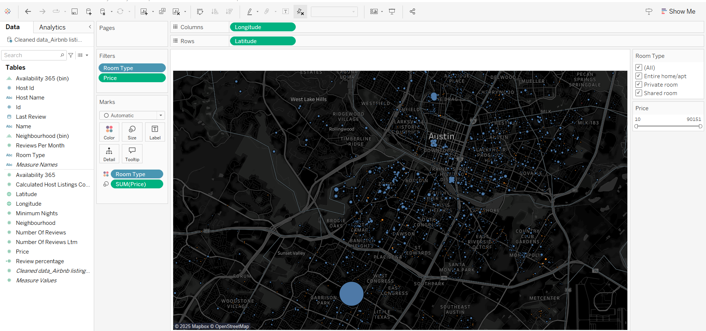

**Visualization Type:** This is a map chart displaying Airbnb listings within the Austin, Texas area.

**Data: The data source appears to be related to Airbnb listings, containing fields such as:**

* **Latitude and Longitude:** Used to plot the locations of the listings on the map.
* **Room Type:** Categorical variable allowing filtering by "Entire home/apt," "Private room," and "Shared room."
* **Price:** Numerical variable used to size the circles representing the listings. Larger circles likely indicate higher prices.

**Key Observations:**

* **Distribution of Listings:** The map shows a concentration of Airbnb listings in and around the central Austin area. There are also noticeable clusters in some of the surrounding neighborhoods.
* **Room Type Distribution:** The "Room Type" filter is currently set to "(All)," indicating that all types of listings are visible on the map.
* **Price Variation:** The varying sizes of the blue circles suggest a range of prices for the listed properties. The largest circles, representing the highest-priced listings, appear to be scattered throughout the central areas and potentially in some desirable neighborhoods.
* **Filtering:** There's a filter applied for "Room Type" and "Price," allowing for interactive exploration of the data based on these criteria. The "Price" filter currently shows a range from 0 to 10,151.

**Potential Insights and Further Exploration:**

* **Price by Location:** You could analyze the relationship between location and price by observing the size of the circles in different areas.
* **Room Type by Location:** By filtering by "Room Type," you could see the geographic distribution of different types of accommodations. For example, are entire homes more common in certain neighborhoods compared to private rooms?
* **Price Range Analysis:** You could use the "Price" filter to focus on listings within a specific price range and observe their distribution.

**Dashboards**

1. **Market Analysis Dashboard**

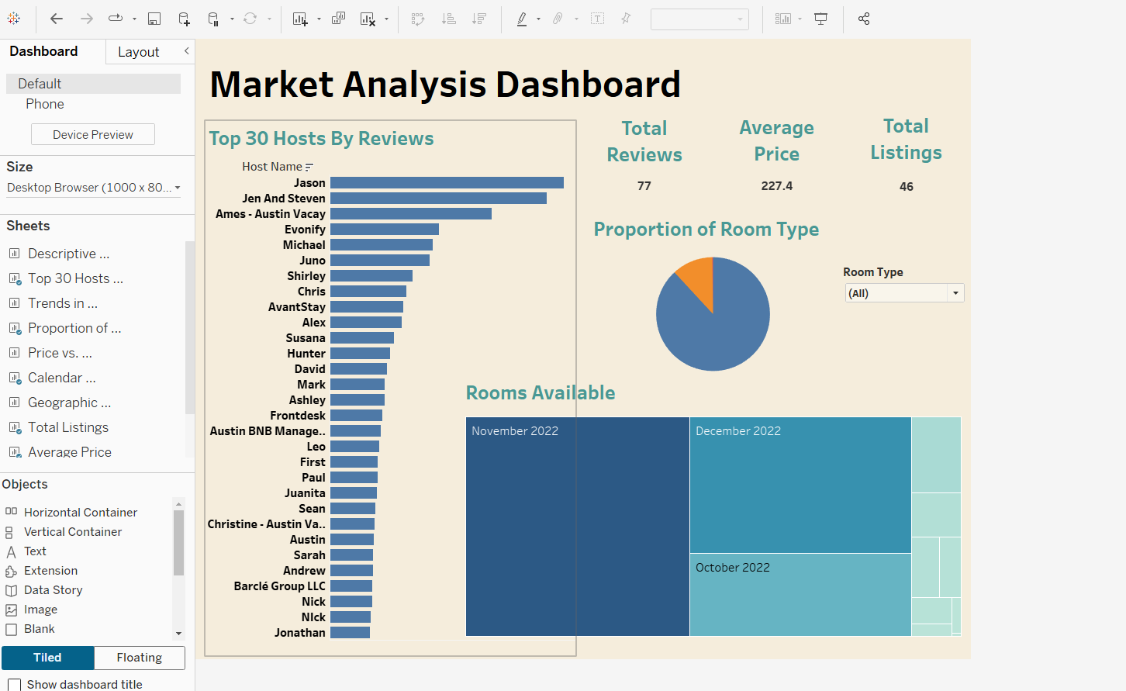

**Key Metrics at the Top:**

* Total Reviews: 77
* Average Price: $227.4
* Total Listings: 46

**Visualizations:**

* **Top 30 Hosts By Reviews:** A horizontal bar chart displaying the top 30 hosts based on the number of reviews they've received. "Jason" has the highest number of reviews among the top hosts shown.
* **Proportion of Room Type:** A pie chart illustrating the distribution of different room types. The legend indicates that the blue portion represents "Entire home/apt" and the orange portion represents "Private room". It appears "Entire home/apt" makes up a larger proportion. There's a filter for "Room Type" allowing the user to analyze specific room types.
* **Rooms Available:** A heatmap or similar visualization showing the availability of rooms over time. It currently displays data for November 2022, December 2022, and October 2022. The intensity of the color likely indicates the number of available rooms or perhaps the occupancy rate.

**Overall Interpretation:**

The dashboard provides a snapshot of the market, highlighting top performers based on reviews, the breakdown of available room types, and a view of room availability over recent months. This kind of analysis could be used by property managers, investors, or individuals looking to understand the local rental market.

1. **Booking Trends**

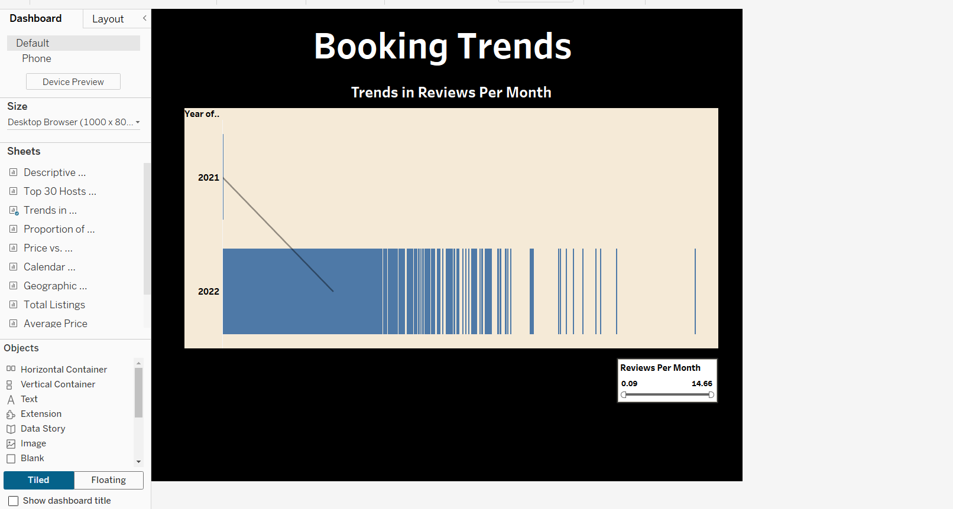

This report shows the "Booking Trends" with a focus on "Trends in Reviews Per Month."

The visualization displays the number of reviews per month across two years, 2021 and 2022.

* 2021: Shows a single data point, indicating a low number of reviews for that period.
* 2022: Shows a significantly higher number of reviews per month, with substantial variation throughout the year.

**Story**

**Title: Unlocking Airbnb Insights: A deep dive into austins listing**

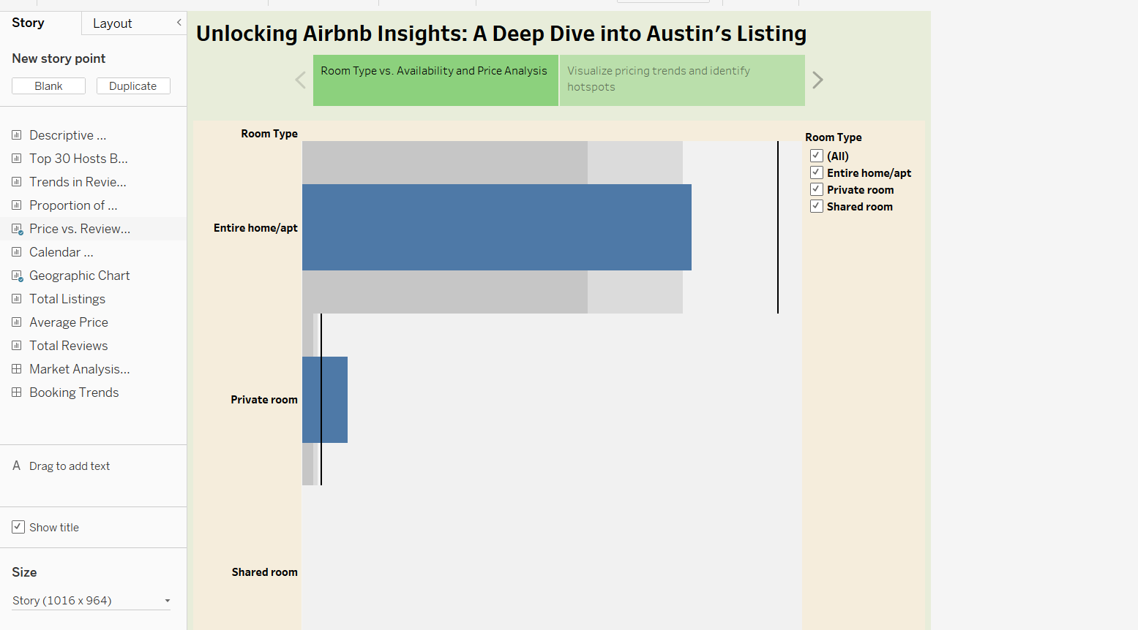

This story report, titled "Unlocking Airbnb Insights: A Deep Dive into Austin's Listing," currently focuses on the relationship between Room Type vs. Availability and Price Analysis in Austin.

The main visualization is a bar chart showing the availability (length of the bar) and potentially the average price (indicated by the vertical line within each bar, though this isn't explicitly labeled) for different room types: Entire home/apt, Private room, and Shared room.

The "Entire home/apt" category appears to have the highest availability, followed by "Private room," and then "Shared room" with the lowest availability.

There's a filter on the right allowing the user to select specific room types or view all. A callout suggests the goal is to "Visualize pricing trends and identify hotspots."

Based on what we've seen so far, the report aims to understand the Austin Airbnb market by looking at the relationship between room type, availability, price, and geographic distribution.

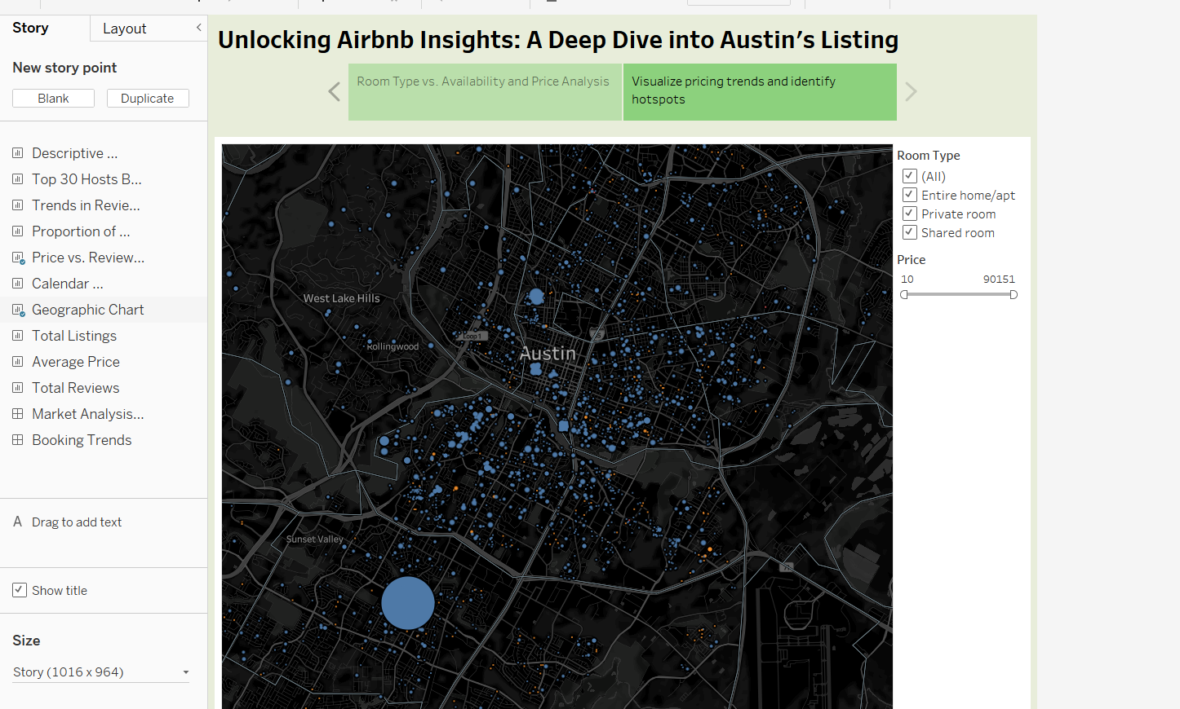

The second page then geographically maps these listings across Austin, allowing users to see where different types of rentals are located and how price varies spatially. The interactive filters for room type and price enable a more granular exploration of the market.

Therefore, the report is starting to provide a multi-faceted view of Austin's Airbnb landscape, connecting listing characteristics with their location. By navigating through the subsequent story points (as indicated in the left sidebar), we can expect to uncover further insights into aspects like top hosts, review trends, pricing dynamics, booking patterns, and other relevant market analyses.

**Decisions and Actions to be performed:  
Optimizing Airbnb Listings**

#### **1. Focus on High-Performing Hosts**

* **Action:** We will research the listings of top hosts such as "Jason" and "Jen and Steven" to identify successful strategies. We will specifically look at their pricing strategies, the amenities they offer, their listing descriptions, and guest reviews.
* **Decision:** We will consider adopting successful elements from their strategies to improve our own listings, with the goal of increasing both bookings and guest reviews.

#### **2. Capitalize on Popular Room Types**

* **Action:** Based on the "Proportion of Room Type" chart, which shows that "Entire home/apt" is more prevalent than "Private room," we will prioritize offering more "Entire home/apt" listings.
* **Decision:** If we currently have a mix of room types, we will shift our marketing focus toward promoting "Entire home/apt" listings to align with market demand.

#### **3. Optimize Pricing Strategy**

* **Action:** We will compare our pricing to the benchmark "Average Price" of $227.4, as well as pricing from top hosts. We will adjust our pricing to remain competitive while maximizing revenue.
* **Decision:** We will analyze the relationship between price and availability in the "Rooms Available" section. Specifically, we will investigate whether there are periods where higher prices can be sustained due to lower availability, and adjust our strategy accordingly.

#### **4. Manage Availability Effectively**

* **Action:** Using the data from the "Rooms Available" section, we will monitor occupancy trends to anticipate demand fluctuations and adjust our pricing and marketing strategies.
* **Decision:** If we observe consistently low availability, we may consider expanding the number of listings. Conversely, if we frequently experience high availability, we will review and refine our pricing and marketing strategies to increase occupancy**.**

#### **5. Identify Potential Growth Areas**

* **Action:** Although not explicitly shown in the data, we will analyze guest reviews and pricing data based on specific neighborhoods or amenities (if available).
* **Decision:** By identifying highly-rated and well-priced listings in specific areas, we can pinpoint potential areas for investment or expansion, ultimately boosting performance.

### **Market-Level Analysis**

#### **1. Understand Market Dynamics**

* **Action:** We will track the high-level market indicators, such as Total Listings, Total Reviews, and Average Price, to monitor market trends over time.
* **Decision:** These metrics will serve as a baseline, allowing us to identify any shifts in the market and adjust our strategies as needed.

#### **2. Assess Room Type Preferences**

* **Action:** We will consider the room type preferences highlighted in the "Proportion of Room Type" chart when evaluating future investments and developments.
* **Decision:** This insight will inform our decisions on which types of accommodations to prioritize, ensuring we align with market demand.

### **Conclusion**

By utilizing the dashboard insights, we can optimize our Airbnb listings through informed decisions on pricing, room types, availability management, and market dynamics. Regular analysis of these metrics will allow us to stay competitive, identify growth opportunities, and enhance our overall performance in the market. The specific strategies and actions outlined above will guide our approach in increasing bookings and improving guest satisfaction.