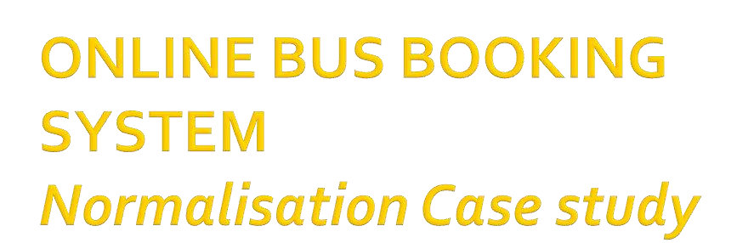



* ABC is an online bus booking system. There are 3 important entities(1) Bus
  1. Passenger
  2. Route
* Any user can login and check for schedule of buses using a username and e-mail address.
* The route table has the details of schedule of every bus.
* It has the attributes like departure date,departure time,bus number,capacity, seat number,status,fare,route name,source,destination and distance.



* The status attribute checks whether any seat is available or not.
* Once,an available seat is viewed by the user,he goes ahead for booking.
* A user can book tickets for many passengers.
* Booking will generate a ticket which has attributes like ticket number and mode of payment.
* The mode of payment can be either by cash or by credit card.



* Normalization is a process in which a given set of relations is replaced by successive collections of relations that have a simpler and more regular

structure.

* It transforms data from a problem into relations while ensuring data integrity and eliminating data redundancy.
* 4 most commonly used normal forms are first (1NF), second (2NF), third (3NF) and Boyce-Codd (BCNF) normal forms.



* To make it feasible to represent any relation in the database.
* To free relations from undesirable insertion, update, and deletion anomalies.



* Full Dependency:-

In a relation, the attribute(s) B is fully

functional dependent on A if B is functionally dependent on A,but not on any proper subset of A.

* Partial Dependency:-

If there is some attribute that can be removed from A and the dependency still holds. Eg. Pid,Pname->userid

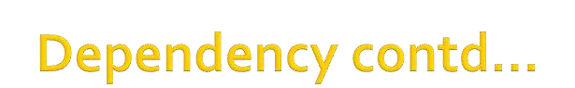

* Transitive Dependency

In a relation, if attribute(s) A->B and B->C, then C is transitively dependent on A via B (provided

that A is not functionally dependent on B or C)

Eg. Bus_no->Route_No and Route_No->Route_name



* A table that contains one or more repeating groups.
* To create an unnormalized table
* Transform the data from the information source
* (e.g. form) into table format with columns and rows.



**ONLINE BUS BOOKING SYSTEM-**

**ABC travels**

Booking_date: userid:

Username: email:

 Ticket No: Seatno:

Departuredate: Departuretime:

PassengerId: PassengerName:

PassengerAddress: DOB:

GENDER: Phoneno:

|  |  |
| --- | --- |
| Busno: | Busname: |
| Capacity: | type: |
| Routeno: | Route-name: |
| Source: | Destination: |
| Distance:  Modeof payment: | Fare: |



* The table cells must be of single value.
* Eliminate repeating groups in individual tables.
* Create a separate table for each set of related data.
* Identify each set of related data with a primary key.



The new tables are as follows:

1)USER

(***userid,***username,u_email)

2)PASSENGER

(***Pid,phno***,pname,paddress, DOB ,gender)

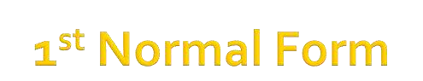3)BUS_ROUTE

(***routeno***,***busno***,routename,source,destination,distance, fare,dept_time,bname,capacity,type, dept_date)

3)RESERVATION

(***seatno,busno,*** status,bookingdate, ticketno, mode_of_payment)



**PASSENGER TABLE-(*Pid,Phno***->pname,paddress,Dob,gender**)**

|  |  |  |  |  |  |
| --- | --- | --- | --- | --- | --- |
| **Pid** | **phno** | **pname** | **paddress** | **DOB** | **gender** |
| 1 | 9676725456 | Ram Sharma | Pune | 6/1/1990 | Male |
| 2 | 9878767878 | Siya Varma | sikar | 3/5/1997 | female |
| 3 | 98786735 | SiyaVarma | sikar | 3/5/1997 | female |

**USER TABLE-(*userid*-**>username,u_email)

|  |  |  |
| --- | --- | --- |
| **Userid** | **Username** | **U_email** |
| 111 | Savita Marwal | savi@gmail.com |
| 222 | Himanish Mansinghani | himanish@yahoo.com |

|  |  |  |  |  |  |
| --- | --- | --- | --- | --- | --- |
| **seatno** | **busno** | **status** | **bdate** | **ticketno** | **modeofpay ment** |
| 1110 | 10 | booked | 1/4/2012 | 1122 | Cash |
| 1111 | 11 | Booked | 2/4/2012 | 1121 | credit |

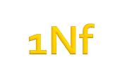**BUS_ROUT**E(***Busno,routeno****->* bname,c~~a~~pacity,type,routename,source, destination,distance,fare,dept_time, dept_date)

**route**

**no**

**Bus**

**no**

**route**

**name**

**sourc**

**e**

**desti**

**natio**

**n**

**dista**

**nce**

**fare**

**Dept**

**_time**

**Dept**

**_date**

**Bus**

**name**

**capac**

**ity**

**type**

2000

10

Delhi

-

Jaipur

delhi

Jaipur

2000

k

m

2000

11:00

am

3

/4/

2

012

AA

20

a/c

2001

11

Pune

-

mum

bai

pune

mum

bai

200

k

n

500

12:

p

m

4

/4/

2

012

BB

25

Non

a/c

**RESERVATION TABLE-**(***seatno,busno->***status,bookingdate,ticketno,mode_of_payment)



○ **A table is in 2NF if it is in 1NF and if all nonkey attributes are dependent on all of the key.**



**1)USER**

(***userid***->username,u_email)

***2)PASSENGER***

***(pid->*** pname,paddress, DOB, gender,userid)

# 3)CONTACTS

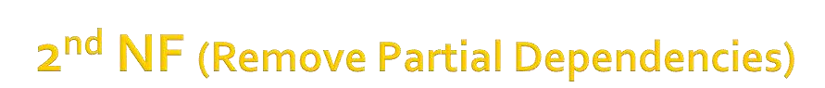(***pid,phid***->phno)

**4)BUS_ROUTE**

(***routeno,busno***->bname,capacity,type, source,destination,distance,fare,Dept_time,dept_date)

**5)RESERVATION**

(***seatno,busno->***status, bookingdate,ticketno, mode_of_payment)



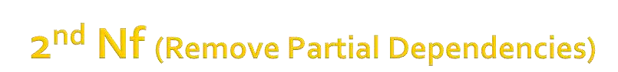 **PASSENGER TABLE-** (Pid(pk)->pname,paddress,Dob,gender,userid)

|  |  |  |  |  |  |
| --- | --- | --- | --- | --- | --- |
| **Pid** | **pname** | **paddress** | **DOB** | **gender** | **userid** |
| 101 | Ram Sharma | Pune | 6/1/1990 | Male | 111 |
| 102 | Siya Varma | sikar | 3/5/1997 | female | 112 |
| 102 | Siya Varma | sikar | 3/5/1997 | female | 112 |

**CONTACTS TABLE** - (phid(pk)->phno)

|  |  |  |
| --- | --- | --- |
| **Phid** | **pid** | **phno** |
| 1 | 101 | 9887656789 |
| 2 | 102 | 9878789098 |
| 3 | 202 | 9767352453 |



○ **A table is in 3NF if it is in 2NF and if it has no transitive dependencies.**



**1)USER**

(***userid->***username,u_email)

2)**PASSENGER**

(***pid***->pname,paddress,DOB, gender,userid)

**3)CONTACTS**

(***pid,phno***->phno)

***(As, busno->routeno and routeno->distance)***

Break **BUS_ROUTE relation** into 2 tables-

**a)BUS**

(***busno***->bname,capacity,type,routeno)

**b)ROUTE**

(***routeno***->routename,source,destination, dept_date,dept_time,distance,fare)



|  |  |  |  |  |  |  |  |
| --- | --- | --- | --- | --- | --- | --- | --- |
| **routeno** | **routena**  **me** | **source** | **destinati on** | **Dept_dat e** | **Dept_ti**  **me** | **distance** | **fare** |
| 2000 | DelhiJaipur | Delhi | Jaipur | 3/4/2012 | 11:00a.m | 2000 | 2000 |
| 2001 | Pune-  Mumbai | Pune | Mumbai | 4/4/2012 | 12:00p.m | 200 | 500 |

**a)BUS** (***busno***->bname,capacity,type,routeno)

|  |  |  |  |  |
| --- | --- | --- | --- | --- |
| **busno** | **bname** | **capacity** | **type** | **routeno** |
| 10 | AA | 20 | A/C | 2000 |
| 11 | BB | 25 | NON A/C | 2001 |

**b)ROUTE** (***routeno***->routename,source,destination,

dept_date,dept_time,distance,fare)



**FROM RESERVATION-*{seatno->ticketno and ticketno->modeof payment}***

A)BOOKING

(***seatno***->pid,busno,status,ticketno)

B) TICKET

(***ticketno-***>bookingdate,mode_of_payment)



* **A table is in BCNF if it is in 3NF and if every determinant is a candidate key.**
* **BCNF is a stronger form of 3NF**
* **BCNF => 3NF**
* **3NF ≠> BCNF**



1)BOOKING

(seatno-> pid,busno,status)

|  |  |  |  |
| --- | --- | --- | --- |
| **seatno** | **pid** | **busno** | **status** |
| 1001 | 101 | 10 | booked |
| 1008 | 102 | 11 | booked |

➢Here,all the attributes other than seatno acts as a candidate key.

➢Eg,pid can act as a primary key alone.

➢Busno can also act as a primary key.

➢Status is not unique(i.e.either booked or available),so we use(seatno and status) as candidate key.



* **A table is in 4NF if it is in BCNF and if it has no multi-valued dependencies.**



* **A table is in 5NF, also called "ProjectionJoin Normal Form" (PJNF), if it is in 4NF and if every join dependency in the table is a consequence of the candidate keys of the table.**

