#include<iostream.h>

#include<conio.h>

class student

{ protected :int rln;

char name[10],branch[10];

public:void idata()

{

cout<<"enter student name ";

cin>>name;

cout<<"enter branch ";

cin>>branch;

cout<<"enter roll no. ";

cin>>rln;

} };

class subject:public student

{

protected:int m1,m2,m3;

float p;

public:void marks()

{

cout<<"enter marks in Math ";

cin>>m1;

cout<<"enter marks in OOPs ";

cin>>m2;

cout<<"enter marks in CA ";

cin>>m3;

}

void per()

{ p=(m1+m2+m3)/3;

} };

class show:public subject

{public:

void disp()

{

cout<<"\nthe name of student "<<name;

cout<<"\nbranch of student "<<branch;

cout<<"\nrollno of student "<<rln;

cout<<"\nenter marks in Math "<<m1;

cout<<"\nenter marks in OOPs "<<m2;

cout<<"\nenter marks in CA "<<m3;

cout<<"\npercentage of student "<<p;

}

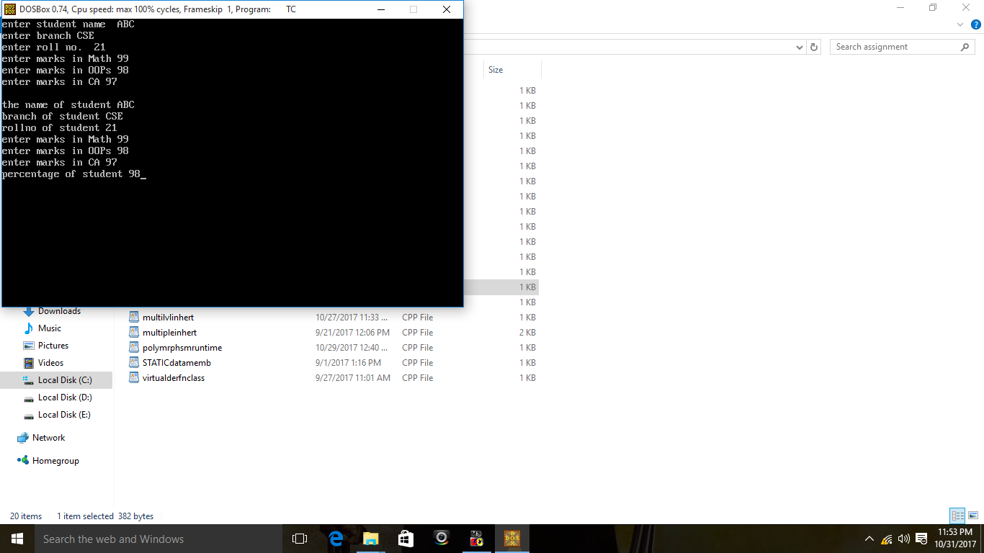 };

void main()

{ clrscr();

show s;

s.idata();

s.marks();

s.per();

s.disp();

getch();

}