#include<iostream.h>

#include<conio.h>

class hod

{

public:

virtual void paisa()

{

cout<<"Base hod is calling ";

}

};

class derived:public hod

{

public:void paisa()

{

cout<<"derived is calling "<<endl;

}

};

void main()

{ clrscr();

hod \*p;

derived std;

p=&std;

cout<<"I've used virtual fn to call derived class fn "<<endl;

p->paisa();

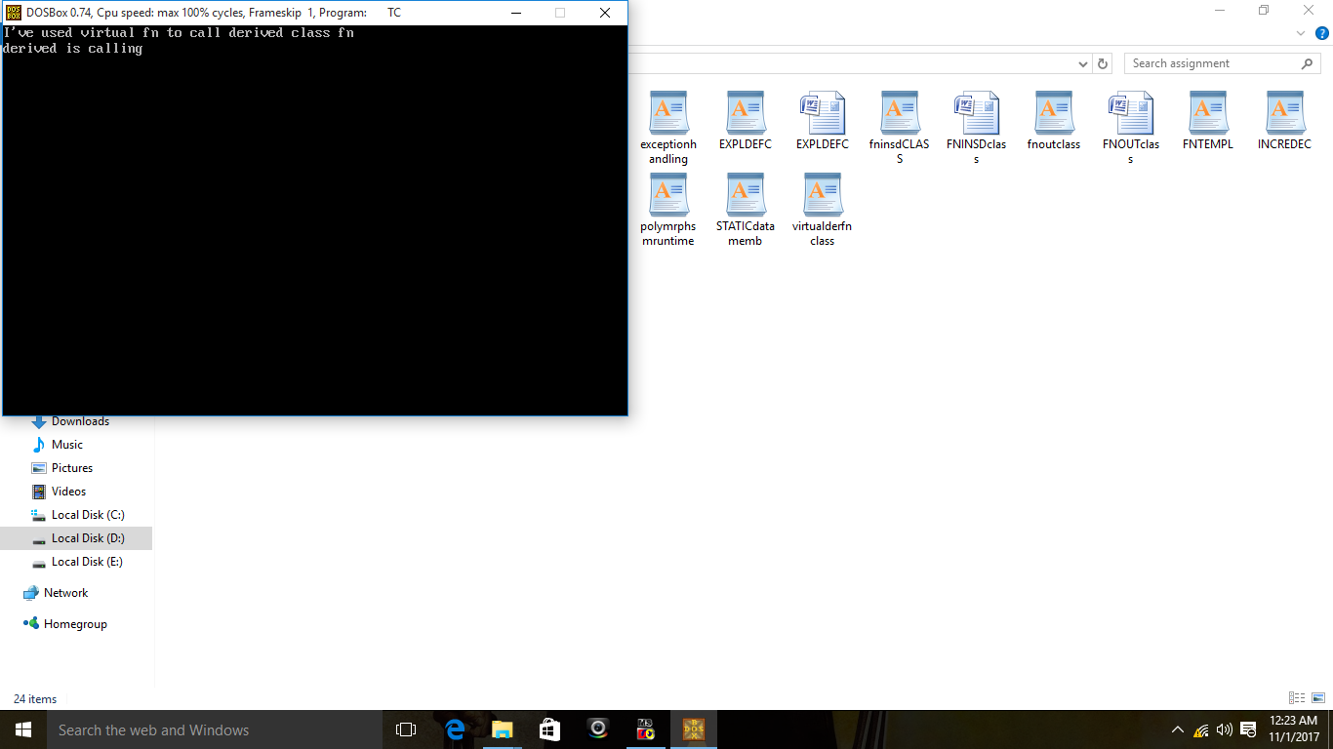 getch();

}