#include<iostream.h>

#include<conio.h>

class gp

{ protected :int a,b;

public:void idata()

{

cout<<"\nenter two number ";

cin>>a>>b;

} };

class p1:virtual public gp

{protected:int c;

public:

void sum()

{

c=a+b;

cout<<"\nthe result of sum(p1) is "<<c;

} };

class p2:public virtual gp

{

protected:int d;

public:

void mul()

{ d=a\*b;

cout<<"\nthe product(p2) of two number is "<<d;

}

};

class ch:public p1,public p2

{

protected :int e;

public:void sosm()

{

e=c+d;

cout<<"\nthe sum of results p1 and p2 is "<<e;

}

};

void main()

{ clrscr();

ch c1;

c1.idata();

c1.sum();

c1.mul();

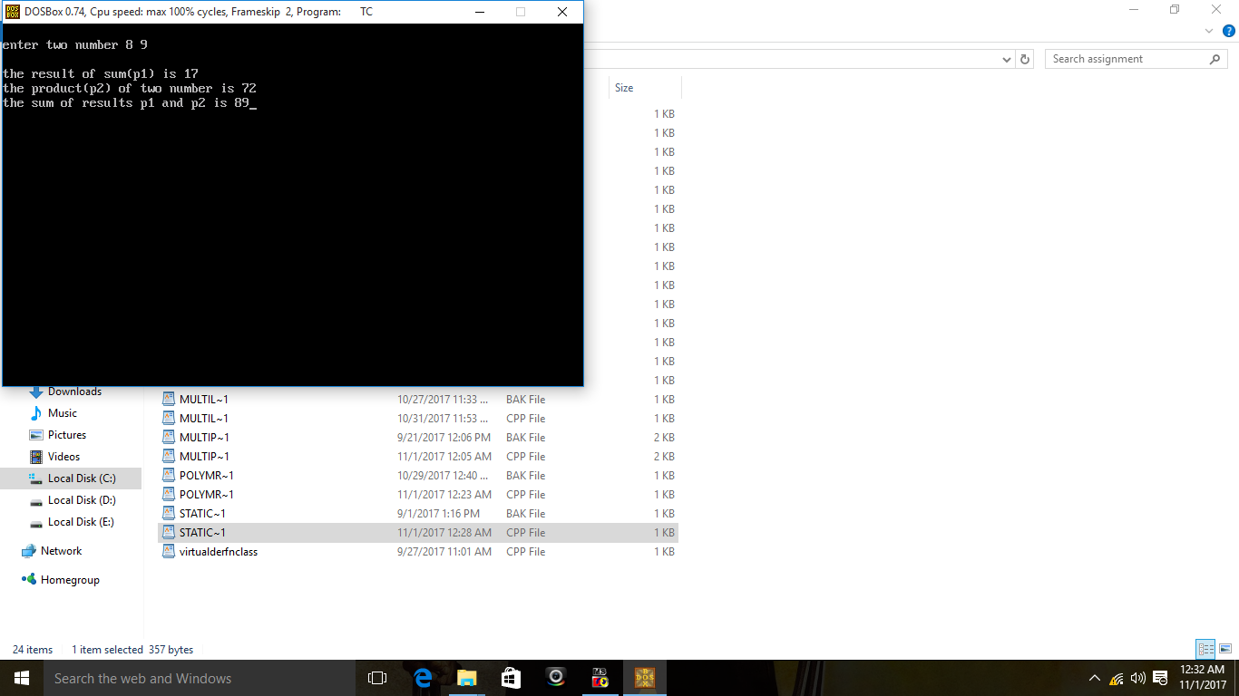 c1.sosm();

getch();

}