#include<iostream.h>

#include<conio.h>

class bnarth

{

int a,b,c;

public:

void in()

{

cout<<"\nenter real number that you want to multiply : ";

cin>>a;

cout<<"\nenter fake number to multiply : ";

cin>>b;}

public:bnarth operator \*( bnarth a1)

{ bnarth a2;

a2.a=a\*a1.a;

a2.b=b\*a1.b;

return a2;

}

void show()

{

cout<<"\nthe product of real number is "<<a;

cout<<"\nthe product of fake number sum is "<<b;

}

};

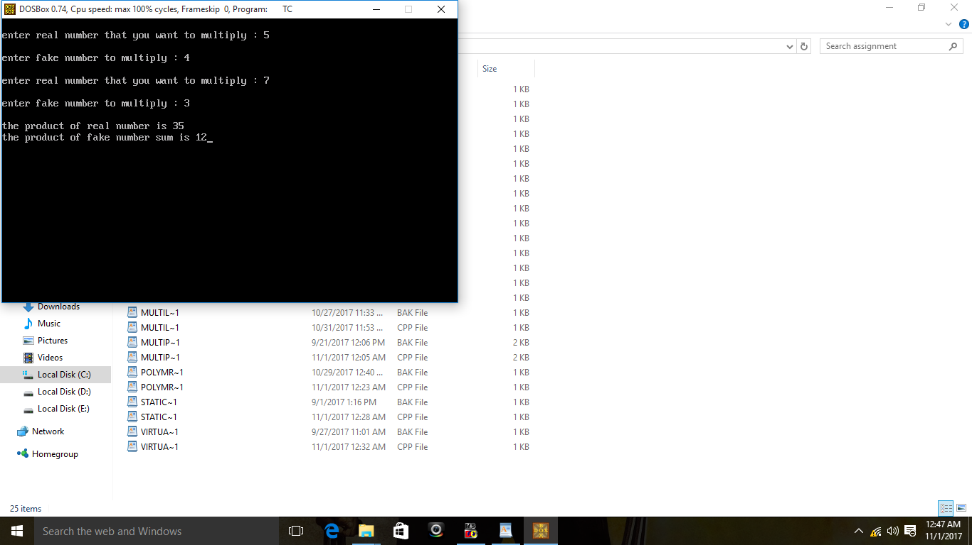void main()

{clrscr();

bnarth m1,m2,m3;

m1.in();

m2.in();

m3=m1\*m2;

m3.show();

getch();

}