#include<iostream.h>

class emply:public address

{

public:char name[10];

float sal;

void ie()

{

cout<<"enter the name : ";

cin>>name;

cout<<"enter salary : ";

cin>>sal;

}

void de()

{

cout<<"\nthe name of emp : "<<name;

cout<<"\n the sal of emp : "<<sal;

cout<<"\n the address of employ is : city - "<<city<<" state - "<<state<<endl;

}

};

#include<conio.h>

class address

{

protected:char city[10],state[10];

public:

void idata()

{

cout<<"enter name of city : ";

cin>>city;

cout<<"enter name of state ";

cin>>state;

}

};

class std:public address

{

public:char sname[10],branch[5];

void is()

{

cout<<"enter std name : ";

cin>>sname;

cout<<"enter branch of std : ";

cin>>branch;

}

void ds()

{

cout<<"\nthe name of student : "<<sname;

cout<<"\n the branch of student : "<<branch;

cout<<"\n the address of student is : city - "<<city<<" , state - "<<state;

}

};

void main()

{clrscr();

cout<<"\nenter the details of employ : ";

emply e1;

std s1;

e1.ie();

e1.idata();

e1.de();

cout<<"\nenter the details of student : ";

s1.is();

s1.idata();

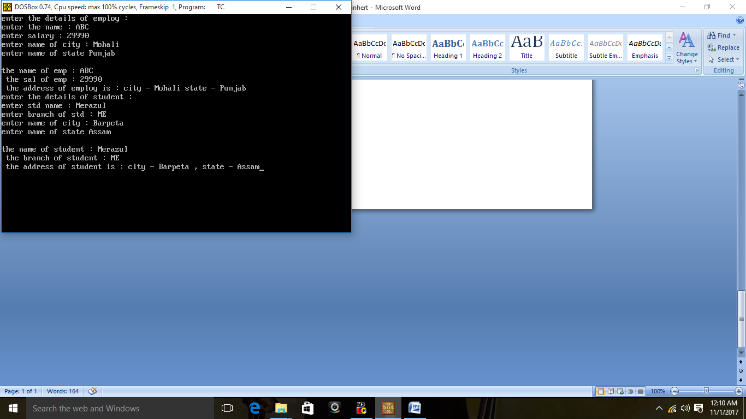s1.ds();

getch();

}