{name}
 | {department} |  | {year}
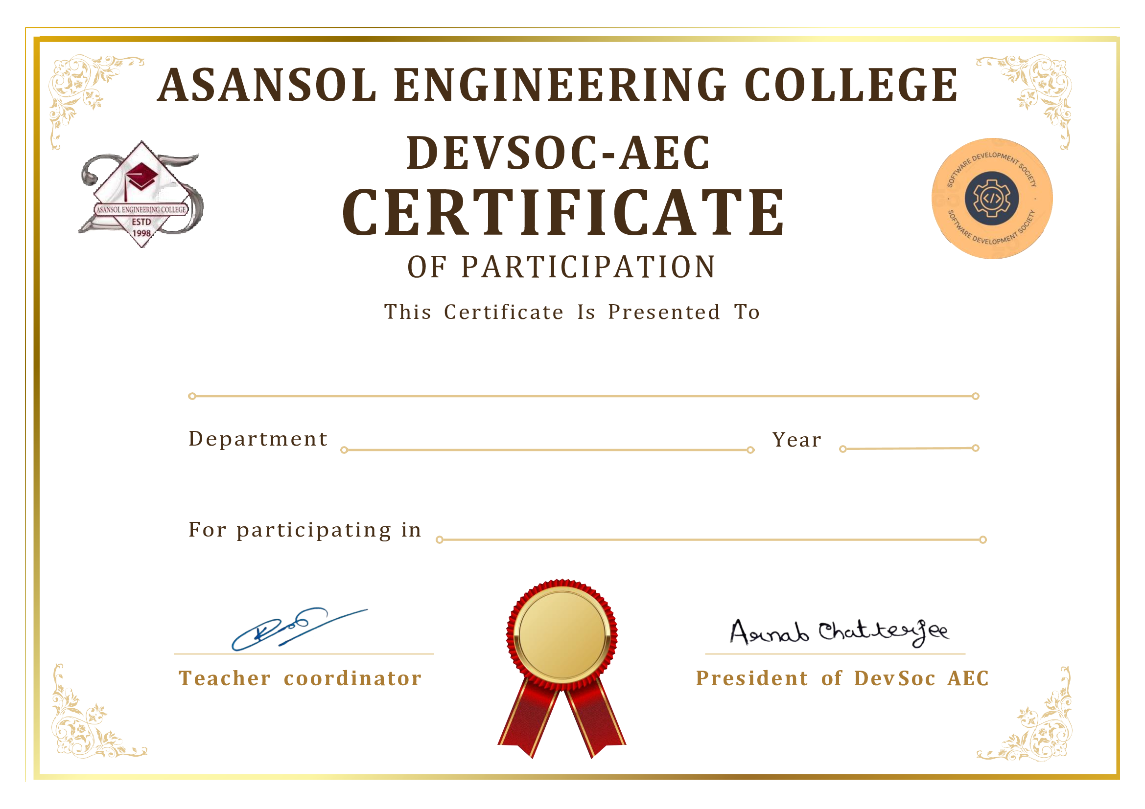

Rapid Round Programming Quiz

