

**WASTE MANAGEMENT SYSTEM**

Aishwarya (1847204)

Sajal Dubey (1847251)

Vikash Singh (1847263)

Under the guidance of

Dr. Arul Kumar N

DBMS project report submitted in partial fulfillment of the requirements for the award of degree of

Master of Computer Applications of CHRIST (Deemed to be University)

October - 2019



CERTIFICATE

*This is to certify that the report titled* **WASTE MANAGEMENT SYSTEM** *is a bona fide record of work done by* ***Aishwarya (1847204), Sajal Dubey (1847251) and Vikash Singh (1847263)*** *of CHRIST (Deemed to be University), Bangalore, in partial fulfillment of the requirements of III Semester MCA during the year 2019.*

**Head of the Department Project Guide**

Valued-by:

|  |  |  |
| --- | --- | --- |
|  | Examination Centre | : CHRIST  (Deemed to be University) |
| 1. |  |
| 2. | Date of Exam | : 30/08/2019 |

# ACKNOWLEDGEMENTS

### First of all, we thank the lord almighty for his immense grace and blessings showered on me at every stage of this work. we are greatly indebted to our Head of the Department of Computer Science, Prof. Joy Paulose, CHRIST (Deemed to be University) for providing the opportunity to take up this project as part of my curriculum.

We are greatly indebted to our MCA Course Coordinator, Prof. Tulasi, for providing the opportunity to take up this project and for helping with her valuable suggestions.

we are deeply indebted to our project guide Dr. Arul kumar N for his assistance and valuable suggestions as a guide. He made this project a reality.

we express our sincere thanks to Dr. Chandra J, Prof. Smitha Vinod and Prof. Nismon Raio, lecturers of the Department of Computer Science, CHRIST (Deemed to be University), for their valuable suggestions during the course of this project. Their critical suggestions helped us to improve the project work.

Acknowledging the efforts of everyone, their chivalrous help in the course of the project preparation and their willingness to corroborate with the work, their magnanimity through lucid technical details lead to the successful completion of my project.

we would like to express our sincere thanks to all our friends, colleagues, parents and all those who have directly or indirectly assisted during this work.

**ABSTRACT**

Waste management or Waste disposal is all the activities and actions required to manage waste from its inception to its final disposal. This includes amongst other things, collection, transport, treatment and disposal of waste together with monitoring and regulation. It also encompasses the legal and regulatory framework that relates to waste management encompassing guidance on recycling etc. Garbage is any substance that is discarded when primary use, or it’s chaffed, defective and of no use. Examples embrace municipal solid waste (household trash/refuse), venturesome waste, sewer water (such as waste matter, that contains bodily wastes (faeces and urine) and surface runoff), radioactive material, and others.

For this one user will request to pick the garbage from home at a particular time and then system staff will come to them with their vehicles and load the garbage into it and take some cost and bump it to the dumping area. Hence this system helps in making the environment clean.

**TABLE OF CONTENTS**

|  |  |  |  |  |  |  |  |  |
| --- | --- | --- | --- | --- | --- | --- | --- | --- |
| **Sl. No.** | | | **Content** | | | **Page No.** | | |
| **1** | | | **Introduction** | | | **1** | | |
|  | | | 1.1 Overview of the system | | | 1 | | |
| **2** | | | **System analysis** | | | **2** | | |
|  | | | 2.1 Existing system | | | 2 | | |
|  | | | 2.1.1 Limitations of the existing system | | | 2 | | |
|  | | | 2.2 Proposed system | | | 2 | | |
|  | | | 2.2.1 Advantages of proposed system | | | 2 | | |
|  | | | 2.3 Literature survey | | | 3 | | |
|  | | | 2.4 Software tools used | | | 3 | | |
|  | | | 2.4.1 Front end | | | 3 | | |
|  | | | 2.4.1.1 Html | | | 3 | | |
|  | | | 2.4.1.2 Bootstrap | | | 4 | | |
|  | | | 2.4.1.3 JavaScript | | | 4 | | |
|  | | | 2.4.2 Backend | | | 5 | | |
|  | | | 2.4.2.1 MySQL | | | 5 | | |
|  | | | 2.5 Software used | | | 5 | | |
|  | | | 2.5.1 GitHub | | | 5 | | |
|  | | | 2.5.2 Sublime text | | | 5 | | |
| **3** | | | **System Requirements** | | | **7** | | |
|  | | | 3.1 System model | | | 7 | | |
|  | | | 3.2 User Requirements | | | 7 | | |
|  | | | 3.2.1 Functional requirements | | | 7 | | |
|  | | | 3.2.1.1 User | | | 7 | | |
|  | | | 3.2.1.2 Volunteer/NGO | | | 7 | | |
|  | | | 3.2.1.3 Admin | | | 8 | | |
|  | | | 3.2.1.4 Contact Us | | | 8 | | |
|  | 3.2.2 Non-Functional requirements | | | | | 9 |
|  | 3.3 System requirements | | | | | 9 |
|  | 3.3.1 Hardware requirements | | | | | 9 |
|  | 3.3.2 Software requirements | | | | | 9 |
|  | 3.3.2.1 Front end | | | | | 9 |
|  | 3.3.2.2 Back end | | | | | 10 |
|  | 3.3.2.3 Software used | | | | | 10 |
| **4** | **Design specification** | | | | | **11** |
|  | 4.1 Architectural design | | | | | 11 |
|  | 4.2 Data flow diagram | | | | | 13 |
|  | 4.2.1 Context diagram (Level 0 DFD) | | | | | 13 |
|  | 4.2.2 Level 1 DFD | | | | | 14 |
|  | 4.2.3 Level 2 DFD | | | | | 14 |
|  | 4.3 Entity relationship diagram | | | | | 15 |
|  | 4.4 Database design | | | | | 16 |
|  | 4.4.1 Admin | | | | | 16 |
|  | 4.4.2 User Info | | | | | 16 |
|  | 4.4.3 NGO Info | | | | | 16 |
|  | 4.4.4 Volunteer Info | | | | | 17 |
|  | 4.4.5 Complaint details | | | | | 17 |
|  | 4.4.6 Location Detail | | | | | 18 |
|  | 4.4.7 Contact Detail | | | | | 18 |
| **5** | **Implementation details** | | | **19** | | |
|  | 5.1 Source code | | | 19 | | |
|  | 5.1.1 Waste Management System | | | 19 | | |
|  | 5.1.1.1 signup1.php | | | 19 | | |
|  | 5.1.1.2 signup.php | | | 23 | | |
|  | 5.1.2 User | | | 24 | | |
|  | 5.1.2.1 beanemployee.php | | | 24 | | |
|  | 5.1.2.2 employee.php | | | 29 | | |
|  | 5.1.2.3 complaint.php | | | 29 | | |
|  | 5.1.2.4 complaintconfirm.php | | | 33 | | |
|  | 5.1.2.5 history.php | | | 34 | | |
|  | 5.1.3 NGO | | | 39 | | |
|  | 5.1.3.1 view_complaint.php | | | 39 | | |
|  | 5.1.3.2 history.php | | | 42 | | |
|  | 5.1.4 Admin | | | 44 | | |
|  | 5.1.4.1 add_location.php | | | 44 | | |
|  | 5.1.4.2 add_location1.php | | | 48 | | |
|  | 5.1.4.3 hotspot_area.php | | | 49 | | |
|  | 5.1.5 hotspot_overall.php | | | 56 | | |
|  | 5.2 Screenshots | | | 64 | | |
|  | 5.2.1 Main Page | | | 64 | | |
|  | 5.2.2 Login Page | | | 64 | | |
|  | 5.2.3 User Home Page | | | 65 | | |
|  | 5.2.4 Complaint Page | | | 65 | | |
|  | 5.2.5 Complaint History Page | | | 66 | | |
|  | 5.2.6 Request Pending Page | | | 66 | | |
|  | 5.2.7 NGO/Volunteer Home Page | | 67 | | | |
|  | 5.2.8 Complaint Raised | | 67 | | | |
|  | 5.2.9 History Page | | 68 | | | |
|  | 5.2.10 Admin Panel Page | | 68 | | | |
| **6** | **Testing** | | **69** | | | |
|  | 6.1 Test plan | | 69 | | | |
|  | 6.2 Test cases | | 70 | | | |
|  | 6.2.1 Login form | | 70 | | | |
|  | 6.2.2 Registration form | | 71 | | | |
|  | 6.2.3 Complaint Raised Form | | 72 | | | |
|  | 6.2.4 User dashboard | | 73 | | | |
|  | 6.2.5 History | | 73 | | | |
|  | 6.2.6 Update Complaint | | 74 | | | |
|  | 6.2.7 Admin | | 74 | | | |
| **7** | **Conclusion** | | **75** | | | |
|  | 7.1 Future enhancement | | 75 | | | |
|  | References | |  | | | |

|  |  |  |
| --- | --- | --- |
| **Table No.** | **Table Name** | **Page No.** |
|  | **Design specification** | **11** |
| Table 4.1 | admin | 16 |
| Table 4.2 | user | 16 |
| Table 4.3 | NGO | 16 |
| Table 4.4 | volunteer | 17 |
| Table 4.5 | complaint | 17 |
| Table 4.6 | locality | 18 |
| Table 4.7 | contact | 18 |
|  | **Testing** | **69** |
| Table 6.1 | Login test cases | 70 |
| Table 6.2 | Registration form test cases | 71 |
| Table 6.3 | Complaint raised form test cases | 72 |
| Table 6.4 | User Dashboard test cases | 73 |
| Table 6.5 | History test cases | 73 |
| Table 6.6 | Update complaint test cases | 74 |
| Table 6.7 | Admin test cases | 74 |

|  |  |  |
| --- | --- | --- |
| **Fig. No.** | **Figure Name** | **Page No.** |
|  | **System Requirements** | **9** |
| Fig. 3.1 | System model | 9 |
|  | **Design specification** | **11** |
| Fig. 4.1 | Three tier architecture | 12 |
| Fig. 4.2 | Level 0 DFD | 13 |
| Fig. 4.3 | Level 1 DFD | 14 |
| Fig. 4.4 | Level 2 DFD | 14 |
| Fig. 4.5 | ER Diagram | 15 |
|  | **Implementation details** | **19** |
| Fig. 5.1 | Main Page | 64 |
| Fig. 5.2 | Login Page | 64 |
| Fig. 5.3 | User Home Page | 65 |
| Fig. 5.4 | Complaint Page | 65 |
| Fig. 5.5 | Completed History Page | 66 |
| Fig. 5.6 | Request Pending Page | 66 |
| Fig. 5.7 | NGO/Volunteer Home Page | 67 |
| Fig. 5.8 | Complaint Raised Page | 67 |
| Fig. 5.9 | History Page | 68 |
| Fig. 5.10 | Admin Panel Page | 68 |

1. **INTRODUCTION**

**1.1 OVERVIEW OF THE SYSTEM**

The main objective of our website is Waste management (or waste disposal) are the activities and actions required to manage waste from its inception to its final disposal. This includes the collection, transport, treatment and disposal of waste, together with monitoring and regulation of the waste management process. Waste Management System deals with all types of waste, including industrial, biological and household. In some cases, waste can pose a threat to human health.

The proposed application is focused on developing a platform for the Users, Volunteers and NGO(s) to participate in the cleanliness of the neighborhood and the city. The user will be able to raise complaints in the medium of images. These images will be used to identify the level of waste spread across a particular location attached by the user. To overcome the misinformation problem this system will provide updates regarding the actions taken by concerned people.

Volunteers are also a major part of this system as they will be helping in segregation and cleaning of wastes around the neighborhood and also creating awareness among the citizens.

Following are the reasons why this application is needed:

* Overcoming the outdated and unsupportive management system.
* Direct communication between user and authority.
* Increase in community involvement by initiating volunteer participation.
* Easy technology used so that every age group can access.
* Creation of awareness among the people.

1. **SYSTEM ANALYSIS**
   1. **EXISTING SYSTEM**

Municipal waste management is not in accordance with municipality of solid waste (Management and Handling) rules, 2000. Approximately 5000 tons of waste is generated in Bengaluru city, out of which only 30% waste is collected by BBMP directly and the 70% of municipal solid waste is collected and transported through contractors. The solid waste is undergoing change in its composition. Some of the landfills are either closed or badly managed. Much of municipal solid waste and household wastes gets dumped in the open dumps and nearby open areas, posing health risks to residents and animals in the city.

* + 1. **LIMITATIONS OF THE EXISTING SYSTEM**
* Due to open beds in tractors and trucks, the waste spills from the truck, during transport, thereby causing a nuisance.
* Loading of waste by manual without the use of the protective gears is dangerous to the health of workers.
* Inappropriate plan for the disposal of waste taking the actual quantities and its composition.
* Lack of technical and trained manpower.
* Lack of community involvement.
  1. **PROPOSED SYSTEM**

The proposed Website is focused on developing a platform for the users, volunteers and NGO(s) to participate in the cleanliness of the neighbourhood and the city in all. The user will be able to raise complaints in the medium of images. These images will be used to identify the level of waste spread across a particular location attached by the user. To overcome the misinformation problem this system will provide updates regarding the actions taken by concerned people.

Volunteers are also a major part of this system as they will be helping in segregation and cleaning of wastes around the neighbourhood and also creating awareness among the citizens.

* + 1. **ADVANTAGES OF PROPOSED SYSTEM**
* Overcoming the outdated and unsupportive management system.
* Direct communication between user and authority.
* Increase in community involvement by initiating volunteer participation.
* Easy technology used so that every age group can access.
* Creation of awareness among the people.
  1. **LITERATURE SURVEY**

Waste management or Waste disposal is all the activities and actions required to manage waste from its inception to its final disposal. This includes amongst other things, collection, transport, treatment and disposal of waste together with monitoring and regulation. Various studies reveal that about 90% of MSW is disposed of unscientifically in open dumps and landfills, creating problems to public health and the environment. In the present study, an attempt has been made to provide a comprehensive review of the characteristics, generation, collection and transportation, disposal and treatment technologies of MSW practiced in India. The study pertaining to MSWM for Indian cities had been carried out to evaluate the status and identify the major problems. Various adopted treatment technologies for MSW are critically reviewed, along with their advantages and limitations. Changing lifestyles and increase in consumerism. Financial constraints, institutional weaknesses, improper choice of technology and public apathy towards Municipal Solid Waste (MSW) have made this situation worse. The current practices of the uncontrolled dumping of waste on the outskirts of towns/cities have created a serious environmental and public health problem.

* 1. **SOFTWARE TOOLS USED**
     1. **FRONT END**
        1. **HTML**

HTML stands for Hyper Text Markup Language and was intended to be used solely to provide document structure for a text-based communication medium. Hypertext Markup Language commonly referred to as HTML is the standard markup language used to create web pages. It is written in the form of HTML elements consisting of tags enclosed in angle brackets (like <html>). HTML tags most commonly come in pairs like <h1> and </h1>, although some tags represent empty elements and so are unpaired, for example <img>. The first tag in a pair is the start tag, and the second tag is the end tag (they are also called opening tags and closing tags). Web browsers can read HTML files and compose them into visible or audible web pages. Browsers do not display the HTML tags and scripts, but use them to interpret the content of the page. HTML describes the structure of a website semantically along with cues for presentation, making it a markup language, rather than a programming language.HTML elements form the building blocks of all websites. HTML allows images and objects to be embedded and can be used to create interactive forms. It provides a means to create

structured documents by denoting structural semantics for text such as headings, paragraphs, lists, links, quotes and other items.

* + - 1. **BOOTSTRAP**

Bootstrap is a free and open-source CSS framework directed at responsive, mobile-first front-end web development. It contains CSS- and JavaScript-based design templates for typography, forms, buttons, navigation and other interface components. The Bootstrap framework is built on HTML, CSS, and JavaScript (JS) to facilitate the development of responsive, mobile-first sites and apps.

Bootstrap includes user interface components, layouts and JS tools along with the framework for implementation. The software is available precompiled or as source code. Bootstrap also comes with several JavaScript components in the form of jQuery plugins. They provide additional user interface elements such as dialog boxes, tooltips, and carousels. Each Bootstrap component consists of an HTML structure, CSS declarations, and in some cases accompanying JavaScript code. They also extend the functionality of some existing interface elements, including for example an auto- complete function for input fields.

* + - 1. **JAVASCRIPT**

JavaScript can function as both a procedural and an object-oriented language. Objects are created programmatically in JavaScript, by attaching methods and properties to otherwise empty objects at run time, as opposed to the syntactic class definitions common in compiled languages like C++ and Java. Once an object has been constructed it can be used as a blueprint (or prototype) for creating similar objects. JavaScript's dynamic capabilities include runtime object construction, variable parameter lists, function variables, dynamic script creation (via eval introspection (via for ... in), and source code recovery (JavaScript programs can decompile function bodies back into their source text). JavaScript is also used in environments that are not Web-based, such as PDF documents, site-specific browsers, and desktop widgets. Newer and faster JavaScript virtual machines (VMs) and platforms built upon them have also increased the popularity of JavaScript for server- side Web applications. On the client side, JavaScript has been traditionally implemented as an interpreted language, but more recent browsers perform just-in-time compilation. It is also used in game development,

the creation of desktop and mobile applications, and server-side network programming with run-time environments such as Node.js.

* + 1. **BACK END**
       1. **MYSQL**

**MySQL** is a freely available open source Relational Database Management System (RDBMS) that uses Structured Query Language (**SQL**).

**SQL** is the most popular language for adding, accessing and managing content in a database. It is most noted for its quick processing, proven reliability, ease and flexibility of use. **MySQL** is an essential part of almost every open source **PHP** application. Good examples for PHP & MySQL-based scripts are WordPress, [Joomla](https://www.siteground.com/tutorials/joomla/), [Magento](https://www.siteground.com/tutorials/magento/) and [Drupal](https://www.siteground.com/tutorials/drupal/).

One of the most important things about using **MySQL** is to have a **MySQL** specialized host.

* 1. **SOFTWARE USED**
     1. **GITHUB**

GitHub is a website and cloud-based service that helps developers store and manage their code, as well as track and control changes to their code. GitHub is a for-profit company that offers a cloud-based Git repository hosting service. Essentially, it makes it a lot easier for individuals and teams to use Git for version control and collaboration.

GitHub’s interface is user-friendly enough so even novice coders can take advantage of Git. Without GitHub using Git generally requires a bit more technical savvy and use of the command line. GitHub have helped us to collaborate with each other and to synchronize and smooth way at the time of developing, integrating the projects modules.

* + 1. **SUBLIME TEXT**

Sublime Text natively supports many programming languages and markup languages, and functions can be added by users with plugins.

There are many features that allows users to select entire columns at once or place more than one cursor in text, which allows for simultaneous editing. All cursors then behave

as if each of them was the only one in the text. Commands like move by character, move by line, text selection, move by words, move by sub words, move to beginning/end of line, etc. Affect all cursors independently, allowing one to edit slightly complex repetitive structures quickly without the need to use macros or regex.

Sublime Text will offer to complete entries as the user is typing depending on the language being used. It also auto-completes variables created by the user. The dark background is intended to reduce eyestrain and increase the amount of contrast with the text. Syntax highlighting also makes syntaxes of the language easier to read. These editors allow users to run code for certain languages from within the editor, which eliminates the need to switch out to the command line and back again. This function can also be set to build the code automatically every time the file is saved.

This editor will also allow users to save blocks of frequently used code and assign keywords to them. The user can then type the keywords and press tab to paste the block of code whenever they require it. This feature is a tool that allows users to switch between open, recent or project files and also navigate to symbols within them.

1. **SYSTEM REQUIREMENTS**
   1. **SYSTEM MODEL**

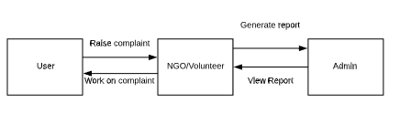

**Fig. 3.1 System Model**

The project has three main users in the form of NGO, Volunteer and user and admin manages all the details. User can raise a complaint and the volunteer/NGO receive the request from the area nearby to NGO or registered Volunteer. The main idea of this project is to make the city clean, generate awareness among people. NGO or Volunteer can help in spreading awareness aong different group of people. NGO are the non-technical working community.

* 1. **USER REQUIREMENTS**
     1. **FUNCTIONAL REQUIREMENTS**
        1. **USER**

This module concentrates on the main users where user can click the picture and raise the complaint. The NGO/Volunteers of the particular place will accept the request and start working on the complaint raised by the user.

* + - 1. **VOLUNTEER/NGO**

This module yields the details about the complaint raised by an user and can check the status of previous work.

* + - 1. **ADMIN**

Admin has all the authority to modify or remove user, NGO, volunteer, branch details. This module also generates overall details area wise as well as date wise that allows admin to identify location that need an arrangement to overcome an issue of waste disposal.

* + - 1. **CONTACT US**

This module will maintain the section about of the web portal. It helps user to send request as a guest without registering as a permanent user. Admin can view the response of a guest and assign work to volunteer or NGO to take necessary action on request asked by a user.

* + 1. **NON-FUNCTIONAL REQUIREMENTS**
       1. Easy registration
       2. Quick response time
       3. It supports multiple web browser
       4. Write the review to express service experience or give suugestion or request for service
  1. **SYSTEM REQUIREMENTS**
     1. **HARDWARE REQUIREMENTS**

The proposed system does not have any explicit hardware requirements.

* + - 1. Operating System: Windows 7/8/10, ubuntu etc.
      2. Processor: Intel i3 and above
      3. Memory: 4GB
      4. Hard Disk Space: 50GB
    1. **SOFTWARE REQUIREMENTS**

The below are the specific software requirements for the system to run successfully.

* + - 1. **FRONT END**
         1. Html 4.0+
         2. Bootstrap
         3. JavaScript
      2. **BACK END**
         1. MySQL
      3. **SOFTWARE USED**
         1. GitHub Desktop
         2. Sublime text

1. **DESIGN SPECIFICATION**
   1. **ARCHITECTURAL DESIGN**

The system is in Three-tier architecture. Three-tier architecture is a client–server software architecture pattern in which the users interface, functional process logic, computer data storage and data access are developed and maintained as independent modules, most often on separate platforms.

* Presentation tier

This is the topmost level of the application. It communicates with other tiers by which it puts out the results to the browser/client tier and all other tiers in the network. In simple terms, it is a layer which users can access directly.

* Application tier

The logical tier is pulled out from the presentation tier and, as its own layer, it controls an application’s functionality by performing detailed processing.

* Data tier

The data tier includes the data persistence mechanisms (database servers, file shares, etc.) And the data access layer that encapsulates the persistence mechanisms and exposes the data.

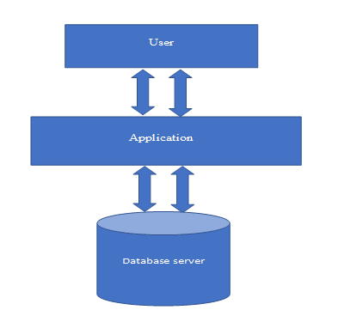

**Fig. 4.1 Three tier architecture diagram**

* 1. **DIAGRAM**
  2. **DATA FLOW**

The context diagram also called as the Level 1 DFD (Fig 4.2 level 0 DFD) depicts the overall data flow in the system. The Figure (Fig 4.3 level 1 DFD) depicts the operations on the system and the more detailed details of the data flow has been included in the Figure (Fig 4.4 level 2 DFD). These figures constitute the data flow representation in the system.

* + 1. **CONTEXT DIAGRAM (LEVEL 0 DFD)**

WMS

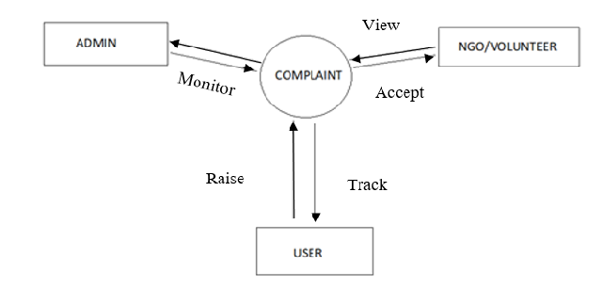

**Fig. 4.2 level 0 DFD**

* + 1. **LEVEL 1 DFD**

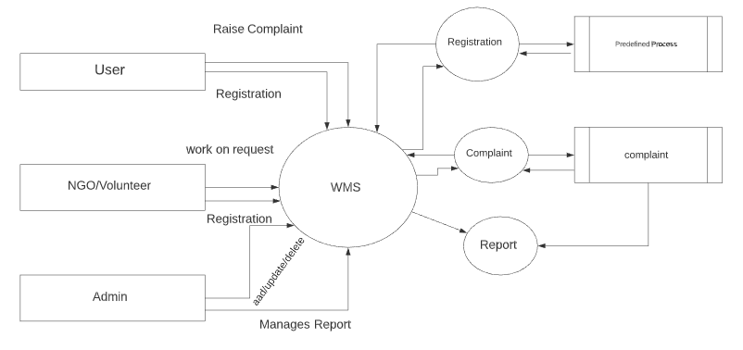

**Fig. 4.3 level 1 DFD**

* + 1. **LEVEL 2 DFD**

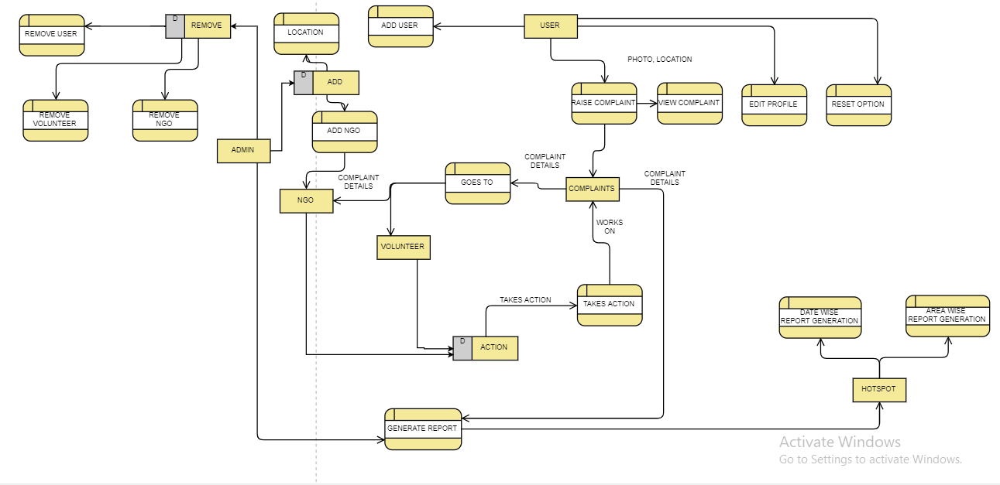

**Fig 4.4 level 2 DFD**

* 1. **ENTITY RELATIONSHIP DIAGRAM**

The entity relationship diagram describes interrelated things in the project. A basic ER model is composed of entity types and specifies relationships that can exist between instances of those entity types. An entity relationship diagram shows the relationships of entity sets stored in a database. An entity in this context is an object, a component of data. An entity set is a collection of similar entities. These entities can have attributes that define its properties.

The entity relationship diagram (Fig. 4.5 ER Diagram), represents the inter relativity of the different project components and how it is related together. the different modules of the project. the entity relationship diagram helps in the design and development of the database.

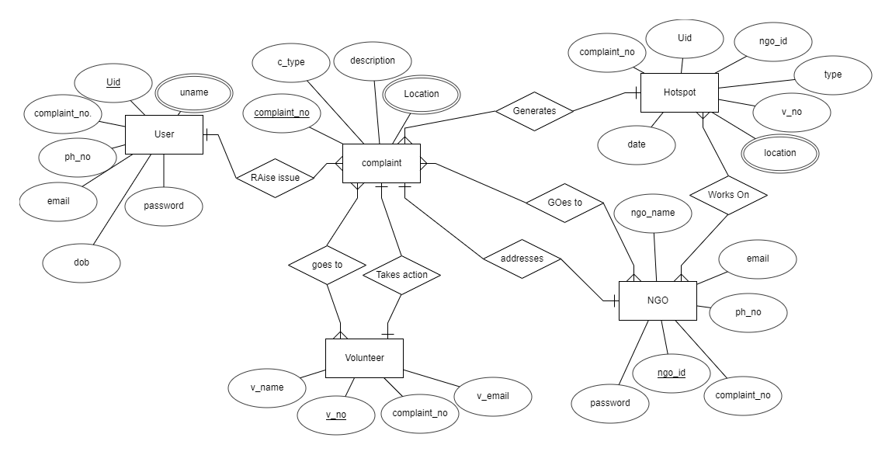

**Fig. 4.5 ER Diagram**

* 1. **DATABASE DESIGN**
     1. **ADMIN**

Table 4.1 admin

|  |  |  |  |
| --- | --- | --- | --- |
| **FIELDS** | **DATA TYPE** | **CONSTRAINTS** | **Desc** |
| adminEmail | Varchar(50) | Primary Key | Admin login |
| adminPassword | varchar(50) | Not Null | Password for admin |

* + 1. **USER INFO**

Table 4.2 user

|  |  |  |  |
| --- | --- | --- | --- |
| **FIELDS** | **DATA TYPE** | **CONSTRAINTS** | **Desc** |
| userID | int(11) | Primary Key | Unique id of user |
| userName | Varchar(40) | Not Null | Name of the user |
| userDate | Varchar(20) | Not Null | Registration date of the user |
| userEmail | DATE | Not Null | Email of the user |
| userRegion | varchar(40) | Foreign Key | Location of the user |
| userMobile | Int(11) | Not Null | Phone no of the user |
| userPassword | Int(5) | Not Null | Password of the user |

## NGO INFO

Table 4.3 ngo

|  |  |  |  |
| --- | --- | --- | --- |
| **FIELDS** | **DATA TYPE** | **CONSTRAINTS** | **Desc** |
| ngoID | int(11) | Primary Key | Id of the ngo |
| ngoName | Varchar(100) | Not Null | Name of the ngo |
| ngoregID | Varchar(20) | Not Null | Registration ID of the ngo |
| ngoDate | Date | Not Null | Registration date of the ngo |
| ngoEmail | Varchar(100) | Not Null | email of the ngo |
| ngoRegion | Varchar(100) | Foreign Key | Location of the ngo |
| ngoMobile | Bigint(11) | Not Null | Mobile of the ngo |
| ngoPass | Varchar(150) | Not Null | Password of the ngo |

## VOLUNTEER INFO

Table 4.4 volunteer

|  |  |  |  |
| --- | --- | --- | --- |
| **FIELDS** | **DATA TYPE** | **CONSTRAINTS** | **Desc** |
| volunteerID | int(11) | Primary Key | Unique id of volunteer |
| volunteerName | Varchar(40) | Not Null | Name of the volunteer |
| volunteerDate | Varchar(20) | Not Null | Registration date of the volunteer |
| volunteerEmail | DATE | Not Null | Email of the volunteer |
| volunteerRegion | varchar(40) | Foreign Key | Location of the volunteer |
| volunteerMobile | Int(11) | Not Null | Phone no of the volunteer |
| volunteerPassword | Int(5) | Not Null | Password of the volunteer |

## COMPLAINT DETAILS

Table 4.5 complaint

|  |  |  |  |
| --- | --- | --- | --- |
| **FIELDS** | **DATA TYPE** | **CONSTRAINTS** | **Desc** |
| ID | int(11) | Primary Key | The id of comp |
| User_email | Varchar(50) | Not Null | User email |
| Complaint_type | Varchar(100) | Not Null | Type of the complaint |
| Description | Varchar(150) | Not Null | Description of complaint |
| Image | blob | Not Null | Image of garbage |
| Location1 | Varchar(150) | Foreign Key | District |
| Location2 | Varchar(150) | Not Null | Specific location |
| VolunteerID | Int(11) | Foreign key | Id of the volunteer |
| ngoID | int(11) | Foreign key | Id of the ngo |
| Date | Date | Not Null | Date complaint raised |

## LOCATION DETAIL

Table 4.6 locality

|  |  |  |  |
| --- | --- | --- | --- |
| **FIELDS** | **DATA TYPE** | **CONSTRAINTS** | **Desc** |
| LID | Int(11) | Primary key | ID of location |
| Locality1 | Varchar(100) | Not Null | location |

## CONTACT DETAIL

Table 4.7 contact

|  |  |  |  |
| --- | --- | --- | --- |
| **FIELDS** | **DATA TYPE** | **CONSTRAINTS** | **Desc** |
| Contact_ID | Int(11) | Primary key | Contact id |
| name | Varchar(50) | Not Null | name |
| email | Varchar(50) | Not Null | Email of guest user |
| subject | Varchar(200) | Not Null | Subject of message |
| date | date | Not Null | Date message was sent |
| message | Varchar(500) | Not Null | message |

# IMPLEMENTATION DETAILS

## SOURCE CODE

* + 1. **WASTE MANAGEMENT SYSTEM**
       1. **signup1.php**

<!DOCTYPE html>

<html lang="en">

<head>

<title>WMS</title>

<meta charset="UTF-8">

<meta name="viewport" content="width=device-width, initial-scale=1">

<!--===============================================================================================-->

<!-- Favicon-->

<link rel="shortcut icon" href="images/two.png">

<!--===============================================================================================-->

<link rel="stylesheet" type="text/css" href="vendor/bootstrap/css/bootstrap.min.css">

<!--===============================================================================================-->

<link rel="stylesheet" type="text/css" href="fonts/font-awesome-4.7.0/css/font-awesome.min.css">

<!--===============================================================================================-->

<link rel="stylesheet" type="text/css" href="vendor/animate/animate.css">

<!--===============================================================================================-->

<link rel="stylesheet" type="text/css" href="vendor/css-hamburgers/hamburgers.min.css">

<!--===============================================================================================-->

<link rel="stylesheet" type="text/css" href="vendor/select2/select2.min.css">

<!--===============================================================================================-->

<link rel="stylesheet" type="text/css" href="css/util.css">

<link rel="stylesheet" type="text/css" href="css/main.css">

<!--===============================================================================================-->

<style>

/* The container */

.container {

display: block;

position: relative;

padding-left: 45px;

margin-bottom: 12px;

cursor: pointer;

font-size: 22px;

-webkit-user-select: none;

-moz-user-select: none;

-ms-user-select: none;

user-select: none;

}

/* Hide the browser's default radio button */

.container input {

position: absolute;

opacity: 0;

cursor: pointer;

}

/* Create a custom radio button */

.checkmark {

position: absolute;

top: 0;

left: 0;

height: 25px;

width: 25px;

background-color: #eee;

border-radius: 50%;

}

/* On mouse-over, add a grey background color */

.container:hover input ~ .checkmark {

background-color: #ccc;

}

/* When the radio button is checked, add a blue background */

.container input:checked ~ .checkmark {

background-color: #009900;

}

/* Create the indicator (the dot/circle - hidden when not checked) */

.checkmark:after {

content: "";

position: absolute;

display: none;

}

/* Show the indicator (dot/circle) when checked */

.container input:checked ~ .checkmark:after {

display: block;

}

/* Style the indicator (dot/circle) */

.container .checkmark:after {

top: 9px;

left: 9px;

width: 8px;

height: 8px;

border-radius: 50%;

background: white;

}

</style>

</head>

<body>

<div class="limiter">

<div class="container-login100">

<div class="wrap-login100">

<div class="login100-pic js-tilt" data-tilt>

<a href="../Intro/index.php">

<img src="images/img-01.png" alt="IMG"></a>

</div>

<form class="login100-form validate-form" action="signup.php" method="POST">

<span class="login100-form-title">

WMS SignUp

</span>

<div class="wrap-input100 validate-input" data-validate = "Valid Username is required">

<input class="input100" type="text" name="name" placeholder="User Name">

<span class="focus-input100"></span>

<span class="symbol-input100">

<i class="fa fa-user" aria-hidden="true"></i>

</span>

</div>

<div class="wrap-input100 validate-input" data-validate = "Valid Email is required">

<input class="input100" type="Email" name="email" placeholder="User Email">

<span class="focus-input100"></span>

<span class="symbol-input100">

<i class="fa fa-envelope" aria-hidden="true"></i>

</span>

</div>

<div class="wrap-input100 validate-input" data-validate = "Valid Address is required">

<select id="region" name="region" class="input100">

<option value="" disabled selected>Locality</option>

<?php

session_start();

include("connect.php");

$sql = "SELECT * FROM locality";

$result = mysqli_query($conn,$sql);

while($row = mysqli_fetch_array($result))

{

?>

<option value="<?php echo($row['LID']);?>" ><?php echo($row['locality1']);?></option>

<?php

}

?>

</select>

<!-- <select id="region" name="region" class="input100">

<option value="SG PALYA">SG PALYA</option>

<option value="JAYANAGAR">JAYANAGAR</option>

<option value="JP NAGAR">JP NAGAR</option>

</select> -->

<span class="focus-input100"></span>

<span class="symbol-input100">

<i class="fa fa-address-card" aria-hidden="true"></i>

</span>

</div>

<div class="wrap-input100 validate-input" data-validate = "Valid Phone Number is required">

<input class="input100"type="text" name="phone" pattern="[789][0-9]{9}" maxlength="10" placeholder="Phone Number" required data-validation-required-message="Please enter your Phone Number.">

<span class="focus-input100"></span>

<span class="symbol-input100">

<i class="fa fa-phone" aria-hidden="true"></i>

</span>

</div>

<div class="wrap-input100 validate-input" data-validate = "Password is required">

<input class="input100" type="password" name="password" placeholder="Password">

<span class="focus-input100"></span>

<span class="symbol-input100">

<i class="fa fa-lock" aria-hidden="true"></i>

</span>

</div>

<label class="container">Navie User

<input type="radio" checked="checked" value="1" name="radio">

<span class="checkmark"></span>

</label>

<label class="container">Volunteer

<input type="radio" value="2"name="radio">

<span class="checkmark"></span>

</label>

<div class="container-login100-form-btn">

<button class="login100-form-btn">

signup

</button>

</div>

<div class="text-center p-t-136">

<a class="txt2" href="index.php">

Have An Account?Login

<i class="fa fa-long-arrow-right m-l-5" aria-hidden="true"></i>

</a>

</div>

</form>

</div>

</div>

</div>

<!--===============================================================================================-->

<script src="vendor/jquery/jquery-3.2.1.min.js"></script>

<!--===============================================================================================-->

<script src="vendor/bootstrap/js/popper.js"></script>

<script src="vendor/bootstrap/js/bootstrap.min.js"></script>

<!--===============================================================================================-->

<script src="vendor/select2/select2.min.js"></script>

<!--===============================================================================================-->

<script src="vendor/tilt/tilt.jquery.min.js"></script>

<script >

$('.js-tilt').tilt({

scale: 1.1

})

</script><!--===============================================================================================-->

<script src="js/main.js"></script>

</body>

</html>

## signup.php

<?php

session_start();

include("connect.php");

// username and password sent from form

$name=$_POST['name'];

$password=md5($_POST['password']);

$email=$_POST['email'];

$phone=$_POST['phone'];

$region=$_POST['region'];

$user_type=$_POST['radio'];

//$_SESSION['username']=$username;

//User login

if($user_type==1)

{

$sqll="SELECT * FROM user WHERE userEmail='$email' or userMobile='$phone'";

$result=mysqli_query($conn,$sqll);

$rec=mysqli_fetch_row($result);

$count=mysqli_num_rows($result);

if( $count > 0)

{

echo "<script language=\"JavaScript\">\n";

echo "alert('Email Already Registred');\n";

echo "window.location='signup.html'";

echo "</script>";

}

else

{

$sql="INSERT INTO user VALUES (NULL,'$name',NOW(),'$email','$region','$phone','$password')";

if ($conn->query($sql)=== TRUE) {

echo "<script language=\"JavaScript\">\n";

echo "alert('Registred!!!Login To Continue');\n";

echo "window.location='index.php'";

echo "</script>";

}

else

{

echo "Error: " . $sql . "<br>" . $conn->error;

//echo "window.location='index.php'";

} }

}

else

{

$sqll="SELECT * FROM volunteer WHERE volunteerEmail='$email' or volunteerMobile='$phone'";

$result=mysqli_query($conn,$sqll);

$rec=mysqli_fetch_row($result);

$count=mysqli_num_rows($result);

if( $count > 0)

{

echo "<script language=\"JavaScript\">\n";

echo "alert('Email Already Registred');\n";

echo "window.location='signup.html'";

echo "</script>";

}

else

{

$sql="INSERT INTO `volunteer` VALUES (NULL,'$name',NOW(),'$email','$region','$phone','$password')";

if ($conn->query($sql)=== TRUE) {

echo "<script language=\"JavaScript\">\n";

echo "alert('Registred!!!Login To Continue');\n";

echo "window.location='index.php'";

echo "</script>";

}

else

{

echo "Error: " . $sql . "<br>" . $conn->error;

}

}

}

?>

## USER

* + - 1. **beanemployee.php**

<?php

session_start();

include("connect.php");

#------------------------------------------------------------------------------------------------------------------------------

//$u_email=$_SESSION['email'];// session Email

//$u_email=$_SESSION['email'];// session Email

if(!isset($_SESSION['email']))

header("Location: ../Intro/index.php");

else{

$u_email=$_SESSION['email'];

}

#-----------------------------------------------------------------------------------------------------------------------

?>

<!DOCTYPE html>

<html lang="en">

<head>

<meta charset="utf-8">

<title>Be A Volunteer - WMS</title>

<meta name="viewport" content="width=device-width, initial-scale=1.0" />

<link rel="shortcut icon" href="Img/two.png">

<meta name="description" content="" />

<meta name="author" content="http://bootstraptaste.com" /><!-- css -->

<link href="css/bootstrap.min.css" rel="stylesheet" />

<link href="css/fancybox/jquery.fancybox.css" rel="stylesheet">

<link href="css/jcarousel.css" rel="stylesheet" />

<link href="css/flexslider.css" rel="stylesheet" />

<link href="css/style.css" rel="stylesheet" />

<link rel="stylesheet" href="https://www.w3schools.com/w3css/4/w3.css">

<!-- Theme skin -->

<link href="skins/default.css" rel="stylesheet" />

<link rel="stylesheet" href="https://www.w3schools.com/w3css/4/w3.css">

<link rel="stylesheet" href="https://www.w3schools.com/w3css/4/w3.css">

<style type="text/css">

.form-style-10{

width:450px;

padding:30px;

margin:40px auto;

background: #FFF;

border-radius: 10px;

-webkit-border-radius:10px;

-moz-border-radius: 10px;

box-shadow: 0px 0px 10px rgba(0, 0, 0, 0.13);

-moz-box-shadow: 0px 0px 10px rgba(0, 0, 0, 0.13);

-webkit-box-shadow: 0px 0px 10px rgba(0, 0, 0, 0.13);

}

.form-style-10 .inner-wrap{

padding: 30px;

background: #F8F8F8;

border-radius: 6px;

margin-bottom: 15px;

}

.form-style-10 h1{

background: #009900;

padding: 20px 30px 15px 30px;

margin: -30px -30px 30px -30px;

border-radius: 10px 10px 0 0;

-webkit-border-radius: 10px 10px 0 0;

-moz-border-radius: 10px 10px 0 0;

color: #fff;

text-shadow: 1px 1px 3px rgba(0, 0, 0, 0.12);

font: normal 30px 'Bitter', serif;

-moz-box-shadow: inset 0px 2px 2px 0px rgba(255, 255, 255, 0.17);

-webkit-box-shadow: inset 0px 2px 2px 0px rgba(255, 255, 255, 0.17);

box-shadow: inset 0px 2px 2px 0px rgba(255, 255, 255, 0.17);

border: 1px solid #257C9E;

}

.form-style-10 h1 > span{

display: block;

margin-top: 2px;

font: 13px Arial, Helvetica, sans-serif;

}

.form-style-10 label{

display: block;

font: 13px Arial, Helvetica, sans-serif;

color: #888;

margin-bottom: 15px;

}

.form-style-10 input[type="text"],

.form-style-10 input[type="date"],

.form-style-10 input[type="datetime"],

.form-style-10 input[type="email"],

.form-style-10 input[type="number"],

.form-style-10 input[type="search"],

.form-style-10 input[type="time"],

.form-style-10 input[type="url"],

.form-style-10 input[type="password"],

.form-style-10 textarea,

.form-style-10 select {

display: block;

box-sizing: border-box;

-webkit-box-sizing: border-box;

-moz-box-sizing: border-box;

width: 100%;

padding: 8px;

border-radius: 6px;

-webkit-border-radius:6px;

-moz-border-radius:6px;

border: 2px solid #fff;

box-shadow: inset 0px 1px 1px rgba(0, 0, 0, 0.33);

-moz-box-shadow: inset 0px 1px 1px rgba(0, 0, 0, 0.33);

-webkit-box-shadow: inset 0px 1px 1px rgba(0, 0, 0, 0.33);

}

.form-style-10 .section{

font: normal 20px 'Bitter', serif;

color: #009900;

margin-bottom: 5px;

}

.form-style-10 .section span {

background: #009900;

padding: 5px 10px 5px 10px;

position: absolute;

border-radius: 50%;

-webkit-border-radius: 50%;

-moz-border-radius: 50%;

border: 4px solid #fff;

font-size: 14px;

margin-left: -45px;

color: #fff;

margin-top: -3px;

}

.form-style-10 input[type="button"],

.form-style-10 input[type="submit"]{

background: #009900;

padding: 8px 20px 8px 20px;

border-radius: 5px;

-webkit-border-radius: 5px;

-moz-border-radius: 5px;

color: #fff;

text-shadow: 1px 1px 3px rgba(0, 0, 0, 0.12);

font: normal 30px 'Bitter', serif;

-moz-box-shadow: inset 0px 2px 2px 0px rgba(255, 255, 255, 0.17);

-webkit-box-shadow: inset 0px 2px 2px 0px rgba(255, 255, 255, 0.17);

box-shadow: inset 0px 2px 2px 0px rgba(255, 255, 255, 0.17);

border: 1px solid #257C9E;

font-size: 15px;

}

.form-style-10 input[type="button"]:hover,

.form-style-10 input[type="submit"]:hover{

background: #2A6881;

-moz-box-shadow: inset 0px 2px 2px 0px rgba(255, 255, 255, 0.28);

-webkit-box-shadow: inset 0px 2px 2px 0px rgba(255, 255, 255, 0.28);

box-shadow: inset 0px 2px 2px 0px rgba(255, 255, 255, 0.28);

}

.form-style-10 .privacy-policy{

float: right;

width: 250px;

font: 12px Arial, Helvetica, sans-serif;

color: #4D4D4D;

margin-top: 10px;

text-align: right;

}

</style>

</head>

<body>

<div id="wrapper">

<!--Include Header-->

<!-- start header -->

<header>

<div class="navbar navbar-default navbar-static-top">

<div class="container">

<div class="navbar-header">

<button type="button" class="navbar-toggle" data-toggle="collapse" data-target=".navbar-collapse">

<span class="icon-bar"></span>

<span class="icon-bar"></span>

<span class="icon-bar"></span>

</button>

<a class="navbar-brand" href="index.php"><span><img src="img/two.png"></span>WMS</a>

</div>

<div class="navbar-collapse collapse ">

<ul class="nav navbar-nav">

<li class="active"><a href="index.php">Home</a></li>

<li class="dropdown">

<!-- <a href="#" class="dropdown-toggle " data-toggle="dropdown" data-hover="dropdown" data-delay="0" data-close-others="false">Complaint<b class=" icon-angle-down"></b></a> -->

<li><a href="compliant.php">Complaint</a></li>

<!-- <ul class="dropdown-menu">

<li><a href="compliant.php">Make Complaint</a></li>

<li><a href="loc1/try2.php">Update Location</a></li>

<li><a href="beanemployee.php">Be A Volunteer</a></li>

</ul> -->

</li>

<li><a href="beanemployee.php">Be A Volunteer</a></li>

<li><a href="history.php">History</a></li>

<li><a href="notification.php">Notification<span class="w3-badge w3-red"></span></a></li>

<li><a href="../Logout/logout.php">Logout </a><br></li>

WELCOME User, <?php echo $u_email;?>

</ul>

</div>

</div>

</div>

</header>

<!-- end header -->

<section id="inner-headline">

<div class="container">

<div class="row">

<div class="col-lg-12">

<ul class="breadcrumb">

<li><a href="index.php"><i class="fa fa-home"></i></a><i class="icon-angle-right"></i></li> <li class="active">Be An Employee</li>

</ul> </div>

</div>

</div>

</section>

<section id="content">

<div class="map">

<div class="form-style-10">

<h1>Be A Volunteer !</h1>

<form action="employee.php" method="post">

<div class="section">Be a volunteer</div>

<div class="inner-wrap">

<label>Employee Email <input type="email" name="email" required data-validation-required-message=" Enter EMail." /></label>

</div>

<div class="button-section">

<input type="submit" name="Update" />

<span class="privacy-policy">

</span>

</div>

</form>

</div>

</div>

<div class="container">

<div class="row">

</div>

</div>

</div>

</section>

<br>

<br>

<br>

<br>

<br>

<br>

<br>

<?php include ("footer.php"); ?>

</div>

<a href="#" class="scrollup"><i class="fa fa-angle-up active"></i></a>

<!-- javascript

================================================== -->

<!-- Placed at the end of the document so the pages load faster -->

<script src="js/jquery.js"></script>

<script src="js/jquery.easing.1.3.js"></script>

<script src="js/bootstrap.min.js"></script>

<script src="js/jquery.fancybox.pack.js"></script>

<script src="js/jquery.fancybox-media.js"></script>

<script src="js/google-code-prettify/prettify.js"></script>

<script src="js/portfolio/jquery.quicksand.js"></script>

<script src="js/portfolio/setting.js"></script>

<script src="js/jquery.flexslider.js"></script>

<script src="https://maps.google.com/maps/api/js?sensor=true"></script>

<script src="js/animate.js"></script>

<script src="js/custom.js"></script>

</body>

</html>

## employee.php

<?php

session_start();

include("connect.php");

$u_email=$_SESSION['email'];// session Email

$nemail=$_POST['email'];

$sd="SELECT volunteerEmail FROM volunteer WHERE volunteerEmail='$nemail'";

$result=mysqli_query($conn,$sd);

$no=mysqli_num_rows($result);

if($no>0)

{

echo "<script language=\"JavaScript\">\n";

echo "alert('Volunteer Exists!');\n";

echo "window.location='beanemployee.php'";

echo "</script>";

}

$sd="SELECT * FROM user WHERE userEmail='$u_email'";

$result=mysqli_query($conn,$sd);

$r=mysqli_fetch_array($result);

$name=$r['userName'];

$date=$r['userDate'];

$email=$r['userEmail'];

$region=$r['userRegion'];

$mobile=$r['userMobile'];

$password=$r['userPassword'];

$sqll="INSERT INTO volunteer (volunteerID, volunteerName, volunteerDate, volunteerEmail, volunteerRegion,volunteerMobile,volunteerPassword) VALUES(NULL,'$name','$date','$email','$region','$mobile','$password')";

if ($conn->query($sqll) === TRUE)

{

$sd1="DELETE FROM user WHERE userEmail='$nemail'";

$result1=mysqli_query($conn,$sd1);

echo "<script language=\"JavaScript\">\n";

echo "alert('Login with same email And password!');\n";

echo "window.location='../Intro/index.php'";

echo "</script>";

}

else

{

echo "Error: " . $sqll . "<br>" . $conn->error;

}

?>

## complaint.php

<!DOCTYPE html>

<html lang="en">

<head>

<meta charset="utf-8">

<title>Compliant -WMS</title>

<meta name="viewport" content="width=device-width, initial-scale=1.0" />

<link rel="shortcut icon" href="Img/two.png">

<meta name="description" content="" />

<meta name="author" content="http://bootstraptaste.com" />

<!-- css -->

<link href="css/bootstrap.min.css" rel="stylesheet" />

<link href="css/fancybox/jquery.fancybox.css" rel="stylesheet">

<link href="css/jcarousel.css" rel="stylesheet" />

<link href="css/flexslider.css" rel="stylesheet" />

<link href="css/style.css" rel="stylesheet" />

<link rel="stylesheet" href="https://www.w3schools.com/w3css/4/w3.css">

<style>

* {

box-sizing: border-box;

}

input[type=text], select, textarea{

width: 100%;

padding: 12px;

border: 1px solid #ccc;

border-radius: 4px;

box-sizing: border-box;

resize: vertical;

}

label {

padding: 12px 12px 12px 0;

display: inline-block;

}

input[type=submit] {

background-color: #4CAF50;

color: white;

padding: 12px 20px;

border: none;

border-radius: 4px;

cursor: pointer;

float: right;

}

input[type=submit]:hover {

background-color:#179AF2;

}

.col-25 {

float: left;

width: 25%;

margin-top: 6px;

}

.col-75 {

float: left;

width: 75%;

margin-top: 6px;

}

/* Clear floats after the columns */

.row:after {

content: "";

display: table;

clear: both;

}

/* Responsive layout - when the screen is less than 600px wide, make the two columns stack on top of each other instead of next to each other */

@media (max-width: 600px) {

.col-25, .col-75, input[type=submit] {

width: 100%;

margin-top: 0;

}}

#lname

{

width: 100%;

}

</style>

<!-- Theme skin -->

<link href="skins/default.css" rel="stylesheet" />

</head>

<body>

<div id="wrapper">

<!--Include Header-->

<?php include("header.php");?>

<section id="inner-headline">

<div class="container">

<div class="row">

<div class="col-lg-12">

<ul class="breadcrumb">

<li><a href="index.php"><i class="fa fa-home"></i></a><i class="icon-angle-right"></i></li>

<li class="active">Compliant</li>

</ul>

</div>

</div> </div>

</section>

<section id="content">

<div class="map">

</div>

<div class="container">

<form action="compliantconfirm.php" method="post" >

<div class="row">

<div class="col-25">

<label for="fname">Complaint Type</label>

</div>

<div class="col-75">

<select name="type" required="required">

<option value="" disabled selected>Waste Type</option>

<option value="Home Waste">Dry Waste</option>

<option value="Street Waste">Wet Waste</option>

<option value="Mixed Waste">Mixed Waste</option>

</select>

</div>

</div>

<div class="row">

<div class="col-25">

<label for="lname">Description</label>

</div>

<div class="col-75">

<textarea id="subject" name="subject" pattern="[a-z][0-9]{,50}" title="Maximum 50 character" placeholder="Write Description.." style="height:110px" required="required"></textarea>

</div>

</div>

<div class="row">

<div class="col-25">

<label for="subject">Location Details</label>

</div>

<select id="region" name="locationone" class="input100" required="required">

<option value="" disabled selected>Locality</option>

<?php

session_start();

include("connect.php");

$sql = "SELECT * FROM locality";

$result = mysqli_query($conn,$sql);

while($row = mysqli_fetch_array($result))

{

?>

<option value="<?php echo($row['LID']);?>" ><?php echo($row['locality1']);?></option>

<?php

}

?>

</select>

<br>

<br>

<input type="text" name="locationtwo" pattern="[a-z][0-9]{,50}" title="Maximum 50 character" placeholder="Update Nearest Location" required>

</div>

<div class="row">

<div class="col-20">

<label for="subject">Image</label>

</div>

<div class="col-75">

<input type="file" name="image" placeholder="Image.." required="required">

</div>

</div>

<div class="row">

<input type="submit" value="Submit">

</div>

</form>

</div>

</div>

</section>

<br><br>

<br>

<br>

<br>

<br>

<br>

<?php include ("footer.php"); ?>

</div>

<a href="#" class="scrollup"><i class="fa fa-angle-up active"></i></a>

<!-- javascript

================================================== -->

<!-- Placed at the end of the document so the pages load faster -->

<script src="js/jquery.js"></script>

<script src="js/jquery.easing.1.3.js"></script>

<script src="js/bootstrap.min.js"></script>

<script src="js/jquery.fancybox.pack.js"></script>

<script src="js/jquery.fancybox-media.js"></script>

<script src="js/google-code-prettify/prettify.js"></script>

<script src="js/portfolio/jquery.quicksand.js"></script>

<script src="js/portfolio/setting.js"></script>

<script src="js/jquery.flexslider.js"></script>

<script src="https://maps.google.com/maps/api/js?sensor=true"></script>

<script src="js/animate.js"></script>

<script src="js/custom.js"></script>

</body>

</html>

## complaintconfirm.php

## <?php

## session_start();

## include("connect.php");

## $u_email=$_SESSION['email'];

## $type=$_POST['type'];

## $description=$_POST['subject'];

## $locationone=$_POST['locationone'];

## $locationtwo=$_POST['locationtwo'];

## $image=$_POST['image'];

## date_default_timezone_set('Asia/Kolkata');

## $date=date("Y-m-d");

## $sql="INSERT INTO `compliant`(`User_Email`, `Compliant_Type`, `Description`, `Image`, `Location1`, `Location2`, `Date`) VALUES('$u_email','$type','$description','$image','$locationone','$locationtwo','$date')";

## if ($conn->query($sql) === TRUE)

## {

## echo "<script language=\"JavaScript\">\n";

## echo "alert('Details Updated!');\n";

## echo "window.location='index.php'";

## echo "</script>";

## }

## else

## {

## echo "Error: " . $sql . "<br>" . $conn->error;

## }

## ?>

## history.php

## <!DOCTYPE html>

## <html lang="en">

## <head>

## <meta charset="utf-8">

## <title>History - WMS</title>

## <meta name="viewport" content="width=device-width, initial-scale=1.0" />

## <link rel="shortcut icon" href="Img/two.png">

## <meta name="description" content="" />

## <meta name="author" content="http://bootstraptaste.com" />

## <!-- css -->

## <link href="css/bootstrap.min.css" rel="stylesheet" />

## <link href="css/fancybox/jquery.fancybox.css" rel="stylesheet">

## <link href="css/jcarousel.css" rel="stylesheet" />

## <link href="css/flexslider.css" rel="stylesheet" />

## <link href="css/style.css" rel="stylesheet" />

## <link rel="stylesheet" href="https://www.w3schools.com/w3css/4/w3.css">

## <!-- Theme skin -->

## <link href="skins/default.css" rel="stylesheet" />

## <style>

## table {

## border-collapse: collapse;

## width: 100%;

## }

## th, td {

## text-align: left;

## padding: 8px;

## }

## th {

## 

## background-color: #009900;

## color: white;

## }</style>

## <link rel="stylesheet" href="https://www.w3schools.com/w3css/4/w3.css">

## </head>

## <body>

## <div id="wrapper">

## <!--Include Header-->

## <?php include("header.php");

## ?>

## <!--End Header-->

## <section id="inner-headline">

## <div class="container">

## <div class="row">

## <div class="col-lg-12">

## <ul class="breadcrumb">

## <li><a href="index.php"><i class="fa fa-home"></i></a><i class="icon-angle-right"></i></li>

## <li class="active">View History</li>

## </ul>

## </div>

## </div>

## </div>

## </section>

## <section id="content">

## <div class="map">

## 

## </div>

## <?php

## 

## $zx="SELECT * FROM `Compliant`,locality where User_Email='$u_email' and ((VolunteerID IS NOT NULL) or (ngoID is not NuLL)) AND compliant.Location1=locality.LID";

## $result=mysqli_query($conn,$zx);

## $re = mysqli_num_rows($result);

## if($re>0){?>

## 

## <section id="inner-headline">

## <div class="container">

## <div class="row">

## <div class="col-lg-12">

## <ul class="breadcrumb">

## <li><a href="index.php"><i class="fa fa-home"></i></a><i class="icon-angle-right"></i></li>

## <li class="active">History</li>

## </ul>

## </div>

## </div>

## </div>

## </section>

## <section id="content">

## <div class="map">

## 

## </div>

## <div class="container">

## <div class="row">

## <table>

## <tr>

## <th>Compliant Id</th>

## <th>Type</th>

## <th>Description</th>

## <th>Location Details</th>

## <th>Date</th>

## 

## </tr>

## <?php

## while($re= mysqli_fetch_array($result))

## {

## echo '<tr>';

## echo '<td>'; echo $re['ID']; echo '</td>';

## echo '<td>'; echo $re['Compliant_Type']; echo '</td>';

## 

## echo '<td>';echo $re['Description']; echo '</td>';

## echo '<td>';echo $re['locality1']; echo '</td>';

## echo '<td>';echo $re['Date']; echo '</td>';

## /* #------------------------------------------------------------------------------------------------------------------------------

## $sa="SELECT `name` FROM `employee` WHERE emp_id='$re[6]'";

## $resultta=mysql_query($sa);

## $r=mysql_fetch_array($resultta);

## #------------------------------------------------------------------------------------------------------------------------------

## echo '<td>';echo "<a href ='empview.php?b=$re[6]'>"; echo $r[0]; echo '</td>';

## #------------------------------------------------------------------------------------------------------------------------------

## $sa="SELECT `*` FROM `location` WHERE email='u_email'";

## $resultta=mysql_query($sa);

## $no1=mysql_num_rows($resultt);

## 

## $sqll="select email from employee where emp_id='$re[6]'";

## $qo=mysql_query($sqll);

## $dat=mysql_fetch_array($qo);

## $sqllk="select * from location where email='$dat[0]'";

## $qok=mysql_query($sqllk);

## $no12=mysql_num_rows($qok);

## #-------------------------------------------------------------------------------------------------------------------------------

## if($no1==1 and $no12==1)

## {

## echo "<td style=' padding-left:60px'><a href ='loc1\mymap.php?b=$re[6]'>Locate</td>";

## }

## else

## {

## echo '<td>';echo "Oops!Location Not Avaliable"; echo '</td>';

## }

## echo '<td>'; echo "<a href='orderupdate.php?a=$re[0]'>" ;

## echo '<img src="img/done.jpg" alt="accept" border="0">

## </a>' ; echo '</td>';

## echo '</tr>';

## }

## #------------------------------------------------------------------------------------------------------------------------------ */

## }

## }

## else

## {

## echo '<center>'; echo "NO COMPLAINT RAISED"; echo '</center>';

## }?>

## </table>

## </div>

## </div>

## </div>

## </section>

## <br><br>

## <br>

## <br>

## <br>

## <br>

## <br>

## <?php include ("footer.php"); ?>

## </div>

## <a href="#" class="scrollup"><i class="fa fa-angle-up active"></i></a>

## <!-- javascript

## ================================================== -->

## <!-- Placed at the end of the document so the pages load faster -->

## <script src="js/jquery.js"></script>

## <script src="js/jquery.easing.1.3.js"></script>

## <script src="js/bootstrap.min.js"></script>

## <script src="js/jquery.fancybox.pack.js"></script>

## <script src="js/jquery.fancybox-media.js"></script>

## <script src="js/google-code-prettify/prettify.js"></script>

## <script src="js/portfolio/jquery.quicksand.js"></script>

## <script src="js/portfolio/setting.js"></script>

## <script src="js/jquery.flexslider.js"></script>

## <script src="https://maps.google.com/maps/api/js?sensor=true"></script>

## <script src="js/animate.js"></script>

## <script src="js/custom.js"></script>

## </body>

## </html>

## NGO

* + - 1. **View_complaint.php**

<!DOCTYPE html>

<html lang="en">

<head>

<meta charset="utf-8">

<title>WMS - View Compliant</title>

<meta name="viewport" content="width=device-width, initial-scale=1.0" />

<link rel="shortcut icon" href="Img/two.png">

<meta name="description" content="" />

<meta name="author" content="http://bootstraptaste.com" />

<!-- css -->

<link href="css/bootstrap.min.css" rel="stylesheet" />

<link href="css/fancybox/jquery.fancybox.css" rel="stylesheet">

<link href="css/jcarousel.css" rel="stylesheet" />

<link href="css/flexslider.css" rel="stylesheet" />

<link href="css/style.css" rel="stylesheet" />

<link rel="stylesheet" href="https://www.w3schools.com/w3css/4/w3.css">

<!-- Theme skin -->

<link href="skins/default.css" rel="stylesheet" />

<style>

table {

border-collapse: collapse;

width: 100%;

}

th, td {

text-align: left;

padding: 8px;

}

th {

background-color: #009900;

color: white;

}

</style>

</head>

<body>

<div id="wrapper">

<!-- start header -->

<?php

include("header.php");

?>

<!-- end header -->

<section id="inner-headline">

<div class="container">

<div class="row">

<div class="col-lg-12">

<ul class="breadcrumb">

<li><a href="index.php"><i class="fa fa-home"></i></a><i class="icon-angle-right"></i></li>

<li class="active">View Compliant</li>

</ul>

</div>

</div>

</div>

</section>

<section id="content">

<div class="map">

</div>

<?php

#-----------------------------------------------

//

$dee="SELECT `ngoRegion` FROM `ngo` where ngoEmail='$u_email'";

$rmm=mysqli_query($conn,$dee);

$rrr=mysqli_fetch_array($rmm);

$region_adress=$rrr['ngoRegion'];

//Finding Employee based on the location

$sde="SELECT * FROM `compliant`,locality WHERE ngoID IS NULL AND compliant.Location1=locality.LID AND volunteerID IS NULL AND Location1='$region_adress'";

$resulte=mysqli_query($conn,$sde);

$rrr = mysqli_num_rows($resulte);

if($rrr>0){

#---------------------------------------------

?>

<div class="container">

<div class="row">

<table>

<tr>

<th>Complaint ID</th>

<th>Compliant_Type</th>

<th>Description</th>

<th>Location</th>

<th>Action</th>

<th>Image</th>

</tr>

<?php

//if($resulte>0){

while ($rrr=mysqli_fetch_assoc($resulte))

{

echo '<tr>';

echo '<td>'; echo $rrr['ID']; echo '</td>';

echo '<td>'; echo $rrr['Compliant_Type']; echo '</td>';

echo '<td>'; echo $rrr['Description']; echo '</td>';

echo '<td>'; echo $rrr['locality1'];echo '</td>';

echo "<td>";

echo '<a href="confirm.php?a='.$rrr['ID'].'"> ';

echo '<img src="img/accept.jpg" alt="accept" border="0">

</a>' ;

echo '<td>'; echo'<img src="../User/img/' ; echo $rrr['Image'];echo'" img style= "width:200" height:200'; echo'" figure class="movie-poster">';echo '</td>';

echo '</tr>';

}

/*}

else{

echo "No Matching Location Request.";

}*/

}

else

{

echo '<center>'; echo "NO COMPLAINT RAISED"; echo '</center>';

}

?>

<!--

<tr>

<td><?php //echo $row['Compliant_Type']; ?></td>

<td><?php //echo $row['Description']; ?></td>

<td><?php //echo $row['Location1']; ?></td>

<td><?php //echo $row['ngoEmail']; ?></td>

<td><?php //echo $row['ngoRegion']; ?></td>

<td><?php //echo $row['ngoMobile']; ?></td>

</tr>

-->

</table>

</div>

</div>

</div>

</section>

<br>

<br>

<br>

<br>

<br>

<br>

<br>

<?php include ("footer1.php"); ?>

</div>

<a href="#" class="scrollup"><i class="fa fa-angle-up active"></i></a>

<!-- javascript

================================================== -->

<!-- Placed at the end of the document so the pages load faster -->

<script src="js/jquery.js"></script>

<script src="js/jquery.easing.1.3.js"></script>

<script src="js/bootstrap.min.js"></script>

<script src="js/jquery.fancybox.pack.js"></script>

<script src="js/jquery.fancybox-media.js"></script>

<script src="js/google-code-prettify/prettify.js"></script>

<script src="js/portfolio/jquery.quicksand.js"></script>

<script src="js/portfolio/setting.js"></script>

<script src="js/jquery.flexslider.js"></script>

<script src="https://maps.google.com/maps/api/js?sensor=true"></script>

<script src="js/animate.js"></script>

<script src="js/custom.js"></script>

</body>

</html>

## history.php

<!DOCTYPE html>

<html lang="en">

<head>

<meta charset="utf-8">

<title>WMS - Histroy</title>

<meta name="viewport" content="width=device-width, initial-scale=1.0" />

<link rel="shortcut icon" href="Img/two.png">

<meta name="description" content="" />

<meta name="author" content="http://bootstraptaste.com" />

<!-- css -->

<link href="css/bootstrap.min.css" rel="stylesheet" />

<link href="css/fancybox/jquery.fancybox.css" rel="stylesheet">

<link href="css/jcarousel.css" rel="stylesheet" />

<link href="css/flexslider.css" rel="stylesheet" />

<link href="css/style.css" rel="stylesheet" />

<link rel="stylesheet" href="https://www.w3schools.com/w3css/4/w3.css">

<!-- Theme skin -->

<link href="skins/default.css" rel="stylesheet" />

<style>

table {

border-collapse: collapse;

width: 100%;

}

th, td {

text-align: left;

padding: 8px;

}

th {

background-color: #009900;

color: white;

}

</style>

</head>

<body>

<div id="wrapper">

<!-- start header -->

<?php

include("header.php");

?>

<!--End Header-->

<section id="inner-headline">

<div class="container">

<div class="row">

<div class="col-lg-12">

<ul class="breadcrumb">

<li><a href="index.php"><i class="fa fa-home"></i></a><i class="icon-angle-right"></i></li>

<li class="active">View Compliant</li>

</ul>

</div>

</div>

</div>

</section>

<section id="content">

<div class="map">

</div>

<?php

#-----------------------------------------------

//

$dee="SELECT `ngoID` FROM `ngo` where ngoEmail='$u_email'";

$rmm=mysqli_query($conn,$dee);

$rrr=mysqli_fetch_array($rmm);

$employee_id=$rrr['ngoID'];

//Finding Employee based on the location

$sde="SELECT * FROM `Compliant`,locality where ngoID ='$employee_id' AND compliant.Location1=locality.LID";

//$sde="SELECT * FROM `compliant` WHERE volunteerID IS NOT NULL AND volunteerID='$employee_id'";

$resulte=mysqli_query($conn,$sde);

$rrr = mysqli_num_rows($resulte);

if($rrr>0){

#---------------------------------------------

?>

<div class="container">

<div class="row">

<table>

<tr>

<th>Compliant_Id</th>

<th>Compliant_Type</th>

<th>Description</th>

<th>Location</th>

<th>Status</th>

</tr>

<?php

while ($rrr=mysqli_fetch_assoc($resulte))

{

echo '<tr>';

echo '<td>'; echo $rrr['ID']; echo '</td>';

echo '<td>'; echo $rrr['Compliant_Type']; echo '</td>';

echo '<td>'; echo $rrr['Description']; echo '</td>';

echo '<td>'; echo $rrr['locality1'];echo '</td>';

echo '<td>'; echo "Done"; '</td>';

}

echo '</tr>';

}

else

{

echo '<center>'; echo "NO COMPLAINT RAISED"; echo '</center>';

}

?>

</table>

</div>

</div> </div>

</section>

<br><br>

<br>

<br>

<br>

<br>

<br>

<?php include ("footer1.php"); ?>

</div>

<a href="#" class="scrollup"><i class="fa fa-angle-up active"></i></a>

<!-- javascript

================================================== -->

<!-- Placed at the end of the document so the pages load faster -->

<script src="js/jquery.js"></script>

<script src="js/jquery.easing.1.3.js"></script>

<script src="js/bootstrap.min.js"></script>

<script src="js/jquery.fancybox.pack.js"></script>

<script src="js/jquery.fancybox-media.js"></script>

<script src="js/google-code-prettify/prettify.js"></script>

<script src="js/portfolio/jquery.quicksand.js"></script>

<script src="js/portfolio/setting.js"></script>

<script src="js/jquery.flexslider.js"></script>

<script src="https://maps.google.com/maps/api/js?sensor=true"></script>

<script src="js/animate.js"></script>

<script src="js/custom.js"></script>

</body>

</html>

## ADMIN

* + - 1. **Add_location.php**

<?php

session_start();

include("connect.php");

#------------------------------------------------------------------------------------------------------------------------------

//$u_email=$_SESSION['email'];// session Email

//$u_email=$_SESSION['email'];// session Email

if(!isset($_SESSION['email']))

header("Location: ../Intro/index.php");

else{

$u_email=$_SESSION['email'];

}

#-----------------------------------------------------------------------------------------------------------------------

?>

<!DOCTYPE html>

<html lang="en">

<head>

<meta charset="utf-8">

<meta name="viewport" content="width=device-width, initial-scale=1.0">

<meta name="description" content="Creative - Bootstrap 3 Responsive Admin Template">

<meta name="author" content="GeeksLabs">

<meta name="keyword" content="Creative, Dashboard, Admin, Template, Theme, Bootstrap, Responsive, Retina, Minimal">

<link rel="shortcut icon" href="Img/letter-v.png">

<title>Add LOCATION - WMS</title>

<!-- Bootstrap CSS -->

<link href="css/bootstrap.min.css" rel="stylesheet">

<!-- bootstrap theme -->

<link href="css/bootstrap-theme.css" rel="stylesheet">

<!--external css-->

<!-- font icon -->

<link href="css/elegant-icons-style.css" rel="stylesheet" />

<link href="css/font-awesome.min.css" rel="stylesheet" />

<!-- Custom styles -->

<link href="css/style.css" rel="stylesheet">

<link href="css/style-responsive.css" rel="stylesheet" />

<!-- HTML5 shim and Respond.js IE8 support of HTML5 -->

<!--[if lt IE 9]>

<script src="js/html5shiv.js"></script>

<script src="js/respond.min.js"></script>

<script src="js/lte-ie7.js"></script>

<![endif]-->

<style type="text/css">

.form-style-10{

width:450px;

padding:30px;

margin:40px auto;

background: #FFF;

border-radius: 10px;

-webkit-border-radius:10px;

-moz-border-radius: 10px;

box-shadow: 0px 0px 10px rgba(0, 0, 0, 0.13);

-moz-box-shadow: 0px 0px 10px rgba(0, 0, 0, 0.13);

-webkit-box-shadow: 0px 0px 10px rgba(0, 0, 0, 0.13);

}

.form-style-10 .inner-wrap{

padding: 30px;

background: #F8F8F8;

border-radius: 6px;

margin-bottom: 15px;

}

.form-style-10 h1{

background: #2A88AD;

padding: 20px 30px 15px 30px;

margin: -30px -30px 30px -30px;

border-radius: 10px 10px 0 0;

-webkit-border-radius: 10px 10px 0 0;

-moz-border-radius: 10px 10px 0 0;

color: #fff;

text-shadow: 1px 1px 3px rgba(0, 0, 0, 0.12);

font: normal 30px 'Bitter', serif;

-moz-box-shadow: inset 0px 2px 2px 0px rgba(255, 255, 255, 0.17);

-webkit-box-shadow: inset 0px 2px 2px 0px rgba(255, 255, 255, 0.17);

box-shadow: inset 0px 2px 2px 0px rgba(255, 255, 255, 0.17);

border: 1px solid #257C9E;

}

.form-style-10 h1 > span{

display: block;

margin-top: 2px;

font: 13px Arial, Helvetica, sans-serif;

}

.form-style-10 label{

display: block;

font: 13px Arial, Helvetica, sans-serif;

color: #888;

margin-bottom: 15px;

}

.form-style-10 input[type="text"],

.form-style-10 input[type="date"],

.form-style-10 input[type="datetime"],

.form-style-10 input[type="email"],

.form-style-10 input[type="number"],

.form-style-10 input[type="search"],

.form-style-10 input[type="time"],

.form-style-10 input[type="url"],

.form-style-10 input[type="password"],

.form-style-10 textarea,

.form-style-10 select {

display: block;

box-sizing: border-box;

-webkit-box-sizing: border-box;

-moz-box-sizing: border-box;

width: 100%;

padding: 8px;

border-radius: 6px;

-webkit-border-radius:6px;

-moz-border-radius:6px;

border: 2px solid #fff;

box-shadow: inset 0px 1px 1px rgba(0, 0, 0, 0.33);

-moz-box-shadow: inset 0px 1px 1px rgba(0, 0, 0, 0.33);

-webkit-box-shadow: inset 0px 1px 1px rgba(0, 0, 0, 0.33);

}

.form-style-10 .section{

font: normal 20px 'Bitter', serif;

color: #2A88AD;

margin-bottom: 5px;

}

.form-style-10 .section span {

background: #2A88AD;

padding: 5px 10px 5px 10px;

position: absolute;

border-radius: 50%;

-webkit-border-radius: 50%;

-moz-border-radius: 50%;

border: 4px solid #fff;

font-size: 14px;

margin-left: -45px;

color: #fff;

margin-top: -3px;

}

.form-style-10 input[type="button"],

.form-style-10 input[type="submit"]{

background: #2A88AD;

padding: 8px 20px 8px 20px;

border-radius: 5px;

-webkit-border-radius: 5px;

-moz-border-radius: 5px;

color: #fff;

text-shadow: 1px 1px 3px rgba(0, 0, 0, 0.12);

font: normal 30px 'Bitter', serif;

-moz-box-shadow: inset 0px 2px 2px 0px rgba(255, 255, 255, 0.17);

-webkit-box-shadow: inset 0px 2px 2px 0px rgba(255, 255, 255, 0.17);

box-shadow: inset 0px 2px 2px 0px rgba(255, 255, 255, 0.17);

border: 1px solid #257C9E;

font-size: 15px;

}

.

form-style-10 input[type="button"]:hover,

.form-style-10 input[type="submit"]:hover{

background: #2A6881;

-moz-box-shadow: inset 0px 2px 2px 0px rgba(255, 255, 255, 0.28);

-webkit-box-shadow: inset 0px 2px 2px 0px rgba(255, 255, 255, 0.28);

box-shadow: inset 0px 2px 2px 0px rgba(255, 255, 255, 0.28);

}

.form-style-10 .privacy-policy{

float: right;

width: 250px;

font: 12px Arial, Helvetica, sans-serif;

color: #4D4D4D;

margin-top: 10px;

text-align: right;

}

</style>

</head>

<body>

<!-- container section start -->

<section id="container" class="">

<!--header start-->

<?php include ("headers.php"); ?>

<!--header end-->

<!--sidebar start-->

<?php include ("sidebar.php"); ?>

<!--main content start-->

<section id="main-content">

<section class="wrapper">

<div class="row">

<div class="col-lg-12">

<h3 class="page-header"><i class="fa fa-table"></i>Add Location </h3>

<ol class="breadcrumb">

<li><i class="fa fa-home"></i><a href="index.php">Home</a></li>

<li><i class="fa fa-th-list"></i><a href="branch_list.php">Location list</a></li>

<li><i class="fa fa-plus"></i>Add Location </li>

</ol>

</div>

</div>

<!-- page start-->

<div class="row">

<div class="col-lg-12">

<section class="panel">

<div class="table-responsive">

<div class="container">

<div class="row">

<div class="form-style-10">

<h1>Add Location!</h1>

<form action="add_location1.php" method="post">

<div class="section">Location</div>

<div class="inner-wrap">

<label>Location <input type="text" name="locality1" required data-validation-required-message="Please enter branch location." /></label>

</div>

<div class="button-section">

<input type="submit" name="addloc" />

<span class="privacy-policy">

<!--<input type="checkbox" name="field7">You agree to our Terms and Policy. -->

</span>

</div>

</form>

</div>

</div>

</div>

</div>

</section>

</div>

</div>

<!-- page end-->

</section>

</section>

<!--main content end-->

</section>

<!-- container section end -->

<!-- javascripts -->

<script src="js/jquery.js"></script>

<script src="js/bootstrap.min.js"></script>

<!-- nicescroll -->

<script src="js/jquery.scrollTo.min.js"></script>

<script src="js/jquery.nicescroll.js" type="text/javascript"></script>

<!--custome script for all page-->

<script src="js/scripts.js"></script>

</body>

</html>

## add_location1.php

<?php

session_start();

include("connect.php");

if (isset($_POST['addloc'])) {

// $ID = $_POST['ID'];

$locality1 = $_POST['locality1'];

$sql = "SELECT * FROM locality WHERE locality1='$locality1'";

$run = mysqli_query($conn,$sql);

if ($r = mysqli_num_rows($run)>0) {

echo '<script>alert("BRANCH LOCATION ALREADY IN THE DATABASE. ");window.location="index.php"</script>';

}else{

$sql = "INSERT INTO locality VALUES(NULL,'$locality1')";

$run = mysqli_query($conn,$sql);

//echo $run;

echo '<script>alert("'.$locality1.' LOCATION SUCCESSFULLY ADDED TO THE DATABASE.");window.location="index.php"</script>';

}

}else{

header("Location: index.php");

} ?>

## hotspot_area.php

<?php

session_start();

include("connect.php");

#------------------------------------------------------------------------------------------------------------------------------

//$u_email=$_SESSION['email'];// session Email

//$u_email=$_SESSION['email'];// session Email

if(!isset($_SESSION['email']))

header("Location: ../Intro/index.php");

else{

$u_email=$_SESSION['email'];

}

#-----------------------------------------------------------------------------------------------------------------------

?>

<!DOCTYPE html>

<html lang="en">

<head>

<meta charset="utf-8">

<meta name="viewport" content="width=device-width, initial-scale=1.0">

<meta name="description" content="Creative - Bootstrap 3 Responsive Admin Template">

<meta name="author" content="GeeksLabs">

<meta name="keyword" content="Creative, Dashboard, Admin, Template, Theme, Bootstrap, Responsive, Retina, Minimal">

<link rel="shortcut icon" href="Img/letter-v.png">

<title>Area Report | WMS</title>

<!-- Bootstrap CSS -->

<link href="css/bootstrap.min.css" rel="stylesheet">

<!-- bootstrap theme -->

<link href="css/bootstrap-theme.css" rel="stylesheet">

<!--external css-->

<!-- font icon -->

<link href="css/elegant-icons-style.css" rel="stylesheet" />

<link href="css/font-awesome.min.css" rel="stylesheet" />

<!-- Custom styles -->

<link href="css/style.css" rel="stylesheet">

<link href="css/style-responsive.css" rel="stylesheet" />

<!-- HTML5 shim and Respond.js IE8 support of HTML5 -->

<!--[if lt IE 9]>

<script src="js/html5shiv.js"></script>

<script src="js/respond.min.js"></script>

<script src="js/lte-ie7.js"></script>

<![endif]-->

<style type="text/css">

.form-style-10{

width:450px;

padding:30px;

margin:40px auto;

background: #FFF;

border-radius: 10px;

-webkit-border-radius:10px;

-moz-border-radius: 10px;

box-shadow: 0px 0px 10px rgba(0, 0, 0, 0.13);

-moz-box-shadow: 0px 0px 10px rgba(0, 0, 0, 0.13);

-webkit-box-shadow: 0px 0px 10px rgba(0, 0, 0, 0.13);

}

.form-style-10 .inner-wrap{

padding: 30px;

background: #F8F8F8;

border-radius: 6px;

margin-bottom: 15px;

}

.form-style-10 h1{

background: #2A88AD;

padding: 20px 30px 15px 30px;

margin: -30px -30px 30px -30px;

border-radius: 10px 10px 0 0;

-webkit-border-radius: 10px 10px 0 0;

-moz-border-radius: 10px 10px 0 0;

color: #fff;

text-shadow: 1px 1px 3px rgba(0, 0, 0, 0.12);

font: normal 30px 'Bitter', serif;

-moz-box-shadow: inset 0px 2px 2px 0px rgba(255, 255, 255, 0.17);

-webkit-box-shadow: inset 0px 2px 2px 0px rgba(255, 255, 255, 0.17);

box-shadow: inset 0px 2px 2px 0px rgba(255, 255, 255, 0.17);

border: 1px solid #257C9E;

}

.form-style-10 h1 > span{

display: block;

margin-top: 2px;

font: 13px Arial, Helvetica, sans-serif;

}

.form-style-10 label{

display: block;

font: 13px Arial, Helvetica, sans-serif;

color: #888;

margin-bottom: 15px;

}

.form-style-10 input[type="text"],

.form-style-10 input[type="date"],

.form-style-10 input[type="datetime"],

.form-style-10 input[type="email"],

.form-style-10 input[type="number"],

.form-style-10 input[type="search"],

.form-style-10 input[type="time"],

.form-style-10 input[type="url"],

.form-style-10 input[type="password"],

.form-style-10 textarea,

.form-style-10 select {

display: block;

box-sizing: border-box;

-webkit-box-sizing: border-box;

-moz-box-sizing: border-box;

width: 100%;

padding: 8px;

border-radius: 6px;

-webkit-border-radius:6px;

-moz-border-radius:6px;

border: 2px solid #fff;

box-shadow: inset 0px 1px 1px rgba(0, 0, 0, 0.33);

-moz-box-shadow: inset 0px 1px 1px rgba(0, 0, 0, 0.33);

-webkit-box-shadow: inset 0px 1px 1px rgba(0, 0, 0, 0.33);

}

.form-style-10 .section{

font: normal 20px 'Bitter', serif;

color: #2A88AD;

margin-bottom: 5px;

}

.form-style-10 .section span {

background: #2A88AD;

padding: 5px 10px 5px 10px;

position: absolute;

border-radius: 50%;

-webkit-border-radius: 50%;

-moz-border-radius: 50%;

border: 4px solid #fff;

font-size: 14px;

margin-left: -45px;

color: #fff;

margin-top: -3px;

}

.form-style-10 input[type="button"],

.form-style-10 input[type="submit"]{

background: #2A88AD;

padding: 8px 20px 8px 20px;

border-radius: 5px;

-webkit-border-radius: 5px;

-moz-border-radius: 5px;

color: #fff;

text-shadow: 1px 1px 3px rgba(0, 0, 0, 0.12);

font: normal 30px 'Bitter', serif;

-moz-box-shadow: inset 0px 2px 2px 0px rgba(255, 255, 255, 0.17);

-webkit-box-shadow: inset 0px 2px 2px 0px rgba(255, 255, 255, 0.17);

box-shadow: inset 0px 2px 2px 0px rgba(255, 255, 255, 0.17);

border: 1px solid #257C9E;

font-size: 15px;

}

.form-style-10 input[type="button"]:hover,

.form-style-10 input[type="submit"]:hover{

background: #2A6881;

-moz-box-shadow: inset 0px 2px 2px 0px rgba(255, 255, 255, 0.28);

-webkit-box-shadow: inset 0px 2px 2px 0px rgba(255, 255, 255, 0.28);

box-shadow: inset 0px 2px 2px 0px rgba(255, 255, 255, 0.28);

}

.form-style-10 .privacy-policy{

float: right;

width: 250px;

font: 12px Arial, Helvetica, sans-serif;

color: #4D4D4D;

margin-top: 10px;

text-align: right;

}

</style>

<style type="text/css">

#myInput {

background-image: url(../Admin/img/icons/search-line-icon.png); /* Add a search icon to input */

background-position: 10px 12px; /* Position the search icon */

background-repeat: no-repeat; /* Do not repeat the icon image */

width: 100%; /* Full-width */

font-size: 16px; /* Increase font-size */

padding: 12px 20px 12px 40px; /* Add some padding */

border: 1px solid #ddd; /* Add a grey border */

margin-bottom: 12px; /* Add some space below the input */

}

</style>

</head>

<body>

<!-- container section start -->

<section id="container" class="">

<!--header start-->

<?php include ("headers.php"); ?>

<!--header end-->

<!--sidebar start-->

<?php include ("sidebar.php"); ?>

<!--main content start-->

<section id="main-content">

<section class="wrapper">

<div class="rec">

<div class="col-lg-12">

<h3 class="page-header"><i class="fa fa-table"></i>Area Report</h3>

<ol class="breadcrumb">

<li><i class="fa fa-home"></i><a href="index.php">Home</a></li>

<li><i class="fa fa-search"></i>Search Area Report</li>

</ol>

</div>

</div>

<!-- page start -->

<div class="rec">

<div class="col-lg-12">

<section class="panel">

<div class="table-responsive">

<table class="table">

<thead>

<tr>

<th><form action="hotspot_area.php" method="post">

<input type="text" id="myInput" name="locality1" placeholder="Search by location.."">

<input type="submit" name="search" style="display: none;"></form></th>

</tr>

<?php

if (isset($_POST['search']))

{

$volunteerName = $_POST['locality1'];

$sql="SELECT * FROM locality WHERE locality1='$volunteerName' ";

$record=mysqli_query($conn,$sql);

$rec=mysqli_fetch_assoc($record);

if($rec>0)

{

$sqlv="SELECT COUNT(volunteerID) as vid FROM volunteer,locality WHERE locality1='$volunteerName' and volunteer.volunteerRegion=locality.LID ";

$recordv=mysqli_query($conn,$sqlv);

$recv=mysqli_fetch_assoc($recordv);

$vol=$recv['vid'];

$sqln="SELECT COUNT(ngoID) as nid FROM ngo,locality WHERE locality1='$volunteerName' and ngo.ngoRegion=locality.LID ";

$recordn=mysqli_query($conn,$sqln);

$recn=mysqli_fetch_assoc($recordn);

$ngo=$recn['nid'];

$sqlu="SELECT COUNT(userID) as uid FROM user,locality WHERE locality1='$volunteerName' and user.userRegion=locality.LID ";

$recordu=mysqli_query($conn,$sqlu);

$recu=mysqli_fetch_assoc($recordu);

$usr=$recu['uid'];

$sql1="SELECT COUNT(ID) as pending FROM compliant,locality WHERE locality1='$volunteerName' and compliant.Location1=locality.LID AND ((ngoID is NULL) && (volunteerID is NULL))";

/*ngoID is NULL and volunteerID is null */

$record1=mysqli_query($conn,$sql1);

$rec1=mysqli_fetch_assoc($record1);

$pen=$rec1['pending'];

$sql2="SELECT COUNT(ID) as completed FROM compliant,locality WHERE locality1='$volunteerName' and compliant.Location1=locality.LID AND ((ngoID is not NULL) || (volunteerID is not NULL))";

/* ngoID is not NULL or volunteerID is not null */

$record2=mysqli_query($conn,$sql2);

$rec2=mysqli_fetch_assoc($record2);

$com=$rec2['completed'];

$sql3="SELECT COUNT(ID) as tot FROM compliant,locality WHERE locality1='$volunteerName' and compliant.Location1=locality.LID ";

/* ngoID is not NULL or volunteerID is not null */

$record3=mysqli_query($conn,$sql3);

$rec3=mysqli_fetch_assoc($record3);

$totl=$rec3['tot'];

$sqlvc="SELECT COUNT(volunteerID) as vid FROM compliant,locality WHERE locality1='$volunteerName' and compliant.Location1=locality.LID ";

$recordvc=mysqli_query($conn,$sqlvc);

$recvc=mysqli_fetch_assoc($recordvc);

$cvol=$recvc['vid'];

$sqlc="SELECT COUNT(ngoID) as nid FROM compliant,locality WHERE locality1='$volunteerName' and compliant.Location1=locality.LID ";

$recordc=mysqli_query($conn,$sqlc);

$recc=mysqli_fetch_assoc($recordc);

$cngo=$recc['nid'];

?>

</tr>

</thead>

<tbody>

</tbody>

</table>

</div>

</section>

</div>

</div>

<div class="rec">

<div class="col-lg-12">

<section class="panel" >

<div class="table-responsive">

<div class="container" id="divToPrint">

<div class="rec">

<div class="form-style-10" >

<h1>Area Report!</h1>

<form action="" method="post">

<div class="section"><span>1</span>Area</div>

<div class="inner-wrap">

<label>Area Name<input type="text" name="id" value="<?php echo $volunteerName; ?>" readonly /> </label>

</div>

<div class="section"><span>2</span>Total user</div>

<div class="inner-wrap">

<label>No. of User <input type="text" name="name" value="<?php echo $usr; ?>" readonly /></label>

</label>

</div>

<div class="section"><span>3</span>Total Workforce</div>

<div class="inner-wrap">

<label>Volunteer<input type="text" value="<?php echo $vol; ?>" readonly/></label>

<label>NGO<input type="text" name="phone" value="<?php echo $ngo; ?>" readonly/></label>

</div>

<div class="section"><span>4</span>Total Complaint </div>

<div class="inner-wrap">

<label>Total Request<input type="text" value="<?php echo $totl; ?>" readonly/></label>

<label>On Progress<input type="text" value="<?php echo $pen; ?>" readonly/></label>

<label>Completed<input type="text" name="phone" value="<?php echo $com; ?>" readonly/></label>

</div>

<div class="section"><span>5</span>Complaint Completed</div>

<div class="inner-wrap">

<label>Volunteer<input type="text" value="<?php echo $cvol; ?>" readonly/></label>

<label>NGO<input type="text" name="phone" value="<?php echo $cngo; ?>" readonly/></label>

</div>

<input type="button" value="Print" onclick="PrintDiv();" />

<?php

}

else{

echo '<script>alert("'.$volunteerName.' NOT FOUND IN THE DATABASE.");window.location="hotspot_area.php"</script>';

}

}?>

<!-- </div>

<div class="button-section">

<input type="submit" name="Update" value="Update" />

<span class="privacy-policy">

</span>

</div> -->

</form>

<?php

/*}

else{

//echo '<script>alert("DATA NOT FOUND IN THE DATABASE.");window.location="branch_list.php"</script>';

}

}*/

?>

</div>

<!-- <button onclick="printDiv('printMe')">Print only the above div</button>

-->

</div>

</div>

<!-- <a href="javascript:void(0);" onclick="printPageArea('printableArea')">Print</a> -->

</div>

</div>

<!-- <button onclick="myFunction()">Print this page</button>

-->

</section>

</div>

</div>

<!-- page end-->

</section>

</section>

<!--main content end-->

</section>

<!-- container section end -->

<!-- javascripts -->

<script src="js/jquery.js"></script>

<script src="js/bootstrap.min.js"></script>

<!-- nicescroll -->

<script src="js/jquery.scrollTo.min.js"></script>

<script src="js/jquery.nicescroll.js" type="text/javascript"></script>

<!--custome script for all page-->

<script src="js/scripts.js"></script>

<script type="text/javascript">

document.getElementById('dt').max = new Date(new Date().getTime() - new Date().getTimezoneOffset() * 60000).toISOString().split("T")[0];

</script>

<!-- <script>

function myFunction() {

window.print();

}

</script> -->

<script type="text/javascript">

function PrintDiv() {

var divToPrint = document.getElementById('divToPrint');

var popupWin = window.open('', '_blank', 'width=300,height=300');

popupWin.document.open();

popupWin.document.write('<html><body onload="window.print()">' + divToPrint.innerHTML + '</html>');

popupWin.document.close();

}

</script>

</body>

</html>

## hotspot_overall.php

<?php

session_start();

include("connect.php");

#------------------------------------------------------------------------------------------------------------------------------

//$u_email=$_SESSION['email'];// session Email

//$u_email=$_SESSION['email'];// session Email

if(!isset($_SESSION['email']))

header("Location: ../Intro/index.php");

else{

$u_email=$_SESSION['email'];

}

#-----------------------------------------------------------------------------------------------------------------------

?>

<!DOCTYPE html>

<html lang="en">

<head>

<meta charset="utf-8">

<meta name="viewport" content="width=device-width, initial-scale=1.0">

<meta name="description" content="Creative - Bootstrap 3 Responsive Admin Template">

<meta name="author" content="GeeksLabs">

<meta name="keyword" content="Creative, Dashboard, Admin, Template, Theme, Bootstrap, Responsive, Retina, Minimal">

<link rel="shortcut icon" href="Img/letter-v.png">

<title>Area Report | WMS</title>

<!-- Bootstrap CSS -->

<link href="css/bootstrap.min.css" rel="stylesheet">

<!-- bootstrap theme -->

<link href="css/bootstrap-theme.css" rel="stylesheet">

<!--external css-->

<!-- font icon -->

<link href="css/elegant-icons-style.css" rel="stylesheet" />

<link href="css/font-awesome.min.css" rel="stylesheet" />

<!-- Custom styles -->

<link href="css/style.css" rel="stylesheet">

<link href="css/style-responsive.css" rel="stylesheet" />

<!-- HTML5 shim and Respond.js IE8 support of HTML5 -->

<!--[if lt IE 9]>

<script src="js/html5shiv.js"></script>

<script src="js/respond.min.js"></script>

<script src="js/lte-ie7.js"></script>

<![endif]-->

<style type="text/css">

.form-style-10{

width:450px;

padding:30px;

margin:40px auto;

background: #FFF;

border-radius: 10px;

-webkit-border-radius:10px;

-moz-border-radius: 10px;

box-shadow: 0px 0px 10px rgba(0, 0, 0, 0.13);

-moz-box-shadow: 0px 0px 10px rgba(0, 0, 0, 0.13);

-webkit-box-shadow: 0px 0px 10px rgba(0, 0, 0, 0.13);

}

.form-style-10 .inner-wrap{

padding: 30px;

background: #F8F8F8;

border-radius: 6px;

margin-bottom: 15px;

}

.form-style-10 h1{

background: #2A88AD;

padding: 20px 30px 15px 30px;

margin: -30px -30px 30px -30px;

border-radius: 10px 10px 0 0;

-webkit-border-radius: 10px 10px 0 0;

-moz-border-radius: 10px 10px 0 0;

color: #fff;

text-shadow: 1px 1px 3px rgba(0, 0, 0, 0.12);

font: normal 30px 'Bitter', serif;

-moz-box-shadow: inset 0px 2px 2px 0px rgba(255, 255, 255, 0.17);

-webkit-box-shadow: inset 0px 2px 2px 0px rgba(255, 255, 255, 0.17);

box-shadow: inset 0px 2px 2px 0px rgba(255, 255, 255, 0.17);

border: 1px solid #257C9E;

}

.form-style-10 h1 > span{

display: block;

margin-top: 2px;

font: 13px Arial, Helvetica, sans-serif;

}

.form-style-10 label{

display: block;

font: 13px Arial, Helvetica, sans-serif;

color: #888;

margin-bottom: 15px;

}

.form-style-10 input[type="text"],

.form-style-10 input[type="date"],

.form-style-10 input[type="datetime"],

.form-style-10 input[type="email"],

.form-style-10 input[type="number"],

.form-style-10 input[type="search"],

.form-style-10 input[type="time"],

.form-style-10 input[type="url"],

.form-style-10 input[type="password"],

.form-style-10 textarea,

.form-style-10 select {

display: block;

box-sizing: border-box;

-webkit-box-sizing: border-box;

-moz-box-sizing: border-box;

width: 100%;

padding: 8px;

border-radius: 6px;

-webkit-border-radius:6px;

-moz-border-radius:6px;

border: 2px solid #fff;

box-shadow: inset 0px 1px 1px rgba(0, 0, 0, 0.33);

-moz-box-shadow: inset 0px 1px 1px rgba(0, 0, 0, 0.33);

-webkit-box-shadow: inset 0px 1px 1px rgba(0, 0, 0, 0.33);

}

.form-style-10 .section{

font: normal 20px 'Bitter', serif;

color: #2A88AD;

margin-bottom: 5px;

}

.form-style-10 .section span {

background: #2A88AD;

padding: 5px 10px 5px 10px;

position: absolute;

border-radius: 50%;

-webkit-border-radius: 50%;

-moz-border-radius: 50%;

border: 4px solid #fff;

font-size: 14px;

margin-left: -45px;

color: #fff;

margin-top: -3px;

}

.form-style-10 input[type="button"],

.form-style-10 input[type="submit"]{

background: #2A88AD;

padding: 8px 20px 8px 20px;

border-radius: 5px;

-webkit-border-radius: 5px;

-moz-border-radius: 5px;

color: #fff;

text-shadow: 1px 1px 3px rgba(0, 0, 0, 0.12);

font: normal 30px 'Bitter', serif;

-moz-box-shadow: inset 0px 2px 2px 0px rgba(255, 255, 255, 0.17);

-webkit-box-shadow: inset 0px 2px 2px 0px rgba(255, 255, 255, 0.17);

box-shadow: inset 0px 2px 2px 0px rgba(255, 255, 255, 0.17);

border: 1px solid #257C9E;

font-size: 15px;

}

.form-style-10 input[type="button"]:hover,

.form-style-10 input[type="submit"]:hover{

background: #2A6881;

-moz-box-shadow: inset 0px 2px 2px 0px rgba(255, 255, 255, 0.28);

-webkit-box-shadow: inset 0px 2px 2px 0px rgba(255, 255, 255, 0.28);

box-shadow: inset 0px 2px 2px 0px rgba(255, 255, 255, 0.28);

}

.form-style-10 .privacy-policy{

float: right;

width: 250px;

font: 12px Arial, Helvetica, sans-serif;

color: #4D4D4D;

margin-top: 10px;

text-align: right;

}

</style>

<style type="text/css">

#myInput {

background-image: url(../Admin/img/icons/search-line-icon.png); /* Add a search icon to input */

background-position: 10px 12px; /* Position the search icon */

background-repeat: no-repeat; /* Do not repeat the icon image */

width: 100%; /* Full-width */

font-size: 16px; /* Increase font-size */

padding: 12px 20px 12px 40px; /* Add some padding */

border: 1px solid #ddd; /* Add a grey border */

margin-bottom: 12px; /* Add some space below the input */

}

</style>

</head>

<body>

<!-- container section start -->

<section id="container" class="">

<!--header start-->

<?php include ("headers.php"); ?>

<!--header end-->

<!--sidebar start-->

<?php include ("sidebar.php"); ?>

<!--main content start-->

<section id="main-content">

<section class="wrapper">

<div class="rec">

<div class="col-lg-12">

<h3 class="page-header"><i class="fa fa-table"></i>Area Report</h3>

<ol class="breadcrumb">

<li><i class="fa fa-home"></i><a href="index.php">Home</a></li>

<li><i class="fa fa-search"></i>Search Area Report</li>

</ol>

</div>

</div>

<!-- page start -->

<div class="rec">

<div class="col-lg-12">

<section class="panel">

<!--<header class="panel-heading">

Advanced Table

</header> -->

<div class="table-responsive">

<table class="table">

<thead>

<tr >

<th><form action="" method="post">

<!-- <input type="text" id="myInput" name="locality1" placeholder="Search by location..">

--> <h3 style="text-transform: uppercase;">Select date to get report of all Area</h3><br>

<label>Address</label><input type="text" name="area" required="required"><br>

<!-- <Label>you can search</Label>

<input type="radio" name="search_type" value="ngo">NGO

<input type="radio" name="search_type" value="vol">Volunteer<br> -->

<label class="fa fa-calendar">&nbsp;Start Date <input type="date" id="dt" name="Stardate_" required data-validation-required-message="Please enter the Date" /></label>

<label class="fa fa-calendar">&nbsp; End Date <input type="date" id="dt" name="Enddate_" required data-validation-required-message="Please enter the Date" /></label>

<input type="submit" value="Generate Report" name="search" ></form></th>

</tr>

</thead>

</table>

</div>

</section>

<?php

/*

$prj= mysqli_query($conn,"select * from project where uid=$uid") or die(mysqli_error($conn));

$record = array();

while($row = mysql_fetch_assoc($prj)){

$record[] = $row;

}*/

/* $sqln1="SELECT locality1 FROM locality ";

$recordn1=mysqli_query($conn,$sqln1);

$record = array();

while ( $recn1=mysqli_fetch_array($recordn1)) {

$record[] = $recn1;

//echo $record;

}

// $ngo1=$recn1['nid'];

foreach($record as $rec){*/

?>

<?php

if (isset($_POST['search']))

{

$Stardate_ = $_POST['Stardate_'];

$Enddate_ = $_POST['Enddate_'];

$area = $_POST['area'];

$sql = "SELECT * FROM compliant,locality WHERE locality1='$area' AND compliant.Location1=locality.LID AND ((VolunteerID IS NOT NULL) or (ngoID is not NuLL)) AND Date BETWEEN str_to_date(' $Stardate_', '%Y-%m-%d') AND '$Enddate_'";

$result = mysqli_query($conn,$sql);

$row = mysqli_num_rows($result);

if($row>0){

/* $sqlv="SELECT COUNT(volunteerID) as vid FROM volunteer,locality WHERE volunteer.volunteerRegion=locality.LID ";

$recordv=mysqli_query($conn,$sqlv);

$recv=mysqli_fetch_assoc($recordv);

$vol=$recv['vid'];

$sqln="SELECT COUNT(ngoID) as nid FROM ngo,locality WHERE ngo.ngoRegion=locality.LID ";

$recordn=mysqli_query($conn,$sqln);

$recn=mysqli_fetch_assoc($recordn);

$ngo=$recn['nid'];

$sqlu="SELECT COUNT(userID) as uid FROM user,locality WHERE user.userRegion=locality.LID ";

$recordu=mysqli_query($conn,$sqlu);

$recu=mysqli_fetch_assoc($recordu);

$usr=$recu['uid'];

$sql1="SELECT COUNT(ID) as pending FROM compliant,locality WHERE compliant.Location1=locality.LID AND ((ngoID is NULL) && (volunteerID is NULL))";

/*ngoID is NULL and volunteerID is null */

/* $record1=mysqli_query($conn,$sql1);

$rec1=mysqli_fetch_assoc($record1);

$pen=$rec1['pending'];

*/

/* $sql2="SELECT COUNT(ID) as completed FROM compliant,locality WHERE compliant.Location1=locality.LID AND ((ngoID is not NULL) || (volunteerID is not NULL))";

ngoID is not NULL or volunteerID is not null

$record2=mysqli_query($conn,$sql2);

$rec2=mysqli_fetch_assoc($record2);

$com=$rec2['completed'];

*/

/* $sql3="SELECT COUNT(ID) as tot FROM compliant,locality WHERE compliant.Location1=locality.LID ";

ngoID is not NULL or volunteerID is not null

$record3=mysqli_query($conn,$sql3);

$rec3=mysqli_fetch_assoc($record3);

$totl=$rec3['tot'];

*/

/* $sqlvc="SELECT COUNT(volunteerID) as vid FROM compliant,locality WHERE compliant.Location1=locality.LID ";

$recordvc=mysqli_query($conn,$sqlvc);

$recvc=mysqli_fetch_assoc($recordvc);

$cvol=$recvc['vid'];

$sqlc="SELECT COUNT(ngoID) as nid FROM compliant,locality WHERE compliant.Location1=locality.LID ";

$recordc=mysqli_query($conn,$sqlc);

$recc=mysqli_fetch_assoc($recordc);

$cngo=$recc['nid'];*/

?>

<table class="table table-striped table-advance table-hover">

<tbody>

<caption>Area : <input type="text" name="" value="<?php echo $area; ?>"> Report From : <input type="text" name="" value="<?php echo $Stardate_; ?>" readonly> To : <input type="text" name="" value="<?php echo $Enddate_; ?>" readonly>Status : <input type="text" name="" value="Completed" readonly=""> </caption>

<!-- <tr >

<th style="text-align: center; border: 1px solid #ddd;">Area</th>

<th colspan="2" style="text-align: center; border: 1px solid #ddd;">Total Workforce</th>

<th colspan="3" style="text-align: center; border: 1px solid #ddd;" >Total Complaint</th>

<th colspan="2" style="text-align: center; border: 1px solid #ddd;">Complaint Completed</th>

<th style="text-align: center; border: 1px solid #ddd;">Area Status </th>

</tr> -->

<tr >

<th style="text-align: center; border: 1px solid #ddd;" >Address</th>

<!-- <th style="text-align: center; border: 1px solid #ddd;" >No. of User</th>

--> <th style="text-align: center; border: 1px solid #ddd;">Compliant Type</th>

<th style="text-align: center; border: 1px solid #ddd;">Description</th>

<!-- <th style="text-align: center; border: 1px solid #ddd;" >Completed On</th>

<th style="text-align: center; border: 1px solid #ddd;">Completed By</th>

-->

</tr>

<!-- <tr>

<th>ID</th>

<th><i class="icon_profile"></i> Full Name</th>

<th><i class="icon_calendar"></i> Date</th>

<th><i class="icon_mail_alt"></i> Email</th>

<th><i class="icon_pin_alt"></i> Region</th>

<th><i class="icon_mobile"></i> Mobile</th>

<!--<th><i class="icon_cogs"></i> Action</th>-->

<!-- </tr> -->

<?php

while($row = mysqli_fetch_assoc($result))

{

?>

<tr >

<td style="text-align: center; border: 1px solid #ddd;"><?php echo $row['Location2']; ?></td>

<td style="text-align: center; border: 1px solid #ddd;"><?php echo $row['Compliant_Type']; ?></td>

<td style="text-align: center; border: 1px solid #ddd;"><?php echo $row['Description']; ?></td>

</tr>

<?php

}

} else

{

echo "NO DATA AVAILABLE IN THE DATABASE BETWEEN '$Stardate_' TO '$Enddate_'";

}

}

?>

<?php ?>

</tbody>

</table>

</section>

</div>

</div>

<!-- page end-->

</section>

</section>

<!--main content end-->

</section>

<!-- container section end -->

<!-- javascripts -->

<script src="js/jquery.js"></script>

<script src="js/bootstrap.min.js"></script>

<!-- nicescroll -->

<script src="js/jquery.scrollTo.min.js"></script>

<script src="js/jquery.nicescroll.js" type="text/javascript"></script>

<!--custome script for all page-->

<script src="js/scripts.js"></script>

<script type="text/javascript">

document.getElementById('dt').max = new Date(new Date().getTime() - new Date().getTimezoneOffset() * 60000).toISOString().split("T")[0];

</script>

<script type="text/javascript">

</script>

</body>

</html>

## SCREENSHOTS

* + 1. **MAIN PAGE**

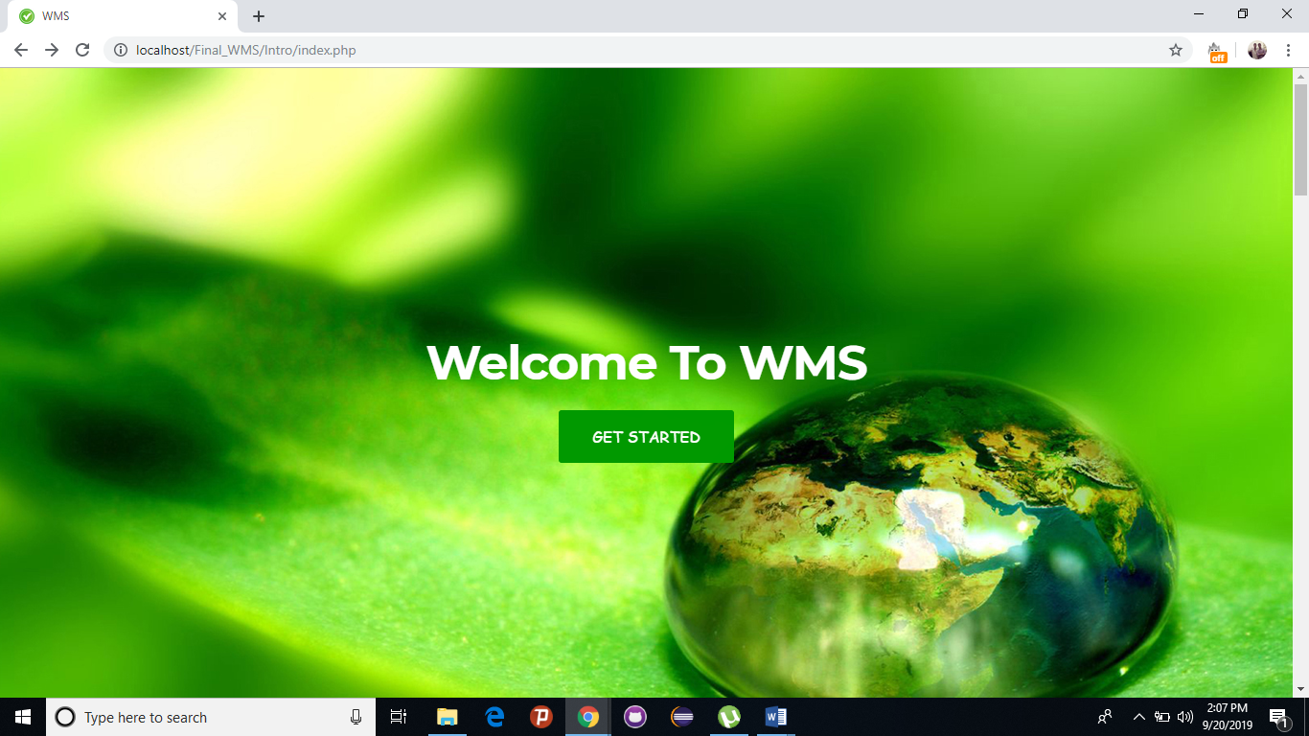

Figure 5.1 represents the main page of the system.

* + 1. **LOGIN PAGE**

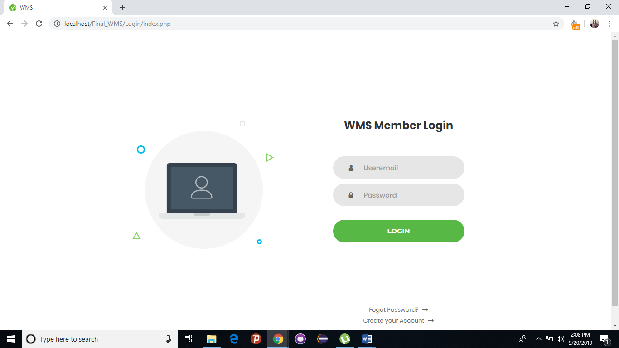

Figure 5.2 represents the login page of the system.

* + 1. **USER HOME PAGE**

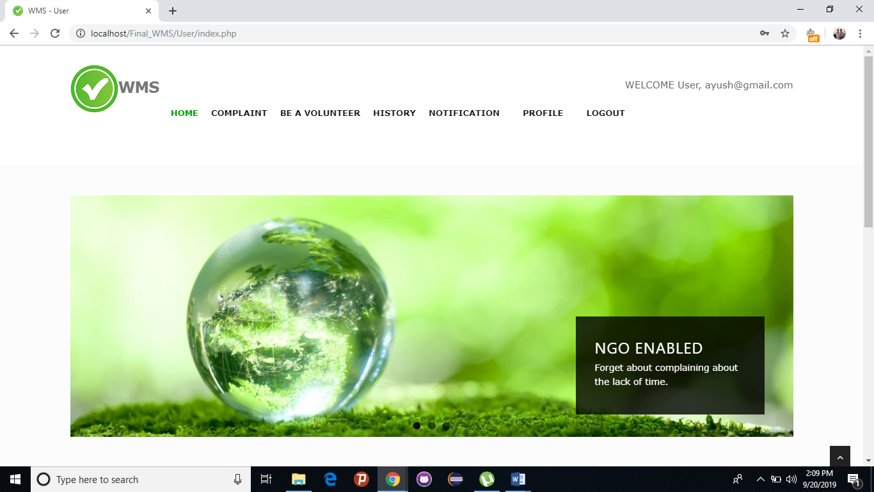

Figure 5.3 represents the user home page of the system.

* + 1. **COMPLAINT PAGE**

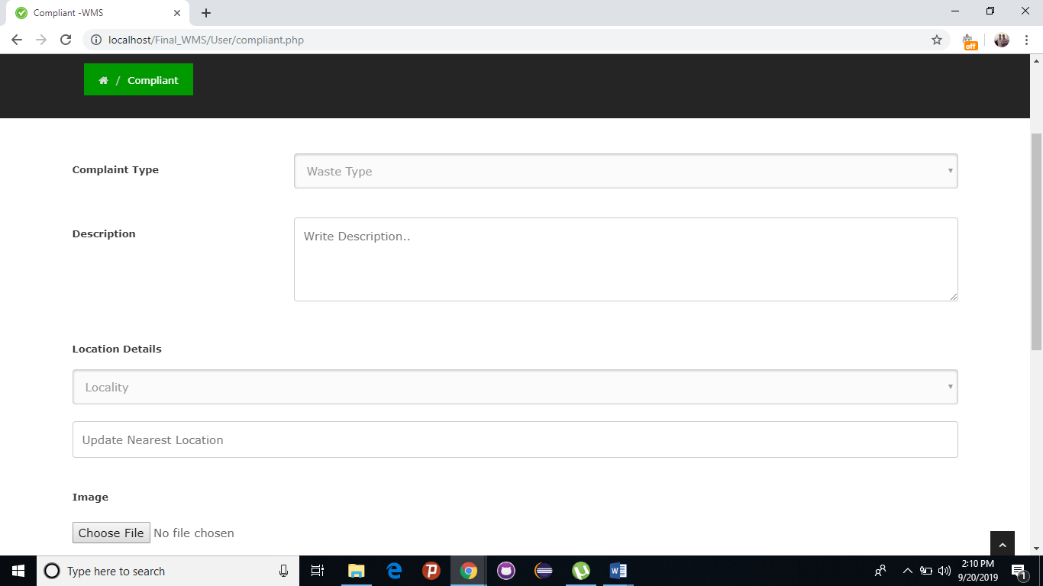

Figure 5.4 represents the complaint page of the system.

* + 1. **COMPLETED HISTORY PAGE**

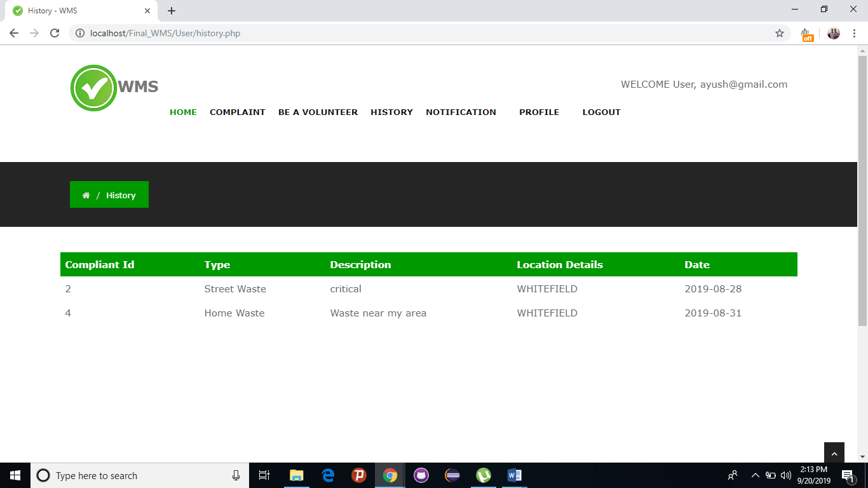

Figure 5.5 represents the history of request completed by volunteer/NGO.

* + 1. **REQUEST PENDING PAGE**

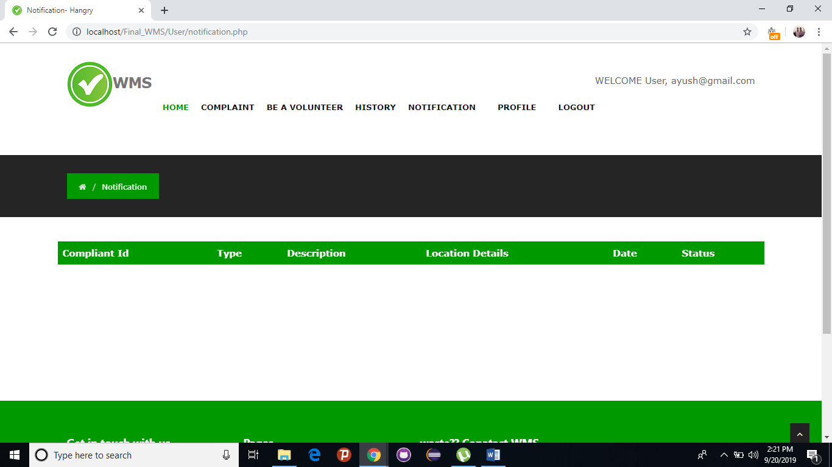

Figure 5.6 represents the request still pending in the system in user’s page.

* + 1. **NGO/VOLUNTEER HOME PAGE**

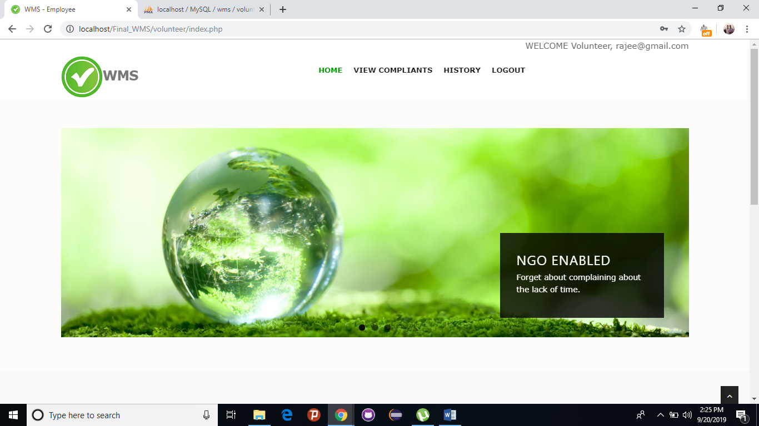

Figure 5.7 represents the NGO/Volunteer home page of the system.

* + 1. **COMPLAINT RAISED PAGE**

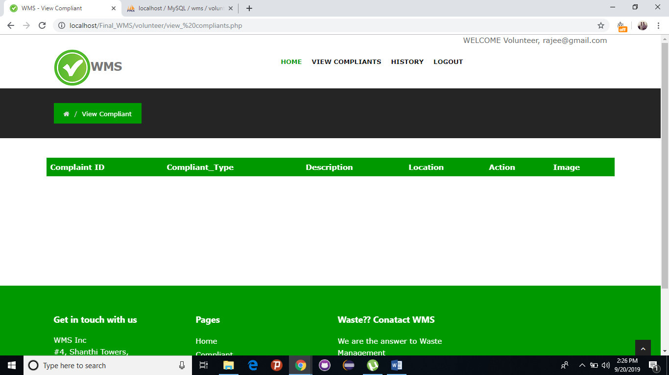

Figure 5.8 represents the complaint raised by the user.

* + 1. **HISTORY PAGE**

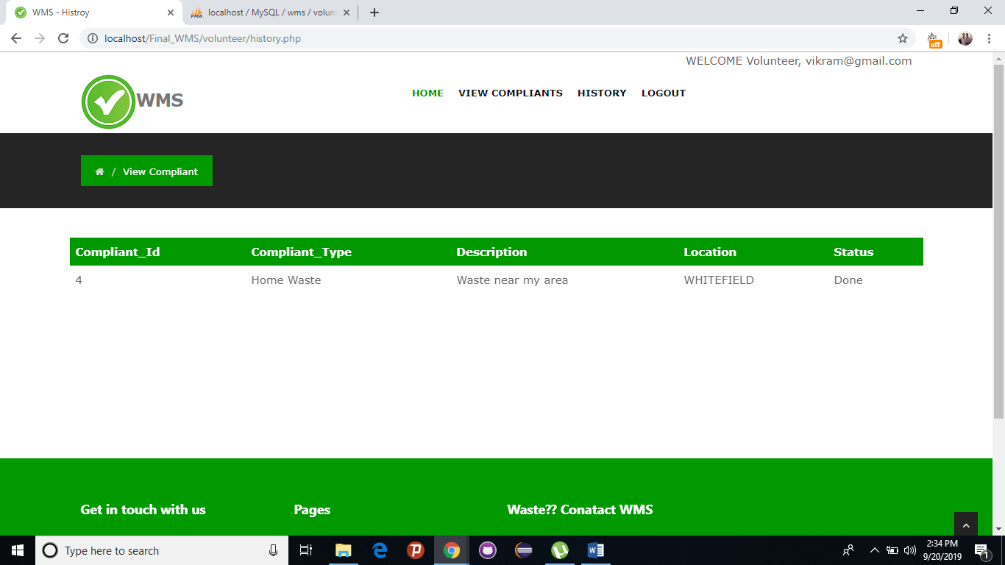

Figure 5.9 represents the history completed by NGO/volunteer.

* + 1. **ADMIN PANEL PAGE**

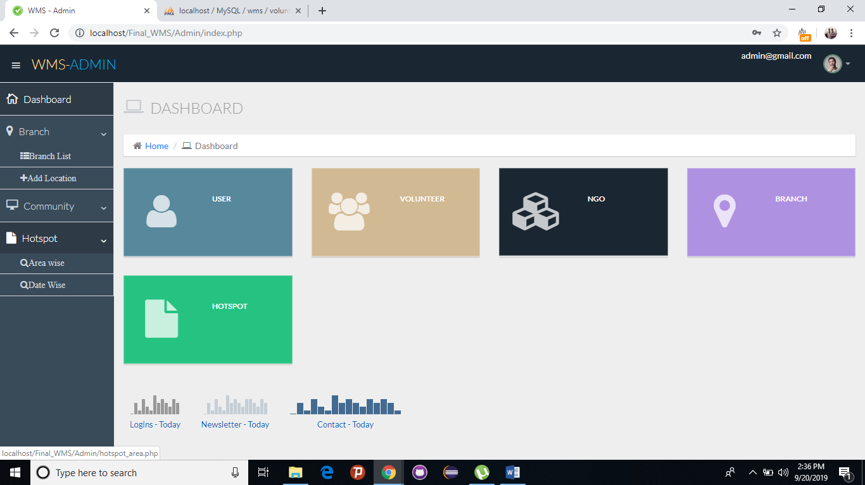

Figure 5.10 represents the admin home page. Admin can add NGO, Branch, update NGO/volunteer, delete NGO/user/volunteer. Hotspot generate report arear wise of work completed.

# TESTING

## TEST PLAN

### Testing provides an objective, independent view of the software to allow the developers to appreciate and understand the risks of software implementation. Test techniques include, but are not limited to, the process of executing a program or an application with the intent of finding errors, bugs and defects. Software testing, depending on the testing method employed, can be implemented at any time in the development process. Traditionally most of the test effort occurs after the requirements have been defined and the coding process has been completed.

A primary purpose of testing is to detect software failures so that defects may be discovered and corrected. Testing cannot establish that a product functions properly under all conditions but can only establish that it does not function properly under specific conditions. The scope of software testing often includes examination of code as well as execution of that code in various environments and conditions as well as examining all aspects of code: does it do what it is supposed to do and do what it needs to do. Not all software defects are caused by coding errors. One common source of expensive defects is caused by requirement gaps, e.g., unrecognized requirements that result in errors of omission by the program designer. A common source of requirements gaps in non-functional requirements such as testability, scalability, maintainability, usability, performance and security.

A very fundamental problem with software testing is that testing under all combinations of inputs and preconditions (initial state) is not feasible, even with a simple product. This means that the number of defects in a software product can be very large and defects that occur infrequently are difficult to find in testing. More significantly, non- functional dimensions of quality (how it is supposed to be versus what it is supposed to do) usability, scalability, performance, compatibility, reliability can be highly subjective; something that constitutes sufficient value to one person may be intolerable to another. We plan to test our project by various methods of testing. We aim at testing our project and run it under maximum testing combinations possible. By doing this we can check the functionality and the durability of our product. We plan to test our project

in three phases, being, unit testing, integration testing and validation testing. Integration

testing is the most detailed and longest process of testing as it consists of the top down approach, a bottom up approach, umbrella approach, black box testing and white box testing.

* 1. **TEST CASES**
     1. **Login Form**

Table 6.1 Login test cases

|  |  |  |  |  |
| --- | --- | --- | --- | --- |
| **No.** | **Test Scenario** | **Expected Result** | **Observed Result** | **Result** |
| 1 | Form displayed with all the controls | Display the login form with all the controls | Form loaded successfully with all the controls | Pass |
| 2 | Enter wrong username and password | Display login form again with invalid message. | Message displayed | Pass |
| 3 | Enter not registered details. | Display invalid message. | Message displayed | Pass |
| 4 | Enter correct username and correct password of any of the registered users. | The appropriate home page is loaded. | Login to their home pages | Pass |
| 5 | Press login button without filling the username and password | Display warning message to fill the details | Warning message displayed | Pass |

## Registration Form

Table 6.2 registration form test cases

|  |  |  |  |  |
| --- | --- | --- | --- | --- |
| **No.** | **Test Scenario** | **Expected Result** | **Observed Result** | **Result** |
| 1 | Form displayed | Display form with all controls | Form loaded with all controls | Pass |
| 2 | Click Register button without data | Display warning message to fill all the details | Warning Message displayed to fill data | Pass |
| 3 | Enter correct data and fill the registration form | The data is stored in the database and a mail is sent to the registered mail address. And a message for successful registration is displayed | Registration is successful and a message to login appears. | Pass |
| 4 | Enter Wrong Mail Address | Display error message to enter correct mail address | Error message displayed | Pass |
| 5 | Enter Wrong Phone number | Display error message to enter correct phone number | Error message displayed | Pass |
| 6 | Enter different password | Display error message to enter matching passwords | Error message displayed | Pass |

|  |  |  |  |  |
| --- | --- | --- | --- | --- |
| 7 | Enter invalid picture format | Display error message to select correct file type | Error message displayed | Pass |

## Complaint Raised Form

Table 6.3 complaint raised form test cases

|  |  |  |  |  |
| --- | --- | --- | --- | --- |
| **No.** | **Test Scenario** | **Expected Result** | **Observed Result** | **Result** |
| 1 | Form displayed | Display form with all controls | Form loaded with all controls | Pass |
| 2 | Click Submit button without data | Display warning message to fill all the details | Warning Message displayed | Pass |
| 3 | Enter correct data to the fields | Event registered successfully and redirect to the events page | Events gets successfully registered | Pass |
| 4 | Click save button with wrong inputs | Display corresponding warning messages | Message displayed | Pass |
| 5 | Give invalid inputs to different fields | Appropriate validation messages are shown | The messages gets shown | Pass |

## User Dashboard

Table 6.4 User dashboard test cases

|  |  |  |  |  |
| --- | --- | --- | --- | --- |
| **No.** | **Test Scenario** | **Expected Result** | **Observed Result** | **Result** |
| 1 | On login the user dashboard is displayed | Dashboard is displayed | Dashboard appears when login as user/ngo/volunteer | Pass |
| 2 | Check different navigation links | All links redirect to the corresponding pages | All links worked | Pass |

## History

Table 6.5 history test cases

|  |  |  |  |  |
| --- | --- | --- | --- | --- |
| **No.** | **Test Scenario** | **Expected Result** | **Observed Result** | **Result** |
| 1 | Page loaded with all the complaint raised done | Work done listed | Status listed successfully | Pass |
| 2 | Status details are listed | All the completed task are listed | All status are listed | Pass |

## Update Complaint

Table 6.6 update complaint test cases

|  |  |  |  |  |
| --- | --- | --- | --- | --- |
| **No.** | **Test Scenario** | **Expected Result** | **Observed Result** | **Result** |
| 1 | The page loaded with all the controls | The page is shown with all the controls | The page is loaded with all the controls | Pass |
| 2 | Fill the form with appropriate data | The Data gets saved | The status gets updated | Pass |

## Admin

Table 6.7 admin test cases

|  |  |  |  |  |
| --- | --- | --- | --- | --- |
| **No.** | **Test Scenario** | **Expected Result** | **Observed Result** | **Result** |
| 1 | change the project URL to the admin page | admin login window appears | window loaded correctly | Pass |
| 2 | Add details to the project pages | Add the details should be saved and viewed in the pages corresponding | could save the details and view in the modified the places | Pass |
| 3 | Delete details from the admin side | Details get deleted | details got deleted | Pass |

# CONCLUSION

In this time of need where garbage and waste has taken over our surrounding making it unhealthy and uninhabitable, this application will work as an interface between Naive users, the Employees and the NGOs to interact and work towards cleaner India. The aim is to provide a clean environment to the public and for that this application will target audiences such as City administration, District administrations/NGO(s), Municipalities, Waste trucks owning companies who will work towards cleaning the city. Users such as households, schools, restaurants, hospitals etc. will be using this application for raising issues regarding cleanliness.

This application is totally dedicated towards healthy and hygienic environment by creating awareness towards clean cities and its need.

* 1. **FUTURE ENHANCEMENT**

Currently, WASTE MANAGEMENT SYSTEM (WMS) which is developed as a website. Further, it can be extended to work as application on Android, OS, Windows and other platforms. Places outside the local limited range can also be included to increase the ease of usage for the users thereby providing much wider and better scope for the use of this website. The user interface is designed so as to cater to all the needs of a WMS.

**REFERENCES**

# [1]. "Introducing the MySQL 8 Document Store”

url: <https://www.apress.com/gp/book/9781484227244>

[2]. “MySQL 8.0 Reference Manual” url: “[https://downloads.mysql.com/docs/refman-8.0-en.pdf](https://downloads.mysql.com/docs/refman-8.0-en.pdf%20) “

[3]. Patrick Dalton, Paul Whitehead, “SQL SERVER BLACK BOOK”

Dream Tech New Delhi, 2005.

[4]. Roger Pressman, “Software Engineering A Practitioner’s Approach”, McGraw-Hill Company, 2001.