- National Invoice Usage Template
This template will be used for tax invoices for Domestic/National customers.

Page | Description
Cover page | One-page (or multi-page) summary invoice: franchise and operator details, invoice metadata, traffic summary by period and product type, invoice totals, bank payment details, and contact number.
Detail page | Supporting detail listing each product / rating line with counts, usage, rate, and amount; includes subtotals by traffic period and product group.

- Document flow
flowchart TB
Cover[Cover page — summary invoice]
Detail[Detail page — line breakdown]
Cover --> Detail

- General Instruction on the invoice templates:
- Each invoice template will be 2 pages PDF.
- Cover Page
- Detail Page
- Date format across invoice document would be DD-MON-YYYY format.
- Volumes should be comma formatted, e.g. 1,001,999
- Where two currencies are shown on a single invoice, both should show the full description, e.g. NZD & USD
- 0 currency amounts should be shown as $-.
- 0 volume amounts should be shown as 0.00
- All Amount, Percentage and Duration figures shown on the invoice would be rounded to 2 decimal places.
- Font ‘Callbri’ to be used for all documents.
- Page number and total pages (e.g. *Page 1 of 2*), right aligned

- Cover Page

REPORT | Sections | Description
COVER PAGE | 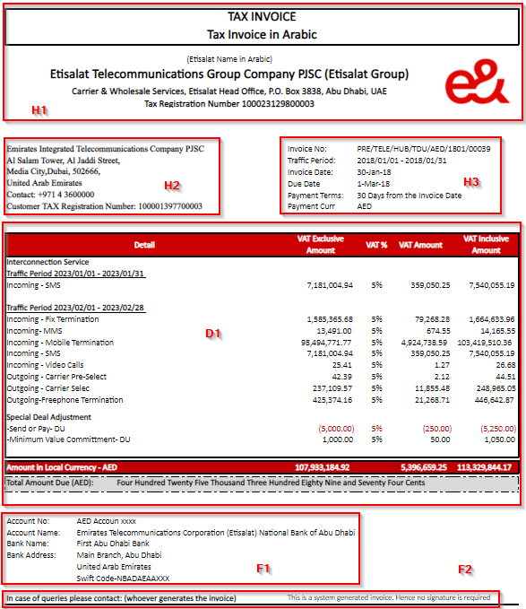
 | Sections | Label | Description
 | HEADER and TITLE | H1 | - Document Type: Invoice or Declaration  - Tax Invoice  - Outbound Statement  - Franchise Name: Full Name of the Franchise  - Address: Full Address of the Franchise  - Tax Registration Number: Tax number of the Franchise
 |  | H2 | - Operator Name: Full Name of the billed Operator  - Contact Number: Telephone number of the billed Operator  - Tax Registration Number: Tax number of the billed Operator
 |  | H3 | - Invoice Number: Invoice Number  - Invoice Period: Billing Period  - Invoice Date: Date of invoice generation  - Invoice Due Date: Invoice Due Date calculated based on Term ID  - Invoice Terms: Payment invoice terms  - Payment Curr: Invoice currency
 | DETAIL | D1 | This Section of the invoice gives the summary of the traffic billed to the customer.  - Traffic Period: the traffic period, sorted from older to new. Format: YYYY/MM/DD - YYYY/MM/DD  - Detail  - Interconnection Service:  - Domestic: Description is derived based on ICT rating scenario name eg: "Incoming - Fix Termination"  - International: ICT billed product eg: "International Direct Dial"  - Special Deal Adjustment: This section will appear only if there is VBR for national traffic.  - VAT Exclusive Amount: Total Amount without taxes  - VAT%: Taxes percentage per product  - VAT Amount: Total taxes amount  - VAT Inclusive Amount: Total amount including taxes  - Amount In Words: Total amount of invoice in words
 | FOOTER | F1 | - Account No: Franchise bank account number for the invoice currency  - Swift Code: Franchise swift code  - Account Name: Franchise bank account name  - Bank Name: Franchise bank account name  - Bank Address: Franchise bank address  - Telephone: Franchise telephone number
 |  | F2 | - Contact No: User who approved/generated the invoice

  - Data Source
Main query -> VW_DOCUMENT_TRANS_SUMMARY
Alias: TRANS. Implements Fields Needed for cover page
SELECT
TRANS.DOCUMENT_TYPE,
TRANS.FRN_NAME,
TRANS.FRN_ADDRESS_LINE1,
TRANS.FRN_ADDRESS_LINE2,
TRANS.FRN_ADDRESS_LINE3,
'X123' FRN_TAX_REG_NO,
'HDFC BANK' FRN_BANK_NAME,
'ERTY' FRN_BANK_ACCOUNT_NAME,
TRANS.FRN_BANK_ADDRESS_LINE1,
'AABBCC' FRN_BANK_ACCOUNT_NO,
TRANS.FRN_BANK_SWIFT_CODE,
TRANS.FRN_TELEPHONE,
TRANS.FRN_EMAIL,
TRANS.OPR_NAME,
'1234' OPR_CONTACT_NO,
'Y123' OPR_TAX_REG_NO,
TRANS.CURRENCY,
TRANS.BILLING_PERIOD,
TRANS.DOCUMENT_DATE,
TRANS.PAYMENT_DUE_DAYS,
TRANS.PAYMENT_DUE_DATE,
TRANS.DOCUMENT_NUMBER,
TRANS.SERVICE_NAME,
TRANS.TRAFFIC_PERIOD,
TRANS.DATA_TYPE,
'SERVICE' DETAIL_TYPE,
TRANS.TRANS_TYPE,
TRANS.CALL_COUNT,
TRANS.USAGE,
TRANS.NET_AMOUNT,
TRANS.TAX_PCT,
TRANS.TAX_AMOUNT,
TRANS.TOTAL_AMOUNT,
TRANS.AMOUNT_IN_WORDS,
'TERM' RATING_COMPONENT,
'DUMMY' ORIGINATION,
'INDIA' DESTINATION,
'MIN' RATE_UNIT,
'0.52' RATE,
'TELE' PRODUCT_GROUP
FROM VW_DOCUMENT_TRANS_SUMMARY TRANS
WHERE ID = $P{P_TRANS_ID}

AND TRANS.TOTAL_AMOUNT <> 0
ORDER BY TRANS.TRAFFIC_PERIOD, TRANS.DATA_TYPE, TRANS.SERVICE_NAME
  - Business Rule

Field | Section and Level | Used on | Business Rule
Document Type | HEADER and TITLE; H1 |  | Tax Invoice when document type is invoice (INV); Outbound Statement when declaration (DEC); otherwise show the system document type.
All other listed fields | All other labels on HEADER and FOOTER | Per query
Traffic period | DETAIL, D1 |  | Under each traffic period, charges grouped by traffic type:  Line items:- One row per service/product with amounts and tax columns.  Section subtotal:- Subtotal per data type (domestic / international / special deal) for net, tax, and total.  Invoice totals: - Total Net Amount, Tax Amount, Total Amount; Amount in words for the invoice total.

- Detail Page

REPORT | Sections | Description
DETAIL PAGE | 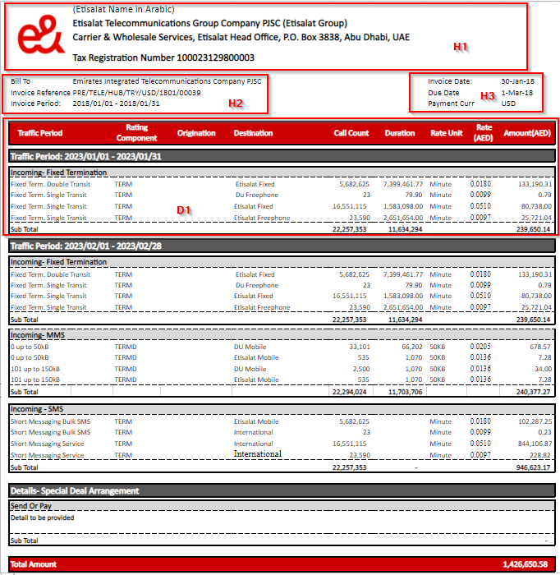
 | Sections | Label | Description
 | HEADER and TITLE | H1 | - Franchise Name: Full Name of the Franchise  - Tax Registration Number: Tax number of the Franchise
 |  | H2 | - Bill To: Operator Name  - Invoice Reference: Invoice Number  - Invoice Period: Billing Period
 |  | H3 | - Invoice Date: Date of invoice generation  - Invoice Due Date: Invoice Due Date calculated based on Term ID  - Payment Curr: Invoice currency
 | DETAIL | D1 | This Section of the invoice gives the detail of the traffic billed to the customer.  - Traffic Period: the traffic period, sorted from older to new. Format: YYYY/MM/DD - YYYY/MM/DD  - Detail: this should be break down by product or VBR and subtotals calculated  - Product Description: Description is derived based on ICT rating scenario name eg: Incoming - Fix Termination OR description derived from Step Number Name.  - Rating Component: ICT rating component  - Origination: TBD  - Destination: Tier name  - Count: Number of events  - Usage: Total minutes or volume  - Unit: Rate unit  - Rate: Unit cost used or flat rate charge  - Amount: amount without taxes

  - Data Source
Main query -> VW_DOCUMENT_TRANS_SUMMARY
Alias: TRANS. Implements Fields Needed for detail page
SELECT
TRANS.DOCUMENT_TYPE,
TRANS.FRN_NAME,
TRANS.FRN_ADDRESS_LINE1,
TRANS.FRN_ADDRESS_LINE2,
TRANS.FRN_ADDRESS_LINE3,
'X123' FRN_TAX_REG_NO,
'HDFC BANK' FRN_BANK_NAME,
'ERTY' FRN_BANK_ACCOUNT_NAME,
TRANS.FRN_BANK_ADDRESS_LINE1,
'AABBCC' FRN_BANK_ACCOUNT_NO,
TRANS.FRN_BANK_SWIFT_CODE,
TRANS.FRN_TELEPHONE,
TRANS.FRN_EMAIL,
TRANS.OPR_NAME,
'1234' OPR_CONTACT_NO,
'Y123' OPR_TAX_REG_NO,
TRANS.CURRENCY,
TRANS.BILLING_PERIOD,
TRANS.DOCUMENT_DATE,
TRANS.PAYMENT_DUE_DAYS,
TRANS.PAYMENT_DUE_DATE,
TRANS.DOCUMENT_NUMBER,
TRANS.SERVICE_NAME,
TRANS.TRAFFIC_PERIOD,
TRANS.DATA_TYPE,
'SERVICE' DETAIL_TYPE,
TRANS.TRANS_TYPE,
TRANS.CALL_COUNT,
TRANS.USAGE,
TRANS.NET_AMOUNT,
TRANS.TAX_PCT,
TRANS.TAX_AMOUNT,
TRANS.TOTAL_AMOUNT,
TRANS.AMOUNT_IN_WORDS,
'TERM' RATING_COMPONENT,
'DUMMY' ORIGINATION,
'INDIA' DESTINATION,
'MIN' RATE_UNIT,
'0.52' RATE,
'TELE' PRODUCT_GROUP
FROM VW_DOCUMENT_TRANS_SUMMARY TRANS
WHERE ID = $P{P_TRANS_ID}
AND TRANS.TOTAL_AMOUNT <> 0
ORDER BY TRANS.TRAFFIC_PERIOD, TRANS.DATA_TYPE, TRANS.SERVICE_NAME

  - Business Rule

Field | Section and Level | Used on | Business Rule
Traffic period | Detail, D1 |  | Under each traffic period, charges grouped by traffic type:  Line items:- One row per service/product with amounts and no tax columns.  Section subtotal:- Subtotal per data type (domestic / international / special deal) for net, and total.  Invoice totals:- Total Net Amount, Total Amount;
All other listed fields | All other labels on Detail | Per query

- Parameters

Parameter | Required | Purpose
P_TRANS_ID | Yes | Document transaction ID (TRANS.ID in views). Passed from main subreport parameter.

