Flow Diagram

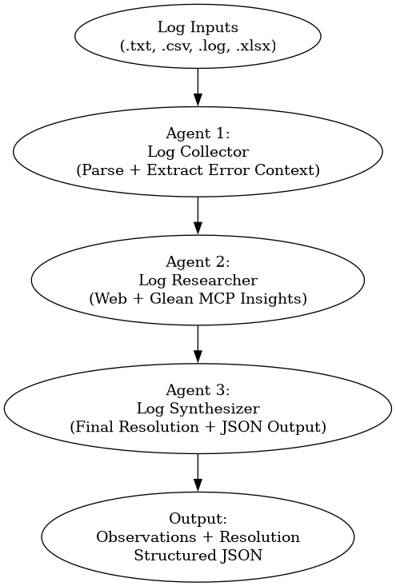

Flow Explanation Summary
1. Log Inputs
- The flow begins with ingestion of log files in multiple formats:
  - .txt, .csv, .log, .xlsx
- These files may contain structured or unstructured system/application logs.

2. Agent 1: Log Collector
- Purpose: Parse and extract relevant error context.
- Key Actions:
  - Reads input files using file tools
  - Identifies errors, exceptions, warnings
  - Extracts contextual details:
    - Timestamp
    - Module/service
    - Stack traces
- Output:
  - Structured error context dataset (clean and filtered)

3. Agent 2: Log Researcher
- Purpose: Analyze and research error context.
- Key Actions:
  - Interprets errors and patterns
  - Searches:
    - Public web sources (docs, forums)
    - Enterprise knowledge via Glean MCP
    - BMC Helix ITSM incidents
- Constraints:
  - Read-only (no changes)
- Output:
  - Observations + possible causes + known resolutions

4. Agent 3: Log Synthesizer
- Purpose: Consolidate findings into final resolutions.
- Key Actions:
  - Combines:
    - Error context (Agent 1)
    - Research insights (Agent 2)
  - Produces:
    - Final root cause
    - Clean, actionable resolution
  - Persists results as structured artifacts
- Constraints:
  - No DB query, no web, no Glean calls
  - No modifications
- Output:
  - Final synthesized resolution per error
  - Structured JSON (log + observation)

5. Final Output
- A ready-to-use diagnostic output:
  - Error summary
  - Root cause
  - Resolution steps
  - Supporting observations
- Stored in machine-readable JSON format for reuse, audit, or automation

✅ End-to-End Value
This pipeline ensures:
- Automation of log analysis
- Reduction in manual debugging effort
- Consistent and explainable resolutions
- Separation of concerns across agents
- Scalable and reusable architecture

Detail Description of Agents
Agent 1 - Log Collector Agent – Description
The Log Collector Agent is designed as a senior developer–level intelligent component responsible for ingesting, parsing, and analyzing log files to extract meaningful error insights. Its primary role is to streamline log analysis by identifying relevant error messages and providing contextual outputs that aid in debugging and system monitoring.
Role and Responsibilities
- Acts as a senior developer with deep understanding of application logs, system behavior, and error patterns.
- Reads and interprets log data from multiple file formats including:
  - .txt
  - .csv
  - .log
  - .xlsx
- Utilizes file read and write tools to efficiently access input data and store processed outputs or intermediate results.
Core Capabilities
- Multi-format File Handling
  - Seamlessly reads structured and unstructured data from supported file formats.
  - Handles tabular data (CSV/XLSX) as well as plain text logs.
- Log Parsing and Analysis
  - Parses log entries to detect:
    - Error messages
    - Warning messages
    - Exception traces
    - Failure patterns
  - Applies intelligent filtering to isolate critical events from noise.
- Context Extraction
  - Captures relevant surrounding context for each identified error, such as:
    - Timestamp
    - Module or service name
    - Stack trace details
    - Related preceding or succeeding log entries
  - Ensures outputs are actionable and meaningful for debugging.
- Data Transformation and Output
  - Structures extracted information into a clean, readable format.
  - Writes processed outputs into desired formats (e.g., summarized logs, reports, or structured datasets).
Inputs
- Log files in .txt, .csv, .log, or .xlsx formats.
- Optional filtering criteria (e.g., keywords, error levels, time ranges).
Outputs
- A curated list of relevant error messages with contextual information, including:
  - Error type and message
  - Timestamp and origin
  - Associated stack trace or related entries
- Optionally, a summarized report highlighting key issues or recurring patterns.
Value Proposition
The Log Collector Agent reduces manual effort in scanning large log files and enables faster issue resolution by delivering precise, context-rich error insights, much like an experienced senior developer reviewing logs for root cause analysis.

Agent 2 - Log Researcher Agent – Description
The Log Researcher Agent functions as a senior developer–level analytical component responsible for interpreting and investigating error contexts produced by the Log Collector Agent. Its primary objective is to analyze identified issues, research potential resolutions, and provide actionable observations without making any system modifications.

Role and Responsibilities
- Acts as a senior developer and investigator, specializing in troubleshooting and root cause analysis.
- Consumes error context data generated by the Log Collector Agent.
- Performs deep analysis and correlation of errors with known issues and resolutions.
- Maintains a read-only, non-intrusive approach — it does not modify logs, systems, or configurations.

Core Capabilities
- Error Context Analysis
  - Interprets structured error data, including:
    - Error messages
    - Stack traces
    - Timestamps
    - Application/service identifiers
  - Identifies patterns, anomalies, and potential root causes.
- Public Web Research
  - Searches publicly available technical resources such as:
    - Documentation
    - Developer forums
    - Knowledge bases
    - Issue trackers
  - Maps observed errors to known issues, fixes, or best practices.
- Enterprise Knowledge Search (Glean MCP Integration)
  - Queries enterprise knowledge repositories via Glean MCP to:
    - Identify similar historical incidents
    - Retrieve past resolutions or workarounds
    - Reference BMC Helix ITSM incident records
  - Uses internal insights to complement public research.
- Correlation and Insight Generation
  - Combines findings from:
    - Log context
    - Public knowledge
    - Enterprise incident data
  - Correlates issues across environments or recurring incidents.

Inputs
- Error context data from the Log Collector Agent, including:
  - Extracted error messages
  - Associated metadata (time, module, stack trace)
- Optional scope constraints (e.g., system name, timeframe, severity).

Outputs
- A structured set of observations and insights, including:
  - Likely root cause(s) of the issue
  - Possible resolutions or workarounds identified from research
  - References to similar incidents (especially from BMC Helix ITSM via Glean MCP)
  - Confidence level or likelihood of each identified solution
- Clearly documented findings without making changes or recommendations for execution.

Key Principles
- Read-Only Operation: Does not perform any modifications or trigger actions.
- Evidence-Based Analysis: All observations are derived from log data and research.
- Context Preservation: Maintains traceability between original errors and derived insights.
- Enterprise + Public Intelligence: Blends internal incident knowledge with external expertise.

Value Proposition
The Log Researcher Agent enhances troubleshooting efficiency by acting as an intelligent research assistant, bridging the gap between raw error logs and actionable understanding. By leveraging both public web knowledge and enterprise incident history (via Glean MCP and BMC Helix ITSM), it enables faster and more informed decision-making for development and support teams.

Agent 3 - Log Synthesizer Agent – Description
The Log Synthesizer Agent acts as the final decision-making and consolidation layer in the log analysis pipeline. Operating with the expertise of a senior developer and solution architect, its role is to unify insights from upstream agents and produce a clear, actionable resolution per identified error, while maintaining a strictly read-only and non-intrusive approach.

Role and Responsibilities
- Consumes:
  - Error context from the Log Collector Agent (Agent 1)
  - Research insights and observations from the Log Researcher Agent (Agent 2)
- Synthesizes all inputs into cohesive, actionable outcomes
- Produces final resolution guidance for each error without executing any changes
- Persists structured outputs for traceability and future reference

Core Capabilities
- Multi-Source Synthesis
  - Combines:
    - Raw error data (logs, stack traces, timestamps)
    - External research insights (public web findings)
    - Enterprise knowledge (via Glean MCP outputs from Agent 2)
  - Ensures all perspectives are aligned into a unified understanding
- Error-to-Resolution Mapping
  - Generates a final resolution per error, including:
    - Root cause summary
    - Recommended fix or workaround
    - Supporting evidence from research and logs
  - Eliminates ambiguity by reconciling conflicting observations
- Structured Output Generation
  - Produces outputs in well-defined formats, including:
    - Observation summaries
    - Resolution statements
    - Log + observation JSON artifacts
  - Ensures outputs are machine-readable and suitable for downstream automation or reporting
- Persistence Layer Integration
  - Writes synthesized results into structured storage formats (e.g., JSON files)
  - Maintains:
    - Traceability (linking error → research → resolution)
    - Auditability for future analysis
- Solution Proposal
  - Provides clean, concise, and implementable solutions
  - Focuses on clarity and completeness rather than execution
  - Avoids redundancy and highlights the most effective resolution path

Operational Constraints
- No External Calls:
  - Does not perform web searches
  - Does not query Glean MCP
  - Does not access databases
- Read-Only Behavior:
  - Does not modify logs, systems, or data sources
  - Does not trigger any remediation actions
- Relies entirely on inputs provided by Agent 1 and Agent 2

Inputs
- Agent 1 (Log Collector Agent):
  - Parsed error messages with contextual data
- Agent 2 (Log Researcher Agent):
  - Observations, likely causes, and researched resolutions

Outputs
- Final Observations and Resolutions, including:
  - Consolidated error description
  - Validated root cause
  - Recommended resolution steps
  - Supporting references (from research insights)
- Structured JSON Output, for each error:
  - Error metadata
  - Context snapshot
  - Synthesized observations
  - Final resolution

Key Principles
- Synthesis Over Discovery: Focuses on combining, not generating new research
- Clarity and Actionability: Outputs are precise and ready for implementation
- Traceable Decision-Making: Each resolution is backed by input context and observations
- Non-Intrusive Operation: No modifications or external interactions

Value Proposition
The Log Synthesizer Agent transforms fragmented insights into clear, decision-ready resolutions, acting as the final intelligence layer in the pipeline. By consolidating log context and researched knowledge into structured, actionable outputs, it enables faster issue resolution while ensuring consistency, traceability, and reliability across the troubleshooting process.

