DATA ANALYTICS PROJECT REPORT

FINANCIAL PERFORMANCE
ANALYSIS
Detailed Data Analytics Project Report
MySQL • SQL • Power BI

Submitted by
Vikash Bairwa
B.Tech – Electrical Engineering
Jaipur Engineering College and Research Centre
Project Portfolio Report | 2026

Submitted by
Learnnex Academy

DECLARATION
I, Vikash Bairwa, declare that this project report titled “Sales & Order Management Analytics System” has been prepared to document my learning and implementation of a SQL-based data analytics project. The report describes the project objectives, relational data model, SQL techniques, analytical questions, and dashboard/reporting workflow.
The work is intended for academic and professional portfolio demonstration. Any external references used for SQL concepts or tool documentation should be acknowledged in the references section. Dataset-specific conclusions should be verified against the actual data and query outputs before the report is submitted or published.
I understand that accuracy, reproducibility, and transparent reporting are important in analytics. Therefore, results should be presented only when supported by the executed queries, and any assumptions or limitations should be disclosed.
Name: Vikash Bairwa
Date: 30-10-2026

ACKNOWLEDGEMENT
I would like to express my gratitude to everyone who supported my learning journey and helped me strengthen my understanding of data analytics, database management, and reporting. This project provided an opportunity to apply SQL concepts to a practical business scenario rather than learning each concept in isolation.
I am thankful to the educators, documentation authors, and learning communities whose resources explain relational databases, query design, aggregation, joins, common table expressions, window functions, views, and indexing. These concepts formed the foundation of the analysis.
I also acknowledge the value of hands-on practice: creating tables, loading data, validating records, writing queries, reviewing outputs, and connecting analytical results to dashboard visuals. The process helped me understand that a useful analytics project requires both technical correctness and clear communication.
Finally, I thank my family and well-wishers for their encouragement. I hope this report demonstrates my willingness to learn, solve practical problems, and communicate analytical work in a structured and professional manner.

ABSTRACT
This project, titled “Financial Performance Analysis”, demonstrates the use of data analytics techniques to organize, validate, analyze and visualize financial information. The project uses two CSV datasets: a transaction-level dataset containing 600 records and a monthly budget dataset containing 24 records for the years 2024 and 2025.
MySQL is used to store the data, while SQL queries are used to validate records, summarize transaction amounts, calculate revenue and expenses, and derive expected profit and planned profit margins from monthly budget values. Microsoft Power BI is used to create an interactive dashboard containing key performance indicators, slicers and charts for monthly trends, payment methods, regional comparisons, transaction status and expense categories.
The recorded transaction validation results show a revenue / amount measure of ₹6,920,303.71, expenses of ₹2,307,912.90 and a calculated difference of ₹4,612,390.81. The annual budget analysis reports expected profit of ₹3,385,000 for 2024 and ₹3,625,000 for 2025. These transaction-level and budget-level measures are presented separately because they represent different data sources and analytical meanings.
The project illustrates how structured data processing and interactive visualization can support financial monitoring and decision-making. It also highlights the importance of data validation, correct relationship design, consistent KPI definitions and filter-context awareness.
Keywords: Financial Analytics, MySQL, SQL, Power BI, Revenue, Expenses, Expected Profit, Profit Margin, Budget Analysis, Data Visualization

TABLE OF CONTENTS
Update this table in Microsoft Word: right-click the table and choose “Update Field” → “Update entire table”.
DECLARATION 1
ACKNOWLEDGEMENT 1
ABSTRACT 1
TABLE OF CONTENTS 1
Executive Summary 1
Table of Contents 1
1. Introduction 1
2. Business Problem and Motivation 1
3. Objectives and Scope 1
4. Technology Stack 1
5. Source Data and Data Dictionary 1
6. Data Import and Preparation 1
7. Database Design and Data Model 1
8. Data Quality and Validation 1
9. SQL Analysis and Query Evidence 1
10. Financial KPIs and Definitions 1
11. Transaction-Level Results 1
12. Monthly Budget and Annual Analysis 1
13. Power BI Dashboard Overview 1
14. Dashboard Visual Analysis 1
15. Dashboard Filter Context and KPI Interpretation 1
16. Key Findings and Interpretation 1
17. Business Recommendations 1
18. Challenges and Resolutions 1
19. Limitations and Data Governance 1
20. Future Enhancements 1
21. Conclusion 1
Appendix A: SQL Query and Output Evidence 1
A.1 Record Count 1
A.2 Transaction Type Totals 1
A.3 Annual Budget Summary 1
A.4 Monthly Profit Margin 1
Appendix B: Exact Screenshot Placement Guide 1
Appendix C: Final Verification Checklist 1

EXECUTIVE SUMMARY
This report documents an end-to-end financial analytics project built with MySQL, SQL and Microsoft Power BI. The project works with two data sources: a transaction-level CSV containing 600 records and a monthly budget CSV containing 24 monthly records for 2024 and 2025. The purpose is to validate and summarize financial activity, calculate planned profit from monthly targets and budgets, compare annual plans, and communicate results through a dashboard.
The SQL validation results recorded during project development show transaction revenue/amount of ₹6,920,303.71, expenses of ₹2,307,912.90 and a calculated difference of ₹4,612,390.81. Separately, the monthly budget data reports 2024 revenue targets of ₹10,970,000, expense budgets of ₹7,585,000 and expected profit of ₹3,385,000. For 2025, the corresponding figures are ₹11,710,000, ₹8,085,000 and ₹3,625,000.
Indicator | 2024 | 2025 | Change
Revenue target | ₹10,970,000 | ₹11,710,000 | +6.74%
Expense budget | ₹7,585,000 | ₹8,085,000 | +6.59%
Expected profit | ₹3,385,000 | ₹3,625,000 | +7.09%
Planned profit margin | 30.86% | 30.96% | +0.10 pp

The supplied dashboard screenshot presents a filtered view with visible KPI cards: Total Revenue ₹3.49M, Total Expenses ₹1.17M, Net Profit ₹2.32M and Profit Margin 66.39%. The slicers shown include Year 2024, Month 1, Category Consulting and Status Cancelled. These are filter-context values from the displayed report and are not the same as the full-dataset SQL validation totals or the annual budget totals. The report keeps these three groups of measures distinct to avoid misleading comparisons.
Important data note: the original CSV files are not attached to this current chat turn. This report therefore uses the verified figures available from the project history and the dashboard screenshot supplied with this request. It does not invent missing category, payment-method or regional totals. Where an exact SQL output was not available, a clearly marked screenshot/output insertion point is provided.

1. INTRODUCTION
Financial performance analysis is the systematic review of revenue, expenses, budgets and profitability indicators. It helps an organization understand financial position, monitor progress against plans and identify areas requiring attention. When the source information is stored in CSV files or separate tables, manual analysis can become repetitive and difficult to audit.
This project demonstrates a practical analytics workflow. MySQL provides structured storage, SQL provides transparent calculations, and Power BI provides an interactive presentation layer. The work focuses on two distinct data grains: individual transaction records and monthly budget records.

1.1 Project Overview
The transaction dataset includes 600 records with date, type, category, department, description, amount, status, payment method and region. The monthly budget dataset includes 24 records, covering January to December in 2024 and 2025, with revenue target and expense budget fields.

1.2 Report Structure
The report explains the source data, import process, database structure, validation approach, SQL metrics, budget comparisons, Power BI dashboard and recommendations. It also identifies the exact places where query-result screenshots and Power BI evidence should be inserted.

2. BUSINESS PROBLEM AND MOTIVATION
Financial information must be accurate, consistent and understandable before it can support decisions. A large transaction file can make it difficult to quickly calculate revenue and expenses. A separate budget file can make planned-versus-actual comparisons harder, particularly when dates are stored in different formats.

2.1 Problem Statement
The project addresses the need for a repeatable method to import, validate, summarize and visualize financial data. It aims to reduce manual calculations and make key financial indicators easier to review.

2.2 Analytical Questions
- How many transaction records were imported successfully?
- What are the total transaction revenue and expense values?
- How do monthly revenue targets and expense budgets compare across 2024 and 2025?
- What is the expected profit and planned profit margin?
- How do dashboard filters affect the displayed KPIs?
- How can results be presented without confusing transaction actuals with budget targets?

3. OBJECTIVES AND SCOPE

3.1 Objectives
- Import the transaction and budget CSV files into MySQL.
- Validate record counts, data types, identifiers and date fields.
- Calculate revenue, expenses and transaction-level difference using SQL.
- Calculate expected profit and planned margin from monthly budget values.
- Compare annual targets and budgets between 2024 and 2025.
- Build a Power BI dashboard with slicers, KPI cards and comparison visuals.
- Document the queries, outputs, dashboard evidence and key findings.

3.2 Scope
The project includes data preparation, descriptive analysis and dashboard reporting. It does not claim to provide an independent audit, statutory financial statement, tax calculation or predictive forecast. Transaction totals and budget targets remain separate measures.

4. Technology STACK
Technology | Role
MySQL Server 8.0.45 | Database engine for storing structured project tables.
MySQL Workbench | Database creation, CSV import, schema inspection and SQL execution.
SQL | Record validation, conditional aggregation, date grouping and financial calculations.
Microsoft Power BI | Data model, KPI cards, slicers, charts and dashboard reporting.
CSV | Input format for transaction and monthly budget data.
GitHub | Version control, project organization and portfolio documentation.

Project database: financial_performance_db. The project was developed on Windows using MySQL Workbench and Power BI Desktop. The repository is maintained under the GitHub project Financial-Performance-Analysis.

4.1 Environment details to record
MySQL/version: [Ver 9.6.0]
Power BI/version: [2.159.883.0]
Dataset source: [Kaggle]
Project repository: [https://github.com/Vikash756/Sales-Order-Analytics]
LinkedIn: www.linkedin.com/in/vikash-bairwa-859b30265

5. SOURCE DATA AND DATA DICTIONARY

5.1 Transactions Dataset
The transactions dataset contains 600 rows. The project schema includes transaction_id, transaction_date, transaction_type, category, department, description, amount_inr, status, payment_method and region.
Field | Meaning | Analysis Use
transaction_id | Unique transaction identifier | Record identity / duplicate check
transaction_date | Date of transaction | Monthly and yearly grouping
transaction_type | Transaction classification | Revenue and expense split
category | Financial category | Category analysis
department | Business department | Department comparison
description | Transaction description | Context / audit review
amount_inr | Amount in INR | Financial aggregation
status | Transaction status | Status filtering
payment_method | Payment channel | Payment method analysis
region | Business region | Regional comparison

5.2 Monthly Budget Dataset
The monthly budget dataset contains 24 rows, one for each month of 2024 and 2025. Its key fields are month, revenue_target_inr and expense_budget_inr. A month_date DATE field was created to support date-based aggregation.

5.3 Dataset Grain
A transaction row represents one transaction. A budget row represents one month. This difference is critical: joining one monthly budget row to many transaction rows can repeat the budget amount and inflate totals. A separate calendar dimension or carefully designed measures is recommended in the Power BI model.

6. DATA IMPORT AND PREPARATION
- Create the financial_performance_db database in MySQL.
- Import the transactions CSV into the transaction table.
- Verify the transaction row count; the project validation reported 600 records.
- Import the monthly budget CSV and verify 24 records.
- Inspect table columns and data types in MySQL Workbench.
- Create a DATE field for the budget month using STR_TO_DATE.
- Connect Power BI to the MySQL database and load the required tables.
- Check date formats and field names before creating DAX measures and visuals.

6.1 Date Normalization

The financial budget dataset covers a period of 24 months, starting from January 2024 and ending in December 2025. The Budget Month field stores the month values in DATE format, enabling accurate monthly and yearly financial analysis.

6.2 Evidence to Insert

MySQL table import and row-count verification

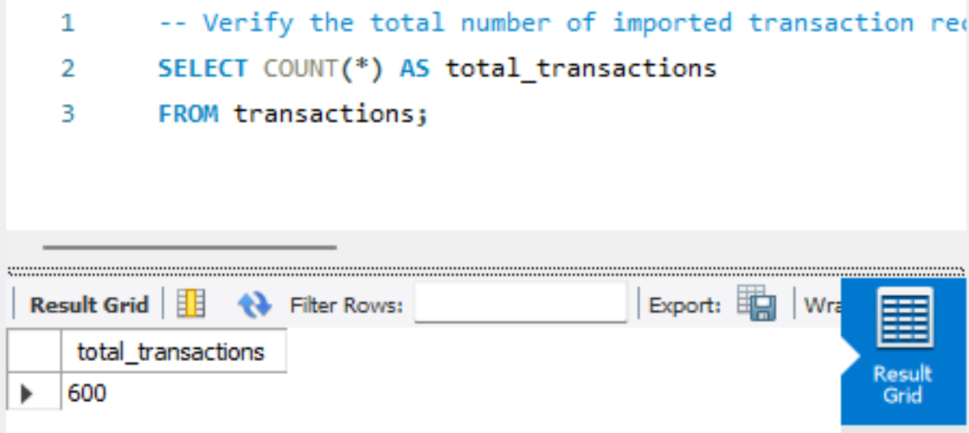

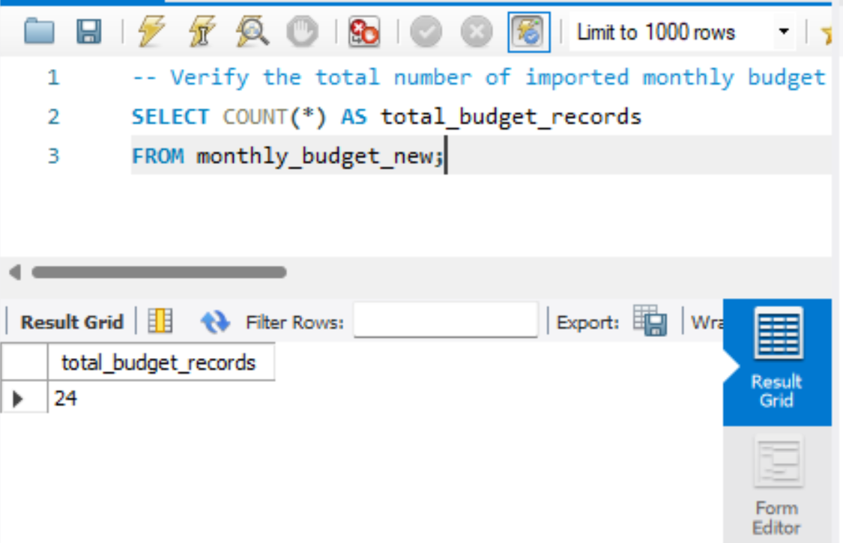

7. DATABASE DESIGN AND DATA MODEL
The database financial_performance_db stores transaction and budget information in separate tables. The transaction table supports detailed analysis, while monthly_budget_new stores monthly planning values.

7.1 Transaction Table
Primary identifier: transaction_id. Amounts use a decimal numeric type to preserve currency precision. Transaction date is stored as DATE for reliable grouping.

7.2 Budget Table
The budget table includes month, revenue_target_inr, expense_budget_inr and the derived month_date field. The table should contain one unique record for each month.

7.3 Power BI Relationship Guidance
The Power BI Model View displays the relationship between the transactions and monthly_budget tables. It shows the table structure, relationship cardinality, and cross-filter direction used in the financial performance analysis.

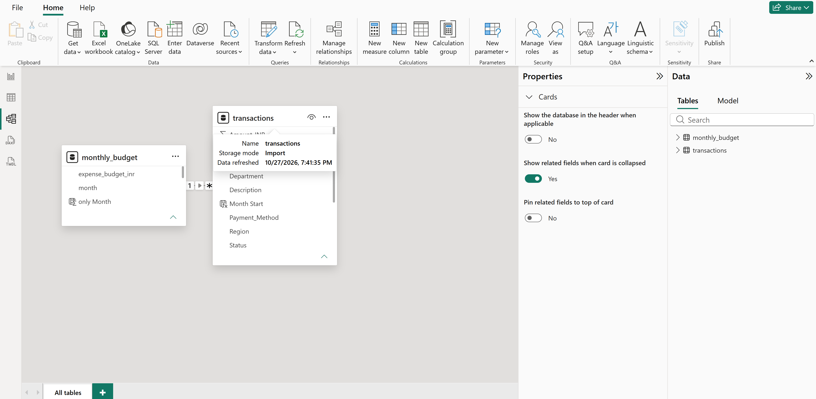

8. DATA QUALITY AND VALIDATION
Data validation ensures that the imported records can be used safely for analysis. Import completion alone does not guarantee data quality.
- Record count check: transactions = 600; monthly budget = 24.
- Primary-key check: transaction_id should be unique and not null.
- Date check: transaction_date and month_date should be valid date values.
- Numeric check: amount_inr, revenue_target_inr and expense_budget_inr should be numeric.
- Category check: transaction_type, status, region and category values should be consistent.
- Aggregation check: compare SQL totals with Power BI after applying identical filters.

8.1 Known Validation Output
Validation Measure | Recorded Result
Transaction rows | 600
Transaction revenue / amount measure | ₹6,920,303.71
Transaction expenses | ₹2,307,912.90
Difference | ₹4,612,390.81
Monthly budget rows | 24

The difference is calculated as the reported transaction revenue measure less reported expenses. Confirm the exact transaction_type and status filters in the final SQL script before describing this as net profit.

9. SQL ANALYSIS AND QUERY EVIDENCE
The following query templates use the project table names and fields documented during development. If the physical transaction table is named differently in MySQL, replace transactions with the exact table name shown in the schema. Each query includes a short comment describing its purpose.

9.1 Verify Transaction Count
-- Count transaction rows to confirm that the CSV import completed.
SELECT COUNT(*) AS total_records
FROM transactions;
Recorded output: 600 rows.

9.2 Revenue and Expense Summary
-- Summarize transaction amounts by transaction type.
SELECT transaction_type,
SUM(amount_inr) AS total_amount
FROM transactions
GROUP BY transaction_type
ORDER BY transaction_type;
Known project summary: revenue / amount measure ₹6,920,303.71; expenses ₹2,307,912.90. Insert the exact grouped query output screenshot so the type labels and filters are visible.

9.3 Transaction Summary Totals
-- Calculate revenue, expenses and their difference from transaction records.
SELECT
SUM(CASE WHEN transaction_type = 'Revenue' THEN amount_inr ELSE 0 END) AS total_revenue,
SUM(CASE WHEN transaction_type = 'Expense' THEN amount_inr ELSE 0 END) AS total_expenses,
SUM(CASE WHEN transaction_type = 'Revenue' THEN amount_inr ELSE 0 END)
- SUM(CASE WHEN transaction_type = 'Expense' THEN amount_inr ELSE 0 END) AS net_difference
FROM transactions;
Expected figures based on the saved project validation: ₹6,920,303.71; ₹2,307,912.90; ₹4,612,390.81. If your final type labels differ in spelling/capitalization, adjust the CASE values to match the actual data.

SQL transaction summary output
The SQL query was executed in MySQL Workbench to validate the transaction records and calculate total revenue, total expenses, and net profit. The query also verifies the total number of transaction records and monthly budget records.

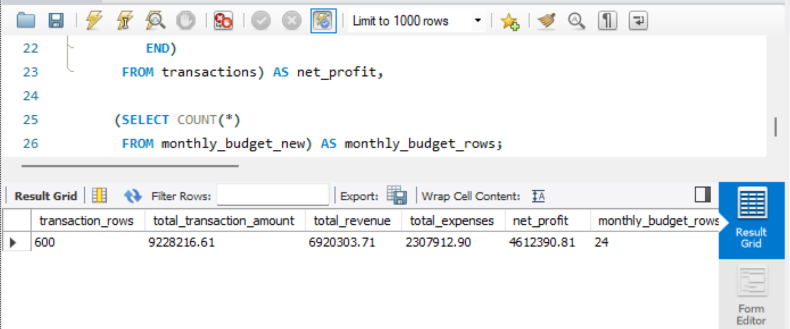

9.4 Annual Budget Summary
-- Calculate annual revenue target, expense budget and expected profit.
SELECT YEAR(month_date) AS budget_year,
SUM(revenue_target_inr) AS revenue_target,
SUM(expense_budget_inr) AS expense_budget,
SUM(revenue_target_inr - expense_budget_inr) AS expected_profit
FROM monthly_budget_new
GROUP BY YEAR(month_date)
ORDER BY budget_year;
Recorded annual outputs are shown in Section 12. Insert the final query result screenshot below.

Annual budget SQL output
The annual budget analysis summarizes the revenue targets, expense budgets, expected profit, and profit margins for 2024 and 2025. The results help compare yearly financial performance and identify changes in expected profitability.

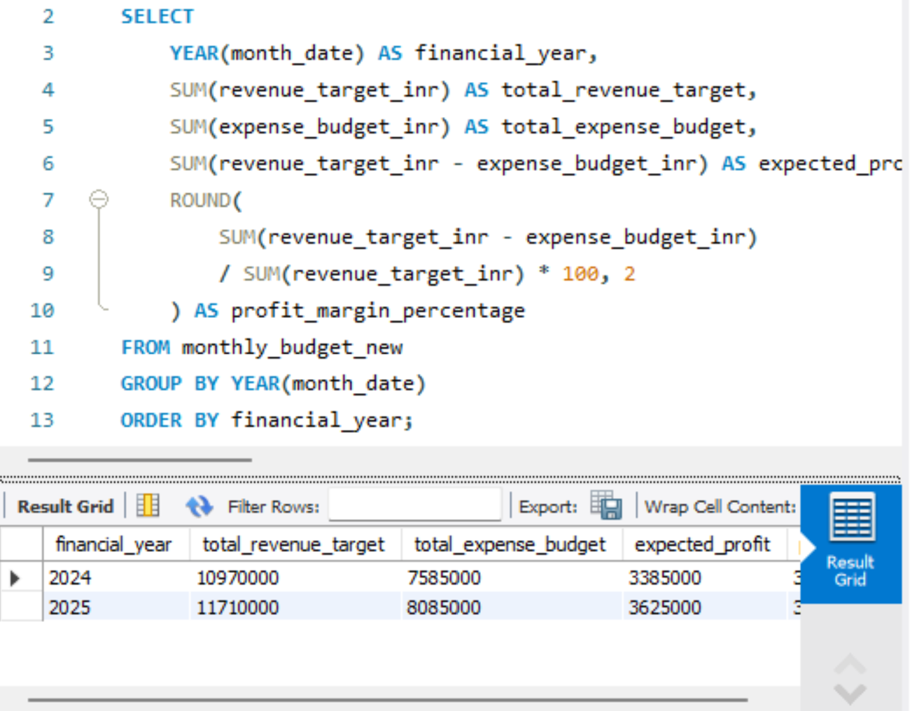

9.5 Monthly Profit and Margin
-- Calculate monthly expected profit and planned profit margin.
SELECT month_date,
revenue_target_inr,
expense_budget_inr,
revenue_target_inr - expense_budget_inr AS expected_profit,
ROUND((revenue_target_inr - expense_budget_inr)
/ NULLIF(revenue_target_inr, 0) * 100, 2) AS profit_margin_pct
FROM monthly_budget_new
ORDER BY month_date;
Use the full 24-row output to verify monthly trends and identify the highest and lowest planned margin months.

Monthly budget SQL output

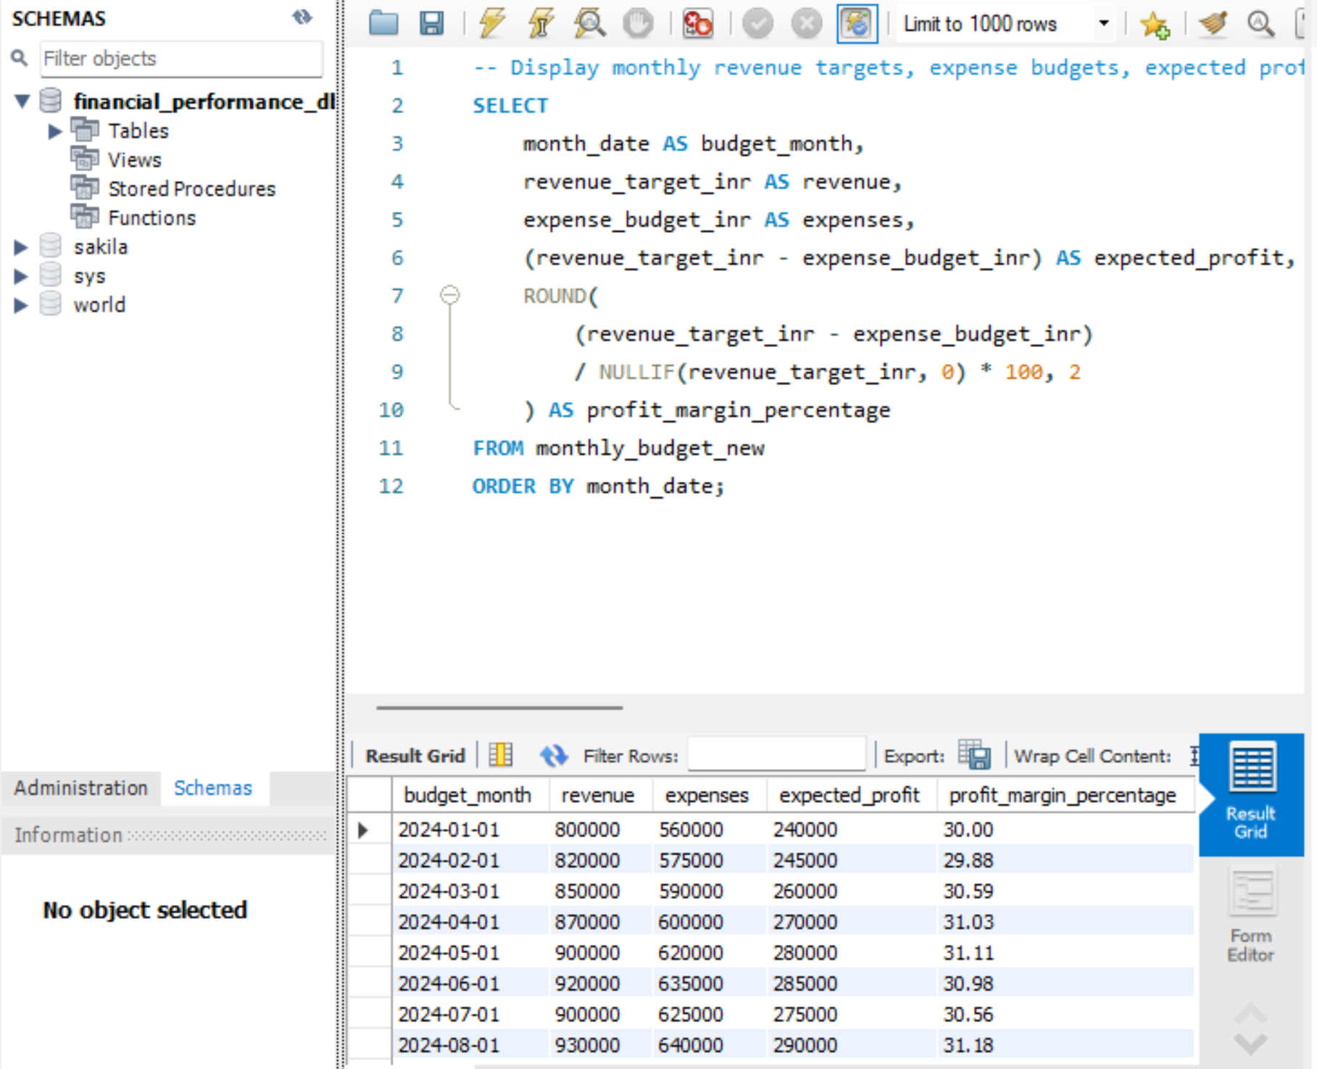

10. FINANCIAL KPIS AND DEFINITIONS
KPI | Definition | Interpretation
Total Revenue | Sum of transaction amounts classified as revenue | Recorded transaction inflow
Total Expenses | Sum of transaction amounts classified as expense | Recorded transaction outflow
Net Profit / Difference | Revenue minus expenses | Use only after confirming transaction definitions
Expected Profit | Revenue target minus expense budget | Planned financial result
Profit Margin % | Profit ÷ revenue × 100 | Share of revenue remaining as profit
YoY Growth % | (Current year − prior year) ÷ prior year × 100 | Annual change in planned value

The dashboard's KPI cards should use consistent definitions. Actual transaction KPIs must be labelled as actual/recorded values, while budget-derived KPIs should be labelled as target, budget or expected values.

10.1 Example Calculation
2024 expected profit = ₹10,970,000 − ₹7,585,000 = ₹3,385,000. Planned profit margin = ₹3,385,000 ÷ ₹10,970,000 × 100 = 30.86%.
2025 expected profit = ₹11,710,000 − ₹8,085,000 = ₹3,625,000. Planned profit margin = ₹3,625,000 ÷ ₹11,710,000 × 100 = 30.96%.

11. TRANSACTION-LEVEL RESULTS
The transaction-level SQL validation output provides a summary of the imported 600 records.
Measure | Value
Transaction records | 600
Total revenue / amount measure | ₹6,920,303.71
Total expenses | ₹2,307,912.90
Calculated difference | ₹4,612,390.81

The calculated difference is not automatically an audited net profit. The analyst must verify transaction classification, transaction status, refunds, reversals and any excluded records. This is particularly important because the dashboard includes a Status slicer.

11.1 Recommended Analysis Dimensions
- Month and year
- Region
- Department
- Category
- Payment method
- Transaction status

Transaction analysis by region or department
The department-wise expense analysis compares total expenses across different departments. It helps identify which departments contribute most to the organization's overall expenditure and supports better cost-control decisions.

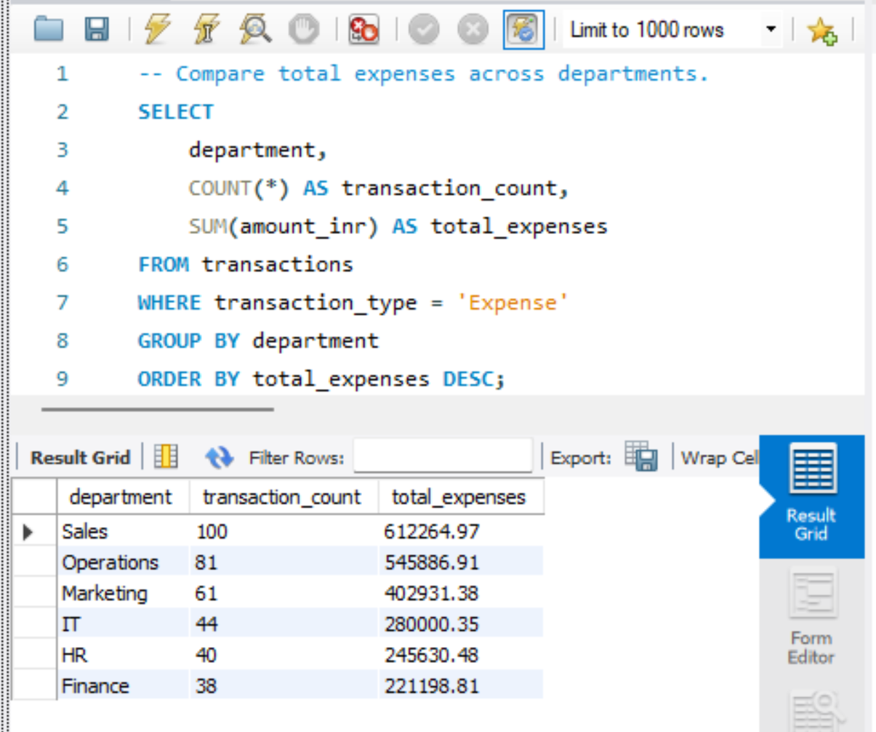

12. MONTHLY BUDGET AND ANNUAL ANALYSIS
Year | Revenue Target | Expense Budget | Expected Profit
2024 | ₹10,970,000 | ₹7,585,000 | ₹3,385,000
2025 | ₹11,710,000 | ₹8,085,000 | ₹3,625,000
Combined | ₹22,680,000 | ₹15,670,000 | ₹7,010,000

12.1 Year-over-Year Change
Measure | Absolute Change | Growth
Revenue target | +₹740,000 | 6.74%
Expense budget | +₹500,000 | 6.59%
Expected profit | +₹240,000 | 7.09%

The budget plan indicates that revenue target, expense budget and expected profit all rise in 2025. Expected profit grows at a slightly higher percentage than the revenue target.

12.2 Planned Profit Margin
Year | Expected Profit | Revenue Target | Margin
2024 | ₹3,385,000 | ₹10,970,000 | 30.86%
2025 | ₹3,625,000 | ₹11,710,000 | 30.96%

The planned margin improves by approximately 0.10 percentage points. This is a modest change in the plan, not proof of realized margin improvement.

Annual budget comparison chart

The annual budget comparison visual presents the revenue targets and expense budgets for 2024 and 2025. It helps compare year-wise financial performance and understand changes in planned revenue and expenditure.

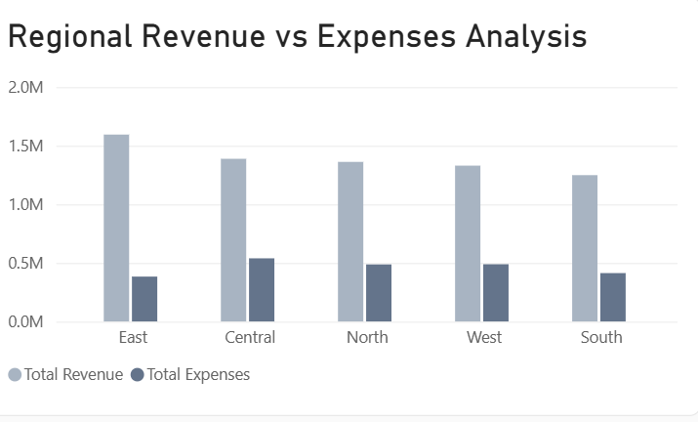

13. POWER BI DASHBOARD OVERVIEW
The supplied Power BI dashboard uses a white background, navy/blue-grey visual styling, light borders and a compact layout. The report title is FINANCIAL PERFORMANCE ANALYTICS. The dashboard includes four KPI cards, slicers and multiple chart types.
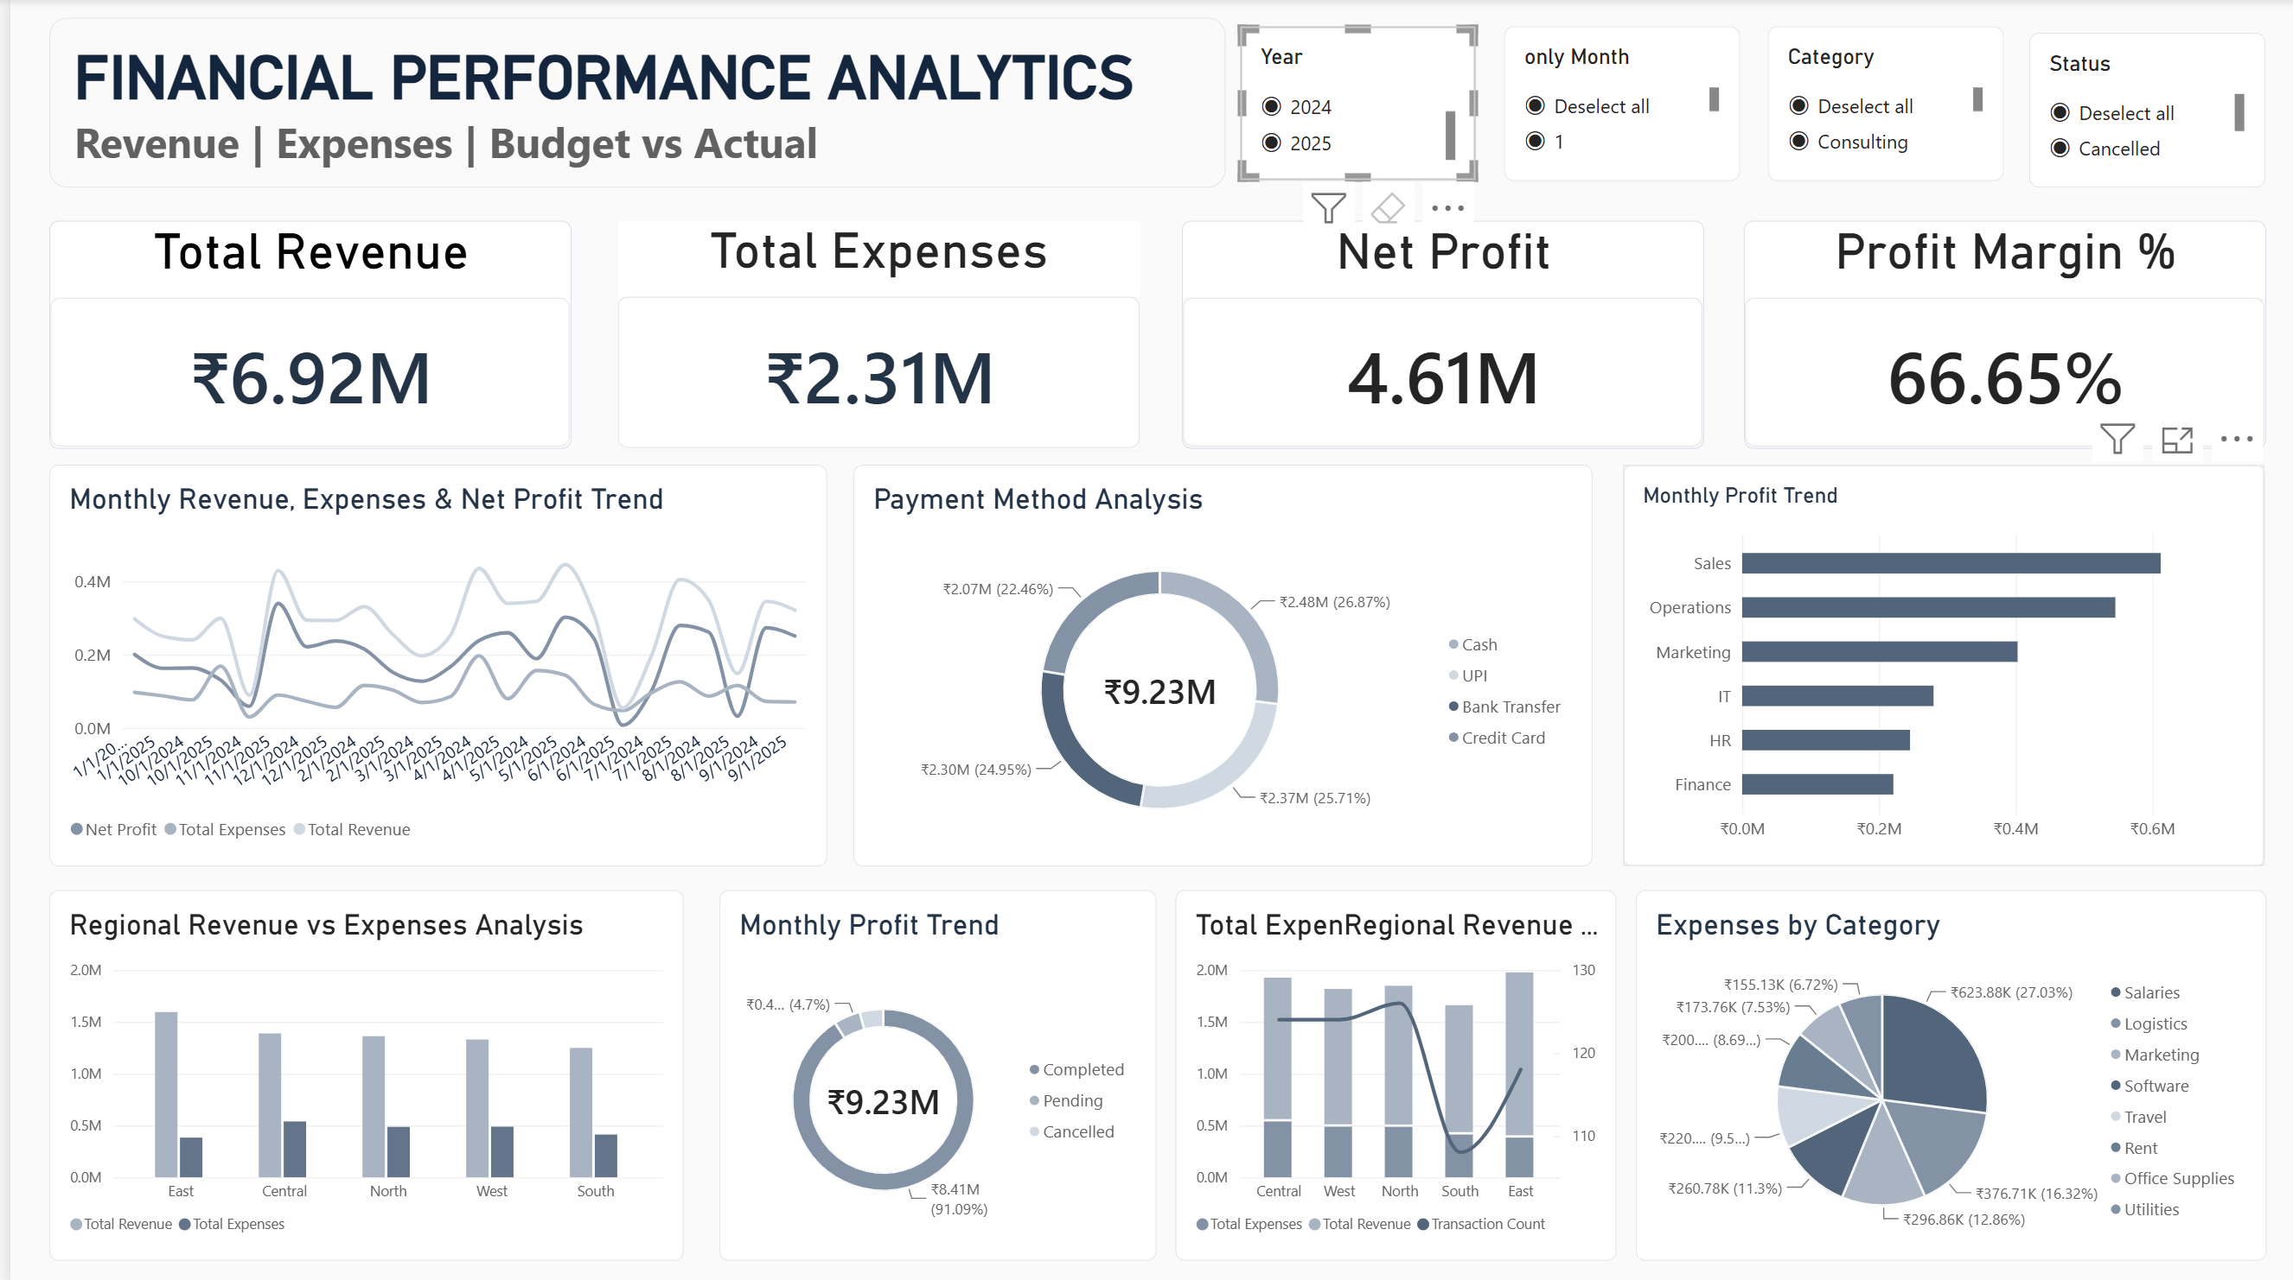
Figure 1. User-provided Financial Performance Analytics dashboard screenshot.

13.1 Slicers Visible in the Screenshot
Slicer | Visible Selection
Year | 2024
only Month | 1
Category | Consulting
Status | Cancelled

The screenshot appears to show these slicer selections. The KPI cards therefore represent the current filter context rather than the unfiltered full dataset. Confirm the exact selection state in Power BI before final submission.

13.2 KPI Cards Visible
KPI Card | Displayed Value
Total Revenue | ₹3.49M
Total Expenses | ₹1.17M
Net Profit | ₹2.32M
Profit Margin % | 66.39%

These values are transcribed from the supplied dashboard image. They are not substituted for the full-dataset SQL totals or the annual budget targets.

14. DASHBOARD VISUAL ANALYSIS
Dashboard Visual | What it Communicates | Evidence / Notes
Monthly Revenue, Expenses & Net Profit Trend | Monthly movement of three financial measures | Line chart; check month sorting and consistent measure definitions.
Payment Method Analysis | Share or amount by payment method | Donut chart; visible categories include Bank Transfer, Cash, Credit Card and UPI.
Monthly Profit Trend (department bars) | Department comparison in the screenshot | The displayed labels appear to be departments; rename the visual to match the actual axis and value.
Regional Revenue vs Expenses Analysis | Revenue and expense comparison across regions | Clustered columns for South, North, Central, East and West.
Status Analysis | Transaction totals by status | Donut chart with Completed, Pending and Cancelled categories.
Regional Revenue / Expense / Transaction Count | Multiple regional measures | Combo chart; use a title that accurately describes columns and line.
Expenses by Category | Expense distribution by category | Donut chart; category labels include Salaries, Logistics, Marketing, Rent, Travel, Software, Office Supplies and Utilities.

14.1 Visual Naming Corrections
- Use 'Department-wise Financial Amount' if the horizontal bars compare departments, not months.
- Use 'Transaction Status Distribution' for the status donut chart.
- Use 'Regional Revenue, Expenses and Transaction Count' for the regional combo chart.
- Keep 'Expenses by Category' only if the measure is filtered to expense transactions.
- Check that the monthly trend line chart uses a proper month-year axis rather than text sorting.
A title should describe the fields actually displayed. If a chart uses department on the axis, it should not be called a monthly profit trend.

15. DASHBOARD FILTER CONTEXT AND KPI INTERPRETATION
The dashboard image shows Year 2024, Month 1, Category Consulting and Status Cancelled selected. This combination can produce a narrow subset of transactions. The four KPI cards in the screenshot are therefore a filtered view.

15.1 Filtered Dashboard Values
Metric | Visible Value
Total Revenue | ₹3.49M
Total Expenses | ₹1.17M
Net Profit | ₹2.32M
Profit Margin | 66.39%

15.2 Full Dataset SQL Values
Metric | Known Validation Value
Revenue / amount measure | ₹6,920,303.71
Expenses | ₹2,307,912.90
Difference | ₹4,612,390.81
Transaction count | 600

Do not compare the two groups as if they should match: the dashboard screenshot has slicer filters, while the SQL validation values were reported as full-dataset totals. For an exact reconciliation, clear all slicers and apply identical transaction type and status rules in both SQL and Power BI.

15.3 Screenshot Evidence

KPI cards

The four KPI cards present the overall financial performance of the dataset, including total revenue, total expenses, expected profit, and profit margin. All four slicers—Year, Month, Category, and Status—were cleared before capturing the dashboard to ensure that the displayed KPIs represent the unfiltered dataset.

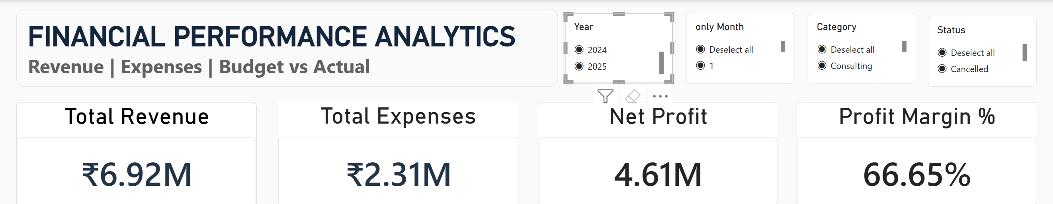

16. KEY FINDINGS AND INTERPRETATION
- The transaction table contains 600 imported records.
- The saved SQL validation totals are ₹6.92M for revenue/amount, ₹2.31M for expenses and ₹4.61M calculated difference.
- The budget dataset contains 24 monthly records across two years.
- Planned revenue target increases by 6.74% from 2024 to 2025.
- Planned expense budget increases by 6.59%.
- Expected profit increases by 7.09%, from ₹3.385M to ₹3.625M.
- Planned profit margin increases slightly from 30.86% to 30.96%.
- The supplied dashboard screenshot demonstrates slicer-based analysis and multiple visual types.
The overall interpretation is that the 2025 plan projects growth in revenue and expected profit while also allowing for a higher expense budget. Transaction-level results provide a separate view of recorded activity. A complete actual-versus-budget performance assessment requires matching actual monthly revenue and expenses with the corresponding budget months.

17. BUSINESS RECOMMENDATIONS
- Monitor actual revenue against the monthly revenue target.
- Track expenses against the monthly expense budget and investigate unfavorable variances.
- Review departments and categories with the highest expense values.
- Use status filters consistently so cancelled or reversed records are treated correctly.
- Create an actual-versus-budget variance page in Power BI.
- Use a calendar dimension to make month and year filtering reliable.
- Add tooltips showing exact values and definitions for each KPI.
- Document every measure and SQL filter so the report can be reproduced.

17.1 Variance Metrics
Revenue variance = Actual Revenue − Revenue Target. Expense variance = Actual Expenses − Expense Budget. Revenue above target is generally favorable; expenses above budget are generally unfavorable. Interpret each variance using the organization's accounting rules.

18. CHALLENGES AND RESOLUTIONS
Challenge | Resolution / Learning
CSV import and wizard issues | Used MySQL Workbench import steps and verified row counts.
Budget month imported as text | Created a normalized DATE column using STR_TO_DATE.
Different field names in Power BI | Checked exact field names before creating DAX expressions.
Transaction and budget data have different grains | Documented the risk of repeated budget values and recommended a calendar model.
Dashboard values change with slicers | Recorded the filter context and separated filtered KPI values from full dataset totals.
Chart titles do not always match axes | Recommended titles based on the actual fields and measures.

19. LIMITATIONS AND DATA GOVERNANCE
- Only the supplied datasets and the dashboard screenshot are considered.
- The transaction data has not been independently audited.
- Budget targets are not actual revenue or expenses.
- The dashboard screenshot is filtered and does not show an unfiltered full-dataset view.
- Detailed numeric values for each payment method, department, region and category were not available in the saved project notes; they should be taken from final Power BI or SQL outputs, not estimated.
- One-to-many relationships can duplicate monthly budget values if the data model is not designed carefully.
Privacy and governance: avoid including real customer names, email addresses or sensitive transaction descriptions in public screenshots or the GitHub repository. Mask confidential fields before sharing the project.

20. FUTURE ENHANCEMENTS
- Create a dedicated Calendar table and consistent month key.
- Build actual-versus-budget revenue and expense variance measures.
- Add drill-through pages for department, region and category.
- Add a reconciliation page showing SQL totals beside Power BI totals.
- Automate refresh from the database when new monthly records are added.
- Add anomaly detection after a longer history is available.
- Introduce forecasting only after sufficient historical actual data is collected.
- Publish a data dictionary, SQL scripts, dashboard screenshots and methodology in GitHub.

21. CONCLUSION
The Financial Performance Analysis project demonstrates how MySQL, SQL and Power BI can be combined to transform structured financial files into validated metrics and a dashboard. The project imported 600 transaction records and 24 monthly budget records, normalized budget dates, calculated transaction summaries and compared planned financial performance across 2024 and 2025.
The saved SQL validation results show ₹6.92M in revenue/amount, ₹2.31M in expenses and ₹4.61M calculated difference. The budget analysis shows expected profit of ₹3.385M for 2024 and ₹3.625M for 2025. The supplied dashboard image shows a filtered view with revenue ₹3.49M, expenses ₹1.17M, net profit ₹2.32M and profit margin 66.39%. These filtered dashboard values are kept separate from full-dataset SQL results.
The project emphasizes that accurate financial reporting depends on data quality, correct aggregation grain, clear KPI definitions and transparent filter context. The next improvement should be a robust Calendar-based model and a dedicated actual-versus-budget variance analysis page.

APPENDIX A: SQL QUERY AND OUTPUT EVIDENCE
Paste each SQL query into MySQL Workbench, run it, and capture both the query and result grid. The query snippets below are templates aligned with the project schema. Verify exact table and field names before running.

A.1 Record Count
-- Verify the number of transaction rows imported.
SELECT COUNT(*) AS total_records FROM transactions;
Recorded result: 600.

A.2 Transaction Type Totals
-- CALCULATE THE TRANSACTION AMOUNT TOTAL FOR EACH TRANSACTION TYPE.
SELECT TRANSACTION_TYPE, SUM(AMOUNT_INR) AS TOTAL_AMOUNT
FROM TRANSACTIONS GROUP BY TRANSACTION_TYPE;
INSERT OUTPUT SCREENSHOT: SCREENSHOT 3.

A.3 Annual Budget Summary
-- Summarize annual revenue target, expense budget and expected profit.
SELECT YEAR(month_date) AS budget_year,
SUM(revenue_target_inr) AS revenue_target,
SUM(expense_budget_inr) AS expense_budget,
SUM(revenue_target_inr-expense_budget_inr) AS expected_profit
FROM monthly_budget_new GROUP BY YEAR(month_date)
ORDER BY budget_year;
Recorded results: 2024 = ₹10,970,000 revenue target, ₹7,585,000 expense budget, ₹3,385,000 expected profit. 2025 = ₹11,710,000, ₹8,085,000 and ₹3,625,000.

A.4 Monthly Profit Margin
-- Calculate monthly expected profit and planned profit margin.
SELECT month_date, revenue_target_inr, expense_budget_inr,
revenue_target_inr-expense_budget_inr AS expected_profit,
ROUND((revenue_target_inr-expense_budget_inr)/NULLIF(revenue_target_inr,0)*100,2) AS margin_pct
FROM monthly_budget_new ORDER BY month_date;
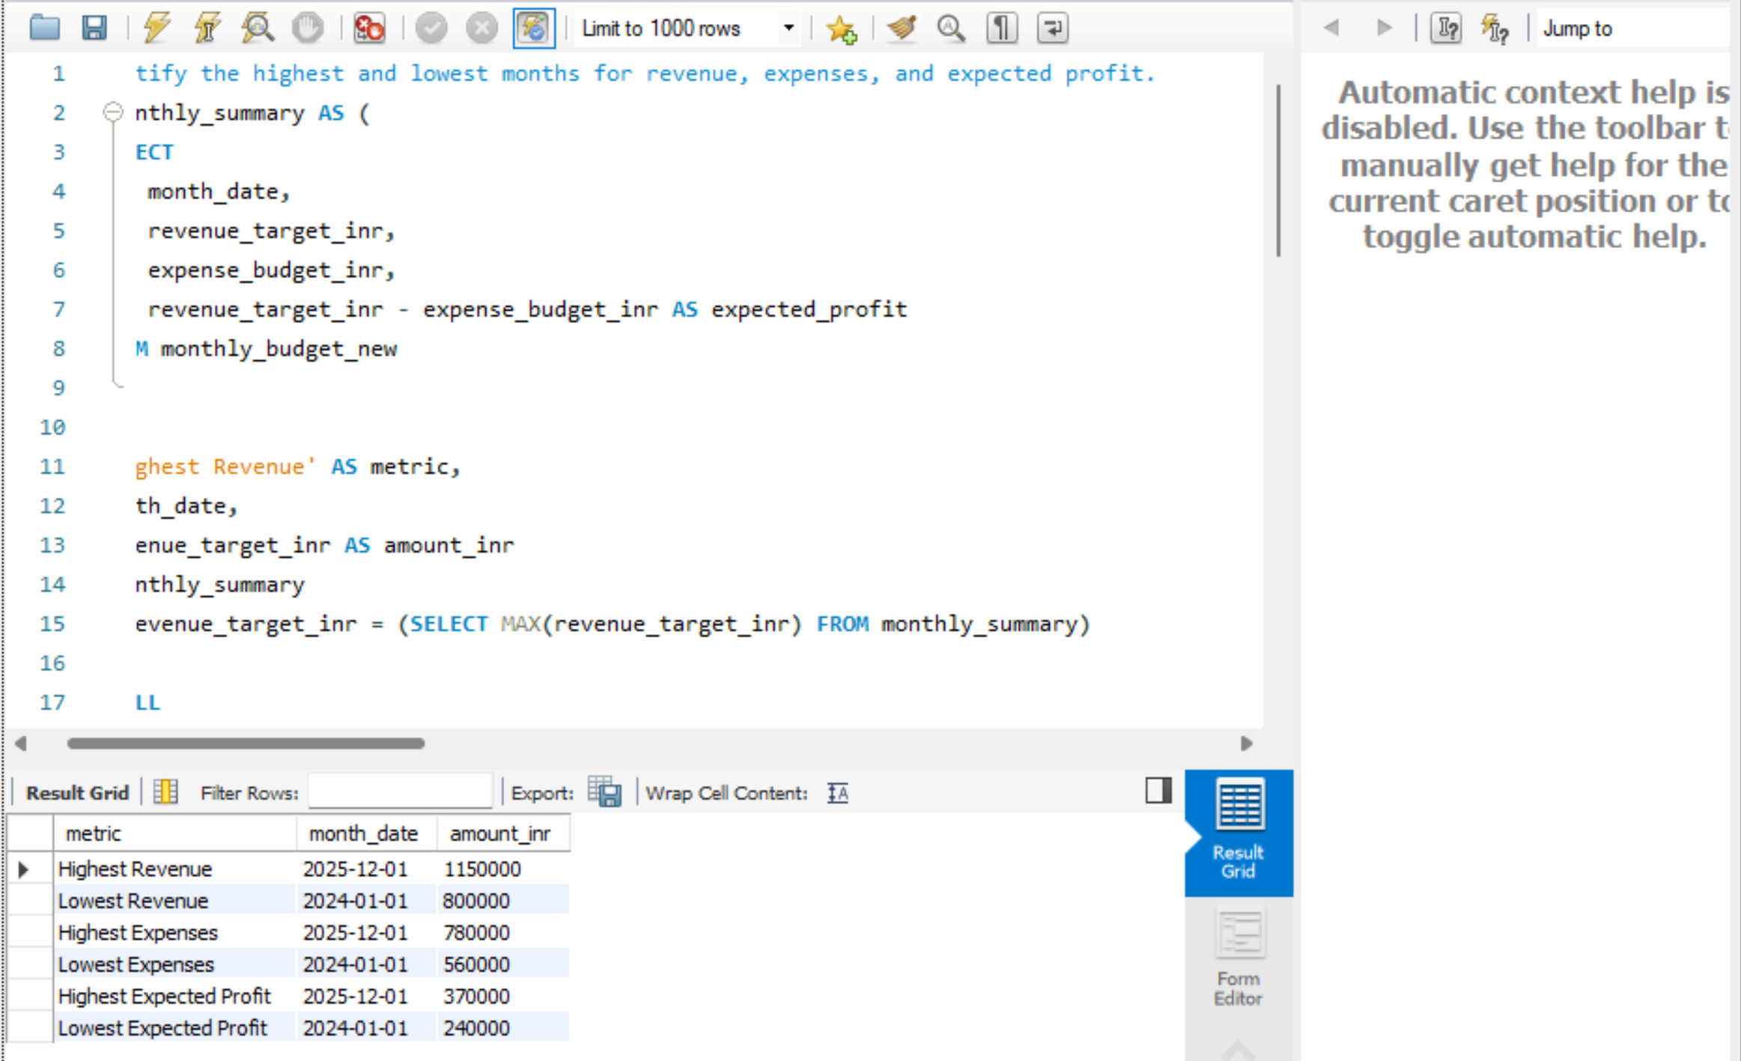

Appendix B: Exact Screenshot Placement Guide
No. | Screenshot to Capture | Where to Place It
1 | MySQL table row counts (600 and 24) | Section 6.2 / after import steps
2 | Power BI Model view with relationships | Section 7.3
3 | SQL transaction summary query + result grid | Section 9.3
4 | SQL annual budget query + result grid | Section 9.4
5 | SQL monthly profit/margin query + result grid | Section 9.5
6 | Region or department analysis output | Section 11.1
7 | Power BI annual budget comparison chart | Section 12.2
8 | Unfiltered KPI cards with all slicers cleared | Section 15.3
9 | Filtered KPI cards with slicer selections visible | Section 15.3
10 | Full dashboard screenshot (provided image) | Section 13 — already inserted

For SQL screenshots, keep the query text and result grid visible together. For Power BI screenshots, include the visual title, axis labels, legend and filter selections. Avoid cropped images where values or slicers cannot be read.

APPENDIX C: FINAL VERIFICATION CHECKLIST
- Check all SQL table names and column names against MySQL Workbench.
- Re-run transaction summary queries and confirm the displayed values.
- Re-run the annual and monthly budget queries.
- Clear all Power BI slicers and compare dashboard totals with SQL using identical filters.
- Verify that budget values are not duplicated by transaction-level relationships.
- Add the missing SQL result screenshots at the marked positions.
- Add the final dashboard screenshot and any additional visual screenshots.
- Fill in student, institution, course and guide details on the cover.
- Check the final Word page breaks and table formatting before submission.
- Commit the final report and evidence screenshots to the GitHub repository.
End of Report

