I have observed below trends after aggregating the data at different levels.

1. Small Size schools have more passing percentage when compared with Large Size schools.

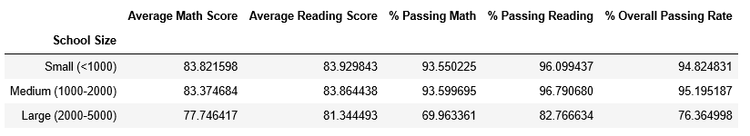

1. Charted Schools have more passing percentage then District Schools

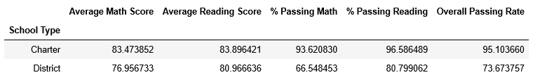

1. Overall Math Pass percentage is less than Reading Pass percentage



1. Charted Schools are top performance schools than District Schools.

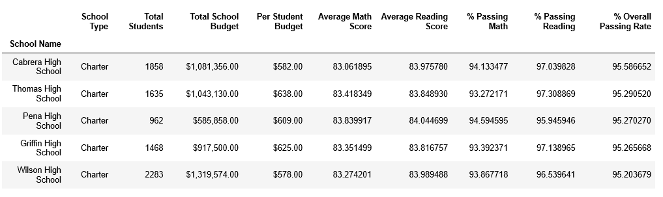

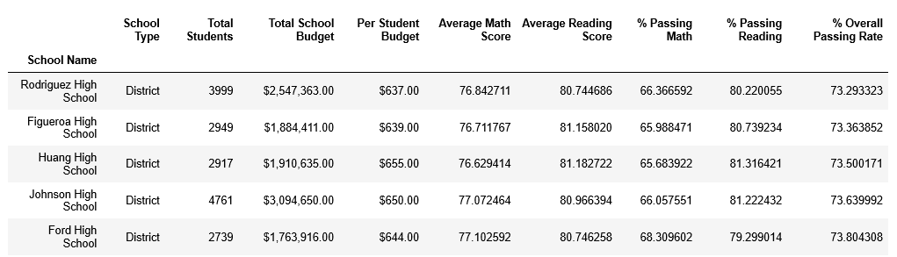

1. In Every Grade, reading score is more than Math score.

Math Score

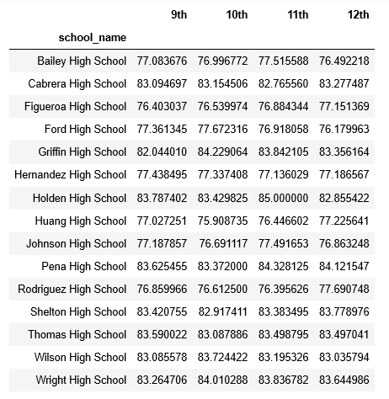

Reading Score

