ICEM MINI PROJECT

Group - 5

**Group Members :**

Adarsh Kumar Singh - 23CE10005 Vikash Siyak - 23CE10085

Priyanshu Verma - 23CE10045 Karthikk Kalluri - 23CE10025

Shashank Sahil - 23CE10065 RohitKumar Ramnaresh Meena – 23CE10055

Surbhi – 22CE10081

RESIDENTIAL COMPLEX

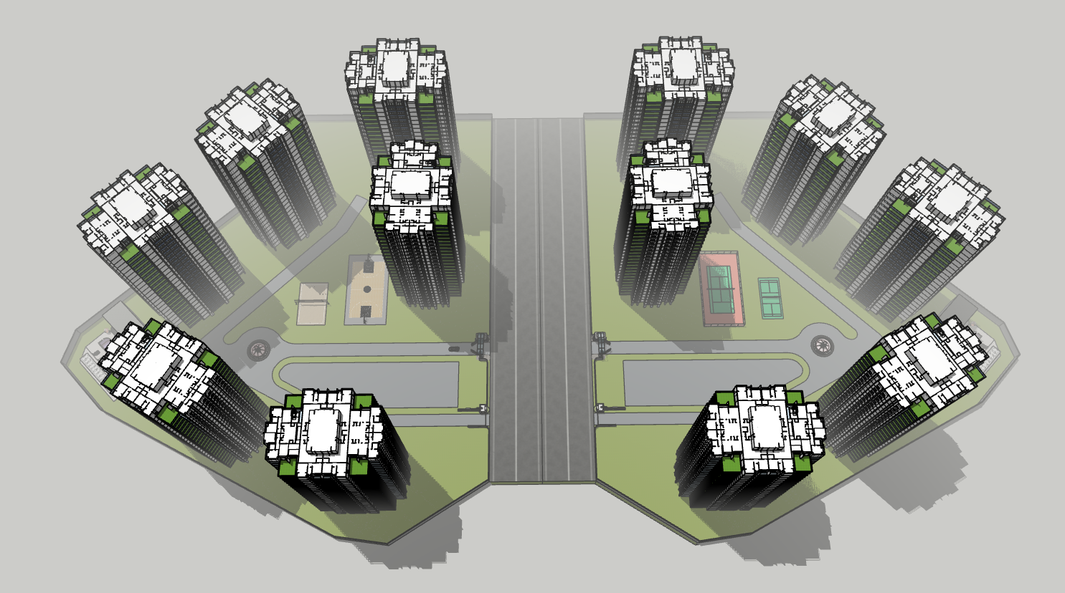

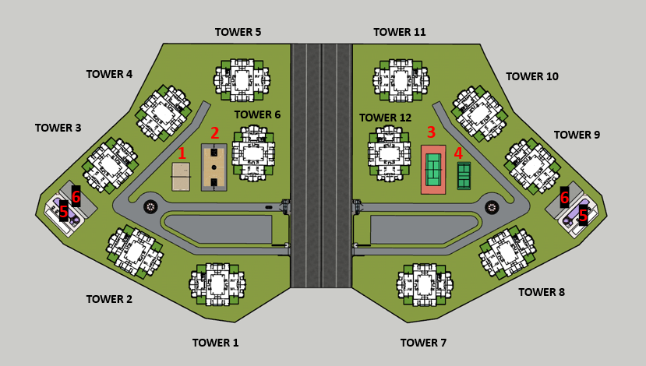

**Number of Towers**: 12, each with Ground + 24 floors.

1. Volley Ball Court 5. Swimming Pool
2. Basket Ball Court 6. Club House with
3. Tennis Court, Gym, Indoor games, 4. Badminton Court, Library and Movie

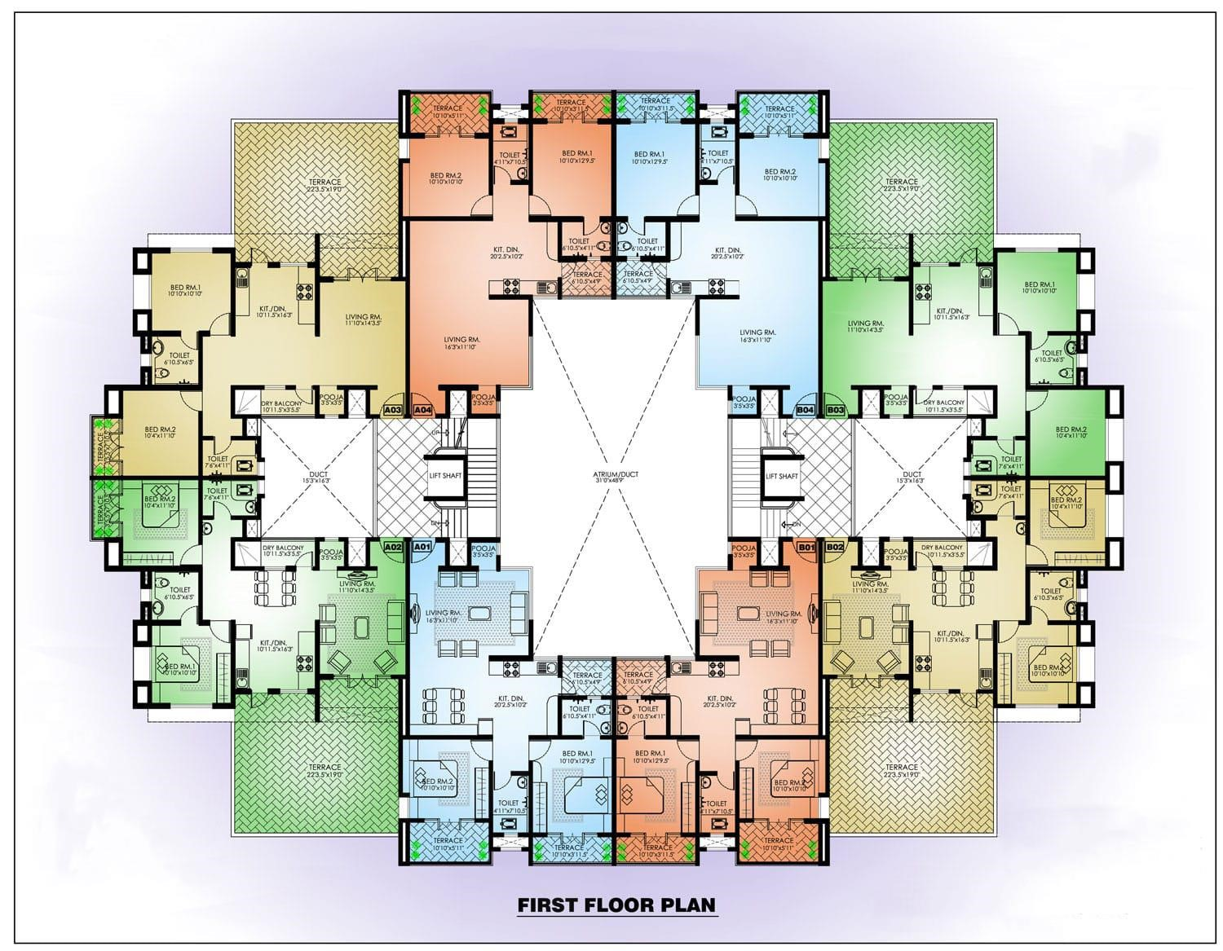

**1ST Floor Layout:-**

* **Apartments per Floor**:
* 8 apartments in a mix of 2BHK and 3BHK units.
  + 2BHK Units: 2 or 3 units per floor
  + 3BHK Units: 6 or 5 units per floor
* **Staircases and Lifts**:
  + **Staircases**: 2 staircases in each tower for emergency exits.
  + **Lifts**:
    - Three lifts per tower, with different capacities for efficient traffic flow.
      * Lift 1: 13-passenger capacity (high-capacity for peak times)
      * Lift 2: 10-passenger capacity
      * Lift 3: 8-passenger capacity

**Club House and Amenities:-**

* **Swimming Pool**: Designed for both recreational and lap swimming, with ample deck space and seating.
* **Gymnasium**: Equipped with modern cardio machines, weight training equipment, yoga/aerobics space.
* **Indoor Games Area**:
  + Carrom boards
  + Table Tennis tables
  + Billiards table
* **Library**: Quiet reading space with comfortable seating, a selection of books, and work desks.
* **Office Rooms**: Three office spaces for meetings, community management, and administrative functions.

**Parking Solutions:-**

* **Parking:** To optimize space, a multi-level parking tower is recommended, as it maximizes parking capacity without occupying open spaces.
  + Alternatively, a combination of open parking and basement parking could be considered if space permits.

**Sports and Recreation Facilities:-**

* **Playgrounds**:
  + **Badminton Court**: One or two courts, depending on space availability.
  + **Basketball Court**: Standard half-court or full-court based on resident needs.
  + **Volleyball Court**: Sand or hard court option.
  + **Tennis Court**: Full-sized court for recreational and competitive play.
* **Gardening and Green Spaces**:
  + Dedicated gardening spaces with flowers, shrubs, and seasonal plants.
  + Community garden areas where residents can grow herbs or plants for relaxation and leisure.