Project report
on
Market Analysis on Electric Vehicles in india

Vikash Singh

Background
Electric vehicles (EVs) are swiftly transforming the automotive landscape. These eco-friendly vehicles produce zero carbon emissions, reducing environmental impact and combatting climate change. Beyond the environmental benefits, EVs also offer economic advantages. Although their upfront costs can be higher, lower operational and maintenance expenses, combined with government incentives, make them cost-effective in the long run. EV sales in India increases 174% YoY to 12,47,120 units in FY23.

Breakdown of problem Statement

There are mainly two problems statements on which we need to work on-
1. What Type of Electric vehicle company will manufacture?
2. What type of customer we need to target for sell?

Data Sources
- State-wise Charging Stations in india, PIB Delhi, Ministry of Heavy Industries
- People Earning Data, kaggle
- State-wise Subsidy on Electric Vehicles, bankbazaar.com
- Electric vehicles sales data CY2023, autocarpro.in
- State-wise electricity generation data, Wikipedia
- State-wise petrol Fuel price data, NDTV
- State-wise Per capita income, PIB Delhi, Ministry of Statistics & Programme Implementation
- Vehicle registration in indian-cities 2014-18,Open city Urban data portal

Exploratory Data Analysis
Libraries used for EDA are Pandas,Seaborn and Matplotlib.
EDA on first problem statement- What Type of Electric vehicle company will manufacture?

For solving the first problem, I have used Datasets like State wise per-capita income, Fuel prices, Electricity generation, Subsidy on electric vehicles. I combined all these datasets in one and then start EDA.
First I start visualize the State-wise per-capita income with only main Fourteen states

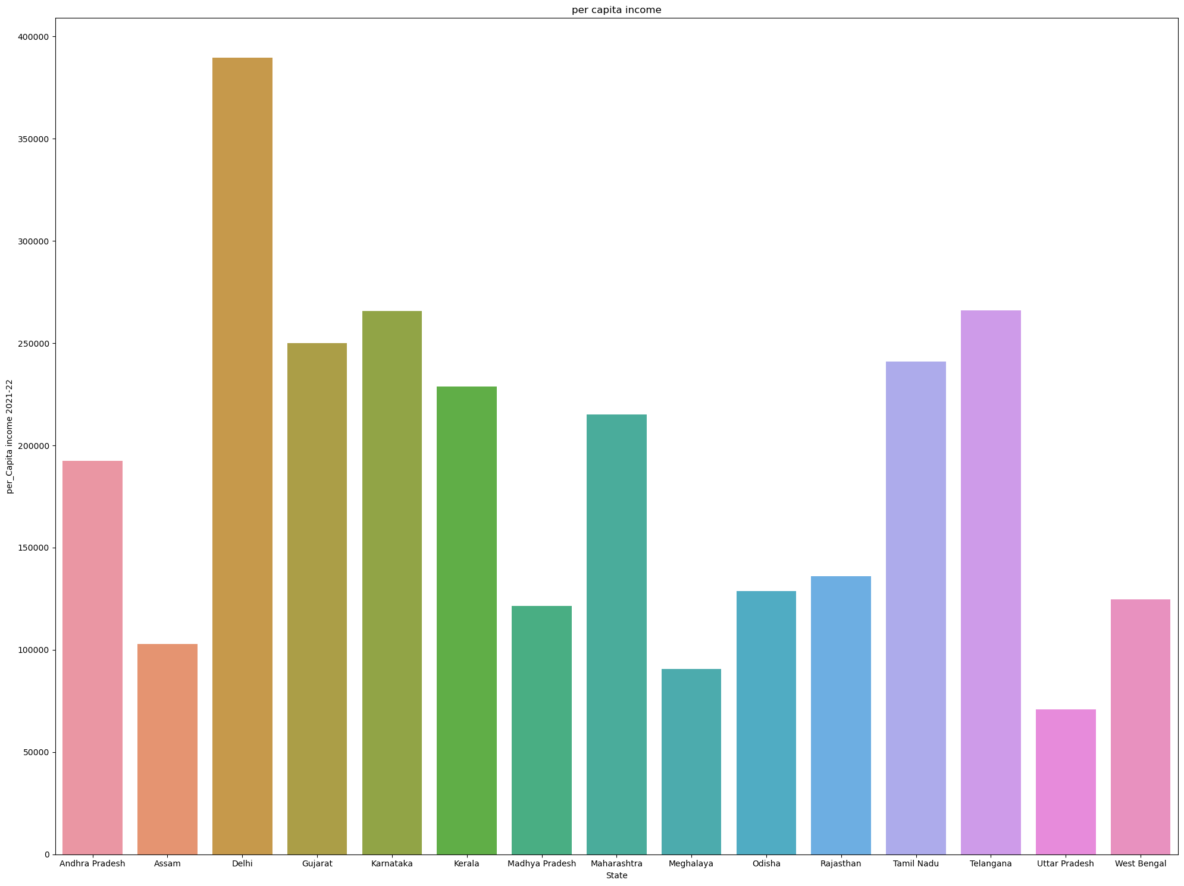
State-wise Per-capita income

State-wise per-capita income - Fuel prices.

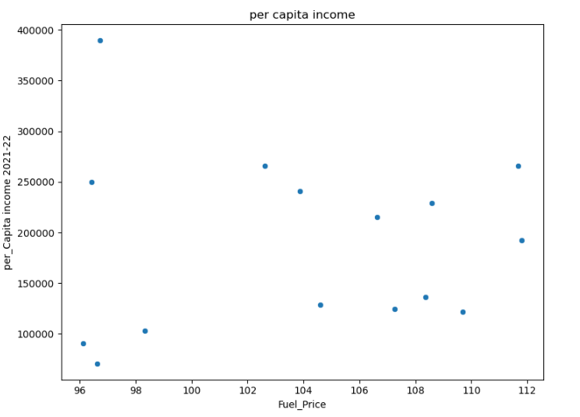
We can see that some of the states has higher fuel prices per litres. Suppose a state with Rs 2.5 lakh per capita income means Rs 2.5 lakh yearly, So average monthly income is around Rs 21000 and fuel prices on an average is Rs 100.

State-wise Electricity generation
In each states, there are installed capacity, Installed Capacity means the amount of electricity that a power station can produce when it’s running at full blast. This maximum amount of power is typically measured in megawatts (MW) or kilowatts and helps utilities project just how big of an electricity load a generator can handle.
So state-wise electricity installed capacity can tell us good idea about electricity presence in Indian states.

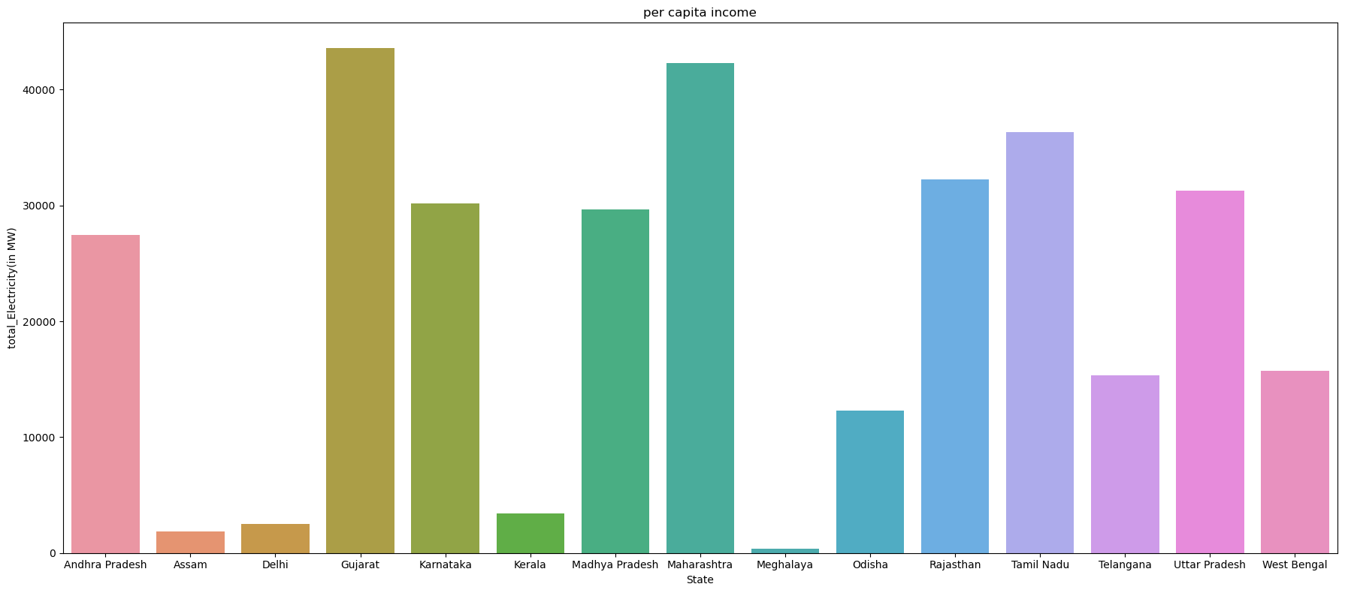
State-wise Electricity Generation in Installed capacity in MW

Now I have used State-wise Electricity generation + Statewise population data and obtain per -capita Electricity generation (kW/person) by using
Per Capita Electricity Generation (kW/person)=
Total Electricity Generation(MW) in State Installed capacity*1000
Population (people) in State
Installed Capacity means the amount of electricity that a power station can produce when it’s running at full blast. This maximum amount of power is typically measured in megawatts (MW) or kilowatts and helps utilities project just how big of an electricity load a generator can handle.
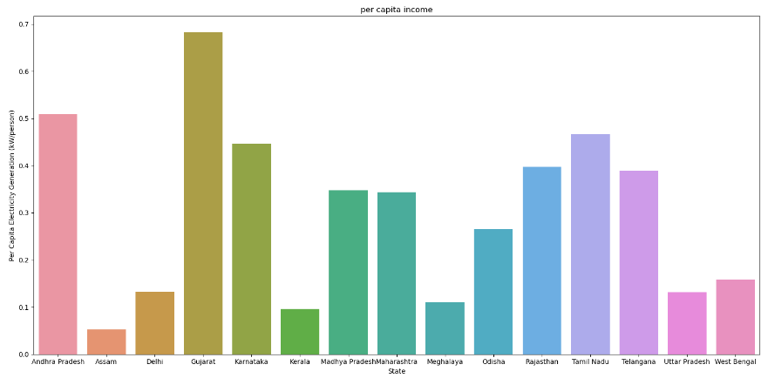
This data kW/person tells us how much kiloWatt electricity is generate for a person
State-wise Per Capita Electricity Generation (kW/person)

As we can see from the Bar graph that max 0.7 kW/person in Gujarat can be generate, or we can on an average 0.5 kwh can be generate in Installed capacity.

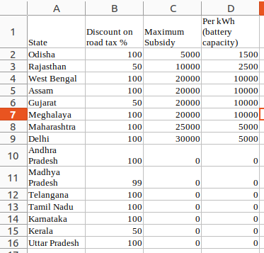

State-wise subsidy table

This table tell us that those States who gives subsidy on EV purchase. As we can understand by this table that some States are giving 100% discount on road tax and some are giving 50%. Some States like Gujarat, Assam etc are also giving subsidy on per kWh (battery capacity).

Conclusion on problem statement
2-Wheeler vehicles is most suitable for company to manufacture because our per-capita incomes are in the range 1 lakh to 3.8 lakh, so major market customers per capita will be in this range.Now as per electricity generation all states has enough capacity installed to fulfill the demands of energy.

Problem statement 2
- What type of customer we need to target for sell?

I have gathered a dataset consists people earning, occupation, age, Education level etc for segment those customers who can definitely purchase the EV. So as we are focusing on 2-wheeler market.
So types 2-wheeler electric vehicles are
1. Electric Scooter
2. Electric Bikes
3 Electric Bicycles

So we will focus on these above electric vehicle market.

Data Pre-processing
Information about used Dataset

RangeIndex: 6704 entries, 0 to 6703
Data columns (total 6 columns):
# Column Non-Null Count Dtype
--- ------ -------------- -----
0 Age 6702 non-null float64
1 Gender 6702 non-null object
2 Education Level 6701 non-null object
3 Job Title 6702 non-null object
4 Years of Experience 6701 non-null float64
5 Salary 6699 non-null float64
dtypes: float64(3), object(3)
memory usage: 314.4+ KB

Salary feature values are in per month.
So there are columns which contain some null values but it very minor. So instead of imputing the null values,we have removed the null values.

Now Let describe the data.

 | Age | Years of Experience | Salary
count | 6698.000000 | 6698.000000 | 6698.000000
mean | 33.623022 | 8.095178 | 115329.253061
std | 7.615784 | 6.060291 | 52789.792507
min | 21.000000 | 0.000000 | 350.000000
25% | 28.000000 | 3.000000 | 70000.000000
50% | 32.000000 | 7.000000 | 115000.000000
75% | 38.000000 | 12.000000 | 160000.000000
max | 62.000000 | 34.000000 | 250000.000000
Correlation between numeric attributes
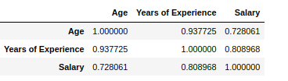

As we can understand from this is, age and Year of experience is very much correlated which is obvious. Salary an year of experience is also very much correlated.

Now we see the distribution of Age and Salary, which tells about what distribution both are actually following. Analyzing the feature distributions helps you understand the inherent structure of your data. We can get some intuition about outliers present in data.

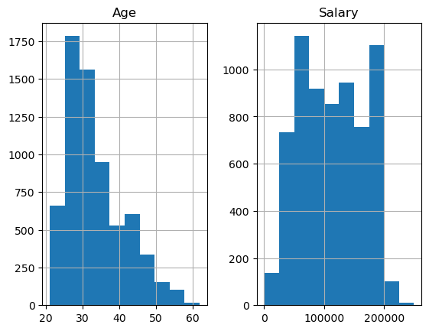

We know that Age follows Normal distribution but as in dataset Age value start from 21 to 62. So it’s look little right skewed. Salary Feature is not in normal distribution.
So some Feature engineering required here.

Data Cleaning
Education level feature contain values with same meaning like
Bachelor's Degree 2267
Master's Degree 1573
PhD 1368
Bachelor's 756
High School 448
Master's 288
phD 1

Here Bachelor’s Degree or Bachelor’s is same and Master’s degree and Master’s is same so I replace the Bachelor’s Degree to Bachelor’s and Bachelors will remain Bachelors, same done with Master’s degree. This pre-processing step will reduce the dummy variables by Education level

Feature Scaling
I will do feature scaling because as we know that K-means clustering uses Distance Based technnique to calculate the similarity between the data points. I have used Standard scaler for scaling the features values.
So we will perform standard scaler on two features Age, salary. I am not scaling year of experience because the Year of experience is very much correlated to Age.

One-hot encoding
Categorical features like Gender, Educational level. One hot encoding technique will be used for encoding these categorical variables. I will not use the ‘job profile’ feature for further process it contain many categorical values which make a huge sparse matrix.

K-means Clustering technique
K-Means clustering is an unsupervised machine learning technique used to partition a dataset into K distinct, non-overlapping clusters.

I am going to use features like Age,Education level, salary and Gender.
I am going use n_cluster hyperparameter as 3 because i want to segment the market for my three 2-wheeler EV.

n_clusters=3

Principal Components Analysis (PCA)
PCA is a dimensionality reduction technique in machine learning and statistics. It identifies the most significant features, or principal components, in a dataset while minimizing information loss. I have used PCA for data visualization, as we know that more than 3-dimensonal data cannot be understand by human eyes.

n_components=2
or
Principal components=2

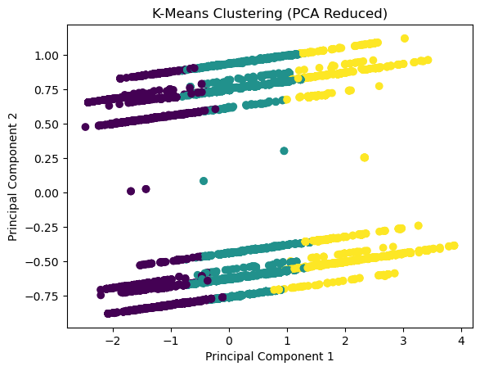

we got silhouette_score=0.27

n_components=3
or
Principal components=3

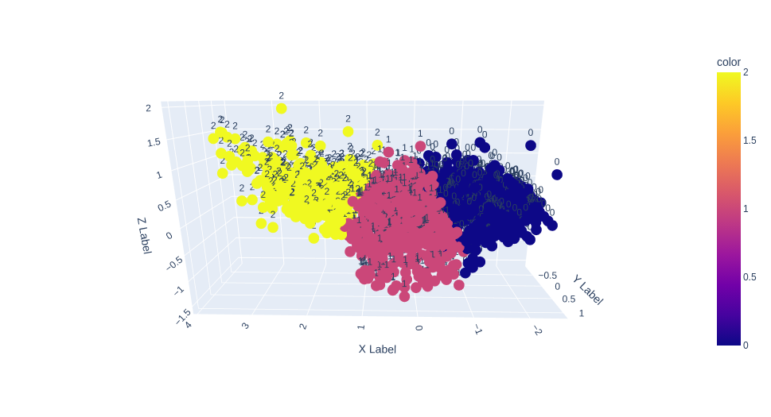
We converted features into 2, 3 principal components but most important feature used for clustering is Age and Salary

silhouette_score:
The silhouette_score is a metric used to evaluate the quality of clusters in unsupervised machine learning. It measures the separation and cohesion of data points within clusters, providing a value between -1 and 1. Higher values indicate better-defined and well-separated clusters, while lower values suggest overlapping or poorly formed clusters.

So we got silhouette_score=0.29

Let we use only Age and Salary feature for performing clustering algorithm because these two features are most important in them all. These tells a lot about a people like it’s income and age . So let make cluster and visualize it.
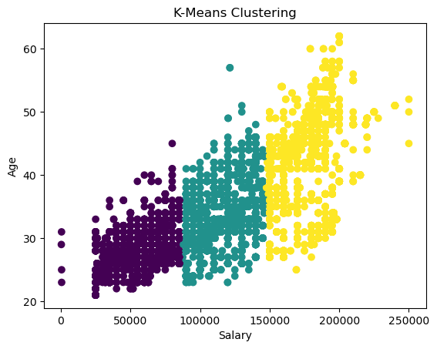
we got silhouette_score=0.60

Profiling and describing potential segments
I have used Age and Salary for Potential segemnt, and have used Age,Salary, Educational level, Gender for potential segment.
So we are doing 3 segments where the main contributors of making the segments is Age and salary. These two features tells us more about person alone with respect to combined features.

The Company is going to manufacture 2-Wheelers Evs. So 2-Wheelers Evs are Electric Bicycle, Electric Scooter, Electric Bikes.

Description of potential Segments
1st Segment = potential customers for purchase Electric Bicycle
2nd Segment=potential customers for purchase Electric Scooter
3rd Segment=potential customers for purchase Electric Bikes

Selection of Target Segements

Person’s Salary with greater than 25,000 thousand and age is starting from 21 years so these can be the potential customer for buying the Electric bicycles. Persons With >75000 salary can be the best suited for purchasing the Electric Scooter. Those ones who have their salary >140000 can be best customers for the Electric Bikes.

- A good quality Electric Bicycle manufacture cost would be minimum 18,000 but different variants will vary in manufacture cost c and after profit margin of manufacturer, distributors the E-bicycle cost is more than or equal to 30,000. So potential buyers would be that people with salary >25000.

- A good quality Electric Scooter manufacture cost would be minimum 50,000 but different variants will vary in manufacture cost and after profit margin, CGST, SGST etc the bicycle cost is more than 90,000. So potential buyers would be that people with salary >75000.

- A good quality Electric Bike manufacture cost would be minimum 60,000 but different variants will vary in manufacture cost and after profit margin, CGST, SGST etc the bicycle cost is more than 90,000. So potential buyers would be that people with salary >75000.

So from Figure above

- Black coloured segement is a segment of potential customers who can purchase Electric Bicycle.
- Grey coloured segement is a segment of potential customers who can purchase Electric Scooter.
- Yellow coloured segement is a segment of potential customers who can purchase Electric Bikes.

Customizing the Marketing Mix

Here's how each element of the marketing mix can be customized:

Product- Company is going to produce 2-wheeler Electric vehicles. 2-Wheeler like Electric Bicycle, Electric Scooters, Electric Bikes. Each on has more than one variants
This 2-wheeler electric Vechicles comes with many features

Price- The Prices of products will be affordable. Each Evs will have >1 variants then one would be come with little less feature compare to its higher variant would cost less or upper variant would cost liitle more. Services for each 2-wheeler vehicle will be less than 1000 for next five years and then after 5years battery replacement would cost more.

Promotion-Marketting of product would focus on the best given features, safety, and security. Advertisement on the Television, Newspapers etc for consumer awareness that some company is selling best in class 2-wheeler Evs.

Distribution (Place)- Our potential region is Urban, here people earn more money than people living in rural areas. The Distribution partners also will be high for the business. Urban region also has good electricity and road infrastructure that will make our product high.

Maximize Profit- Due to high compatible and ease the customers will purchase the 2-wheeler EV and those who nature guards will love this product.

Competition- High competition for 2-wheeler EV segment. Other players also coming in ground. So to look different we need to do different and provide best in class products

