ANVIQ Website
Page updates: before and after
AI Radiologist • Privacy Policy • Terms & Conditions • Contact Support • 29 September 2026

Summary
This document covers the second round of updates to the ANVIQ website. Four pages were redesigned to match the new teal green + orange theme and glass style. Screenshots show each page before and after.
Page | Before | After
AI Radiologist: sample report | Long single list on a plain dark header | Two-column report: stat tiles, organ status with green dots, orange action alert
AI Radiologist: modalities | Underlined tabs, white cards, 3 per row with one card left alone | Dark teal band, glass pill tabs, 4 glass cards per row, shine on hover
Privacy Policy | One long white card of plain text | Teal hero, at-a-glance cards, sticky contents list, 13 numbered sections
Terms & Conditions | Header only; content hidden below it | Same design as Privacy; 15 sections updated for all 4 products
Contact Support | Four text cards and a list of emails, no form | Help-topic cards, working contact form that emails the team, FAQ
Note: screenshots come from a test browser without the Mulish font and icon font, so fonts differ slightly and icons appear as empty squares. Colours and layout are accurate.

1. AI Radiologist page

1.1 "See what the AI generates" sample report
BEFORE
- Near-black header; every finding in one long single-column list.
- Alert shown as a plain block of text.
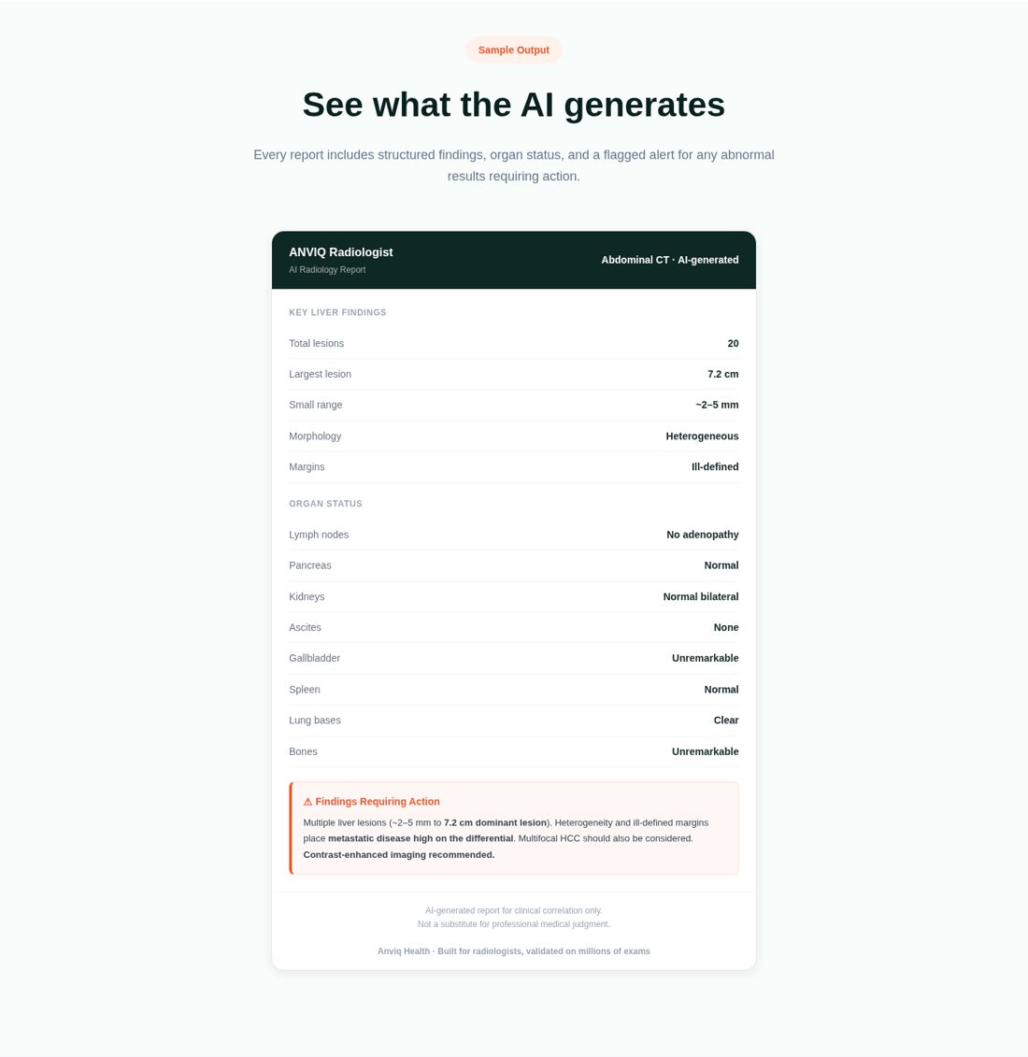
AFTER
- Teal header with "Abdominal CT" and "AI-generated" tags.
- Left: key liver findings as stat tiles; the largest lesion is highlighted in orange.
- Right: organ status list with a green dot for each normal result.
- Orange "Findings requiring action" alert with a pulsing icon and a "Contrast-enhanced imaging recommended" pill.
- Section background changed to soft grey so the white report stands out.
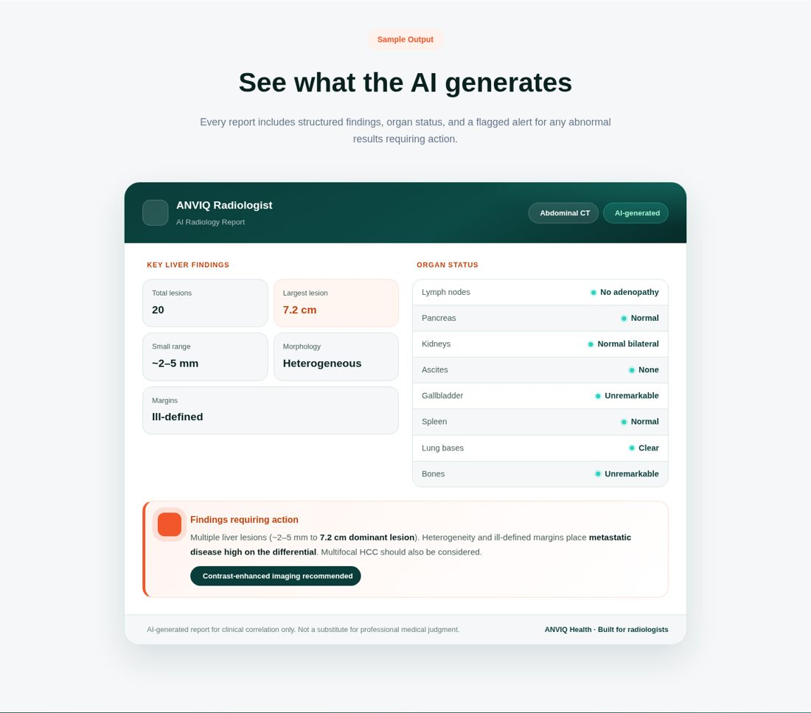

1.2 "Coverage across imaging modalities"
BEFORE
- Light grey section with underlined tabs.
- Plain white cards, 3 per row, so the 4th card sat alone on a new line.
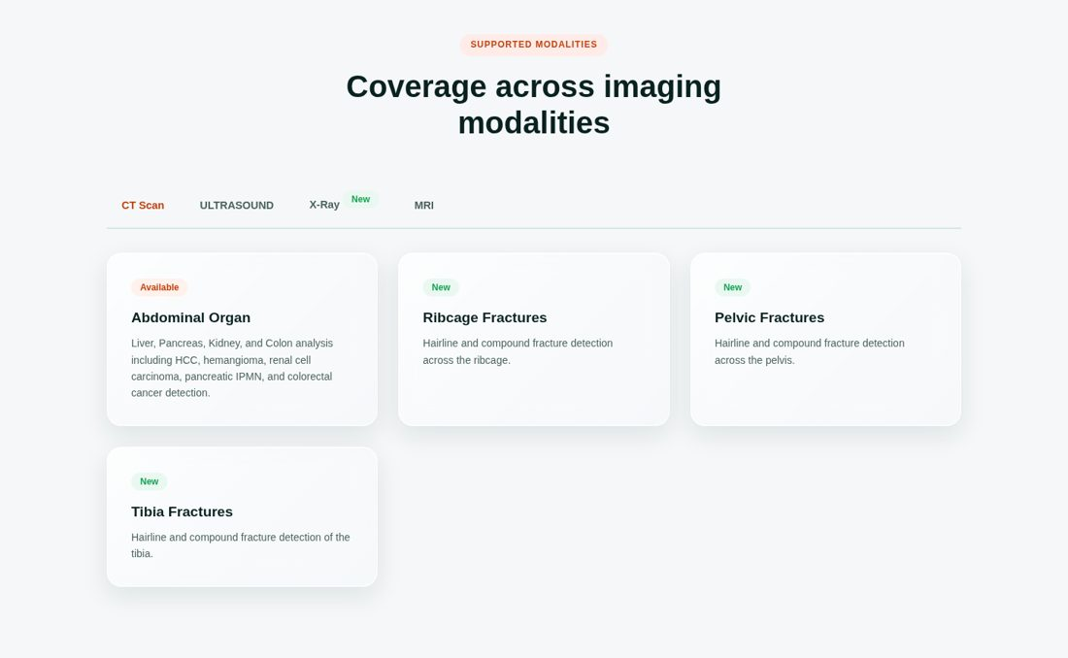
AFTER
- Dark teal band with soft mint and orange glow (moved here from the report section).
- Tabs are a glass pill switcher; the selected tab turns white.
- 4 dark glass cards per row. "Available" tag in orange text on light orange with an orange border; "New" tag in mint.
- Hover: card lifts, a glass shine sweeps across and a soft mint glow appears. Cards fade in when you switch tabs.
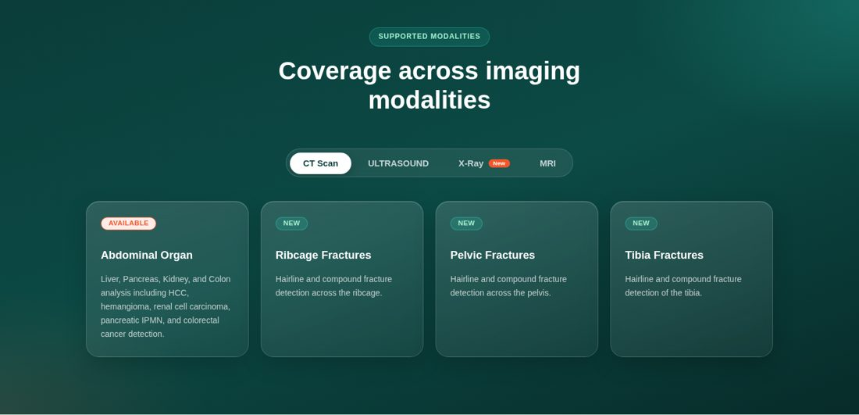

2. Privacy Policy page

Privacy Policy
BEFORE
- White page with a small "Legal" label.
- All 12 sections inside one long card of plain text.
- Generic content that did not mention the website forms, email or hosting.
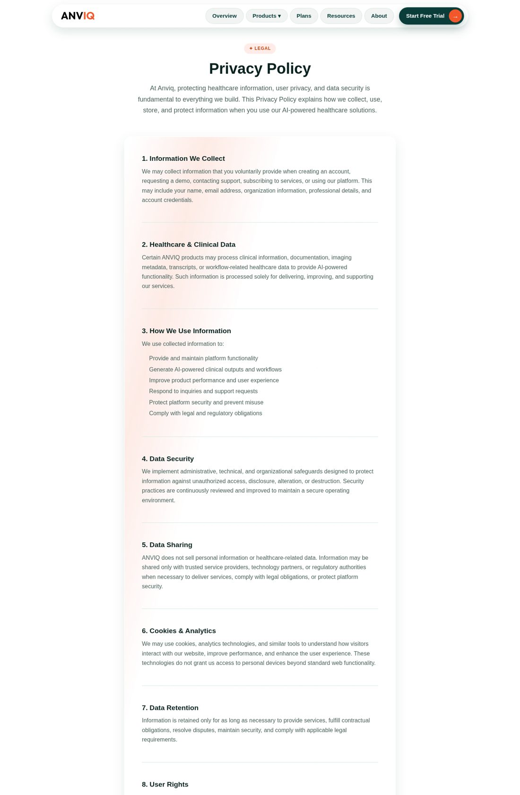
AFTER
- Dark teal hero with "Last updated", "DPDP Act, 2023" and "6 min read" tags.
- 4 "at a glance" cards: we never sell data, forms go only to our team, no tracking cookies, you stay in control.
- Sticky "On this page" contents list that highlights the section you are reading.
- 13 numbered section cards, a table explaining the Early Access and Notify forms, "Your rights" cards and a dark teal contact block.
- Content updated for the current site: Google Workspace email, Vercel hosting, Google Fonts / cdnjs, spam protection and DPDP rights.
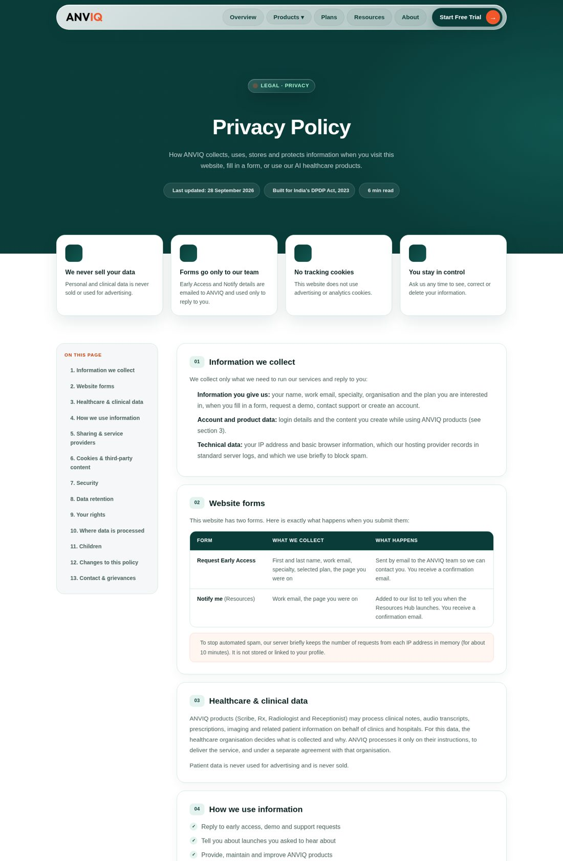

3. Terms & Conditions page

Terms & Conditions
BEFORE
- On the website only the heading showed; the content below stayed hidden (the screenshot shows it unhidden so you can compare).
- Plain text in one long card; mentioned only Scribe and Radiologist.
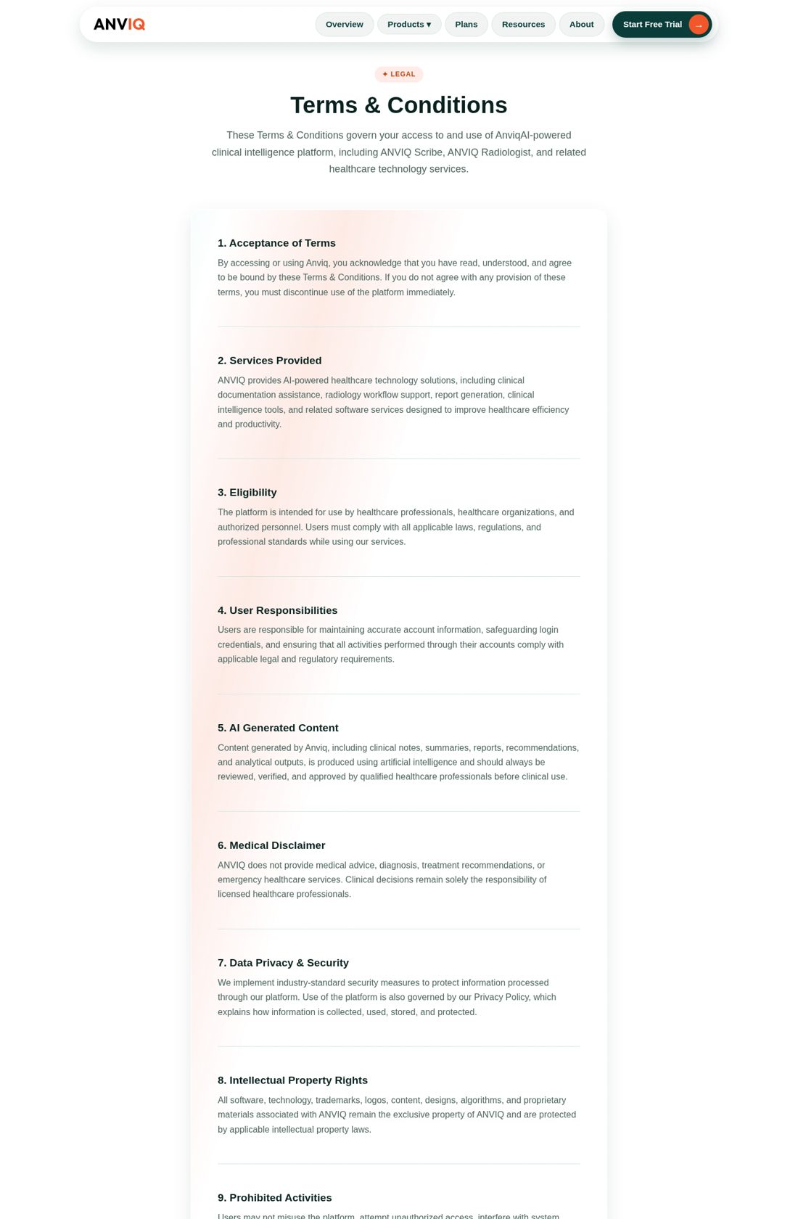
AFTER
- Same design as the Privacy page: teal hero, 4 at-a-glance cards, sticky contents list, 15 numbered sections and a contact block.
- Covers all 4 products (Scribe, Rx, Radiologist, Receptionist), free trials and plans.
- Clear warning that every AI output must be reviewed by a qualified professional, plus a medical disclaimer.
- Data ownership with a link to the Privacy Policy, acceptable use (including form spam) and Indian law.
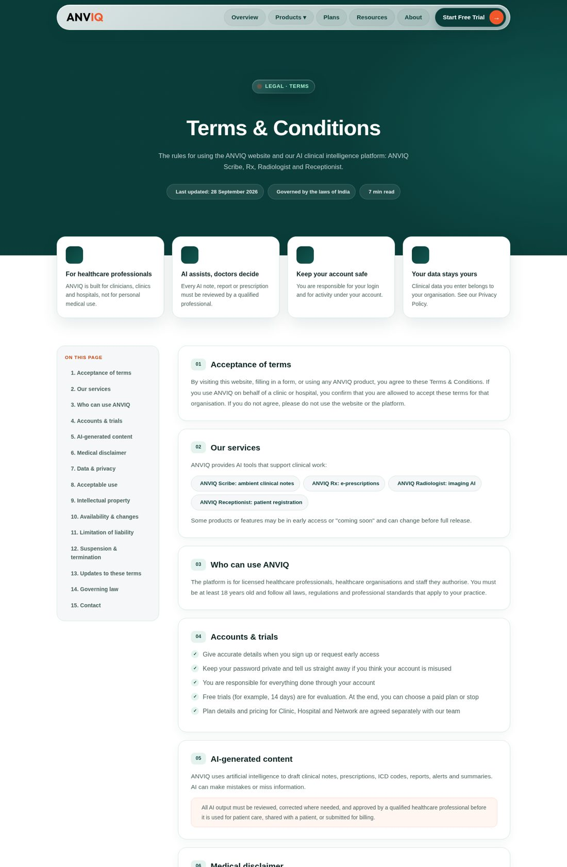

4. Contact Support page

Contact Support
BEFORE
- White page with 4 text cards (no actions).
- A list of the same email address repeated five times.
- No way to send a message from the website.
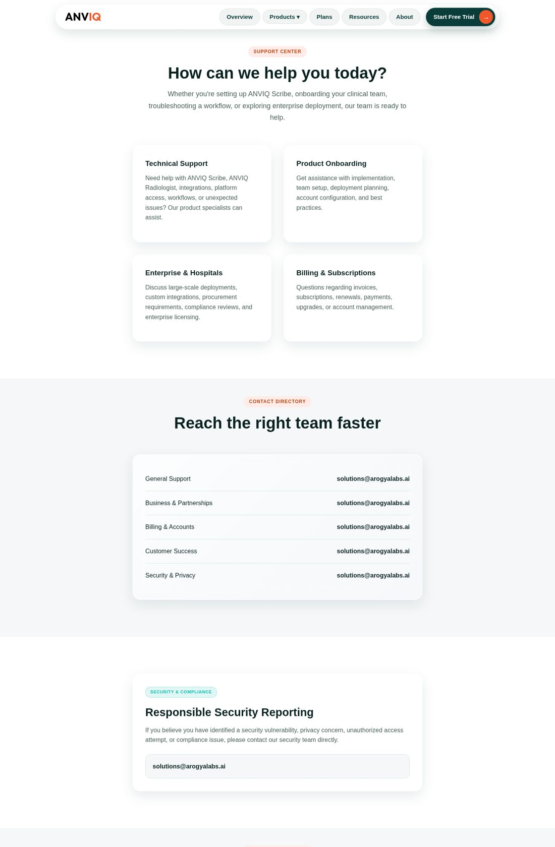
AFTER
- Dark teal hero with "Replies within 24 hours" tags.
- 4 help-topic cards; clicking one scrolls to the form and pre-selects that topic.
- Contact form (name, email, clinic, topic, message) that emails vikash@lumeneo.ai and sends the visitor a confirmation. A large "Message sent!" confirmation appears in the form.
- Form and sidebar end at the same line. Sidebar holds the contact directory and a dark "Report a security issue" card.
- Response-time cards (24h / 48h / Priority) and a 5-question FAQ that opens on click.
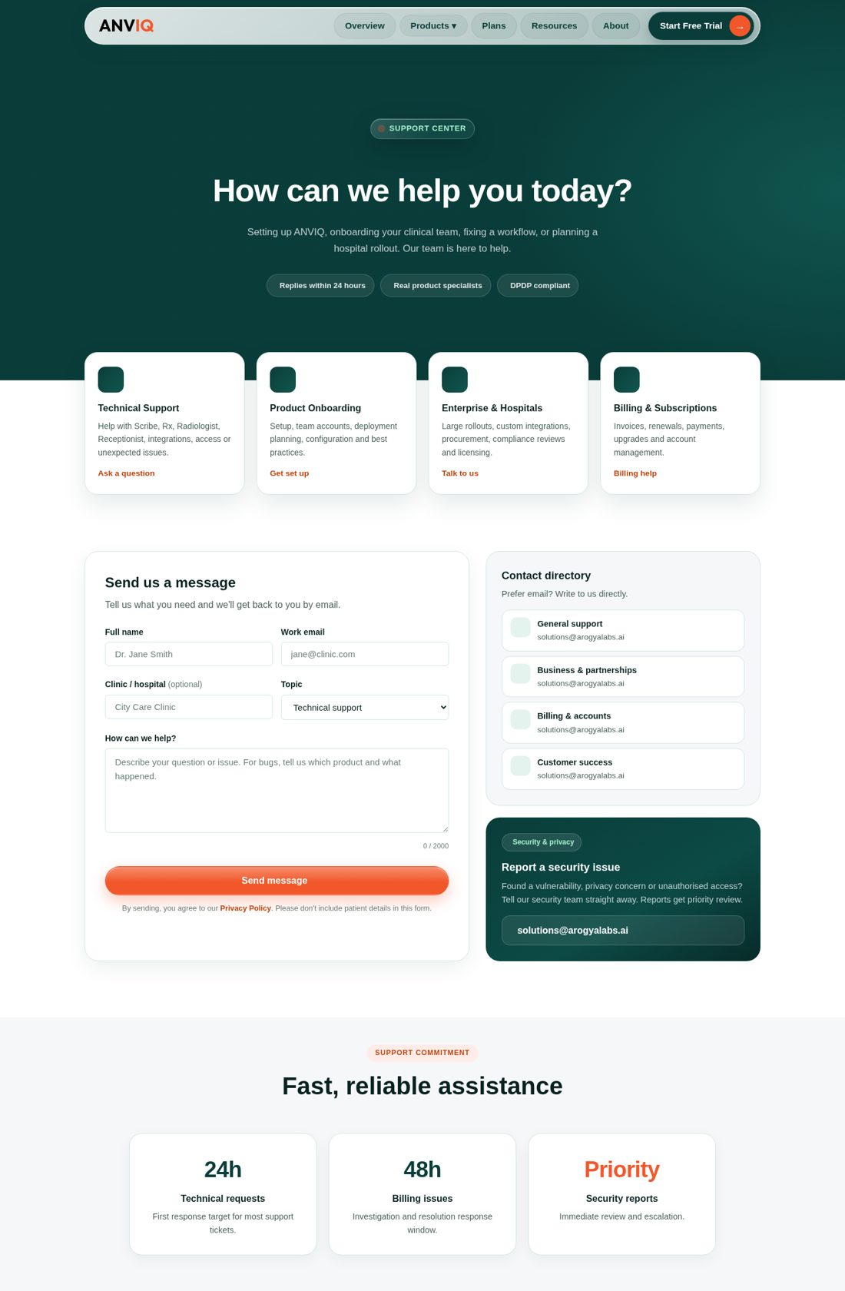

5. Files changed
File | What changed
index.html | New HTML for the report card, modalities section, Privacy, Terms and Contact pages
css/report.css (new) | Sample report card, Radiologist page backgrounds, modality tabs and cards
css/privacy.css (new) | Shared design for the Privacy and Terms pages
css/contact.css (new) | Contact Support page and form
js/ui.js | Contents list highlighting, contact form (topic cards, counter, sending, confirmation)
lib/mailer.js, api/contact.js, server.js | New /api/contact endpoint; submission copies saved outside the website folder

Before going live
- Have the Privacy Policy and Terms & Conditions checked by the company's legal or compliance team (grievance officer name, reply time, data retention).
- Confirm the FAQ facts: 10+ Indian languages, PACS/HIMS integration, 14-day trial, 24h / 48h response times.
- Set SMTP_PASS in Vercel Environment Variables so the contact form sends email on the live site.

Your review
# | Question | Your answer
1 | Do the new Radiologist report and modality cards look clear?
2 | Are the Privacy and Terms pages easy to read and navigate?
3 | Does the Contact form work for you (did you get the confirmation email)?
4 | Anything you want changed? (page + change)

