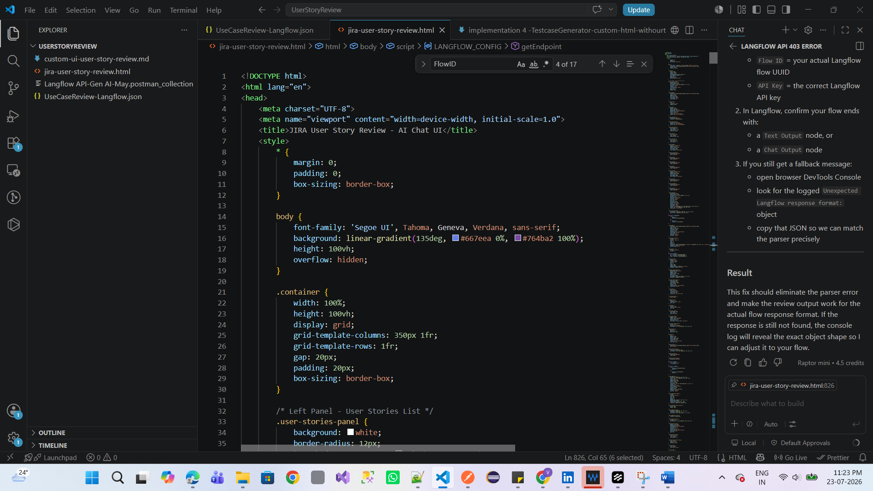
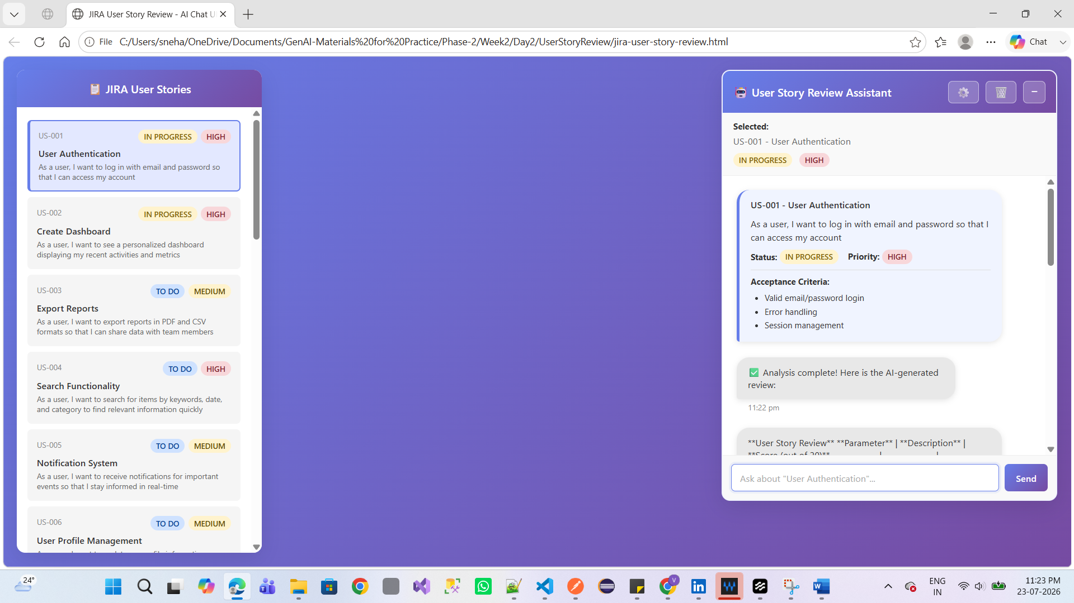
Output:
**User Story Review** **Parameter** | **Description** | **Score (out of 20)** -------------|---------------|------------------- **Clarity** | The story is somewhat ambiguous and lacks detailed acceptance criteria. | 12 **Completeness** | Preconditions not clearly mentioned, and acceptance criteria are missing. | 10 **Business Value Alignment** | The story reflects some healthcare value, but it's not explicitly stated. | 15 **Testability** | Can be tested through inpatient workflow automation, but it's not clear what specific aspects to test. | 13 **Technical Feasibility** | Technically feasible with existing hospital systems, but it's not clear what specific systems to integrate. | 14 **Overall Score:** 64 / 100 **Improvement Areas:** 1. **Add explicit acceptance criteria**: Define clear and specific acceptance criteria for the inpatient dashboard functionality, including error handling and edge cases. 2. **Specify preconditions**: Clearly mention the preconditions for the inpatient dashboard, such as user roles, permissions, and system requirements. 3. **Enhance business value alignment**: Explicitly state the healthcare value of the inpatient dashboard, such as improved patient safety, reduced errors, or increased operational efficiency. 4. **Improve testability**: Provide more detailed guidance on what specific aspects of the inpatient dashboard to test, including user interactions, data validation, and system integrations. 5. **Clarify technical feasibility**: Specify the exact hospital systems and technologies required for the inpatient dashboard implementation, including any necessary integrations or custom development. **Recommendations:** * Review the user story with the development team to ensure everyone understands the requirements and acceptance criteria. * Create a detailed acceptance criteria document that outlines the specific requirements for the inpatient dashboard. * Develop a test plan that covers all aspects of the inpatient dashboard, including user interactions, data validation, and system integrations. * Schedule a meeting with the project stakeholders to discuss the user story, acceptance criteria, and test plan to ensure everyone is aligned. **Action Items:** * Review and revise the user story based on the feedback and recommendations. * Create a detailed acceptance criteria document and test plan. * Schedule a meeting with the project stakeholders to discuss the user story and test plan.

